- Deploy Your flask backend and express frontend in amazon single ec2 instance.
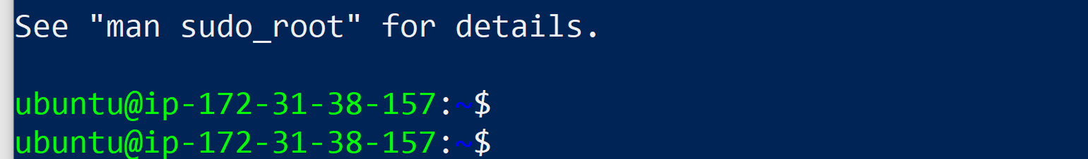
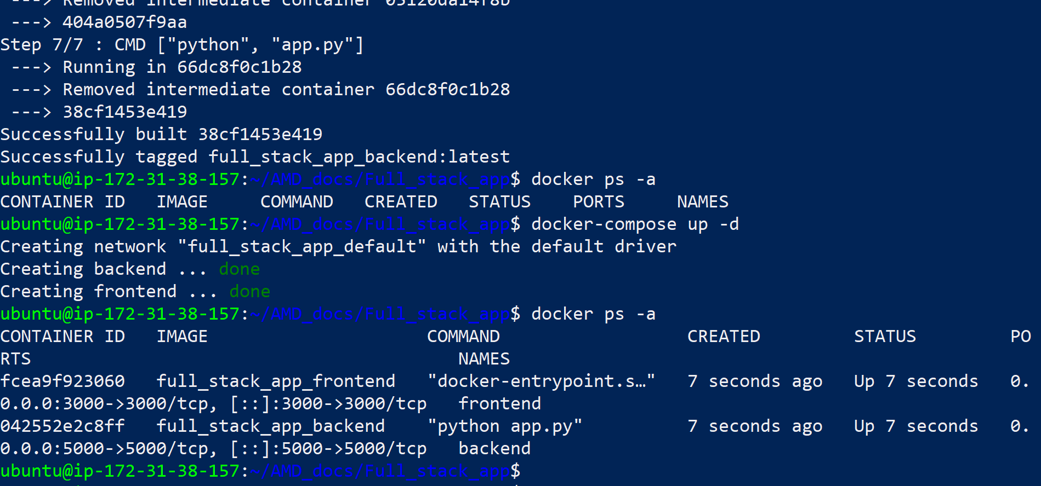
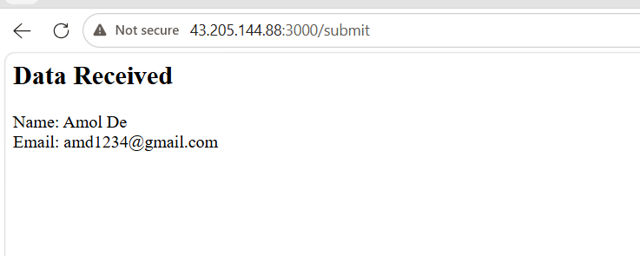

Github URL : AMD_docs/Full_stack_app at main · deoreamol54-ghub/AMD_docs

- Deploy Your flask backend and express frontend in separate ec2 instances.
Backend is running on 1st ec2 instance
Github url : AMD_docs/separate_be at main · deoreamol54-ghub/AMD_docs
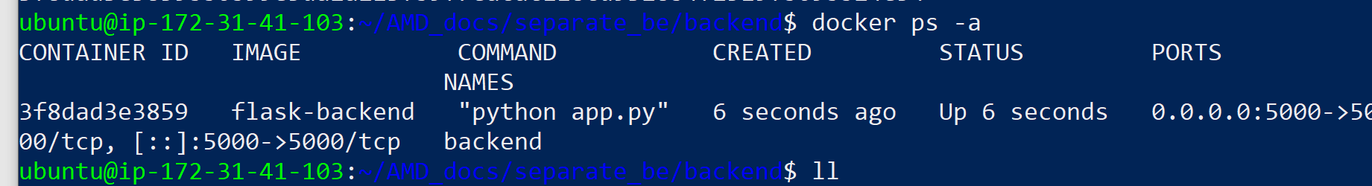
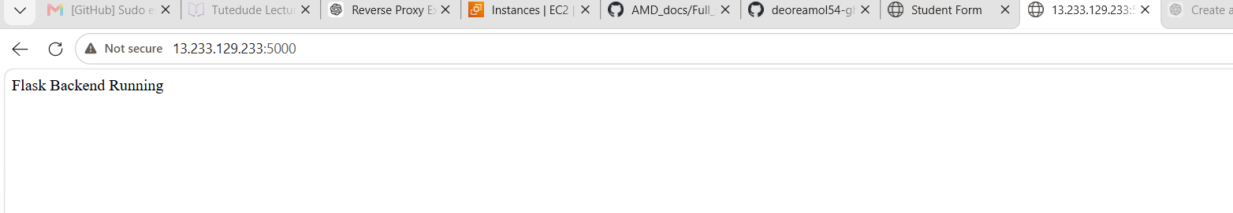

Frontend is running on 2nd ec2 instance
Github url : AMD_docs/separate_fe at main · deoreamol54-ghub/AMD_docs
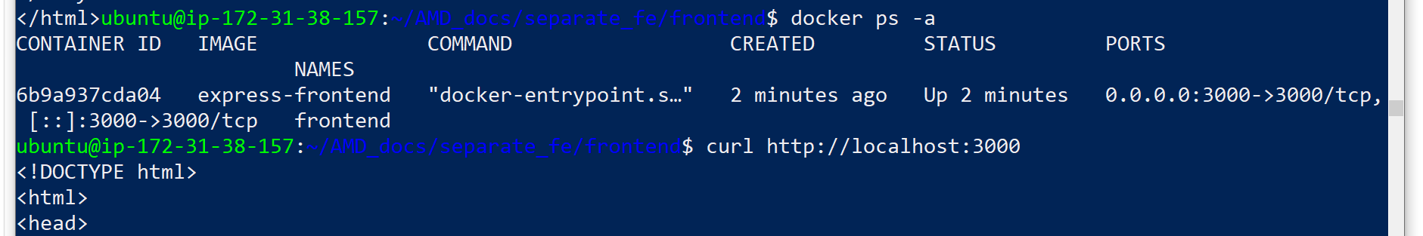
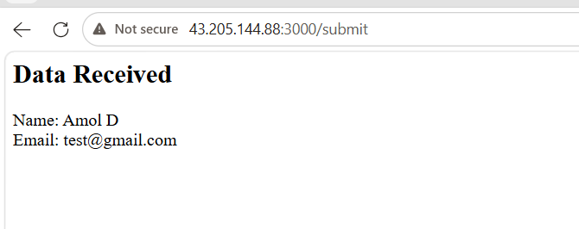

3. Deploy Your flask backend and express frontend Docker Container using aws ecr, ecs and vpc services

