Terraform provisioning to deploy a webserver

It includes below services are included:

1. VPC
2. Private and Public Subnet
3. Internet Gatway
4. One EIP
5. Nat Gatway
6. Routing table
7. Security Group
8. Security Group for Load Balancer
9. Target Group
10. Load balancer
11. Launch Configuration
12. Auto-scaling

Architecture Diagram

request

Load Balancer

IGW

NAT

**Public Sub- CIDR-10.0.0.0/26**

**Public Sub- CIDR-10.0.0.64/26**

Private Route table 2

Private Route table 1

Webserver1

Webserver1

**Public Sub- CIDR-10.0.0.128/26**

**Public Sub- CIDR-10.0.0.192/26**

**AZ- us-east-2b**

**AZ- us-east-2c**

**VPC CIDR 10.0.0.0/24**

**Here is my Web page which accessible with Load balancer’s DNS name:**

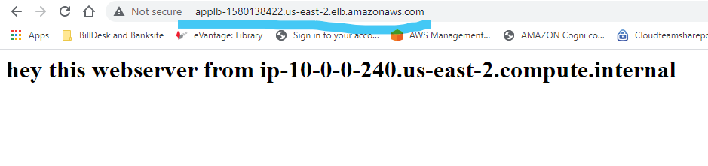

Created a VPC along with private and public subnet in two different availability zones

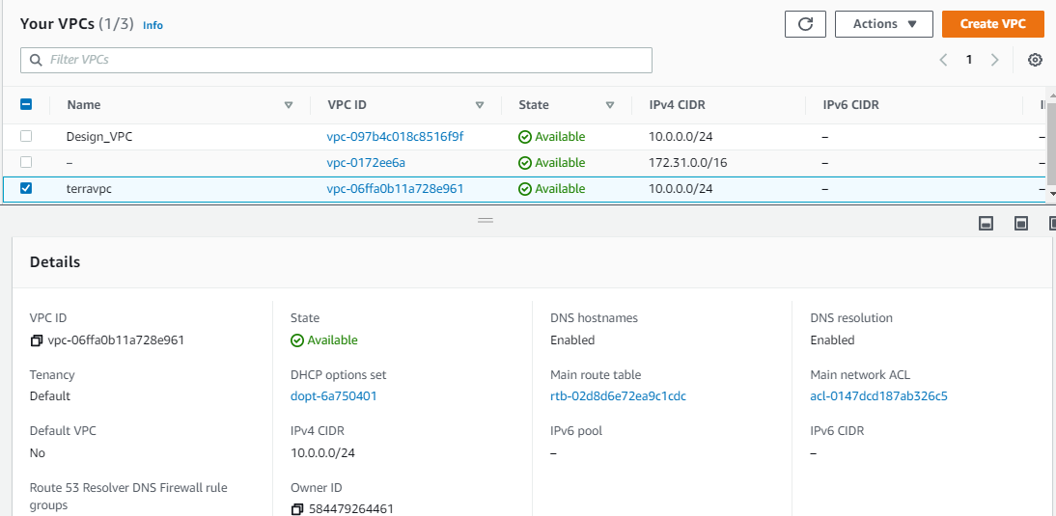

|  |  |  |  |  |
| --- | --- | --- | --- | --- |
| Type of subnet | Subnets | CIDR blocks | Roting table |  |
| Public | Subnet-1 | 10.0.0.0/26 | Public_RT | Internet Gateway |
| Subnet-2 | 10.0.0.64/26 |
| Private | Subnetpri-1 | 10.0.0.128/26 | Private_RT | NAT Gateway |
| Subnetpri-2 | 10.0.0.192/26 |

Subnets:

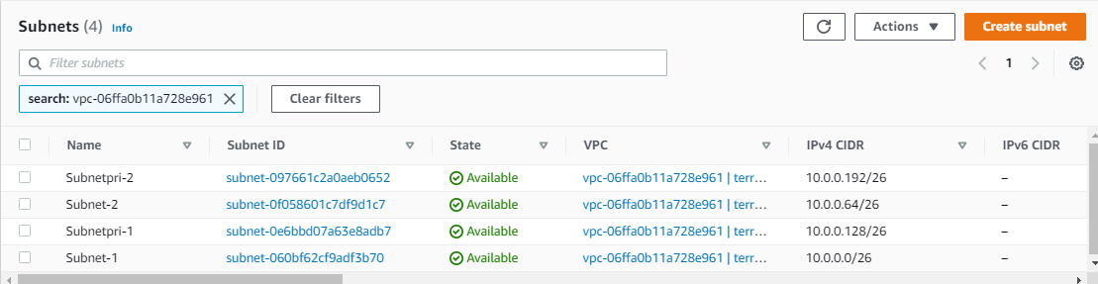

Routing Tables

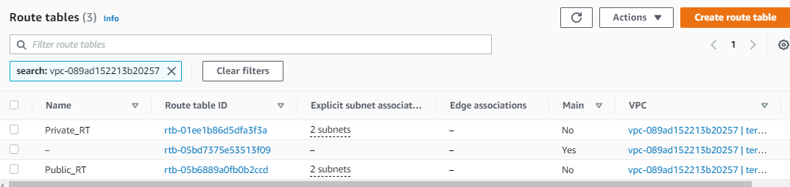

Association of public subnet to public routing table

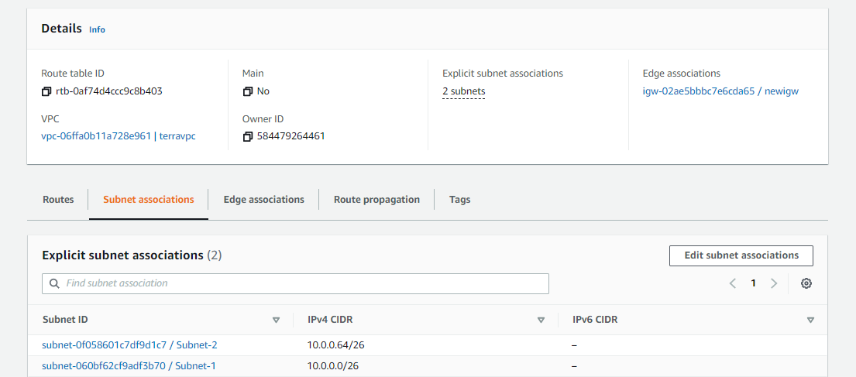

Association of private subnet to private routing table

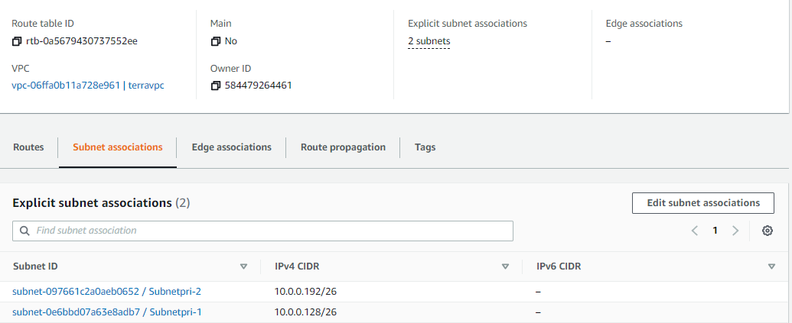

Internet Gateway

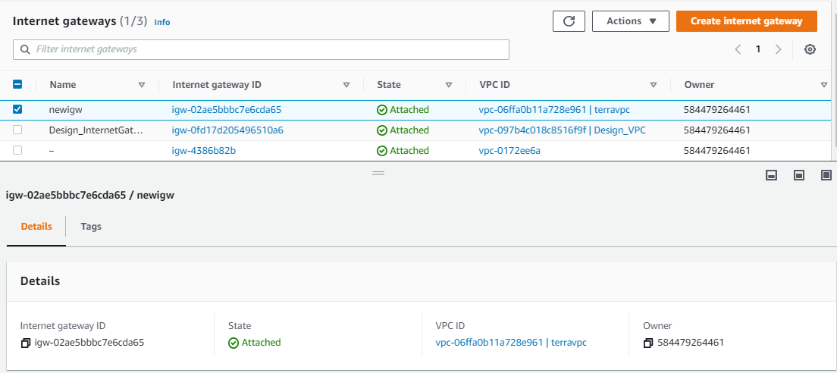

Association of Internet Gateway to Public Routing table

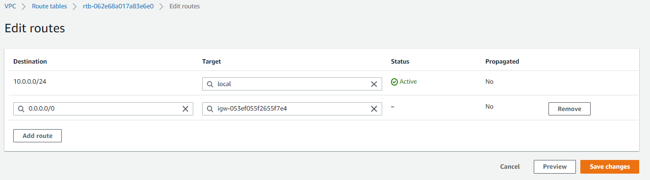

NAT Gateway

Created NAT gateway in public subnets



NAT Gateway association to private routing table- Done through AWS management console because of below terraform limitations:

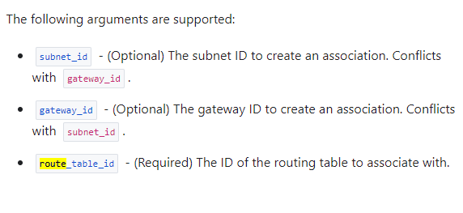

Associated NAT to private routing to communicated with private subnet ips and get response to load balancer - Done through AWS management console

To communicate with internet facing load balancer webservers should be in same Availability Zone in which NAT gateway resides in private subnet.

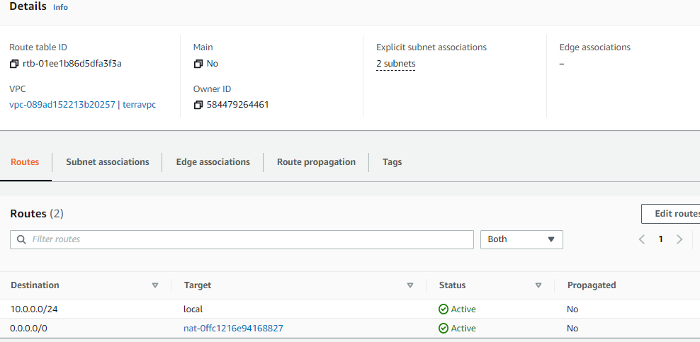

Launched two EC2 instances in private subnet

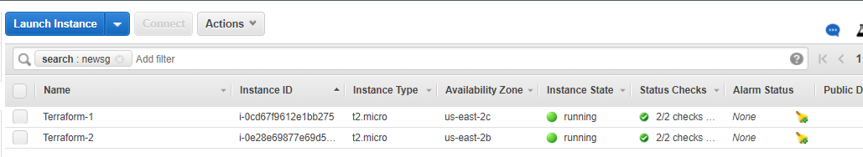

It has only private IPs

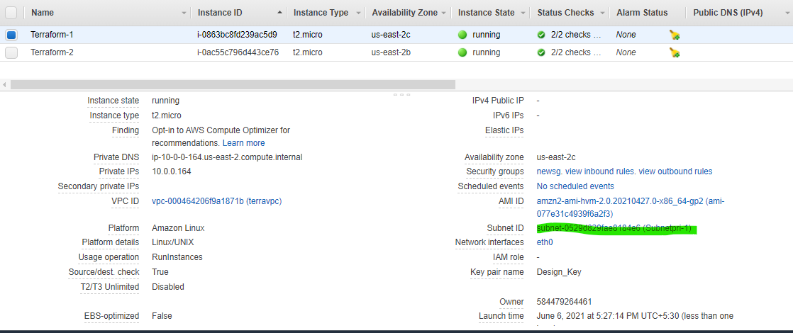

Security Groups

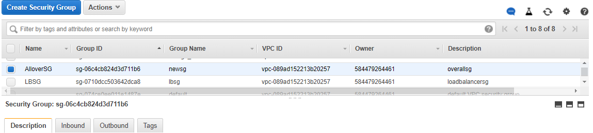

Main SG inbound and outbound:

In main VPC Security Group should allow inbound all traffic on port 80 and 443

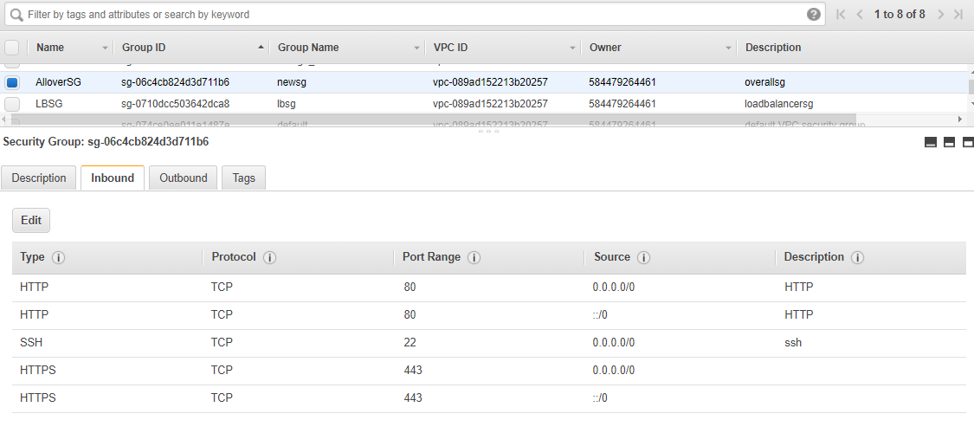

And Allow outbound traffic to load balancer’s security group

I have done this with aws management console

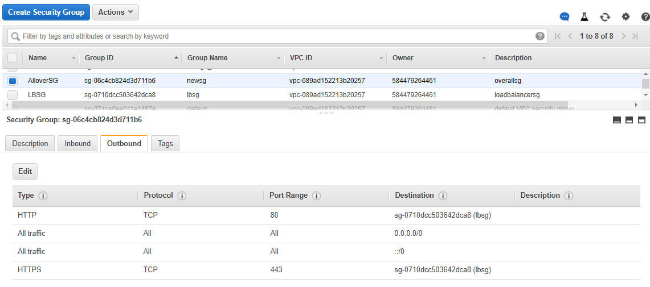

Load Balancer SG

Which allow inbound/outbound traffic to port 80

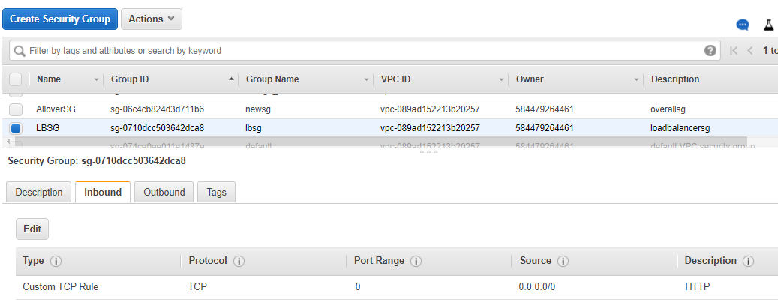



Created Target Group

Target group decides number of instances allocate to load balancer to serve requests.

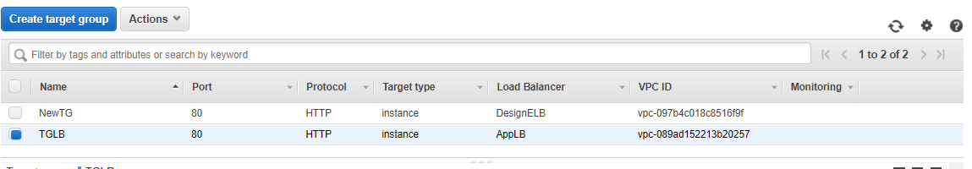

Two ec2 instances which are in private subnets are attached

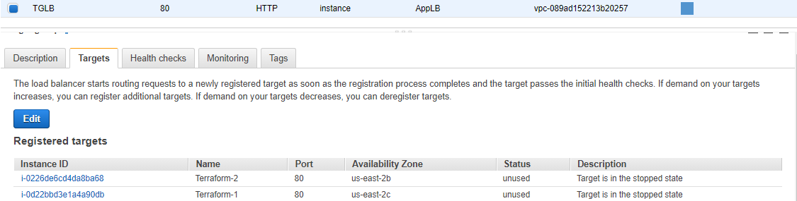

Load balancer

Here we will get loadbalacer’s address which is internet facing address.

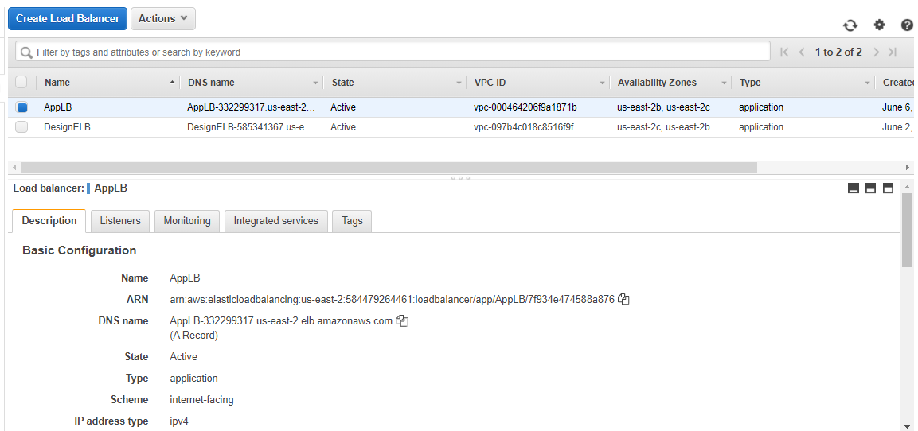

Launch Configuration

Launch configuration helps to select image and instance type for auto scaling purpose.

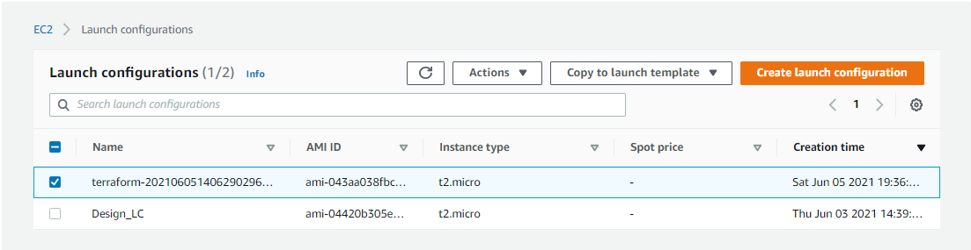

Auto Scaling Group

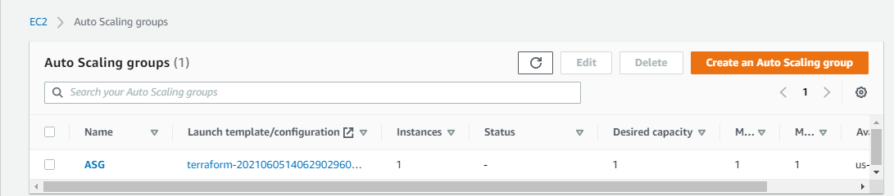

Things I have managed by AWS console Management:

IGT association to Public routing table:

Terraform version

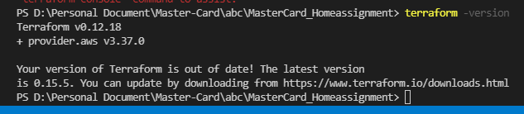

Ignore below error – it will get until Nat gatway come in available state

