**SYNOPSIS**

**TITLE OF THE PROJECT: Time Table Management System (TMS)**

**ABSTRACT:**

The "Timetable Management System" has been developed to override the problems prevailing in the practising manual system. This software is supported to eliminate and, in some cases, reduce the problems faced by this existing system. Moreover, this system is designed for the particular need of the organization to carry out operations in a smooth and effective manner.

A timetable is a temporal arrangement of a set of lectures and classrooms in which all given constraints are satisfied. Creating such timetables manually is complex and time-consuming process.

By automating this process with computer assisted timetable generator can save a lot of precious time of administrators who are involved in creating and managing course timetables. Since every college has its own timetabling problem, the commercially available software packages may not suit the need of every college. Hence, we have developed practical approach for building lecture course timetabling system, which can be customized to fit to any colleges timetabling problem. This project introduces a practical timetabling algorithm capable of taking care of both strong and weak constraints effectively, used in an automated timetabling system. So that the teacher can view their timetable once they are finalized for a given semester.

**PROBLEM DESCRIPTION:**

* It generates the Timetable and Faculty details.
* You can easily save the generated timetable and view it when necessary.
* Generated Timetable can be exported to PDF and directly printed.
* Faculty and admin can manage the list of subjects.
* Admin can manage the details of Faculty.

**AIM OF THE PROJECT:**

The main aim of the project is to reduce the work of manual creation of a timetable. The current web application generates the timetable automatically.

**PLATFORM/TOOLS/LANGUAGE TO BE USED:**

**Front End :** HTML5, CSS3, Bootstrap, JavaScript, Jquery/AJAX  
 **Back End :** PHP, MySql  
 **IDE** : Visual Studio Code

**COMPONENT DIAGRAM:**

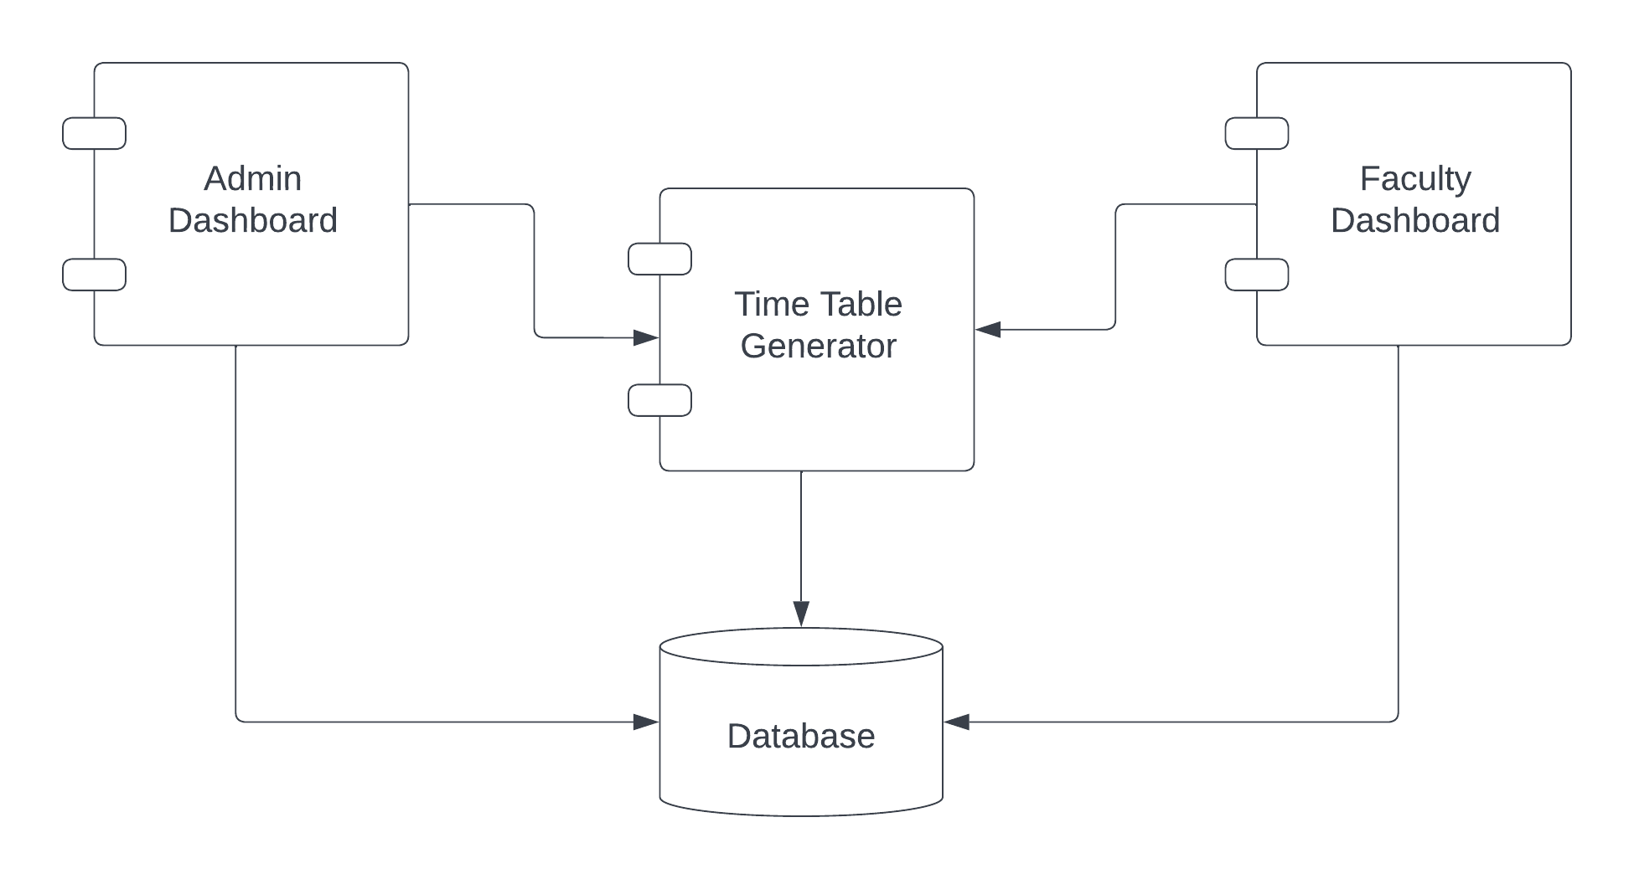

**Name of the Student: Deepak Boniface Cardoza**

**USN:**

**Signature**