**Data Lab - Lab Report (CSCI 3160)**

**Deep Desai**

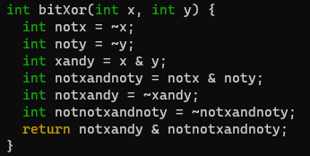

1. **bitXor**
   1. We did this one in class.
   2. Time: 10 minutes
2. **A black background with colorful text

   Description automatically generatedTmin**
   1. Not too bad, just left shifting the int.
   2. Time: 10 minutes
3. **isTmax**
   1. Checks if the input integer represents the maximum value for its type and returns 1 if it does, and 0 otherwise.
   2. A black background with white text

      Description automatically generatedTime: 20 minutes
4. **allOddBits**
   1. Creates masks to isolate the odd-positioned bits in a 32-bit integer, then applies the masks to the input integer, and checks if all odd bits are set by comparing the result with the mask and returning 1 if they match, and 0 otherwise.
   2. Time: 20 minutes

1. **Negate**
   1. A black background with white text

      Description automatically generatedTake the bitwise complement and add 1.
   2. Time: 5 minutes
2. **isASCIIDigit**
   1. Determines whether the input integer is an ASCII digit by checking if it falls within the bounds of ASCII digits (0-9), and returns 1 if it does, and 0 otherwise, through bitwise operations and comparisons with upper and lower bounds.
   2. A computer screen shot of a code

      Description automatically generatedTime: 30 minutes
3. **Conditional**
   1. Uses a mask to decide between y and z based on the “truthiness” of x. It creates a mask that is 1 if x is nonzero and 0 otherwise, then applies this mask to select either y or z using bitwise AND and OR operations.
   2. A black background with white text

      Description automatically generatedTime: 20 minutes
4. **isLessOrEqual**
   1. Checks if x is less than or equal to y and returns 1 if true, 0 otherwise, utilizing bitwise operations to account for positive, negative, and sign-different cases.
   2. A screenshot of a computer

      Description automatically generatedTime: 30 minutes
5. **logicalNeg** 
   1. Checks if the input integer is zero and returns 1 if it is, otherwise returns 0, using bitwise operations to negate x, perform a logical OR operation, and then check the sign bit of the result.
   2. **A screenshot of a computer screen

      Description automatically generated**Time: 20 minutes
6. **howManyBits**
   1. Calculates the number of significant bits in the input integer, accounting for whether x is zero or non-zero, by iterating through each position and applying bitwise operations to find the leftmost bit, and then adding 1 if x is zero.
   2. Time: 45 minutes
   3. I had some trouble with this problem, so the Internet helped me.
   4. A screen shot of a computer program

      Description automatically generated<https://www.chegg.com/homework-help/questions-and-answers/1-howmanybits-return-minimum-number-bits-required-represent-x-two-s-complement-examples-ho-q67832415>
7. **floatScale2**
   1. Scales the floating-point number represented by the input uf by a factor of 2, modifying its exponent part accordingly while preserving its sign and fractional part. If the input represents a special value, it returns the input unchanged.
   2. Time: 45 minutes

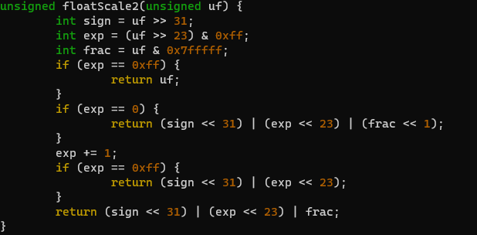

1. **floatFloat2Int**
   1. Converts a floating-point number represented by the input uf into an integer by extracting its sign, exponent, and fractional parts, adjusting the exponent bias, and handling special cases such as overflow or underflow.
   2. Time: 45 minutes
   3. I read more about this online, but I didn’t copy/paste code or anything.

1. **floatPower2**
   1. Calculates the floating-point representation of 2 raised to the power x, where x is an integer exponent, by adjusting the exponent bias and constructing the corresponding floating-point number with the sign, exponent, and fractional parts. It handles special cases such as overflow and underflow by returning special values for those cases.
   2. Time: 1 hour

**Final Remarks**

Make command:

Scoring Script (driver.pl):