**Exp. 1** Design an LED flasher

**Circuit Diagram:**

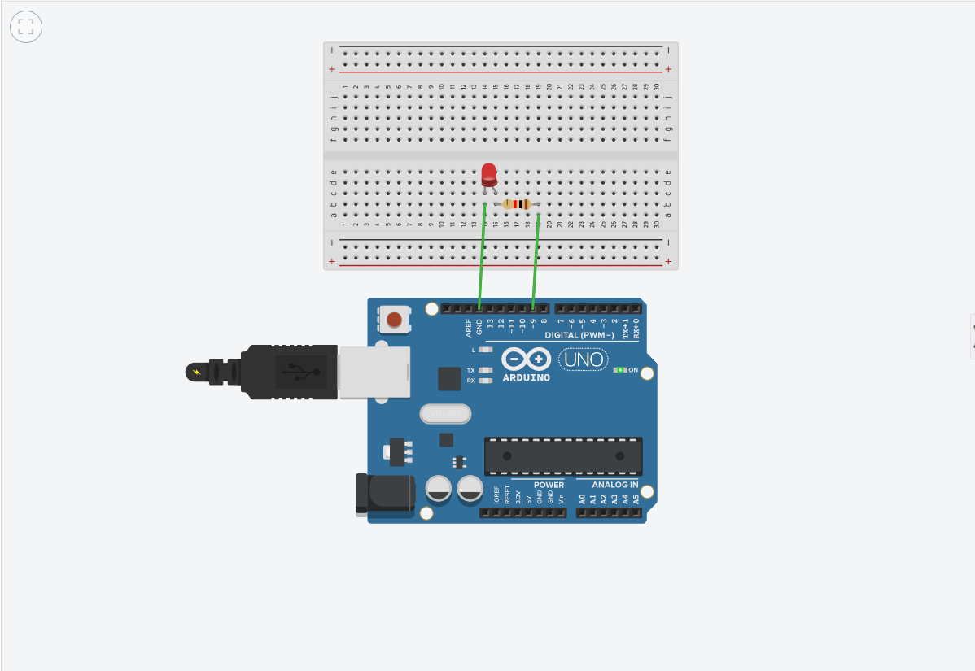

**Theory**

**Concept Used:**

* **OHM’s LAW**

Ohm’s law states that the voltage or potential difference between two points is directly proportional to the current or electricity passing through the resistance ,and inversely proportional to the resistance of the circuit.

* **KIRCHHOFF’s LAW**

Voltage law states that for a closed circuit path the algebraic sum of all the voltage around any closed loop in a circuit is equal to zero.

**LEARNING AND OBSERVATION:**

* **LEARNING**
* I learned about connection pattern in breadboard.

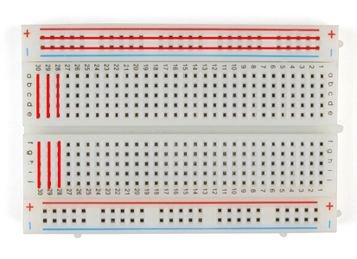

* The arduino board can supply a power of 5 Volt as digital output signals through the 14 pins (namely 0-13) present in it as digital input or output signal.

The GND pin of the arduino board acts as ground.

* **OBSERVATIONS:**

We observed that LED glows when code is uploaded.

**PROBLEMS AND TROUBLESHOOTING:**

* The LED bulb was not working. I had to replace the bulb with another one.
* The circuit was not getting closed because the wires were not placed at the right position so I check the position of wire again.
* The p and n side of a diode should be connected appropriately.

**PRECAUTIONS:**

* The connections at different points should not be loose and the pins should be inserted properly.
* Select the correct port.
* Select the correct board from tools option.

**LEARNING OUTCOMES:**

* I have learned how to make circuits using an arduino board and a bread board and some other hardware.
* Through this experiment I have gained the skill of making a circuit using different hardware and controlling the functions done by that circuit with the help of codes.