**EXPERIMENT -7**

**Aim**:Design a Programmable Digital Data Display system.

**Apparatus:**Arduino, resistance, variable resistance, wires, Breadboard, LCD.

**Circuit Diagram:**

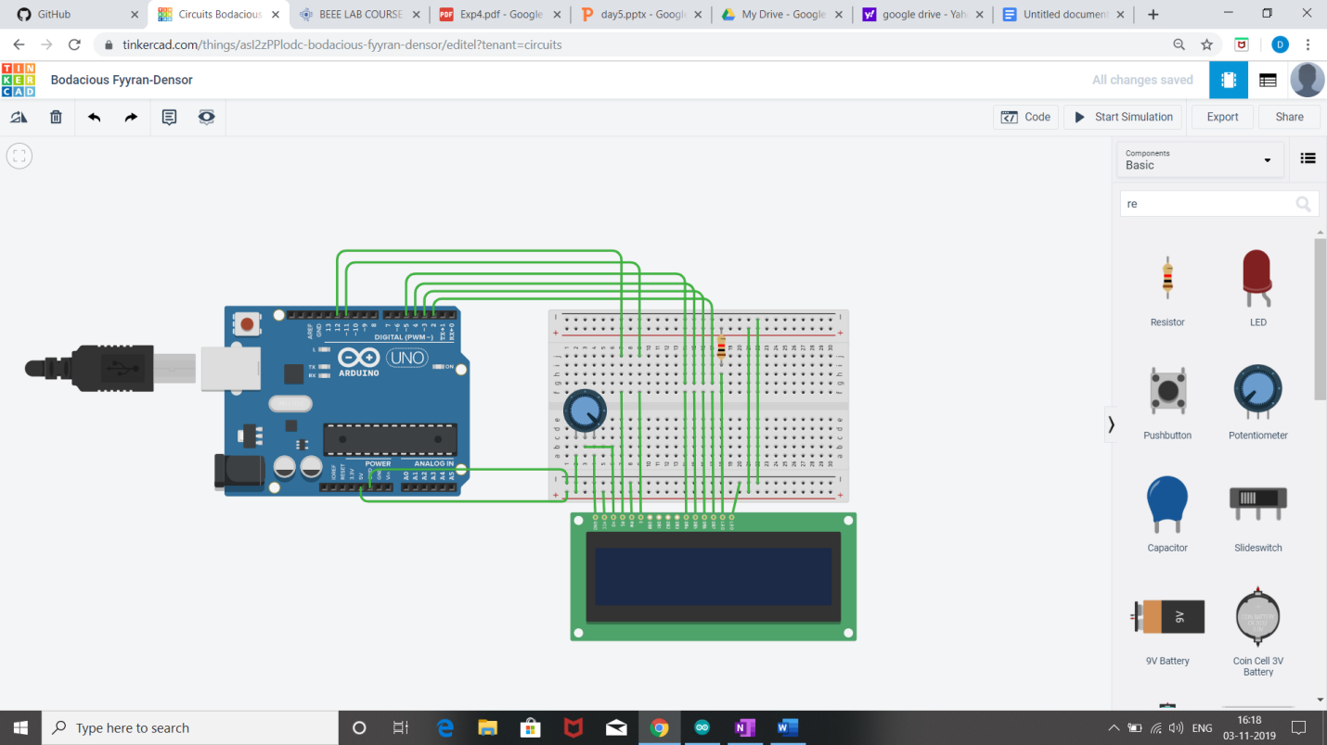

**THEORY:**

**Concept used:**

* We have used the concept of **LCD(liquid crystal display).**
* We have used the potentiometer for variable resistance.

**Learning and observation:**

* The Liquid Crystal library works with all LCD displays that are compatible with the driver.
* Potentiometer keeps voltage difference constant.
* A digital data display of hello world can be seen when you turn on the circuit.
* A in-built library **#include <LiquidCrystal.h>** is used to reduce the code which already contain the details of connections.

**Problem and Troubleshooting:**

* Port selection should be done properly where you have connected arduino to the system.
* End wires of potentiometer should be connected 0 and 5 volt connecting middle wire change the voltage difference.
* Connection should not be loose.

**Precautions:**

* Avoid dropping or applying mechanical impact on LCD as it can damage display surface.
* Check the working of LCD beforehand.

**Learning outcome:**

* I have learnt the use of input library function for lcd .
* I have learnt how to change the movement of cursor at different location of on display screen.