**TASK**

**Design a system for home security systems ,such that whenever someone approaches the gate ,the LED starts blinking once every 100ms.**

**CIRCUIT DIAGRAM:**

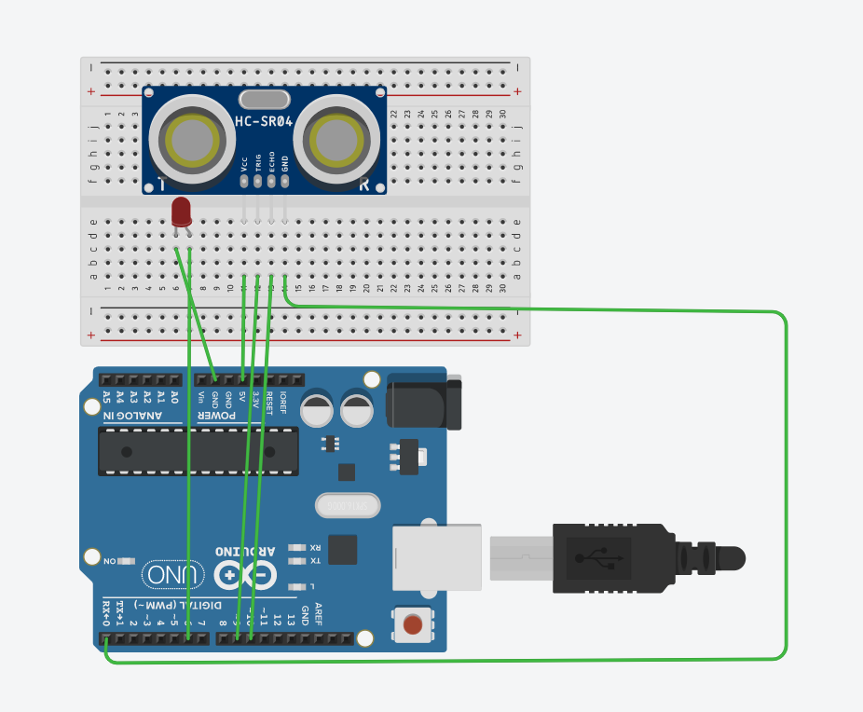

**THEORY:**

**Concept used:**

* Ultrasonic sensors measures the distance by using ultrasonic waves.
* LED blinks when range of distance measured from ultrasonic waves becomes equal to distance in the condition.

**LEARNING AND OBSERVATIONS:**

* When distance become less than 50 cm LED starts blinking with the speed of 100ms.

**PROBLEMS AND TROUBLESHOOTING:**

* Arduino should be connected in correct port.
* Check the LED before hand whether it is working or not.

**PRECAUTIONS:**

* The wires are inserted properly and tightly at the required points so that the circuit does not get short.
* The two pins of the LED should be connected at their appropriate point that is the positive point should be connected with the p pin and negative point should bbe be connected with

be connected with the negative pin.

* We should take care that the circuit is closed.

**LEARNING OUTCOMES**

* I have learned how to make house security using ultrasonic sensor.
* I have learned how a ultrasonic sensor works.