# **Digital Traffic Regulation Orders (D-TRO) Beta**

**Standard terms and definitions spreadsheet**

**Explanatory Notes (v2)**

**Table of Contents**

1. Context
2. Purpose
3. Structure of the spreadsheet
4. Spreadsheet review
5. How to comment?

**Context**

The D-TRO (Digital Traffic Regulation Orders) Service being developed by DfT is centred on a standardised data model. This data model seeks to enable different forms of TRO and traffic management measures to be encoded in a standardised data structure. Digital versions of TROs conforming to the D-TRO Data Model will be sent from the Traffic Regulation Authorities (TRAs) to the DfT centralised service, and then onward distributed to data consumers.

The data model itself has been developed over the course of several projects. It seeks to balance the challenges of the wide spectrum of TRO that may exist, with the formulation of a standardised data structure.

At a technical level, the data model contains a number of lists. Within each list each item entry holds a particular value. The data model itself uses a short wordphrase – short phrases that describe concepts in shorthand IT terms. For each of the item entries in each of the lists in the data model, these wordphrases for the different lists are represented within this spreadsheet. There are approximately 35 lists within the data model as a whole.

Many of these lists contain background contextual information (such as lists of the days of the week and months of the year). There are other lists which contain key semantic concepts relevant to TROs. To name a few, we have lists that cover vehicle type, regulation types, vehicle usage types, types of different weight measures that might be used, types of permit, etc.

**Purpose**

The intention of the spreadsheet was to provide a firm definition for each item that exists in the lists within the D-TRO data model. This is particularly relevant for those lists items that address semantic content such as vehicle type and regulation type, etc.

There is a risk if no standardised definition is provided by DfT that different TRAs will interpret the data model item wordphrases locally, and differently. This could result in variation between local instances of the interpretation of the data conforming to the data model.

The underlying principle of this spreadsheet is to try to seek to identify and where necessary, develop singular definitions for each semantic concept (i.e. each list item entry).

In the work done by Steve Thompson, the original author, he has identified instances where item wordphrases are defined within UK legislation. Definition arising in the Traffic Signs Regulations and General Directions 2016 (TSRGD), where they exist, are taken to be the primary reference.

For example, looking at worksheet “2 vehicleType” the data model has an item wordphrase “pedestrian-controlledVehicle+”. This has two potential existing definitions, and therefore has two entries included within the table. Ideally for the purposes of D-TRO it is necessary where possible to identify a single definition per entry.

Steve's also added in many entries where he believes additional entries should be included in the data model. These are the non-bold item entries in the “Item” column on each worksheet.

The content of the spreadsheet is developmental in nature – there will be room for improvement.

**Structure of the spreadsheet**

This spreadsheet is provided in Microsoft Excel format.

The first worksheet provides an index to the other worksheets (tabs).

Numbered worksheets each represent one list within the data model. These lists have been developed over time, drawing on the experience from TRO practitioners.

On each numbered worksheet you will find (see example on next page):

* The “Code” column that provide a code for each list item entry.
* The “Item” column, which provides the list entries and the wordphrase that is used in the data model – The format of the wordphrase is done using an IT convention which is called lower camel case (i.e. a concatenated wordstring with no spaces. Each word within the wordstring starts with a capital letter, except the first word which starts with a lower case character).
  + Those entries that exist within version 3.2.2 are in bold.
  + Where more than one existing UK legal definition is identified for a list item the multiple entries are given. The Item worksphrases have a plus (+) suffix.
* The “Definition” column seeks to provide a future standardised definition for each list item. Where an existing UK legal definition has been identified this in included with the legislation identified in the “Source” column. Other definitions have been provided that may be suitable, but do not have an identified UK legal definition.
* The “Notes” column has been developed by the authors of the spreadsheet – highlighting possible additions, deletions, wording changes etc.
* The “Link” column provides any relevant hyperlinks.
* The “Ver” columns indicates if the list item exists in the current version of the data model (version 3.2.1) or is a potential addition into a future data model release.

**Example worksheet – no. 2 vehicleType**

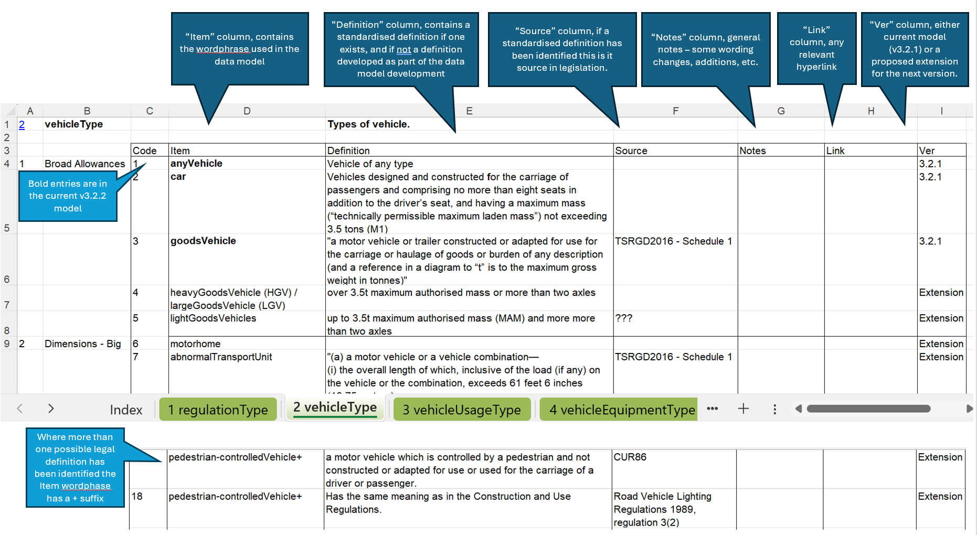

**Spreadsheet review**

The worksheet tabs have been colour coded to help focus a review. The worksheet tabs which are coloured green have the heaviest semantic content, providing the key data concepts held in TROs. These tabs would benefit most from review.

It would be helpful to review not only the definitions that have been identified, but also the item entries within the semantic oriented worksheets (the green tabs), to understand whether Steve's suggestions and the existing entries make sense.

**How to comment?**

DfT welcomes comment. The preferred route to comment is to add comments to the existing GitHub issue thread for this topic (title: Standard terms and definitions). Due to the limitations of Microsoft Excel it is preferable to reference any comment as follows:

Your name:

Your organisation:

Proposed change [Worksheet][Code][Description of nature of change]

Example :

Your name: John Cooper

Your organisation: DfT

Proposed change 1 [vehicleType][6][Agree motorhome entry needed. My suggested definition is XYZ]

Proposed change 2 [vehicleType][new][Please add entry “eScooter” with the definition ABC]