Chart Review Data Preparation

What is ChartReview?

ChartReview is a multi-project, multi-user web application that is hosted on a VA machine called vhacdwdwhweb11 within the VINCI firewall.  You access it by logging into vinci and opening a FireFox browser that has been configured for Windows Integrated Authentication to access the server.  You are added to ChartReview as a user and you are able to create projects yourself.  As a user, you will only see the projects and data that you are included on and that you have database permissions to see.  A project definition includes a JDBC url which tells ChartReview the location of your project database.  A mapping is created in ChartReview between the database tables and the view of that data in the user interface using a SQL query.  Many projects define views in the db with all of the filters (cohort patients only, time window, only required fields, etc.) and indexes pre-applied so that the query to map data into ChartReview is very simple and fast.  The mappings are called clinical element definitions and when viewed in the ChartReview UI, they are called clinical element views.  A chart is made up of N number of project coordinator defined clinical elements and the set of clinical elements can be different for each annotation workflow that is created.

As you define the queries for the views you will see as part of a chart for a given annotation task in ChartReview, consider the following questions:

1. Do you want to see all of the fields in the tables in the ChartReview view (would that be too much information for the annotators given their task)?
2. What would you like for the annotators to see as the names of these fields?
3. Any other filters needed (station, age, service-related status)?
4. How many patients are in these tables?   Would you want more speed by creating a views of that data for only those patients in the cohort?
5. Do you want to see this data for all time or for just a window of time (create a view with the time filter)?

The following is an example list of the type of queries that you would need to define a project and annotation workflow in ChartReview. Note these queries will differ depending upon the clinical element definitions you need for your project and the database environment you are in.

Each view has two queries. The first query returns all of the rows of the table that belong to the principal clinical element (i.e. the patient). In the UI, this pulls all the records that will be displayed in a clinical element view’s grid. The second query returns a particular record in the table. In the UI, this pulls in the record that will be displayed in the clinical element view’s detail panel. This means that each of the tables needs to effectively have a principal clinical element id column (a patient id column) and a recordID column. The patientid colum, for example, is used to pull all records for a given patient. The recordID column needs to be a unique id for each record in the table and is used to pull that one record by id. Note that if you need to perform joins, etc to accomplish having these two columns in each table, it is most convenient to create a view in the database that contains the possibly changing complexity, and to have a simple query to enter into the ChartReview UI. This allows the data construct to change without modifying all of the ChartReview project configuration, including Clinical Element definitions, and project workflow processes.

Example Notes Query

All Elements By Patient Id Query

SELECT [patientid], [TIUDocumentSID], [Sta3n], [ReferenceDateTime], [TIUDocumentDefinition], [reporttext]

FROM [ORD_PI_2014010007B].[Dflt].[notes_vw]

WHERE patientid = ?

ORDER BY [ReferenceDateTime]

Single Element Query

SELECT [patientid], [TIUDocumentSID], [Sta3n], [ReferenceDateTime], [TIUDocumentDefinition], [reporttext]

FROM [ORD_PI_2014010007B].[Dflt].[notes_vw]

WHERE TIUDocumentSID = ?

ORDER BY [ReferenceDateTime]

Column to Display Mapping

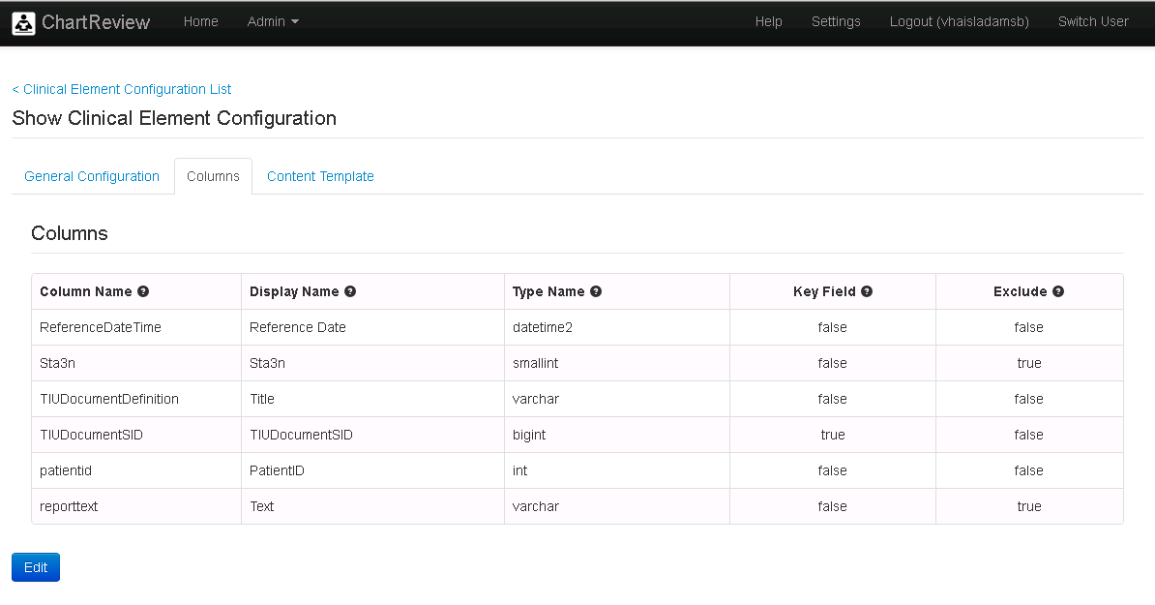

Content Template

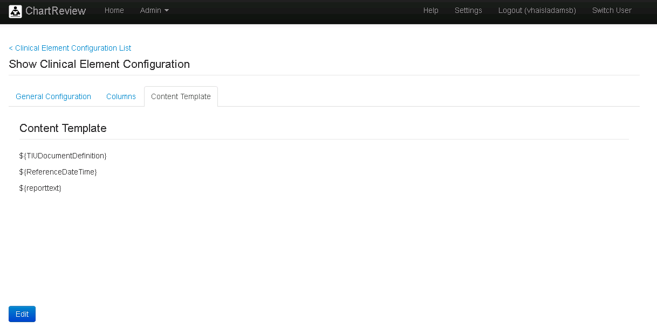

Example Diagnosis Query

All Elements By Patient Id Query

SELECT [patientid], [Sta3n], [DiagnosisDate], [ICD9Code], [ICD9Description], [dxSID], [dxType]

FROM [ORD_PI_2014010007B].[Dflt].[diagnoses_vw]

WHERE **patientid** = ?

ORDER BY diagnosisdate

Single Element Query

SELECT [patientid], [Sta3n], [DiagnosisDate], [ICD9Code], [ICD9Description], [dxSID], [dxType]

FROM [ORD_PI_2014010007B].[Dflt].[diagnoses_vw]

WHERE **dxSID** = ?

ORDER BY [diagnosisdate]

Column to Display Mapping

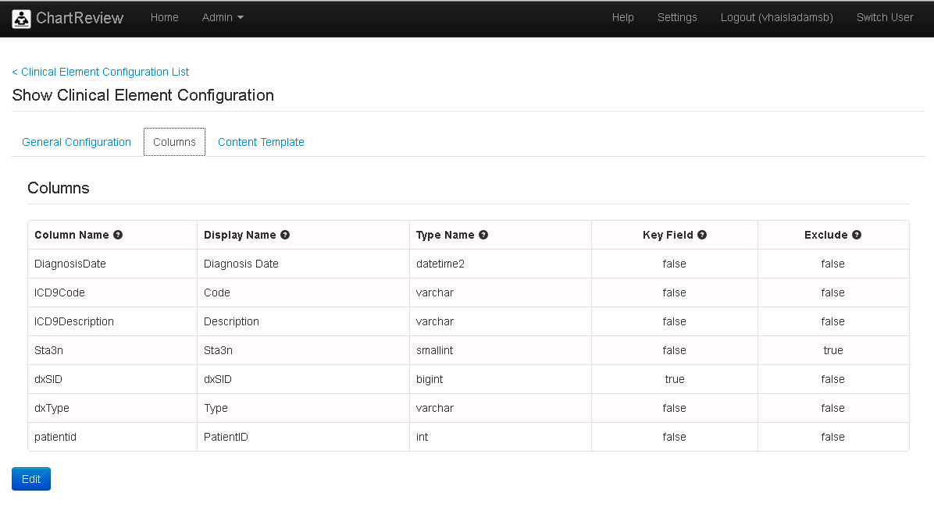

Content Template

No content template needed because this will just be displayed as a table in the UI.

Example Labs Query

All Elements By Patient Id Query

SELECT [PatientID], [LabChemSID], [Sta3n], [LabChemTestName], [LabTestType], [dxSID], [LabPanelSID], [LabChemSpecimenDateTime], [LabChemCompleteDateTime], [LabChemResultValue], [Units], [Abnormal], [RefLow], [RefHigh]

FROM [ORD_PI_2014010007B].[Dflt].[labs_vw]

WHERE **patientid** = ?

ORDER BY [LabChemSpecimenDateTime]

Single Element Query

SELECT [PatientID], [LabChemSID], [Sta3n], [LabChemTestName], [LabTestType], [dxSID], [LabPanelSID], [LabChemSpecimenDateTime], [LabChemCompleteDateTime], [LabChemResultValue], [Units], [Abnormal], [RefLow], [RefHigh]

FROM [ORD_PI_2014010007B].[Dflt].[labs_vw]

WHERE **LabChemSID** = ?

ORDER BY [LabChemSpecimenDateTime]

Column to Display Mapping

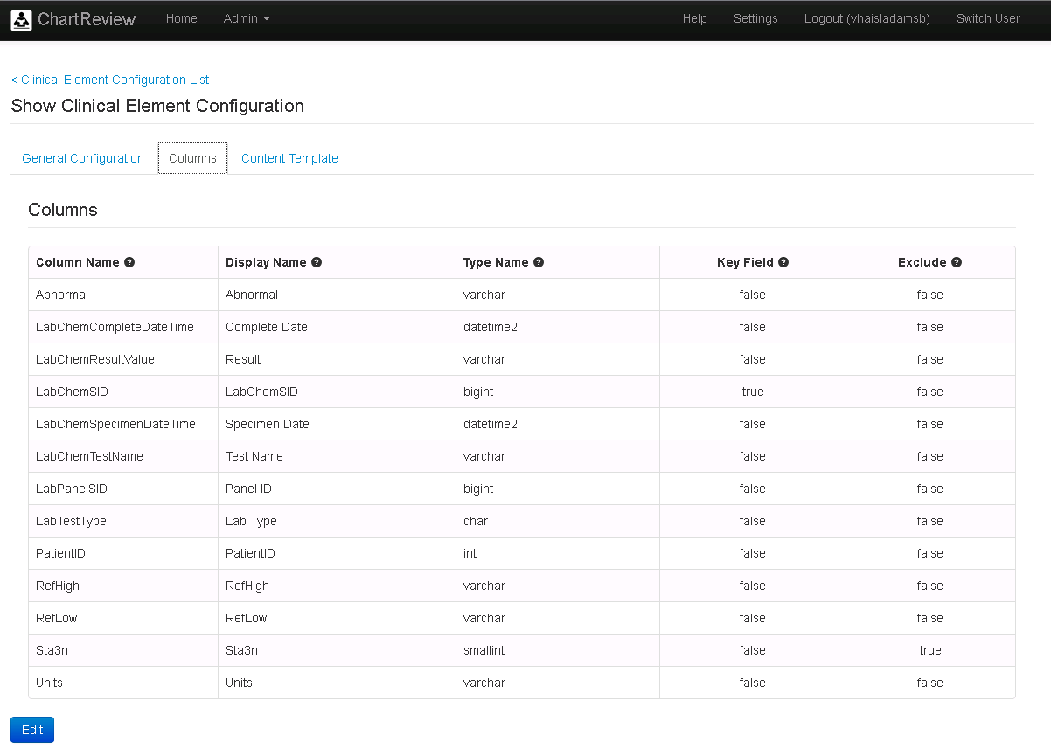

Content Template

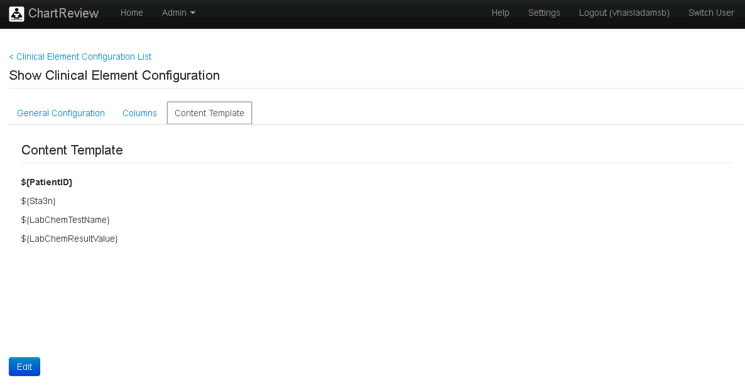

Example Medications Query

All Elements By Patient Id Query

SELECT [PatientID], [MedicationDateTime], [MedicationCode], [MedicationName], [Sta3n], [Qty], [UnitOfAdministration], [DaysSupply], [OrderDosage], [RxType], [MedicationSID]

FROM [ORD_PI_2014010007B].[Dflt].[medications_vw]

WHERE **patientid** = ?

ORDER BY [MedicationDateTime]

Single Element Query

SELECT [PatientID], [MedicationDateTime], [MedicationCode], [MedicationName], [Sta3n], [Qty], [UnitOfAdministration], [DaysSupply], [OrderDosage], [RxType], [MedicationSID]

FROM [ORD_PI_2014010007B].[Dflt].[medications_vw]

WHERE **MedicationSID** = ?

ORDER BY [MedicationDateTime]

Column to Display Mapping

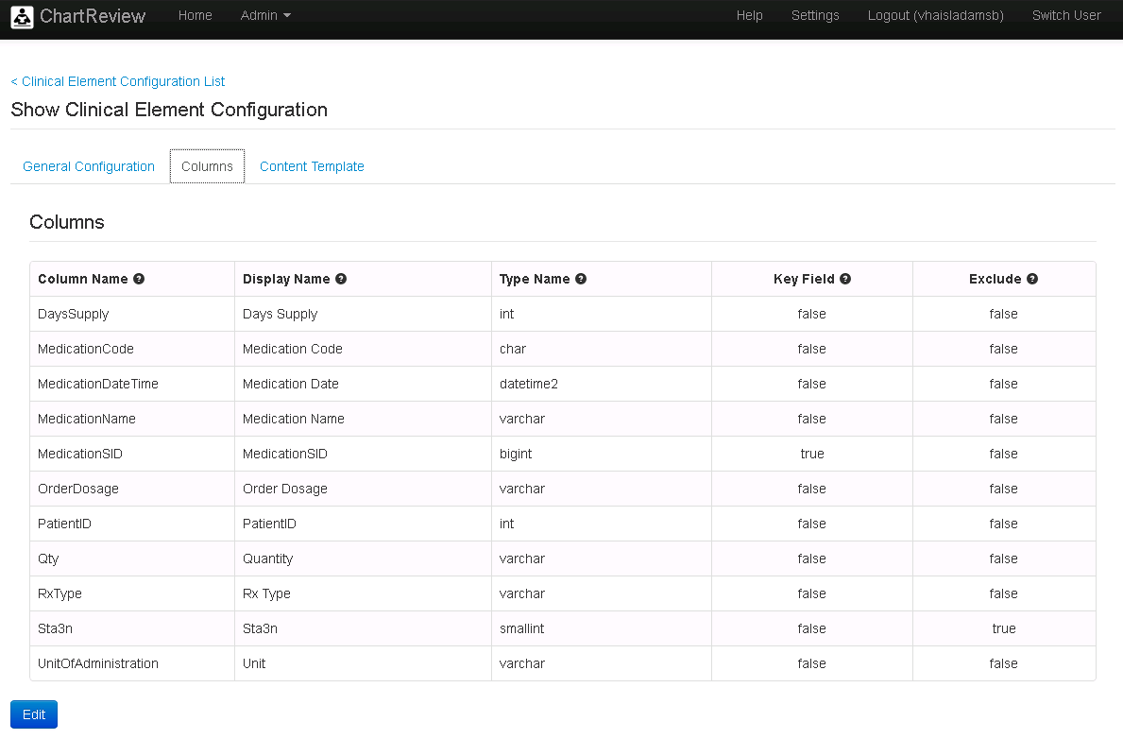

Content Template

No content template needed because this will just be displayed as a table in the UI.

Example Patient Query (This is the Principal Clinical Element)

All Elements By Patient Id Query

SELECT [PatientID], [ScrSSN], [IndexDate], [procType], [timePeriod], [PatientName], [Gender], [DateOfBirth]

FROM [ORD_PI_2014010007B].[Dflt].[patient_cohort_vw]

WHERE PatientID = ?

ORDER BY [PatientID]

Single Element Query

SELECT [PatientID], [ScrSSN], [IndexDate], [procType], [timePeriod], [PatientName], [Gender], [DateOfBirth]

FROM [ORD_PI_2014010007B].[Dflt].[patient_cohort_vw]

WHERE PatientID = ?

ORDER BY [PatientID]

Column to Display Mapping

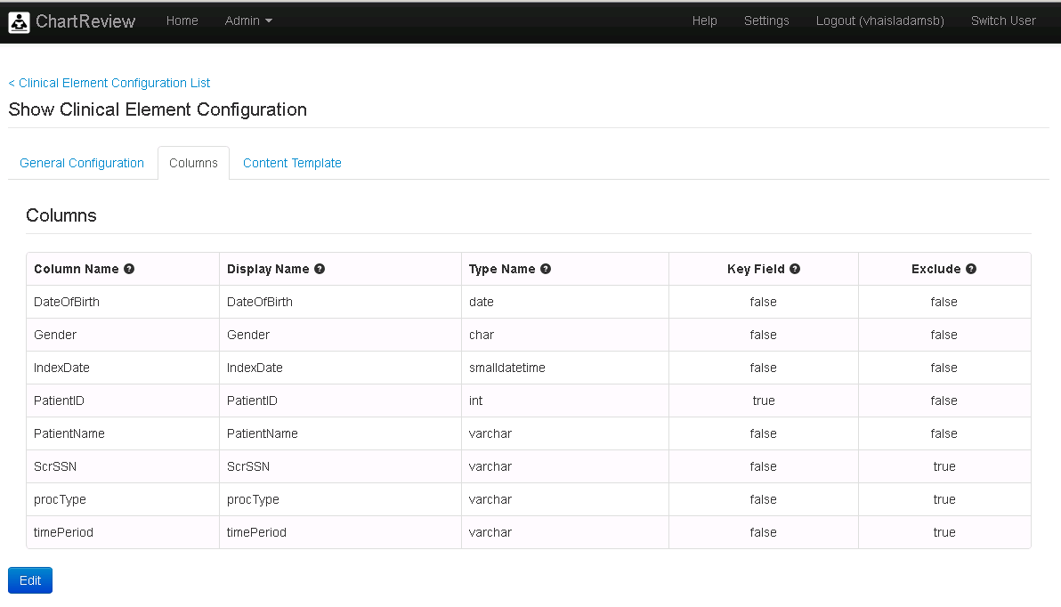

Content Template

