GI Bill Comparison Tool(GIBCT)   
Data Service(GIDS) User Guide

|  |  |  |  |
| --- | --- | --- | --- |
| Document History | | | |
| Draft | Rick Lee | 05/11/2016 | Initial Draft |
| V1 | Rick Lee | 6/15/2016 | Completed Training Manual |
| V1.1 | Rick Lee | 7/3/2016 | Revisions to reflect application changes since 6/15/2016 |
| V2 | Marc Harbatkin | 4/12/2017 | Revisions to reflect new GIDS release |

Document Scope 3

GIDS Scope Limitations 3

Authentication 3

New Users 3

Forgotten Passwords or Password Resets 4

Access 4

Environments 4

Production Data Service 4

Staging 5

Using the GIDS 5

Application Interface 6

Dashboard 6

Dashboard Interactions 6

Primary Workflow 8

Troubleshooting 10

Interpreting Error Messages 10

White Screen Following CSV Upload Attempt 11

Application Defects 11

Appendices 11

Appendix 1 – Project Team 11

Appendix 2 – Additional Resources 11

# Document Scope

This document covers the workflows, procedures and policies required to ingest and deploy data to the GIBCT application. The scope of this document does not include the specific data contained within each file nor the source of each subset of data. Please refer to the EDU project manager for the specific information related to each data set managed by the DS.

Please refer to the ADDITIONAL RESOURCES section of this document for more information about the GIBCT Data Service (GIDS) application.

# Terminology

There are a number of terms referenced in this document that are defined as follows:

* **Source Csvs**: These is the data, in the form of *.csv (Comma Separated Values) files, produced by the VA and other external providers.
* **Preview Data**: Data that resides in the Institution table (aka data.csv in older versions) that is awaiting validation and not yet “pushed” into production.
* **Production Data**: Data that resides in the Institution table (aka data.csv in older versions) that is currently used by the GI Bill Comparison Tool application and presented to the public.
* **Version**: Every build of the Institution table (aka data.csv in the older versions) will have a version number. The Institution table is “built” by using the “Generate New Preview Version” button. This will generate a new version of data – stored as preview data in the Institution table – that is assigned its own version number.
* **GIBCT**: GI Bill Comparison Tool
* **GIDS**: GI Bill Comparison Tool Data Service

# GIDS Scope Limitations

The GIDS application is intended to permit the EDU stakeholders to affect changes to the data rendered by the GIBCT. The scope of this tool is limited to data changes only. The following types of changes require Digital Service developer interventions as they are not covered by the scope of the GIDS application (this is not an exhaustive list):

* Changes to non-data content (i.e. Info icon content).
* Design changes to rendered content (i.e. colors, fonts, layout, etc.).
* The addition of fields to the GIBCT data set (I.e. fields not currently included in the GIBCT or additional CSV columns).
* Changes in functionality of the GIBCT.

Please contact the vets.gov project manager (Kelly.O'Connor@va.gov) to request application modifcations not covered by the scope of the GIDS application.

# Authentication

## New Users

Access to the GIBCT Data Service (GIDS) is managed through a two part process

1. All users requiring access to the GIDS must request access from the EDU project manager (Stephanie Price - [Stephanie.Price3@va.gov](mailto:Stephanie.Price3@va.gov)).
   1. Project manager supplies user Name and Email Address of new user.
   2. Ms. Price Submits request via email.
2. Ms. Price will request that technical access from the Digital Service Technical Lead (Alex Yale-Loehr - [Alex.Yale-Loehr@va.gov](mailto:Alex.Yale-Loehr@va.gov))
   1. Digital Service Technical Lead creates and distributes credentials.
   2. Distribution of credentials will be via secure, encrypted method.

## Forgotten Passwords or Password Resets

All requests for password resets or retrieval will be addressed to the Digital Service Technical Lead (Alex Yale-Loehr - [Alex.Yale-Loehr@va.gov](mailto:Alex.Yale-Loehr@va.gov))

# Access

Production Data Service  
https://www.vets.gov/gids

Staging Server  
https://www.vets.gov/gids

A user name and password are required for access. Please contact the Digital Service Technical Lead (Alex Yale-Loehr - [Alex.Yale-Loehr@va.gov](mailto:Alex.Yale-Loehr@va.gov)) for more information.

# Environments

There are two environments in which EDU users will interact.

## Production Data Service

The production Data Service environment provides the functionality to:

1. **Upload** the data consumed and rendered by the GIBCT in the form of .csv files. **(note: the scope of this document does not include the specific data contained within each file nor the source of each subset of data. Please refer to the EDU project manager for the specific information related to each data set managed by the DS.)**
2. **Build** (or rebuild) the GIBCT data base.
3. **Preview** GIDS data changes in a non-public staging environment
4. **Export** the preview data as a Csv, flat-file version of the GIBCT data base.
5. **Download** the most current versions of each source csv file used to populate the GIBCT database.
6. **Review** most recent upload dates for each source csv file added to the GIDS.
7. **Review** a file upload history of all source csv files added to the GIDS repository.
8. **View** the version information for preview and production data.

# Using the GIDS

IMPORTANT!

CSV files added to the GIDS MUST be in a very specific format. This format has been established based on the formatting of the CSV files aggregated into the legacy Access data base as of April 2017. It is likely that, over time, the source CSV files will be altered by the originators of each data set. In order for the GIDS to function properly, alterations to the source CSV files will need to be made manually to enable these files to be ingested by the GIDS.

## Application Interface

### Dashboard

The Dashboard renders a list of the most current CSV files that comprise the data within the GIBCT data base. The Dashboard is primary user interface through which all user based interactions will occur. There are three main sections.

* **Latest Production**: This area contains the version number (**Version ID**), an internal identifier (**Version-UUID**), the user that published this data into production (**Published By**), the date the data was published (**Published Date**), and actions that can be performed on the production data.
* **Latest Preview**: This area contains the version number (**Version ID**), an internal identifier (**Version-UUID**), the user that published this data into production (**Created By**), the date the data was published (**Created Date**), and actions that can be performed on the preview data.
* **Latest Uploads**: This area contains information on the latest uploads for each permissible source csv. There is one row for each type (Weam, Crosswalk, etc.) of source csv, and each row provides information on the type of CSV (**CSV Type**), the status (**Status**) of the upload - successful or failed, the name of the file (**File Name**), the date it was uploaded (**Upload Date**), the user that uploaded the file (**Uploaded By**), any comments attached to the upload (**Comments**), and actions that can be performed for the csv type.

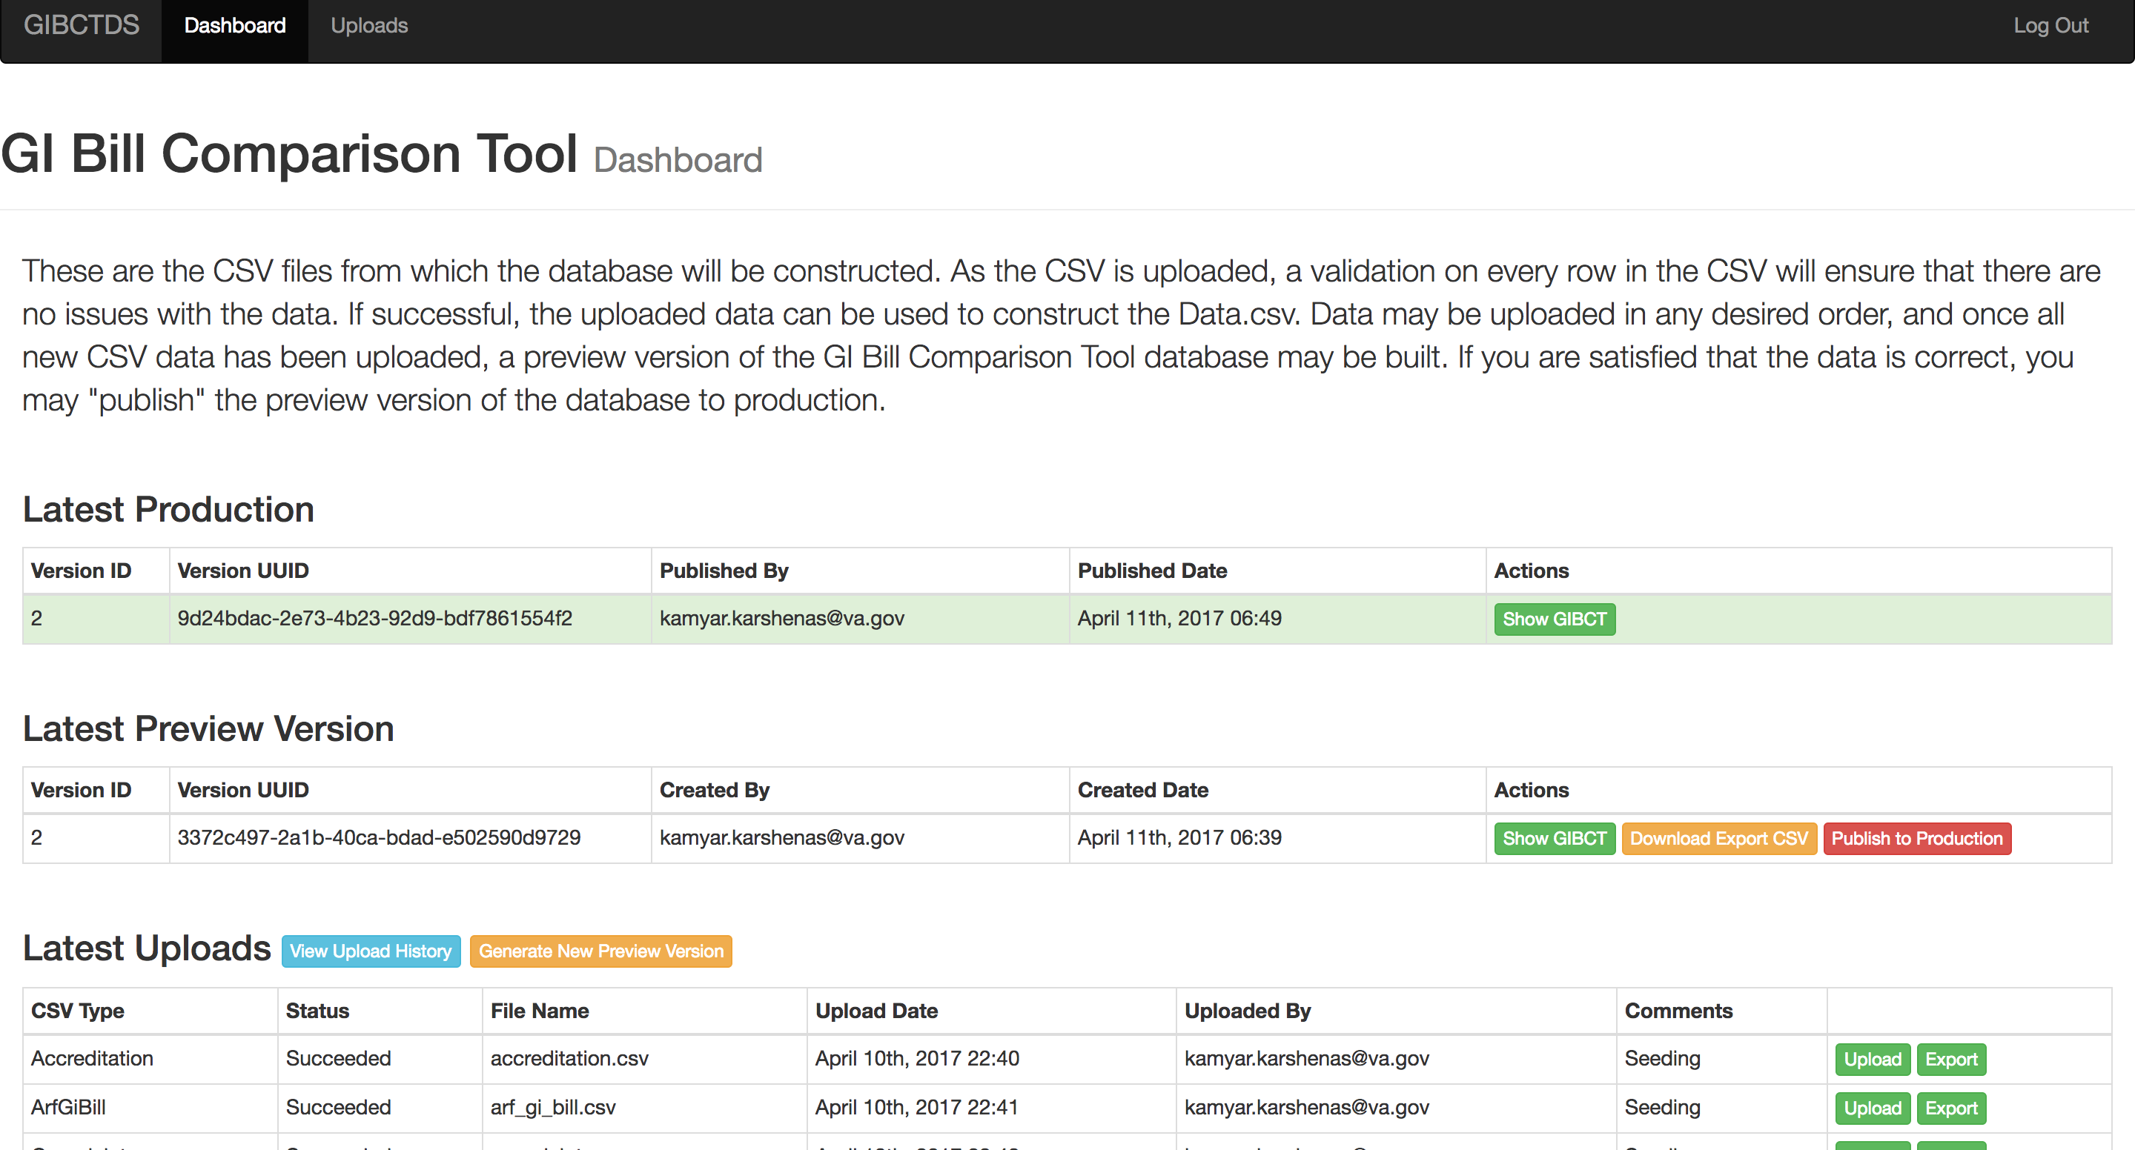

The actions that are associated with preview and production data may at times be disabled. This is normal occurrence that is governed by the state of the database.

### 

### Actions

Latest Production

1. **Build New data.csv** processes all of the uploaded CSV files and creates a new version of the aggregated ‘data.csv’ file
2. **Export data.csv** downloads the most recently built version of the ‘data.csv’ file to the users desktop through the browsers download file. (note: check your ‘downloads’ directory to locate the file after selecting this interaction.)
3. **Push Data to Staging Gibct** pushes the contents of the latest build of data.csv to the staging environment (non-public) for review and approval of data changes.
4. **Push Data to Production Gibct** pushes the content of the latest build of data.csv to the Production environment (public).

File Specific Interactions

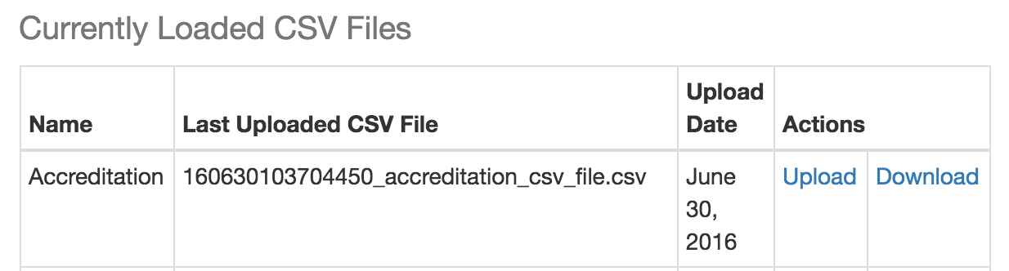

The currently loaded CSV Files table lists the most recent version of each file type loaded into the system and provides the functionality required to upload changes into the GIDS system via a new CSV file.

1. **Upload** initiates the workflow enabling the replacement of the current CSV file with the CSV file containing the required data changes.
2. **Download** permits the user to download a copy of the most recent version of each file types CSV file. The most common uses of this feature will be for reviewing the file format used for each CSV to:
   1. Ensure that the file intended for upload matches the required GIDC formatting and column headers.
   2. Differentiate the data contained within the current CSV file with a new CSV file of each type.

## Primary Workflow

1. **Before logging into the system**, manually execute any changes to the required CSV file as specifiied by the EDU project manager.
2. Log-in to the GIDS here: <http://prod-gids-elb-162991039.us-east-1.elb.amazonaws.com>
3. After a successful log-in, the application redirects to the application Dashboard.
4. From the ‘Currently Loaded CSV Files’ table, identify the file that you would like to replace.
5. Click on the ‘Upload’ link next to the desired CSV file upload.
6. The Upload CSV file window will be presented to the user.  
   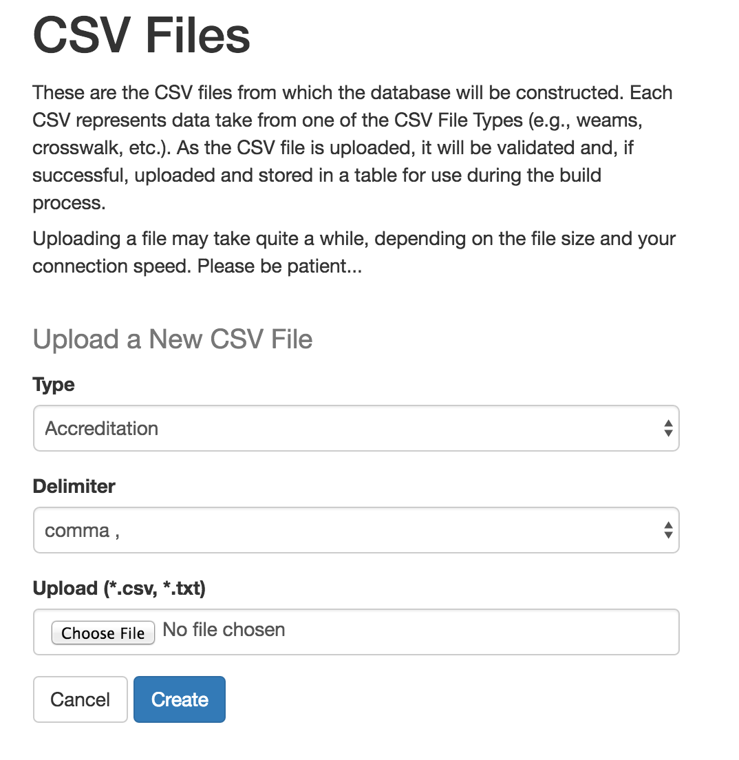
   1. The application attempts to minimize the inputs required by the user by prepoulating the most common selections.
   2. ‘Type’ will be prepoluated based on the CSV file selected from the ‘Currently Loaded CSV Files’ table on the Dashboard screen.
   3. ‘Delimiter’ indicates the type of delimitation used in the file. At this time, all CSV files are comma delimited, however the Digital Service team recognized that this may change over time and built this functionality into the application to assist in extending the applications longevity.
   4. ‘Upload’ permits the user to select the file required for upload FROM THEIR COMPUTER’S FILE SYSTEM.
7. Select the required file for upload using your computer’s file navigation system.
8. Click ‘Create’ to begin the upload process
9. IMPORTANT! – Many of the files ingested by the data service contain tens of thousands of records and are, therefore, very large. In an effort to streamline the development process, the Digital Service team has not included a progress indicator in the application. **PROPER FUNCTIONING OF THE APPLICATION REQUIRES THAT THE USER WAIT FOR THE FILE TO UPLOAD AND PROCESS.** There will be no indicator of the file’s upload state during this process. In some cases, the user’s browser may provide a browser-based indicator that a process is ongoing. **YOUR FILE UPLOAD WILL NOT BE COMPLETE UNTIL YOU RECEIVE A MESSAGE SIMILAR TO THIS:**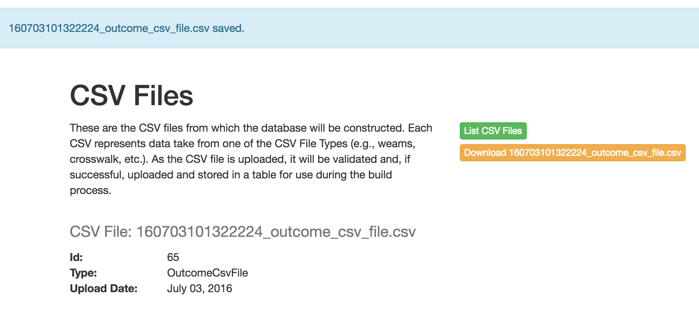In this case, the file uploaded was the ‘outcomes’ CSV file.
10. Continue the above steps for each CSV file requiring an update. **(note: it is only necessary to upload files that contain changes. You do not need to upload each CSV file everytime a change is required to one CSV file, only the file containing the changes.)**
11. Once all changed files have been uploaded to the GIDS system, it is necessary to ‘Build’ a new data.csv file. This is completed by navigating to the **Dashboard** and simply clicking on the  button.
12. **Publishing New Data** can be accomlished using two methods. Below is the reccommended workflow for publishing data to the production GIBCT:
    1. **To Staging:** From the Dashboard, publish data changes to the staging server (<https://staging.vets.gov/gi-bill-comparison-tool>). The staging server provides the user with an opportunity to preview changes to the data in a non-public version of the GIBCT to ensure that the desired changes are correct. The staging environment also permits supervisory team members to preview and approve changes before publishing these changes to the production environment.
       1. From the Dashboard, click the  button.
       2. Review changes using the staging server access link and credentials
          1. <https://staging.vets.gov/gi-bill-comparison-tool>
          2. Username: veterans  
             Password: am3rica
    2. **To Production:** Once the user has confirmed that the changed data is correctly rendering in the staging environment, it will be necessary to push the data into the production environment before it will be visible on the GIBCT public application.
       1. From the Dashboard, click the button.
       2. Visit the production version of the GIBCT (<https://www.vets.gov/gi-bill-comparison-tool>) to confirm that your changes are rendering as expected.
       3. **Congratulate yourself on successfully making a data update(s) to the GIBCT without the need for developer intervention!!!**

# Troubleshooting

## Interpreting Error Messages

Improperly formatted CSV files or alterations to the text of column headers will trigger an error handling message during the CSV upload process.



In this case, the error is indicating that the for the file ‘160703105253581_accreditation_csv_file.csv’ the application was not able to locate the expected column headers ‘["institution_name", "institution_opeid", "institution_ipeds_unitid", "campus_name", "campus_ipeds_unitid", "accreditation_type", "agency_name", "last action", "periods"]’ which are required to be present in the CSV file type selected for upload.

**Solution:**

In this case, the user should navigate to the Dashboard and download the file that corresponds to the most recent accreditation file to review the proper formatting for the column headers, then manually edit the new accreditation file to ensure that the headers are correctly included and formatted.

## White Screen Following CSV Upload Attempt

Do due a variety of VA network considerations, it is possible that an attempt to upload a file will fail. **BEFORE REPORTING THIS ISSUE, IT IS IMPORTANT TO REMEMBER THAT SOME OF THE FILE UPLOAD PROCESSES WILL BE TIME CONSUMING.** Some files will require the user to wait in excess of 10 minutes with no indication of upload progress. This is expected behavior, however if the prescribed waiting period has passed and the application screen has changed to a blank, all white screen, the user should seek the assistance of the Digital Service developers and development-operations teams. These teams can be accessed via the vets.gov project manager (Kelly.O'Connor@va.gov).

## Application Defects

Please report all application defects to the vets.gov project manager (Kelly.O'Connor@va.gov) or create an issue describing the defect on the GIDS GitHub repository, which can be accessed via <https://github.com/department-of-veterans-affairs/gibct-data-service/issues>.

# Appendices

## Appendix 1 – VA Digital Service Project Team

Product Lead (07/2016 – Present) – Stacey Langer ([stacey.langer@va.gov](mailto:stacey.langer@va.gov))

Technical Lead – Marc Harbatkin ([marc.harbatkin@va.gov](mailto:marc.harbatkin@va.gov))

Dev-Ops Lead – Alex Yale-Leohr ([Alex.Yale-Loehr@va.gov](mailto:Alex.Yale-Loehr@va.gov))

Vets.Gov Project Manager – Kelly O’Connor (Kelly.O'Connor@va.gov)

Legacy Team (Provided for historical information only. Please refer all requests to the above team.):

* Product Lead (09/2015 – 06/2016) – Rick Lee ([ricklee.va@gmail.com](mailto:ricklee.va@gmail.com))

## ­Appendix 2 – Additional Resources

* Public Project Github Repository - <https://github.com/department-of-veterans-affairs/gibct-data-service>
* GIBCT Data Dictionary – <https://github.com/department-of-veterans-affairs/gibct-data-service/blob/master/Data_Management_Artifacts/GIBCT_Data_Dictionary.xlsx>
* GIDS Source Ownership Matrix - <https://github.com/department-of-veterans-affairs/gibct-data-service/blob/master/Data_Management_Artifacts/GIBCT_Data_Ownership.xlsx>