**VA Northern California Health Care System**

**Pharmacy Residency Programs**

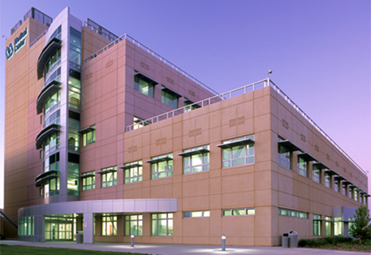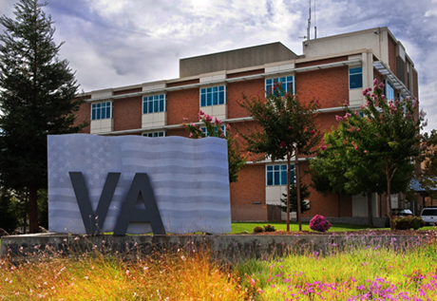

*Sacramento VA Medical Center; Mather, CA*

*VA Martinez Outpatient Clinic; Martinez, CA*

**2020 Residency Showcase Information**



**Fall Open House 2020**

* Virtual event via Webex
* Friday, October 16 (9:00 AM)
* 2020 PGY1 applicants only
* Please RSVP by 10/9 to: <https://forms.gle/KNR717U8reHWYMLq8>
* Questions: [duyen.doan@va.gov](mailto:duyen.doan@va.gov)

**ASHP Midyear 2020**

* Virtual Residency Showcase
* Booth date/time TBD, please refer to ASHP conference materials

**Winter Open House 2020**

* Virtual event via Webex
* Friday, December 4th (1-3 PM)
* 2020 PGY1 and PGY2 applicants only
* Questions and RSVP by 11/30 to: [cassandra.mark3@va.gov](mailto:cassandra.mark3@va.gov)



**VA Northern California Health Care System**

The VA Northern California Health Care System (VANCHCS) is an integrated health care delivery system, offering a comprehensive array of medical, surgical, rehabilitative, mental health, and extended care to veterans in Northern California. The health system is comprised of a 66-bed medical center in Sacramento; a rehabilitation and long-term care facility in Martinez, and seven outpatient clinics. The outpatient clinics are located in Auburn, Oakland, Mare Island, Fairfield, McClellan (Sacramento area), Yuba City, Chico, Redding, and Yreka.

VANCHCS has two divisions, each with an Associate Director. The Sacramento Valley Division is comprised of medical facilities in Sacramento, Chico, and Redding. The East Bay Division is comprised of medical facilities in Fairfield, Mare Island, Martinez, and Oakland. VANCHCS serves over 251,000 veterans across 17 counties, covering an area of more than 40,000 square miles.

As part of the VA Sierra Pacific Network (VISN 21), VANCHCS provides veterans access to an extensive range of health and specialty services. VISN 21 is one of eighteen VISNs in the Veterans Health Administration (VHA). VISN 21 serves veterans in Northern and Central California, Nevada, Hawaii, the Philippines, and U.S. Territories in the Pacific Basin.

**VANCHCS Mission**

Our mission is to provide comprehensive health care services to Veteran patients in a compassionate, high quality, and cost effective manner. We are committed to achieving customer satisfaction by meeting or exceeding the needs of our patients and staff.

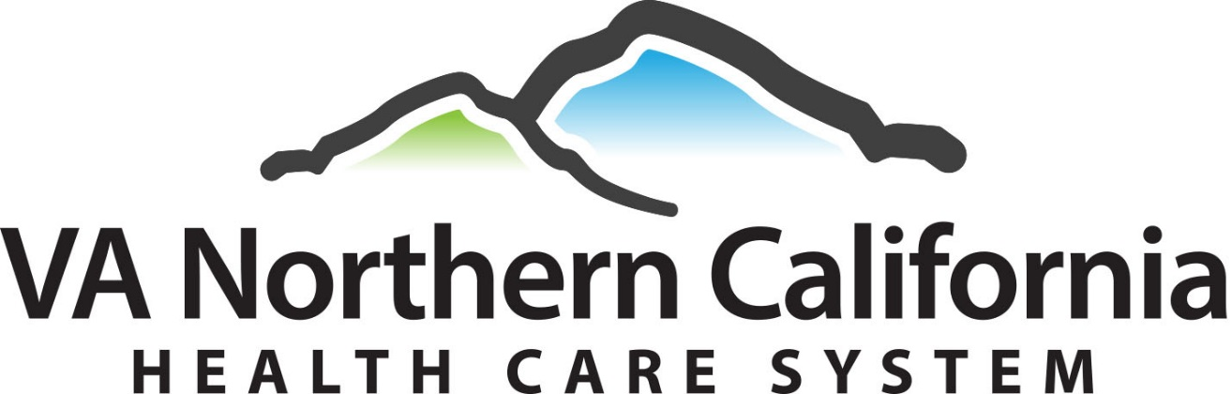

**VA Northern California Health Care System**

**Pharmacy Service**

**VANCHCS Pharmacy Service**

The pharmacy service has nearly 70 pharmacists, 4 PGY1 pharmacy residents, and 1 PGY2 psychiatric pharmacy resident. The Pharmacy Service has formal affiliations with several schools of pharmacy for advanced pharmacy practice experiences (APPEs). Computerized provider order entry is utilized in all settings and bar code recognition technology is in place for verification and documentation of medication administration. The Pharmacy Service has implemented automated technology for many of its dispensing activities. The Inpatient Pharmacy provides 24-hour, hospital-wide unit dose and intravenous admixture services. Pharmacists are assigned to clinical duties in acute care, extended care, primary care, and several other specialty care areas (e.g. mental health, infectious diseases, academic detailing). Clinical services include medication reconciliation, patient monitoring, medication management, discharge counseling, drug information, patient education, pharmacokinetics, drug usage evaluations, and adverse drug event reporting.

**VANCHCS Pharmacy Service Philosophy and Mission Statement**

The Pharmacy Service commits to provide high quality primary and acute patient care services, education, and research through pharmacist, technician, trainee, and administrative personnel expertise and skills.

Shared responsibility for patient care outcomes results in interdisciplinary teams including pharmacists that provide inpatient and outpatient pharmaceutical care.

Pharmaceutical care involves the identification, resolution, and prevention of drug-related problems affecting patient care outcomes, and encompasses the total spectrum of patient care, education and research.

The Pharmacy Service offers an effective drug use control system to support pharmaceutical care by pharmacists in clinically oriented activities of patient compliance, telephone medicine advice, and pharmacoeconomics.

The system for drug use control includes:

1. patient-specific drug distribution and administration logistics
2. participation in educational and therapeutic decisions supporting rational pharmacotherapy
3. consistent drug use monitoring and surveillance documenting and ensuring quality drug therapy outcomes

Attuned to changing trends in healthcare, the Pharmacy Service adapts pharmaceutical care to the need of the veteran patient population by observing and surpassing the most up-to-date standards of practice. To accomplish this, the Pharmacy Service fosters continual staff growth by developing patient education, clinical pharmacology, research, and academic skills.

**Pharmacy Residency Programs**

|  |  |  |  |
| --- | --- | --- | --- |
| Program | Residents | Established | Accreditation |
| PGY1 Pharmacy | 4 | 1980 | ASHP |
| PGY2 Psychiatric Pharmacy | 1 | 2015 | ASHP |

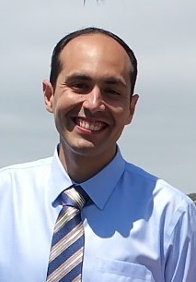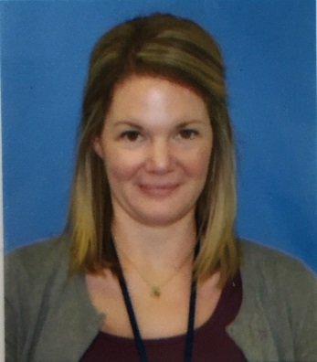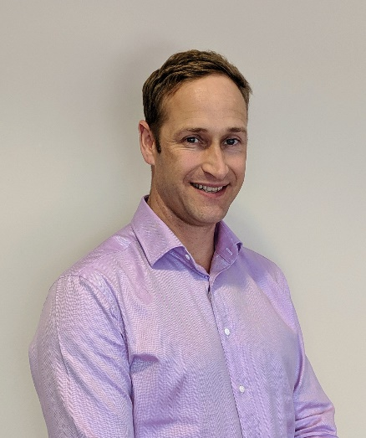**Applicant Qualifications and Process**

**Richard M. Martinez, Pharm.D.**

PGY1 Residency Program Director

richard.martinez2@va.gov

916-843-7296

***Please note, the PGY1 RPD will change in the 2021-2022 year***

**Christine Johnston, Pharm.D., BCPP**

PGY2 Psych Residency Program Director

christine.johnston2@va.gov

916-843-9357

**Karsten Duncan, Pharm.D.**

Chief, Pharmacy Service

**APPLICANT QUALIFICATIONS**

* Register with the National Matching Service (NMS).
* Possess United States citizenship.
* Possess a Doctor of Pharmacy degree from an ACPE accredited School or College of Pharmacy.
* PGY1 applicants must be eligible for licensure to practice pharmacy in any state at the beginning of their residency program.
* PGY1 applicants must submit a separate application in PhORCAS for each location to which they wish to apply.
* PGY2 applicants must have completed or be in the process of completing an ASHP accredited PGY1 residency or have equivalent experience. PGY2 applicants must also hold current pharmacist licensure in a State of the United States.

**APPLICATION PROCESS**

* All application materials must be submitted through PhORCAS, as below (no late submission accepted):
* **Phase I Deadline for PGY1 Program: December 27, 2020**
* **Phase I Deadline for PGY2 Program: January 8, 2021**
* **Phase II Deadline for ALL open Programs: March 24, 2021 (see page 10)**
* Submitted materials must include (all materials must be submitted through PhORCAS):
  + Official transcripts from School/College of Pharmacy (sent directly to PhORCAS from your school)
    - PGY2 applicants: Transcript must be official and indicate Pharm.D. degree was conferred.
  + Personal Statement/Letter of Intent
    - PGY1 applicants: Include your short-term and long-term professional goals. Describe how our residency program will assist you in accomplishing your goals.
  + Curriculum Vitae
    - All applicants: Include details of rotation activities for in-progress, completed, and to-be completed rotations. Include duration spent on each rotation. Also, include details of extracurricular activities.
  + Three letters of recommendation using the standardized reference template in PhORCAS
    - PGY1 applicants: At least one letter writer should be a preceptor of a direct patient care APPE (preferably inpatient internal medicine or ambulatory care).
  + Supplemental information
    - All applicants: Application for Health Professions Trainees (VA Form #10-2850D) accessible at <http://www.va.gov/oaa/archive/vaform10-2850d.pdf>.
    - PGY1 applicants: Application Cover Sheet, accessible on our residency website.
    - PGY2 applicants: Copy of pharmacist license.
* Selected PGY1 and PGY2 applicants will be invited to interviews occurring in February. An interview is required. Interviews may take place on-site or virtually (pending the COVID-19 pandemic). All applicants who are not invited for an interview will be notified by e-mail no later than January 22, 2021.

**General Residency Information**

**Pay and Benefits**

* Period of Appointment
* PGY1: 12 months, from July 1, 2021 through June 30, 2022
* PGY2: 12 months, from July 2021 through June 2022
* *Estimated* Stipend
  + PGY1: $50,141
  + PGY2: $54,319
* Benefits
  + 13 days of Annual Leave (“vacation”) and 13 days of Sick Leave
    - Sick Leave is earned at the rate of 4 hours every two weeks and can be used for illness and injury as well as medical, dental, optical and other medically-related appointments or procedures
  + 10 paid federal holidays
  + Administrative leave and financial support (if available) to attend selected professional meetings
  + Health, life, vision/dental insurance options

**Pharmacist Licensure**

**PGY1:** Residents are expected to possess full, current, and unrestricted licensure to practice pharmacy in a State, Territory, or Commonwealth of the United States, or the District of Columbia by October 1st (90 days) following the commencement of the residency program. At the start of the residency year, the RPD will meet with each resident to determine his or her licensure status and timeline for completion. A copy of all pharmacist licenses will be obtained and kept on file by the Pharmacy Service. Residents needing to re-take board exams should work with state and national boards of pharmacy to ensure a re-take date as soon as possible. If the resident is unsuccessful in obtaining licensure by October 1st, input will be sought by the Residency Advisory Committee regarding disciplinary action. Disciplinary action may include extension of the residency year or dismissal from the program.

**PGY2:** Current licensure in at least one State of the United States is required at the time of application to the residency program. Therefore, all PGY2 residents are expected to be licensed prior to the start of the residency experience and will furnish VANCHCS with a copy of licensure. The residency experience is directly related to the status of licensure. Without licensure, skill building will be minimized leading to a less than optimal residency experience. Please note that out-of-state residents are welcome to pursue licensure in California, but it is not a requirement for working at VANCHCS. The only requirement is that the resident be licensed in at least one state of choice.

**PGY1 Program Overview**

**Program Purpose**

PGY1 pharmacy residency programs build on Doctor of Pharmacy (Pharm.D.) education and outcomes to contribute to the development of clinical pharmacists responsible for medication-related care of patients with a wide range of conditions, eligible for board certification, and eligible for postgraduate year two (PGY2) pharmacy residency training.

**Program Description**

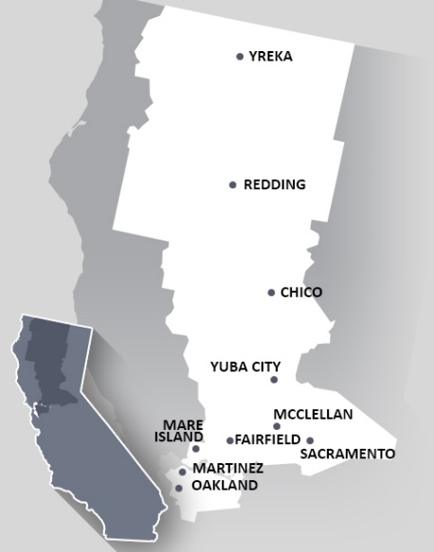We aim to develop in residents the ability to provide pharmaceutical care across a variety of practice settings (e.g. ambulatory care, acute care, pharmacy benefit management, and pharmacy operations). We offer residents opportunities to rotate in a number of these settings, including our expansive ambulatory care clinics. Residents complete the same required (“core”) learning experiences, and electives are customized based on resident interest (outlined on page 9).

**While offering a well-rounded PGY1 experience, the VA Northern California specifically offers very strong experiences in ambulatory care.** Graduates of our program are well prepared for PGY2 training and advanced clinical roles.

In addition to the clinical reasoning skills residents will gain, we also further develop residents professionally. Professional development takes place throughout the year and includes topic discussions, readings, and seminars. These activities will prepare the resident as they embark on a path toward professional excellence.

For a PGY1 resident interested in pursuing additional training in mental health, the resident may early commit to the PGY2 psychiatric pharmacy residency program if general qualifications and selection criteria are met.

**Program Location**

Our program offers four PGY1 pharmacy residency positions. Two PGY1 residents are based at our Martinez, CA site and two PGY1 residents are based at our Sacramento, CA site. Applicants can choose to apply to the Sacramento based program, Martinez based program, or both programs. **Although residents are primarily located in either Sacramento or Martinez, rotations are completed throughout the health care system.** The VANCHCS is pictured above. PGY1 residents may rotate through clinics located at Mare Island, Martinez, Fairfield, Sacramento, and McClellan.

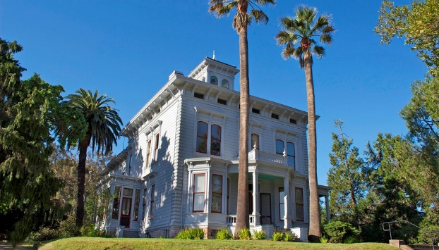

*John Muir National Historic Site, Martinez, CA*

*Tower Bridge, Sacramento, CA*

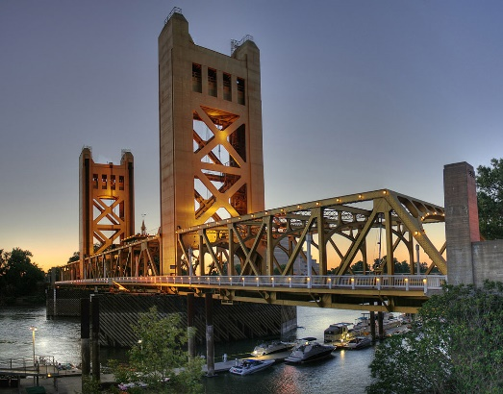

**PGY1 Program Structure**

**Program Structure**

* Orientation: 2 weeks
* 9 rotation blocks (5-6 weeks each)
* No pharmacy staffing (outside of required Outpatient Pharmacy Operations rotation)

|  |  |
| --- | --- |
|  | PGY1 Pharmacy Residency |
| **Required Rotations**  **(# of blocks)** | Acute Care/Internal Medicine (1)  Administration (1)  Ambulatory Care* (2)  Drug Information (1)  Outpatient Operations (1)  Electives (3)  *\*Clinics may include: Anticoagulation, Pulmonary, Neurology, and Primary Care/Patient Aligned Care Team (PACT)* |
| **Elective Rotations** | Academic Detailing  Applied Pharmacoeconomics  Cardiology  Emergency Department  Home Based Primary Care (HBPC)  Infectious Diseases  Inpatient Pharmacy Operations  Mental Health (Outpatient Clinic)  Transitions of Care |
| **Required Longitudinal Experiences** | Chief Resident (3 months)  Pharmacy Research Project |

**PGY1 Match Information**

* Applicants may apply to the Sacramento based program, Martinez based program, or both programs using the NMS Code(s) below. Determining if you should apply to one program or both is an individual decision. If you are flexible with location and desire to complete a PGY1 residency at VA Northern California regardless of location, you may apply to both programs and then rank (or not rank) the two based on your interest.
* We interview all invited candidates via the same process and will note if candidates have applied to more than one program. If you are invited to interview, only one interview date will be scheduled if you applied to both programs.
* Should positions remain open in Phase II of the Match, please contact the residency program director **via email** for any additional application requirements. Applications for any open positions in Phase II are due March 24, 2021.

|  |  |
| --- | --- |
|  | PGY1 Match Information |
| **Resident’s**  **Primary Location** | Sacramento: 2 residents  Martinez: 2 residents |
| **ASHP Program Code** | 92422 |
| **NMS Code** | Sacramento: 208121  Martinez: 208113 |

**For additional information, contact:**

Richard M. Martinez, Pharm.D.**\***

PGY1 Residency Program Director

10535 Hospital Way

Pharmacy Service (119)

Mather, CA 95655

richard.martinez2@va.gov

Phone: 916-843-7296

\****please note, the PGY1 Residency Director will change in the 2021-2022 year***



*ASHP accredits the PGY1 pharmacy residency program at VANCHCS*

**Current Pharmacy Residents**

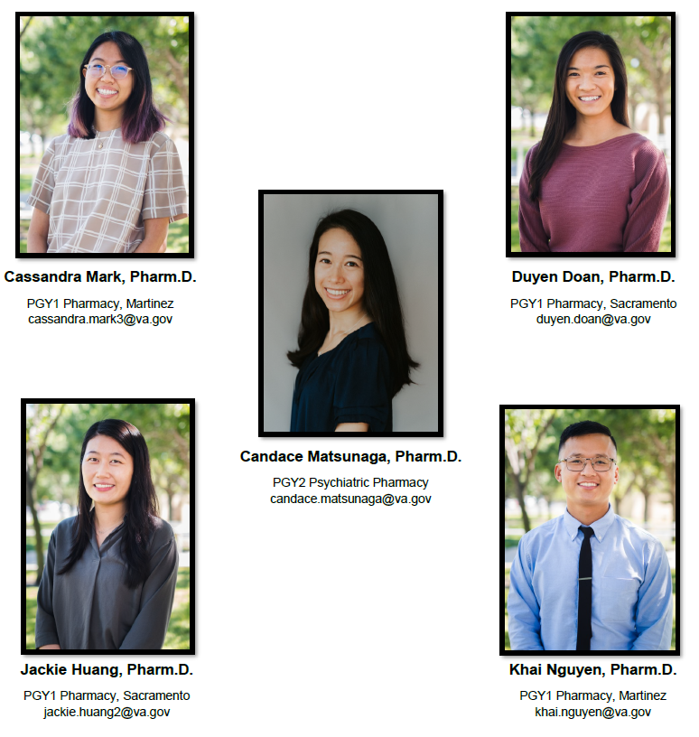

**PGY2 Psychiatry Pharmacy Residency**

**Program Overview**

**Program Purpose**

The VA Northern California Health Care System (VANCHCS) PGY2 psychiatric pharmacy residency program builds on Doctor of Pharmacy (Pharm.D.) education and PGY1 pharmacy residency programs to contribute to the development of clinical pharmacists in the specialized area of psychiatric pharmacy practice. This PGY2 residency program provides residents with opportunities to function independently as practitioners by conceptualizing and integrating accumulated experience and knowledge and incorporating both into the provision of patient care that improves medication therapy in individuals with psychiatric and neurologic disorders. Residents who successfully complete this PGY2 pharmacy residency will possess competencies that qualify them for clinical pharmacist and/or faculty positions and position them to be eligible for attainment of board certification in psychiatric pharmacy practice.

**Description of VANCHCS Mental Health Services**

VANCHCS provides mental health services to an adult population with diagnoses including major depression, anxiety disorders, substance use disorders, schizophrenia and other psychotic disorders, bipolar disorder, trauma and stress-related disorders, and more. The system employs one inpatient, one rural heath/telehealth, and eight outpatient psychiatric clinical pharmacy specialists, all of whom function as members of psychiatric interdisciplinary care teams. The Sacramento campus offers outpatient mental health services in General Mental Health (GMH), PTSD Clinical Team (PCT), Addiction Recovery Treatment Service (ARTS), Primary Care Mental Health Integration (PCMHI) and inpatient acute stabilization in the 16-bed Behavioral Health Inpatient Care Unit (BHICU).

**Facility**

The resident is based at the Sacramento VA Medical Center campus. Most activities will occur from this site.

**For additional information, contact:**

Christine Johnston, Pharm.D., BCPP

PGY2 Psychiatric Pharmacy Residency Program Director

10535 Hospital Way

Pharmacy Service (119)

Mather, CA 95655

christine.johnston2@va.gov

Phone: 916-843-9357



*ASHP accredits the PGY2 psych pharmacy residency program at VANCHCS*

**PGY2 Residency Program Structure**

**Program Structure**

The PGY2 program begins with 2-4 weeks of orientation followed by two consecutive 8-12 week blocks each in outpatient and inpatient mental health to complete the first half of the residency year. This serves to fully immerse the resident within the mental health service in order to build a solid foundation prior to shifting into the second half of the year, which is largely longitudinal. The program structure during the second half of the year is designed to allow the PGY2 resident to fully experience and balance the myriad responsibilities of a specialty psychiatric clinical pharmacist.

Example weekly schedule for second half of residency year:

|  |  |  |  |  |  |
| --- | --- | --- | --- | --- | --- |
|  | Monday | Tuesday | Wednesday | Thursday | Friday |
| **AM** | Inpatient MH | Post-DC Clinic | Outpatient Addictions | Resident Clinic | Inpatient MH |
| **PM** | Resident Clinic | Outpatient GMH | Outpatient GMH | Admin Time | Admin Time |

|  |  |
| --- | --- |
|  | PGY2 Psychiatric Pharmacy |
| **Required Rotations** | Outpatient Mental Health  Addiction Recovery Treatment Service  Geriatric Psychiatry  Post-discharge Clinic  Inpatient Mental Health  PBM and eConsult Service  Residency Project  Mental Health Didactics  Pharmacy Administration/Professional Development |
| **Elective Rotations** | TBI/Neuropsychiatry  Pain Management |
| **Locations** | Sacramento: 1 resident |
| **ASHP Program Code** | 92123 |
| **NMS Code** | 723466 |

**First Position Accepted Post-Residency**

**2013-2020 Classes**

**PGY1 Pharmacy Residents**

* **PGY2 Outcomes and Health Care Analytics at the VA’s VISN 21 (x2 graduates)**
* **PGY2 Psychiatric Pharmacy Residency at VA Madison**
* **PGY2 Psychiatric Pharmacy Residency at VA Palo Alto**
* **PGY2 Transitions of Care at Sharp HealthCare in San Diego**
* **Pharmacoeconomics pharmacist at VA Sierra Nevada**
* **Ambulatory Care pharmacist at VA Northern California (x7 graduates)**
* **Oncology Clinical pharmacist at VA Northern California**
* **ED pharmacist at VA Northern California**
* **Inpatient pharmacist at VA Palo Alto**
* **Outpatient pharmacist at VA Northern California (x2 graduates)**
* **Outpatient pharmacist at New Mexico VA**
* **Ambulatory Care pharmacist at Kaiser South Sacramento**
* **Ambulatory Care pharmacist at Kaiser South San Francisco**
* **Ambulatory Care pharmacist at Kaiser Oakland**
* **Inpatient pharmacist at NorthBay Healthcare in Fairfield**
* **Poison Control pharmacist at San Diego Poison Control Center**
* **Clinical pharmacist at Fircrest Residential Habilitation Center in Washington**
* **Pharmacoeconomics pharmacist at VA Northern California**
* **PGY2 Psychiatric Pharmacy Residency at VA Northern California**
* **Clinical Pharmacist Floater at VA Northern California**
* **Ambulatory Care pharmacist at Kaiser San Jose**

**PGY2 Psychiatric Pharmacy Residents**

* **Outpatient mental health pharmacist at Kaiser South San Jose**
* **Rural health pharmacist, mental health at VA Northern California**
* **Rural health pharmacist, pain management at VA Northern California**
* **Outpatient mental health pharmacist at VA Northern California (x2 graduates)**

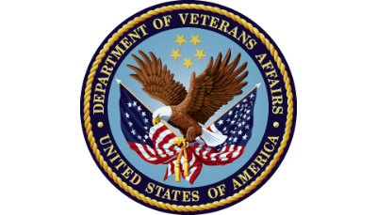

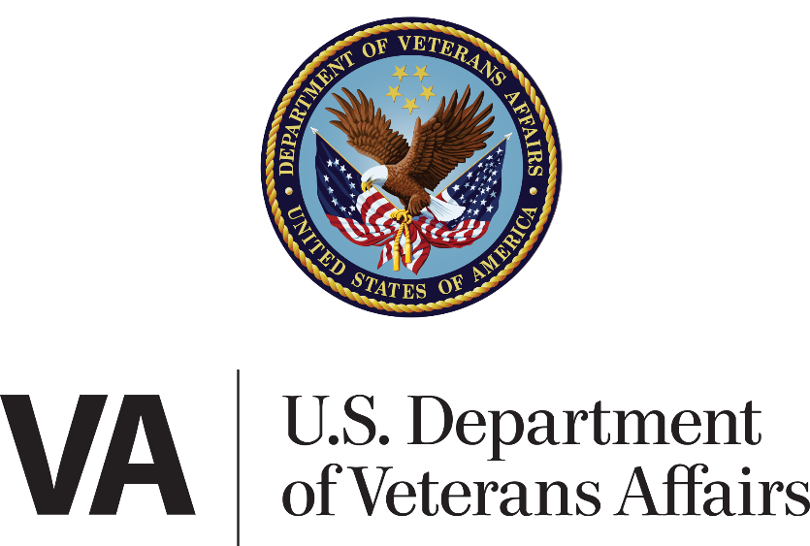

VA Northern California Health Care System

10535 Hospital Way

Pharmacy Service (119)

Mather, CA 95655

Phone: 916-843-7296

http://www.northerncalifornia.va.gov/careers/pgy1/