**Department of Veterans Affairs**

**Digital Veterans Platform (DVP)**

**Integration with**

**Identity and Access Management Services**

**Integration Requirements Specification Document**

**

November 2020

Version 0.2

Revision History

| **Date** | **Version** | **Description** | **Author** |
| --- | --- | --- | --- |
| 11/23/2020 | 0.2 | Updated to include the SaaS use-case | DVP Team |
| 9/6/2017 | 0.1 | Initial draft | Linda Reimonenq, Brian Toval |

**Table of Contents**

1.0 Introduction 1

1.1 Purpose 1

1.2 Scope 1

1.3 References 2

1.3.1 Requirements, Design, and Service Description Documentation 2

1.3.2 Business Policy Documentation 2

1.3.3 Abbreviations and Definitions 2

1.3.4 Additional Documentation 2

2.0 Functional Requirements 3

2.1 Functional Requirements for DVP 3

2.1.1 Assumptions / Constraints / Risks 3

2.1.2 Get Corresponding IDs 4

2.2 Functional Requirements for IAM 7

2.2.1 Get Corresponding IDs 7

3.0 Other Specifications 8

3.1 Business Rules Specifications 8

3.2 Design Constraints Specifications 8

3.3 Disaster Recovery Specifications 8

3.4 Performance Specifications 8

3.5 Quality Attributes Specifications 8

3.6 Reliability Specifications 9

3.7 Security Specifications 10

4.0 Attachment A: Approval Signatures 11

Appendix A – DVP Initial Release 12

**List of Figures**

Figure 1: DVP Process Retrieval Request - To Be Process (zoom to 200%) 5

Figure 2: DVP Process - To Be Initial Release (zoom to 200%) 12

# Introduction

## Purpose

The purpose of this integration Requirements Specification Document (iRSD) is to provide the requirements that the Digital Veteran’s Platform (DVP) Development team needs to integrate DVP with Identity and Access Management (IAM) services, in accordance with the IAM Service Request SR-985.

Integrations with IAM services are mandated by executive management via the following mandates:

* IAM Identity Services (IdS) mandate memorandum (VAIQ #7011145). All applications within VA must comply with IAM requirements to ensure that references to the identities of Veterans and their beneficiaries are accurate.
* IAM Access Services (ACS) functionality within VA is mandated by VAIQ #7060071 (<http://vaww.iam.va.gov/IAM_Business_PMO.asp>).

The target audiences for this iRSD include the following:

* **Veterans Experience Office (VEO) / Office of Identity, Credential, and Access Management (OICAM):** This group is the business owner for Identity Services/Master Veteran Index (MVI), and is responsible for managing the IdS business requirements.
* **Access and Identity Management (AIM) Program Management Office (PMO) under OICAM, Office of Operations, Security, & Preparedness (OSP):** This group is responsible for managing the AcS business requirements.
* **DVP Development team**. This group is responsible for fulfilling the IAM requirements within the DVP system.
* **DVP Business Owner**: This group is responsible for business requirement and final approval of DVP application.
* **IAM Development Leads**: They are responsible for the implementation of IAM requirements and ensuring the correct integration of DVP with IAM-approved requirements.

**NOTE:** This document does not contain the detailed requirements for the changes needed in the DVP systems to integrate with IAM services. The DVP team should use this document as a guide for writing the detailed system and, if applicable, user interface design specifications. The DVP team should include both IAM business and technical representatives as stakeholders regarding the DVP design documents. The Quality Attributes Specification section of this document provides more information about the integration process.

## Scope

This document provides high level requirements for the integration between DVP and IAM. DVP is the VA’s Gateway, responsible for transport of data between internal VA and external producers and consumers. The DVP enables secure seamless interoperability between VA and commercial applications, enabling advanced analytics to deliver a cohesive Veteran-centered experience both inside and outside VA. The proposed architecture contains a number of strategic, integrated components: Electronic Health Record(s), Operation Management Platforms including: financial, supply chain, and human resource systems, Customer Relationship Management system, Analytics systems, and Application Programming Interface (API) gateway, along with a number of legacy systems that support key business lines in order to provide seamless interoperability with internal and external systems.

DVP will check the request, correlate the patient ID and retrieve the requested information and return the results to the consumer.

As part of its integration to IAM services, the DVP initiates calls to the following service.

* Get Corresponding IDs

## References

### Requirements, Design, and Service Description Documentation

The applicable IAM requirements, design, and service description documents include the following:

* [Enterprise-Level IdM Requirements (ENTRs)](http://tspr.vista.med.va.gov/warboard/ProjectDocs/MVI/Enterprise-Level%20Identity%20Management%20Requirements.pdf)
* [VA Enterprise Identity and Access Management (IAM) Services (VAIQ #7011145)](http://tspr.vista.med.va.gov/warboard/ProjectDocs/MVI/VAIQ%207011145%20Memo_Roger_Baker.pdf)
* [Designation of Identity and Access Management Business Sponsor (VAIQ #7060071)](http://vaww.iam.va.gov/IAM_Business_PMO.asp)
* [MVI Use Cases](http://tspr.vista.med.va.gov/warboard/anotebk.asp?proj=1385&Type=Parked&From=GlobalGroup)
* [MVI Service Description Document](http://tspr.vista.med.va.gov/warboard/ProjectDocs/MVI/MVI_Service_Description.pdf)

### Business Policy Documentation

The applicable IAM business policy documents include the following:

* [VA Directive 6500 Information Security Program](http://www.va.gov/vapubs/viewPublication.asp?Pub_ID=374&FType=2)
* [Section 508 Standards Guide](http://www.section508.gov/section-508-standards-guide)

### Abbreviations and Definitions

The abbreviations and terms used in this document are defined in the Identity_and_Access_Services_Master_Glossary.pdf.

### Additional Documentation

The following DVP documents are available for reference at <http://vaww.oed.portal.va.gov/sites/vrm/IAM/IAM%20Service%20Request%202.0/IAM%20SR-985.xml>:

* EPIC_API_Gateway_20170507.doc
* DVP-MVIIntegratopm-210617-1652.pdf

# Functional Requirements

## Functional Requirements for DVP

The functional requirements for the DVP integration with IAM services are identified in this section.

Integration Pattern: DVP interactions with MVI follows the MVI decentralized hybrid integration pattern. The business process supported/managed within the integrated system is a continuation of a business process started in another system that is correlated to the MVI. There is a business need for this integrated system to retrieve information with other lines of business as a continuation of the business process.

DVP receives identifier for a person record that is correlated with the MVI. DVP does not establish a correlation with MVI.

Since no business need has been identified, DVP does not maintain the Integration Control Number (ICN) with MVI updates. The ICN may be stored temporarily for use as an identifier (i.e., to contact data systems) immediately after it is obtained from MVI as part of a specific inquiry. The ICN may also be stored as a searchable trait in a DVP person record to assist in linking existing DVP person records to data returned from MVI. An ICN that is stored as a trait **after** a specific inquiry cannot be used to query or contact systems outside the DVP system boundary.

DVP looks for all MVI-correlated identifiers related to the identifier provided by the external system. The list of identifiers may be obtained in one of the following ways:

* The external system provides DVP with a single identifier. DVP calls MVI’s Get Corresponding IDs service to obtain the MVI correlated identifier(s) required for the interaction.
* As part of an upstream process, the external system may have already obtained the list of identifiers from MVI, and have the capability to submit multiple identifiers. In this case, DVP will search using the identifiers provided and not interact with MVI.

**NOTE:** The DVP development team needs to adhere to the implementation guidance found in the MVI use cases and MVI Service Description Document, which are posted on the [Technical Services Project Repository (TSPR) Project Notebook](http://tspr.vista.med.va.gov/warboard/anotebk.asp?proj=1385&Type=Active).

### Assumptions / Constraints / Risks

The DVP integration with IAM services is based on the following assumptions:

1. VA Providers will log into the consuming application using SSOi or their Veterans Integrated Technology Architecture (VistA) based Access/Verify codes.
2. Veterans will log into the consuming application using an SSOe enabled Credential Service Provider (CSP) with a Level of Assurance of 2 or higher.
3. Approved SaaS products will access the consuming application using OAuth 2.0 access tokens.
4. For the SaaS use-case, DVP will access MPI using system-to-system (unattended) credentials.
5. Usage of DVP will reduce the risk associated with using separate systems.
6. DVP will be a new platform or modernized system that allows for Veteran and employee increased transparency.
7. DVP will provide a solution that eliminates multiple silos.
8. DVP will meet or exceed VA data security requirements.
9. DVP will integrate with other VA systems including VBMS, EDW, CDW, VistALink, Corporate, and a number of legacy systems.

### Get Corresponding IDs

DVP uses MVI’s Get Corresponding IDs Service to retrieve all identifiers associated with an MVI person record.

**Integration Requirements**

1. DVP shall call MVI’s Get Corresponding IDs Service to retrieve identifiers associated to a person record.
   1. DVP shall follow the business rules defined by IAM Subject Matter Experts (SMEs) when performing a Get Corresponding IDs request. (See References section.)
   2. DVP shall send a Get Corresponding IDs message to MVI.
   3. The DVP request to MVI shall contain a fully qualified identifier of an active or deactivated Site ID/DFN, ICN, EDIPI, etc.

**NOTE:** A Source ID is a term used to describe the components that define a unique correlation in MVI. MVI supports two formats of the Source ID:

Format 1

1. **Assigning Authority** (e.g., USVHA, USDoD)
2. **Assigning Facility** (e.g., Station #)
3. **IDType**

* The Valid Identifier Types are **EI, NI** or **PI**.
* Identifier Type **NI** can only be assigned by MVI.

1. **Internal Entry Number**: A code used at the assigning location to uniquely identify a person.

Format 2

1. **Assigning Authority Object Identifier (OID)**: The Assigning Authority OID provides the assigning authority and the station number of the assigning facility.
2. **Internal Entry Number**: A code used at the assigning location to uniquely identify a person.
3. DVP shall have the capability to receive and process results of the Get Corresponding IDs request. MVI can return any of the following results:
   * + MVI Unavailable

* MVI Available – Successful (Corresponding IDs Returned)
  + - MVI Available – Error (No Results Found)/Exception

The following diagrams illustrate the DVP To-Be process.

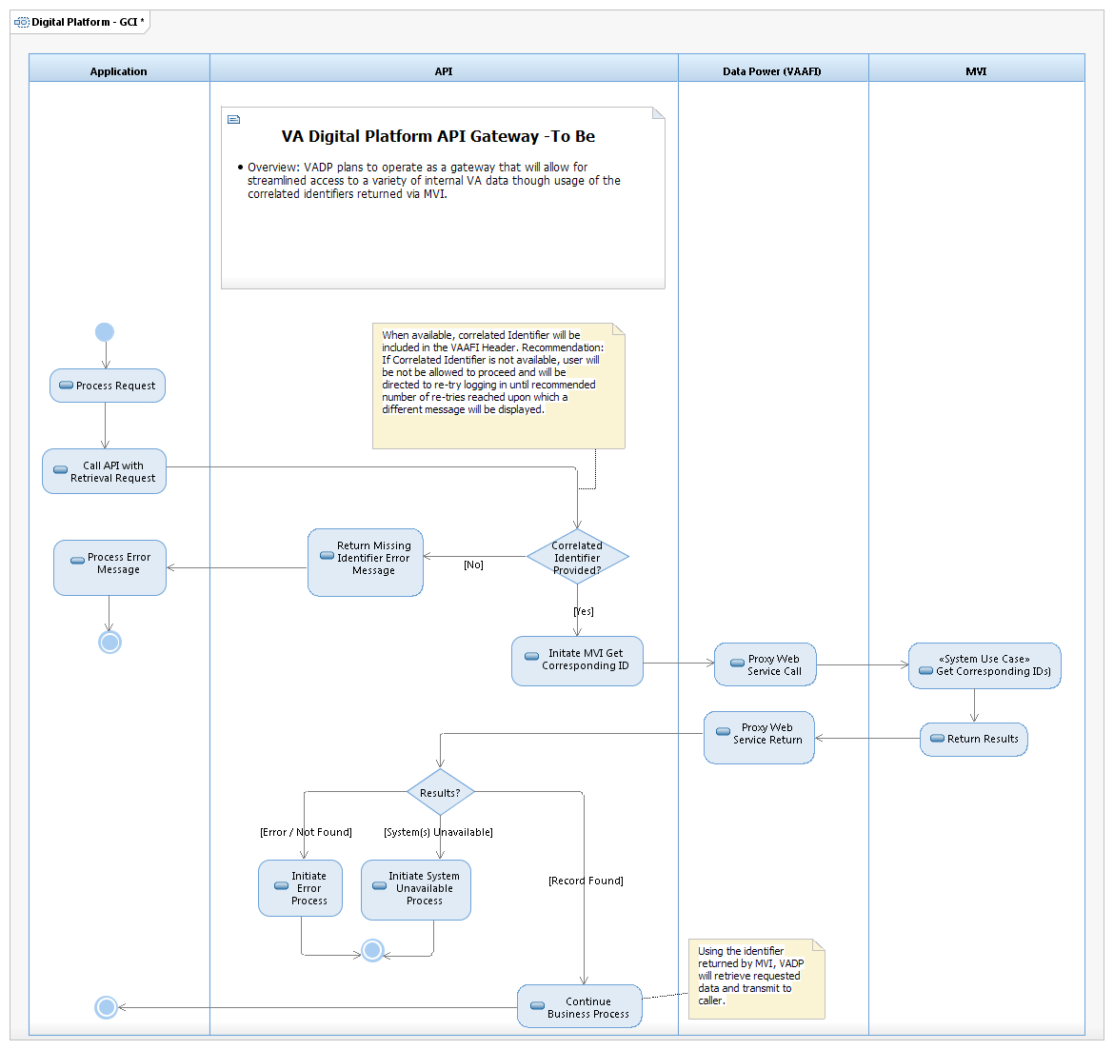

Figure 1: DVP Process Retrieval Request - To Be Process (zoom to 200%)

The identifier(s) returned from MVI will be used to obtain the following information from the appropriate VA source.

| **Name** | **Source** | **Required** | **Type** | **Description** |
| --- | --- | --- | --- | --- |
| Identifier |  | Yes | Identifier | An identifier for this patient |
| Active |  |  | Boolean | Whether this patient's record is in active use |
| Name |  | Yes |  | A name associated with the patient |
| telecom |  |  |  | A contact phone detail for the individual |
| Gender |  | Yes | Code | male | female | other | unknown |
| Birth Date |  | Yes | Date | The date of birth for the individual |
| Deceased |  |  | Boolean / Date Time |  |
| Address |  |  | Address | Addresses for the individual |
| Marital Status |  |  | Code | Marital (civil) status of a patient |
| Multiple Birth Indicator |  |  | Boolean |  |
| Photo |  |  | Attachment | Image of the patient |
| Contact Relationship |  |  | Code | The kind of relationship |
| Contact Name |  |  |  | A name associated with the contact person |
| Contact Telecom |  |  |  | A contact phone detail for the person |
| Contact Address |  |  | Address | Address for the contact person |
| Contact Gender |  |  | Code | male | female | other | unknown |
| Contact Organization |  |  | Reference Table | Organization that is associated with the contact |
| Contact Period |  |  |  | The period during which this contact person or organization is valid to be contacted relating to this patient |
| Animal Species |  |  |  | E.g. Dog, Cow |
| Animal Breed |  |  |  | E.g. Poodle, Angus |
| Animal GenderStatus |  |  |  | E.g. Neutered, Intact |
| Communication Language |  | Yes |  | A list of Languages which may be used to communicate with the patient about his or her health |
| Communication Preferred |  |  | Boolean | Language preference indicator |
| CareProvider |  |  | Reference Table | Patient's nominated primary care provider |
| Managing Organization |  |  | Reference Table | Organization that is the custodian of the patient record |
| Race |  | Yes |  | List of race categories from OMB Race Categories |
| Ethnicity |  | Yes |  | List of ethnicity categories from OMB Categories |
| Birth Sex |  | Yes |  | Code classifying the person’s sex assigned at birth as specified by the [Office of the National Coordinator for Health IT (ONC)](https://www.healthit.gov/newsroom/about-onc). |
| Appointments |  | Yes |  | Upcoming appointments at VHA facilities |
| Coverage |  | Yes |  | Non-VA coverage on file |

## Functional Requirements for IAM

The IAM functional requirements for the DVP integration are identified in this section. IdS provides the following functionality.

### Get Corresponding IDs

**Requirements**

1. IAM shall support Get Corresponding IDs requests from DVP.

# Other Specifications

## Business Rules Specifications

The business rules specifications for this integration are reflected in the Functional Requirements section of this document.

## Design Constraints Specifications

The design constraints specifications are identified in the Functional Requirements section of this document and in the following document:

* MVI Service Description Document

## Disaster Recovery Specifications

There are no disaster recovery specifications for the DVP integration with IAM services. The IdS disaster recovery specifications include the following:

* The disaster recovery specifications are detailed in the Person Service Identity Management (PSIM) Continuity of Operations Plan (COOP), Master Patient Index(MPI) COOP, and Austin Information Technology Center (AITC) Master Disaster Recovery Plan. These documents are protected and stored securely in the VA Security Management and Reporting Tool (SMART) system.

## Performance Specifications

DVP estimates the following:

* Estimated daily total number of Get Corresponding IDs requests: 15,000 daily (initially)
* Estimated monthly total number of Get Corresponding IDs requests: 450,000 monthly (initially)
* Standard hours of operation:
  + Peak usage times: 24/7/365
* Bulk Processes: No
* Estimated growth rate: 275,0000 requests daily within six months

## Quality Attributes Specifications

DVP shall be required to conform to all IAM design and coding standards. The IAM and DVP integration teams comply with the quality specifications set forth by the VA IAM Project Management Plan, Section 5 Quality Management Approach. IAM and DVP participate in the following activities to ensure the quality of the system:

* Acceptance and baseline of the iRSD
* Change control
* Unit testing
* Integration/functional testing
* User acceptance testing

The following quality processes are followed:

1. Stakeholder Review and Oversight

The DVP development team shall include both IAM business and technical representatives as stakeholders for approval of the IAM-related detailed requirements and design.

1. Requirements Management Traceability

The IAM portion of the DVP detailed system and user interface requirements and design specifications shall be traceable back to this iRSD.

1. Change Control

The baselined version of this iRSD is stored in IBM Jazz Team Server. Changes to this iRSD shall be accomplished by creating an IAM work item (WI) and shall follow the Veteran focused Integration Process (VIP) approval processes.

1. Integration Testing

Integration testing between DVP and IAM shall be accomplished via connection to the IAM test environment.

**NOTE:** An integration test schedule needs to be developed to identify the test environment.

## Reliability Specifications

There are no reliability requirements specific to the DVP-IAM integration at this time. The IAM average response time for a Get Corresponding IDs call is 500 milliseconds. The IAM reliability specifications are identified in the following table:

| **Service Availability Level 4** | |
| --- | --- |
| **Description** | Mission Critical Information |
| **Minimum Availability** | 99.9% |
| **Maximum Downtime Per Month** | 43 minutes |
| **Business Value** | Essential to fundamental business operations – outage seriously impairs functioning of business |
| **Operational Hours** | Required 24 hours a day, every day |
| **Significant Outage** | More than five minutes of downtime is considered significant at any time and requires an Automated Notification Report (ANR) to be sent out to the appropriate teams |
| **Outage Impact** | Interruption of service may result in severe financial, regulatory, patient safety, patient health, or other business issues |
| **Scheduled Maintenance** | Scheduled maintenance must provide continuity of service availability with minimal interruption |

## Security Specifications

To be IAM compliant, DVP needs to meet the following requirements:

1. DVP and IAM shall conform to the VA security standards detailed in VA Handbook 6500 Information Security Program.
2. DVP shall follow VA Authentication Federation Infrastructure (VAAFI) standards when interacting with the Master Veteran Index (MVI). VAAFI is the security framework between these IAM services and DVP.
3. Before invoking calls, DVP shall register with the IAM Development team in accordance with the guidance from the standard process for IAM integrations.

# Attachment A: Approval Signatures

REVIEW DATE: <mm/dd/yyyy>

Signed: *David Mazik* Date: <mm/dd/yyyy>

*<DVP System Owner >*

Signed: *Tim Robinson* Date: <mm/dd/yyyy>

*<DVP Project Manager >*

Signed: *Denise Kitts* Date: <mm/dd/yyyy>

*<Director, IAM Enterprise Business Office>*

Signed: *Sara Temlitz* Date: <mm/dd/yyyy>

*<Data Quality Business Product Manager>*

Signed: *Jeff Podolec* Date: <mm/dd/yyyy>

*<IT Program Manager>*

Signed: *Shelby Bell* Date: <mm/dd/yyyy>

*<Business Sponsor, Director, AIM, OICAM>*

# Appendix A – DVP Initial Release

The following diagram illustrates the consumer specific functionality that will be supported in the initial release of the DVP product. The overall functionality that will be supported by DVP is included in Section 2.1.2 of this document.

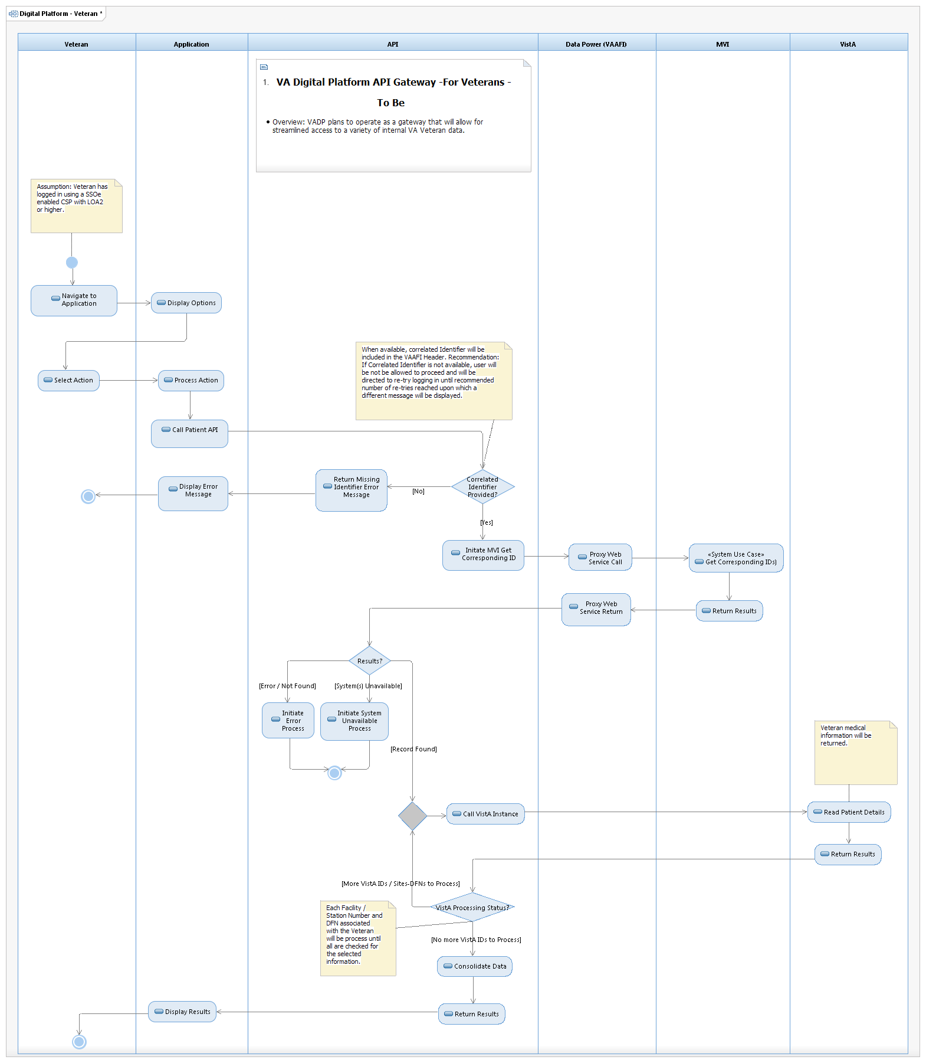

Figure 2: DVP Process - To Be Initial Release (zoom to 200%)