Education Forms Integration Design

Table of Contents
- Table of Contents
- Introduction
  - Scope
  - Key Functional Requirements
  - Non-Functional Requirements
• High-level Design
  - Design Constraints
  - Design Logical

  - Wire-Frame
  - Deployment Diagram
  - Design Overview
    - Coding Standard
- Specific Implementation
  - Model Objects & Shared Sub-flows
  - Shared Global Top-Menu Navigation in parent-flows and sub-flows
  - va-profile-webparts
  - va-profile-services
  - Service Client JARs
  - Persistence Layer JAR
  - edu-1990-webparts
  - edu-1990-services
  - MVI Proxy Add
  - Identifying Veteran | Dependent | Representative
  - Contact Info
  - Direct Deposit
  - Employment History
  - Education History
  - Military History
  - PDF Generation
  - Veteran Message Notification
  - Routing
  - Submission Process Flow
  - Spool File Format
  - Confirmation Number
  - Attachments Handling
  - Spool File Creation & Transfer
  - Job Failure and Recovery
  - Asynchronous access to common-services
- WSDLs and XSDs
- Required for all Features
  - Packaging
  - Google Analytics
- Acronyms
  - Risks:
  - Design Decision:
- Pending Design Clarifications

Introduction
"Acquiring Education Benefits" is the #2 priority customer journey for myVA. Purpose of this effort is to integrate following Education forms in EVSS that are currently supported by VONAPP. It will alleviate security concern related to VONAPP and help consolidate VA applications and self service benefits for the veterans.
Apply for Education Benefits (VA Form 22-1990)
Apply for Education Benefits-National Call to Svc (NCS) (Form 22-1990N)
Change Program/Place of Training (Form 22-1995)
Dependent Application for VA Education Benefits (Form 22-5490)
Dependent Request for Change of Program or Place of Training (Form 22-5495)
Education Benefits-Application for Family Member to Use Transferred Benefits (Form 22-1990E)

Scope
Currently the focus is to integrate VA Form 22-1990 that's most commonly used form for applying for education benefits.

Key Functional Requirements
- The system shall allow eBenefits and SEP users to Apply for Education Benefit(22-1990) and capture all the user data provided in the interview process.
- Notify user about submitted application.
- 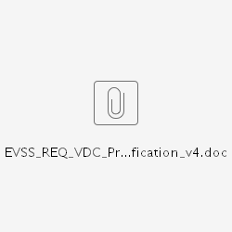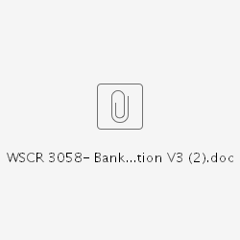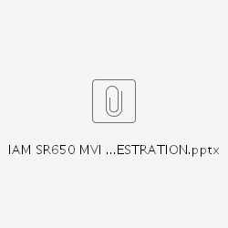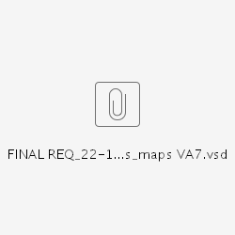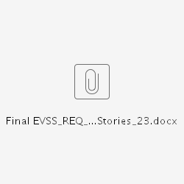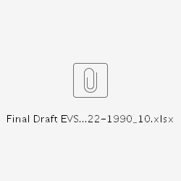
- The system should send generated 22-1990 pdf and attachments to veterans VBMS eFolder
- The system shall track submitted application and be able to generate nightly spool files with following criteria:
  - There will be four spool files created nightly corresponding to each Regional Processing Office(RPO) for education claim processing
  - Each spool file will contain complete application information for all the applications that should be routed to that processing office and was submitted within last day
  - Spool file will follow format provided by TIMS for packaging multiple applications within same spool file
- All application attachments also need to be send to TIMS on daily basis. Attachments belonging to each RPO will be zipped together before transferring to TIMS.

Non-Functional Requirements
- Page load time shall be at or below 5 secs so that users are able to access the page reasonably quickly
- The system shall create 22-1990 application on submission,evaluate successful creation in less than two (2) seconds.
- The system shall log System activity and account activity events within the context of the 22-1990 submission:
  - Success 22-1990 created
  - Failed 22-1990 submission attempts
- The system shall log tranaction events for spool file creation and transmission for each RPO.
  - Successful spool file created for RPO
  - Failed spool file creation attempt
  - Spool file successfully transferred
  - Failed spool file transmission
  - Attachments successfully transferred
  - Failed attachment transferred


High-level Design

Design Constraints
Based on our discussions with Education LOB stakeholders and the technical POC for TIMS, currently looks like the only option to integrate education forms is to interface with legacy TIMS (The Imaging Management System) system and focus is to replicate VONAPP functionality in EVSS. EVSS will be constrained due to limitations of TIMS in terms of system integration and manual intensive claim processing . Concern is that beside helping VOAPP sunset, we will not be adding much value due to following constraints:
- Legacy Integration Mechanism: Currently only way to integrate with TIMS(System of record for education ) is to send spool files through SFTP to VONAPP SFTP servers and TIMS pulls these spool files again using SFTP. TIMS wants to stick to same process so we have to SFTP spool files nightly to VONAPP servers. As per TIMS these SFTP servers will not be sunset. TIMS does not have funding for modernization or any system transformation.
- Dependents Application: Also out of 6 different types of education forms currently supported by VONAPP, 3 are for dependents that we may not be able to support immediately since EVSS currently does not support dependents applying for benefit.
- No ability to retrieve data or COE: TIMS is proprietary and legacy image document management system and currently there is no way to get application status or retrieve any data from TIMS including any certificate of eligibility or denial. This means that the Education claims processing staff will continue to use 100% manual data entry processes for the foreseeable future.
- Limited Data Pre-population: Form 22-1990 is large form with lot of redundant user input fields, business requirements have not strategically identified what’s really needed for processing this form. Education stakeholders have advised not to use payment information stored in Corp for Education applications.So we may not be able to pre-populate most part of this large form that will leave burden on users and reduce usability.

Design Logical
Following diagram shows integration of Education forms with EVSS at conceptual level. In the current phase integration is mainly through sending spool(text) files via SFTP due to the constraint mentioned above.EVSS will create four spool files daily corresponding to each Education RPO(Regional Processing Office) and send it to Philadelphia Enterprise Ops Server via SFTP. TIMS will retrieve spool files from Enterprise Ops Server again via SFTP and convert it into image corresponding to each claim. Claim will be processed manually by creating claim in BDN or LTS as needed.

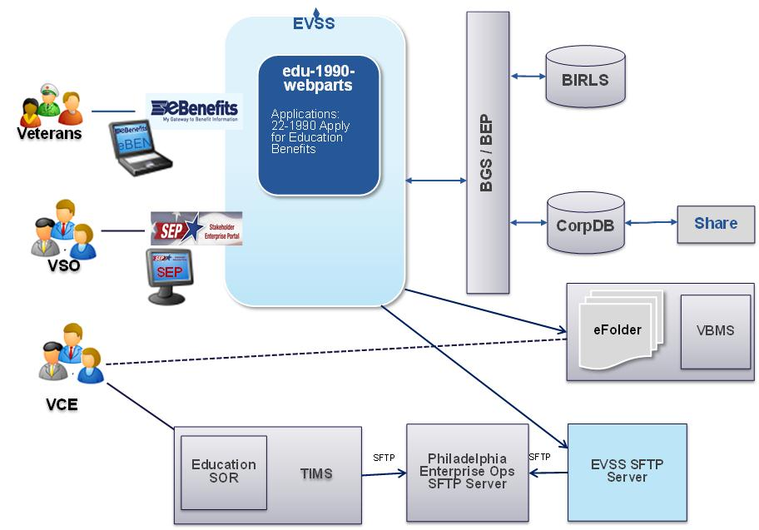

Wire-Frame
http://fzp9pm.axshare.com/

Deployment Diagram
Following diagram shows new deployment components and partner services that will be leveraged for integration of 22-1990 Form:

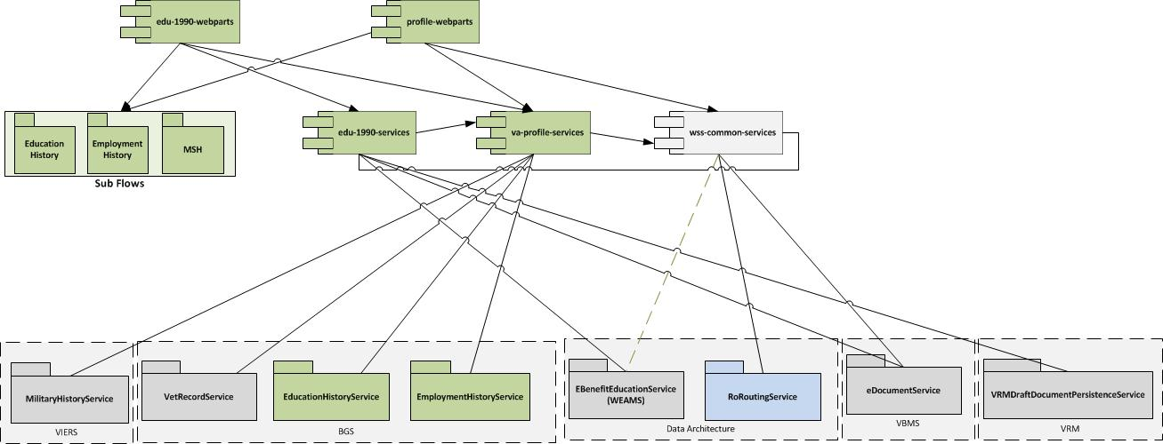

Design Overview
Integration of VA Form 22-1990 will follow typical VDC interview pattern. Education Form 22-1990 data will be captured through interview process consisting of multiple screens.Screen flow will be based on Spring WebFlow framework. At a high level following steps need to be performed to support integration of form 22-1990 through EVSS:
- Pre-populate available data during Interview process
  - Pre-populate data available in corp DB
  - Leverage services from va-profile-services for pre-populating data
- Captured data in draft form & Corp DB
  - Capture Contact Information as part of PCIU
  - Capture Employment and Education Record in Corp DB using newly requested services
  - Capture Period of Service using VIERS Military History Service
  - Persist information in Draft Form using VRMDraftForm Service
- Send generated 22-1990 PDF and attachments to VBMS eFolder using VBMS eDocument Service
- Send notification to message center by using UserMessageService.
- Create Nightly Spool files & attachments zip file for routing to four Education Regional Offices
  - Use RORoutingService to determine Regional Office based on address
  - On nightly basis create spool file and zip file containing attachments for each Regional Office that will include all the education applications that should be routed to that office.
- SFTP spool files and attachments on daily basis to Philadelphia Enterprise Ops Server for being picked up by TIMS

Coding Standard
All new and changed code must follow EVSS Coding Standards.

Specific Implementation
Following new maven project with corresponding svn repositories need to be created to support this functionality as depicted in the deployment referenced above. These projects and svn repositories will be setup similar to wss-common-services and wss-common-webparts.
- va-profile-webparts
- va-profile-services
- edu-1990-webparts
- edu-1990-services
These components will be deployed as separate wars and will share server space with wss-common-services and wss-common-webparts components .

Model Objects & Shared Sub-flows
Use generic data model for employment, education and military history that can be shared across different upcoming education forms and if needed with others web components within EVSS application.
For purpose of VonappUserProcessMapper Form 190 can be referenced as ,FORM1990' with corresponding value as 'Apply for Education Benefits'.

Shared Global Top-Menu Navigation in parent-flows and sub-flows
Using flow inheritance and state inheritance the navigation flow for menu related items, especially top-menu, can be centralized and actual flows, doesn't have to handle global navigation. To handle this, we have 2 parent-flows, one for main-flows and the other for sub-flows.
To transition to correct menu item,
- If the global transition (menu-item click) occurs in the same level (in the same flow), it needs to transition to corresponding view-state or subflow-state
- If the global transition (menu-item click) occurs, when the user is sub-flow, the sub-flow needs to be end properly, so that all the objects related to that flow is cleaned and control needs to come to parent and transition will happen in the parent-flow.
The inheritance way of design will handle the above 2 without having the inherited flow aware of it.
main-flows-parent-flow.xml
<?xml version="1.0" encoding="UTF-8"?>
<flow xmlns="http://www.springframework.org/schema/webflow"
xmlns:xsi="http://www.w3.org/2001/XMLSchema-instance"
xsi:schemaLocation="http://www.springframework.org/schema/webflow
http://www.springframework.org/schema/webflow/spring-webflow-2.0.xsd" abstract="true">

<global-transitions>

<!-- Transitions coming from main flow, usually from view-state -->
<transition on="eduProgram" to="educationProgram"/>
<transition on="milHistory" to="militaryHistory"/>
<transition on="empHistory" to="employmentHistory"/>

<!-- Transitions coming from subflows, usually from subflow-state in main flow -->
<transition on="educationProgramEnd" to="educationProgram"/>
<transition on="militaryHistoryEnd" to="militaryHistory"/>
<transition on="employmentHistoryEnd" to="employmentHistory"/>
</global-transitions>

</flow>
The above flow main-flows-parent-flow.xml is the parent flow for all the main flows. It has 2 typed of global transitions. Each transition ( eduProgram,milHistory,empHistory ) represent a menu-item. The first 3 transitions is for all view-states defined in main-flow. Ex:
edu1990-flow.xml
<?xml version="1.0" encoding="UTF-8"?>
<flow xmlns="http://www.springframework.org/schema/webflow"
xmlns:xsi="http://www.w3.org/2001/XMLSchema-instance"
xsi:schemaLocation="http://www.springframework.org/schema/webflow
http://www.springframework.org/schema/webflow/spring-webflow-2.0.xsd" parent="main-flows-parent-flow">
....
<view-state id="generalTerms" view="edu1990/eblandingPage">
<transition on="continue" to="applicationAlreadyOpen" />
<transition on="exit" to="edu1990" />
</view-state>
....
</flow>
For sub-flows (residing in webparts project or residing in subflow project ex: wss-vaprofile-webparts), the parent flow is:
sub-flows-parent-flow.xml
<?xml version="1.0" encoding="UTF-8"?>
<flow xmlns="http://www.springframework.org/schema/webflow"
xmlns:xsi="http://www.w3.org/2001/XMLSchema-instance"
xsi:schemaLocation="http://www.springframework.org/schema/webflow
http://www.springframework.org/schema/webflow/spring-webflow-2.0.xsd" abstract="true">

<end-state id="educationProgramEnd"/>
<end-state id="militaryHistoryEnd"/>
<end-state id="employmentHistoryEnd"/>

<global-transitions>

<transition on="eduProgram" to="educationProgramEnd"/>
<transition on="milHistory" to="militaryHistoryEnd"/>
<transition on="empHistory" to="employmentHistoryEnd"/>

</global-transitions>
</flow>
Each transition ( eduProgram,milHistory,empHistory ) represent a menu-item.
State Inheritance:
Above mentioned inheritance is flow based inheritance, where all states defined in the flow will inherit all the global transitions and end states defined in the parent-flow. If there is a use-case where you have specific transitions for a group of view-states (or sub-flow states), you can inherit from main-flows-common-states.xml flow.
main-flows-common-states.xml
<?xml version="1.0" encoding="UTF-8"?>
<flow xmlns="http://www.springframework.org/schema/webflow"
xmlns:xsi="http://www.w3.org/2001/XMLSchema-instance"
xsi:schemaLocation="http://www.springframework.org/schema/webflow
http://www.springframework.org/schema/webflow/spring-webflow-2.0.xsd" abstract="true" parent="main-flows-parent-flow">

<subflow-state id="parentMainFlowSubflowStateGrp1" >

</subflow-state>

<view-state id="parentMainFlowViewStateGrp1">

</view-state>

</flow>
Flow using the state Inheritance:
edu1990-flow.xml
<?xml version="1.0" encoding="UTF-8"?>
<flow xmlns="http://www.springframework.org/schema/webflow"
xmlns:xsi="http://www.w3.org/2001/XMLSchema-instance"
xsi:schemaLocation="http://www.springframework.org/schema/webflow
http://www.springframework.org/schema/webflow/spring-webflow-2.0.xsd">
.......
<view-state id="applicationAlreadyOpen" view="edu1990/applicationAlreadyOpen" parent="main-flows-common-states#parentMainFlowViewStateGrp1">
<transition on="continue" to="appInfo" />
<transition on="previous" to="generalTerms"/>
<transition on="exit" to="edu1990" />
</view-state>
.......
<subflow-state id="appInfo" subflow="applicant-info-flow" parent="main-flows-common-states#parentMainFlowSubflowStateGrp1">
<transition on="nextFlow" to="employmentHistory"/>
<transition on="previousFlow" to="applicationAlreadyOpen"/>
<transition on="exit" to="edu1990"/>
</subflow-state>
.......
</flow>
The above states that inherited from group state, get all global transitions defined in main-flows-parent-flow.xml and all the transitions defined in the state parentMainFlowViewStateGrp1 (or parentMainFlowSubflowStateGrp1) defined in main-flows-common-states.xml.
Integrate sub-flows residing as separate project:
To integrate sub-flows that are residing as separate project (ex: wss-vaprofile-webparts), the following needs to be updated in parent webparts application (ex: edu1990-webparts).
- Add the following properties in *local_dev.properties
wss-framework.freemarker.classpathTemplateSources.enabled=true
wss-framework.freemarker.classpathTemplateSources.prefix=classpath:/freemarker/webflow/
- Add to @Import of Parent webparts application ex: EduWebConfig.java
@Import({ EduWebPropertiesConfig.class,WssFreemarkerServletConfig.class,VaProfileSubflowWebConfig.class,RestHttpClientConfig.class,WssFrameworkRestClientConfig.class})

va-profile-webparts
This war will host all the web components related to veteran profile that will include personal info, dependents info, education history, employment history, military service history. This component will be build over a period of time. As part education form integration effort common web flow Jars related to Education, Employment and most probably Military History components will be pulled in into this war.

va-profile-services
VAProfileService will be moved out of wss-common-services and will be packaged as va-profile-services WAR. Corresponding maven project will include VAProfileService and all its dependencies. Dependencies will be packaged as consumable service client JAR with one JAR containing one WSDL unless its specified otherwise.
BGS will be proving following two new services for supporting Employment and Education History:

  - EmploymentWebService (WSCR 2551)
    - BGS has created EmploymentWebService
    - Package as client jar under newly created wss-partner-employmentrecord project
  - EducationWebservice (WSCR 2548)
    - BGS has added education history methods into EducationWebservice,
    - Package as client jar under newly createdwss-partner-educationhistory project.
Following services including any other service that VAProfileProfile is dependent on will be moved in its own JAR:

  - MviService
  - RatingInformationWsClient
  - ClaimantGeneralWsClient
  - Chapter31CaseWsClient
  - ShareStandardDataWsClient
  - ContentionWsClient
  - ClaimantFindPOAService

Service Client JARs
Following service clients need to be packaged as jar that will be included with edu-1990-services war and other wars as needed.
- EBenefitEducationService(WEAMS)
- Draft form services need to be packaged together
  - VRMDraftFormDocumnetServiceService
  - VRMDraftFormService
- VBMS File Upload Service with queuing
- VIERS MilitaryHistoryService
- Common Services Persistence Layer. Scope will be limited to separating EBN_APP persistence component only.
- RORoutingService
- UserMessageService
- Direct Deposit Validation

Persistence Layer JAR
Persistence Layer need to be move out from wss-common-services and packaged as JAR.Additional entities needed for education form persistence related to VONAPPUSERPROCESSMAPPER and Transaction log will be added.

edu-1990-webparts
It will be based on Spring WebFlow framework for managing 1990 interview flow process. This web component will include controllers, validators and front end components for supporting Form 1990. It will utilize SubFlow components for Education History, Employment History and Military History. Make sure that each page has distinct title so that it can be easily tracked by Google Analytics.

edu-1990-services
This services component will include service orchestration for loading, saving and submitting 1990 form.It will also include Quartz Job and batch process for asynchronous submission handling and creating nightly spool file. It will include following new services.
- Load1990Service
- Save1990Service
- Submit1990Service
- DocumentUploadService
- DirectDepositValidationService

MVI Proxy Add
User will be added to corp DB if Corp DB record does not exist at the time of submitting. SR-650 has been submitted to IAM for awareness with the expectation that it will be using same PSMID (200VDC) that is being used by VDC. VAProfileService getPerson() method can be used for adding record into corp DB with following criteria.
Note: After analyzing SR-650, IAM has created new PSMId '200VEDU' for MVI proxy add for education form.
- Check if user is Veteran | Dependent | Representative.
- In the BasePersonRequest pass PSMID provided by IAM through properties if its different from '200VDC'
- If Veteran, call VAProfileService getPerson() with dataSetsToLoad = { IDENTITY_VBA_CORPORATE, … } and addToCorporate = true ( drive this flag by properties)
- If Dependent, error out
- If Representative, call VAProfileService getPerson() with dataSetsToLoad = { IDENTITY_VBA_CORPORATE, … } and addToCorporate = false

Identifying Veteran | Dependent | Representative
To check if the user is representative verify if user has VSO, Attorney or Agent Role:
SecurityUtils.isUserInRole(WSSRole.ROLE_VSO.value())|| SecurityUtils.isUserInRole(WSSRole.ROLE_ATTORNEY.value()) || SecurityUtils.isUserInRole(WSSRole.ROLE_AGENT.value())
If user is not representative getBeneficiaryProfile() from UserProfileService, call isVeteran() to check if Beneficiary is a veteran otherwise user will be dependent.

Contact Info
It will use PCIU page from web-parts.Payment and direct deposit info need to be hidden while displaying PCIU page for this form since payment/direct deposit info is specific to particular education benefit and stored separately.

Direct Deposit
Payment/direct deposit info will be collected in the interview process, captured in draft from and will be included in the spool file. Validate accounting number/Routing Number need to be validated using existing mechanism used in 526EZ form.Validate routing number and account number for pattern and check-sum based on logic similar to PCIU in PciuServiceHelperBean. Use BGS AddressService readFinancialOrg operation to validate that routing number belongs to non-fraudulent financial organization.

Employment History
Employment History front end component and controller will use Spring WebFlow based SubFlow for education history. It will be packaged in a jar and will be hooked as part of 1990 interview flow. Employment History Sub-flow will be shared by
Profile and other upcoming education forms. Please the link below for education history design from Vet Profile prescriptive.
Employment History Technical Design

Education History
Education History will follow similar design pattern as mentioned in Employment History. It will also be shared by Profile and other upcoming education forms. Please the link below for education history design from Vet Profile prescriptive.
Education History Technical Design

Military History
Military History front end compo net will also be based on Spring WebFlow based Sub-Flow and will be packaged packed in jar. It will use VIERS MilitaryHistoyService for getting info related to service periods and adding unverified period of service. Any addition info that is not supported by MilitaryHistoyService will only be saved in draft from.

PDF Generation
Use following method from gov.va.wss.framework.form.DocumentService to generate PDF Document
byte[] formToDocument(final FormData formData, final DocumentType documentType) throws IOException

Veteran Message Notification
Post message to Veteran's Message Center by using sendUserMessages operation of the UserMessageService.

Routing
Use RORoutingService to determine processing office for education application by passing 'EDU' as line of business. If school is selected pass address of school otherwise pass contact address of claimant. Routing info need to be determined at the time of application submission and need to be captured in draft from. This service is being updated by Data Architecture group to accommodate changes in routing rules. Service client and schema need to be updated to use updated version of RORoutingService.

Submission Process Flow
Following diagram shows submission flow for 1990 form.
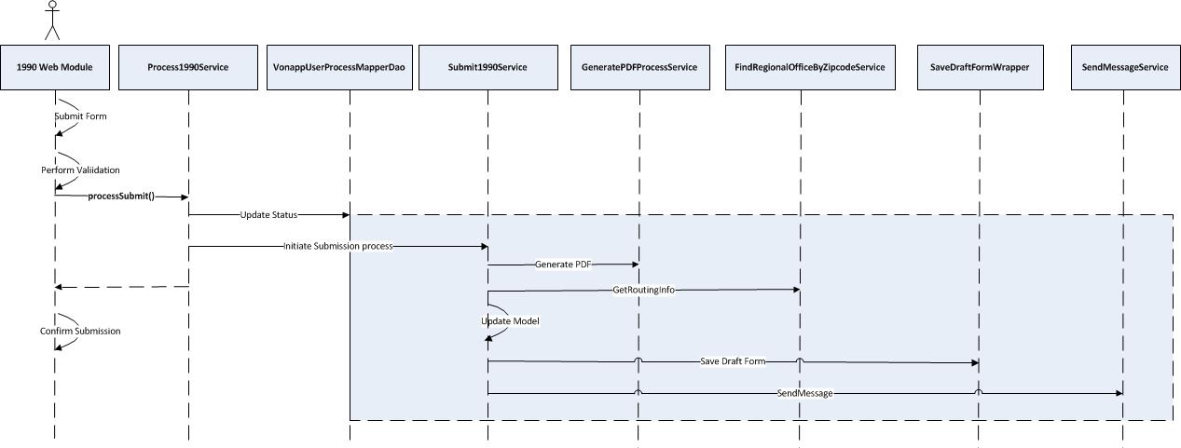

Spool File Format
Spool file is a text file with .SPL extension. Please refer to VBA Spool File Format for spool file format and information that need to be passed as header between *INT* and *START* tags.
Any information that is part of header but not available will be left blank i.e. 'Claimant Middle Initial'. If Veteran itself is claimant SSN info will be repeated.
Here is set of mandatory info that is needed for application to be processed by TIMS auto index process.
Claimant First Name
Claimant Last Name
Veteran's SSN
Claimant's SSN
Document Type
Document type value for 22-1990 will be 'V1990' If benefit t type is not provided it will default to Ch33 benefit type. Please refer to attached Document and Benefit Type Document for complete list of document and benefit types.
Spool file naming convention is: EVSS_TIMS_RPO_RPO#_yyyymmdd_Military time in hh:mm.spl i.e. Ex: EVSS_TIMS_RPO_307_08192013.spl .Sample Spool File is attached.

Confirmation Number
We will use Id from VONAPPUSERPROCESSMAPPER table for confirmation number. Additional field will added in the spool file that will capture 'EVSS' as source.
Source : EVSS
Confirmation Number: xxxxxxx(Number)

Attachments Handling
Attachments will follow follow naming convention.
EVSS_Attachments_RPO_RPO#_mmddyyyy_ Military time in hh:mm

Spool File Creation & Transfer
Use VonappUserProcessMapperDao to get all 22-1990 Application submitted within last day and use 'draftFormId' to fetch corresponding info from draft form.
getUsersByDateRange(final Date beginDate, final Date endDate, final String processType)

Create four spool files corresponding to RPOs and include application data based on the routing info. Follow format defined above for the spool file.
Add com.ironworks.vdc.shared_services_server.scheduled.EducationSpoolFileCreationJob and set corresponding properties to run daily around 01:00 AM. Set corresponding domain properties to ensure it run only from desired server.
For the version of the 1990 from in the spool file use properties file with override capability. Version is usually in the form of 'May 2014'.
If there are attachments please add the indicator in the spool file and include static block of text from requirement for the disclaimer.
Transfer spool files and attachments to Philadelphia Enterprise Ops SFTP server through quartz job using spring integration.
After transferring spool files status of the transmitted applications in VONAPPUSERPROCESSMAPPER table need to be updated to 'Transmitted'. In the claim status it can still show as submitted applications. It will help us track applications in case its not successfully transferred to TIMS.

Job Failure and Recovery
In case of failure in the creation or transferring of spool file send email to Ops and provide REST end point for triggering the Quartz Job for recreating and transferring spool files and attachment.
It will take the date range as input and will retrieve all education applications that have not been marked as transmitted. Ops team will need to manually trigger the REST end point to trigger this process.

Asynchronous access to common-services
For async access to common-services update SecurityUtils in wss-framework to provide mechanism to allows system user to get authenticated.
Education form will need access to UserMessageService for sending message to message center. WCS-1190 has been created and assigned to Jon Shrader for this task.

WSDLs and XSDs
Following WSCRs have been submitted to support this functionality:
WSCR 2551 - EVSS – CRUD operation for veterans employment record
WSCR-2548 - EVSS – CRUD operation for veterans education record
WSCR-3058 - EVSS - Bank Routing Number Verification

Required for all Features

Packaging

Google Analytics
Google Analytics integration will be added to this feature. Please refer Google Analytics Resources

Acronyms
TIMS - The Image Management System
RPO - Regional Processing Office( Currently EDU has 4 regional offices: Buffalo, NY; Decatur, GA; St. Louis, MO; Muskogee, OK)

Risks:
Risk # | 1
Summary | Attachment duplicate submission
Detail | - Education Business stakeholders are not using VBMS eFolder as repository for submitted applications and attachments.  - EVSS need to send attachments to TIMS through SFTP beside sending it to VBMS eFolder for making it available to veterans
Disposition | Owned - EA&I (VRM)
Risk # | 2
Summary | Bulk File Transfer
Detail | - Projected volume of education application is 1100-2000 per day.  - Size of attachments that need to be transmitted daily will in the rage of 2-6 GB. Assuming there are 1-3 attachments per application.
Disposition | Owned - EA&I (VRM)

Design Decision:
Decision # | 1
Problem Summary | Integration approach for linking Profile components Education & Employment History in Edu Forms and Profile
Problem Area | We have to come up with a sustainable pattern for integrating Profile components within Eud interview flow process.
Problem Detail | Current integration approach of linking Profile component from web-parts in the interview flow is not seem-less and adds technical challenges in capturing and managing corresponding data  - User experience is not seem-less since user is getting redirected top another app and it takes time to load  - Difficulties in aligning lay-over  - Complex display logic related to different views
Solution Options | A. Send user to profile within web-parts for completing profile info similar to current PCIU integration in 526  B. Have separate front end component in VDC and web-parts, integrate only at services layer.  C. Have Spring WebFlow based Sub-flow and share it in profile.
Chosen Option | C
Justification | To encourage profile and education form interview front end component remain in Sync
Decision # | 2
Problem Summary | SFTP mechanism for transferring spool file to PITC sFTP Server
Problem Area
Problem Detail | Should we decouple spool file creation process from transferring spool file to Philadelphia Enterprise Ops SFTP Server to manage any uncertainties and changes withing the file transfer process  itself.
Solution Options | A. Unix Cron Job  B. Quartz & Spring Integration/Spring Batch  C.Other SFTP API
Chosen Option | B
Justification | To avoid confusion in co-coordinating with Cron job process in a clustered environment.

Pending Design Clarifications
- Discuss with AIM about adding another VDC form to figure out if new PSMID is needed
- Discuss with Education stakeholders about the mechanism to handle attachments and generated from PDF
- Set expectation about narrowing down data elements being captured in from 22-1990
- Clarify expectation about just capturing data in draft from service
- How VONAPP generates Confirmation number and can it be used for status tracking?
- Confirm routing rules with Data Architecture Group
- Confirm if PCIU contact and payment information can be used for education form.
- Should we allow multiple submission of 22-1990?
- Find if WEAMS service support getting schools without passing category i.e. High School, Post Secondary Schools
- Create ticket for Jon Shrader for implementing security changes for async access to common-services components.
- Add design decision for only loading employment and education history through profile and saving it through education service
- Update sequence diagram
- Pull properties in a service for 526
- RoadMap for MTF list
- Inform PA&I for new additions to VNP tables
- Get RFAC from DA for Corp DB changes
- Call out the PCIU update for hiding payment info.
- Add status update piece and where it shows as submitted and open application.

