Veteran’s Proof of Service Letter Template | Version: 1.7
Veteran’s Proof of Service Letter Template | Date: November 7, 2026
Prepared by: EVSS


- Revision History
Revision | Description of Change | Author | Date
Rev: 1.0 | Initial draft. | Alice Lum | 03/18/2013
Rev: 1.1 | Adding a date on card and card will be printed with front/back sides. | Alice Lum | 04/1/2013
Rev: 1.2 | Added text from Mike Carr. | Alice Lum | 4/22/2013
Rev: 1.3 | - Added the watermark as a background in the front of card.  - Added revised text per comments received from Release 2 planning meeting in the “Do You Have Questions or Need Assistance?” section. | Alice Lum | 5/1/2013
Rev: 1.4 | - Renamed the letter from “Veteran’s Identification Card (VIC) Letter” to “Veteran’s Proof of Service Letter”.  - Revised the phone number “1-877-222-VETS” to “1-877-222-VETS (8387)”.  - Added “You can find Health Benefits related information at http://www.va.gov/healthbenefits/” to the “Do You Have Questions or Need Assistance”, “Use the Internet” section. | Alice Lum | 5/17/2013
1.5 | - Added 3 new attributes to the front of the card: (DoD ID Number, DOB, and Branch of Service).  - Added additional text to back of card:  “This card does not reflect entitlement to any benefits administered by the Department of Veterans Affairs or serve as proof of receiving such benefits.” | Corey Williams | 9/23/2016
1.6 | Corrected positioning of the front/back of card tags from below the cutout to the top to match R12.3 wireframe (http://iqctz1.axshare.com). Note: Since templates contain business rules not present in wires, templates are the preferred artifact for template udpates. | Karen Morris | 1/18/2017
1.7 | Change signature block from Robert Reynolds to generic “Executive Director” (EPB-4571) | Karen Morris | 2/09/2017

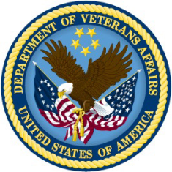
DEPARTMENT OF VETERANS AFFAIRS
810 Vermont Ave NW
Washington, D.C. 20420

(Date Letter Generated)
In Reply Refer To: xxx-xx-(User Last 4 of SSN)
(User First Name User Last Name) 27/eBenefits
(User Address)

Dear (User First Name User Last Name),

Please use the cut-out card below as verification of your honorable service in the Uniformed Services of the United States.

<front of card> <back of card>

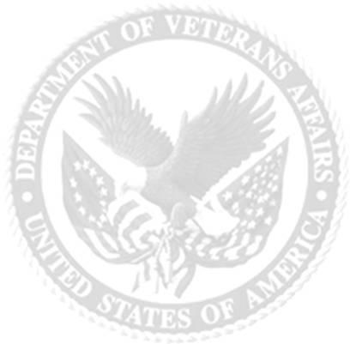
This card is to serve as proof the the individual listed below served honorably in the Uniformed Services of the United States.

(User First Name User Last Name)
(User Address)

Effective as of: (Date Card Generated)
DoD ID Number: (User DoD ID Number)
Date of Birth: (User DOB)
Branch of Service: (User last branch of service with Honorable Discharge)

United States of America
Department of Veterans Affiars

General Benefits Information
1-800-827-1000
Health Care Information
1-877-222-VETS (8387)

This card does not reflect entitlement to any benefits administered by the Department of Veterans Affairs or serve as proof of receiving such benefits.

Do You Have Questions or Need Assistance?
If you have any questions, you can contact us by telephone or Internet.

If you want to | Here is what to do.
Telephone | Call us at 1-800-827-1000, Option 7  If you use a Telecommunications Device for the Deaf (TDD), the number is 711.
Use the Internet | Send electronic inquiries through the Internet at https://iris.va.gov.  Within eBenefits, you can change your address or direct deposit, create a benefits letter, check the status of your claim, obtain a copy of your DD 214, and access additional VA benefit information at http://www.knowva.ebenefits.va.gov.  You can find Health Benefits related information at http://www.va.gov/healthbenefits/.

Sincerely,
Executive Director
Benefits Assistance Service

