
Medications on VA.gov and VAHB
(Q4 2025)
Version 4

1. Product Overview 2
2. User Access 3
2.1 Logging into VA.gov to access Medications (VistA users) 3
2.2 Logging into VA.gov to access Medications (Oracle Health users) 4
3. Navigation 6
3.1 List page 6
3.2 Details page 6
3.3 Refill page 7
4. Functionality 8
4.1 List page 8
4.2 Details page 10
4.3 Refill page 12
4.4 Download/Print 13
5. Major Issues and Error Messages 14
6. Prescriptions on VAHB mobile app 15
6.1 Prescription features 15
6.2 Getting to Prescriptions 15

1. Product Overview
Medications on VA.gov provides Veterans with a comprehensive online pharmacy experience, utilizing familiar features from My HealtheVet with enhancements to the tool. The Medications experience on VA.gov is designed to provide a personalized and seamless pharmacy experience that supports Veterans and builds trust with the VA.
Veterans can use the Medications tool on VA.gov to accomplish the following tasks:
- See a comprehensive list of current and previous medications
- Order a refill for a medication
- Request a renewal for a medication (coming soon, not yet available to Veterans)
- Learn information about a specific medication
- See the refill history of a specific medication
- Check the status of a medication, including:
  - Refill status
  - Shipping Status
  - Tracking information for a medication that has shipped

2. User Access
This section describes how Veterans access the Medications tool on VA.gov, including differences in experience for VistA and Oracle Health users.

2.1 Logging into VA.gov to access Medications (VistA users)
To access Medications on VA.gov, VistA users must first be authenticated with a VA.gov account. Once signed in, users are taken to VA.gov, where My HealtheVet tools are available without requiring a separate login. From there, users can navigate to the Medications tool in the following ways:
- From the My VA homepage, select the medication refill quick link (Figure 2a)
- Select My HealtheVet in the navigation bar, then choose Medications from the sub-navigation (Figure 2b)
- Select My HealtheVet in the navigation bar, then scroll down to refill prescriptions or view the medications list (Figure 2c)
Figure 2a. My VA homepage quick link
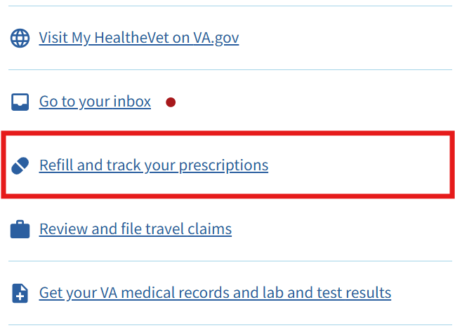
Figure 2b. VA.gov My HealtheVet navigation bar
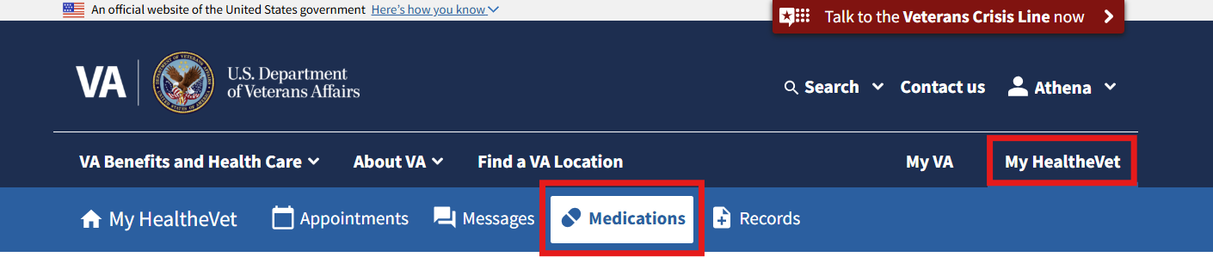
Figure 2c. My HealtheVet landing page
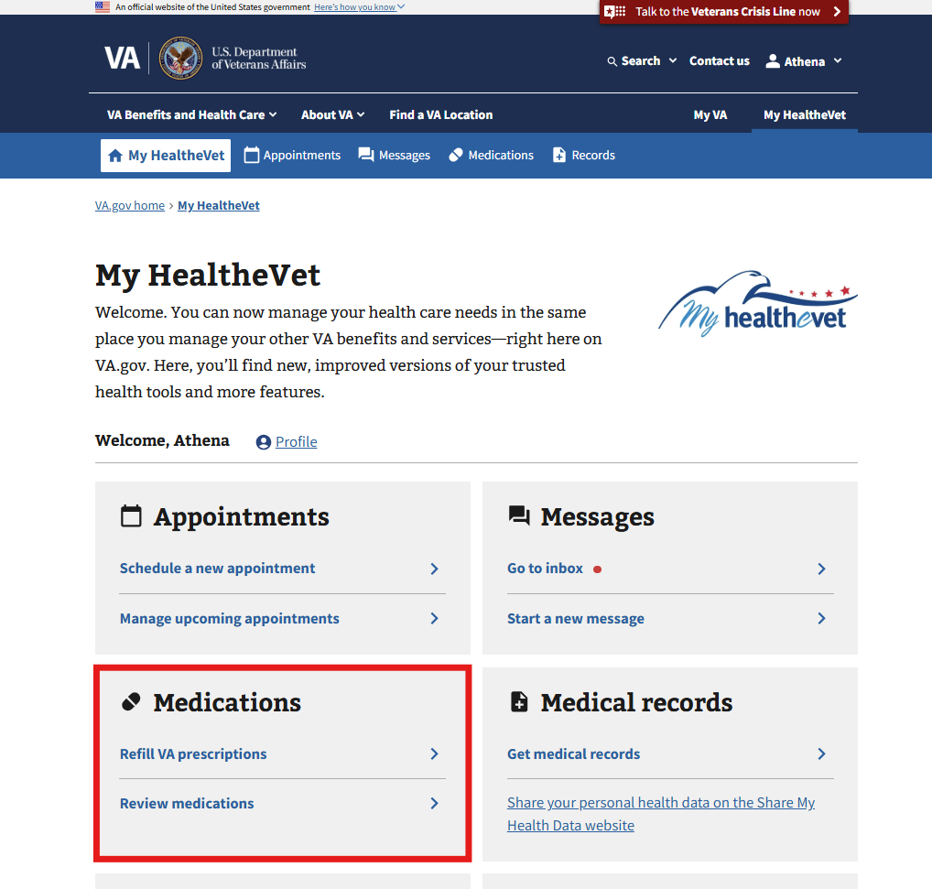

2.2 Logging into VA.gov to access Medications (Oracle Health users)
Oracle Health users follow the same primary access paths as VistA users but may see additional routing alerts related to portal transitions. To access Medications on VA.gov, Veterans who receive care at Oracle Health facilities must first be authenticated with a VA.gov account. Once signed in, Veterans are taken to VA.gov, where My HealtheVet tools are available without requiring a separate login. From there, Veterans can navigate to the Medications tool in the following ways:
- From the My VA homepage, select the medication refill quick link (Figure 2d)
- Select My HealtheVet in the navigation bar, then choose Medications from the sub-navigation (Figure 2e)
- Select My HealtheVet in the navigation bar, then scroll down to refill prescriptions or view the medications list (Figure 2f)
Once on the My HealtheVet landing page, Oracle Health users may see routing alerts that do not appear for Veterans receiving care at VistA facilities (Figures 2g–2h). These alerts appear because some health care tools are managed in a different portal. Users will see either a yellow or a blue routing alert, with only one shown at a time. Which alert appears depends on where the user is in a gradual rollout. Each alert includes a link to My VA Health, and over time the blue alert will replace the yellow alert.
Figure 2d. My VA homepage quick link
Figure 2e. VA.gov My HealtheVet navigation bar

Figure 2f. MHV landing page displayed to Oracle Health users
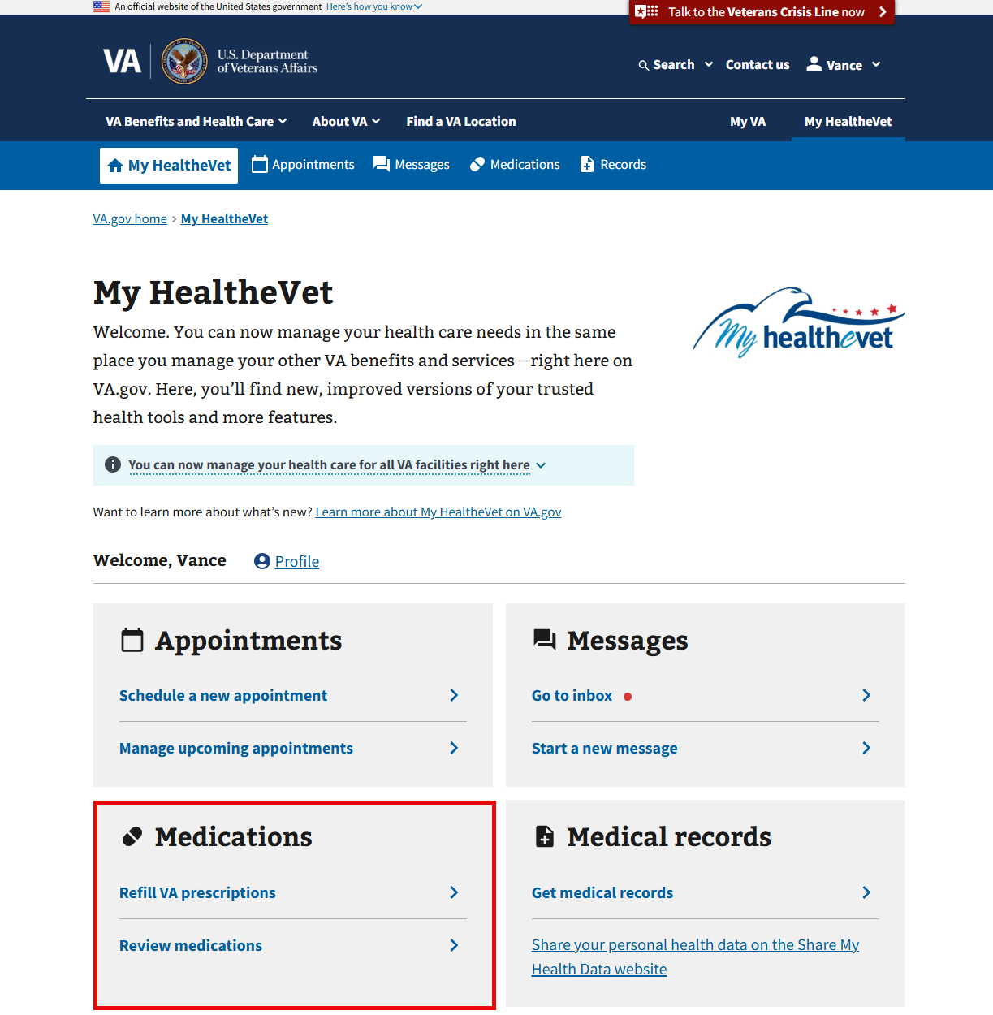
Figure 2g. Yellow Oracle Health routing alert on the Medications landing page
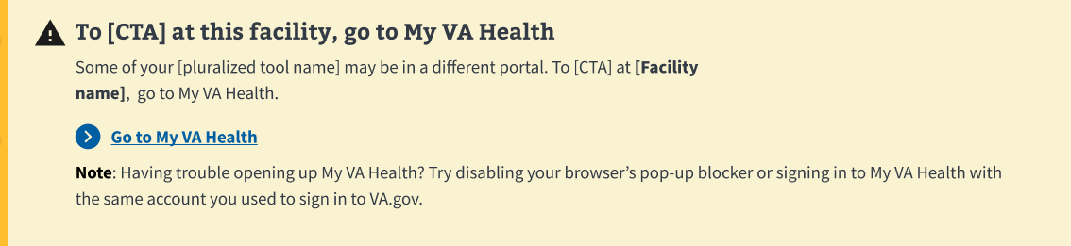
Figure 2h. Blue Oracle Health routing alert on the Medications landing page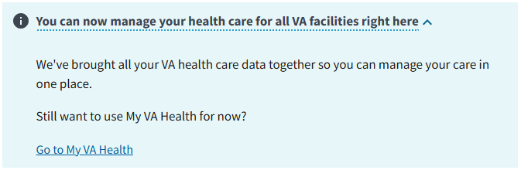

3. Navigation
This section outlines how Veterans navigate within the Medications tool and move between the List, Details, and Refill pages.
Once in the Medications tool, Veterans will be able to navigate to the three pages within the Medications application through links and breadcrumbs:
- List page
- Details page
- Refill page

3.1 List page
The List page is the primary entry point for reviewing prescriptions and accessing related actions.
Most navigation on the List page is conducted through the list of prescription cards. Depending on the status of the prescription, different navigation opportunities will be presented. The following navigation capabilities can be found within the cards:
- The prescription Details page is accessed via the link in the medication name on the prescription card in List View (Figure 3a). Each card has an associated Details page.
- A link to request a renewal via the Secure Messaging tool on VA.gov is available when applicable (Figure 3b).
Figure 3a. Active medication example Figure 3b. Active medication with no refills remaining example
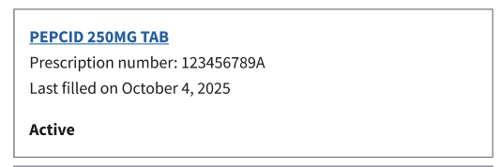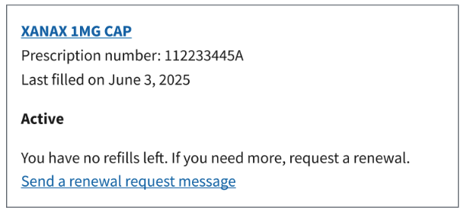

3.2 Details page
The Details page provides prescription-specific information and additional navigation options. The following navigational capabilities are available on the Details page:
- External tracking link to delivery service website (when applicable)
- Breadcrumbs back to the previous page the user was on (list page)
- As found on the cards in the List View, links to the Landing page describing how to renew a prescription (when applicable)
- Link to the Secure Messaging tool on VA.gov (when applicable)
Tracking and shipment information can only be found on the Details page via alert as shown (Figure 3c). External links to the delivery service website are offered.

Figure 3c. Example of a tracking alert for Tacrolimus 1 MG CAP on mobile
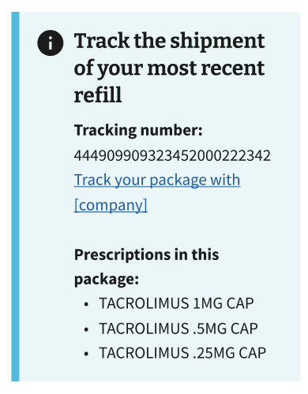

3.3 Refill page
The Refill page allows Veterans to request refills for medications that have refills available.
Figure 3d. Example refill prescriptions page
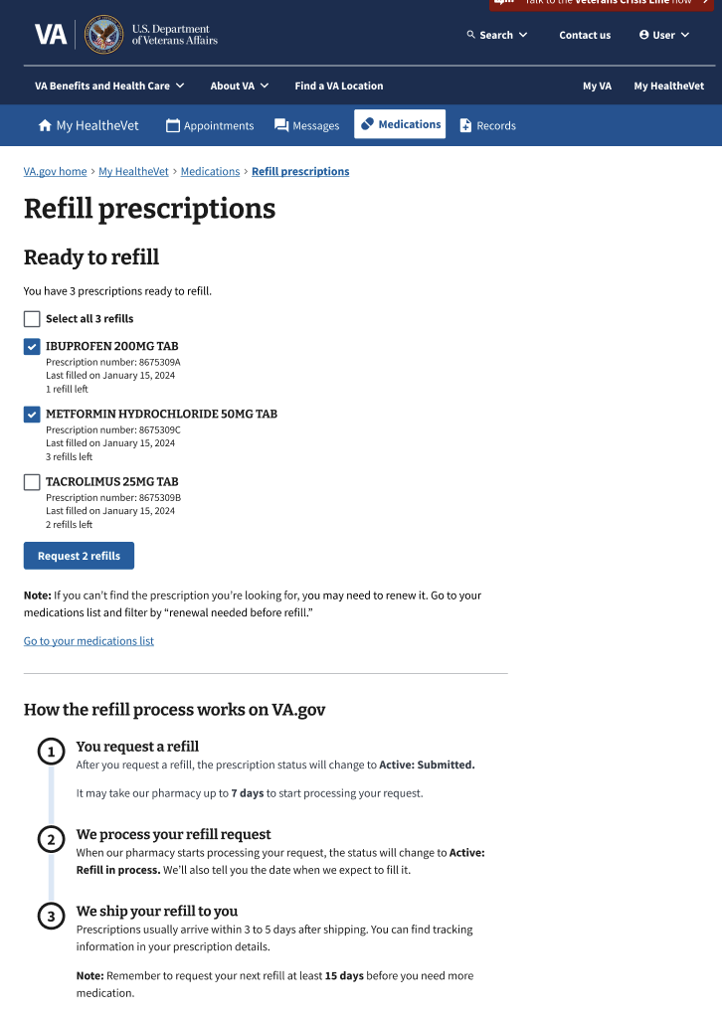

4. Functionality
The main purpose of the Medications tool is to give Veterans a streamlined, digital tool to refill their medications or certain prescription-related supplies. Other capabilities are listed below.

4.1 List page
The List page serves as a dynamic record of current and past VA and Non-VA prescriptions (Figure 4a). From this page, Veterans can navigate to the refill page, access the Details page for a specific prescription (see Section 4.3), and view their complete prescription history.
By default, prescription cards are sorted alphabetically by status, then alphabetically by medication name. Users can adjust the sorting as needed.
Figure 4a. Example of the List page on desktop
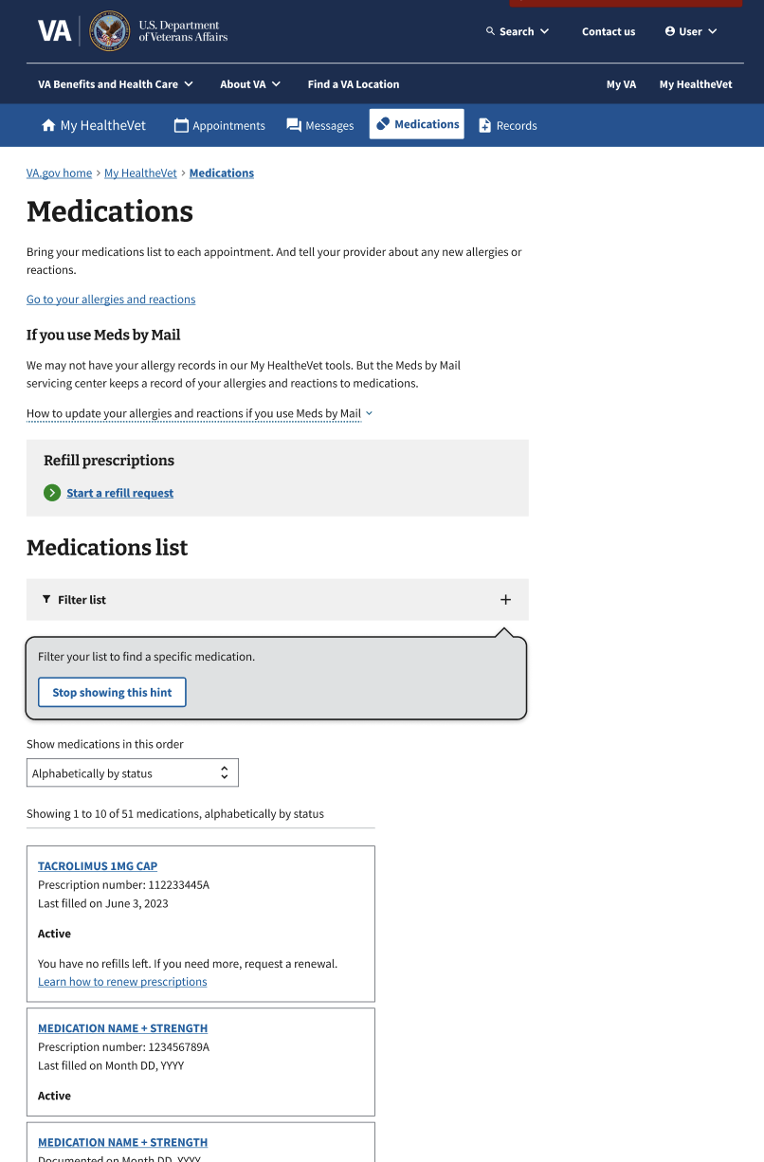

Medication cards are updated to reflect their status.
For medications that are active but out of refills, or expired within the past 180 days, a ‘Request a renewal’ link is available via Secure Messaging. Selecting this link navigates the user out of the Medications tool and into Secure Messaging, where they can submit a pre-populated renewal request, before being returned to the Medications tool (Figure 4b).
Figure 4b. Example of successfully requesting a renewal via secure message on mobile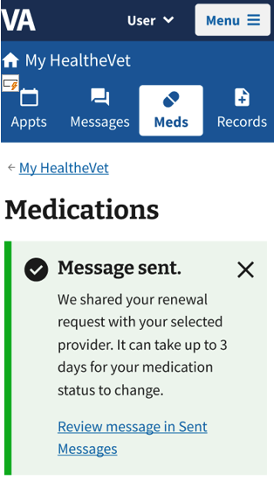
There is filter functionality that allows users to narrow the medication list to the following options (Figure 4c):
- All Medications
- Active
- Recently requested
- Renewal needed before refill
- Non-active
Figure 4c. List page filter
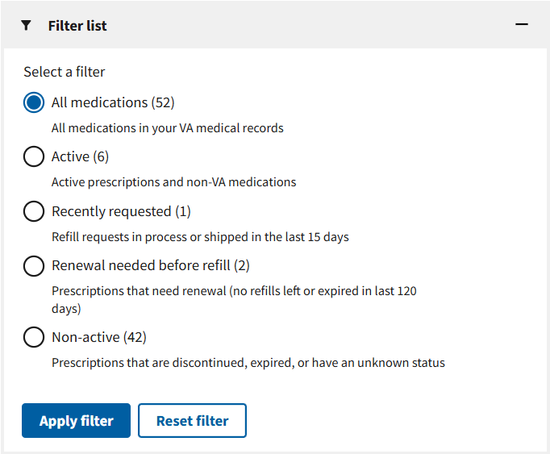
Other functionality includes downloading and printing the list of prescriptions found in the List View. The user’s recorded allergies and adverse reactions are also found in the same printable file.

4.2 Details page
Each prescription has a Details page (Figure 4d) which provides an in-depth look at the history of the prescription as well as important information like the reason for use, the prescription expiration date, the prescription number, the status and its definition, and more.
Figure 4d. Partial screenshot of sample details page
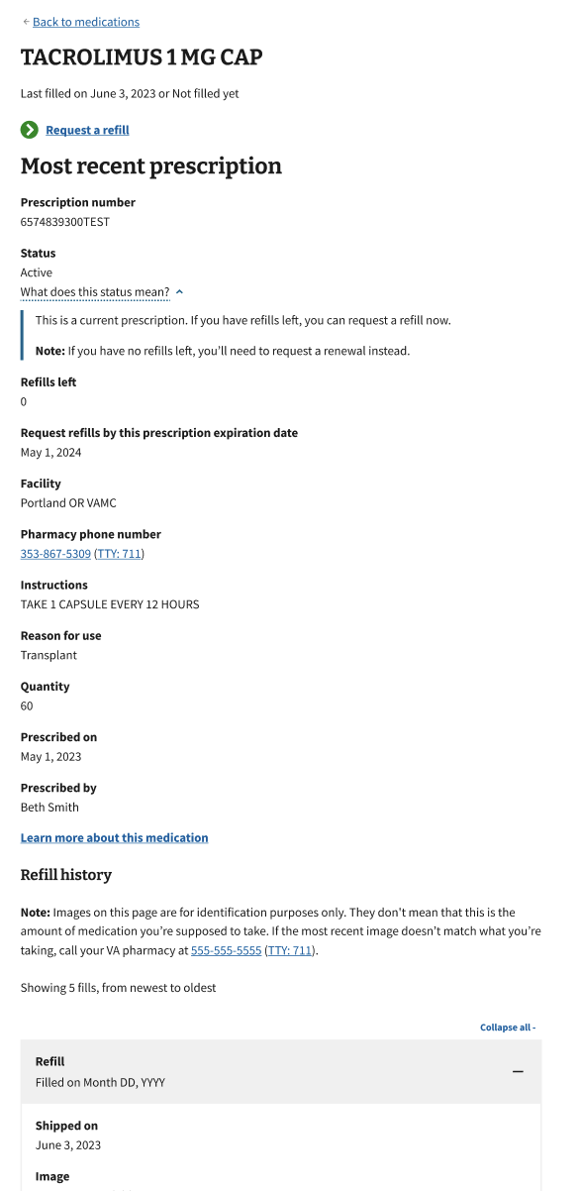

Each Details page is separated into 4 distinct sections with accompanying details:
- About your prescription
  - Status, with dropdown definition
  - Refills left
  - Request refills by this prescription expiration date
  - Prescription number
  - Prescribed on
  - Prescribed by
  - Facility
  - Pharmacy phone number
- About this medication or supply
  - Instructions
  - Reason for use
  - Quantity
- Refill history, listed by individual refill
  - Filled by pharmacy on
  - Shipped on
  - Image (Figure 4e): The drug image provides a visual reference within the medication’s history. Because medications may change color or shape over time, this image helps Veterans recall what their medication looked like and supports questions or concerns about appearance.
Figure 4e. Example of an expanded medication image
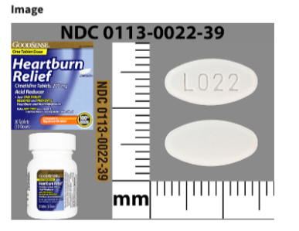
  - Medication description
- Previous prescriptions, listed by individual refill (Figure 4f)
  - This allows the user to see their full history with this medication. This also reduces the number of cards on the list page by grouping all the medications with the same prescription number together into one card.
  - Fields include:
    - Last filled on
    - Quantity
    - Prescribed on
    - Prescribed by

Figure 4f. Example of previous prescriptions on mobile
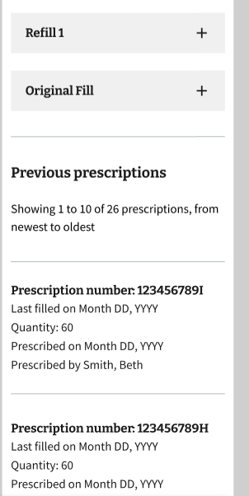

4.3 Refill page
The Refill page displays medications that are ready to be refilled and allows users to submit refill requests (Figure 4g). This is shown as a list of medications with checkboxes that the user can select individually or all at once. If a medication the user expects to see is not listed on the Refill page, it may be because the medication has run out of refills and requires renewal before it can be refilled.
Figure 4g. Refill page, refill section
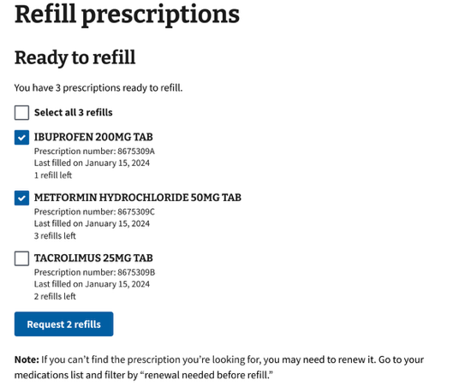

4.4 Download/Print
Users can download and/or print their comprehensive medication list from the List View page (Figure 4h) or download and/or print details for individual medications from each Details page. All medications can be printed, downloaded as PDF, or downloaded as a TXT file.
Available options differ between the List View and Details pages. On the List View page, users can print only the current page or all medications, download a PDF of the list, or download a TXT file of the list. On the Details page, users can print the page or download a PDF or TXT file for that medication.
Selecting a download option displays a green Download started success alert (Figure I) that provides guidance if the file does not download automatically.
Figure 4h. Print or download button on the List View page
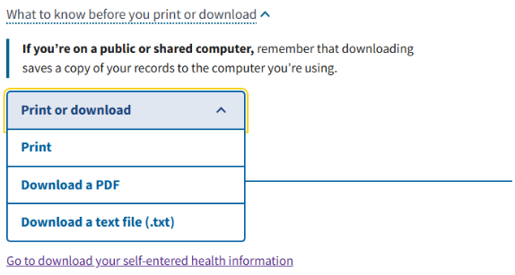
Figure 4I. Download started success alert on the List View page
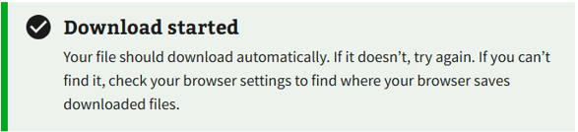

5. Major Issues and Error Messages
This section documents known issues and describes how error messages are displayed within the Medications tool. There are no major issues currently.
Error messages are displayed similarly to refill status updates in the cards and on the Details page (Figure 5a).
If a print or download action fails due to a backend error, an error alert is shown (Figure 5b). The alert uses the same visual styling as other medication-related error messages and provides guidance to try again later or contact support if the issue persists.
Figure 5a. Example of a backend error when trying to fetch medication list
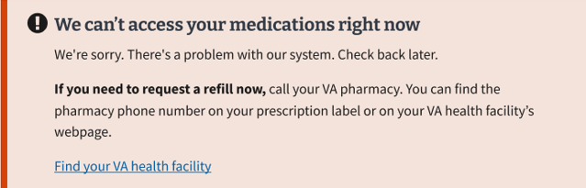
Figure 5b. Example of a backend error when printing or downloading the medication list
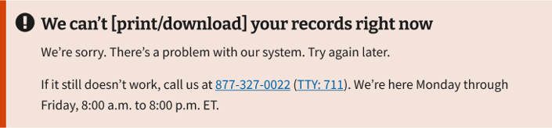

6. Prescriptions on VAHB mobile app
Users can review their VA prescriptions, request refills of their eligible VA prescriptions, and review prescription tracking information. However, they cannot renew prescriptions in the app. The app’s functionality is similar to that found on the My HealtheVet website and the RX Refill app.

6.1 Prescription features
The VAHB mobile app supports the following prescription-related actions (Figures 6a–6b):
- Review active and non-active prescriptions
- Filter and sort prescriptions
- View prescription details
- Request refills for eligible prescriptions
- Review pending (recently submitted or in-process) refills
- Review trackable refills
  - View tracking information for tracked refills

6.2 Getting to Prescriptions
This section describes how users navigate Prescriptions within the VAHB mobile app.
To review prescriptions, users tap the Health icon in the bottom navigation bar. From the Health section, users select Prescriptions. Users are taken to the Prescriptions landing screen, which displays all VA prescriptions, sorted by Status (A–Z) by default, with a secondary sort by medication name.
There is a ‘Filter and sort’ button that allows users to customize their view. Users can apply a filter option to display prescriptions by Status. The Filter and sort button is located below the list title. Pending and Tracking filter options are now available in the Filter panel instead of the tab navigation used in previous experiences.
Selecting a Sort option brings prescriptions matching the selected criteria to the top of the list. Sort options include Fill date, Medication name, Refills left, and Status.
The Filter and sort panel includes options at the top. Users can select Apply to view the updated list or Cancel to return to their previous view.

Figure 6a Prescriptions flow in the mobile app (screens 1 - 4)
Home screen | Health screen | Prescriptions landing screen | Prescription cards on landing screen
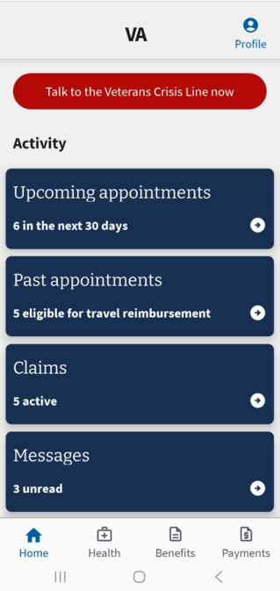 | 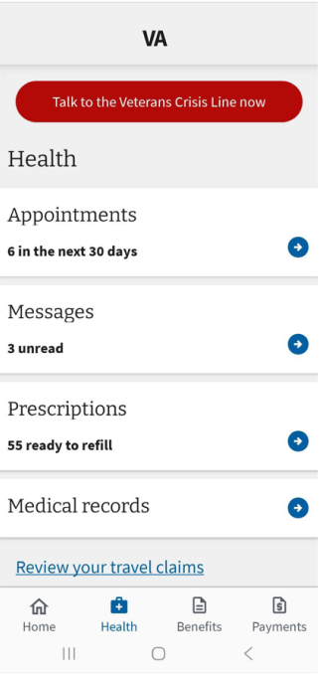 | 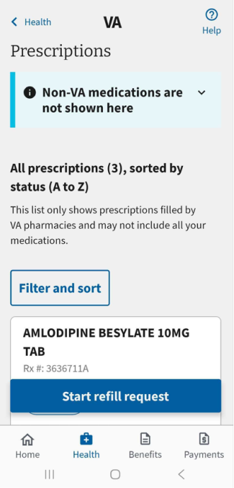 | 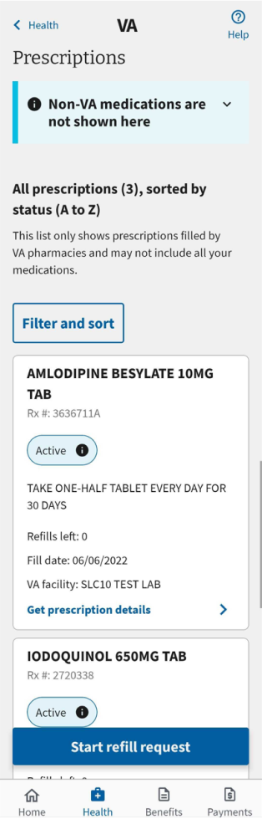

Figure 6b Prescriptions flow in the mobile app (screens 5 - 7)
Prescription details screen | Filter and sort screen | Prescription tracking screen
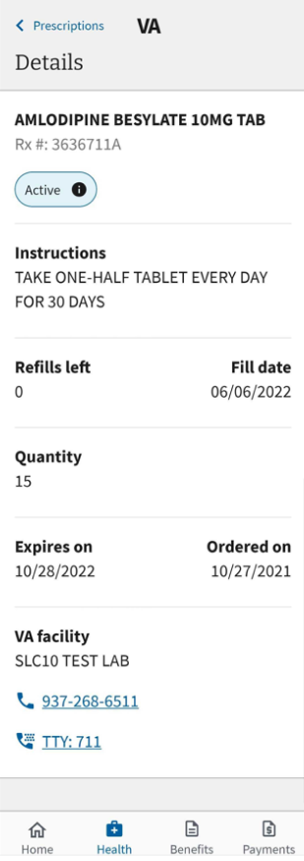 | 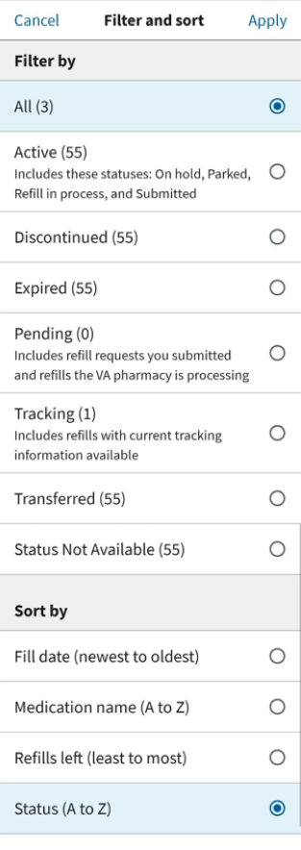 | 