

Veteran-facing Services Applications

September 2, 2021 | Online VA Form 5655 Reference Guide

Version 2.0

Revision History

| Date | Version | Description | Author |
| --- | --- | --- | --- |
| 04/23/2021 | 1 | First iteration | VSA Debt Resolution Team |
| 08/17/2021 | 2 | Second iteration, with expanded explanatory content and updated screen captures to reflect design changes. | VSA Debt Resolution Team |
|  |  |  |  |
|  |  |  |  |
|  |  |  |  |
|  |  |  |  |
|  |  |  |  |
|  |  |  |  |
|  |  |  |  |
|  |  |  |  |

Table of Contents

1 Introduction 1

1.1 Strategies and Principles 1

2 Access and Navigation 2

2.1 Accessing the FSR 2

2.2 The FSR User Experience 4

2.3 Structural Overview 4

2.4 Form Interaction 5

*3* Step 1 of 7: Veteran Information – *Veteran Information* 6

3.1 Veteran Information – *Veteran Information* 6

3.2 Veteran Information – *What debt do you need help with?* 7

3.3 Veteran Information – *Contact Information* 8

4 Step 2 of 7: Household Income 9

4.1 Household Income – *Your work history* 9

4.2 Household Income – *Your VA benefits* 12

4.3 Household Income – *Your other income* 13

4.3.1 Household Income – *Your spouse information* 14

4.3.2 Household Income – *Your dependents* 16

5 Step 3 of 7: Household Assets 17

5.1 Household Assets – *Your household assets* 17

5.2 Household Assets – *Your cars or other vehicles* 20

5.3 Household Assets – *Your other assets* 21

6 Step 4 of 7: Household Expenses 23

6.1 Household Expenses – *Your monthly household expenses* 23

6.2 Household Expenses – Your installment contracts and other debts 25

6.3 Household Expenses – *Other living expenses* 26

7 Step 5 of 7: Repayment or Relief Options 27

7.1 Repayment or Relief Options – *Your financial overview* 27

7.2 Repayment or Relief Options – *Resolution options available* 28

7.3 Repayment or Relief Options – *Supporting personal statement* 31

8 Step 6 of 7: Bankruptcy History 32

8.1 Bankruptcy History – *Your bankruptcy details* 32

9 Step 7 of 7: Review your request 33

Table of Figures and Tables

Figure 1.1: Strategies and Principles 1

Figure 2-1: Debt Portal FSR Access Point 2

Figure 2-2: FSR Starting Point: *Is this the form I need?* 2

Figure 2-3: Decision Points: *Is this the form I need?* 3

Figure 2-4: Digital FSR Structure 4

Figure 2-5: Form Navigation Basics 5

Figure 2-6: The *Finish this request later* link 5

Figure 3-1: Veteran Information 6

Figure 3.2: Debt Selection 7

Figure 3.3: Veteran Information – *Contact information* 8

Figure 4-1: Household Income – *Your work history* 9

Figure 4-2: Household Income – *Your work history* (continued) 10

Figure 4-3: Household Income – *Income for your job at (Job Title)* 11

Figure 4-4: Household Income – *Your VA benefits* 12

Figure 4-5: Your Other Income – *Social Security* 13

Figure 4-6: Your Other Income edit screen 13

Figure 4-7: Household Income – *Are you married?* 14

Figure 4-8: Household Income – *Your spouse information* 14

Figure 4-9: Household Income – *Your spouse information* (continued) 15

Figure 4-10: Household Income – *Your dependents* 16

Figure 4-11: Household Income – *Your dependents* (continued) 16

Figure 5-1: Household Assets – *Your household assets* 17

Figure 5-2: Household Assets – *Your real estate assets* 18

Figure 5-3: Household Assets – *Add real estate* 19

Figure 5-4: Household Assets – *Your cars or other vehicles* 20

Figure 5-5: Household Assets – *Your other assets* 21

Figure 5-6: Household Assets – *Your other assets* (continued) 22

Figure 6-1: Household Expenses – *Your monthly household expenses* 23

Figure 6-2: Household Expenses – *Your monthly utility bills* 24

Figure 6-3: Household Expenses detail – *Your monthly utility bills* 24

Figure 6-4: Household Expenses – *Your installment contracts and other debts* 25

Figure 6-5: Household Expenses detail – *Your installment contracts and other debts* 25

Figure 6-6: Household Expenses – *Other living expenses* 26

Figure 6-7: Household Expenses detail – *Other living expenses* 26

Figure 7-1: Repayment or Relief Options – *Your financial overview* 27

Figure 7-2: Repayment or Relief Options – *Debt repayment or relief options* 28

Figure 7-3: Waiver Checkbox and Explanatory Text 29

Figure 7-4: *Extended monthly payments* Option 29

Figure 7-5: *Compromise* Option 30

Figure 7-6: Repayment or Relief Options – *Supporting personal statement* 31

Figure 8-1: Bankruptcy History – *Your bankruptcy details* 32

Figure 8-2: Bankruptcy History – *Your bankruptcy details* (continued) 32

Figure 9-1: The *Review your request Portion* 33

Figure 9-2: The *Veteran’s statement of truth* portion 34

Figure 9-3: *Request Confirmation* page 35

# Introduction

The VA Form 5655 Financial Status Report (FSR) conversion entails the design, test, and release into the VA.gov production environment of an online version of VA Form 5655. It captures all the information obtained by means of its hardcopy counterpart, including:

1. Veteran Information
2. Household Income
3. Household Assets
4. Household Expenses
5. Resolution Options
6. Bankruptcy History
7. Certification

Veterans, active-duty service members, and members of the National Guard or Reserve must complete the FSR to receive consideration for debt relief, which can take the form of a waiver, compromise offer, or payment plan.

## Strategies and Principles

The overarching strategy is outlined in Figure 1-1.

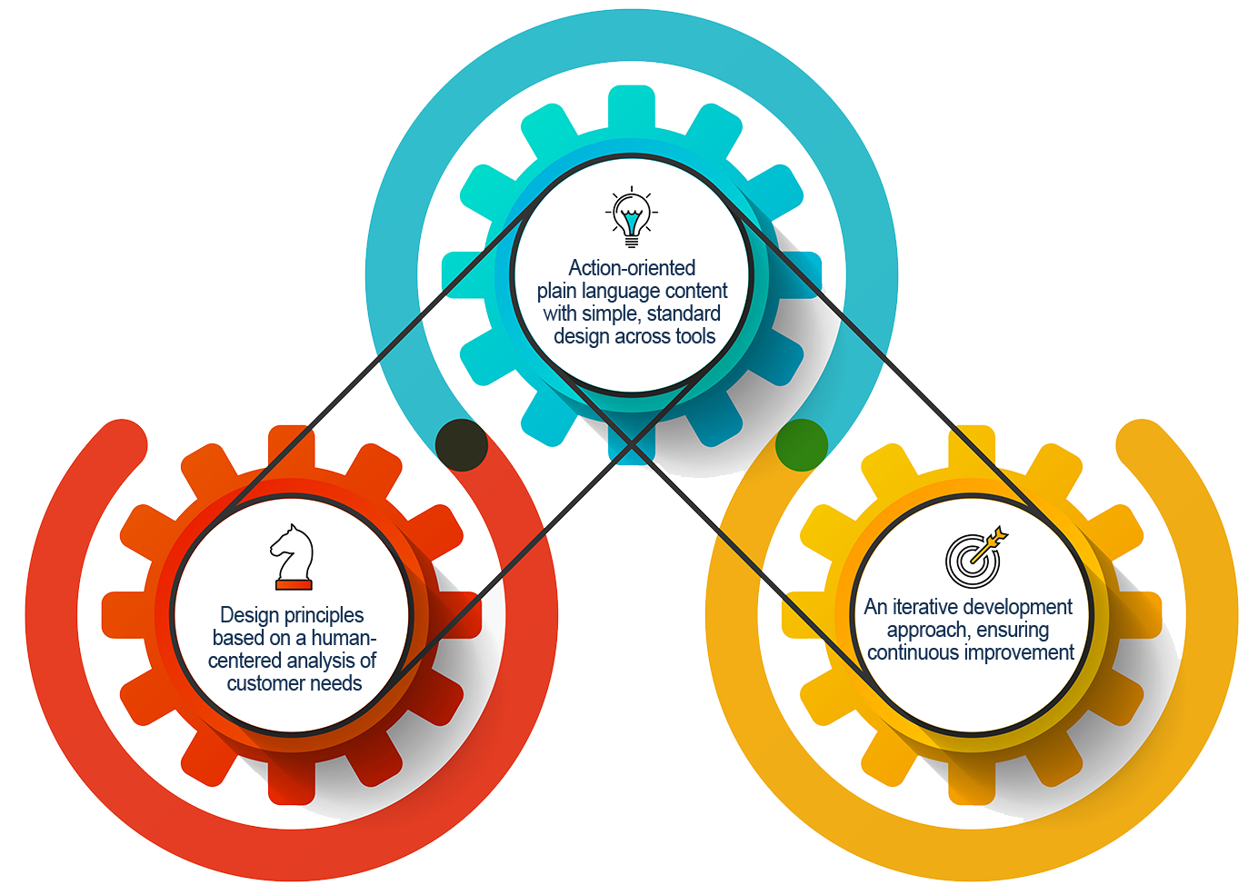

Figure 1.1: Strategies and Principles

# Access and Navigation

## Accessing the FSR

The FSR is accessible either by means of direct link or via a prominently displayed button on the Debt Portal. Every choice made on the form wizard in the Debt Portal further refines and personalizes the user experience, identifying user needs and creating decision tree pathways leading to where those needs can most likely be met.

Refer to Figures 2-1, 2-2, and 2-3.

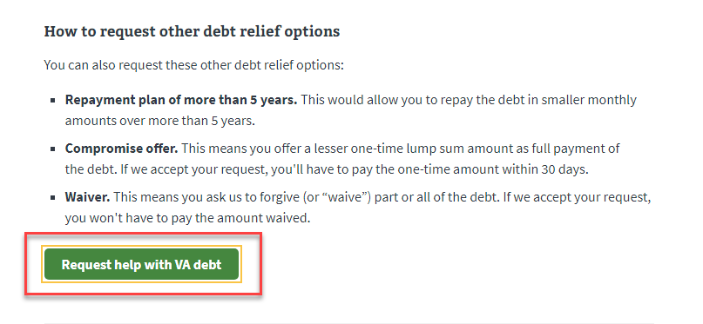

Figure 2-1: Debt Portal FSR Access Point

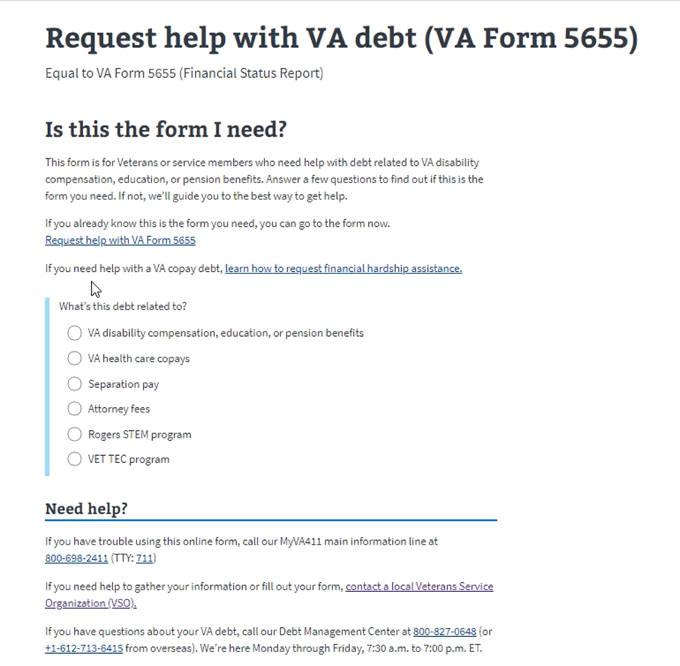

Figure 2-2: FSR Starting Point: *Is this the form I need?*

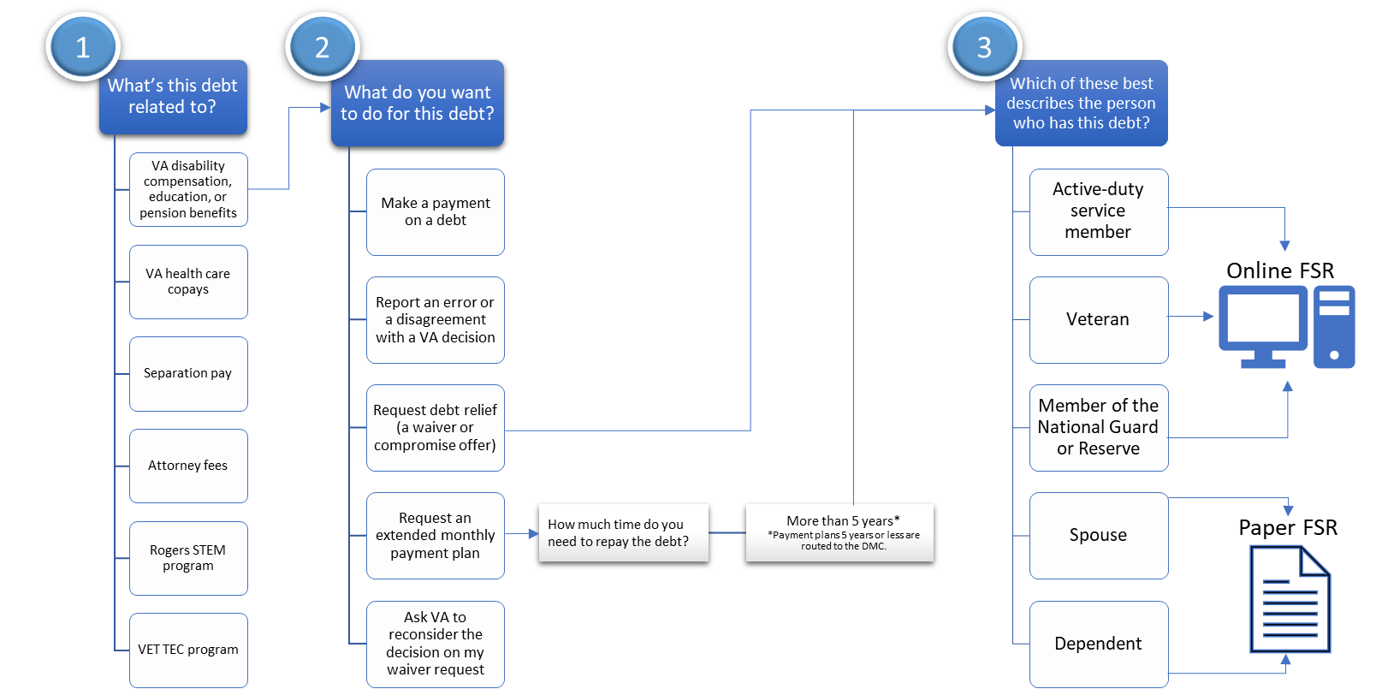

Figure 2-3: Decision Points: *Is this the form I need?*

## The FSR User Experience

The online FSR is user-friendly, straightforward, and easy to navigate, typically taking 30-45 minutes to complete.

* Financial figures are automatically calculated by the form.
* ~40 percent of hardcopy applications are rejected due to arithmetic errors made by Veterans.

Before starting, the Veteran is directed to gather essential documents for ease of reference:

* Paycheck stubs
* Previous year(s) W-2s
* Vehicle registration
* Utility bills
* Spouse financial information, if applicable
* Bankruptcy documents, if applicable
* Debt resolution options are clearly explained and demarcated

The form wizard approach takes the impetus away from the Veteran and provides a one Veteran, one VA experience. Prior to this, Veterans didn’t know where to go to get answers, seek relief, or pay bills. This approach addresses that problem.

## Structural Overview

The original hardcopy FSR consists of 8 sections. These 8 hardcopy sections digitally translate to 7 steps. Refer to Figure 2-4.

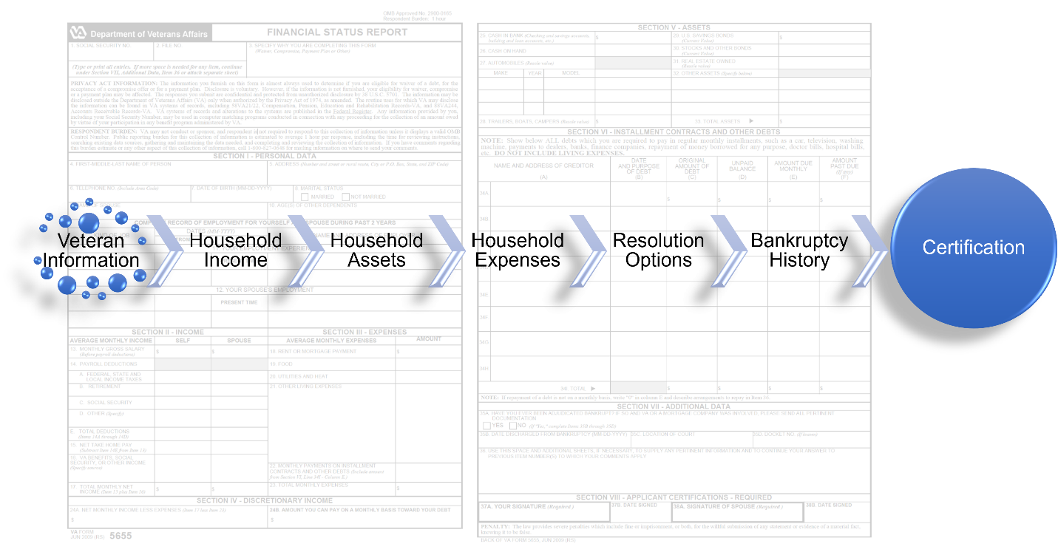

Figure 2-4: Digital FSR Structure

## Form Interaction

Each page of the form has a progress status bar at top telling the user how far they’ve progressed through the form. The *Back* and *Continue* buttons are self-explanatory. The underscored text below the *Back* button, “Finish this request later,” represents the save functionality of the form. See Figure 2-5.

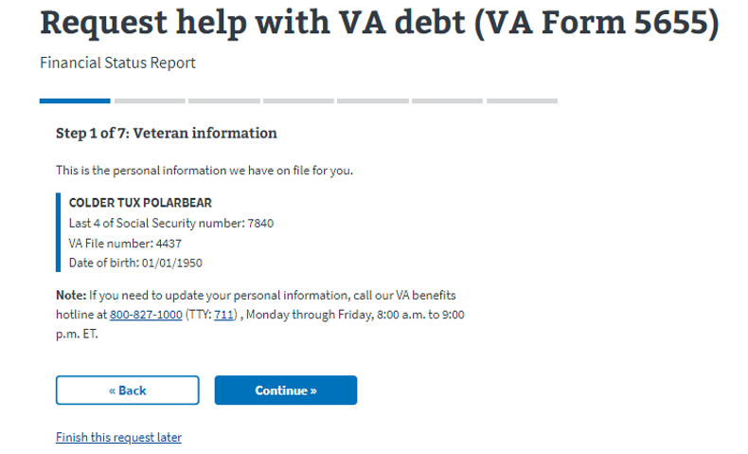

Figure 2-5: Form Navigation Basics

Selecting that linked text takes the user to a form page informing them their application has been saved and indicating they can continue with the application or start a new one if they choose. The application is auto-saved frequently. See Figure 2-6.

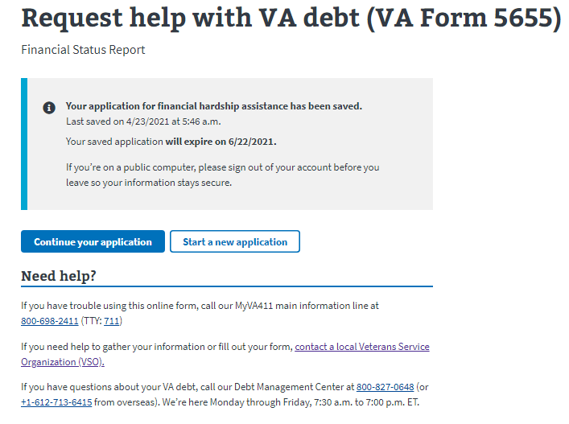

Figure 2-6: The *Finish this request later* link

# Step 1 of 7: Veteran Information – *Veteran Information*

## Veteran Information – *Veteran Information*

The information presented on the Veteran information page of the form is straightforward. At this point, the Veteran should confirm the information is correct.

See Figure 3-1.

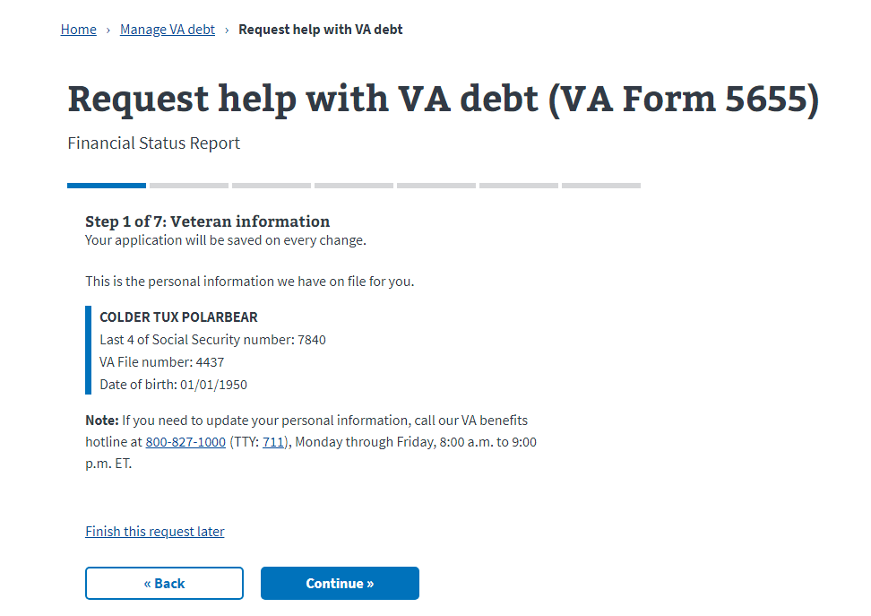

Figure 3-1: Veteran Information

## Veteran Information – *What debt do you need help with?*

Selecting *Continue* brings up the *What do you need help with?* debt selection page. The user must select at least one of the listed debts before progressing further. Note the *Finish this request later* prompt at lower left. System save functionality allows the user to come back to this point later.

Refer to Figure 3-2.

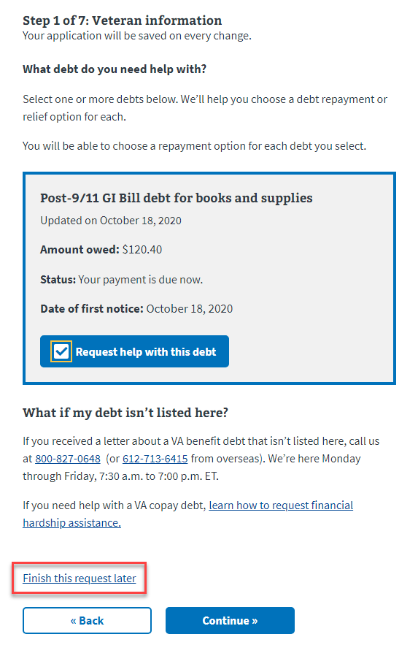

Figure 3-2: Debt Selection

## Veteran Information – *Contact Information*

Selecting *Continue* takes the user to the Contact Information page.

See Figure 3.3. Selecting *Edit mailing address* allows the user to update their address, if necessary. Note that email address must be entered into both email address fields before proceeding.

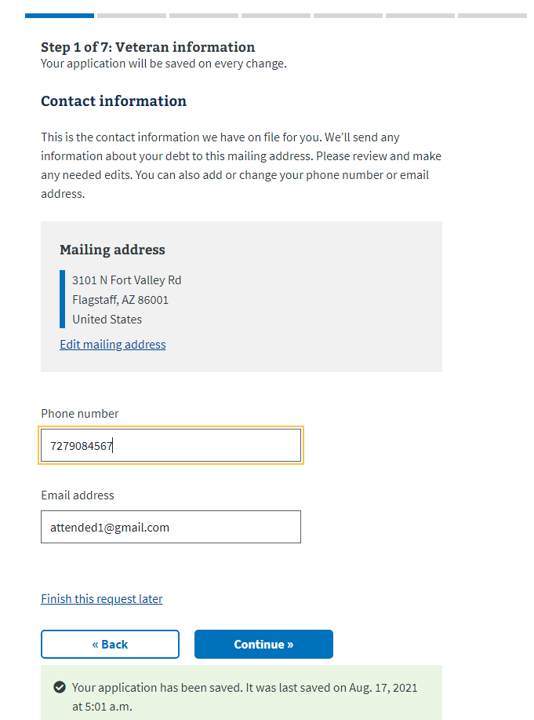

Figure 3-3: Veteran Information – *Contact information*

# Step 2 of 7: Household Income

## Household Income – *Your work history*

*Your work history* requires the following information:

* Type of work
* Date started work
* Employer name
* Gross monthly income
* Payroll deductions
* Another current job
* Other jobs

Refer to Figure 4-1.

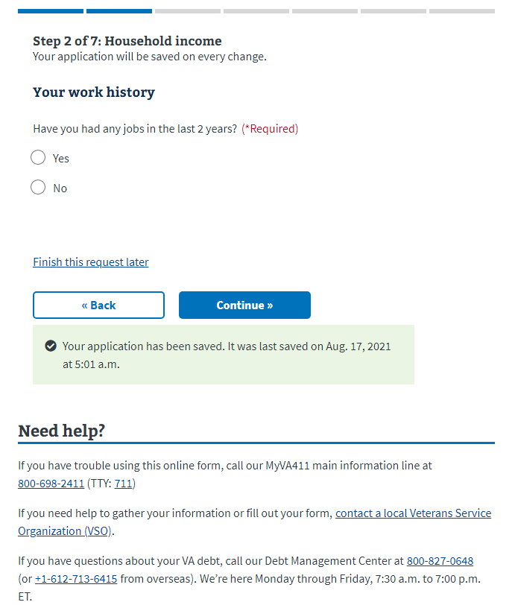

Figure 4-1: Household Income – *Your work history*

Selecting *Yes* to the question *Have you had any jobs in the last 2 years?* will bring up the *Your work history* page of the form. The information needed to complete this section is typically derived from paycheck stubs and W-2 forms. Refer to Figure 4-2. The *Add Job* prompt at lower left allows the user to fill out as many employment positions as required.

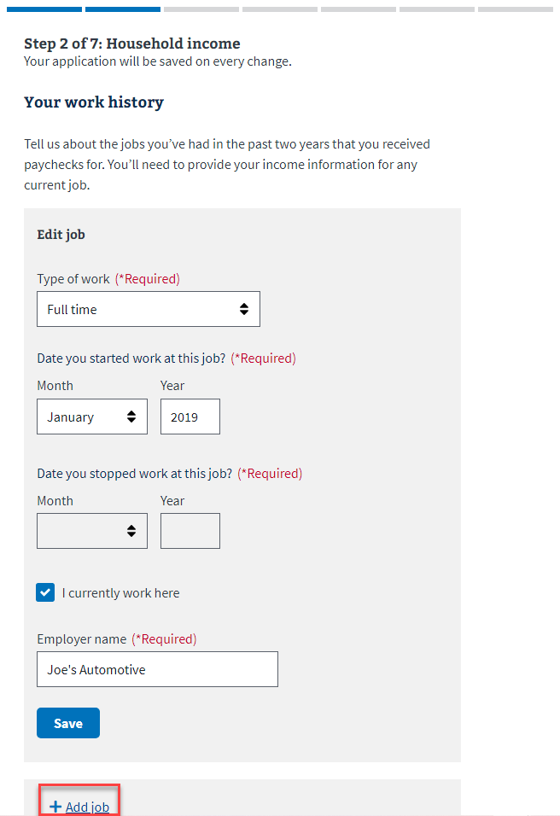

Figure 4-2: Household Income - *Your work history* (continued)

Once a job is entered and *Continue* is selected, the user is then taken to the *Income for your job at (Employer Name)* page. The user is required to fill out gross monthly income and the amount of payroll deductions. See Figure 4-3. Note when the user enters a given field—in this case *Type of payroll deductions*—a dropdown appears with a list loop array of possible choices. This functionality is present throughout the FSR and makes for easier value entry.

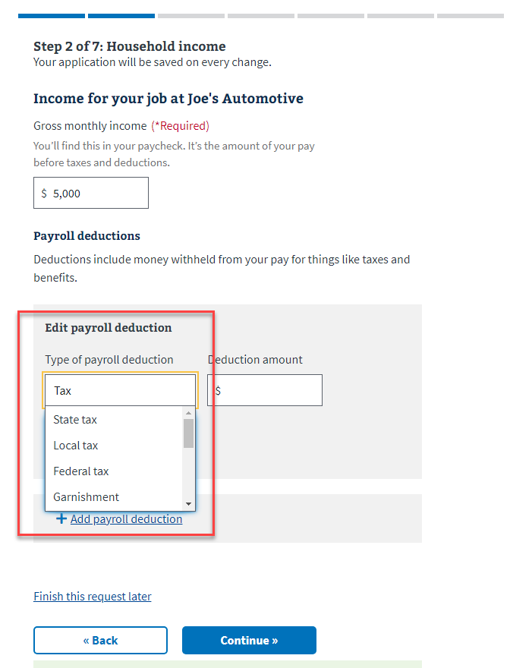

Figure 4-3: Household Income – *Income for your job at (Job Title)*

## Household Income – *Your VA benefits*

The user’s VA benefits auto-populate this portion of the FSR. The Veteran should confirm this VA benefits information is correct. If the information is incorrect, a VA Benefits hotline number is listed beneath the benefits listing. See Figure 4-4.

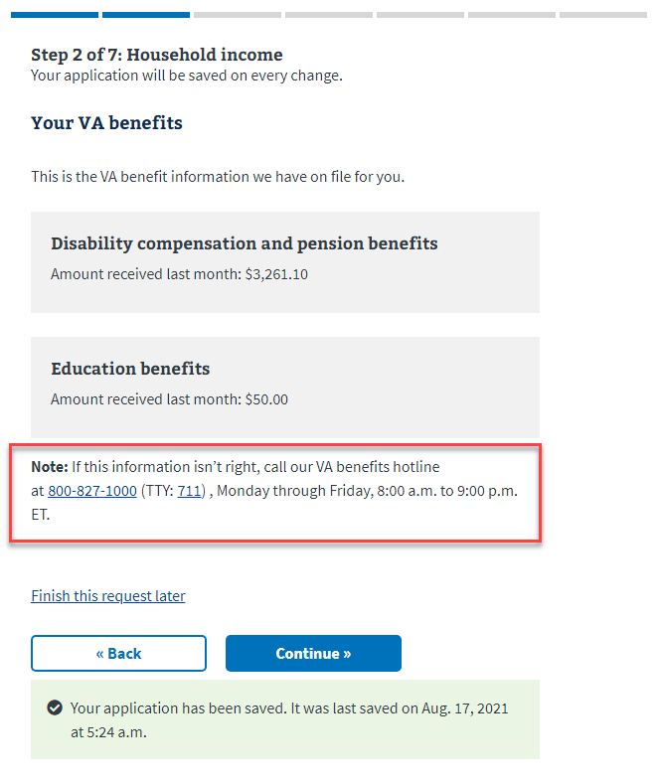

Figure 4-4: Household Income – *Your VA benefits*

## Household Income – *Your other income*

There are two different instances of *Your other income*. The first asks specifically about Social Security. The second pertains to income sources such as alimony and pensions. See Figure 4-5.

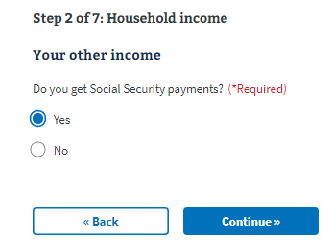

Figure 4-5: Your Other Income – *Social Security*

Selecting *Yes* and then *Continue* brings up a query asking, *How much do you get for* *Social Security each month?* Enter the amount. Upon continuing, the next page asks, *Do you get income from any other sources (like a retirement pension or alimony support)?* Refer to Figure 4-6.

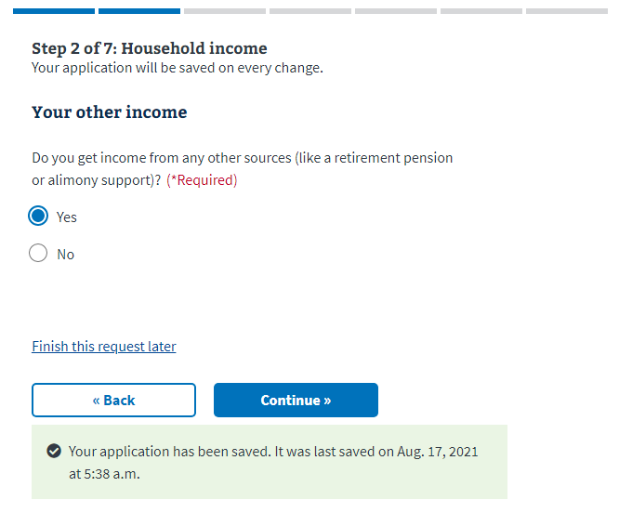

Figure 4-6: Your Other Income *Edit* screen

### Household Income – *Your spouse information*

The first question of this section regards marital status. See Figure 4-7.

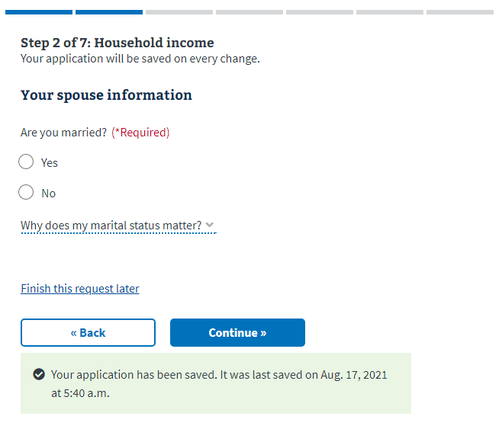

Figure 4-7: Household Income – *Are you married?*

If *Yes* is selected, the user is taken to the *Your spouse information* screen, depicted in Figure 4-8, below.

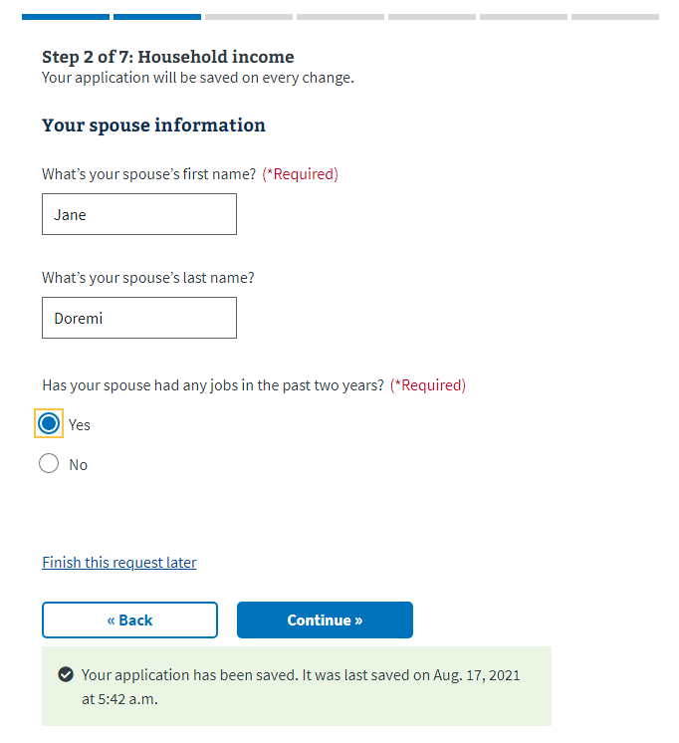

Figure 4-8: Household Income – *Your spouse information*

If *Yes* is selected, meaning the user’s spouse has a job, the user is presented with an employment page identical to the one presented to the user in the work history screen. Again, documentation such as paycheck stubs and W-2 forms would have the information needed to complete this portion of the form. Refer to Figure 4-9.

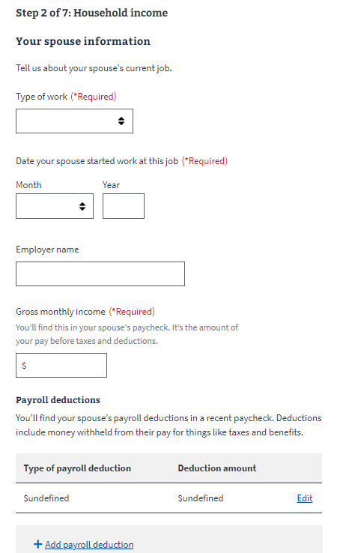

Figure 4-9: Household Income – *Your spouse information* (continued)

More job-related queries follow, mirroring the employment questions asked of the user under work history for the last 2 years*.* Other questions include *Does your spouse get VA benefits?* and *Does your spouse currently get Social Security payments?* The final question in this series is *Does your spouse get income from any other sources (like a retirement pension or alimony support)?* Once those questions are answered, the FSR takes the user to the *Your dependents* category.

### Household Income – *Your dependents*

The *Your dependents* section is straightforward. See Figure 4-10.

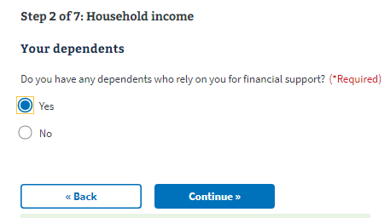

Figure 4-10: Household Income – *Your dependents*

Upon selecting *Yes*, the *Your dependents* detail screen comes up and simply asks for the age of the dependents. See Figure 4-11.

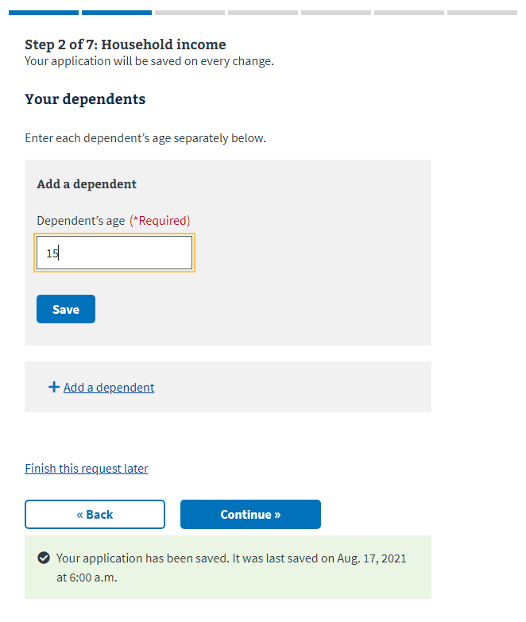

Figure 4-11: Household Income – *Your dependents* (continued)

# Step 3 of 7: Household Assets

## Household Assets – *Your household assets*

Refer to Figure 5-1.

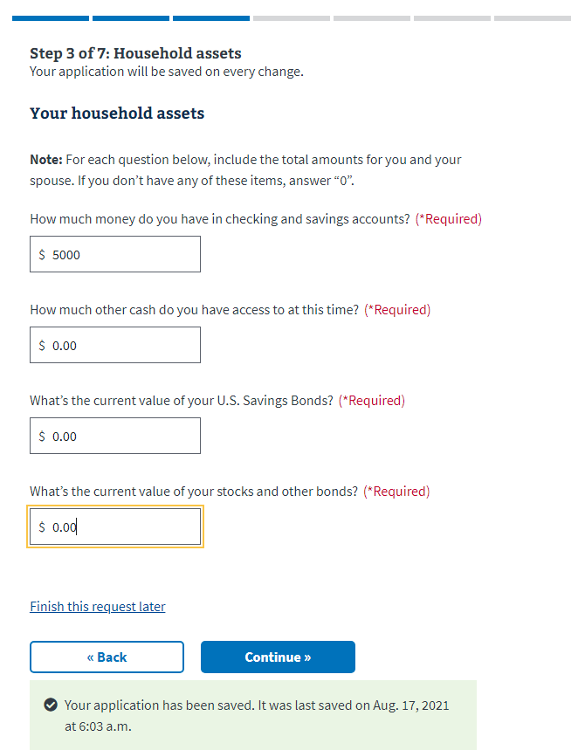

Figure 5-1: Household Assets – *Your household assets*

Upon completion of this general assets page, the user is taken to *Your real estate assets*. Note that most of the participants of the study group knew without looking the real estate type and value of their holdings. See Figure 5-2.

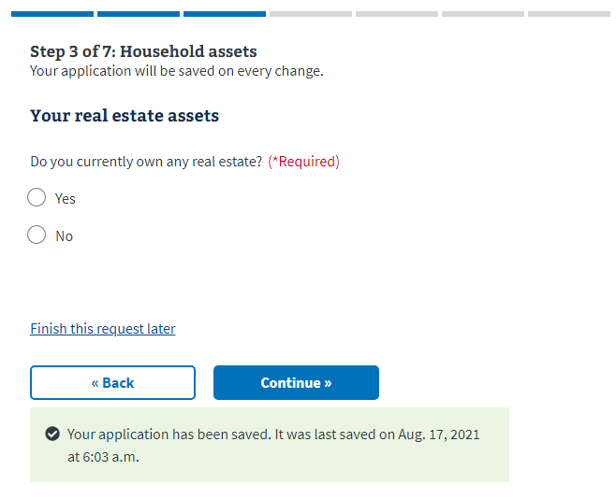

Figure 5-2: Household Assets – *Your real estate assets*

If *Yes* is selected, the user is taken to the *Add real estate* page. Refer to Figure 5-3.

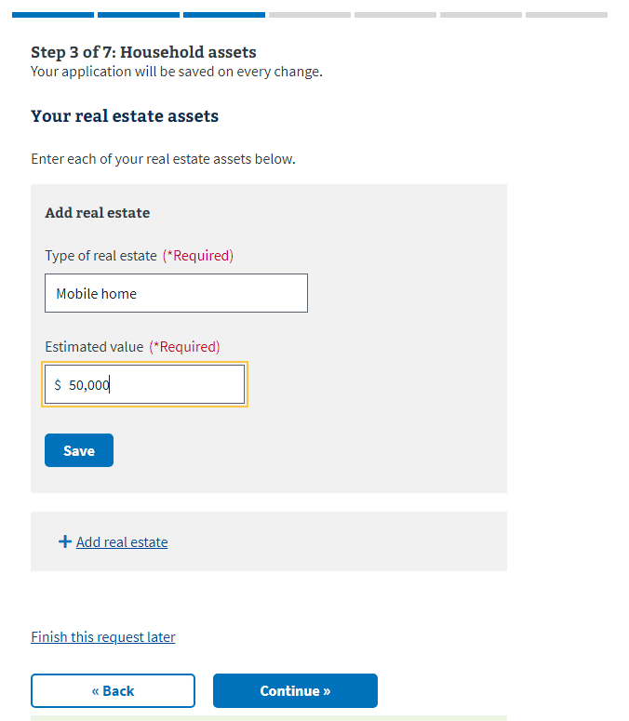

Figure 5-3: Household Assets – *Add real estate*

## Household Assets – *Your cars or other vehicles*

The following information is necessary to fill out this section:

* Type of vehicle
* Vehicle make
* Vehicle model
* Vehicle year
* Estimated value

Refer to Figure 5-4. If the user doesn’t know the estimated value of their vehicle(s), then they are advised to include the amount of money they think they would get if the vehicle was sold in their community. To get an idea of prices, they are referred to:

* Online forums for their community
* Classified ads in local newspapers
* Websites that appraise the value of vehicles

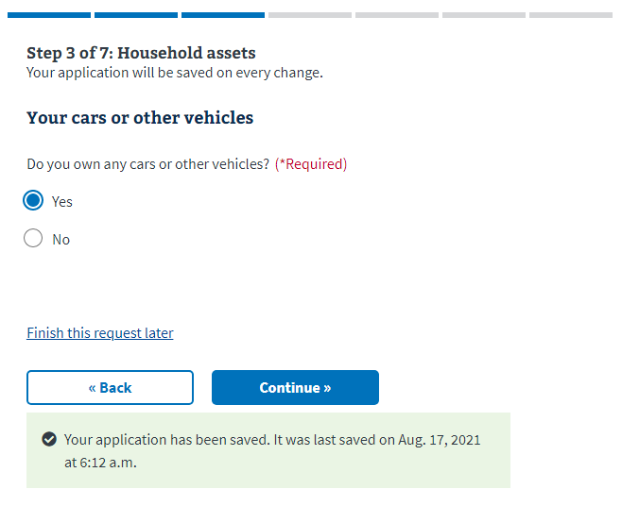

Figure 5-4: Household Assets – *Your cars or other vehicles*

After completion, a second query comes up asking, *Do you own any trailers, campers, or boats?*

## Household Assets – *Your other assets*

“Other assets” in this context mean items of value, such as jewelry or art. Refer to Figure 5.5.

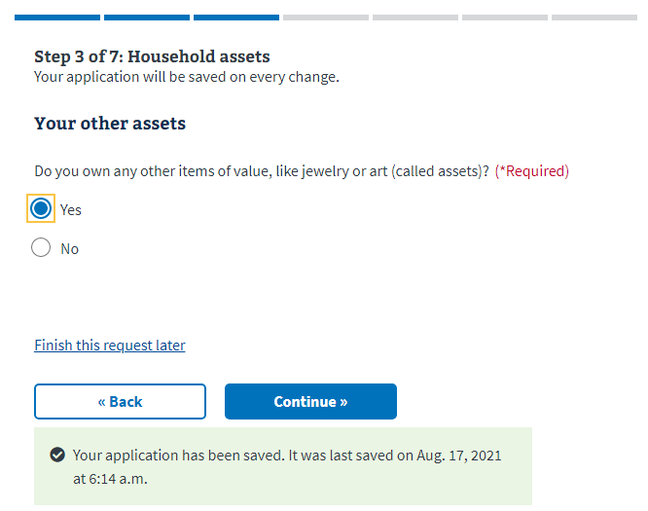

Figure 5-5: Household Assets – *Your other assets*

Selecting *Yes* takes the user to the *Add asset* screen. Note that these assets are asked about only so reviewers may form a more complete picture of the Veteran’s financial situation. Refer to Figure 5-6.

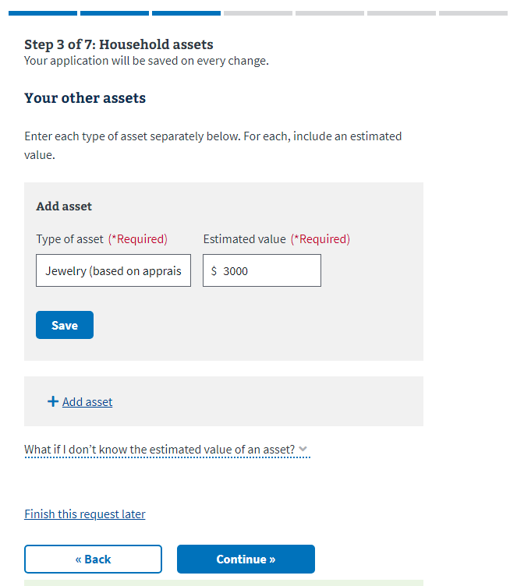

Figure 5-6: Household Assets – *Your other assets* (continued)

# Step 4 of 7: Household expenses

## Household Expenses – *Your monthly household expenses*

Refer to Figure 6-1.

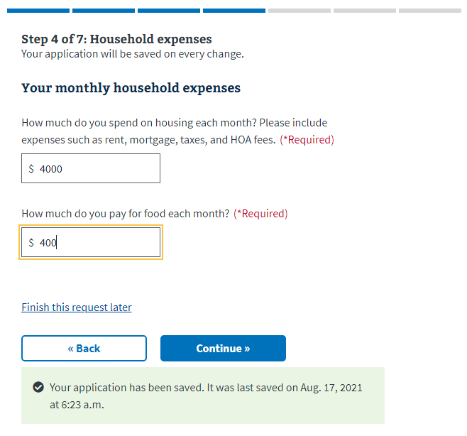

Figure 6-1: Household Expenses – *Your monthly household expenses*

A series of questions follows concerning expenses, e.g., housing, food, utility bills, installment contracts, credit cards, and other debts. By now, the user will have gained familiarity with FSR *Edit* and *Add* functionality in each of the sections. Refer to Figures 6-2 and 6-3.

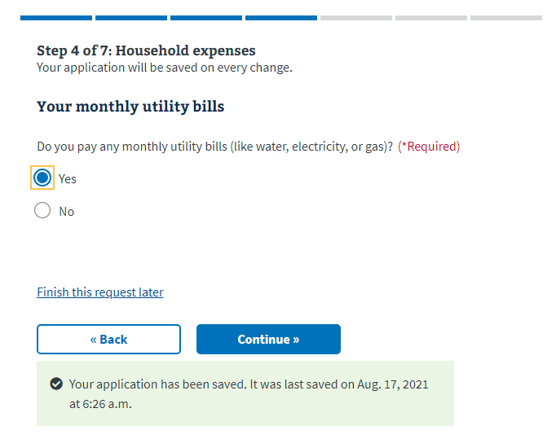

Figure 6-2: Household Expenses – *Your monthly utility bills*

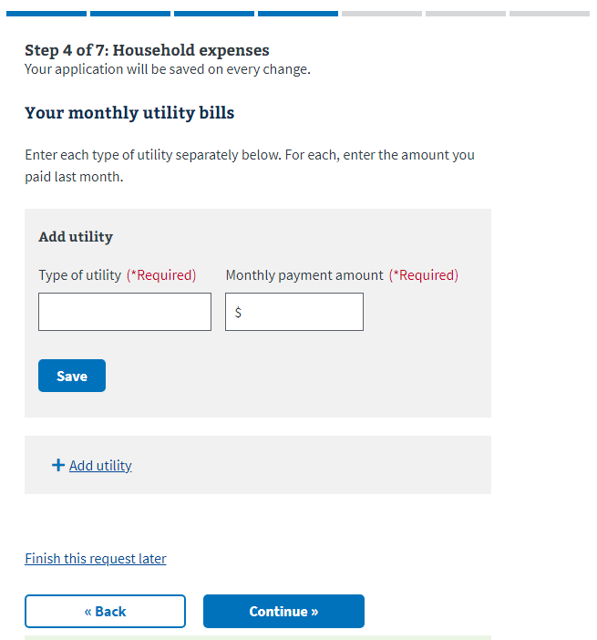

Figure 6-3: Household Expenses detail – *Your monthly utility bills*

## Household Expenses – *Your installment contracts and other debts*

Note the term “installment contracts” in this context usually means credit card payments but can also be things such as tuition or life insurance payments. Refer to Figures 6-4 and 6-5.

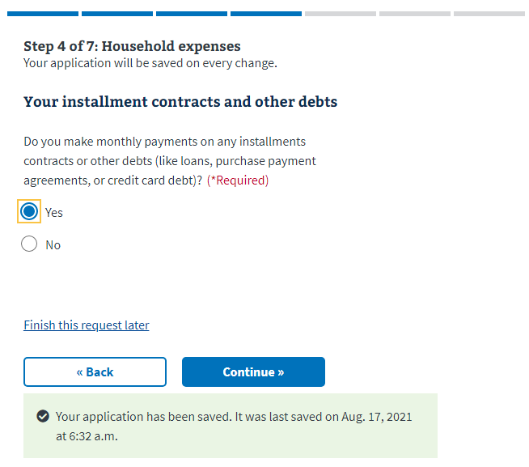

Figure 6-4: Household Expenses – *Your installment contracts and other debts*

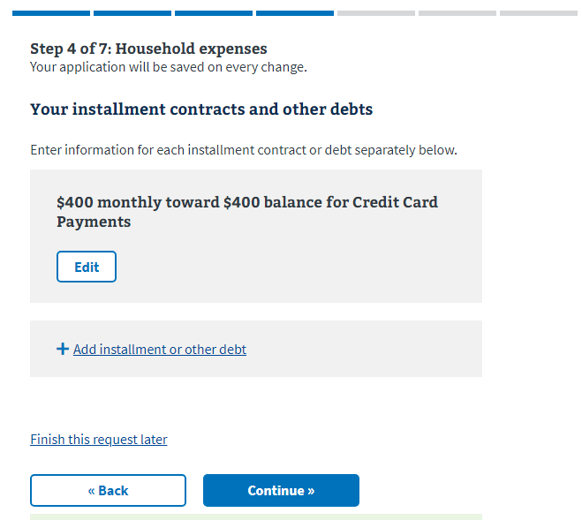

Figure 6-5: Household Expenses detail – *Your installment contracts and other debts*

## Household Expenses – *Other living expenses*

Other living expenses encompass goods and services such as clothing, transportation, childcare, and healthcare costs. Refer to Figures 6-6 and 6-7.

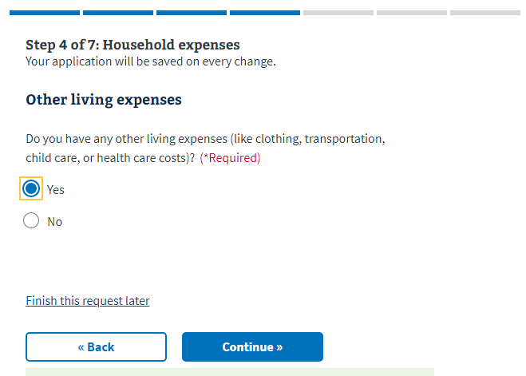

Figure 6-6: Household Expenses – *Other living expenses*

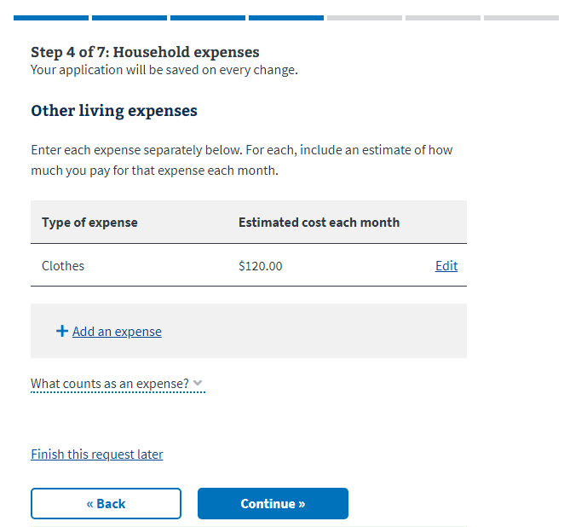

Figure 6-7: Household Expenses detail – *Other living expenses*

# Step 5 of 7: Repayment or Relief Options

Step 5 consists of 2 major sections: *Your financial overview* and *Resolution options available*. For ease of reference, the 3 repayment or relief options include:

* Waiver
* Extended monthly payments
  + Monthly offsets
  + Monthly payment plan
* Compromise

## Repayment or Relief Options – *Your financial overview*

*Your financial overview* is exactly what its name implies. It’s an itemized listing of total monthly income, total monthly taxes and expenses, and income after taxes and expenses. See Figure 7-1.

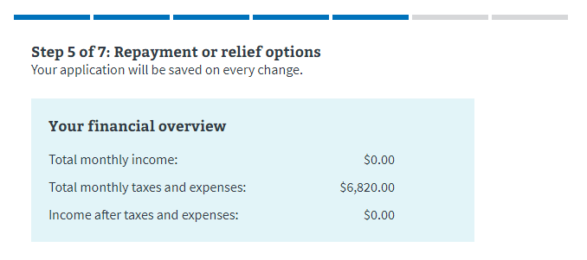

Figure 7-1: Repayment or Relief Options – *Your financial overview*

## Repayment or Relief Options – *Resolution options available*

The second part*, Resolution options available*, lists and describes each of the 3 options available to the user, which are detailed in full in Figure 7-2 below.

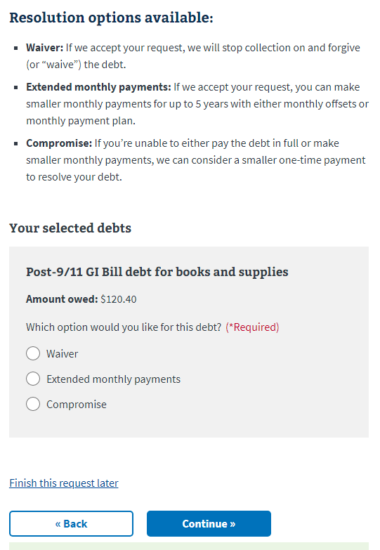

Figure 7-2: Repayment or Relief Options – *Debt repayment or relief options*

When *Waiver* is selected, a checkbox with explanatory text appears at the bottom of the page, just above the Back and Continue buttons. See Figure 7-3. The user cannot advance if *Waiver* is selected and the checkbox isn’t checked.

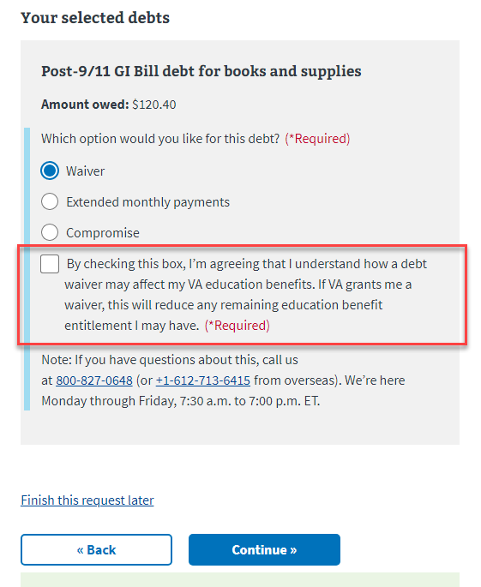

Figure 7-3: Waiver Checkbox and Explanatory Text

Selection of Extended monthly payments results in the following, Figure 7-4. The user should enter the monthly payment amount they think they can afford.

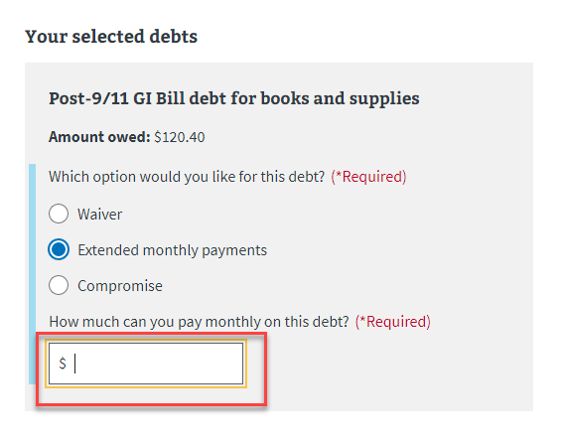

Figure 7-4: *Extended monthly payments* Option

Compromise is the third selection and displays an option allowing entry of the one-time payment the Veteran thinks they can afford. See Figure 7-5.

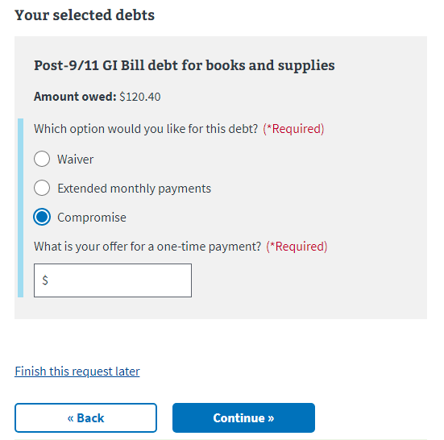

Figure 7-5: *Compromise* Option

## Repayment or Relief Options – *Supporting personal statement*

Viewed in context, the supporting personal statement is arguably one of the most significant sections of the form, giving the user the opportunity to communicate directly with those making the decision, allowing those needing the waiver, payment plan, or compromise to explain their situation, providing a necessary personal, human element to an often impersonal, by-the-numbers process.

Refer to Figure 7-6.

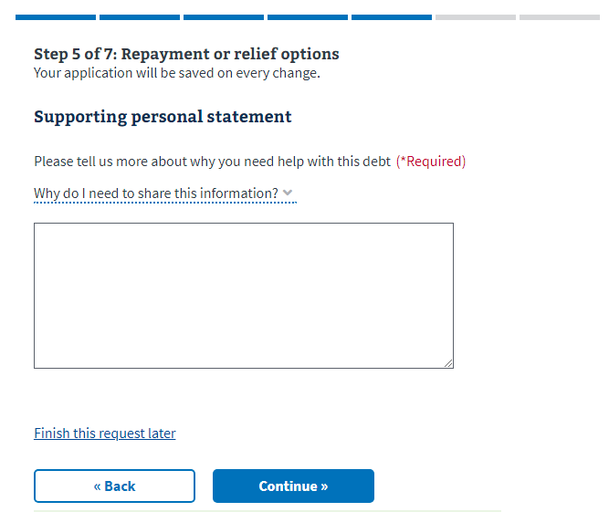

Figure 7-6: Repayment or Relief Options – *Supporting personal statement*

# Step 6 of 7: Bankruptcy History

## Bankruptcy History – *Your bankruptcy details*

If the user answers *Yes* to the question, *Have you ever declared bankruptcy*, then they continue to *Your bankruptcy details*, which requires they enter Month, Year, Location of court, and case or docket number before proceeding. See Figures 8-1 and 8-2.

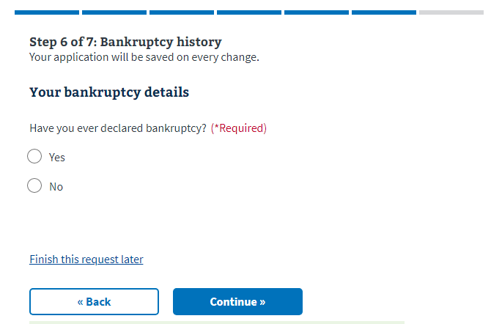

Figure 8-1: Bankruptcy History – *Your bankruptcy details*

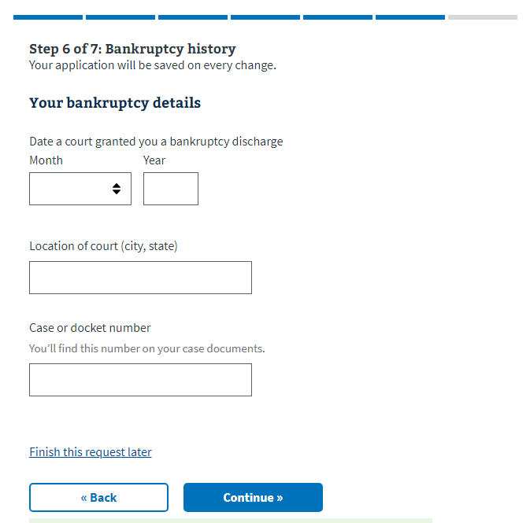

Figure 8-2: Bankruptcy History – *Your bankruptcy details* (continued)

# Step 7 of 7: Review your request

The final step gives the user the opportunity to perform a final check to ensure the information entered is correct, and it provides editing functionality to allow corrections. The various sections are displayed using an accordion-style expansion functionality. The plus sign expands that section while an Edit link allows entry and revision. See Figures 9-1 and 9-2.

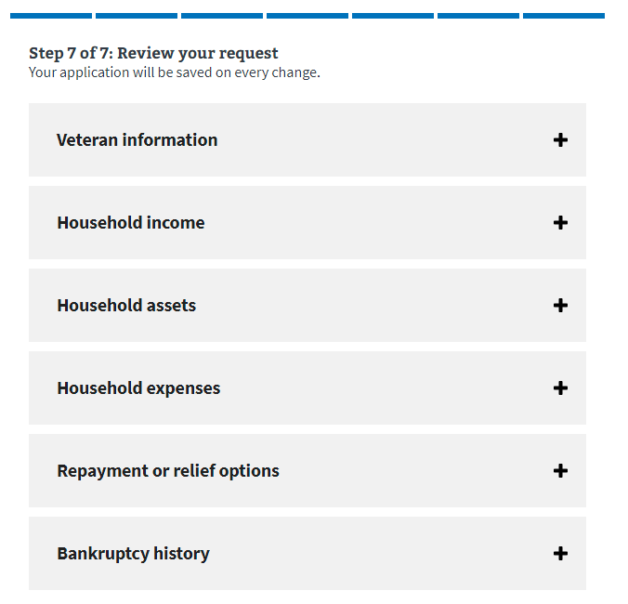

Figure 9-1: The *Review your request* portion

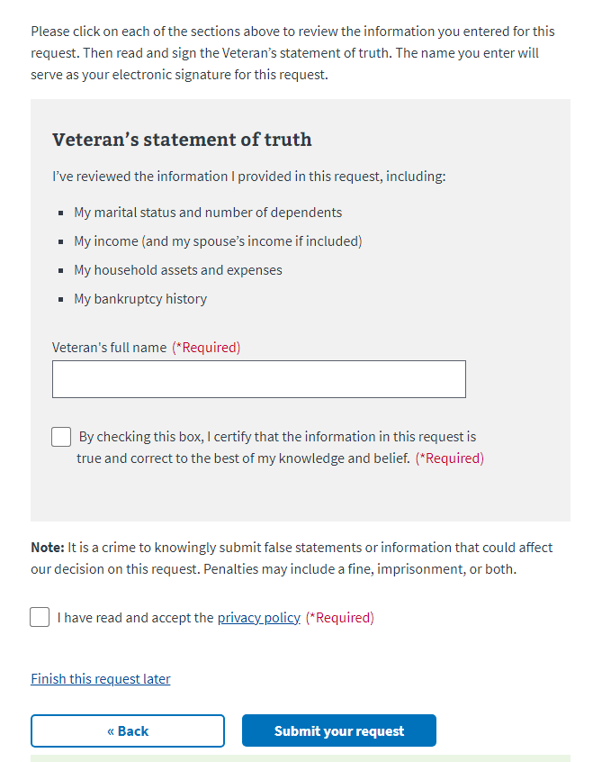

Figure 9-2: The *Veteran’s statement of truth* portion

Once the user is finished and has checked the certification checkbox and submitted the application, they are then routed to an acknowledgement page confirming the request has been received.

Refer to Figure 9-3.

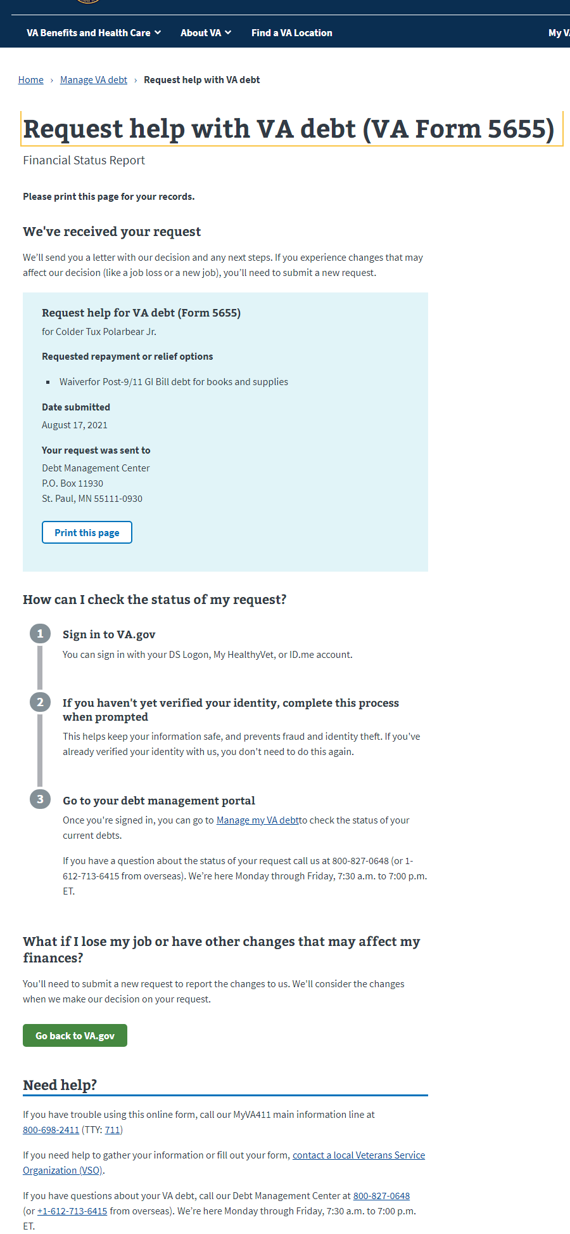

Figure 9-3: *Request Confirmation* page