**Keep Me Informed COVID-19 Vaccine Form**

Table of Contents

Keep Me Informed Form Overview 2

User Access 2

Who can access this application? 2

Navigation 3

Filling Out the Form 4

Confirmation Email 5

Top KMI Questions or Concerns 7

I am trying to sign in to fill out the form but it is not working. 7

I can’t submit the form because I don’t have an email address and/or phone number. 7

How will VA contact me when I can get a COVID-19 vaccine? 7

How do I stop receiving Keep Me Informed emails from the VA? 8

I filled out the Keep Me Informed form, but I haven’t received any communication from the VA about COVID-19 vaccine. 8

If I complete this form, am I signing up to get the COVID-19 vaccine? 8

Why are you asking for my date of birth and Social Security Number? 9

What can I expect to happen after I fill out this form? 9

# Keep Me Informed Form Overview

The Keep Me Informed solution (KMI) is a digital form on VA.gov that Veterans can fill out to indicate current intent/interest in receiving a vaccine as well as to sign up for updates on how the VA is providing COVID-19 vaccines across the country—and when they can get a vaccine if they want one. If a Veteran is enrolled in VA health care, their local VA health facility may use this information to determine when to contact them once their risk group becomes eligible.

**But** **It is important to note that this form is not a sign up or registration for the vaccine.** The VA will contact every eligible Veteran in each risk group. A Veteran does not need to sign up to get a vaccine.

## User Access

### Who can access this application?

Veterans do not need to be signed in to complete this application. However, if they aren’t signed in, the application will not be prefilled with their information.

If a user is having trouble signing in when attempting to complete the KMI form, please direct them to click the “Continue without signing in” button and provide their SSN and DOB on the form. We can use that information to identify them.

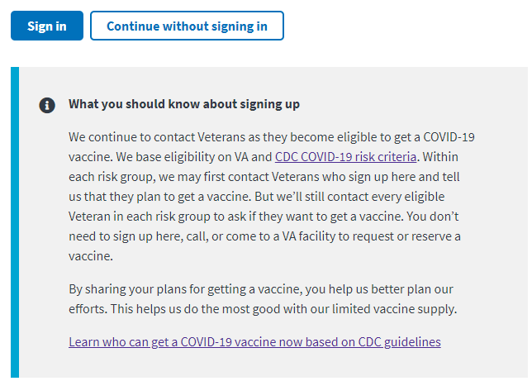

## Navigation

**Direct url:**​ <https://www.va.gov/health-care/covid-19-vaccine/stay-informed>

**Or** from the link on the COVID-19 Vaccine Hub: <https://www.va.gov/health-care/covid-19-vaccine/>

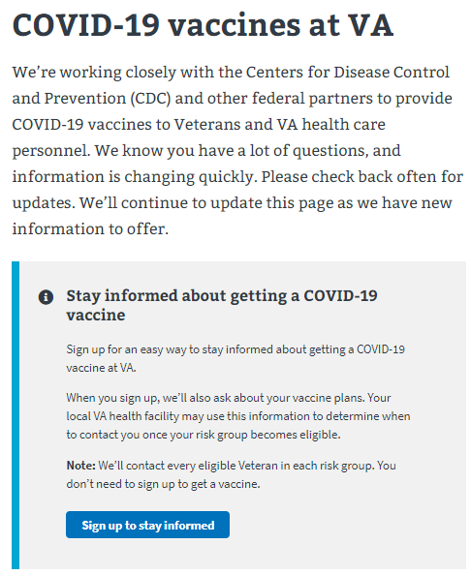

# Filling Out the Form

The KMI form has 9 questions. If a user **is** signed in, this information is often pre-filled but the user can edit their answers if they want to. If the user is **not** signed in, they will need to enter the required information. The form asks for the following information:

* First name (required)
* Last name (required)
* Date of birth (optional, but highly useful for matching patient records)
* Social Security Number (optional, but highly useful for matching patient records)
* Email address (required)
* Phone (required)
* Zip code (required)
* Question 1: Will you be in this zip code for the next 6-12 months? (required)
* Question 2: Do you plan to get a COVID-19 vaccine when one is available to you? (required)

[*Please refer to VA.gov to see what the form looks like*](https://www.va.gov/health-care/covid-19-vaccine/stay-informed/form)

Once a Veteran has filled out the form, they will see a confirmation page.

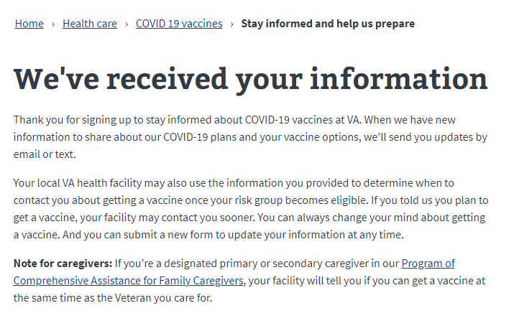

# Confirmation Email

After filling out the form, the user will also receive a confirmation email:

[subject line]Thank you for signing up for COVID-19 vaccine updates

Thank you for signing up to stay informed about COVID-19 vaccines at VA. When we have new information to share about our COVID-19 plans and your vaccine options, we'll send you updates by email or text.

Your local VA health facility may also use the information you provided to determine when to contact you about getting a vaccine once your risk group becomes eligible. If you told us you plan to get a vaccine, your facility may contact you sooner. You can always change your mind about getting a vaccine. And you can submit a new form to update your information at any time.

**Note for caregivers:** If you’re a designated primary or secondary caregiver in the Program of Comprehensive Assistance for Family Caregivers, your facility will tell you when you can get a vaccine at the same time as the Veteran you care for.

**You should know:**

* To get a vaccine at VA, Veterans must be already receiving health care at VA. If you don’t receive care at VA now, [find out if you're eligible for VA health care and how to apply](https://www.va.gov/health-care/how-to-apply).
* To get a vaccine at VA, family caregivers must be enrolled in our [Program of Comprehensive Assistance for Family Caregivers](https://www.va.gov/family-member-benefits/comprehensive-assistance-for-family-caregivers/). Caregivers are eligible for a vaccine when the Veteran they care for becomes eligible for one.
* You can change your mind about getting a vaccine at any time. If you want to learn more before you decide:  
  [Get answers to common questions about COVID-19 vaccines at VA](https://www.va.gov/health-care/covid-19-vaccine/)  
  [Get more facts about COVID-19 vaccines from the Centers for Disease Control and Prevention (CDC)](https://www.cdc.gov/coronavirus/2019-ncov/vaccines/facts.html)  
  [Read about one VA nurse’s decision to get a COVID-19 vaccine](https://blogs.va.gov/VAntage/83031/va-nurse-tuskegee-daughter-urges-veterans-learn-vaccines/)

**How will VA contact me when I can get a COVID-19 vaccine?**

Your local VA health facility may contact you by phone, email, or text message. If you’re eligible and want to get a vaccine, we encourage you to respond.

But before you provide any personal information or click on any links, be sure the call, email, or text is really from VA.

* Text messages will always come from **53079**.
* Emails will always come from a **va.gov** email address.
* If someone calls you from VA and you don’t recognize the phone number, ask for a number to call them back. Then call your local VA health facility to verify.

Your facility may invite you to get a vaccine in different ways:

* They may invite you to a large vaccination event, like a drive-thru clinic.
* They may offer you a specific date and time to get a vaccine.
* They may ask you to schedule an appointment.

**Please know:** By sharing your plans for getting a vaccine, you help us better plan our efforts. But we’ll still contact every eligible Veteran in each risk group to ask if they want to get a vaccine. You don’t need to call or come to a VA facility to request or reserve a vaccine.

[footer]

You’re getting this email because you signed up on VA.gov to get updates about our COVID-19 vaccine plans. If someone forwarded this email to you, you can [sign up to receive future updates](https://www.va.gov/health-care/covid-19-vaccine/stay-informed).

If you don’t want to get these emails anymore, you can unsubscribe at any time.

Please don’t reply to this email. If you need to contact us, go to <https://www.va.gov>.

# Top KMI Questions or Concerns

### I am trying to sign in to fill out the form but it is not working.

If a user is having trouble signing in when attempting to complete the KMI form, please direct them to click the “Continue without signing in” button and provide their SSN and DOB on the form. We can use that information to identify them.

### I can’t submit the form because I don’t have an email address and/or phone number.

A phone number and email address are required to fill out the Keep Me Informed. If a Veteran does not have an email and/or phone number, you can provide the following options:

1. Advise that the Veteran call their Medical Facility to register their interest in receiving the vaccine.
2. If the Veteran has a trusted family member, friend, or caregiver, they can fill out the form with their phone number and/or email address. **Note:** This means that the owner of that phone number and/or email will receive COVID-19 vaccine updates from the VA.

### How will VA contact me when I can get a COVID-19 vaccine?

Your local VA health facility may contact you by phone, email, or text message. If you’re eligible and want to get a vaccine, we encourage you to respond.

**But before you provide any personal information or click on any links, be sure the call, email, or text is really from VA.**

* Text messages will always come from **53079**.
* Emails will always come from a **va.gov** email address.
* If someone calls you from VA and you don’t recognize the phone number, ask for a number to call them back. Then call your local VA health facility to verify.

Your facility may invite you to get a vaccine in different ways:

* They may invite you to a large vaccination event, like a drive-thru clinic.
* They may offer you a specific date and time to get a vaccine.
* They may ask you to schedule an appointment.

### How do I stop receiving Keep Me Informed emails from the VA?

If veterans want to stop receiving email updates about VA plans for COVID-19 vaccine, instruct them they can do this by going to the bottom of the email in the footer and clicking on the link "you can unsubscribe at any time."

**[footer]**

You’re getting this email because you signed up on VA.gov to get updates about our COVID-19 vaccine plans. If someone forwarded this email to you, you can [sign up to receive future updates](https://www.va.gov/health-care/covid-19-vaccine/stay-informed).

If you don’t want to get these emails anymore, you can unsubscribe at any time.

### I filled out the Keep Me Informed form, but I haven’t received any communication from the VA about COVID-19 vaccine.

Keep Me Informed updates are not sent out on regular schedule so there might be some delay from when a Veteran fills out the Keep Me Informed form and when they receive their first COVID-19 vaccine update. However, anyone who fills out the KMI form will receive a confirmation email. Verifying if the Veteran received the confirmation email confirms they will receive any future COVID-19 vaccine updates.

*Helping a Veteran check to see if they received the Keep Me Informed Confirmation Email:*

* Advise the Veteran to check the email they entered into the KMI form and use their inbox search to locate the confirmation email by searching for:
  + An email from the U.S. Department of Veterans Affairs
  + An email with the subject “Thank you for signing up for COVID-19 vaccine updates”
* If they are unable to locate the email you can recommend they check their trash or spam folders.

If they are unable to locate a confirmation email or any other VA COVID-19 vaccine emails, you can recommend they fill out the KMI form again and pay close attention to entering their email correctly.

### If I complete this form, am I signing up to get the COVID-19 vaccine?

You don’t need to sign up to get a vaccine. And you can change your mind about getting a vaccine at any time. We’ll use the information you provide to understand your interest and keep you informed by email.

### Why are you asking for my date of birth and Social Security Number?

It is not required to provide your date of birth or social security number when filling out this form. However, providing this information will help the VA match your information to your Veteran records so we can better understand your needs as we keep you informed on the VA’s COVID-19 vaccine distribution plan.

### What can I expect to happen after I fill out this form?

When the VA has new information to share about its COVID-19 plans and your vaccine options, you will receive an update by email or text.

You can also visit our main [COVID-19 vaccines at VA page](https://staging.va.gov/health-care/covid-19-vaccine/) for the latest information and answers to common questions: <https://www.va.gov/health-care/covid-19-vaccine/>

*Remember:* This form doesn’t sign you up to get a vaccine. And you can change your mind about getting a vaccine at any time. The VA will use the information you provided to understand your interest and keep you informed. If you want to update your information later, you can submit a new form.