**Heroku FAQ**

# How do we use Heroku?

Heroku generates a preview of pages built in GitHub before they go live on the VA site. These preview pages are reviewed for style consistency, grammatical and content accuracy, and working links, by fellow team members, stakeholders, and subject matter experts (SMEs). Skip to ***How to generate a Heroku preview of a GitHub page*** to learn how to generate Heroku preview URLs so that others may view your newly created or updated GitHub page.

# Drupal vs. GitHub pages

Our team has shifted to primarily using Drupal to build and maintain VA.gov pages (this includes most pages originally built in GitHub). Here’s a current list of pages that still, and may permanently, reside in Github due to page complexity:

* Housing hub pages (this may eventually be migrated to Drupal)
* GI Bill Comparison Tool (permanent)
* Disability Decision Reviews (permanent)

Despite Drupal being the main application used to build and maintain VA pages, there will still be future instances of building pages in GitHub. Reach out to Jennifer Lee for more information.

# How to generate a Heroku preview of a GitHub page

The [GitHub_content_process](https://github.com/department-of-veterans-affairs/vets.gov-content/blob/master/templates-and-guides/guides/GitHub_content_process.pdf) document details how to create a GitHub page and a pull request for the GitHub page. The basic process includes:

1. Creating a branch in your desired GitHub repository.
2. Making updates to a branch and clicking **Commit**.
3. Creating a pull request.

To generate a Heroku preview of the GitHub page:

1. Open the pull request.
2. Scroll down and click **View deployment**.



Figure 1: View Deployment Button on Pull Request

* 1. A Heroku-generated preview version of the VA home page should open in a new window tab.

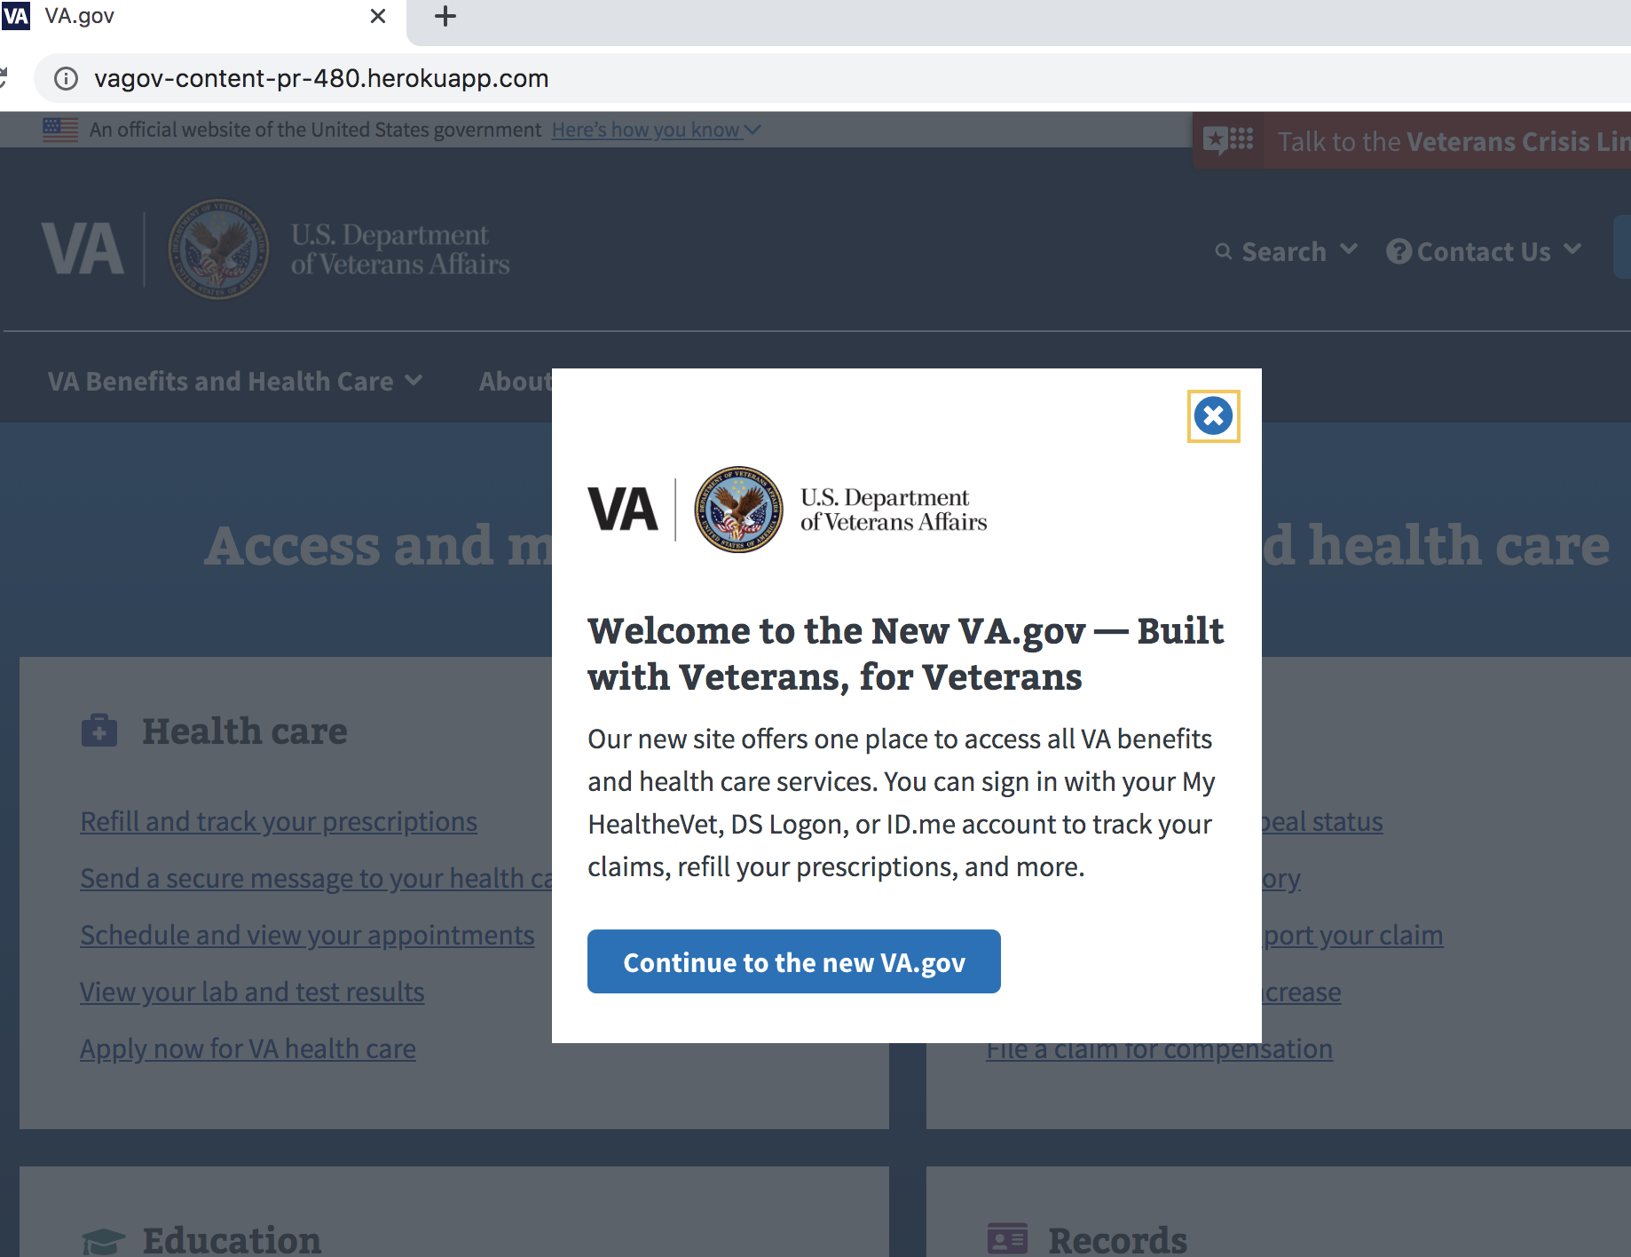

Figure 2: Heroku-generated Preview Page

* 1. Go back to the pull request and copy the page URL (which should be included) and paste it in the URL field of the preview page after “.com” (see **Figure 2**). Click **Enter** (*Return* for Mac users). You can also find the URL by clicking the **Files changed** tab in the pull request.

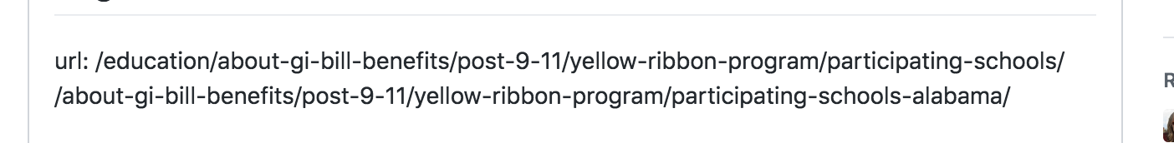

Figure 3: URL on Pull Request Ticket

## Pull request tips

* Reach out to the pull request creator if there is no page URL included in the pull request ticket.
* Reach out to a front-end engineer in case a pull request fails since it is likely not a content issue.

# How to tell which VA pages have been built on Drupal vs. GitHub

VA pages that are a built and maintained in Drupal will show “Last updated” details at the bottom of the page.

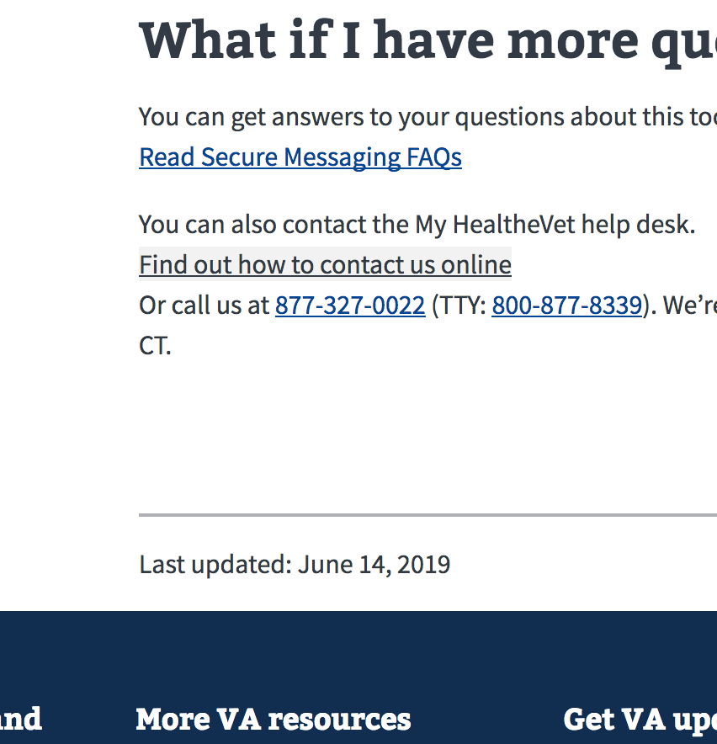

Figure 4: Drupal-based VA Page