

OCTO-DE Benefit Tools Crew | Accredited Representation Management

September 6, 2024 | Find a Representative

Version 2.4

Revision History

|  |  |  |  |
| --- | --- | --- | --- |
| Date | Version | Description | Author |
| 12/5/2023 | 1.0 | MVP: Minimum Viable Product | Lindsay Li-Smith |
| 2/26/2024 | 2.0 | Adjustments and enhancements based on UX research findings | Lindsay Li-Smith |
| 4/26/2024 | 2.1 | Corrected links to reflect the most up-to-date URLs | Lindsay Li-Smith |
| 6/14/2024 | 2.2 | Removed the “Other” input field for the Report Outdated Information feature | Lindsay Li-Smith |
| 7/25/2024 | 2.3 | Removed the Report Outdated Information feature | Lindsay Li-Smith |
| 9/6/2024 | 2.4 | Added in a FAQ #10 and resource #4 below | Lindsay Li-Smith |
| 7/31/2025 | 2.5 | Added guidance on how representatives can update their contact information to the Major Issues and Error Messages section | Lindsay Li-Smith |

Table of Contents

1. Product Overview 4

2. User Access 4

3. Navigation 4

4. Functionality 5

5. Major Issues and Error Messages 8

6. Frequently Asked Questions 11

7. Table of Figures 12

## 1. Product Overview

The Find a Representative product is a user-friendly, accessible tool for Veterans to search for an accredited representative on VA.gov, intended to mirror the representative search functionality of older tools: [OGC](https://www.va.gov/ogc/apps/accreditation/index.asp) and [eBenefits](https://www.ebenefits.va.gov/ebenefits/vso-search).

Users will be able to search for representatives based on:

1. Type of accredited representative (*Required)
   1. Veteran Service Officer (VSO), attorney, claims agent
2. Location (*Required)
   1. Address, city, state, or postal code
   2. “Use my location”
3. Search area
   1. Defaults to 50 miles
   2. Other options: 5 miles, 10 miles, 25 miles, 100 miles, 200 miles, Show all
4. Name of accredited representative
   1. Open text input field

## 2. User Access

All users will have access to the Find a Representative product; authentication is not required for this experience.

## 3. Navigation

Accredited Representative Landing Page

Most of the benefits pages on VA.gov will have a link that points to our landing page “Get help from a VA accredited representative”, often in the “What if I need help?” (or similar) section towards the bottom of the page.

The URL for this landing page will be <https://va.gov/get-help-from-accredited-representative>.

Find a Representative Product Page

The landing page mentioned above will link to our Find a Representative product page, which will have a URL of <https://va.gov/get-help-from-accredited-representative/find-rep>.

Search

Users will also be able to find our Find a Representative tool through the VA.gov search in the “Our top recommendations for you” section.

The landing page and product page will appear in this sectionof search results, for any searches on VA.gov that match key words in the page title or description.

## 4. Functionality

Search for an Accredited Representative

Users will be able to search for accredited representatives based on the following parameters:

1. Type of accredited representative (*Required)
   1. Veteran Service Officer (VSO), attorney, claims agent
2. Location (*Required)
   1. Address, city, state, or postal code
   2. “Use my location”
3. Search area
   1. Defaults to 50 miles
   2. Other options: 5 miles, 10 miles, 25 miles, 100 miles, 200 miles, Show all
4. Name of accredited representative
   1. Open text input field

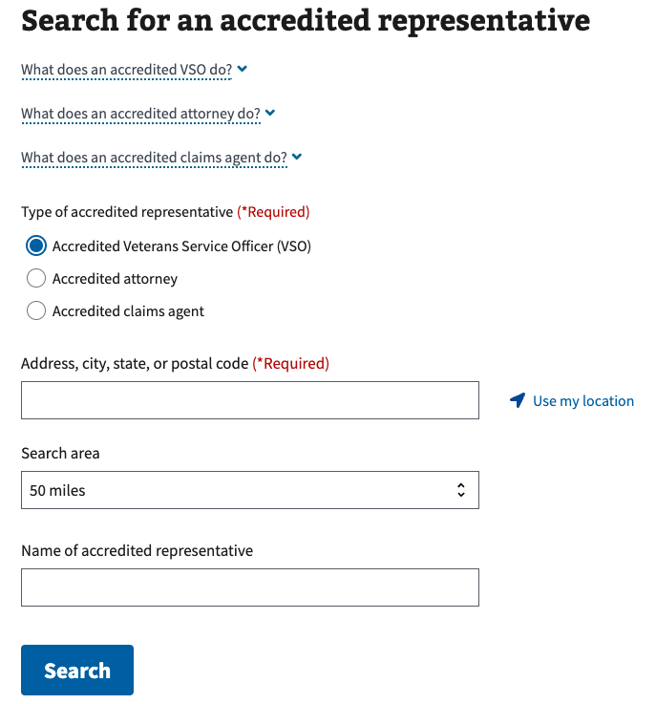

Figure 1. Search criteria for Find a Representative.

Search Results

A list of representatives matching the user’s search parameters will be displayed, with 10 results per page.

The search results will include the following representative details:

1. Distance in miles
2. Full name
3. Associated organization(s)
4. Address (clickable, opens Google Maps in a new tab)
5. Phone number (clickable, initiates a phone application)
6. Email (clickable, initiates an email application)

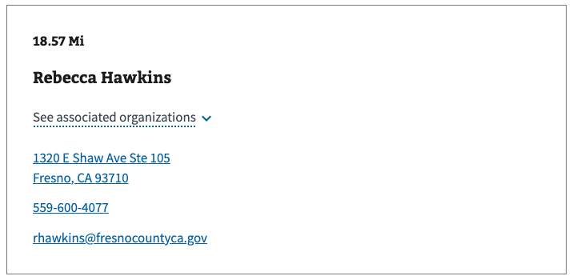

Figure 2. Example of a representative in search results.

The search results allow the following “Sort by” options:

1. Distance (closest to farthest) - default
2. First name (A - Z)
3. First name (Z - A)
4. Last name (A - Z)
5. Last name (Z - A)

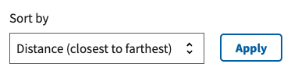

Figure 3. Default sort.

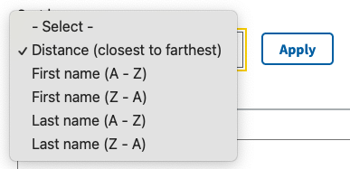

Figure 4. All sort options.

Outdated Information

Findings from user research indicate the contact information for accredited representatives are not always accurate. While we cannot control the contact information in the accredited representative database, we have implemented a banner at the top of the search results, to inform users of data quality.

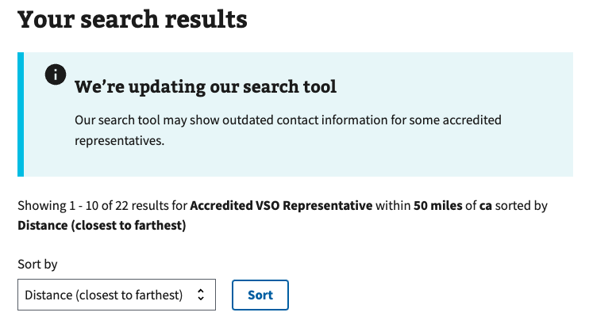

Figure 5. A banner above the search results informs users that some contact information may be out of date.

## 5. Major Issues and Error Messages

If the Find a Representative page is not loading for users, please ensure they are using the most updated version of their browser and/or operating system.

If a user tries to search without entering a location, the location input field will become highlighted in red with an error message “Please **enter a valid location**.”:

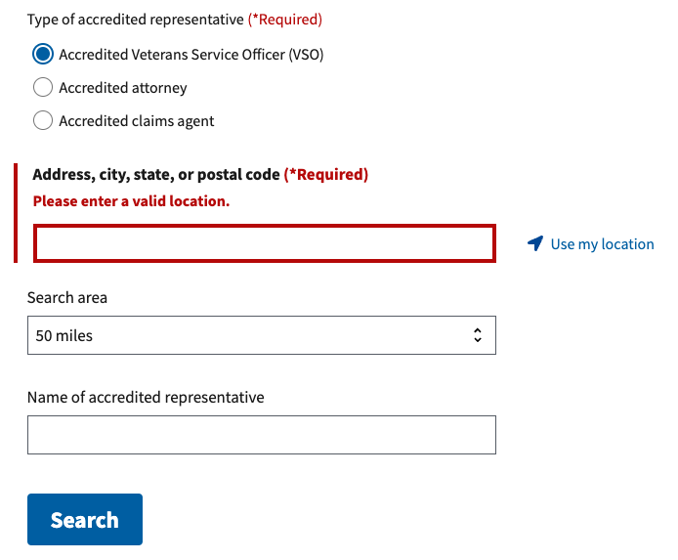

Figure 6. Error message when a location has not been specified.

If a user has not enabled location sharing in their browser and tries to “Use my location”, a “We need to use your location**. Please enable location sharing in your browser to use this feature.**” alert will appear:

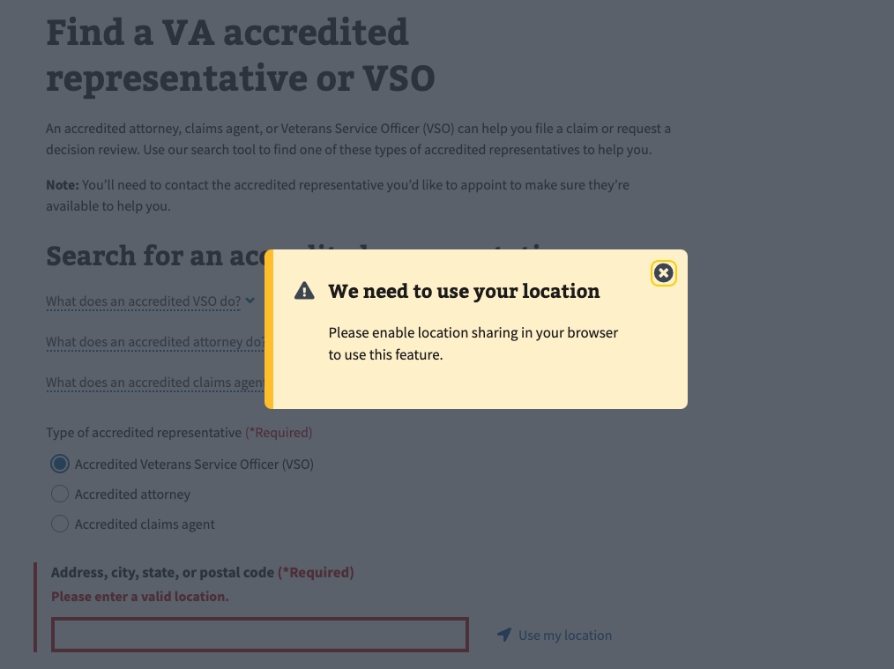

Figure 7. Alert when location sharing is disabled.

If there is an issue retrieving search results, whether that’s with the VA network or our connected location service (Mapbox), a general “We’re sorry, something went wrong. Please try again soon.” alert will appear below the Search button:

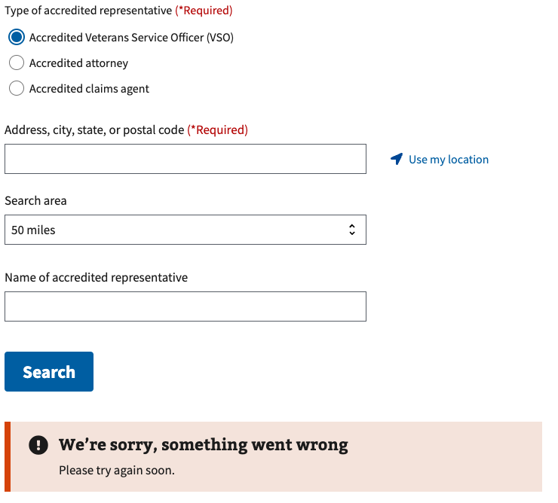

Figure 8. General alert when there is an issue with retrieving search results.

If a representative notices that their contact information is incorrect and requests an update, they will need to send their update request to the Office of General Council. The messaging below can be copied/pasted into an email response, to the representative seeking help updating their information.

When emailing a representative with the information below, please inform the Accredited Representation Management team so they can track the frequency of these requests.

* If you have OCTO Slack access, post in #benefits-representation-management
* If you do NOT have OCTO Slack access, email [jennifer.bertsch@va.gov](mailto:jennifer.bertsch@va.gov), [shannon.ford1@va.gov](mailto:shannon.ford1@va.gov), [lindsay.li-smith@va.gov](mailto:lindsay.li-smith@va.gov), [marisa.dominguez@va.gov](mailto:marisa.dominguez@va.gov).

**Representative Type: Accredited Attorneys and Claims Agents**

The information presented on VA.gov’s Find a Representative tool is from the VA OGC database. Once the representative's information is updated using one of the processes below it will update on VA.gov. Instructions on how to update are outlined below:

Attorneys and claims agents wishing to change their contact information with VA should do so with both OGC and the Veterans Benefits Administration by following the instructions set forth in this Fact Sheet on the Process for Attorney and Claims Agent Contact Change Requests.

Link to Fact Sheet: <https://www.va.gov/OGC/docs/Accred/FactSheet_OBI-21-03.pdf>

**Representative Type: Veterans Service Organization (VSO) Representatives**

The information presented on VA.gov’s Find a Representative tool is from the VA OGC database. Once the representative's information is updated using one of the processes below it will update on VA.gov. Instructions on how to update are outlined below:

Veterans Service Organization (VSO) Representatives wishing to change their contact information with VA should contact the certifying official for their primary VSO, who will send the updated information to VA OGC. If they're unable to contact their certifying official, a supervisor may be able to help contact the certifying official at the VSO’s headquarters.

Learn more about OGC and accreditation at their website: <https://www.va.gov/ogc/accreditation.asp>

## 6. Frequently Asked Questions

Users may have the following questions, when using this product:

1. What's the differences between accredited representatives (VSOs, attorneys, claims agents)?
2. What makes a representative accredited?
3. Do accredited representatives charge fees?
4. How do I appoint an accredited representative?
5. How can an accredited representative help me?
6. Does an accredited representative have to help me?
7. Can I work with more than one accredited representative at a time?
8. Can I work with an accredited representative online or over the phone?
9. How do I cancel my representation?
10. What if the representative contact information is incorrect?

Answers to these questions, and additional information about accredited representatives can be found on:

1. The top of the “Find a Representative” product page includes definitions of each type of accredited representative: <https://va.gov/get-help-from-accredited-representative/find-rep>
2. The “Get help from an accredited representative” landing page includes information on how to find and appoint an accredited representative: <https://va.gov/get-help-from-accredited-representative>
3. The “FAQ” page includes additional information about accredited representatives: <https://www.va.gov/resources/va-accredited-representative-faqs/>
4. Slack Canvas guidance for updating representative contact information: <https://dsva.slack.com/docs/T03FECE8V/F07JJKCGSFL>

## 7. Table of Figures

Figure 1. Search criteria for Find a Representative. 5

Figure 2. Example of a representative in search results. 6

Figure 3. Default sort. 6

Figure 4. All sort options. 6

Figure 5. A banner above the search results informs users that some contact information may be out of date. 7

Figure 6. Error message when a location has not been specified. 8

Figure 7. Alert when location sharing is disabled. 8

Figure 8. General alert when there is an issue with retrieving search results. 9