

OCTO-DE Benefit Tools Crew | Accredited Representation Management

May 15, 2025 | Representative Status

Version 2.0

Revision History

|  |  |  |  |
| --- | --- | --- | --- |
| Date | Version | Description | Author |
| 4/29/2024 | 1.0 | MVP: Minimum Viable Product | Lindsay Li-Smith |
| 7/2/2024 | 1.1 | Updated error state | Lindsay Li-Smith |
| 5/15/2025 | 2.0 | Added in LOA1 state, updated screenshots of user states  Subpage added to Profile, with a link on MyVA | Lindsay Li-Smith |

Table of Contents

1. Product Overview 4

2. User Access 4

3. Navigation 4

4. Functionality 4

5. Major Issues and Error Messages 6

6. Frequently Asked Questions 6

7. Table of Figures 7

## 1. Product Overview

The Representative Status product reflects a Veteran’s current status related to accredited representation. The different possible user states are:

1. Unauthenticated, prompt to sign in
2. LOA1, prompt to verify identity
3. Authenticated, no representative
4. Authenticated, represented by a Veteran Service Organization (VSO)
5. Authenticated, represented by an individual (an attorney or claims agent)
6. Error

## 2. User Access

The Representative Status **widget** is visible to all users.

1. Unauthenticated users will be prompted to sign in.
2. LOA1 users will be prompted to verify their identity.
3. Authenticated (LOA3) users will see their representative information.
4. There is a general error state if there was an issue retrieving the representative status.

The Representative Status **Profile subpage** can only be accessed by LOA3 users. This subpage is **not available** to:

1. LOA1 users. These users can only see an "Account security" page with a warning to verify their identity.
2. Users classified as "incompetent". These users can only see an "Account security" page with a warning "We can't show your information".
3. Users with a fiduciary appointed. These users can only see an "Account security" page with a warning "We can't show your information".

## 3. Navigation

Representative Status is present as a widget on various VA.gov pages, as well as a dedicated subpage in the user’s Profile.

Widget: Accredited Representative Landing Page

The Representative Status widget is included near the top of the landing page under a “Check if you already have an accredited representative” header.

The URL for this landing page is <https://va.gov/get-help-from-accredited-representative>.

Widget: Find a Representative Product Page

The Representative Status widget is included at the top of the Find a Representative page, so users can understand if they have representation before beginning a representative search.

The URL for the Find a Representative page is <https://va.gov/get-help-from-accredited-representative/find-rep>.

Profile: Accredited Representative Subpage (and MyVA link)

The Representative Status is present in the Profile as its own subpage. The URL for this Profile subpage is <https://va.gov/profile/accredited-representative>.

There is also a link to this Profile subpage on MyVA, in the Claims and Appeals section titled “Get help from your accredited representative or VSO”. The URL for MyVA is <https://va.gov/my-va>.

## 4. Functionality

The following screenshots show Representative Status in both the widget and Profile experience. Possible user states are:

1. Unauthenticated, prompt to sign in
2. LOA1, prompt to verify identity
3. Authenticated, no representative
4. Authenticated, represented by a Veteran Service Organization (VSO)
5. Authenticated, represented by an individual (an attorney or claims agent)
6. Error

The “Learn about accredited representatives” link in the authenticated states link to our Accredited Representatives FAQ page: <https://www.va.gov/resources/va-accredited-representative-faqs/>



Figure : Unauthenticated (widget view).

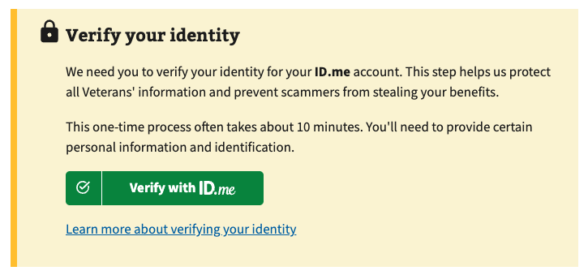

Figure : LOA1 prompt to verify identity (widget view).

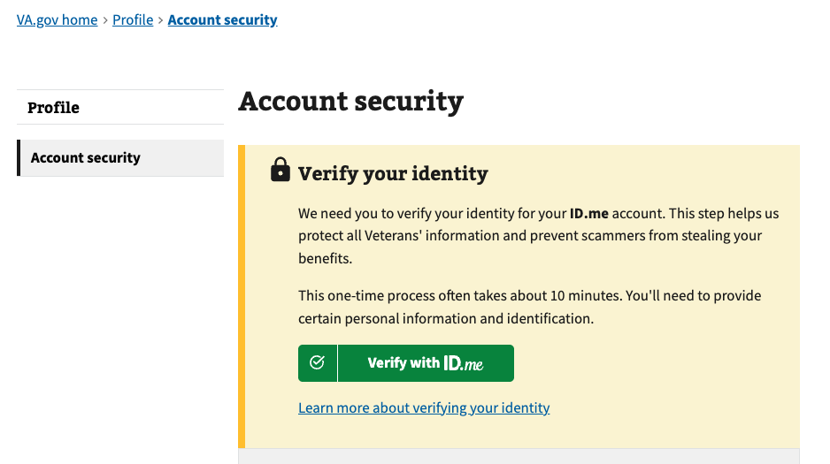

Figure : LOA1 prompt to verify identity (Profile view).



Figure : Authenticated, no representative (widget view).

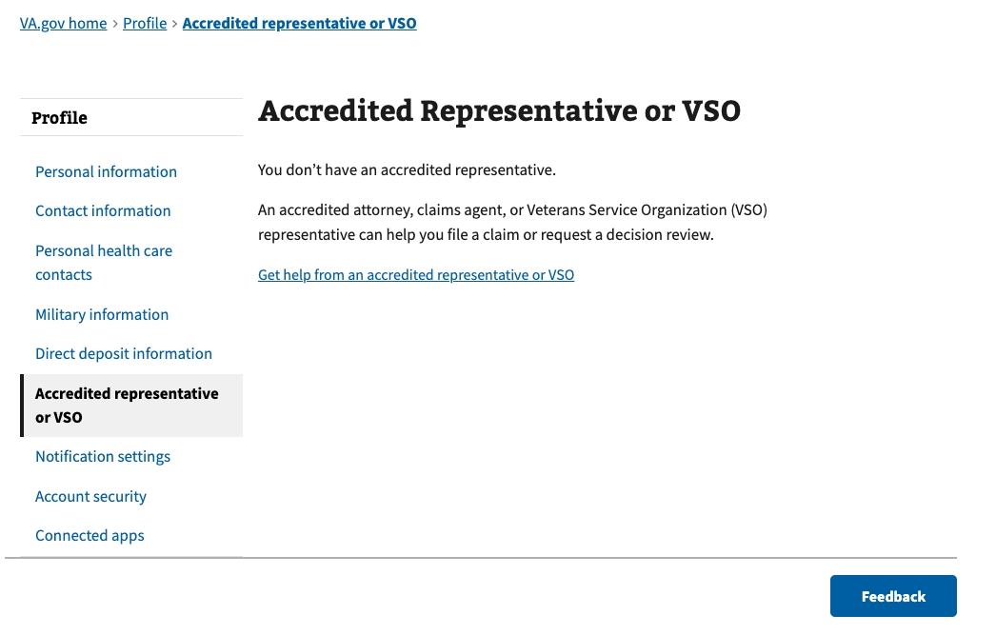

Figure : Authenticated, no representative (Profile view).

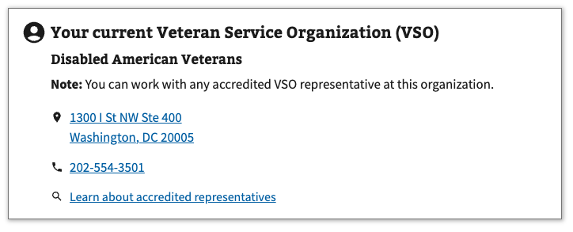

Figure : Authenticated, represented by a Veteran Service Organization (widget view).

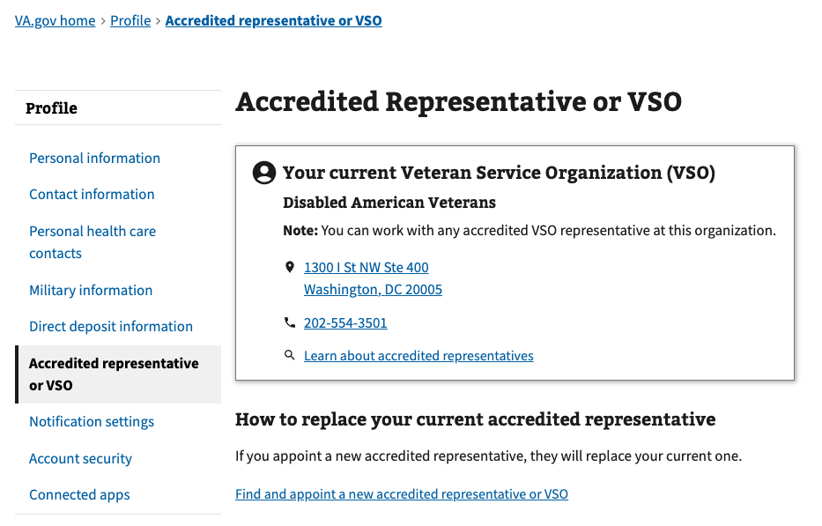

Figure : Authenticated, represented by a Veteran Service Organization (Profile view).

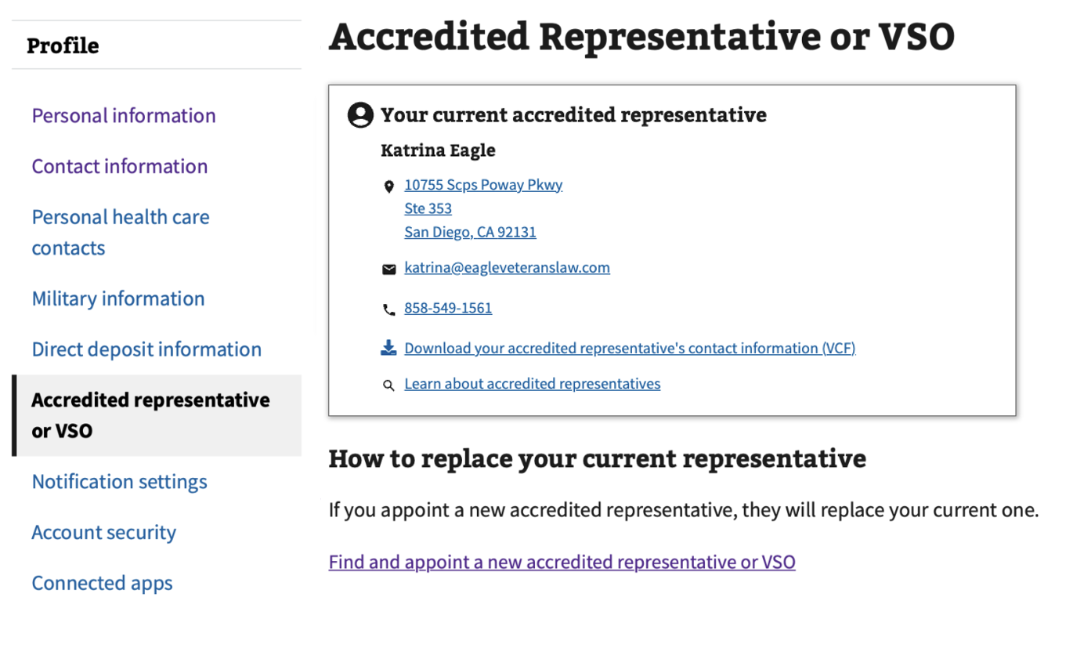

Figure Authenticated, represented by an individual attorney or claims agent (Profile view).

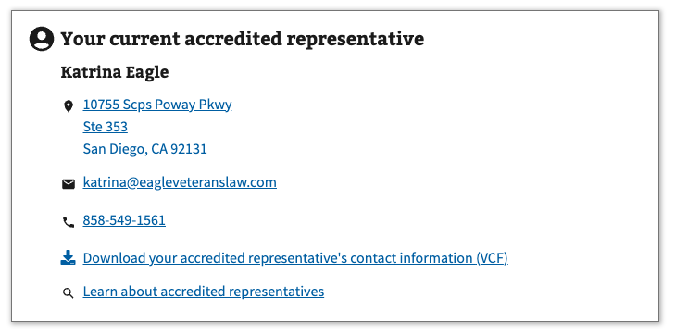

Figure . Authenticated, represented by an individual attorney or claims agent (widget view).

## 5. Major Issues and Error Messages

If there is an issue retrieving the active representation for an authenticated user, an error message will be displayed.

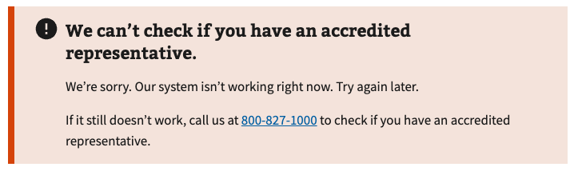

Figure . Authenticated, error.

## 6. Frequently Asked Questions

Users may have the following questions, when using this product:

1. What makes a representative accredited?
2. How do I appoint a new accredited representative?
3. How can an accredited representative help me?
4. Does an accredited representative have to help me?
5. Can I work with more than one accredited representative at a time?
6. Can I work with an accredited representative online or over the phone?
7. How do I cancel my representation?

Answers to these questions, and additional information about accredited representatives can be found on:

1. The top of the “Find a Representative” product page includes definitions of each type of accredited representative: <https://va.gov/get-help-from-accredited-representative/find-rep>
2. The “Get help from an accredited representative” landing page includes information on how to find and appoint an accredited representative: <https://va.gov/get-help-from-accredited-representative>.
3. The “FAQ” page includes additional information about accredited representatives: <https://www.va.gov/resources/va-accredited-representative-faqs/>

## 7. Table of Figures

Figure 1. Unauthenticated. 5

Figure 2. Authenticated, no representative. 5

Figure 3. Authenticated, represented by a Veteran Service Organization. 5

Figure 4. Authenticated, represented by an individual (attorney or claims agent). 5

Figure 4. Authenticated, error. 6