**Table of Contents:**

1. Product Overview
2. User Access
3. Navigation & Functionality
4. **Product Overview:**

Today, deep content on very long pages is not easily shared. Only the URL of the page can be copied and sent to others.

So when a Veteran, caregiver, VA public affairs, or customer service representative wants to direct someone to a specific Question & Answer, they can only share a link for the whole page. This leaves it up to the recipient to navigate through a long list of information to find the deeper content they seek which can be frustrating and time-consuming.

The goal of this pilot is to test making it possible to share deep content contained within a very long page and easier to access deep content through a shared link.

A new clickable icon will be introduced on one page for the pilot. The new clickable icon will enable users to copy a deep link to their clipboard. They can then paste that link and share it in an email or their choice of application.

The coronavirus FAQ page will be used to pilot this new feature.

1. **User Access:**

Users do not need to be signed in to use this feature. The feature will be available for any user who visits the [coronavirus FAQ page](https://www.va.gov/coronavirus-veteran-frequently-asked-questions/), whether or not they have a VA.gov account.

1. **Navigation and Functionality**

On the [coronavirus FAQ page](https://www.va.gov/coronavirus-veteran-frequently-asked-questions/) users will see this new clickable icon for copying a deep link:

**Macintosh HD:Users:Jennifer:Downloads:image (14).png**

The new “copy deep link” icon will be available in accordion FAQs, as well as Q&As that are not inside accordions.

When a Q&A is inside an accordion, the new icon will be visible after opening the accordion. On default all accordions are closed:

[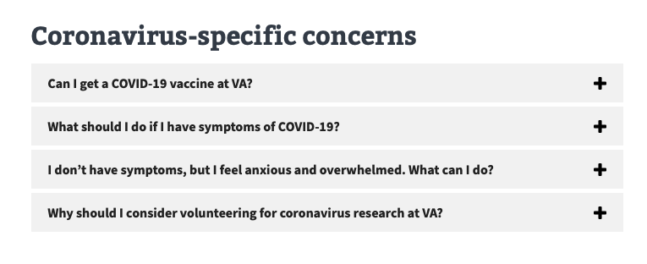](https://user-images.githubusercontent.com/74627978/117226609-018aff00-ade3-11eb-8b23-aad0a7a5eea7.png)

Clicking the “+” sign opens the accordion and shows the answer text. The new clickable “copy deep link” icon is visible at the end of the answer:

r:

After clicking the icon, the icon changes color and the user will see a “Link copied” message:

[](https://user-images.githubusercontent.com/74627978/117226744-4fa00280-ade3-11eb-803d-881f9e6aca39.png)

The link has now been copied to the user’s clipboard and they can paste into an email or other application of their choice to share.

When the recipient clicks on a shared deep link, it will take link directly to the deep Q&A content. If the Q&A is inside an accordion, the accordion for that question will be open upon landing:

