**Resources and support (formerly learning center)**

Table of Contents

Resources and support product overview 2

User Access 2

Navigation 2

Need more help/contact info section 3

# Resources and support product overview

## **Resources and support** is a new area of the VA website. It will include articles meant to help customers find answers to common questions. The information in this new area can be described as help, support, and resources content.

**Resources and support** will initially go live as a beta launch (eta October 29 – November 5), with just 2 categories of articles:

* VA account and profile
  + Example: articles about signing in, updating your address, creating an account…
* Other topics and questions
  + Example: articles about PDF problems, claim status…

At the end of December, we will add more categories such as health care, disability, education, life insurance, and others.

## 

## User Access

Users do not need to be signed in. Resources and support articles will be publicly available to all.

## Navigation

**Direct url:**​ [https://www.va.gov/resources/](https://www.va.gov/gi-bill-comparison-tool)

**Footer:** A “Resources and support” link will be added to the global footer

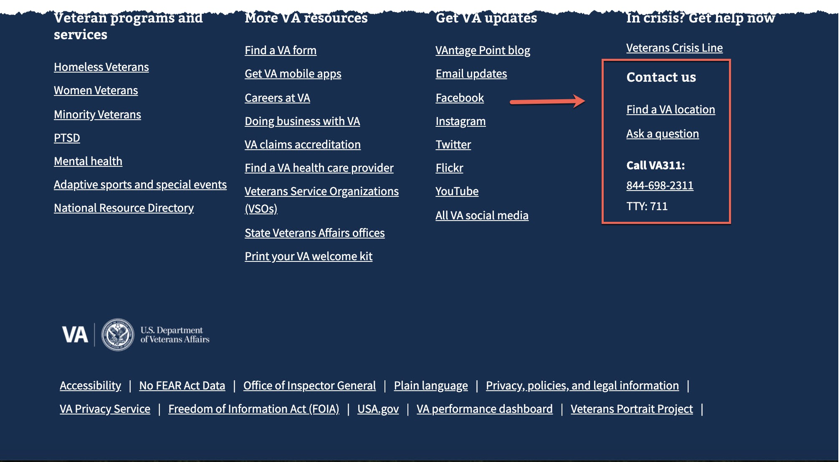

# Need more help/contact info section

Every resources and support articles will have a help contact info section at the bottom of the page.

For the beta launch categories of **VA account and profile** and **Other topics and questions**, the articles will include the VA411 (formerly VA311) help desk phone number.

