

Veteran-facing Services Applications

May 12, 2021 | Notice of Disagreement Product Guide

Version 1.0

Revision History

| Date | Version | Description |  |
| --- | --- | --- | --- |
| 04/23/2021 | 1 | First Iteration | Veronica Henry |
|  |  |  |  |
|  |  |  |  |
|  |  |  |  |
|  |  |  |  |
|  |  |  |  |
|  |  |  |  |
|  |  |  |  |
|  |  |  |  |
|  |  |  |  |

Table of Contents

1 Introduction 4

1.1 User Access 5

1.2 Access & Navigation 5

2 Notice of Disagreement Tool Functionality 6

2.1 Step 1 of 4: Veteran Details 6

2.2 Step 2 of 4: Issues for review 9

2.3 Step 3 of 4: Board review option 10

2.3.1 Direct Review 11

2.3.2 Submit Additional Evidence 11

2.3.3 Hearing with a Veterans Law Judge Option 13

2.4 Step 4 of 4: Review your request 14

Table of Figures and Tables

Figure 1-1: Request a Board Appeal Landing Page 4

Figure 1.2-1. Access Options 5

Figure 2-1. Starting the Board Appeal Process 6

Figure 2.1-1: Step 1 of 4: Veteran Details 6

Figure 2.1-2: Step 1 of 4: Veteran details – *Are you currently homeless?* 7

Figure 2.1-3: Step 1 of 4: Veteran details – *Representative/Attorney Question* 7

Figure 2.1-4: Step 1 of 4: Veteran details – Representative or VSO Name Entry 8

Figure 2.2-1. Step 2 of 4: Issues for review 9

Figure 2.3-1: Step 3 of 4: Board review options 10

Figure 2.3.1-1: Direct Review Option 11

Figure 2.3.2-1: *Submit additional evidence* Option 11

Figure 2.3.2-2: *Additional evidence* – Submission Prompt 12

Figure 2.3.2-3: *Upload your additional evidence* functionality 12

Figure 2.3.3-1: *Hearing with a Veterans Law Judge* Option 13

Figure 2.3.3-2: *Hearing with a Veterans Law Judge* – Hearing Type Selection 13

Table 2.4-1: Step 4 of 4: Review your request 14

# Introduction

Online Notice of Disagreement functionality makes it easier for Veterans to apply for a decision review, allowing Veterans to submit requests for disability claims decision reviews. Refer to Figure 1-1, which is the starting point of the process.

Figure 1-1: Request a Board Appeal Landing Page

## User Access

Users do not need to be signed into complete this application. The full functionality of the tool is available for a user, whether or not they have a VA.gov account.

## Access & Navigation

[This is the direct link to the Request a decision review or appeal form.](https://www.va.gov/decision-reviews/board-appeal/) The link for the decision reviews application can also be found on the VA.gov homepage. Refer to Figure 1.2-1.

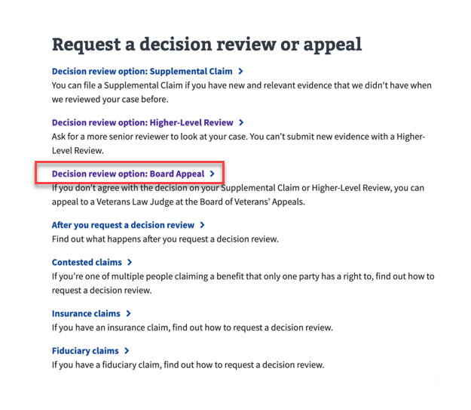

Figure 1.2-1. Access Options

Notice of Disagreement functionality is also accessible via Main Menu dropdown selection [or a link on the Education Hub Page.](https://www.va.gov/education/)

# Notice of Disagreement Tool Functionality

After selecting “Start Board Appeal request” the user will be presented with a screen allowing them to verify their information. See Figure 2-1.

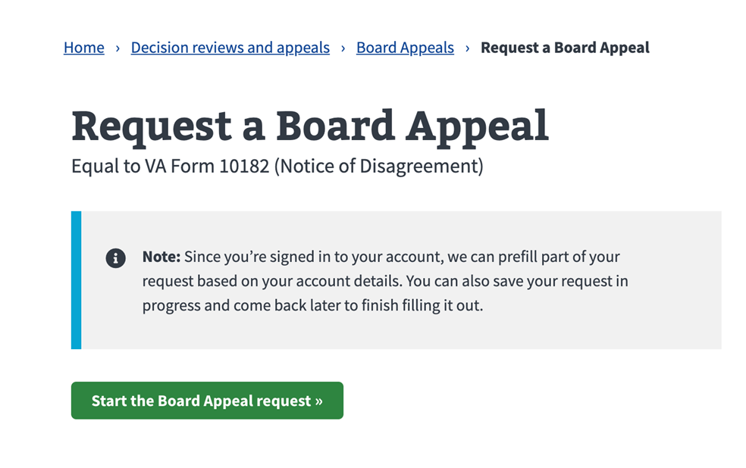

Figure 2-1. Starting the Board Appeal Process

## Step 1 of 4: Veteran Details

*Step 1 of 4: Veteran detail*s is displayed. The information presented is straightforward but all of the details should be verified by the user to ensure accuracy. See Figure 2.1-1.

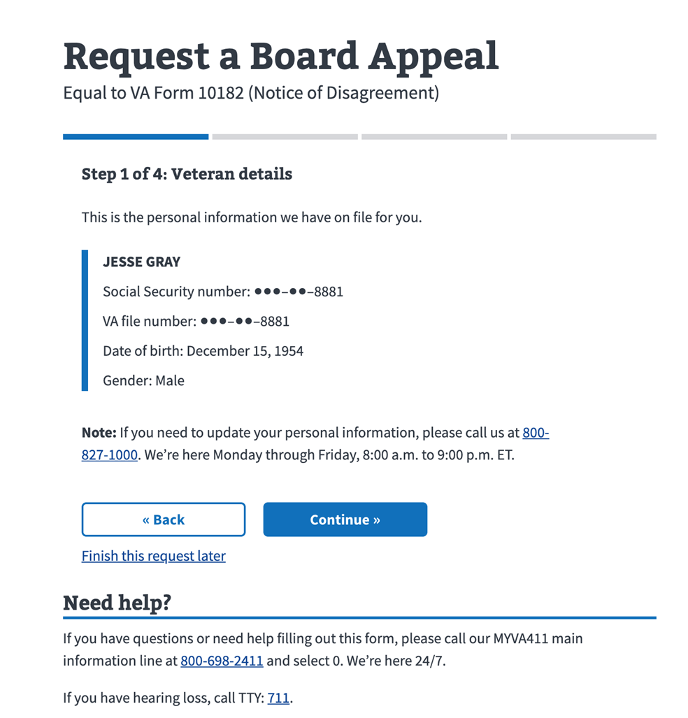

Figure 2.1-1: Step 1 of 4: Veteran Details

Selecting *Continue* brings up the question, *Are you currently homeless?* See Figure 2.1-2.

Figure 2.1-2: Step 1 of 4: Veteran details – *Are you currently homeless?*

If *either Yes or* *No* and *Continue* are selected, the Veteran is asked, *Do you have a representative, like a Veteran Service Organization (VS0) or a VA-accredited attorney or agent, helping you file this appeal?*

See Figure 2.1-3.

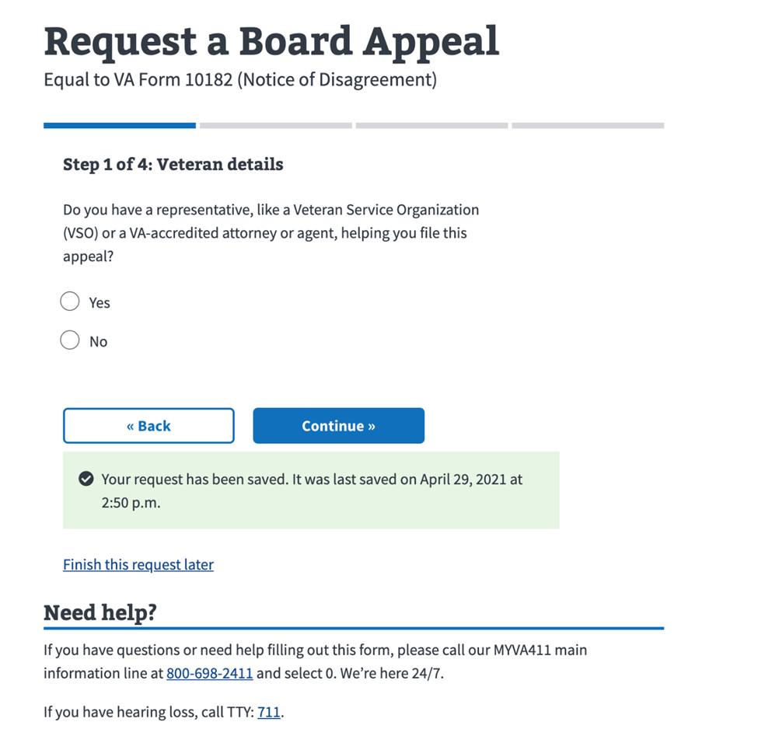

Figure 2.1-3: Step 1 of 4: Veteran details – *Representative/Attorney Question*

Selecting *Yes* and *Continue* are selected a detail screen is displayed asking the Veteran to identify the Representative or VSO name. Refer to Figure 2.1-4.

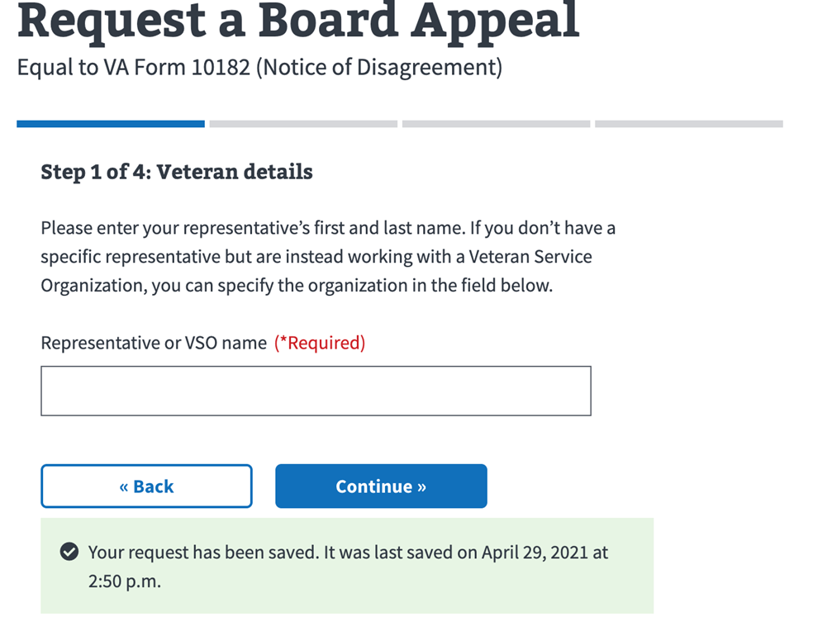

Figure 2.1-4: Step 1 of 4: Veteran details – Representative or VSO Name Entry

## Step 2 of 4: Issues for review

This section of the form lists issues for review. The issue is labeled and the decision date is provided below. The user can then either enter a new issue using the *Add* *issue* button or select an existing issue. See Figure 2.2-1.

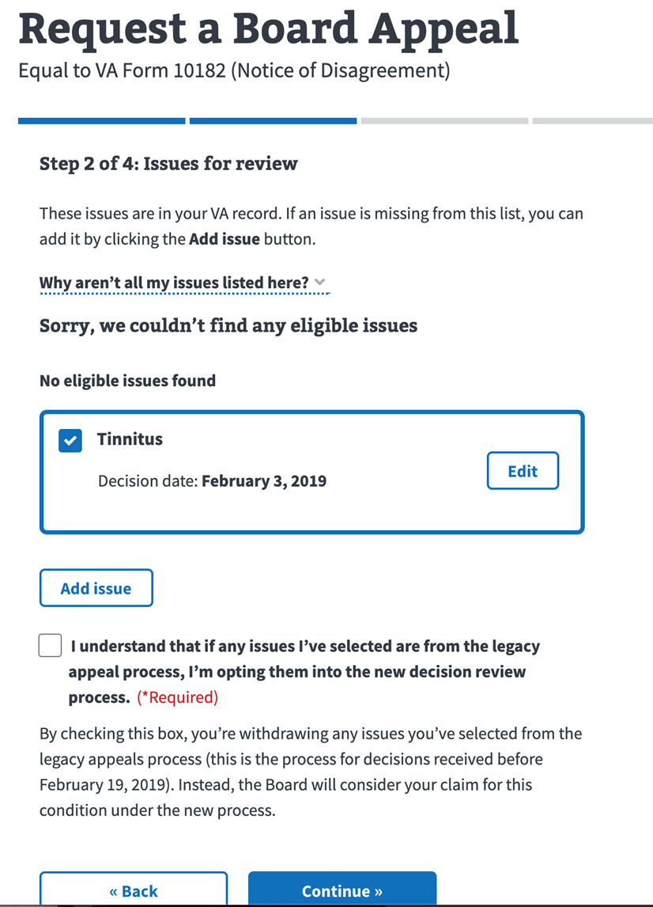

Figure 2.2-1. Step 2 of 4: Issues for review

## Step 3 of 4: Board review option

After selecting *Continue*, users are brought to *Step 3 of 4: Board review option*, where they’re asked to select one of three review alternatives:

* Direct review
* Submit additional evidence
* Hearing with a Veteran Law Judge

Refer to Figure 2.3-1.

Figure 2.3-1: Step 3 of 4: Board review options

### Direct Review

Direct review is the fastest option. **The appeal will be decided based on evidence already submitted.**

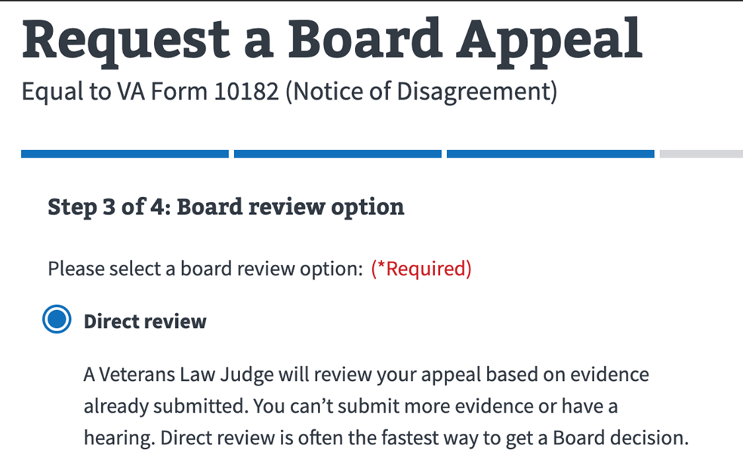

Figure 2.3.1-1: Direct Review Option

### Submit Additional Evidence

The second option is a prompt to submit additional evidence. The user can perform that submission now or later in the process. Refer to Figure 2.3.2-1.

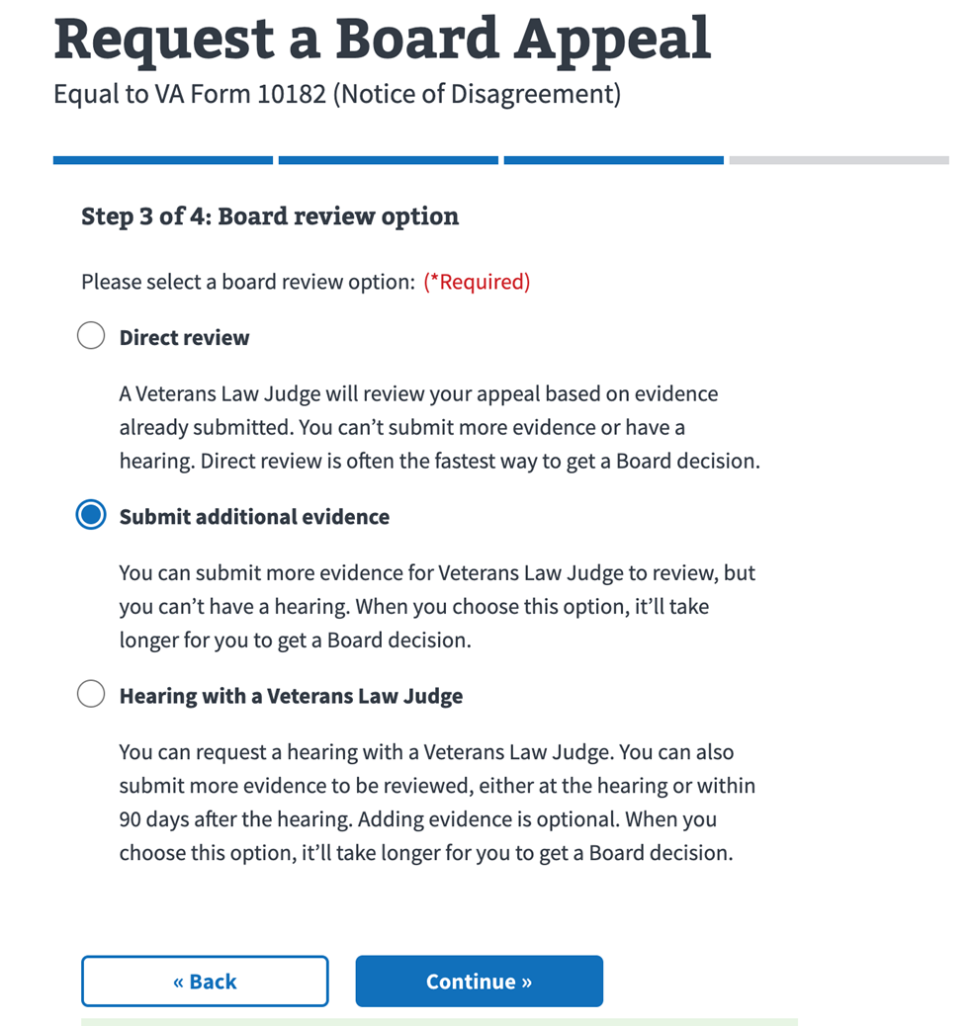

Figure 2.3.2-1: *Submit additional evidence* Option

if the *Submit additional evidence* option is selected, the user is directed to a submission prompt asking, *Would you like to submit more evidence right now?* Refer to Figure 2.3-2-2.

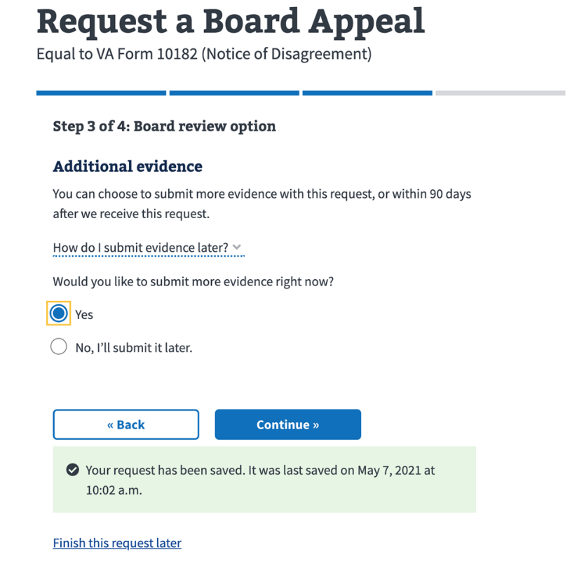

Figure 2.3.2-2: *Additional evidence* – Submission Prompt

If *Yes* is selected, users will be provided document uploading functionality. See Figure 2.3.2-3.

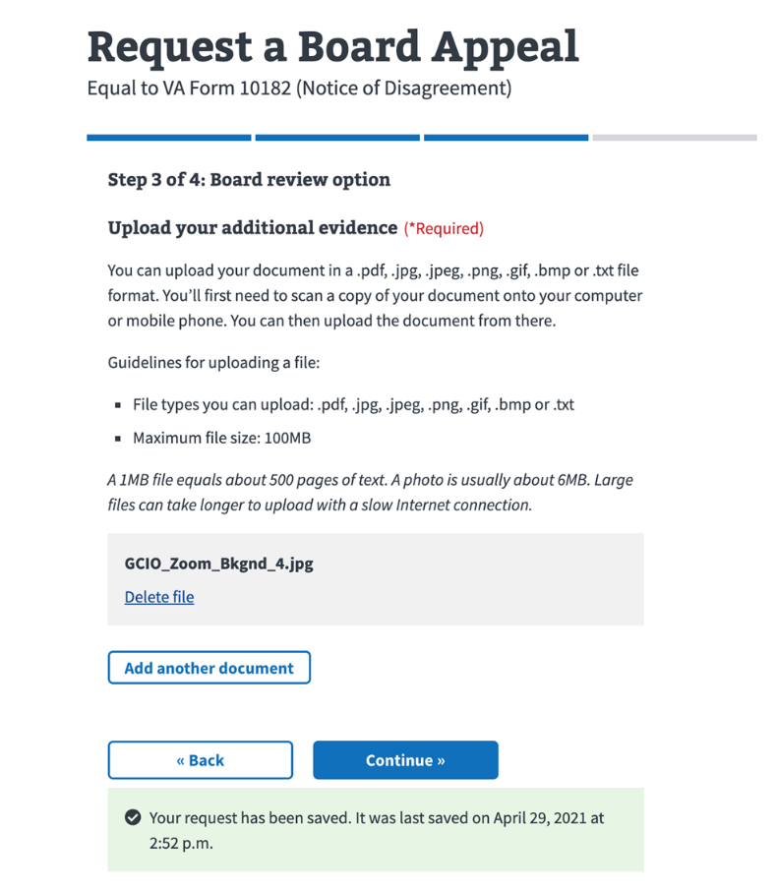

Figure 2.3.2-3: *Upload your additional evidence* functionality

### Hearing with a Veterans Law Judge Option

This option allows the user to request a hearing with a Veterans Law Judge.

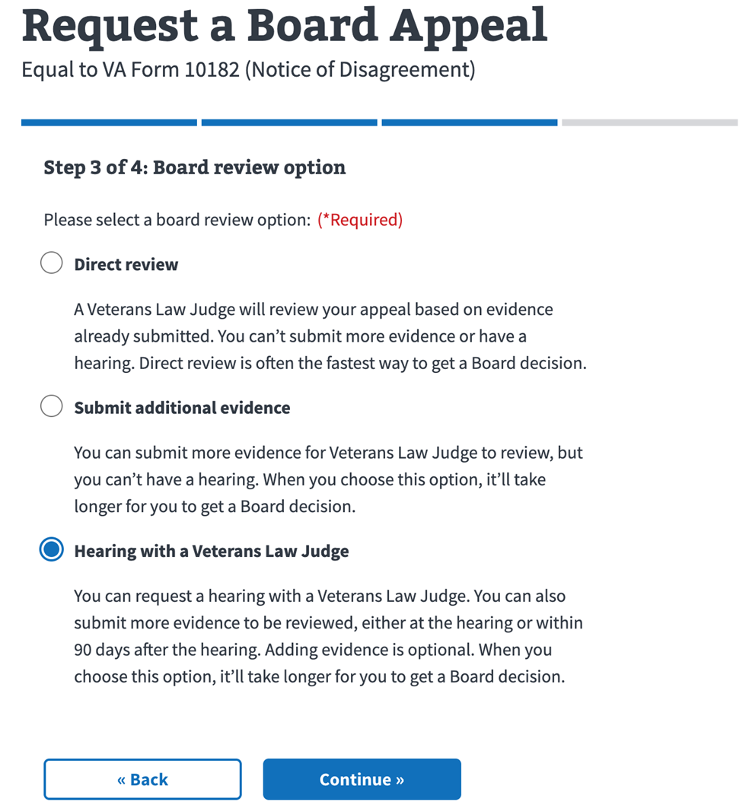

Figure 2.3.3-1: *Hearing with a Veterans Law Judge* Option

Refer to Figure 2.3.3-2. Selecting the *Hearing with a Veterans Law Judge* option and *Continue* presents the user with the following choices in hearing types. After selection is made, the user can then review and submit their request.

* Virtual tele-hearing from my home
* Video hearing form a VA location near me
* In-person hearing at the Board in Washington, D.C.

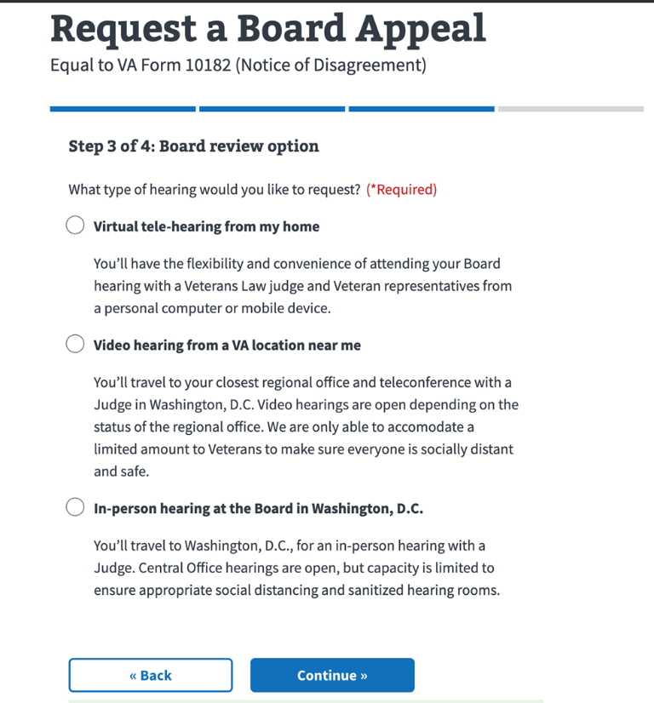

Figure 2.3.3-2: *Hearing with a Veterans Law Judge* – Hearing Type Selection

## Step 4 of 4: Review your request

This is the final step. Users may now review entries, correcting them if necessary, and—upon checking the privacy policy box—submit the form. Refer to Figure 2.4-1.

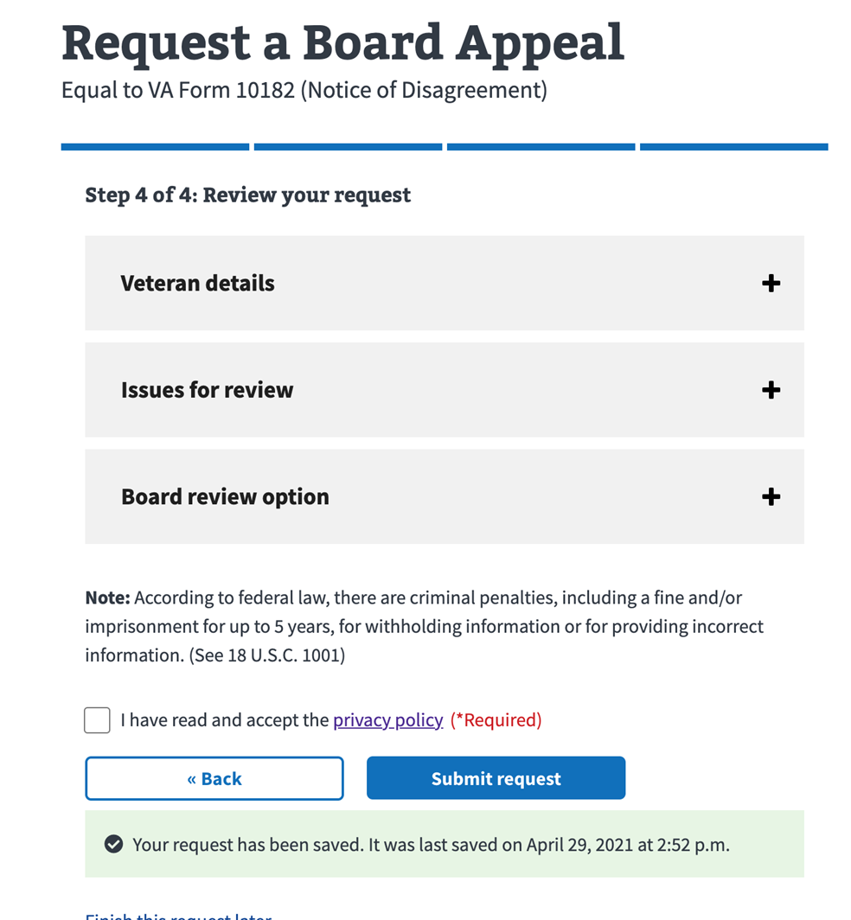

Table 2.4-1: Step 4 of 4: Review your request