

**VA Form 20-0995  
Supplemental Claim Form**

Version 2

Updated: October 2024  
Launch: TBAVersion History

| **Date** | **Version** | **Description** | **Author** |
| --- | --- | --- | --- |
| January 2023 | 1 | Product debut | Sade Ragsdale |
| October 2024 | 2 | Update with error notification | Maurice DeBeary |

## Table of Contents

**Overview**

**User Access**

Who can access these tools?

How can users access these tools?

**Navigation**

**Functionality**

Supplemental claim form

Introduction Page

Getting started—Is this the form I need?

Getting started—Check your eligibility, gather info, and get started

Intent to File

Form Step 1—Contact and Veteran information

Claimants select their primary phone number on this page.

Form Step 2—Add issues to the claim

Add new issues to the claim

Request for VA Medical Evidence

Request for Private Medical Evidence

Claimants can also upload their evidence. They are not required to upload evidence.

Form Step 4—Review and submit

Before claimants submit, they can conduct a final review of the info they provided.

The screen below is shown after successful submission.

**Major Issues and Error Messages**

**FAQ**

Supplemental Claim Form (20-0095)

Should I file a supplemental claim?

What kind of issues can I add to my supplemental claim?

I think my claim falls under the PACT Act. Should I file?

I don’t think my claim falls under the PACT Act. Should I file?

**Email Error Notification**

VA Form (21-4142)

## Overview

VA Form 20-0995 Supplemental Claim Form is the final decision review form to launch on VA.gov. Supplemental claims are filed when a claimant disagrees with a previous decision and has new and relevant evidence that may establish a theory of service connection. Supplemental claims are the most frequently used decision review pathway.

Note: The Veteran Benefits Administration anticipates a high volume of supplemental claims to be filed by Veterans due to the PACT Act.

## User Access

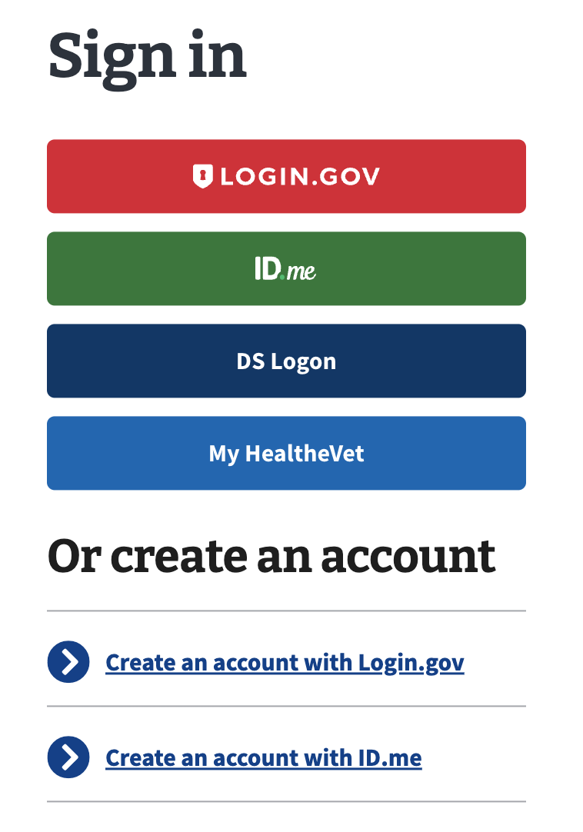

### Who can access these tools?

Active service members and Veterans who have logged in with Level of Assurance 3 (LOA3)—the highest level of identity verification on VA.gov—can access the Supplemental Claim form via [VA form 20-0095](https://www.va.gov/decision-reviews/supplemental-claim/file-supplemental-claim-form-20-0995/start).

### How can users access these tools?

Veterans can sign in to VA.gov and access the Certificate of Eligibility (COE) using any of the 4 identity verification partners: Login.gov, ID.me, DS Logon, or My HealtheVet.

## Navigation

Users will access VA Form 20-0995 at <https://www.va.gov/decision-reviews/supplemental-claim/file-supplemental-claim-form-20-0995/start>.

Both the form and status applications will be accessible at <https://www.va.gov/decision-reviews/supplemental-claim/>.

## Functionality

### Supplemental claim form

#### *Introduction Page*

Members must sign in to start the application. Veterans' account information (Social Security number, date of birth, etc.) must be verified before proceeding. If this information is not verified, the Veteran cannot start a supplemental claim on VA.gov.

Note: The information shown in the screenshots in this document is fake test user data.

There are 4 sign-in states:

1. Not signed in:

Save time - and save your work in progress - by signing in before starting your request. 

When you’re signed in to your VA.gov account:

- We can prefill part of your request based on your account details.
- You can save your request in progress, and come back later to finish filling it out. You’ll have 60 days from the date you start or update your request to submit it. After 60 days, we’ll delete the request and you’ll need to start over.

Note: If you sign in after you’ve started your request, you won’t be able to save the information you’ve already filled in.

Sign in to start your request button

1. Signed in and ready to start (save-in-progress renders this):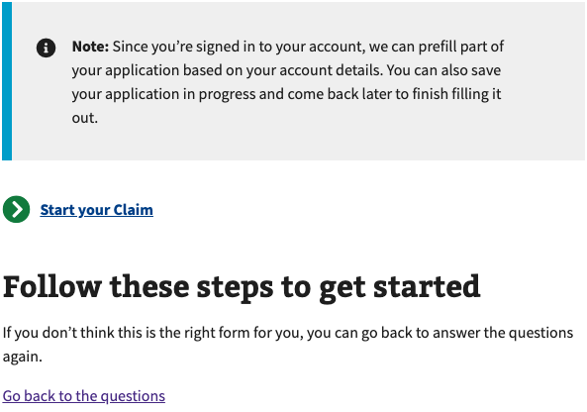
2. Signed in and not LOA3 verified:



1. Signed in and missing either Social Security number or date of birth:

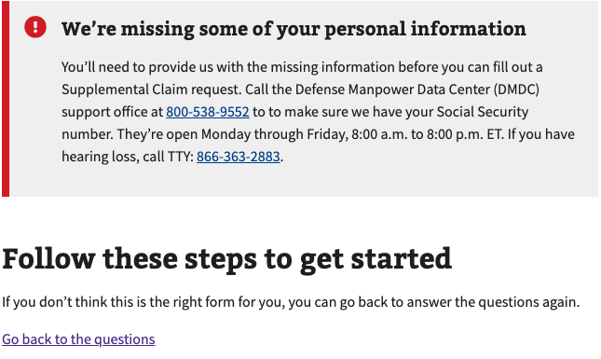

#### *Getting started—Is this the form I need?*

The claimant selects the type of claim they are filing for. This version of the supplemental claim form on VA.gov is only for disability compensation claims. Claimants are redirected to the PDF form for non-disability compensation claims.

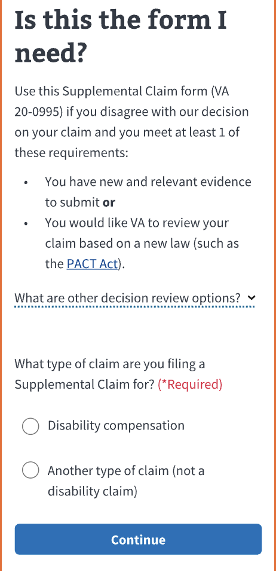

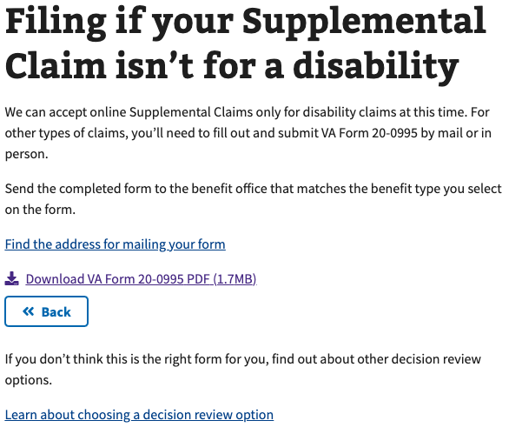

#### *Getting started—Check your eligibility, gather info, and get started*

Claimants can review content to help them determine if they are ready to file a supplemental claim before they start. They can also learn about what happens after they submit their claim.

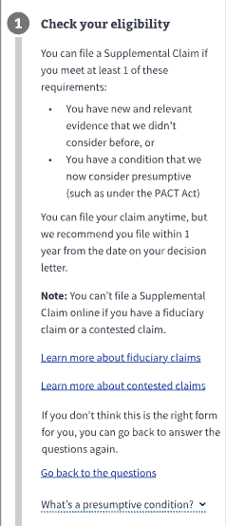

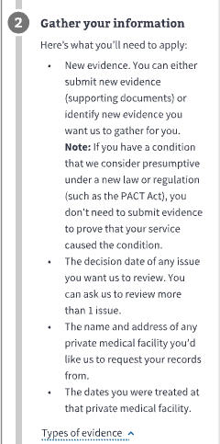

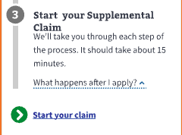

#### *Intent to File*

* An Intent to File form will be submitted on the claimant’s behalf when they begin the supplemental claim form on VA.gov.
* The user will be notified of the expiration date if an existing Intent to File is stored in VBMS.
* If claimants have concerns about how their Intent to File form is associated with their supplemental claim, please let them know that the claim processor reviewing both forms will pair them appropriately.
* Additionally, the Intent to File date for a supplemental claim will only be used if the supplemental claim is submitted over a year after the decision date.

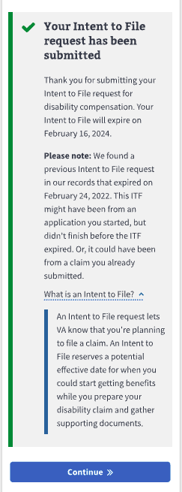

#### *Form Step 1—Contact and Veteran information*

Claimants can then review their Veteran information on this page.

#### 

#### Claimants select their primary phone number on this page.

#### 

#### 

#### *Form Step 2 - Add issues to the claim*

* Claimants must select or add issues that VA has decided to include in their claim.
* Issues that have received a decision will be pre-populated.
* They can add multiple issues to a single claim, including previously decided issues they think are or are *not* PACT eligible for.

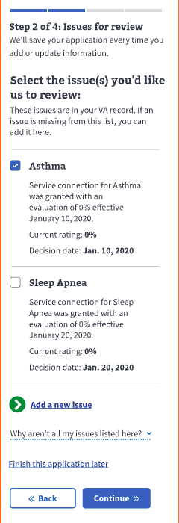

#### 

#### *Add new issues to the claim*

Only issues for which the claimant has received a VA decision notice can be added to a claim. If they file an initial claim, they must use Form 526EZ, not the supplemental claim form.

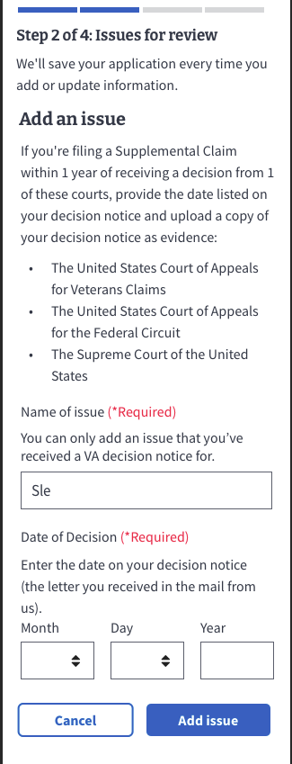

***Opt into the AMA Decision Review Process***

The form will explain the AMA decision review process, which helps process their claim more efficiently if it was decided on or before February 19th, 2029. This explanation shows when the claim has contestable issues in the legacy process, or the Veteran adds an issue that wasn’t pre-populated.

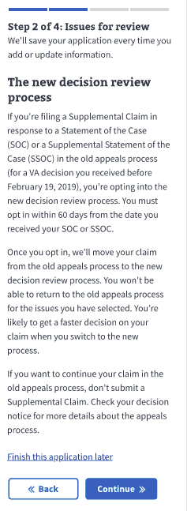

***Form Step 3—Notice of Evidence Needed***

* Claimants must check the box to confirm they’ve reviewed the “***Notice of Evidence Needed***,” which explains what evidence is submitted with a supplemental claim.
* If the claimant thinks they have a presumptive condition related to the PACT Act, they can submit the form.

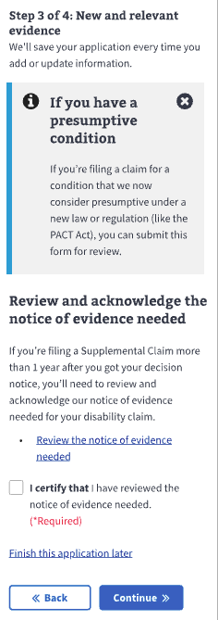

#### 

#### *Request for VA Medical Evidence*

Claimants can optionally allow VA to gather their VA medical records on their behalf.

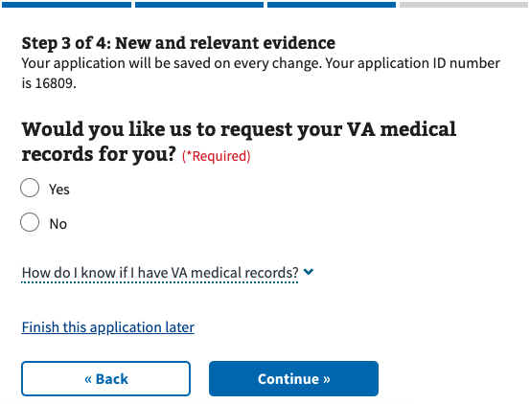

* If they select Yes, they must add VA facility names and treatment dates for their treatment. They can add multiple VA facilities.
* This step is only shown if the user allows VA to gather VA medical evidence.

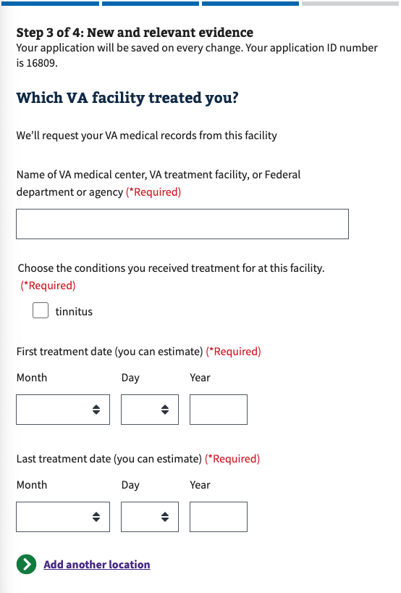

#### 

#### *Request for Private Medical Evidence*

Claimants can optionally allow VA to gather their private medical records on their behalf.

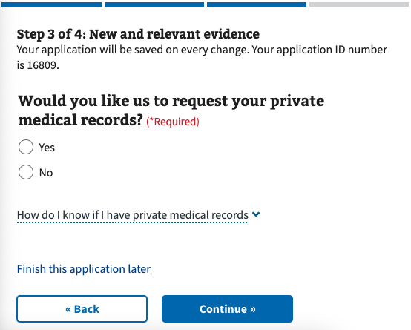

* If they select Yes, they must authorize VA to gather their private medical records on their behalf by checking the box at the bottom of the page.
* This is only shown if the user allows VA to gather private medical evidence.

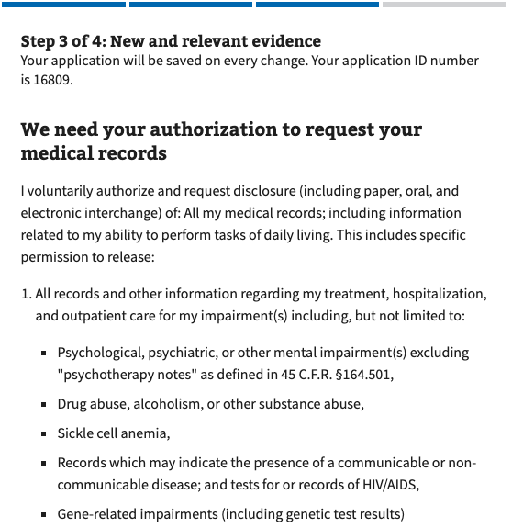

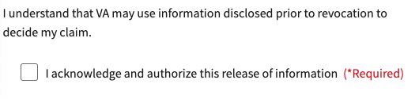

They must also add the private facility names and treatment dates for their treatment. They can add multiple VA facilities. This is only shown if the user allows VA to gather private medical evidence.

#### 

#### 

Claimants can optionally limit the private medical record information VA can access by describing the limitations in a text box. This is only shown if the user allows VA to gather private medical evidence.

#### 

#### Claimants can also upload their evidence. They are not required to upload evidence.

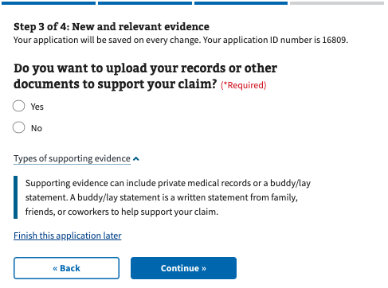

#### 

#### 

#### *Form Step 4—Review and submit*

#### Before claimants submit, they can conduct a final review of the info they provided.

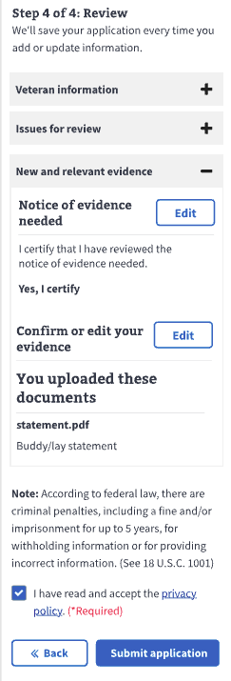

#### The screen below is shown after successful submission.

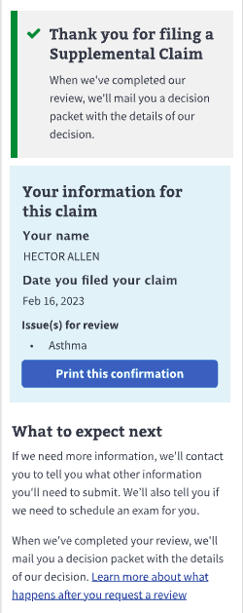

**Note:** All information shown in the screenshots is fake test user data.

## Major Issues and Error Messages

*Veteran information validation errors*

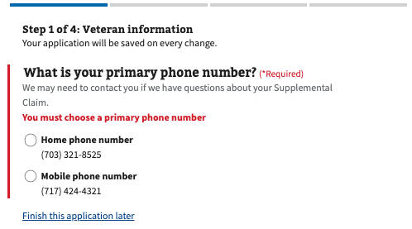

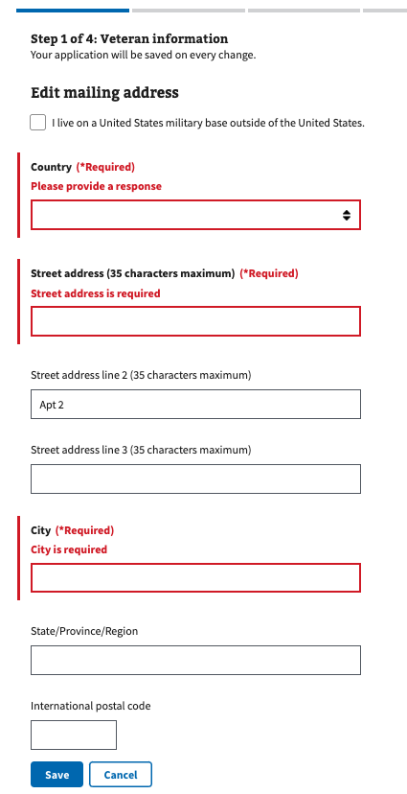

Eligible issues validation error

Instruction: Our record system has no known issues on which VA previously made a decision. If the Veteran receives this, please advise them to manually click “Add a new issue” to add their issue to the claim. Please also remind them that the supplemental claim form is only for issues on which VA previously made a decision. Veterans will know whether or not the issue received a decision based on their decision letters. If the Veteran cannot find their paper decision letters, they can download them from the Claim Status tool on VA.gov.

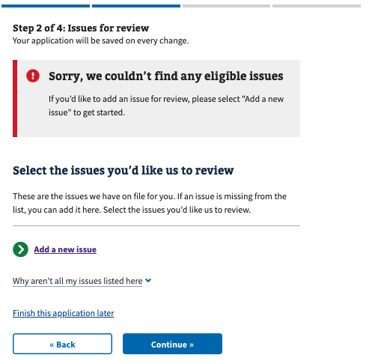

Notice of acknowledgment validation errors: Veterans must check the box below this section to continue.

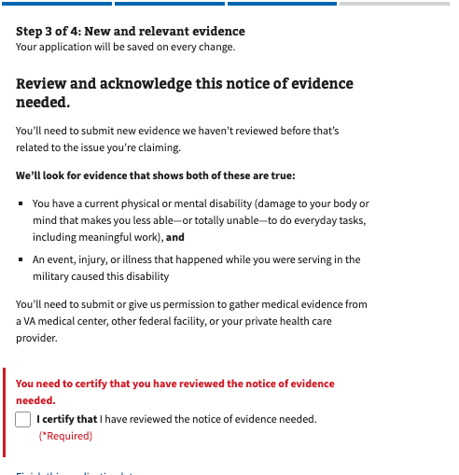

Evidence-gathering validation errors: Veterans must select Yes or No when asked if they would like VA to gather their VA or private medical records on their behalf.

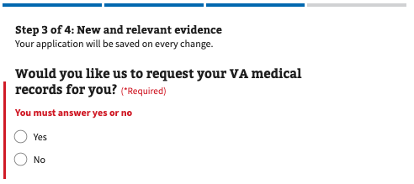

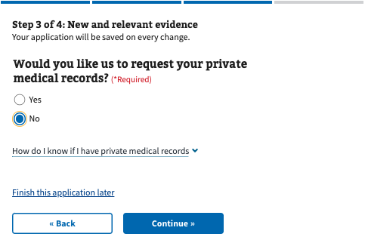

Private evidence-gathering validation errors: To allow VA to gather private evidence on the Veteran's behalf, they must check the box below the section titled “We need your authorization to request your medical records” to continue. If they do not want to authorize this, they can press the back button and select No when asked, “Would you like us to request your private medical records?”

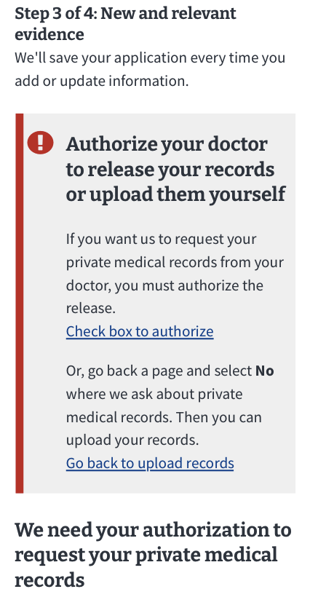

## FAQ

### Supplemental Claim Form (20-0095)

Here are some common scenarios that Veterans may experience when filing their claim.

### Should I file a supplemental claim?

The supplemental claims are filed for claims previously denied by VA. If the Veteran’s claim was not previously denied, the Veteran is filing a claim for an increase, or has not filed a claim before, then the 526EZ may be the correct form for them to use.

For more information about how to choose the right type of form for their claim, they can visit these pages on VA.gov:

* <https://www.va.gov/disability/how-to-file-claim/when-to-file/>
* <https://www.va.gov/resources/choosing-a-decision-review-option/>

### What kind of issues can I add to my supplemental claim?

Veterans may add any issues that VA previously denied. If it is available in our system of record, we will display it on VA.gov. Issues that VA did not decide on are ineligible for a supplemental claim and will not appear as an option on the form on VA.gov.

Veterans can check their decision letters to see which issues VA denied.

If VA has denied the Veteran for an issue that does not yet appear on VA.gov, they may manually add that issue to their claim.

### I think my claim falls under the PACT Act. Should I file?

VA.gov is accepting PACT Act claims. If the Veteran believes their claim is PACT eligible, they should submit it with or without evidence. VA will manually review all claims to determine if more evidence is needed and will contact the Veteran directly. Evidence can be shared through VA.gov using the claim status tool.

### I don’t think my claim falls under the PACT Act. Should I file?

If the Veteran believes their claim is not PACT eligible, they should submit their claim with evidence but will be allowed to submit without it. VA will manually review all claims to determine if they are PACT eligible or if more evidence is needed and will reach out to the Veteran directly. Evidence can be shared through VA.gov using the claim status tool.

## Email Error Notification

Suppose the supplemental form fails at any point post-submission. In that case, we will send the Veteran an “action needed” email notifying them that their form submission has failed and that they should resubmit it by mail or in person to avoid further issues.

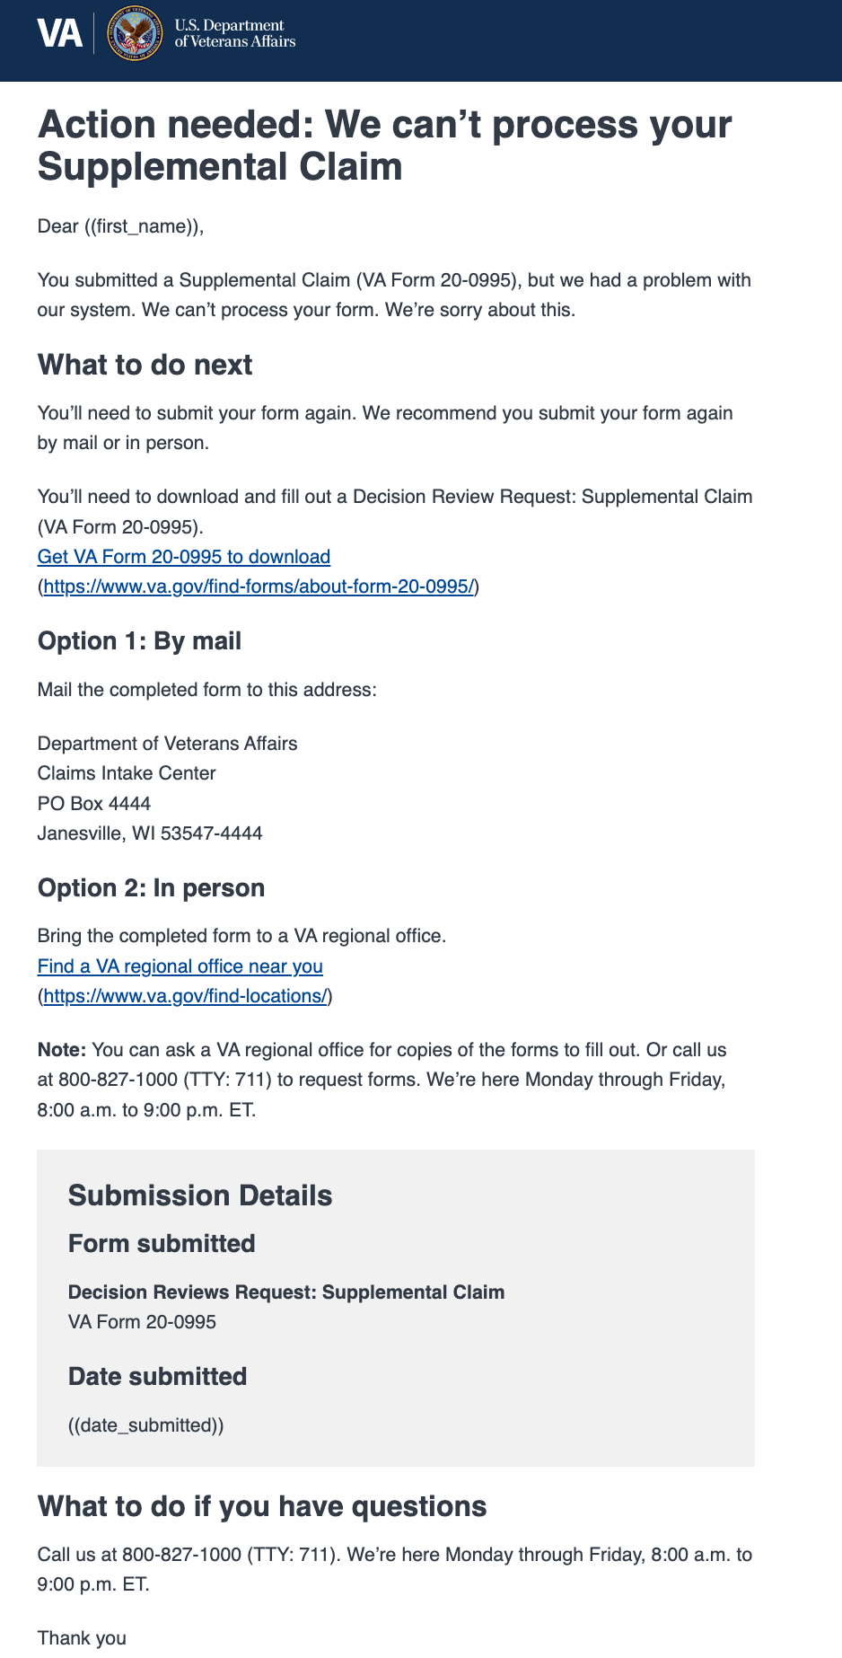

Suppose the supporting document fails at any point post-submission. In that case, we will send the Veteran an “action needed” email notifying them that their supporting document submission has failed and that they should resubmit the form by mail or in person to avoid further issues.

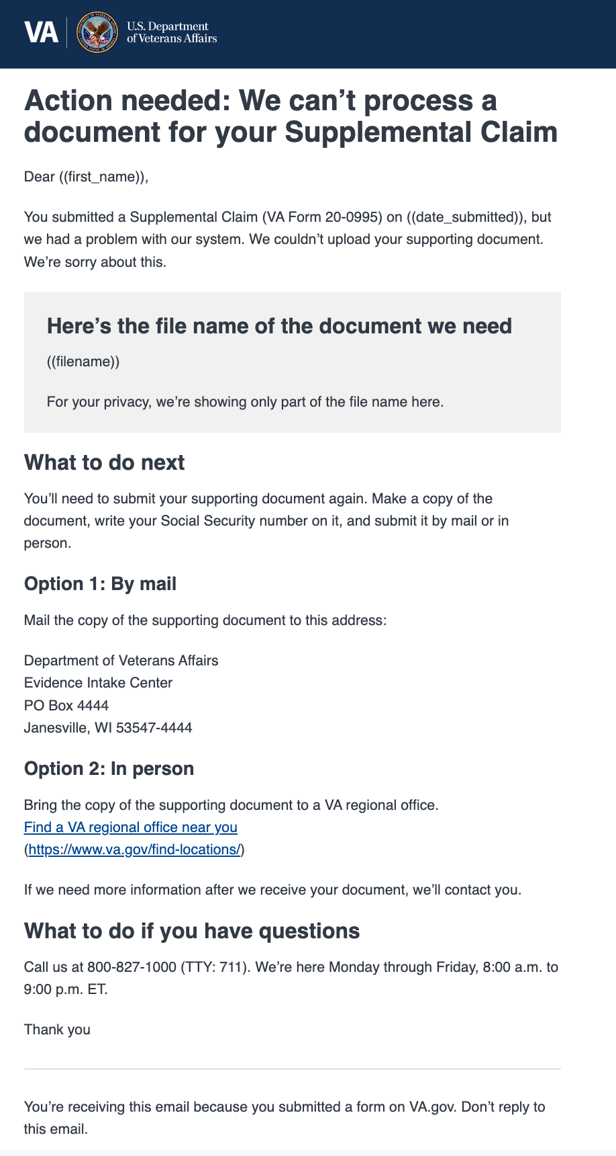

### 

### VA Form (21-4142)

Suppose the supporting form fails at any point post-submission. In that case, we will send the Veteran an “action needed” email notifying them that their supporting form submission has failed and that they should resubmit the form online or by mail to avoid further issues.

