**DECISION READY CLAIM (DRC)**

**PLAYBOOK**

# *Version History*

|  |  |  |  |  |
| --- | --- | --- | --- | --- |
| **Rev #** | **Revision Description** | **Section(s) Affected** | **Implemented By** | **Revision Date** |
| 1.1 | Draft provided to DRC Workgroup for feedback. | All | N/A | 06/26/17 |
| 1.2 | Updated draft provided to leadership. | All | N/A | 07/05/17 |
| 1.3 | Playbook provided to Change Management Agents. | All | CS/OC | 07/13/17 |

# *Playbook Tabs*

|  |  |  |  |
| --- | --- | --- | --- |
| **Tab** | **Title** | **Beginning Page** | **Additional Information** |
| A | Executive Summary | 4 |  |
| B | Standard Operating Procedure | 5 |  |
| C | Training Plan | 19 |  |
| D | [Quality Assurance (QA) Plan](#_Quality_Assurance_(QA)) | 21 |  |
| E | Notice to Union of National Concept | 22 |  |
| F | Change Management | 23 |  |
| G | Performance Measures and Display Plan | 24 |  |
| H | Communications and Stakeholder Engagement | 25 |  |
| I | OIT Assessment | 26 |  |
| Appendix A | VSO/CVSO Instructions for First Time Access | 27 |  |
| Appendix B | DRC Coversheet | 29 |  |
| Appendix C | Contract Examination Exclusions | 30 |  |
| Appendix D | VA Form 21-4138 Example | 31 |  |
| Appendix E | DRC Implementation Plan | 32 |  |
| Appendix F | Frequently Asked Questions (FAQs) | 33 |  |
| Appendix G | DRC Fact Sheet | 37 |  |

# *Executive Summary*

**Problem statement**

The Department of Veterans Affairs (VA) remains committed to continually improving our service to Veterans, their families, and survivors. As part of VA’s continued efforts to improve Veterans’ experience with the disability claims process, VA has developed the Decision Ready Claim (DRC) initiative – an extension of Fully Developed Claims – designed to accelerate the processing of disability compensation claims.

**Summary of problem-solving approach**

With the help of accredited Veterans Service Organizations (VSOs), VA aims to complete claims submitted under DRC within 30 days of VA’s receipt of the claim(s). Participating VSOs will certify all supporting claim evidence (e.g. medical exam, military service records, etc.) is included with the claim at the time of submission to VA.

On May 1, 2017, VA began Phase 1 of the DRC initiative at the St. Paul Regional Office (RO). In June 2017, VA expanded DRC to the Waco and Houston ROs during Phases 2 and 3, respectively. DRC will continue its phased implementation until it is available nationwide by September 2017. Currently, DRC is limited to claims for increased compensation (claims for increase).

During Phases 1 through 3, VA will assess the initiative’s progress and identify ways to include additional claim types in DRC before national implementation.

**Major project results or findings and recommendations**

VA aims to complete all DRC claims within 30 days of submission to VA and plans to make DRC available to Veterans nationwide by September 2017.

The following are sets of recommendations for implementation:

**Phased Approach.** Following Phases 1 through 3, VA will rollout DRC to the remaining ROs in cohorts during Phase 4. National implementation is scheduled to begin in July 2017 with the last cohort deployed by September 2017.

**Continued Improvements.** VA will continue to explore ways to improve upon the DRC process and functionality following national implementation and during subsequent phases.

# *Standard Operating Procedure (SOP)*

***1. Introduction/Background***

This SOP provides detailed information pertaining to the deployment activities and operations for Decision Ready Claim (DRC).

***2. Overview***

The Veterans Benefits Administration (VBA) is implementing a DRC initiative to improve the Veteran’s experience by reducing claims processing time. This initiative is one of the Secretary’s 10 priorities for Fiscal Year (FY) 2017, “Accelerating VBA Performance on Claims.”

To participate in the DRC process, a Veteran must be represented by an accredited Veterans Service Organization (VSO). The VSO works with the applicant to obtain all necessary records for VA to make a decision on his or her claim. This includes federal records and requesting relevant medical evidence using VA’s disability benefits questionnaires (DBQs) or VA examination. VSOs submit DRCs through the Direct Upload Portal DRC queue. Once the DRC is received by VBA, it is reviewed and put under end product (EP) control by a Claims Assistant (CA) and automatically routed via National Work Queue (NWQ) to a Rating Veterans Service Representative (RVSR) for a decision. VA will issue a rating decision within 30 days of receiving the completed DRC.

***3. Scope***

The DRC SOP is intended for regional offices (ROs) and other stakeholders involved in DRC activities.

***4. Prerequisites***

The following materials will be provided to ROs prior to national implementation:

* DRC VSO User Manual
* DCR Training Materials for VSOs
* DCR Training Materials for RO Staff

(See the Training Plan for additional training information.)

***5. Responsibilities***

The following stakeholders and personnel have a significant role in the DRC process:

|  |  |
| --- | --- |
| **Role** | **Responsibilities** |
| Accredited VSOs | * Determine if claim is appropriate as a DRC * Submit Intent to File (ITF) and associated forms * Gather relevant records and evidence on behalf of the claimant * Obtain completed DBQs * Initiate contract exam request process as appropriate * Submit DRC and associated evidence |
| VBA Exam Request Personnel | * Review and input exam requests submitted by VSOs * Tab pertinent records in Veterans Benefits Management System (VBMS) * Address any exams returned for clarification or correction |
| Vendor | * Review DRC checklist for completeness * Transmit complete DRC submissions to VBA * Notify VSOs of incomplete DRC submissions |
| CA | * Receive complete DRCs * Verify DRC status * Establish EPs and enter associated contentions * Add appropriate special issue * Open and close appropriate tracked items * Return non-DRC submissions * Send “DRC Exclusion Letters” as appropriate |
| RVSR | * Complete DRC rating decisions * Make full or partial rating decisions when possible for DRC exclusions * Complete deferred ratings for DRC exclusions when appropriate * Attempt to obtain exam clarification when needed * Order additional exams when needed |
| Veterans Service Representative (VSR) | * Send “DRC Exclusions Letter” when needed * Complete claim development for DRC exclusions |

***6. Procedure***

DRC requires Veterans to work with an accredited VSO to submit a claim under the program and it requires all medical evidence, to include complete DBQs and federal records, to be submitted in conjunction with the DRC. Successful participation in the DRC initiative will result in a claim decision within 30 days of submission.

The DRC initiative offers Veterans faster decisions on disability compensation claims for increase. For the purpose of phase four, claims for increase are defined as:

* Claims for Increase: Claim for disability compensation where the Veteran is currently service-connected for the condition and is requesting an increased disability evaluation for that condition.

At this time, the following claims are excluded for the DRC:

|  |  |
| --- | --- |
| Pre-discharge | Incarcerated Veterans |
| Individual Unemployability | Currently pending disability claim |
| Claims for conditions already assigned the scheduler maximum (i.e. active cancer evaluated at 100%) | DRC conditions currently on appeal |
| Chapter 18 (Spina Bifida) and any other birth defects for dependent children | Restricted Access Claims (includes VBA employees, relatives of VBA employees, National Service Officers or high-ranking government officials) |
| Pension | In-Service Death Claims |
| Pregnant Veterans | Special Monthly Pension |
| Foreign claimants | DRC application submissions signed by the VSO |
| Standalone SMC claims |  |

When the DRC is successfully submitted and accepted through the DRC Direct Upload Portal, a DRC confirmation cover sheet will be automatically uploaded into VBMS. Additionally, DRC submissions will be identified by one of the following three Special Issues: “Decision Ready Claim”, “Decision Ready Claim – Deferred”, “Decision Ready Claim – Partial Deferred.”

**Access**

The Direct Upload Portal is utilized during the DRC process and noted in several areas of this SOP. ROs will provide a list of VSOs and County VSOs (CVSOs) requiring access to the Direct Upload Portal using the [DRC RO SharePoint site](https://vaww.portal2.va.gov/sites/OfficeofFieldOperations/VACO-AREA-RO_Data_Rollup/DRC-RO/default.aspx). For VSO access to the Direct Upload Portal, submit the names, VA email addresses, and specific VSO/CVSO name (e.g., Veterans of Foreign Wars) for each user [here](https://vaww.portal2.va.gov/sites/OfficeofFieldOperations/VACO-AREA-RO_Data_Rollup/DRC-RO/Lists/VSOCVSOInfo/AllItems.aspx). Once a VSO/CVSO receives access, they can follow the steps provided in Appendix A to log into the Centralized Mail (CM) Portal. Additionally, detailed instructions for using the Direct Upload Portal are located in the DRC VSO User Manual.

ROs will also use the [DRC RO SharePoint site](https://vaww.portal2.va.gov/sites/OfficeofFieldOperations/VACO-AREA-RO_Data_Rollup/DRC-RO/default.aspx) to submit the names of employees needing access to the DRC CM Queue. For employee access to the DRC CM Queue, provide a list of employee names, VA email addresses, and access level required for each employee [here](https://vaww.portal2.va.gov/sites/OfficeofFieldOperations/VACO-AREA-RO_Data_Rollup/DRC-RO/Lists/RODRCAccess/AllItems.aspx). The below table provides access information:

|  |  |  |
| --- | --- | --- |
| **Role / Position** | **Access Level** | **Purpose** |
| Claims Assistant | Basic Access | To be able to process mail and establish the DRC claim |
| IPC Coaches (Specially Selected by the RO) | Super User | To move mail to appropriate queues until full automation is available later this year |

**Instructions for Preparing a DRC**

To participate in the DRC program, the accredited VSO representative must submit:

|  |  |
| --- | --- |
| VA Form 21-0966, *Intent to File a Claim for Compensation and/or Pension, or Survivor’s Pension and/or DIC,* to serve as an effective date placeholder for the applicant | ***Important:*** If the applicant or their accredited representative has already submitted an ITF and that ITF remains ‘Active,’ there is no need to submit an additional ITF, as the additional submission would be logged as a ‘Duplicate’ ITF. Additionally, the applicant or their accredited representative can submit their ITF through one of the VBA approved methods described in M21-1III.ii.2.C.2.a.  ***Note:*** If the VSO is submitting the DRC on the same day that the ITF would be submitted, the VSO is not required to submit an ITF, as the ITF would provide the same potential effective date as the date of claim. |
| VA Form 21-22, *Appointment of Veterans Service Organization as Claimant’s Representativ*e, with a 38 U.S.C 7332 compliant form of record (if not already the current power of attorney) via the Direct Upload Portal | ***Important:*** The VSO and Veteran may utilize existing Stakeholder Enterprise Portal (SEP) and eBenefits functionality (M21-1 III.i.4.B.1.c. *Establishment of POA Through VDC/SEP*) to acknowledge representation rather than submitting VA Form 21-22 through the Direct Upload tool. |

If the Veteran currently has a paper claim file that has yet to be converted to a VBMS eFolder, the VSO must notify VA that they are initiating the DRC process and that the paper claims folder must converted to an eFolder. This guidance supersedes the guidance in M21-1 III.ii.3.B.1.e. pertaining to adjudicative actions that require conversion of existing paper claims folders to an electronic format. The M21-1 will be updated to reflect this change during the DRC national rollout.

* ***Note:*** Whenever possible, utilize the local RO Intake Processing Center (IPC) coach to initiate the paper claim folder conversion process.
* ***Important:*** DRC exam requests cannot be requested until the Veteran’s paper file has been converted to an eFolder.

Prior to formal DRC submission, VSOs must gather all relevant records and evidence, including all necessary federal records, DBQs, and medical examinations needed to make a decision. All relevant medical evidence and military service records must be obtained and submitted to VA prior to requesting a contract examination (if applicable). Once the evidence is in the applicant’s VBMS eFolder, the VSO may proceed with requesting contract examination(s).

***Important:*** All evidence and contract exam requests submitted to VA in support of the DRC initiative ***must*** include the DRC coversheet displayed in Appendix B.

***Note***: If the VSO is assisting the Veteran in filing a DRC based on the worsening of the Veteran’s service connected sleep apnea, the VSO must review the current evidence of record and identify the sleep study that was used to diagnose the condition. This evidence will then be tabbed by the contract exam requestor and made available to the examiner as part of the exam.

There are two ways to obtain a completed DBQ:

|  |  |
| --- | --- |
| A private medical provider (Veteran requests completion of DBQ through treating private physician) | ***Note:*** A complete list of DBQs that are available to private providers are found at the below web address: <http://benefits.va.gov/COMPENSATION/dbq_ListByDBQFormName.asp>. |
| A VBA contracted examiner | ***Note:*** A complete list of contract exam exclusions is available in Appendix C. |

A VSO must perform the following actions prior to submitting a request to VA for contracted exams:

|  |  |
| --- | --- |
| **Step** | **Action** |
| 1.1 | Upload all medical records (not already in VBMS) pertaining to the condition(s) for which the exam is being requested utilizing the Direct Upload Portal to include:   * VA treatment records available in CAPRI, * Private medical records, * Vet Center records, and * Military treatment records.   ***Important:*** If the VSO uploaded relevant medical records, they must ensure the records are visible in the VBMS e-Folder prior to submitting the contract exam request. |
| **Step** | **Action** |
| 1.2 | Once all relevant medical records have been submitted and are located in the Veteran’s VBMS eFolder, the VSO must submit VA Form 21-4138, *Statement in Support of Claim*, containing the following language in order to initiate the contract exam request process, as well as the DRC coversheet included in Appendix B:  *Decision Ready Claim (DRC) Contract Exam Information*  *The conditions listed below are being provided in support of my DRC submission:*  *<insert condition name>*  *If you have any questions or need clarification, please contact: <insert VSO name, email address, and phone number>*  *Evidence to be reviewed by examiner:*  *<insert condition name>*  *<insert evidence description>*  ***Important:*** Once VA Form 21-4138 has been received by VA and the conditions in need of a contract exam are identified, DRC Exam Request personnel will request that a DBQ be completed for all conditions warranting an examination.  An example is available in Appendix D. |

Once the DRC Contract Exam Request is received and has been placed under EP control, NWQ will route the EP to the DRC Exam Request station for the DRC Exam Request personnel to review the request and input the exam as applicable. The DRC Exam Request personnel will perform the following actions to review and request contract exams in Centralized Administration Accounting Transaction System (CAATS):

|  |  |
| --- | --- |
| **Step** | **Action** |
| 1.1 | Review VA Form 21-4138 submitted indicating the need for a DRC contract exam request. |
| 1.2 | Determine the appropriate DBQ for the condition(s) identified on VA Form 21-4138 and input into CAATS within 2 business days from the date that the EP 400 used to control the DRC contract exam request was established. |

|  |  |
| --- | --- |
| **Step** | **Action** |
| 1.3 | If the VSO identified any relevant medical evidence pertaining to the claimed conditions, the DRC Exam Request personnel will tab those records in the VBMS eFolder. |
| 1.4 | If the contract exam is returned for clarification or correction, the DRC Exam Request personnel will correct the exam request and resubmit within 2 business days. |

***Note:*** Exam results should be available in the VBMS eFolder within 10 calendar days after the last exam has been completed. If the results are not available at that time, the VSO can email the Mandatory Contract Program Office at [Contractexam.vbavaco@va.gov](mailto:Contractexam.vbavaco@va.gov).

***Important:*** If the Veteran has a paper file that has yet to be digitized to a VBMS eFolder, the paper file must be converted to a VBMS eFolder prior to submission of the DRC exam request.

**Instructions for Processing a DRC**

Upon receipt of VA Form 21-4138 identifying DRC contract exam conditions in need of an examination, the CA completes the following actions:

|  |  |
| --- | --- |
| **Step** | **Action** |
| 1.1 | Establish an EP 400 with the *DRC Exam Request* claim label. |
| 1.2 | Assign the date of claim of the EP 400 based on the receipt date of VA Form 21-4138. |
| 1.3 | Insert “DRC Exam Conditions” into the ‘Contention’ field. |
| 1.4 | Select the ‘Administrative Issue’ selection from the ‘Classification’ dropdown menu. |
| 1.5 | Click ‘Save.’ |

The entry should look like this in VBMS:

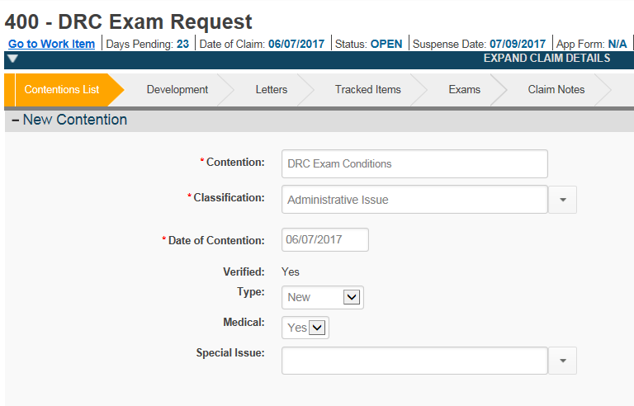

***Important:*** If the Veteran has previously failed to report for a DRC contract exam for a given condition and is currently requesting a DRC contract exam for the same condition(s), do not schedule a new DRC contract exam unless one or both of the events below have occurred:

* It’s been more than one year since the Veteran previously requested a DRC contract exam, or
* The Veteran filed a claim for the condition(s) that they previously failed to report for and that claim has been decided.

If a new DRC contract exam is not warranted based on the criteria above, notify the VSO that a new DRC contract exam will not be requested and that the Veteran will have to provide a DBQ completed by their private physician in order to stay in the DRC program or will have to file a traditional or Fully Developed Claim (FDC).

***Notes:***

* All DRC evidence and contract exam requests should be submitted with the DRC coversheet in Appendix B in order to allow the CA to identify that document submission as being in support of the DRC initiative.
* National Work Queue (NWQ) will route the EP 400 – *DRC Exam Request* to the DRC Exam Request station.
* If the Veteran currently has a paper file that has yet to be converted to a VBMS eFolder, initiate the paper folder conversion to eFolder process as described in M21-1 III.ii.3.B.

DRCs must be submitted by an accredited VSO on behalf of the applicant. Accredited VSOs will use the DRC Direct Upload Portal to submit a DRC electronically.

At time of submission to the DRC Direct Upload Portal, VSOs must submit:

* VA Form 526EZ, *Application for Disability Compensation and Related Compensation Benefits*
* Private Medical DBQs

***Important:*** If VA Form 21-526EZ is signed by the accredited representative, rather than the Veteran, the claim will be excluded from the DRC program. *Please refer to DRC exclusion list above.*

Receipt of an eligible DRC submitted through the DRC Direct Upload Portal requires the scanning vendor to perform the following:

Vendor reviews the DRC for:

* The required documents and evidence identified on the DRC checklist, to make sure they are included in the DRC submission.
* Completeness of all required documents.

***Note:*** Vendor has two business days to review the submission and determine if the DRC is complete or not complete.

If DRC submission is complete:

|  |  |
| --- | --- |
| **Step** | **Action** |
| 1.1 | Vendor transmits DRC to VBA using Direct Upload. |

If DRC submission is incomplete:

|  |  |
| --- | --- |
| **Step** | **Action** |
| 1.1 | Vendor notifies VSO via the Direct Upload Portal that the DRC package is incomplete and provides VSO with an explanation of what is missing and/or incomplete using Direct Upload. |
| 1.2 | VSO has 48 (clock) hours to resubmit complete DRC claim through the DRC Direct Upload Portal. |
| 1.3 | If the VSO resubmits, the vendor will provide another review. |

|  |  |
| --- | --- |
| **Step** | **Action** |
| 1.4 | If the VSO did not resubmit within 48 hours, or the resubmitted claim was still missing required components, the claim is routed through the traditional claim process. |
| 1.5 | The date of claim is the date the VSO first submits the DRC, even if there is a subsequent re-submission into the portal. |

At the time the DRC is submitted and is undergoing vendor review, the claim will be available to both VBA and the vendor simultaneously. In order to ensure that the vendor is given the opportunity to review the submission for accuracy and completeness, CM Portal Super Users should follow the instruction below when routing mail packets to VBA personnel to work:

|  |  |
| --- | --- |
| **If** | **Then** |
| There is a claim in DRC CM queue, but there isn’t a note | Super User should not take any actions. |
| There is a “DRC – Valid” note | Super User should assign claim to a DRC CA. |
| There is a “DRC – VSO Correction Pending” note | Super User should not take any actions. |
| There is a “DRC- Incomplete due to [insert missing information]” note | Super User assigns mail packet to DRC CA to send DRC Exclusion Letter with the reason for exclusion identified in the note. |
| There is a “DRC – Please review DRC CM portal for [missing information] from VSO on [insert date]” note in the DRC assign-queue associated with a DRC claim* | Super User should check the DRC CM queue for the date indicated in the note. Once the date indicated in the note has expired, the Super User should check the DRC CM queue for the missing information mentioned in the note.  Please make sure to identify mail packets using both the file number and social security number.   * If the missing information is found, the Super User should assign both packets to a DRC CA. * If missing information is not found, Super User should assign the original claim to the DRC CA to send DRC Exclusion Letter with the reason for exclusion identified in the note. |

***\*Note:*** Below are the reasons that might be identified in this note:

* There is no 526EZ submitted with this DRC submission
* Missing Veteran Social Security Number (SSN) and Veteran File Number on 526EZ
* Missing disability(ies) on 526EZ
* “I do not want my claim considered for rapid processing…” box checked on 526EZ
* Veteran signature is missing AND POA authorized signature is missing or there is a “X” or thumb print in the Veteran signature box, but no witness signatures present on 526EZ
* Veteran signature is missing and POA authorized signature is present on 526EZ. In this case, the CA will issue an automated 5103 notification.
* Missing Veteran SSN on DBQ(s)
* Physician’s Signature missing on DBQ(s)
* Physician’s Printed Name missing on DBQ(s)
* Date Signed is missing on DBQ(s)
* Physician’s Phone and Fax Number is/are missing on DBQ(s)
* National Provider Identifier (NPI) Number field is blank on DBQ(s)
* Physician’s Address is missing on DBQ(s)

Once a DRC is moved through to the RO CM DRC queue by the Vendor, a CA will perform the following actions:

|  |  |
| --- | --- |
| **If** | **Then** |
| If there is not a pending rating EP or appeal for the DRC issues claimed | * Establish the appropriate EP * Enter in the associated contentions * Add the “Decision Ready Claim” Special Issue to the claim * Open and close a custom tracked item labeled “DRC” to trigger the auto-RFD feature * PCLR the EP 400 used to control the DRC contract exam request (if pending) |
| If there is not a pending rating EP or appeal for the DRC issues claimed AND the submission is on the exclusion list | * Return the claim to the normal queue for processing * Send “DRC Exclusion Letter” to the Veteran using the letter creator tool, citing “one or more claimed conditions is on the DRC exclusion list” as the exclusion reason |

A RVSR will perform the following actions:

|  |  |
| --- | --- |
| **If** | **Then** |
| The claim should be excluded but the RVSR can make a complete decision | * The RVSR should rate the claim and annotate that the “Decision Ready Claim” Special Issue should be removed |
| The claim should be excluded but the RVSR can make a partial decision | * The RVSR should complete the rating and remove the “Decision Ready Claim” Special Issue * The RVSR will follow standard procedures for a partially-deferred rating |
| The claim should be excluded and the RVSR cannot make a decision | * The RVSR should remove the “Decision Ready Claim” Special Issue and defer the claim appropriately * The RVSR will follow standard procedures for a deferred rating |

To facilitate a Veteran-centric process, the RVSR should make a partial decision whenever possible. If an additional exam/clarification is needed, the RVSR should:

|  |  |
| --- | --- |
| **If** | **Then** |
| An additional exam/clarification is needed | * The RVSR should attempt to get clarification from the original examiner (if this can be accomplished within one business day or less and the RVSR can decide the claim after clarification is received) * Attempt to get clarification/exam from the in-house Compensation and Pension (C&P) examiner (if possible) * Order an exam through Veterans Health Administration (VHA) or the Contract Examiner |

If the claim meets the DRC criteria, but does not have sufficient evidence necessary to make a decision on one or more issues, the RVSR will:

|  |  |
| --- | --- |
| **If** | **Then** |
| If the claim is missing sufficient evidence necessary to make a decision on one or more of the issues | * Remove the “Decision Ready Claim” Special Issue * Add either “Decision Ready Claim – Partial Deferred” OR “Decision Ready Claim – Deferred” Special Issue, depending on the situation * Prepare a deferred rating, with free text providing a clear explanation of what is required to make a decision on the claim |

If a DRC is completely deferred by a RVSR, a VSR will perform the following actions:

|  |  |
| --- | --- |
| **Step** | **Action** |
| 1.1 | Send a “DRC Exclusion Letter” to the Veteran using the letter creator tool citing the appropriate deferral reason, as indicated by the RVSR. |
| 1.2 | Complete appropriate development, as necessary. |

Questions about the DRC process detailed in this SOP should be directed to [DRC.VBAVACO@va.gov](mailto:DRC.VBAVACO@va.gov).

***7. References***

Not Applicable.

***8. Definitions***

|  |  |
| --- | --- |
| **Acronym** | **Definition** |
| C&P | Compensation and Pension |
| CA | Claims Assistant |
| CAATS | Centralized Administration Accounting Transaction System |
| CAPRI | Compensation and Pension Record Interchange |
| CM | Centralized Mail |
| CVSO | County Veterans Service Organizations |
| DBQ | Disability Benefits Questionnaires |
| DRC | Decision Ready Claim |
| EP | End Product |
| FDC | Fully Developed Claim |
| IPC | Intake Processing Center |
| ITF | Intent to File |
| NPI | National Provider Identifier |
| NWQ | National Work Queue |
| **Acronym** | **Definition** |
| RO | Regional Office |
| RVSR | Rating Veterans Service Representative |
| SEP | Stakeholder Enterprise Portal |
| SSN | Social Security Number |
| VBA | Veterans Benefits Administration |
| VBMS | Veterans Benefits Management System |
| VHA | Veterans Health Administration |
| VSO | Veterans Service Organizations |
| VSR | Veterans Service Representative |

# *Training Plan*

**Current training methods**

The Compensation Service Training Plan will incorporate a variety of training methods to include live in-person instructor-led and virtual sessions, as well as recorded instructor-led and web-based training courses available in Training Responsibility Involvement and Preparation of Claims (TRIP) Portal and Training Management System (TMS). Audiences for these trainings will vary dependent on topic and may include stakeholders internal to Veterans Benefits Administration (VBA), such as staff at the regional offices (ROs), as well as external stakeholders.

**Short discussion of how current training process support concept**

All VA employees and stakeholders associated with the Decision Ready Claim (DRC) program will maintain training requirements already expected of their positions. Additional training requirements specific to the DRC process will be provided to ROs and Veterans Service Organizations (VSOs) prior to national implementation of DRC. These requirements will include the following:

**Train-the-Trainer** – A cadre of 20 Change Management Agents (CMAs) and five Compensation Service instructors from the Denver Training Facility will be trained to deliver instruction for all stakeholders during the implementation rollout.

**VSO Training** – Training for VSOs includes: DRC Introduction; Gathering and Evaluating Evidence; Examinations and the DRC Program; DIC Claims; Is this Claim Ready for Submission; How to Request an Exam; and DRC Submission Process.

**Claims Assistant (CA) Training** – Following DRC Training, CAs will be able to: identify claims eligible for DRC processing; exclude a claim from the DRC process; establish DRC claims; and identify and establish DRC examination request claims. The current TMS # for this course is 4277838 but may change in the future.

**Veterans Service Representative (VSR) and Rating VSR (RVSR) Training** – After the training, VSRs and RVSRs will be able to: identify claims eligible for DRC processing; process DRC eligible claims; update DRC Special Issues; and process DRC exclusions. The current TMS # for this course is 4277836 but may change in the future.

VBA will provide live sessions prior to national deployment. These sessions will be held either in-person or virtually. For the detailed DRC training schedule, please see the DRC Implementation Plan in Appendix E.

**Short discussion of gap analysis**

Not applicable as current methods satisfy DRC training needs.

**List recommended changes and/or enhancements to training process**

***Future State:*** As the program expands beyond claims for increase only, the implementation game plan should mirror the current state. Compensation Training Staff (213) will design and provide live training at one station, test materials, and make revisions based on feedback. Approximately one month later, 213 will train at a second station and further refine materials based on feedback. Approximately one month after the second station has been trained, 213 will facilitate national rollout of training using subject matter experts and a Lync/webinar format for training delivery. It will be important to rotate the stations during the rollout phase to ensure progress of DRC objectives is sustained as the different aspects of this project are implemented (i.e. initial Service Connection will need its own rollout as it will be much more complex).

It is also recommended that we consider gathering DRC data and extracting trends for use during site visits to reinforce guidance or assist stations experiencing deficiencies in VSO submissions through this process.

# *Quality Assurance (QA) Plan*

**Current QA methods**

* National Systematic Technical Accuracy Review (STAR)
* Local Statistical Quality Control (SQC) reviews completed in accordance with established performance plans
* In Process Reviews (IPRs)

**Short discussion of how current QA process support concept**

A Decision Ready Claim (DRC) is a claims submission option in which participating Veterans Service Organizations (VSOs) will certify all supporting claim evidence is included with the claim at the time of submission to the Department of Veterans Affairs (VA). This program is an extension of the existing Fully Developed Claim (FDC) program and does not change how ratings are decided or authorized. National STAR review examines station rating and authorization quality using a standardized quality review of completed rating claims. The DRC program does not impact how STAR quality is assessed for disability compensation claims since that review only looks at the completed claim.

Individual Quality Reviews (IQRs) assess how individuals process claims based on current regulations, manual requirements, and other directives such as the DRC Playbook. The new DRC program requirements for Veterans Service Representatives (VSRs) and Rating VSRs (RVSRs) will be a part of the normal IQR as applicable and will be no different from FDC or other claims processing requirement.

IPRs will be unchanged as well, and VA will continue to review claims at or before Ready for Decision (RFD) status in the development cycle and at Rating Decision Complete (RDC) for effective dates and sufficient exams. DRC claims will be reviewed in the normal mix of claims.

Internal quality checks specific to DRC are built into the process as detailed in the Standard Operating Procedure. These steps ensure proper DRC designation and routing. Upon submission of the DRC into the DRC Direct Upload Portal, the vendor confirms that all required document and evidence identified on the DRC Checklist are included and complete. Additionally, once received by VA, a Claims Assistant reviews to ensure there is not a pending rating end product or appeal and that the claimed issues are not on the exclusion list.

**Short discussion of gap analysis**

Not applicable as current methods satisfy DRC quality assurance needs.

**List recommended changes and/or enhancements to QA process**

Not applicable as current methods satisfy DRC quality assurance needs.

# *Notice to Union of National Concept*

*Section not applicable for this specific playbook.*

# *Change Management*

**Stakeholder involvement**

Below is a list of stakeholders along with their role in various aspects of the Decision Ready Claim (DRC) process based on the RASCI model (Responsible, Accountable, Supportive, Consulted, Informed). Please note, this is provided as a general guide and may differ depending on location.

|  |  |  |  |  |  |  |  |  |
| --- | --- | --- | --- | --- | --- | --- | --- | --- |
|  |  | ***STAKEHOLDERS*** | | | | | | |
|  |  | CMAs | RO Leadership | RO Employees | VSO | VHA | Congress. Staff | VBACO Staff |
| ***ROLE*** | Deployment Activities | Responsible | Accountable | Supportive | Supportive | Informed | Informed | Responsible |
| VSO Training | Supportive | Accountable | Supportive | Responsible | Informed | Informed | Responsible |
| VBA Staff Training | Supportive | Responsible | Supportive | Informed | Informed | Informed | Responsible |
| Stakeholder Engagement | Responsible | Accountable | Informed | Supportive | Informed | Informed | Responsible |
| Daily DRC Operations | Responsible | Accountable | Responsible | Supportive | Informed | Informed | Supportive |
| DRC Submissions | Responsible | Accountable | Supportive | Responsible | Informed | Informed | Supportive |
| DRC Processing | Responsible | Accountable | Responsible | Supportive | Informed | Informed | Supportive |

**Stakeholder needs/concerns**

Stakeholders need to be involved and informed regarding the DRC process and progress. Ongoing stakeholder engagement is key to successful deployment and continuous operations for DRC. Additional items are addressed in the DRC Frequently Asked Questions (FAQs) in Appendix F.

**Communication, training, and coaching suggestions**

* Initiate stakeholder engagement early in the process
* Provide initial training live either in-person or virtually when possible
* Communicate progress of DRC during various briefings and other communication mediums
* Encourage suggestions for improvements from regional office (RO) staff, Veterans Service Organizations (VSOs), Veterans, and other stakeholders
* Solicit feedback and address any questions/issues through pulse checks with RO staff and VSOs following deployment
* Share DRC success stories with stakeholders to encourage utilization of the program

# *Performance Measures and Display Plan*

*This section is still in development.*

# *Communications and Stakeholder Engagement*

**Short description of concept**

The Decision Ready Claim (DRC) initiative – an extension of Fully Developed Claims – is designed to accelerate the processing of disability compensation claims. With the help of accredited Veterans Service Organizations (VSOs), VA aims to complete claims submitted under DRC within 30 days of VA’s receipt of the claim(s). Participating VSOs will certify all supporting claim evidence (e.g. medical exam, military service records, etc.) is included with the claim at the time of submission to VA.

**Identified completed and upcoming engagements**

* Ongoing national VSO engagement
* Regular updates provided to the VBA Executive Governance Board
* Briefing during the Change Management Agent (CMA) Conference on May 16, 2017 with subsequent updates shared on CMA Monthly Calls
* Updates provided to regional office (RO) leadership during Office of Field Operations (OFO) calls and other forums
* Notification planned for all Congressional members prior to national implementation

**Short discussion**

Stakeholders raised no major concerns about DRC during the engagements listed above. National and local stakeholders are kept informed of the progress and any changes to DRC.

**Strategic communications**

* The DRC initiative is a new claims submission option through accredited VSOs – designed to accelerate claims processing time within 30 days of VA’s receipt of the claim(s).
* The DRC initiative aims to strengthen VA and VSO collaboration in helping Veterans and family members receive quicker decisions on claims for increase compensation.
* DRC is one of the many ways VA is working to improve Veterans’ experience with the disability claims process.

**Tactical communications**

|  |  |
| --- | --- |
| * Frequently Asked Questions (FAQs) * Fact Sheet * Congressional Notifications * Hey VBA Article * Pulse Checks * DRC Internet Site | * DRC Intranet Site * GovDelivery Emails * Social Media * External Blogs * Press Release * Tentative AUSB News Interview |

# *OIT Assessment*

*This section is still in development.*

# *Appendix A – VSO/CVSO Instructions for First Time Access*

**Please note:** These instructions apply to Veterans Service Organizations (VSOs) and County VSOs (CVSOs) that have not previously logged into the Centralized Mail Portal (CMP). These steps ensure that an account is created using the user’s Windows Authentication.

To ensure that VSOs and CVSOs users have the correct access within the CMP for the Decision Ready Claim (DRC) mail queue, users must login to the CMP using the below steps.

Please have those VSOs/CVSOs that are planning to utilize the DRC Direct Upload Portal follow the steps below prior to the RO’s “go-live date.”

The link to the CMP is: <https://cmp-prod.datadimensions.com/CMP>.

1. From the home page, please select “VA Login.”

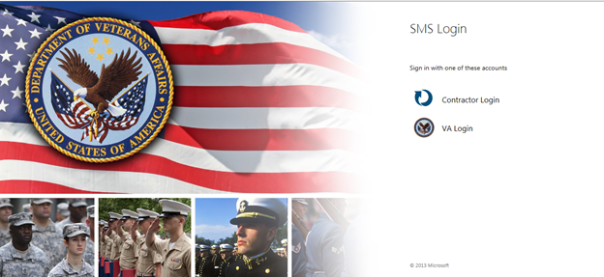

1. After selecting VA Login, the VA Single Sign-On window opens up. Select “View Other Sign-in Options” (highlighted in yellow).

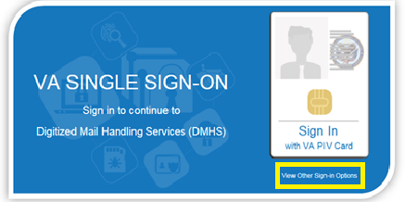

1. Select the “Sign In with Windows Authentication.”

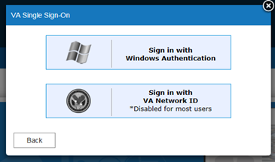

**Please note**: **PIV badge is required for CMP login. Users without a PIV badge will not be able to login to the CMP.**

Please confirm with the POCs once all VSOs and CVSOs have accessed CMP.

Any questions may be directed to OFO POCs Kyle Lee ([kyle.lee@va.gov](mailto:kyle.lee@va.gov)) or Dan Nguyen ([dan.nguyen2@va.gov](mailto:dan.nguyen2@va.gov)).

Thank you,

Office of Field Operations

# *Appendix B – DRC Coversheet*

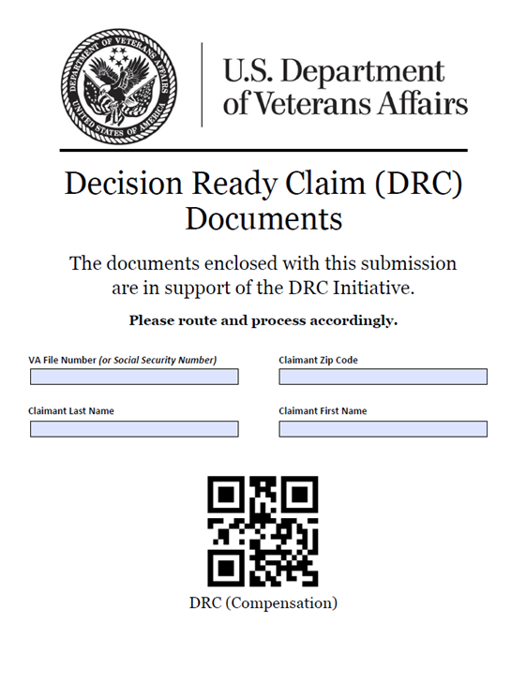

|  |  |
| --- | --- |
| ***Access the DRC Coversheet here:*** |  |

# *Appendix C – Contract Examination Exclusions*

Circumstances under which contract examinations ***must not*** be requested include, but are not limited to, the following:

* Former Prisoner of War (FPOW) Protocol Examination is required
* claim for disability based on exposure to environmental hazards, such as Camp Lejeune contaminated water (CLCW), burn pits, and chemical and biological warfare agents (to include original/new claims, review examinations, and claims for increased disability)
* initial claim for disability based on Gulf War undiagnosed illness (follow-up examinations ***may*** be ordered through contract exam providers)
* claim for any of the following disabilities, if a clinical diagnosis is not a matter of record:
  + Parkinson’s disease
  + multiple sclerosis
  + amyotrophic lateral sclerosis (ALS)
  + narcolepsy
  + epilepsy
  + fibromyalgia
  + chronic fatigue syndrome, and/or
  + restless leg syndrome
* Veteran requires overnight stay (e.g. for performance of a sleep study)
* Veteran requires ambulatory transportation to attend the examination appointment
* Examination requires hospitalization or surgical evaluation, such as colonoscopy
* Veteran is incarcerated
* Veteran is known to be violent (i.e. requires the presence of security personnel during examination)
* Examination based upon a remand from Court of Appeals for Veteran’s Claims
* Veteran is pregnant
* Veteran is an inpatient at a VHA facility, nursing home, extended care facility, or domiciliary (including state-operated Veterans’ homes)
* Veteran requires a Social and Industrial Survey
* Examination for a Veteran’s dependent or survivor
* Veteran is deceased, and an opinion is required
* Veteran has filed a tort claim
* Veteran is filing an initial claim for compensation under 38 U.S.C. 1151
* Veteran is claiming pension, and
* Veteran is a VACO employee.

***Exception***:  Disability claims based on herbicide exposure, unlike those based on exposure to other environmental hazards, are ***not*** excluded from referral to contract examination providers.

# *Appendix D – VA Form 21-4138 Example*

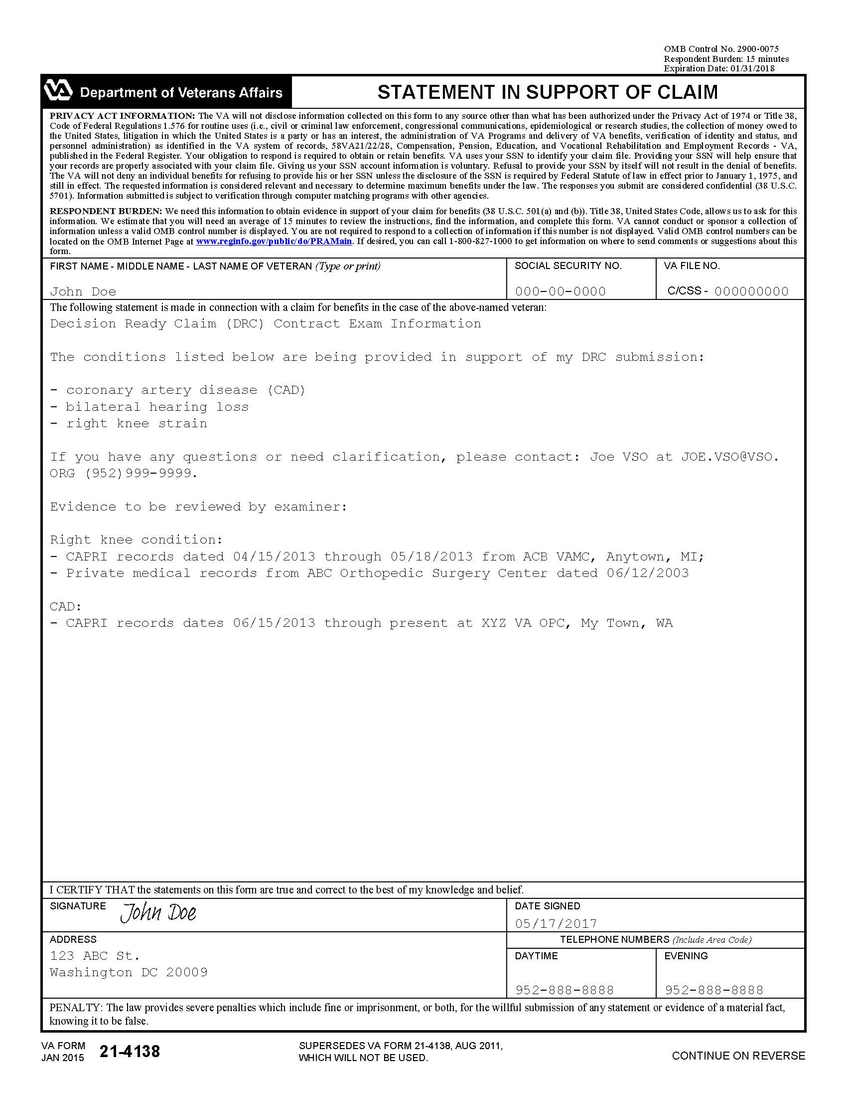

# *Appendix E – DRC Implementation Plan*

The below schedule is current as of July 5, 2017, and may be subject to change.

|  |  |  |
| --- | --- | --- |
| **REGIONAL OFFICE DRC IMPLEMENTATION PLAN** | | |
| **Phase 1** | **Phase 2** | **Phase 3** |
| ***Training: Apr 17-21, 2017*** | ***Training: Jun 5 - Jun 9*** | ***Training: Jun 12 - Jun 16, 2017*** |
| ***Go-Live: May 1, 2017*** | ***Go-Live: Jun 12, 2017*** | ***Go-Live: Jun 19, 2017*** |
| St. Paul | Waco | Houston |
|  |  |  |
| **Phase 4 - Cohort 1** | **Phase 4 - Cohort 2** | **Phase 4 - Cohort 3** |
| ***Training: Jul 17 - 21, 2017*** | ***Training: Jul 24 - 28, 2017*** | ***Training: Jul 31 - Aug 4, 2017*** |
| ***Go-Live: Jul 24, 2017*** | ***Go-Live: Jul 31, 2017*** | ***Go-Live: Aug 7, 2017*** |
| Baltimore | Reno | Portland |
| Boston, White River, Manchester | Albuquerque, Boise | Anchorage, Honolulu |
| Hartford | Des Moines, Little Rock | Chicago |
| Denver, Cheyenne (I) | Pittsburgh | Huntington |
| Wichita | San Juan | Los Angeles (I) |
| Fargo, Sioux Falls | Jackson | Muskogee |
| Newark | Winston-Salem (I) | Nashville (I) |
| **Phase 4 - Cohort 4** | **Phase 4 - Cohort 5** | **Phase 4 - Cohort 6** |
| ***Training: Aug 7 - 11, 2017*** | ***Training: Aug 14 - 18, 2017*** | ***Training: Aug 21 - 25, 2017*** |
| ***Go-Live: Aug 14, 2017*** | ***Go-Live: Aug 21, 2017*** | ***Go-Live: Aug 28, 2017*** |
| Atlanta | Philadelphia, Wilmington | St. Petersburg (I) |
| Buffalo, Providence | Indianapolis | Columbia |
| Salt Lake City, Ft. Harrison | San Diego (I) | Lincoln |
| Togus, New York | Cleveland | Montgomery |
| St. Louis | Detroit | Louisville |
| Oakland (I) | New Orleans | Phoenix |
| Milwaukee | Seattle | Roanoke |
| **Phase 4 - Cohort 7** |  |  |
| ***Training: TBD*** |  |  |
| ***Go-Live: TBD*** |  |  |
| Manila |  |  |
|  |  |  |
|  |  |  |

# *Appendix F – Frequently Asked Questions (FAQs)*

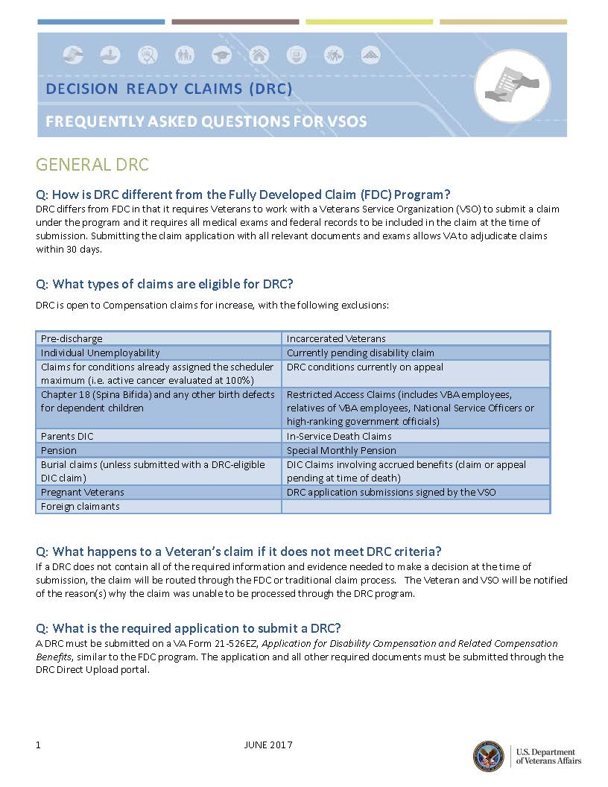

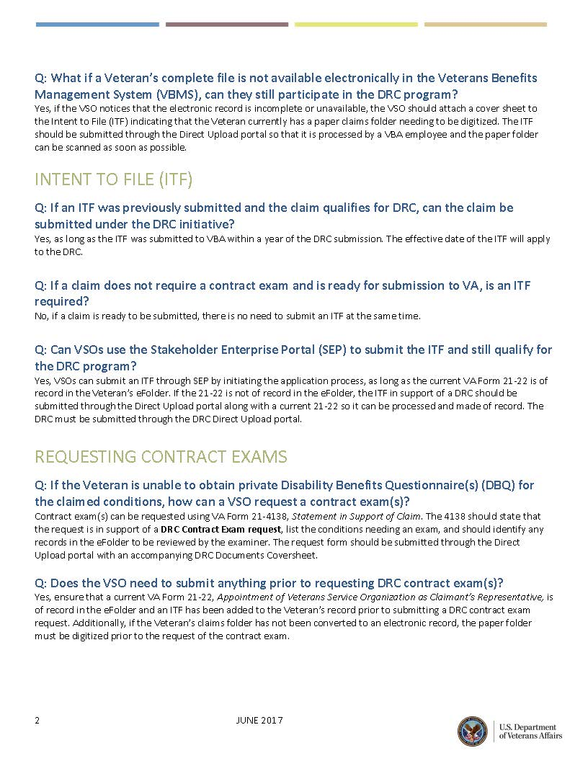

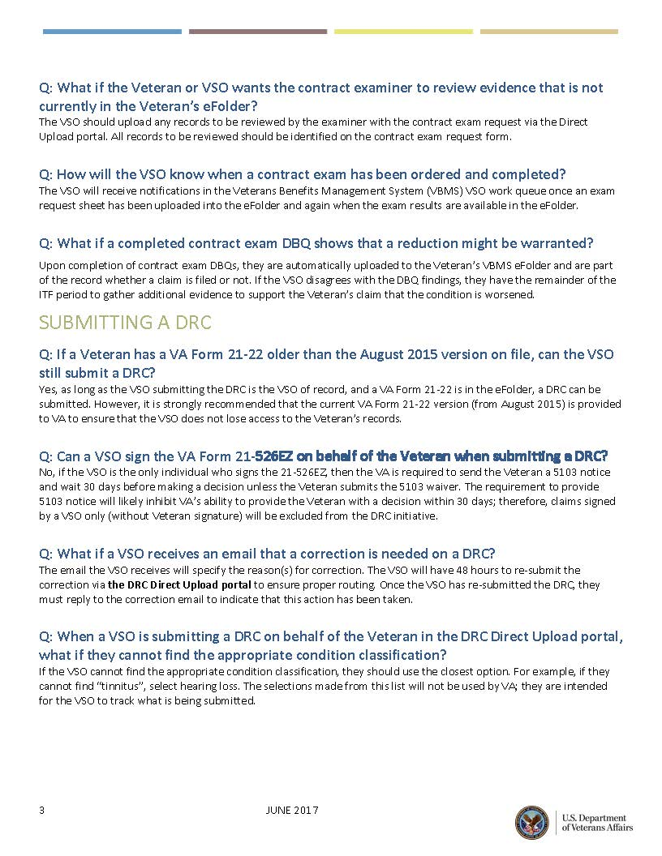

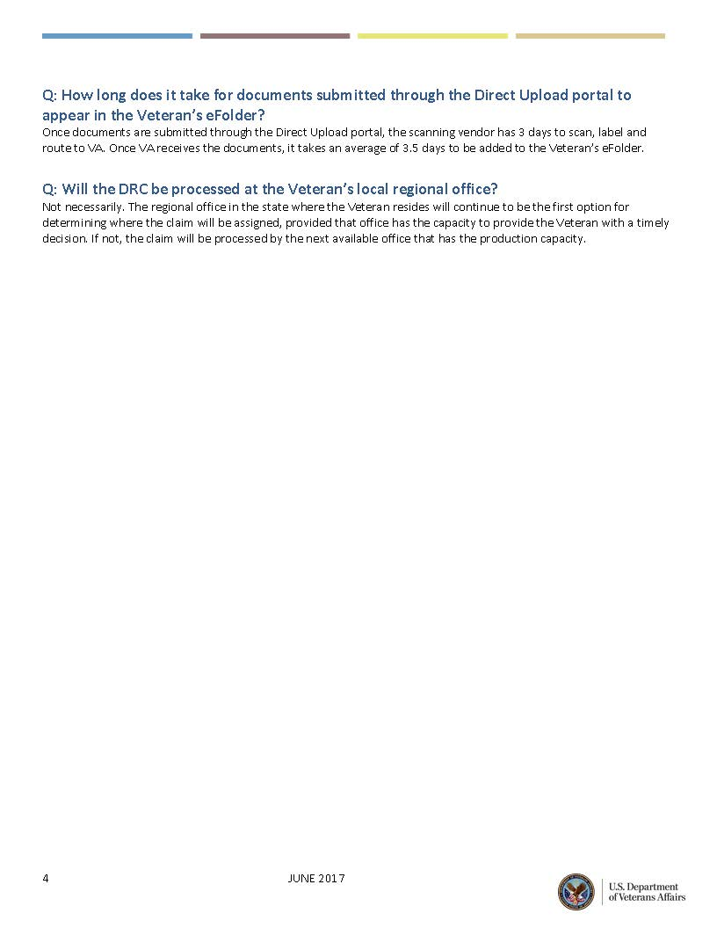

|  |  |
| --- | --- |
| ***Access the DRC FAQ here:*** [DRC RO SharePoint site](https://vaww.portal2.va.gov/sites/OfficeofFieldOperations/VACO-AREA-RO_Data_Rollup/DRC-RO/DRCDocument/Forms/AllItems.aspx). |  |

# *Appendix G – DRC Fact Sheet*

# 

|  |  |
| --- | --- |
| ***Access the DRC Fact Sheet here:*** [DRC RO SharePoint site](https://vaww.portal2.va.gov/sites/OfficeofFieldOperations/VACO-AREA-RO_Data_Rollup/DRC-RO/DRCDocument/Forms/AllItems.aspx). |  |