Tracked Items for Post Submission Correlation of 526 and 4142 Forms

# Overview

The VA.gov online 526 Claims submission process allows veterans to authorize the Veterans Administration to retrieve their private medical records for them via the 4142 form. The 4142 and 4142a data (PMR data) require processing by the PMR vendor to retrieve the medical records and upload to VBMS E-Folder. An API has been implemented that can support this processing. The Intake, Conversion and Mail Handling Services (ICMHS) API is currently being leveraged by the Pension and Burials forms for similar processing. This interface is sometimes referred to as the Benefits Intake API and VCIP. For the purposes of this document we will use ICMHS when describing interactions with the API. The process flow for ICMHS is shown below. The 526 flow leverages a different API based on EVSS to submit data and upload forms to the VBMS E-Folder. This presents a challenge in associating the PMR data with the 526 Claim data. Processing of the PMR data can take up to 20 days whereas the 526 data is processed near real time.

The collection of Private Medical Records (PMRs) as supporting evidence in a 526 claim is initiated via forms 21-4142 and 21-4142a. We will refer to these combined forms as 4142 or collectively as PMR data.

The Veterans Benefits Administration (VBA) uses VA Form 21-4142, Authorization to Disclose Information to the Department of Veterans Affairs (VA), to request private medical records and information regarding the source of records in support of claims for compensation and/or pension benefits. The response helps VA determine whether a source identified by the claimant has pertinent information or records available to consider.

# Process Flows

The below diagrams capture the process flow for the 526/4142, the Benefits Intake API process flow, and the PMR flow.

## 526/4142

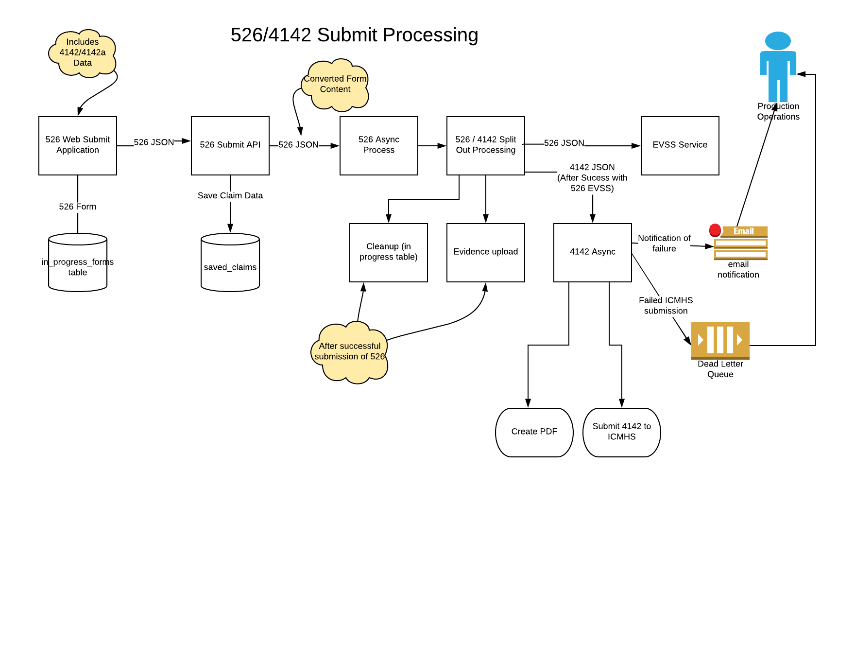

## Benefits Intake Process Flow

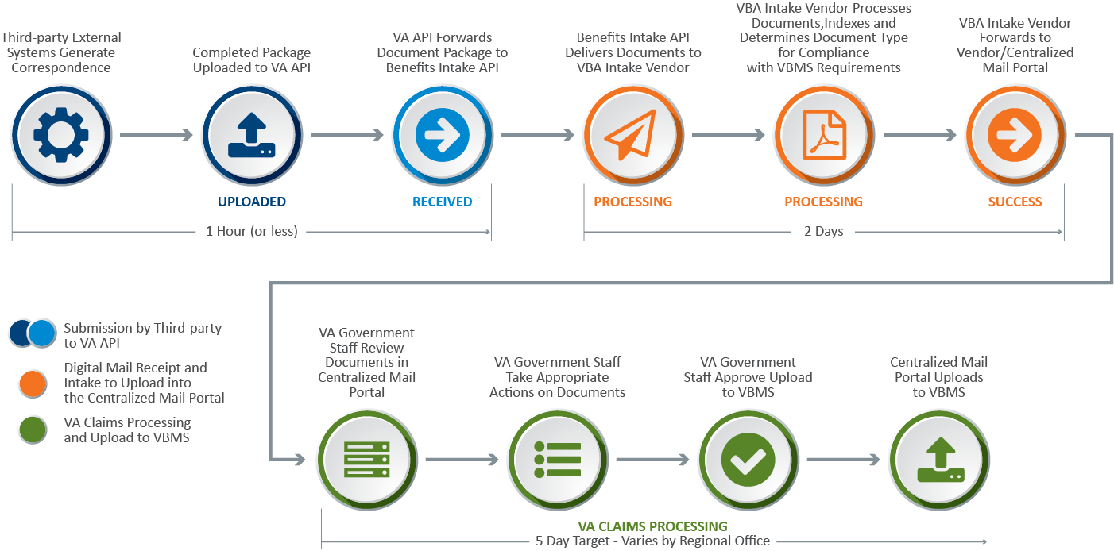

# PMR Routing

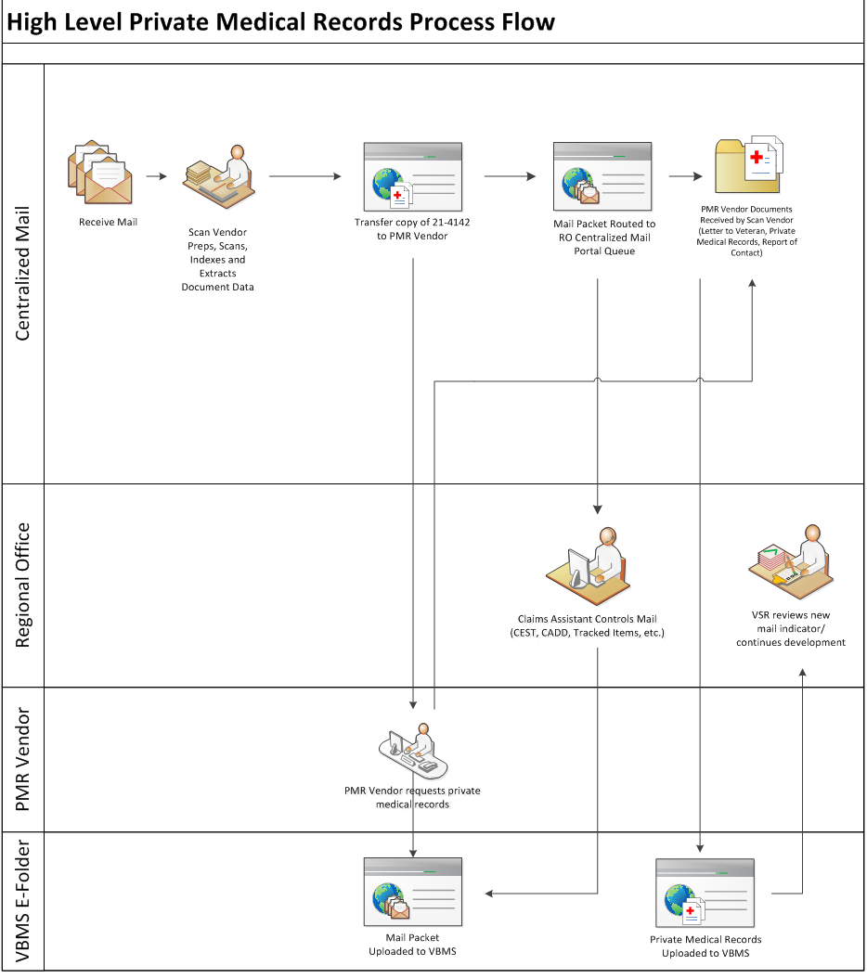

# Solution Approaches

Since the 526 submission is near real time and the 4142 make take up to 20 days to be added to VBMS there is a chance that the VSR may start the adjudication process before the PMRs are retrieved. In the current VBMS system the Tracked Item is a method to indicate to the VSR that PMRs are being processed. Currently the vets.gov or EVSS platforms do not have the ability to programmatically initiate a Tracked Item to VBMS. As a long-term solution, the Tracked Item will be evaluated. As a short-term solution for MVP the overflow pages for the 526 can be leveraged to indicate a 4142 is in process.

## VBMS Tracked Item Service

The VBMS system currently has a mechanism to correlate through a Tracked Item. We summarize the service below. The Tracked Items Service v1.0 Service Contract Document(0003AE_Tracked Items v1.0 SCD 15.0_05112018.pdf) contains the full implementation details.

The following figure displays other services, systems, and databases that the Tracked Items service depends upon or interacts with.



The service utilizes BEP for security purposes. At a high level, a calling client application should integrate with a trusted Identity Provider (IdP) within the BEP infrastructure. The integration mechanism varies based on the type of service consumer.

The IdP collects the username and password from the end-user and then delivers a Security Assertion Markup Language (SAML) token back to the client application confirming the user’s successful authentication into the system.

The client application passes this SAML token to the desired web service within a security element that is part of the message header for the request. The web service tests the validity of the SAML token received from the client application, and either allows access to the invoked service or returns a Simple Object Access Protocol (SOAP) fault to the client application.

**Tracked Item Service Inputs**

|  |  |
| --- | --- |
| **Item** | **Description** |
| fileNumber | String - the fileNumber for the Veteran to associate to the TrackedItem. |
| claimID | Long - the claimId to associate to the TrackedItem |
| suspenseDays | Integer - the number of suspenseDays to be applied to the TrackedItem. |

# Procedural Guidance for Tracked Items

To ensure adequate tracking of development actions completed by the contractor under the PMR Program, RO employees must manually create a tracked item in VBMS when a PMR request is pending.

RO employees must follow the steps in the table below

* prior to placing a case in ready for decision (RFD) status, or
* before making a decision on any case placed in RFD status automatically.

| **Step** | **Action** |
| --- | --- |
| 1 | Review the VBMS electronic contents to verify a medical release request is pending in the PMR Program.  In these cases, the eFolder will contain the   * third party notice sent to the claimant by the PMR contractor, and * medical release request forms bearing the watermark PMR Program Referred.   ***Example***:  **Note**:  If it is determined that medical release requests were sent and they are now rejected or returned to VA, then follow the steps noted in [**M21-1, Part III, Subpart iii, 1.D.2.h**](https://www.knowva.ebenefits.va.gov/system/templates/selfservice/va_ssnew/help/customer/locale/en-US/portal/554400000001018/content/554400000036530/M21-1-Part-III-Subpart-iii-Chapter-1-Section-D-Requesting-Evidence-From-Private-Healthcare-Providers-PHPs#2h). |
| 2 | If a request is still pending in the PMR Program, add a tracked item to VBMS.   * On the CLAIM DETAILS screen, click the   + TRACKED ITEMS tab, and then   + ADD TRACKED ITEM button. * From the ADD TRACKED ITEMS screen   + choose Custom Tracked Item from the CHOOSE A CATEGORY drop-down men   + select the Custom Tracked Item development action, and   + click the ADD TO LIST button. |
| 3 | Click the ADD button to finalize the tracked item after entering the following data:   * enter “DOMA pending – [provider name]” in the ITEM REQUESTED field, and * enter the amount of days remaining from the 35 day suspense period following the initial PMR request.   ***Example***:  If establishing the tracked item 10 days after the PMR request, input 25 in the TRACKED ITEM SUSPENSE field.  **Note**:  In the event the PHP does not respond, the PMR contractor will start the close-out process 31 days after the initial request by completing[**VA Form 27-0820**](http://vbaw.vba.va.gov/bl/20/cio/20s5/forms/VBA-27-0820-ARE.pdf), documenting attempts made to receive the records.  Creating a suspense date 35 days after the initial PMR request will enable the PMR contractor to route [**VA Form 27-0820**](http://vbaw.vba.va.gov/bl/20/cio/20s5/forms/VBA-27-0820-ARE.pdf)through internal quality controls and then for electronic ingestion/transfer to VBMS. |

# Implementation

The Tracked Item Service provided by VBMS is not currently exposed to the Vets.gov platform or EVSS. Additionally, the EVSS platform is not being updated to create new services. New services will be created under the BIP Platform Services.

# Technical Requirements

## 

## Request Volume from VA.gov

## Security Requirements