526 Claim for Increase Flow Integration with PMR (4142/4142a)

(DRAFT)

Table of Contents

Overview 2

Design Considerations 2

Providers per condition 2

Form Builder 2

Option 1 2

Option 2 2

Design Decision 3

526/4142 Integration 3

526/4142 Flow 3

Integration Details 5

External Processing of PMR data 6

Overview 6

PMR Data Processing 6

ICMHS Flow 7

Design Decisions 8

Design Points 8

Requirements Refinements / Questions 8

# Overview

The collection of Private Medical Records (PMRs) as supporting evidence in a claim for increase is initiated via forms 21-4142 and 21-4142a. We will refer to these as 4142 and 4142a or collectively as PMR data.

The Veterans Benefits Administration (VBA) uses VA Form 21-4142, Authorization to Disclose Information to the Department of Veterans Affairs (VA), to request private medical records and information regarding the source of records in support of claims for compensation and/or pension benefits. The response helps VA determine whether a source identified by the claimant has pertinent information or records available to consider.

# 526 / 4142 Integration

Below is a summary of the 526/4142 process. Ownership of these tasks needs to be identified since some of these changes require updates to files created and managed by Ad Hoc.

## UI

* 4142 pages will be added to 526 form - BAH
* 4142 schema will be imported into the 526 schema - BAH
* Update prefill to include PMR elements - BAH
  + full_name, ssn and date_of_birth
  + Available in user profile
  + Example in 526
* Update the PMR choice page -BAH
  + <https://staging.vets.gov/disability-benefits/apply/form-526-disability-claim/supporting-evidence/0/private-medical-records-choice>
  + Need to add patient authorization text and checkbox
  + Need to remove download option
* Composite PMR – Flow needs to change to collect providers on one screen instead of per condition. Pending UI mockups
* Summary of Evidence Page – Display provider names
* Review and Submit page
  + Ability to edit all PMR data on “Review and Submit” page
  + <https://staging.vets.gov/disability-benefits/apply/form-526-disability-claim/review-and-submit>

## API

* 526 submit processing includes 4142 in JSON payload
* 526 API saves data to saved_claims table
* API invokes 526 async process
* Async process will split out 526 and 4142 data – Ad Hoc (BAH to define required elements)
* After completion of 526 EVSS submission the 4142 API will be invoked with 4142 JSON object – Do we need API or can we invoke async directly
* 4142 API invokes 4142 async process
* 4142 async process creates PDF from 4142 JSON
* 4142 async submits 4142 via ICMHS API

## Outstanding Items

* Failure processing for 526 async and 4142 async
* Correlating 526 submission with 4142 (Tracked Item)

# Design Considerations

## Providers per condition

The 526 UI collects supporting evidence for each rated condition in the evidence category of “VA Medical Records” , “Private Medical Records” and “Lay statements or other evidence”. The 4142a does not associate providers to a condition. For the implementation of the 4142 flow all providers will be included on a single 4142a and they will not be associated with a condition.

## Form Builder

The vets.gov platform includes a Form Builder capability to provide creation and processing of web forms. The forms are associated with the vets-api via a schema to support claims processing. In reviewing the options for processing of Private Medical Records there were two options for the processing of PMR related data.

### Option 1

The PMR data could be added to the 526 Schema for the web and API processing. This would minimize the amount of new code to be developed as it would leverage the existing 526 components and processing. This would also require coordination between the Ad Hoc and BAH teams as both teams would be potentially modifying the same components. Option 1 provides less flexibility to 4142 form UI as it would become tightly coupled within 526 schema. So in future if we need to trigger 4142 in a different flow this design won’t support it

### Option 2

Use the Form Builder to create a new web form to support the collection of PMR data. This approach requires implementation of all the processing components but minimizes dependencies with the 526 code base. This will also introduce some design considerations such as navigation components as the 4142 form will show up as a form in the navigation. Option 2 provides flexibility for the 4142 form UI as the form could be triggered in a different flow and integrated with it

### Design Decision

Option 1 will be leveraged to support the PMR data processing. This option was chosen to eliminate the need to pass data between the two forms.

## 526/4142 Integration

### 526/4142 Flow

The diagram below depicts the proposed 526 flow and interactions with the PMR data processing components.

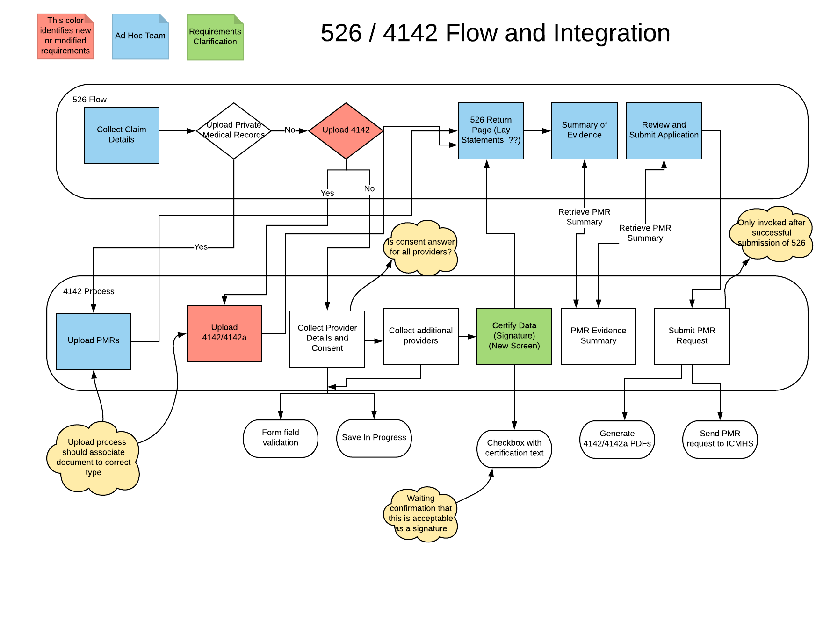

### Flow Questions / Comments

In 526 flow, interview question is “Do you want to upload your private medical records?” when the Veteran selects “No, my doctor has my medical records”, then in the next screen we start collecting provider information. I am not clear on where again the Yes option is for modified requirements to still upload private medical records?

In 526 flow, interview question is “Do you want to upload your private medical records?” if the Veteran changes the option and selects “Yes” after entering the provider data, then 526 flow must identify it and call an end point to DELETE existing in progress form data for 4142, if there isn’t a “No” option selected for any / all conditions.

On the “Summary of Evidence” page, we will need to display the private provider names on 526. So, we would need an API end point to support returning the list of private provider names.

On “Review and Submit Application” page, do we need any additional link to edit the 4142 form?

In the last flow of “Submit PMR Request” there is a sequential flow to “Generate 4142/4142a PDFs” first and then do submit for “Send PMR document and metadata to ICMHS”

### 

## External Processing of PMR data

### Overview

The 4142 and 4142a data (PMR data) require processing by the PMR vendor to retrieve the medical records and upload to VBMS E-Folder. An API has been implemented that can support this processing. The Intake, Conversion and Mail Handling Services (ICMHS) API is currently being leveraged by the Pension and Burials forms for similar processing. This interface is sometimes referred to as the Benefits Intake API and VCIP. For the purposes of this document we will use ICMHS when describing interactions with the API. The process flow for ICMHS is shown below. The 526 flow leverages a different API based on EVSS to submit data and upload forms to the VBMS E-Folder. This presents a challenge in associating the PMR data with the 526 Claim data. Processing of the PMR data can take up to 10 days whereas the 526 data is processed near real time. The VBMS system provides the ability to correlate this data through a Tracked Item. This capability needs to be explored as a solution for the 526/4142 flow.

### PMR Data Processing

The PMR processing will leverage the vets.gov platform capabilities via vets-website, vets-json-schema, and vets-api for processing of the data collected via the web interface. This requires interaction with the 526 flow as described above. Vets will provide claim data and supporting evidence through the 526 flow. The platform provides a save in progress capability so that Vets can add data incrementally. Once all the data is completed the Vet will certify the data by selecting a checkbox associated with certifying text. It is assumed this certification dialogue is sufficient for applying a digital signature to the 4142. At the completion of the flow the Vet will click the “Submit” claim button. This will trigger the submission of the 526 claim data. This will be processed asynchronously. After the 526 processing component has received confirmation that the 526 was submitted it will trigger the asynchronous processing of the 4142 data. TBD INTERACTION OF 4142 API 526 AND BACKGROUND ICMHS PROCESS.

The 4142 API will take the form data that has been collected and create a single PDF consisting of the 4142 and 4142a data. The PDF creation will leverage the platform capability including the application of a digital signature to the document. It is assumed that the 4142 processing would not be invoked unless the Vet certified the data via the certification checkbox. This document will be queued for processing by the asynchronous 4142 job. The 4142 job will create the necessary meta-data and leverage the ICMHS API to submit the PMR PDF for processing by the PMR vendor.

### ICMHS Flow

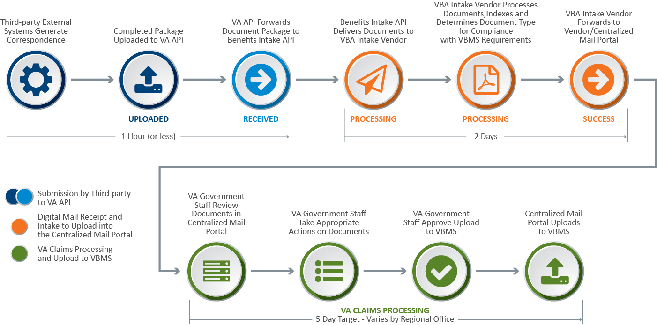

# Design Decisions

Below are some design decisions that need to be validated and approved. The approach for these items are described above but summarized here for consideration.

## Design Points

* Signature
* Tracked Items
* Providers collected per condition
* Limited Consent Text Box – Web Interface doesn’t provide ability to enter free text as is allowed on PDF form. Need text to be provided if Vet is limiting consent. Also need to confirm we can certify the data since this was not entered by the Vet
* Certification of data

## Requirements Refinements / Questions

* Upload of completed 4142 and 4142a forms – During a requirements session the option of uploading completed 4142 and 4142a was discussed. This requirement needs to be evaluated, approved, and then implemented which will require new questions in the flow.
* Text on the following page indicates a 4142 must be completed for each doctor (<https://staging.vets.gov/disability-benefits/apply/form-526-disability-claim/supporting-evidence/0/private-medical-records-choice>) Text - *Since your doctor has your private medical records, you’ll need to fill out an Authorization to Disclose Information to the VA (VA Form 21-4142) so we can request your records. You’ll need to fill out a form for each doctor.*
* Edit option on Review and Submit Page - <https://staging.vets.gov/disability-benefits/apply/form-526-disability-claim/review-and-submit> – Veteran can edit their option to provide PMR data on the summary screen. In staging site this doesn’t take them back to screen for adding PMR data.