**Department of Veterans Affairs**

Intake, Conversion and Mail Handling Services (ICMHS)

API for Vets.gov Interface

**T4 - Intake, Conversion and Mail Handling Services**

Version 2.0

July 31, 2018

DOCUMENT CHANGE HISTORY

The following table summarizes the document change history for the DMHS Integration Approach.

|  |  |  |  |  |
| --- | --- | --- | --- | --- |
| Version # | Change # | Date | Description | Author |
| 1.0 | N/A | October 16, 2017 | ICMHS API for vets.gov connection - DRAFT | ICMHS  Debbie Elgot |
| 1.0 | N/A | January 31, 2018 | ICMHS API for vets.gov connection | ICMHS  Rebecca DeAngelis |
| 1.1 | 1 | February 12, 2018 | Adding Vendor updates | ICMHS  Rebecca DeAngelis |
| 1.2 | 1 | February 12, 2018 | Edits from 2/14 meeting with vets.gov | ICMHS  Rebecca DeAngelis |
| 1.3 | 1 | February 15, 2018 | Updating Source to Vets.gov | ICMHS  Rebecca DeAngelis |
| 1.4 | 2 | March 15, 2018 | Edits from 3/15 meeting with vets.gov.  receiveDt in UTC timezone and changing fileNumber to a string. | ICMHS  Rebecca DeAngelis |
| 1.5 | 1 | March 16, 2018 | VBA ruled that timezone must be Central to be consisted with DRC and Claims | ICMHS  Rebecca DeAngelis |
| 1.6 | 2 | March 19, 2018 | Added two error codes | ICMHS  Rebecca DeAngelis |
| 1.7 | multiple | March 28, 2018 | Sanitized for public use | ICMHS  Rebecca DeAngelis |
| 1.8 | 2 | April 11, 2018 | Made docType optional and file size limit 100MB | ICMHS  Rebecca DeAngelis |
| 1.9 | 1 | May 25, 2018 | CSRA will start accepting international zip codes | ICMHS  Rebecca DeAngelis |
| 2.0 | 1 | July 31, 2018 | Section 2.2.3.1. Status update | ICMHS  Rebecca DeAngelis |

.

TABLE OF CONTENTS

1. Introduction 1–1

1.1 Purpose 1–1

1.2 Scope 1–1

2. ICMHS API for VETS.GOV to send FORMS 2–1

2.1 Overview 2–1

2.2 Technical Description 2–2

2.2.1 Connection Details 2–2

2.2.2 /VADocument/upload 2–2

2.2.3 /VADocument/getStatus 2–4

2.2.4 / VADocument /getUploadStatusSinceTime 2–5

# Introduction

## Purpose

This document presents the API documentation for the interchange of data between Vets.gov and ICMHS to allow for the uploading of forms into Intake Conversion Mail Handling Service (ICMHS). Specifically, this document specifies interface requirements of the participating systems, describes the concept of operations for the interface, defines the message structure and protocols that govern the interchange of data, and identifies the communication paths along which the data is expected to flow.

## Scope

Initially, only pension and burial forms will be supported. Monthly volumes are projected as follows:

|  |  |  |  |
| --- | --- | --- | --- |
|  | **VETS.GOV** | | |
|  | **Pension forms** | **Burial Forms** | **Total** |
| Pages per form | 5 | 2 |  |
| # forms/month | 300 | 100 | 400 |
| # pages/month | 1,500 | 200 | 1,700 |

Projected Monthly Volume

After the forms are collected in ICMHS, the forms will then be uploaded to DMHS. This will be done using the same software and connections that are used for the current National Call Center (NCC) uploads to DMHS, using the existing ISA/MOU.

# ICMHS API for VETS.GOV to send FORMS

## Overview

The diagram below shows the workflow of the new system.

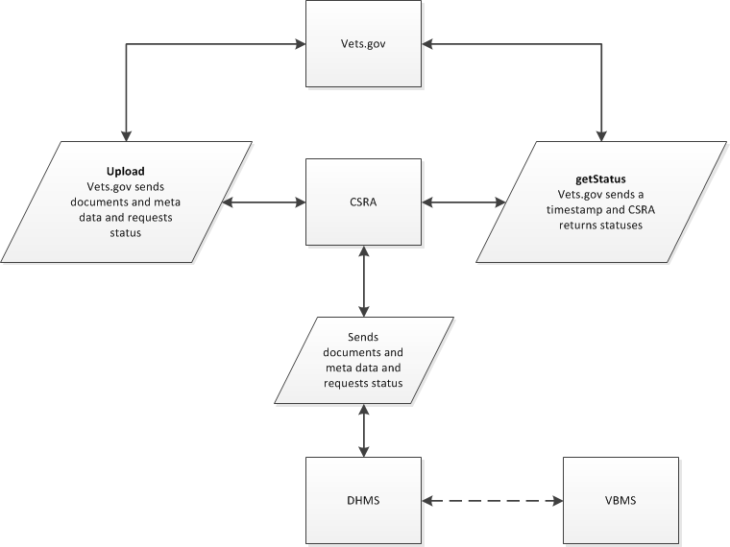

ICHMS Vets.gov Workflow 1

## Technical Description

ICMHS will provide the following two REST APIs over HTTPS to support uploading vets.gov documents to DMHS.

### Connection Details

Communication between two parties will happen over a secure SSL/TLS connection and ICMHS will furnish an api token that needs to be used in every API call.

### /VADocument/upload

This endpoint excepts a multipart-form can be posted containing the following fields:

|  |  |  |  |  |
| --- | --- | --- | --- | --- |
| Parameter Name | Required? | Type | Source | Details |
| token | Y | String | ICMHS | Permit access to call API.  If not correct, system will get 401 Unauthorized |
| document | Y | File/form | Vets.gov | The content of the PDF document |
| attachment1 attachment2 attachment3 | N | File/Form | Vets.gov | Attachments with the same UUID as the main form |
| metadata | Y | JSON | Vets.gov | VBMS required parameters. JSON Map metadata |

The metadata fields are JSON map with the following keys:

|  |  |  |  |  |
| --- | --- | --- | --- | --- |
| Parameter Name | Required? | Type | Source | Details |
| veteranFirstName | Y | String | vets.gov |  |
| veteranLastName | Y | String | vets.gov |  |
| fileNumber | Y | String | vets.gov | An eight or nine digit number. |
| receiveDt | Y | Date/Time | vets.gov | Date received from the Veteran supplied by vets.gov. ICMHS is assuming the format will be: yyyy-mm-dd hh:mm:ss.  Must Central Timezone to stay consistent with DRC and claims |
| zipCode | Y | String | vets.gov | CSRA will accept domestic zip codes and 00000’s for international zip codes. |
| source | Y | String | vets.gov | Vets.gov |
| uuid | Y | String | vets.gov | A Java unique identifier |
| hashV | Y | String | vets.gov | SHA-256 hash of the main form document. |
| ahash1 ahash2 | N | String | vets.gov | SHA-256 hash of the received attachment. |
| numberAttachments | Y | Number | vets.gov | How many attachments |
| docType | N | String | vets.gov | Optional document type, could be overwritten by vendors |
| numberPages | Y | Number | vets.gov | Number of pages in the PDF form. |
| numberPages1 numberPages2 | Y – if attachments are present | Number | vets.gov | Page numbers for the attachments |

Although vets.gov will be doing the POST from their server, below is an example of what an HTML form might look like if it was tested from a browser:

<form action="/VADocument/upload" enctype="multipart/form-data"

method="post"> <input type="hidden" name="token" value="your-token"/>

<input class="form-control" id="document" name="document"

type="file"/> <input class="form-control" id="metadata"

name="metadata" type="text" value='{"prop1":"val1","prop2":"val2"}'/>

<input type="submit" value="Submit">

</form>

The response might look something like:

{"fileSize":867183,"metaSize":31,"md5":"xxxxxxxxxxxxxxxxx"}

Below is a Curl command that illustrates posting a PDF called file.pdf to the staging server:

curl -F 'token=xxxxxxxxxxxxxxxx' -F

metadata='{"field1":"value1","field2":"value2"}' -F

[document=@file.pdf<mailto:document=@file.pdf](mailto:document=@file.pdf%3cmailto:document=@file.pdf)>

https://xxxxxxxxx.xxx/VADocument/upload

The received documents will be stored with the metadata and fully encrypted on S3. The metadata should be less than 2KB. There file size limit is maximum of 100MB (per VBMS specifications).

#### Response

ICMHS will immediately return one of the following codes to vets.gov.

|  |  |
| --- | --- |
| Error Code | Description |
| 200 | Success – ICMHS received successfully, but not processed and at VBMS |
| 400 | Duplicate – document already uploaded with that uuid |
| 401 | Unauthorized – missing or incorrect token |
| 409 | Conflict - mismatched attachments and numbers |
| 412 | Precondition Failed – for meta data failures |
| 415 | Unsupported File type |
| 422 | Unprocessable Request– no file, or issue with PDF, missing attachments |
| 500 | Server Error |

### /VADocument/getStatus

This post requires a UUID and ICMHS will return one or more responses

|  |  |  |  |  |
| --- | --- | --- | --- | --- |
| Parameter Name | Required? | Type | Source | Details |
| token | Y | String | ICMHS | Permit access to call API. If not correct, system will get 401 Unauthorized |
| uuid | Y | String | vets.gov | A list with the maximum of 100 |

#### Response

Please note, these statuses will take time to appear.

|  |  |  |  |  |
| --- | --- | --- | --- | --- |
| Parameter Name | Required? | Type | Source | Details |
| uuid | Y | String | vets.gov | A Java unique identifier, randomness, time |
| status | Y | String | ICMHS | Received/ received by ICMHS In Process/being worked on Success/received by DHMS Error/with errorMessage  Processing Success/Processing Error |
|  |  |  |  |  |

### / VADocument /getUploadStatusSinceTime

This end point accepts a date/time that returns statuses changed since that time.

|  |  |  |  |  |
| --- | --- | --- | --- | --- |
| Field Name | Required? | Type | Description | Source |
| token | Y | String | Permit access to call API.  If not correct, you will get 401 Unauthorized | Vets.gov |
| time | Y | String | yyyy-MM-dd HH:mm:ss | Vets.gov |

Will return a list of 100 uuids with data in the table below, along with the nextTime field – which will contain the date/time Vets.gov can call this API again.

|  |  |  |  |  |
| --- | --- | --- | --- | --- |
| Field Name | Required? | Type | Description | Source |
| imageId | Y | String | Vets.gov unique scan id | Vets.gov |
| dcsId | Y | Number |  | VBMS |
| status | Y | Number | 200 | CSRA |
| errorMessage | Y | String |  | CSRA |