**Private Medical Records**

If the Veteran has private medical records, they can upload them directly to the online application, or authorize the VA to get them from the private doctor.

**Upload**

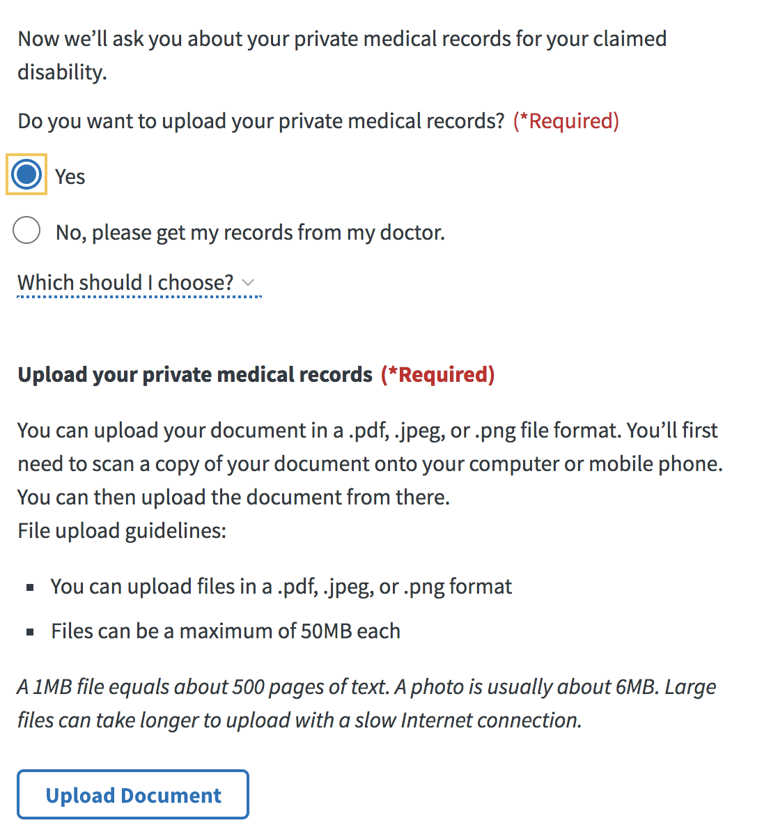

**Complete 4142/4142a**

If the Veteran selects “No, please get my records from my doctor” then the Veteran is presented with a Patient Acknowledgement.

The Patient Acknowledgement check box is required, and it is selected by default. If the Veteran clears this check box, they will not be able to continue with the authorization.

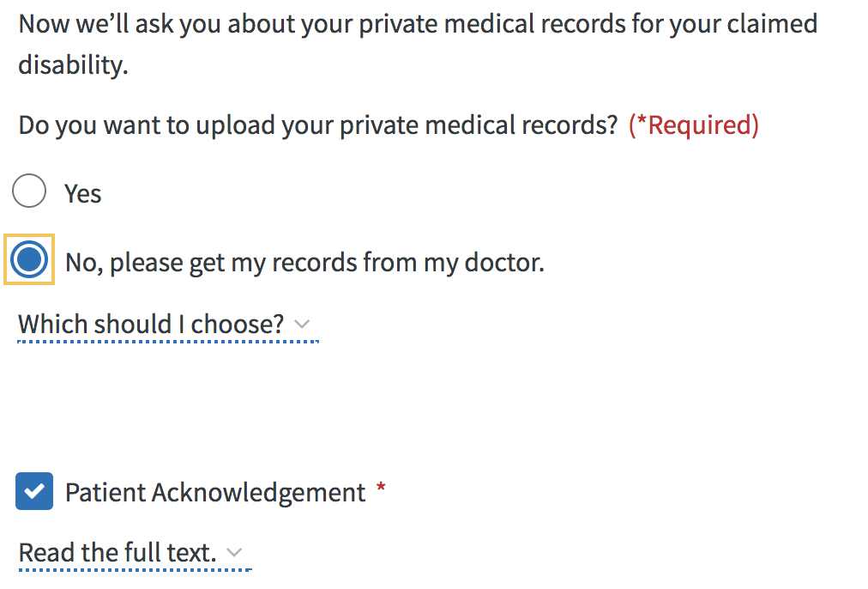

Veterans can select “Read the full text” to expand the Patient Authorization and Patient Acknowledgement text.

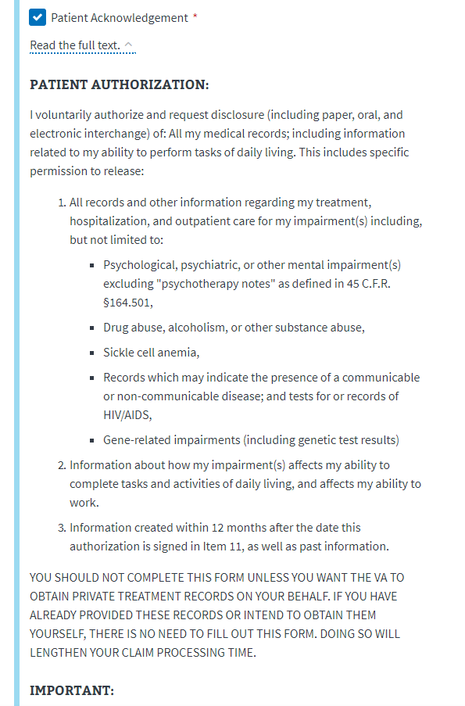

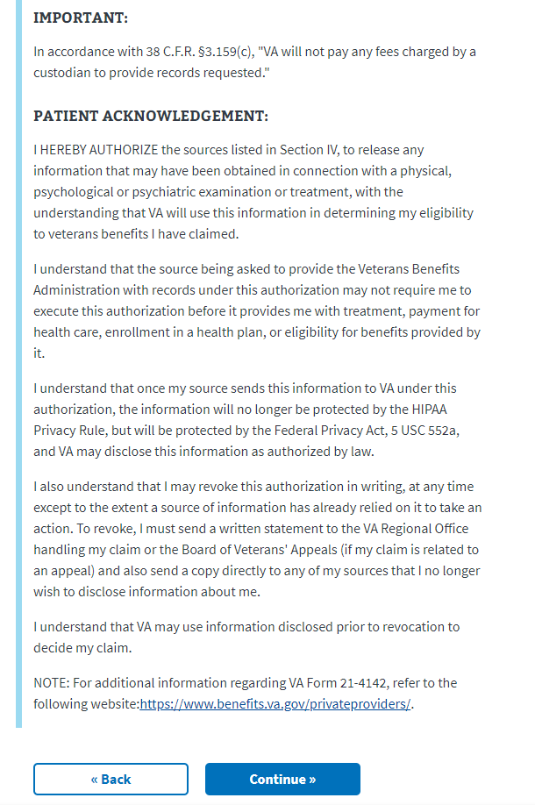

After a Veteran clicks the **Continue** button, the private provider name, address, and approximate first and last date of treatment are required on the next page.

**4142a Cont’d**

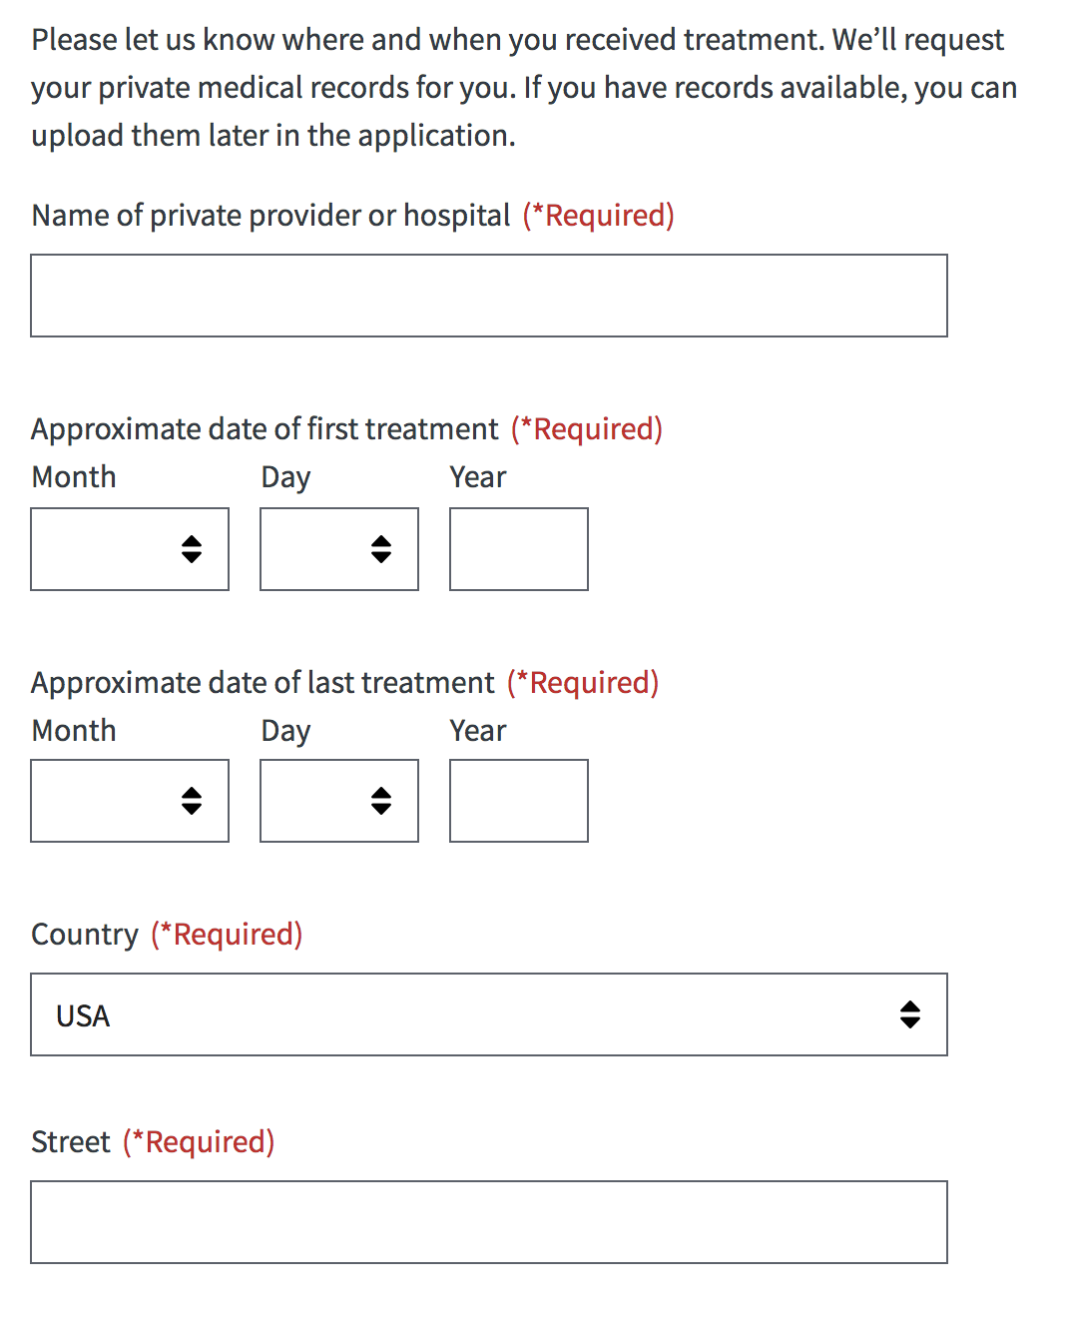

Veterans can add more than one private provider by clicking the **Add Another Provider Facility** button. They also have the option to limit consent and explain what they would like to limit.

