**Post-Traumatic Stress Disorder (PTSD)**

* Form 21-0781: STATEMENT IN SUPPORT OF CLAIM FOR SERVICE CONNECTION FOR POST-TRAUMATIC STRESS DISORDER (PTSD)
* Form 21-0781a: STATEMENT IN SUPPORT OF CLAIM FOR SERVICE CONNECTION FOR POSTTRAUMATIC STRESS DISORDER (PTSD) SECONDARY TO PERSONAL ASSAULT

The Veteran identifies that s/he has a new condition by selecting “Yes.”

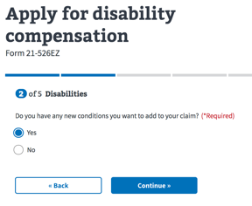

The Veteran identifies the new condition of Post-Traumatic Stress Disorder (PTSD) by selecting one of the autofill suggestions for PTSD (see below) and selecting Continue. This selection will trigger the Form 21-0781/a interview process.

* PTSD personal trauma
* PTSD (post traumatic stress disorder)
* Post Traumatic Stress Disorder (PTSD) Combat – Mental Disorders
* Post Traumatic Stress Disorder (PTSD) Personal Trauma – Mental Disorders

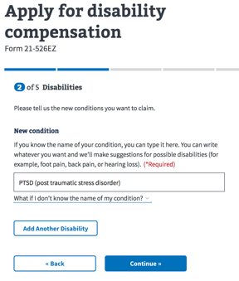

The Veteran is informed that s/he will be guided through the interview process for each condition.

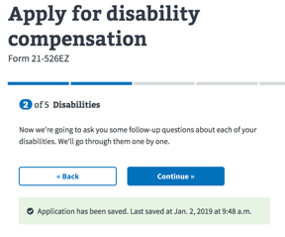

The Veteran is then further informed that s/he is entering the Form 21-0781/a application interview questionnaire

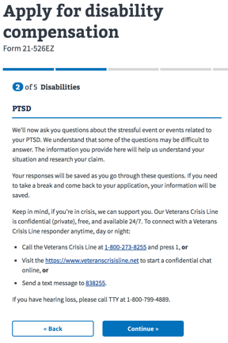

The Veteran is required to identify the event(s) that contributed to her/his PTSD. The selection of “Combat” or “Non-combat PTSD other than sexual trauma or personal assault” will lead to the Form 21-0781 interview questions, while “Sexaul trauma” or “Personal assault” will lead to the Form 21-0781a interview questions. If events from both forms are selected, the Form 21-0781 questionnaire will be the first form to be completed followed by Form 21-0781a.

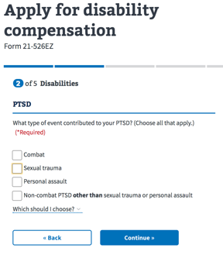

**Form 21-0781 Interview**

The Veteran is provided with the informational screen making her/him aware that they can either upload a completed Form 21-0781 or continue to complete the online interview process.

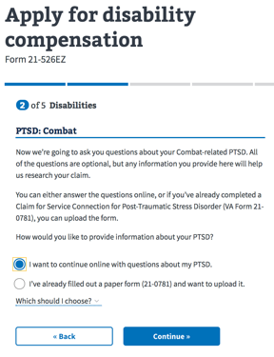

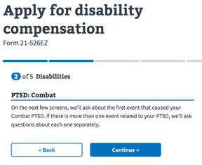

The Veteran has the ability to enter a medal or citation as evidence to support her/his PTSD claim. Population of the field is not required.

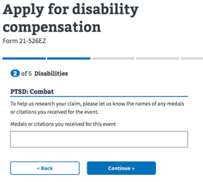

The Veteran is provided the ability to enter an approximate date of the event that contributed to her/his PTSD. Population of the field is not required.

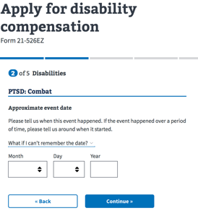

The Veteran is requested to provide the Unit Assignment and Dates assigned to the Unit to further support the event contributing to her/his PTSD contention. The population of the fields are not required.

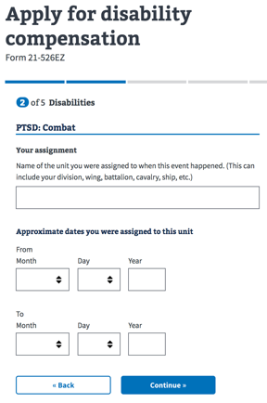

The Veteran is able to provide additional information by completing the Event Location screen. S/he is asked to select the Country of the location as well as populate the State/Province and City. If the United States is selected as Country, then the drop down allows her/him to select the State/Territory; otherwise the State/Province is a free text field.

The Veteran has the ability to enter any additional information in the free text for Additional Details.

The population of any of the fields are, also, not required.

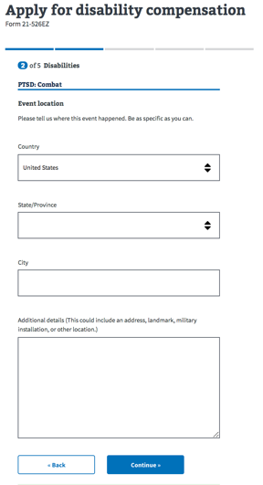

After the event location information has been completed, the Veteran is prompted to answer if any other individuals were involved in the event. The Veteran has the option of selecting “Yes”, “No”, or “Continue” as no response is required.

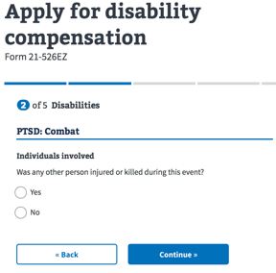

After the Veteran has hit “Continue”, an informational page appears providing a message of support for the Veteran along with information to the Veterans Crisis Line. The Veteran will need to press “Continue” to move forward in the PTSD interview process.

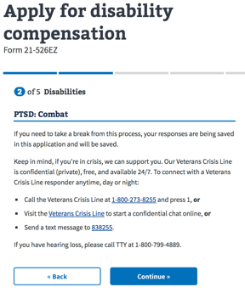

If the Veteran had previously indicated “Yes” another individual was involved in the event, s/he is asked to provide identifying information on the Individuals involved screen.

The Veteran is able to identify the individuals by entering the First, Middle and Last Name or Description of the person through the provided free text fields. The Veteran is also asked to identify whether the individual was a Servicemember by indicating “Yes” or “No”. In addition, the Veteran is asked to identify the date the individual was injured or killed as well as how they were injured or killed.

Additionally, the Veteran is able to indicate if there were additional individuals involved by selecting the button “Add Another Individual”. The “Add Another Individual” button will prompt the Veteran to provide the same information for the other individuals involved.

Though encouraged to complete the information, the fields are, also, not required for the Veteran to continue.

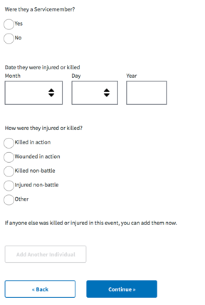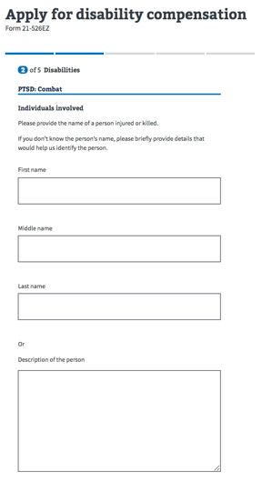

After the Individuals involved questions have been completed, another informational page appears providing a message of support for the Veteran along with information to the Veterans Crisis Line. The Veteran will need to press “Continue” to move forward in the PTSD interview process.

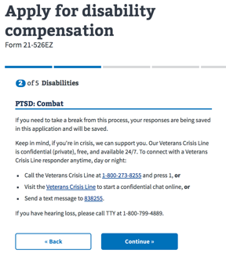

The Veteran is then requested to provide a description of the event in the provided free text field. The event description field is, also, not required for the Veteran to continue.

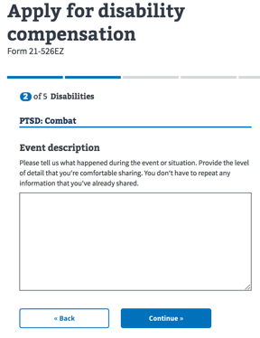

If there are any additional events or situations related to the Veteran’s selection of PTSD related to “Combat” or “Non-combat PTSD other than sexual trauma or personal assault”, s/he can indicate “Yes” and would be led through the interview questionnaire process again.

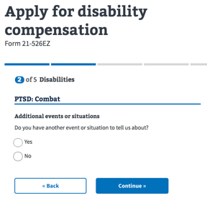

If the Veteran selects “No” or Continues without answering, s/he is asked to they would like to provide any additional information.

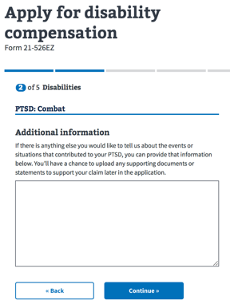

The Veteran is presented with a Thank you for answering the interview questions.

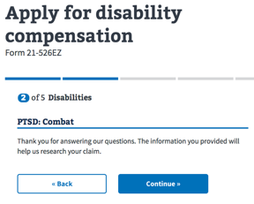

If s/he had indicated earlier that PTSD was the result of “Sexual trauma” or “Personal assault”, the Veteran is led into the Form 21-0781a Interview Process.

**Form 21-0781a Interview**

The Veteran is presented with the opportunity to either upload a completed Form 21-0781a or continue with the interview process.

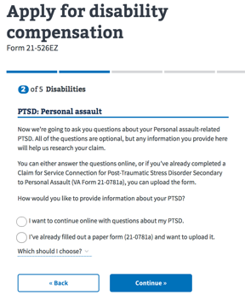

To support the contention, the Veteran is asked to provide the date of the event that contributed to her/his PTSD. Though encouraged the event date field is, also, not required for the Veteran to continue.

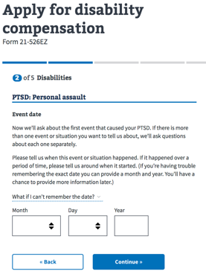

The Veteran is requested to provide the Unit Assignment and Dates assigned to the Unit to further support the event contributing to her/his PTSD contention. The population of the fields are not required.

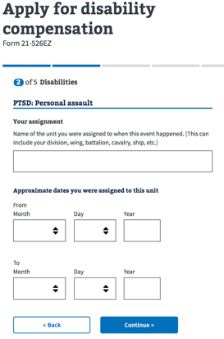

The Veteran is able to provide additional information by completing the Event Location screen. S/he is asked to select the Country of the location as well as populate the State/Province and City. If the United States is selected as Country, then the drop down allows her/him to select the State/Territory; otherwise the State/Province is a free text field.

The Veteran has the ability to enter any additional information in the free text for Additional Details.

The population of any of the fields are, also, not required.

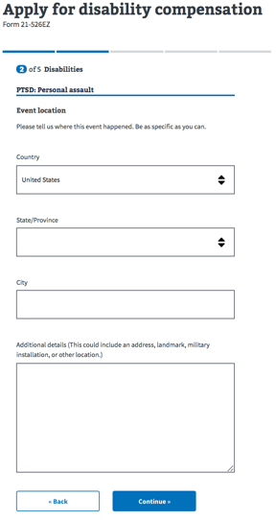

After the Event location questions have been completed, an informational page appears providing a message of support for the Veteran along with information to the Veterans Crisis Line. The Veteran will need to press “Continue” to move forward in the PTSD interview process.

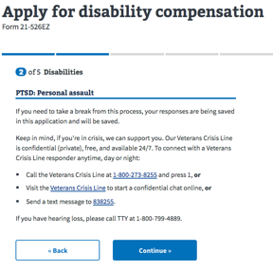

The Veteran is able to provide a free text description of the “Sexual trauma” or “Personal assault” event that led to her/his PTSD contention. The entry is not required to be completed before the Veteran hits Continue.

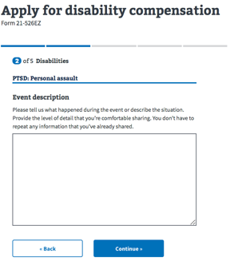

The Veteran is asked if they have any additional supporting evidence and information that s/he would like the VA to retrieve on her/his behalf.

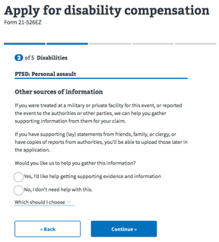

If s/he answers “Yes, I’d like help getting supporting evidence and information”, the clarifying question is asked on what information needs to be gathered.

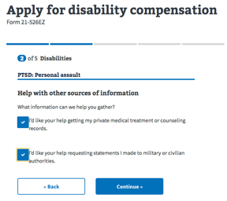

The selection of private medical treatment or counseling records leads them to an informational statement informing her/him that this request will be revisited later in the 526 claims submission process.

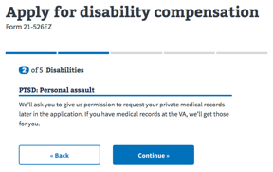

The selection of requesting statements from military and/or civilian authorities provides the Veteran the ability to enter detailed information from whom the VA should retrieve reports: (i) Name of Official or Authority; (ii) Country; (iii) Street Address; (iv) City; (v) State; and (vi) Postal Code. All of the fields are optional.

The Veteran has the ability “Add Another Authority” in the event multiple reports need to be requested.

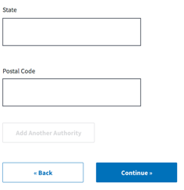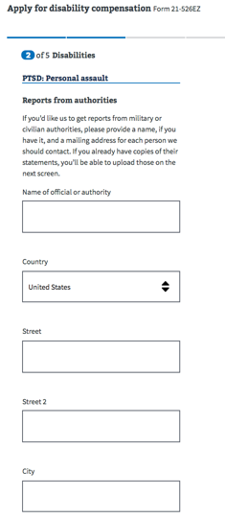

If there any additional supporting documents, the Veteran has the ability to upload them at this point in the interview process.

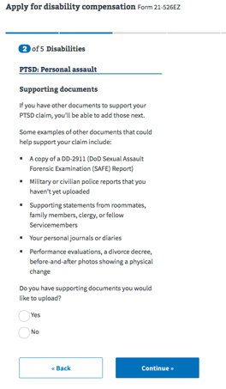

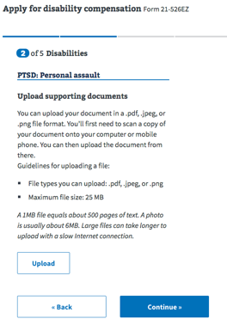

After the Veteran has the opportunity to upload any supporting documents, the Veteran is asked if s/he would like to report another event. If the Veteran indicates “Yes”, s/he is returned to the Event date interview question and to complete the interview process for the additional event.

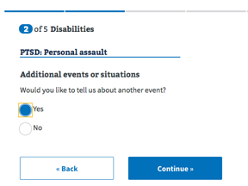

After all additional events have been entered, the Veteran is presented with a series of clarifying questions, in which s/he is able to select any changes in behavior as a result of her/his PTSD contention.

The following questions address:

* Changes in physical health
* Changes in mental health or substance abuse
* Changes in behavior at work
* Changes in social behavior

The Veteran is not required to a response, in order to continue through the interview process.

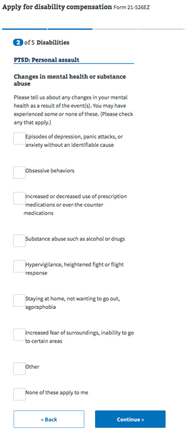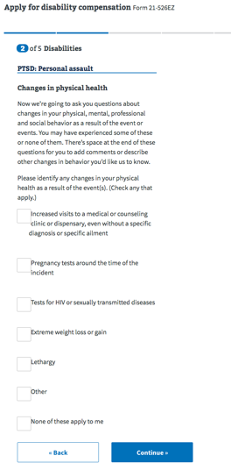

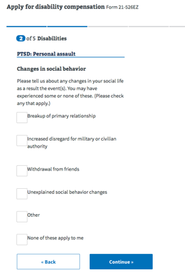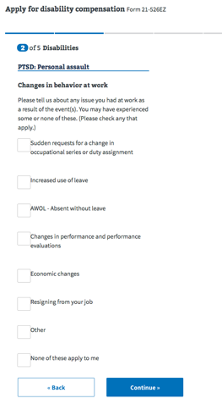

Lastly, the Veteran is able to provide any additional information about her/his changes in behavior in the free text field.

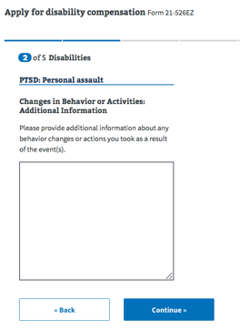

To conclude the Form 21-0781a, the Veteran is thanked for answering the questions and returned to the 526-EZ claim submission process.

