**Need EDU Review**

1. [0994-0.1-Intro](https://staging.va.gov/education/about-gi-bill-benefits/how-to-use-benefits/vettec-high-tech-program/apply-for-vettec-form-22-0994/introduction)

I (Peggy G) think we should shorten this header TO:

*Apply for Veteran Employment through Technology Education Courses (VET TEC)*

**

1. 0994-0.1-Intro

please rewrite to:

*To be eligible for VET TEC, you need to be a Veteran with at least one day of unexpired education benefits. You can complete the VET TEC application to see if you’re eligible for the program, even if you haven’t selected the training program you'd like to attend.*

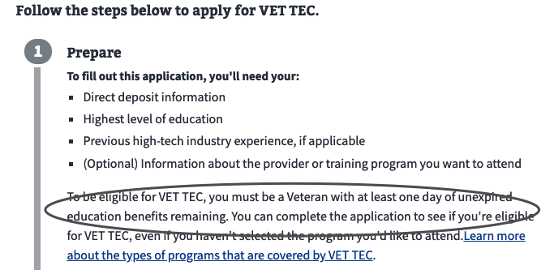

1. 0994-0.1-Intro

please rewrite to:

*Complete this VET TEC application (VA Form 22-0994).*

*After submitting the form, you’ll get a confirmation message. You can print this for your records.*

*If you haven’t already applied for VA education benefits, you’ll need to fill out an Application for VA Education Benefits (VA Form 22-1990). We'll take you to that form after you submit your VET TEC application.*

*\*\*Note:** If you already receive VA education benefits, you don't need to fill out VA Form 22-1990 again.  
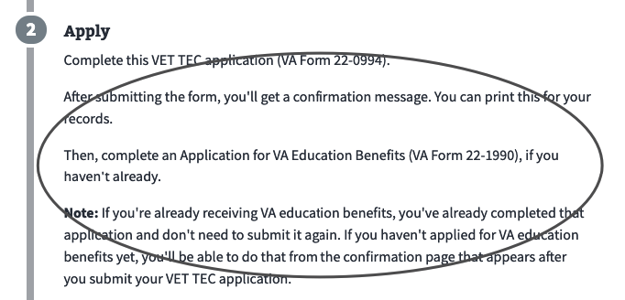*

1. 0994-3.1.2-Active

please update to:

*VET TEC is available only to Veterans. If you're an active-duty Servicemember, please consider applying for VET TEC when you're no longer on active duty.*

0994-3.1.3-Military-Veteran-Yes

*If you’re called to active duty while you’re enrolled in VET TEC, it may affect your eligibility for the program. If you're called to active duty, please let us know as soon as possible.*

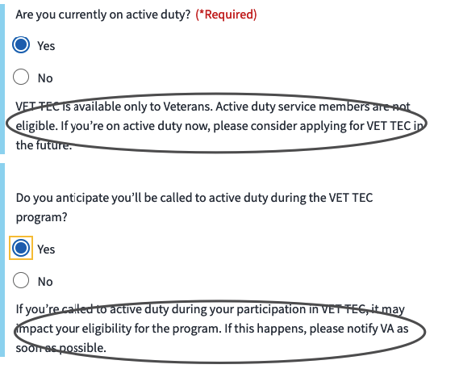

1. 0994-7.1.1-Contact-Info

Please update TO:

*This is the contact information we have on file for you. We’ll send any information about your form to this address.*

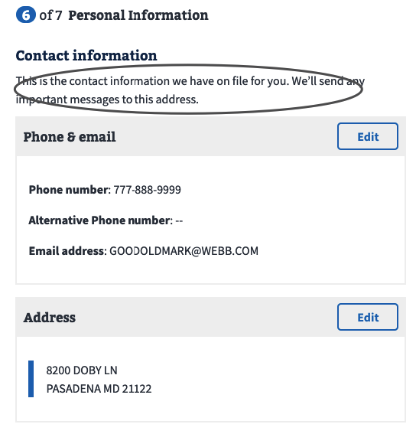

1. 0994-7.1.1-Contact-Info

Please update TO:

*\*\*Note:** Any updates you make here to your contact information will also apply to your other VA benefits, including compensation, pension, and education.*

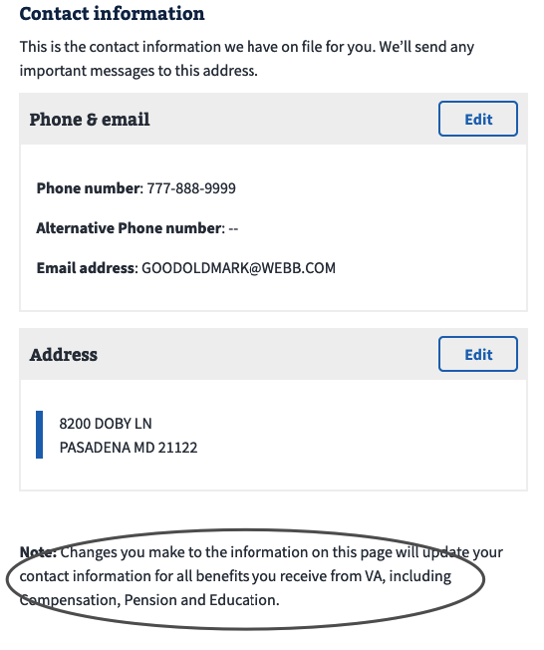

1. 0994-7.2.1-Add-Account

Please update TO:

*This is the bank account information we have on file for you. We’ll pay your housing stipend to this account.*

1. 0994-7.2.2-Add-Account-Helper-Text

please update this Note, per changes on earlier screen.

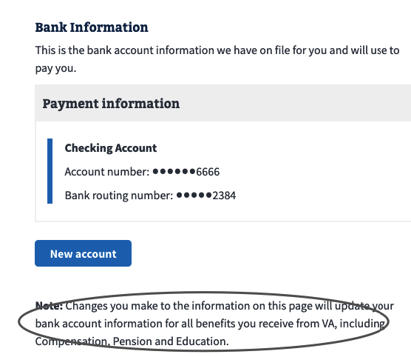

**BAH Team To Do (if approved)**

1. 0994-0.1-Intro- see screenshot for #10 below

please change this to match our form style:

*Equal to VA Form 22-0994 Application for Veteran Employment through Technology Education Courses (VET TEC)*

1. 0994-0.1-Intro

there is a new sign-in message that should replace this one. It is:   
*Note: Since you’re signed in to your account, we can prefill part of your application based on your account details. You can also save your form in progress and come back later to finish filling it out.*

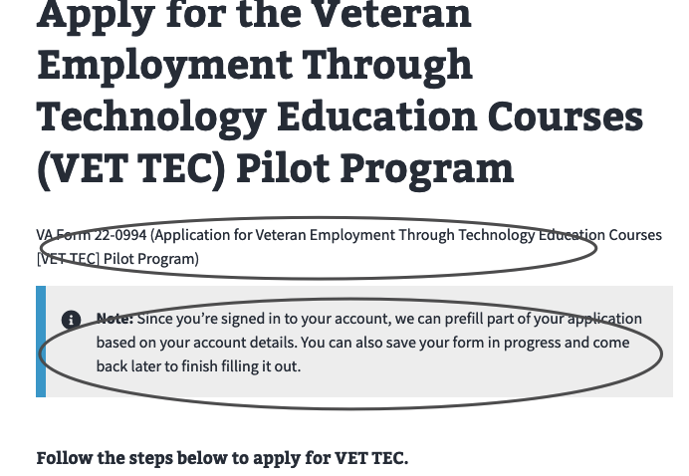

1. 0994-0.1-Intro

please move (Optional) to end of bullet:

- *Information about the provider or training program you want to attend (optional)*

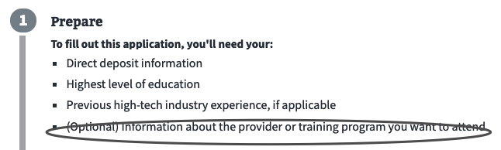

1. 0994-0.1-Intro

please rewrite link to:

*Learn more about the programs covered under VET TEC.*

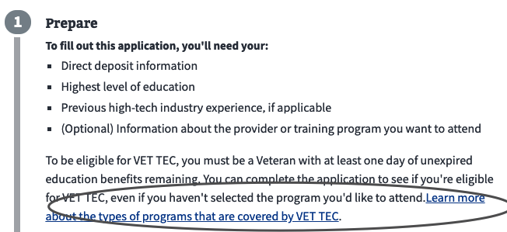

1. 0994-0.1-Intro

please rewrite to:

*An accredited representative, like a Veterans Service Officer (VSO), can help you with your application.*

*[Get help filing your claim](/disability/get-help-filing-claim/).*

*🡨 https://staging.va.gov/disability/get-help-filing-claim/*

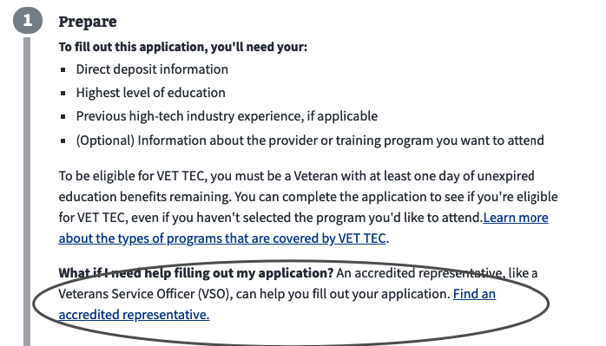

1. 0994-1.1-Applicant-Information

please update to:

*\*\*Note:** If you need to update your personal information, please call Veterans Benefits Assistance at 1-800-827-1000, Monday through Friday, 8:00 a.m. to 9:00 p.m. ET.*

*<br>*

*You can also update your information on your profile page.*

*[Go to your profile page]*

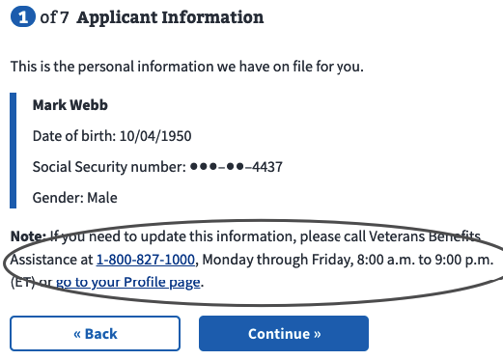

1. 0994-3.1.1-Active-Yes

please update question to:

*Do you expect to be called to active duty while you’re enrolled in a VET TEC program?*

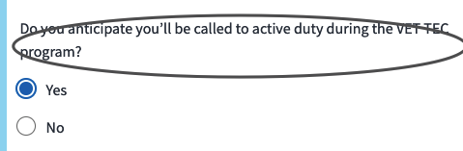

1. 0994-5.1-Employment

Please remove commas from this sentence:

*Are you working in one or more of these high-tech industries now?*

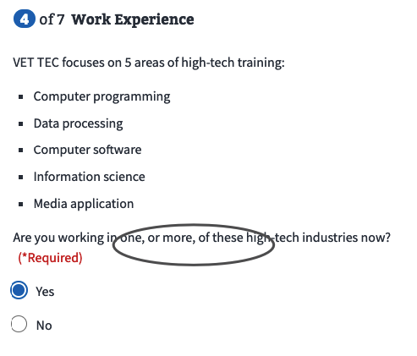

1. 0994-5.2-Employment-Yes

Please update question TO:

*Which area best describes your high-tech work experience? (Check all that apply.)*

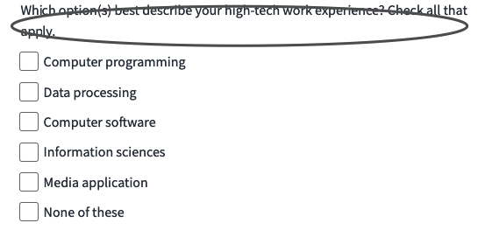

1. 0994-5.6-Employment-No-Worked-Yes

I suggest we update question to (since it's in response to past question)

TO:

*About how much per year do you or have you earned as a high-tech worker?*

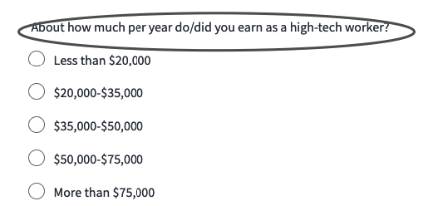

1. 0994-6.1.1-Program

please change to No to follow our form style

*No*

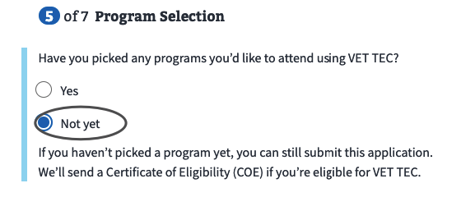

1. 0994-6.1.1-Program

Please update question TO:

*Have you picked a program you’d like to attend using VET TEC?*

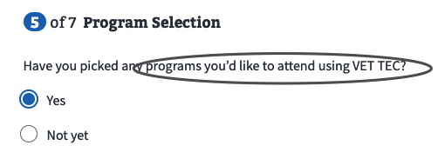

1. 0994-6.1.3-Program-No

Please update to:

*You can still submit this application even if you haven’t picked a program yet. If you're eligible for VET TEC, we’ll send you a Certificate of Eligibility (COE).*

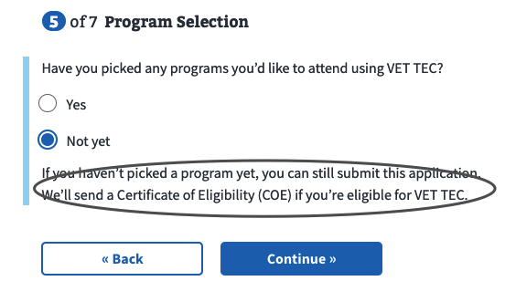

1. 0994-6.2.1-Training

*Now we’ll gather information about the training program you’re interested in attending.*

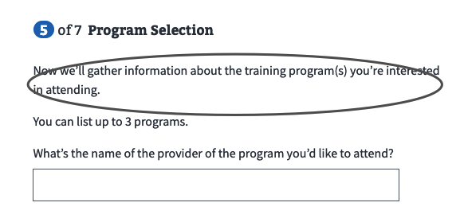

1. 0994-6.2.1-Training

please update to:

*You can enter up to 3 programs.*

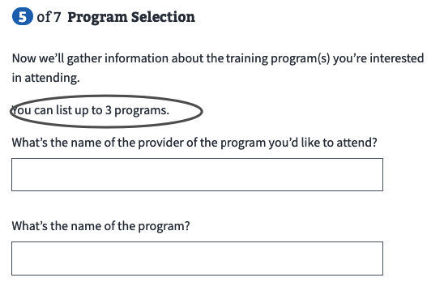

1. 0994-6.2.1-Training

Please update to:

*What’s the name of the program’s provider?*

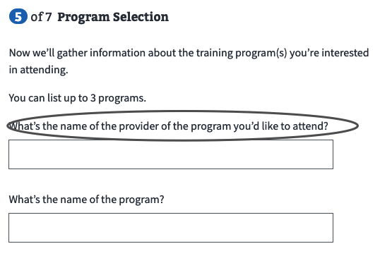

1. 0994-6.2.1-Training

Please change:

What is to *What's*

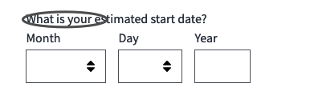

1. 0994-6.2.1-Training

Please update to:

*Is it an in-person or online program?*

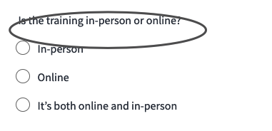

1. 0994-6.2.1-Training

change to the below since it's not used as adjective here:

*In person*

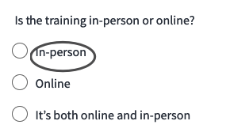

1. 0994-6.2.1-Training

*Both online and in person*

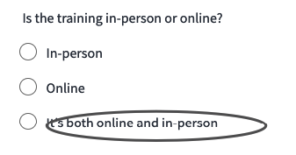

1. 0994-6.2.8-Training-Add-Another

please update this screen with the earlier edits.

BAH TEAM: This will happen automatically

1. 0994-7.2.2-Add-Account-Helper-Text

please update this paragraph TO:

*If you choose not to enroll, you’ll need to call the Department of Treasury at 1-888-224-2950 and speak to a representative handling waiver requests. They’ll encourage you to participate in EFT and address any questions or concerns you have.*

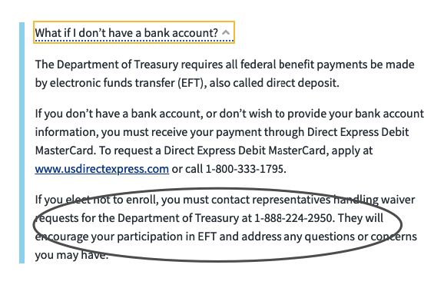

**BAH Team Not Doing**

1. 0994-5.2-Employment-Yes (BAH TEAM: This is being addressed as part of #18)
2. please update question TO:

About how much per year do you earn as a high-tech worker?

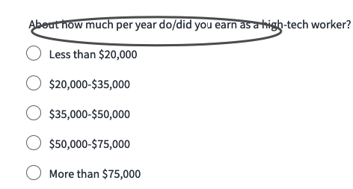

1. I (Peggy G)also suggest we reorder the list to match how the areas are listed above:

• Information science

• Computer programming

• Data processing

Media application

1. 0994-9.1-Confirmation-No-1990 (see screenshot for #35)

please update header to:

*Your claim has been received*

1. 0994-9.1-Confirmation-No-1990 (see screenshot for #35)

please update this sentence to: (there are no docs to submit)

*We may contact you if we have any questions about your application or need more information.*

1. 0994-9.1-Confirmation-No-1990 (see screenshot for #35)

can we update this header to:

*VET TEC Benefit Claim*

1. 0994-9.1-Confirmation-No-1990

Please update to:

*If you haven’t already applied for VA education benefits, you’ll need to fill out an Application for VA Education Benefits (VA Form 22-1990).*

*{button} Go to VA Form 22-1990*

