VetTec Technical Design Document

(DRAFT)

Table of Contents

Overview 2

Education and Training Benefits Implementation 2

vets-json-schema 2

vets-website 2

vets-api 3

VetTec Proposed Design 5

vets-json-schema 5

Schema Design 5

vets-website 5

vets-api 5

# Overview

VetTEC® assists active duty and transitioning Servicemembers and Veterans interested in translating their technical skills from military occupational specialties into civilian jobs by gaining industry-recognized SpaceTEC®, CertTEC®, and ASTM NCATT credentials desired in the fields of aviation, aerospace, and technology.

# Education and Training Benefits Implementation

This section captures current implementation of “VA Education and Training Benefits” functionality. On va.gov, the pages are available under *VA Benefits and Health Care -> Education and Training*. These forms are available on va.gov for un-authenticated users as well. If NOT logged in, the prefill information isn’t populated during the interview process.

Currently following education forms are supported on va.gov:

1. **VA Form 22-0993** - Request to Opt-Out of Information Sharing with Educational Institutions
2. **VA Form 22-1990** - Application for VA Education Benefits
3. **VA Form 22-1990e** - Application for Family Member to Use Transferred Benefits
4. **VA Form 22-1990n** - Application for VA Education Benefits Under the National Call to Service (NCS) Program
5. **VA Form 22-1995** - Request for Change of Program or Place of Training
6. **VA Form 22-5490** - Dependents' Application for VA Education Benefits (Under Provisions of chapters 33 and 35, of title 38, U.S.C.)
7. **VA Form 22-5495** - Dependents' Request for Change of Program or Place of Training (Under Provisions of Chapters 33 and 35, Title 38, U.S.C.)

## vets-json-schema

For the education forms, schema file locations are as below

1. vets-json-schema/src/schemas/22-0993/schema.js ***and*** vets-json-schema/dist/22-0993-schema.json
2. vets-json-schema/src/schemas/22-1990/schema.js ***and*** vets-json-schema/dist/22-1990-schema.json
3. vets-json-schema/src/schemas/22-1990E/schema.js ***and*** vets-json-schema/dist/22-1990E-schema.json
4. vets-json-schema/src/schemas/22-1990N/schema.js ***and*** vets-json-schema/dist/22-1990N-schema.json
5. vets-json-schema/src/schemas/22-1995/schema.js ***and*** vets-json-schema/dist/22-1995-schema.json
6. vets-json-schema/src/schemas/22-5490/schema.js ***and*** vets-json-schema/dist/22-5490-schema.json
7. vets-json-schema/src/schemas/22-5495/schema.js ***and*** vets-json-schema/dist/22-5495-schema.json

## vets-website

VA Education and Training Benefits introduction pages are captured below

1. View All in Education: <https://staging.va.gov/education/>
2. How to Apply: <https://staging.va.gov/education/how-to-apply/>
3. Apply for education benefits: <https://staging.va.gov/education/apply-for-education-benefits/application/1990/introduction>
4. Apply to use transferred education benefits: <https://staging.va.gov/education/apply-for-education-benefits/application/1990E/introduction>
5. Apply for education benefits under the National Call to Service program: <https://staging.va.gov/education/apply-for-education-benefits/application/1990N/introduction>
6. Manage your education benefits: <https://staging.va.gov/education/apply-for-education-benefits/application/1995/introduction>
7. Apply for education benefits as an eligible dependent: <https://staging.va.gov/education/apply-for-education-benefits/application/5490/introduction>
8. Manage your education benefits: <https://staging.va.gov/education/apply-for-education-benefits/application/5495/introduction>

## vets-api

vets-api repo codebase has the implementation for backend processing of the education forms.

* Package **“vets-api/app/workers/education_form/”** contains modules, classes, and templates for the education form submissions.
* A CRON job is scheduled to run daily Mon-Fri that generates daily set of spool files and transmits them over SFTP to a backend system.
  + vets-api/app/workers/education_form/create_daily_spool_files.rb
* Capability to generate reports for the submissions available via the below listed modules
  + vets-api/app/workers/education_form/create_daily_fiscal_year_to_date_report.rb
  + vets-api/app/workers/education_form/create_daily_year_to_date_report.rb
  + vets-api/app/workers/education_form/create_spool_submissions_report.rb
* Education benefits claims and saved claims older than 2 months are removed
  + vets-api/app/workers/education_form/delete_old_applications.rb
* There are 4 Regional Processing Offices (RPO) available for form data transmission, file vets-api/app/workers/education_form/education_facility.rb
  + eastern: 'BUFFALO (307)',
  + southern: 'ATLANTA (316)',
  + central: 'ST. LOUIS (331)',
  + western: 'MUSKOGEE (351)'

vets-api call invocation steps

* on submission of the form, data is submitted to the API end point
* create method of the education benefits controller is invoked
  + vets-api/app/controllers/v0/education_benefits_claims_controller.rb
* new records are created into the “saved_claims” and “education_benefits_claims” tables
  + vets-api/app/models/saved_claim/education_benefits.rb
  + vets-api/app/models/education_benefits_claim.rb

Examples for 1990, 1990e and 5495 forms shown

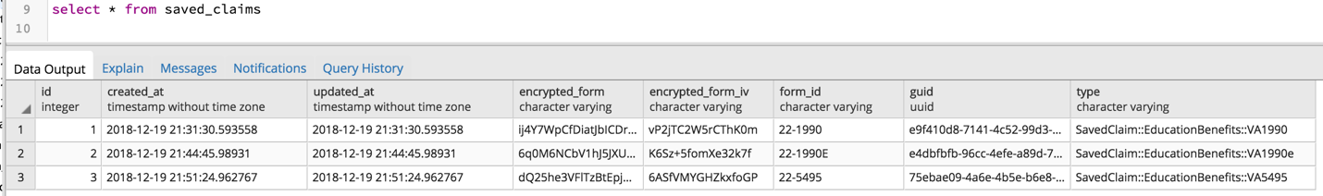

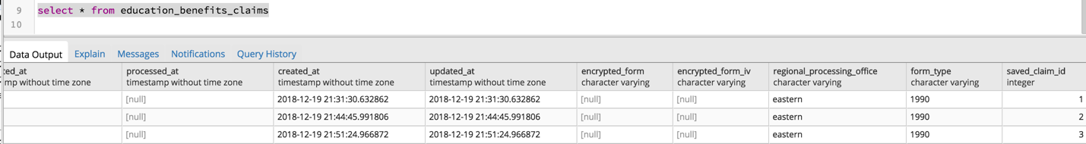

* a new record is created in education_benefits_submissions table. Examples for 1990, 1990e and 5495 forms shown

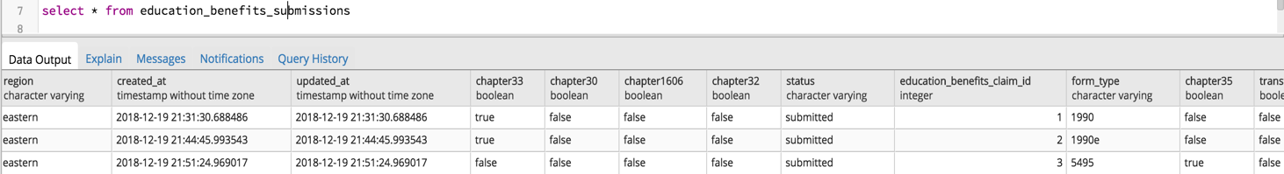

Education Form Serialization & Submission

* A series of spool files are created with applications grouped into regions
* The files are created from individual applications stored in the database for a given day
* The applications are stored in a format that matches the edu-benefits schema in the vets-json-schema repo
* The applications are formatted and concatenated using one of the template files located under **/education_form/templates**. For example, 22-1990.erb
* The file must use windows-style newlines, and have a maximum line length of 78 characters before the newlines
* The generated files are SFTPed to a remote system or systems

Testing Locally

If you want to generate spool files locally, you have two options:

* With at least Sidekiq running, run `rake jobs:create_daily_spool_files`
* With a rails console (`bin/rails c`), run `EducationForm::CreateDailySpoolFiles.new.perform`

The files will be written into `tmp/spool_files`, with each regional file starting with the current date.

Reprocessing an application

If an application needs to go to a different processing center, we can take the ID and queue it up to be sent over the next time the spool file job runs:

* application_id = ###
* new_region = one of 'eastern', 'western', or 'central'
* application = EducationBenefitsClaim.find(application_id)
* application.reprocess_at(region)

*Scheduling CreateDailySpoolFiles {"cron"=>"0 3 * * MON-FRI America/New_York", "class"=>"EducationForm::CreateDailySpoolFiles", "description"=>"Generate a daily set of spool files and transmit them over SFTP to a backend system"}*

# VetTec Proposed Design

## vets-json-schema

For the VetTec forms, schema file locations

* Source: vets-json-schema/src/schemas/22-0994/schema.js
* *Output*: vets-json-schema/dist/22-0994-schema.json

### Schema Design

<<*TBD*>>

## vets-website

* VetTec Introduction Page

<<*Page Label Goes Here*>>

<https://staging.va.gov/education/apply-for-education-benefits/application/0994/introduction>

## vets-api

vets-api repo has the backend implementation to process new VetTec education form 22-0994. At a high level, proposed changes are listed in this section.

Create the below new files, pattern aligned with the other education forms

* vets-api/app/workers/education_form/forms/va0994.rb
  + Module as EducationForm::Forms and class VA0994
  + Extends class EducationForm:Forms:Base
  + Define methods as necessary for the form application
* vets-api/app/workers/education_form/templates/va0994.erb
  + Embedded ruby templating file for the form
  + Based on the PDF version of the form, this needs to be configured
* vets-api/app/models/saved_claim/education_benefits/va0994.rb
  + Class SavedClaim::EducationBenefits::VA0994 that extends SavedClaim::EducationBenefits
  + add_form_and_validation for 22-0994
* vets-api/app/models/form_profiles/va0994.rb
  + Class FormProfiles::VA1990 that extends FormProfile
  + Prefill information as needed for the form
* vets-api/config/form_profile_mappings/22-0994.yml
  + Define prefill attributes as per the requirement of the form
* vets-api/spec/factories/va0994.rb
  + FactoryBot va0994 to support rspec tests
  + For the class SavedClaim::EducationBenefits::VA0994 with parent as education_benefits
* vets-api/spec/jobs/education_forms/forms/va0994_spec.rb
  + Spec for the class EducationForm::Forms::VA0994
* vets-api/spec/models/saved_claim/education_benefits/va0994_spec.rb
  + Spec for the class SavedClaim:EducationBenefits::VA0994

Modify the files to add support for form 22-0994

* vets-api/app/workers/education_form/education_facility.rb
  + To configure routing address to the correct RPO
* vets-api/app/workers/education_form/create_daily_spool_files.rb
  + Add 0994 for the LIVE_FORM_TYPES