

# **Apply for VET TEC**

VA Form 22-0994

**What Is It?**

**A Veteran will be able to apply for the Veteran Employment Through Education Technology Education Courses (VET TEC) Pilot Program online within the Va.gov education benefits application. The following features will be included:**

- Veteran can file an application for VET TEC (VA Form 22-0994) online

- Guided instruction and questions about military status, education history, employment history, VET TEC programs, banking information

- Integration with the existing Education Benefits Spool file so that any 0994 applications entered on va.gov will be transmitted accordingly

- Integration with the existing Education daily file that includes the submission counts for each education form so that 0994 counts will also be included

*Target launch date: March 1, 2019*

**Table of Contents**

**User Access** **3**

Who can access these tools? 3

How can users access these tools? 3

**Navigation** **4**

**Functionality**5

# User Access

## Who can access these tools?

Veterans who are signed in with the highest level of identity verification on VA.gov (LOA3), and are found in the Master Veteran Index (MVI).

## How can users access these tools?

Users can sign in using their DS Logon Premium, MHV Premium, or ID.me accounts. They need to be registered as LOA3 users and found in MVI.

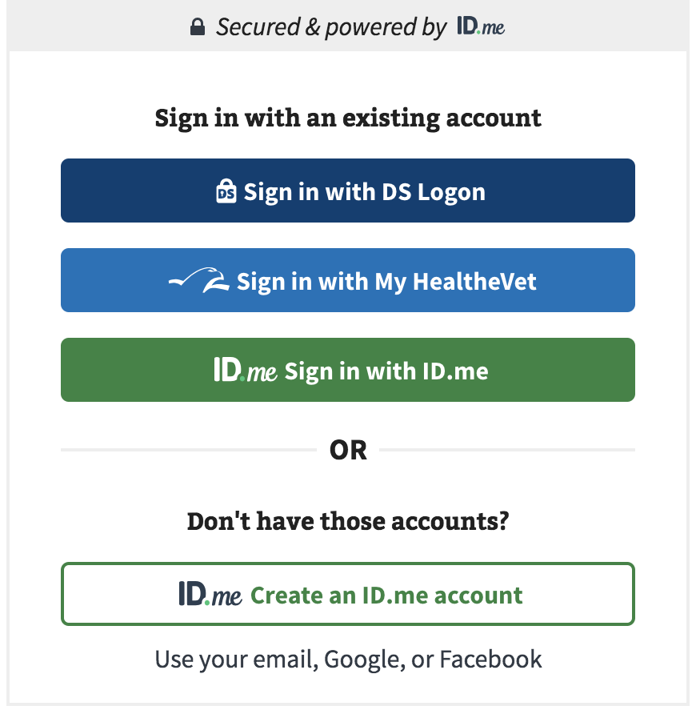

# 

# Navigation

**Direct url:** <https://va.gov/education/apply-for-education-benefits/application/0994/introduction>

or

The link for the Education benefit application can be found on the **VA.gov** homepage.

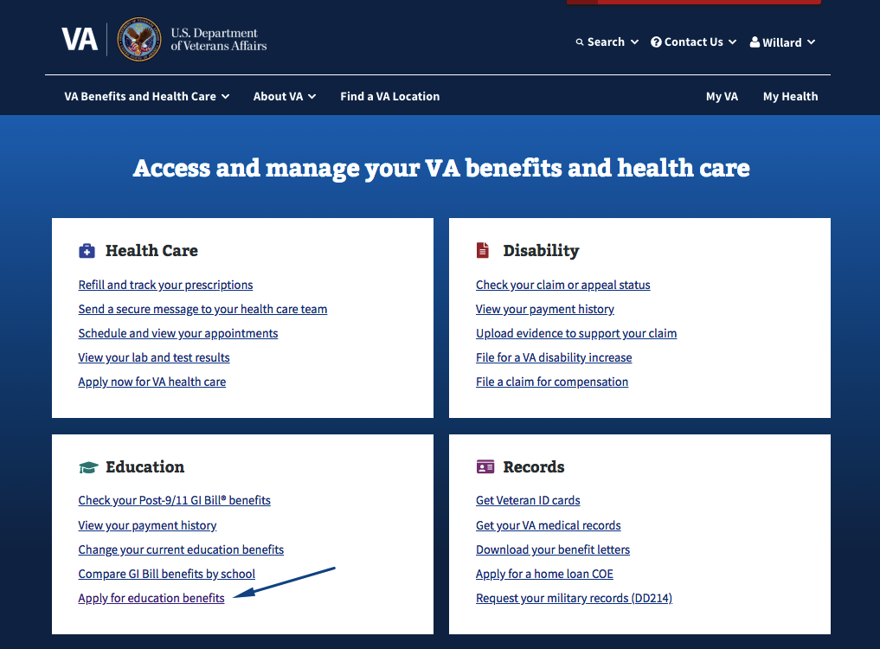

# Functionality

<https://staging.va.gov/education/how-to-apply/>

**Part 1: How do I apply?**

On this screen the Veteran will answer a few questions in order to determine which eduction benefits are pertinent for them. The Veteran must indicate they are, in fact, a Veteran and select that they are applying for VET TEC.

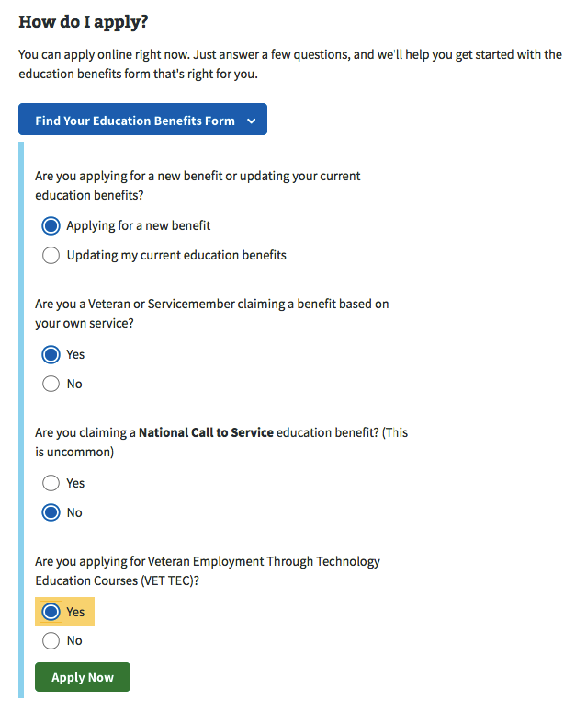

**Part 2: Introduction/Veteran Profile**

The next screen is a brief introduction for the Veteran. It explains a little more about the VET TEC application process and what is needed in order to complete it online.

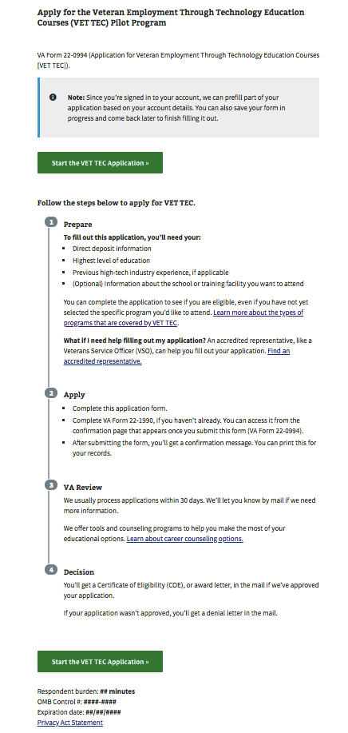

Next the Veteran is shown their profile details

**Name, DOB, SSN, Gender** - view only

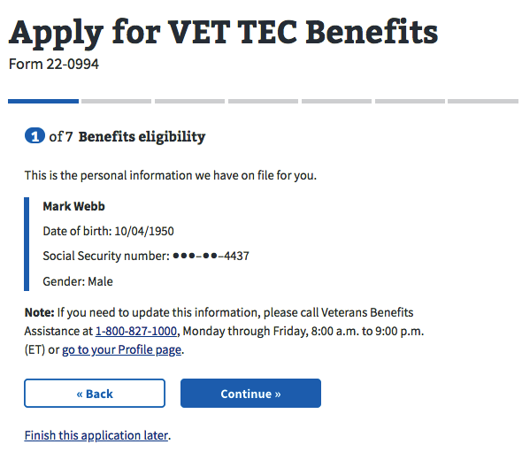

Then the Veteran is asked if they’ve previously submitted a VA Form 22-1990

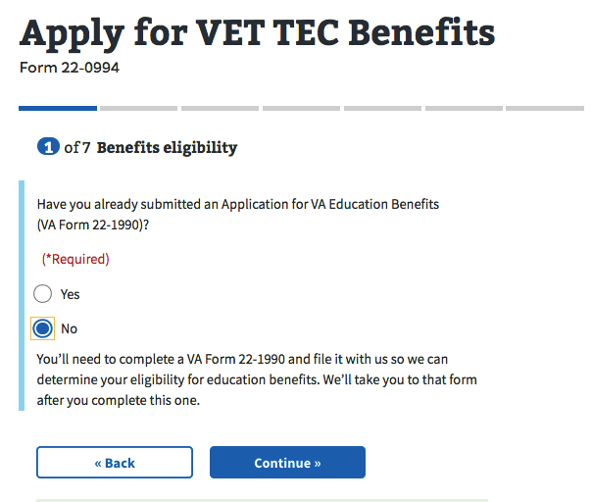

Next the Veteran is asked about their Military Status because if they are on Active Duty then they may not be eligible for VET TEC benefits at this time

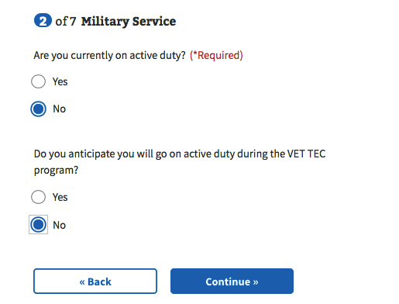

After that the Veteran is asked about the highest level of education they have completed

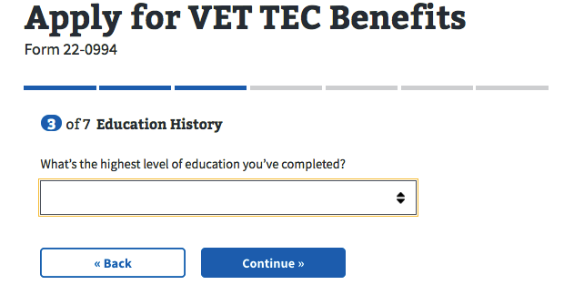

Then they are asked about their work experience in the high-tech industry

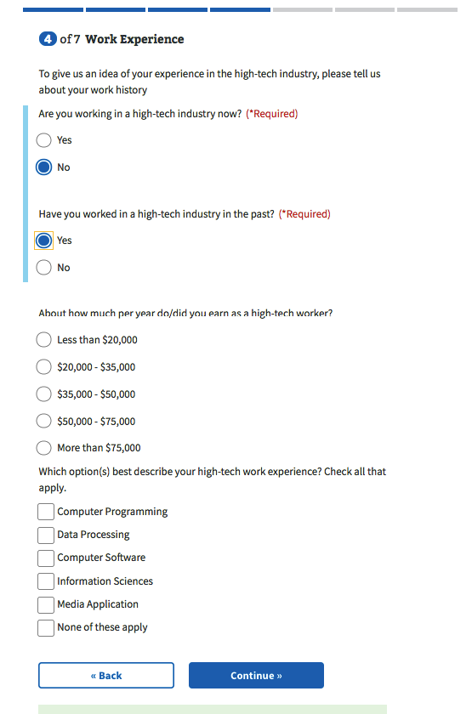

**Part 3: Program entry**

Next the Veteran is asked about the programs they would like to attend using VET TEC benefits. The user is able to add up to 3 programs.

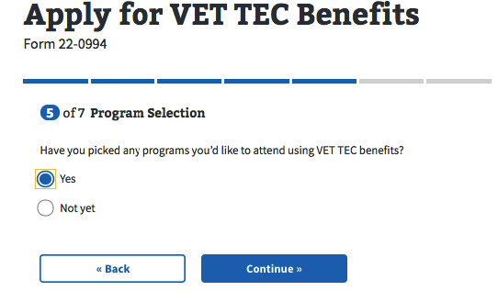

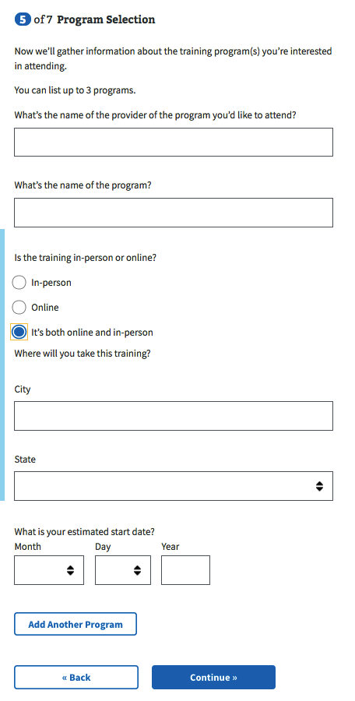

Then the Veteran is asked about their contact information

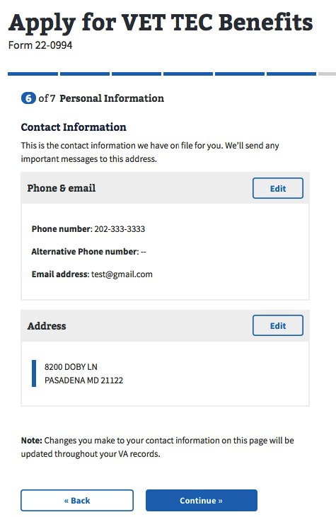

After that the Veteran is asked to review/enter their banking information

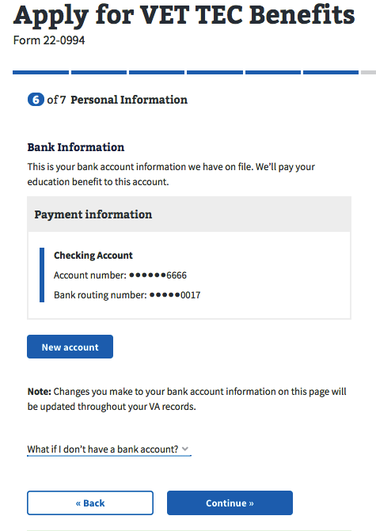

**Part 4: Review Application**

## The final step for the Veteran is to review their application and then submit. Before submitting their application, Veterans can review each section of the form for accuracy, using the ‘+’ toggle buttons to reveal detailed information. Veterans will need to accept the privacy policy and click the provided checkbox before they can submit their application. .

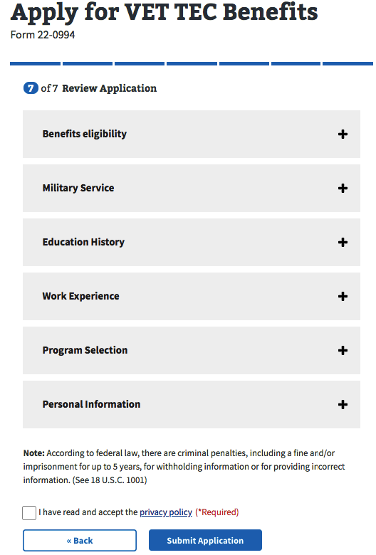

## 

Successful Submission: Submitted applications will receive a system generated message that contains a **‘Confirmation number’** number that Veterans can use to track their application.

**Success Confirmation:

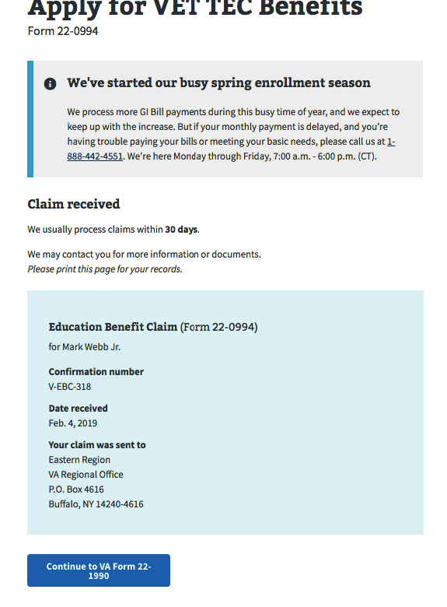

After Submit: An application is stored on the va.gov file, just like all of the other Education applications. There is a nightly job that generates a spool file, which is then sent to an sftp site. After that happens, a daily report is generated that contains the counts for all of the Education forms. Typically about 15 minutes after the daily report is generated, then a spool file submission report is generated.