**GIBCT Colmery Act Sec 107 Veteran Discussion Script**

*July 9, 2019 – JESSICA*

**107**

Would be looking at Tuition & Fees per year.

Interested in whether classes or day or night (flexible schedule)

Uses “learn more” elements throughout the tool

Not sure how changing the course/school location would effect the profile page.

**VET TEC**

Interested in attending courses based on location.

Preferred provider – probably safer campus and better degree. I’d look for why it was starred, hopefully would have a key for that.

Logo – anticipates it will resonate with Veterans based on color alone.

**Welcome and Opening Remarks (5 minutes)**

Are you comfortable if I record the audio as we talk today?

**Yes.**

**Warm-up Questions (5 minutes)**

Before we look at the website, let’s start with a few warm-up questions.

1. Are you interested in using VA Education benefits in the future?

**Yes. Have not used them yet.**

1. Have you used the GI Bill Comparison Tool before? If yes, what was your experience?

**Has not.**

1. What factors are most important to you as you compare schools or institutions?

**Location and price.**

1. What role will geography play in your decision?

Okay, let's go ahead and walk through a few scenarios.

**Prototype**

<https://bahdigital.invisionapp.com/share/EXIAAV8QGY3#/screens/296016673>

**Scenario #1 (10 minutes)**

Let's say you've decided to apply to the University of California at Davis. Using the GI Bill Comparison Tool, how would you determine what benefits you'd receive while taking classes at the University of California at Davis?

[After the particpant has explored the calculator fields and benefits panel]

Would make sure the right GI Bill was selected.

Knows which GI Bill she has.

***Veteran from 2 deployments but still in.***

**Would click in Cumulative Post 9/11 just to see other options in there. Not sure what would be there.**

If you clicked on schools, expects it would give you all schools that were eligible.

How do you want to take classes: could I do virtual classrooms in other schools?

**PROFILE PAGE**

Would be looking at tuition & fees per year.

Would be a Yellow Ribbon recipient – would expect that something would change. Would expect that there’d be information about dates. Would be interested in whether classes were daytime or night time classes (has 2 kids).

Wonders if nighttime classes could still be considered full time.

Wonders what kicker bonus is (tries to click “Learn more”)

Where would you take majority of your classes? Sees UC-Davis, notes that it’s correct

VERY THOROUGH. Reviewing the entire page.

OUTCOMES Data – Thinks image below is showing that Veterans make less money than average.

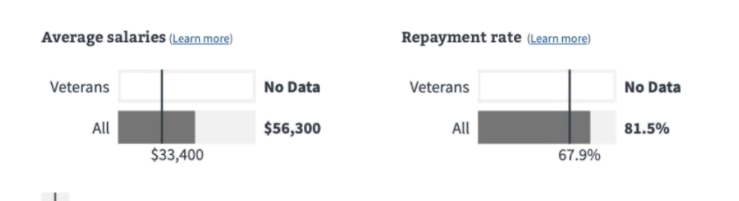

**Potential Probing Questions**

1. What are your first impressions?
2. What aspect of the page or the process might other Veterans find confusing or unclear? Why?
3. Would you expect to receive the same benefits if you were to attend University of California in another location?

**Scenario #2 (10 minutes)**

Let say most of your classes will be held downtown at the UC Davis Technlogy Center. Using the site, how would you determine what amount of housing you'd receive while studying at the UC Davis Technology Center?

*[After the participant has explored the prototype and shared thoughts aloud ]*

Would try “Get help choosing a school” or click on the weblink (to look at the school site)

**Potential Probing Questions**

1. What are your thoughts on the last question on the left ("Will the majority of your classes be on the main campus?")?
2. What would you expect to happen if you selected "Other"?

**Scenario #3 (10 minutes)**

Let say you're interested in checking out UC Irvine, as well. Using the site, how would you determine how much housing allowance you'd receive if you attended UC Irvine?

[If the participant navigates to UC Irvinte via the Search Results Page or search box, ask if there a way to access the UC Irvine page from the School Profile page?]

Would look at the Housing Allowance “Learn more”

Not really sure how changing the course/school location would effect the profile page.

Thinks that changing to a tech school would add tech fees.

Thinks the housing allowance would be more “expensive” based on higher housing allowance.

**Potential Probing Questions**

1. What are your thoughts on the listing of all campuses in the locations section?
2. Under what circumstances would you review a list like this?

**Scenario #4 #116 VET TEC Benefits Panel (10 minutes)**

<https://bahdigital.invisionapp.com/share/BXIAAZ0PHY3#/screens>

Let’s assume you're moving to Detroit, Michigan and you'd like to advance your IT career by taking advantage of the VA's new high-tech program. Using the GI Bill Comparison Tool, how would you find a training course in Detroit and determine how much money you’d receive to help pay your rent while attending the course?

Interested in attending courses based on location.

Preferred provider – probably safer campus and better degree. I’d look for why it was starred, hopefully would have a key for that. WOULD LOOK FOR

Logo will resonate with Veterans- based on colors alone.

Looking at the Benefits Panel…

**Potential Probing Questions**

1. What questions do you have regarding the tuition breakdown?
2. What aspect of the Benefits panel might other Veterans find confusing or unclear? Why?
3. What are your thoughts on the logo? What does it mean to you when you see it? What do you wonder when you see it?
4. What are your thoughts on the Preferred Provider logo?

**Thank-You and Closing**

*[The moderator concludes each session by thanking the participant for their time and for offering his/her opinions and suggestions.]*

Thank you very much for taking the time to give us your feedback today. We really appreciate your help!