1. VHA Facility Types

**Summary**

**Context:**

* VHA Facility “Types” are standardized by a Classification structure within VHA that is updated annually. However, the services conducted across the agency are broad and varied. For the public, Facility “Types” are often defined within the context of Services provided, at an aggregate or singular level. Where a service is defined in our data systems, our target audience may prefer to view a service as a Facility “Type” and would want the ability to search for those services or functions in a centralized Facility Locator on vets.gov.

**Recommendations:**

* Convene Focus Groups/Conduct Survey of Veterans to identify ideal list of Facility “Types” Veterans would like most the ability to search for in a web based Facility locator.
  + - Solidify a Facility Framework from Veterans perspective.
    - Engage in Data Mapping/Architecture Mapping.
* Assessment of data requested in terms of sources and reliability of sources over time:
* Identify Authoritative sources.
* Where there are no known authoritative sources - identify decentralized sources as a starting point.
* Make a plan to identify authoritative, centralized data sources over the longer term.
* Interim solution will be combination of centralized and non-centralized data sources in addition to Facility point of contact inputs.
* Standardize where and how you can.
* Leverage known authoritative sources (such as VAST)
* In the interim-Bridge the gap with data elements that do not have a known authoritative source.
* Long term-establish/identify authoritative sources.
* i.e. VAST🡪Health Care Systems
  + Need a long term plan for maintenance and sustainment of currency of data.

**Details below**

# What Types of Facilities do Veterans want the ability to search for in a Locator? (Focus on those with known Authoritative Sources in Wave 1)

* We picked the following as a starting point:
  + VA Medical Center1
  + VA Clinic1
  + Community Living Center (Extended Care)2
  + Domiciliary (Residential Care)3
  + Hospital4
  + Vet Center5

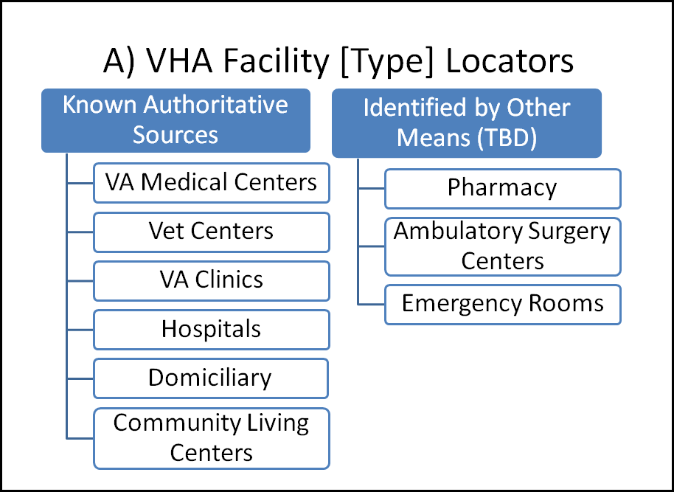

* Others to consider Adding in the Future:
  + Emergency Rooms
  + Urgent Care/After Hours
  + Pharmacy
  + Lab
  + Dialysis
  + Ambulatory Surgery Centers
  + State Veterans Nursing Homes

1. **Data Sources:**

|  |  |  |
| --- | --- | --- |
|  | **Source/POC** | **Data** |
| 1 | VA Site Tracking System (VAST) Data  Point of Contacts:   * Michael Villeneuve in CDW * SP Thakur & Chad Holmes in VSSC | * VAST data includes:   + VHA Sites of clinical care: VA outpatient clinics, VAMCs &Vet Centers * In VAST but excluded from Locator:   + Mobile Vet Centers   + Mobile Sites |
| 2 | GEC Program Office POCs:   * Lisa Minor * Janet Barber | * GEC Program Office:   + Community Living Center (Extended Care) |
| 3 | MH Program Office POCs:   * Kate Lysell * Jamie Ploppert * Jennifer Burden * Gayle Iwamasa * Loren Wilkenfeld * Camilla Doctor | * MH Program Office:   + Domiciliary (Residential Care) |
| 4 | Annual Site Classification Data | * Classification data includes:   + VHA Hospitals |
| 5 | Vet Centers  Maintained in VAST by RCS pocs:   * Bob Moses * Gregory Harms * Charles Flora | * Vet Centers: |

1. **Data Elements:**

* Districts; Source: VAST
* VISNs; Source: VAST
* Health Care Systems (HCS); Source: *No known authoritative source.*

Recommendation:

* + Use current List as a starting point



* + Identify Authoritative source and centralized data source for the long term
  + VAST is an option as a solution for authoritative data source
  + Would need VHA 10N Policy/Operational Support to govern changes/updates, etc.
* VHA Facilities; Sources: VAST; [Annual Classification Crosswalk of Services Report](http://reports2.vssc.med.va.gov/ReportServer/Pages/ReportViewer.aspx?/PMR/VASTClassification/VASTFacilityCrosswalk&rs:Command=Render)
* Inclusion Criteria:
  + Have a Station Number
  + Operational Status-Be an Active Site (Not Planned, Not Temporarily Deactivated or Not Permanently Deactivated)
  + Non-Mobile Sites
  + Classified Sites
  + Vet Centers
* Exclusion Criteria:
* Records without Station Numbers are excluded
* Planned, Temporarily Deactivated or Permanently Deactivated Sites of Care are excluded
* Mobile Sites are excluded
* Unclassified Sites are excluded (Except for Vet Centers)
* Fields:

|  |  |  |
| --- | --- | --- |
| Only Operational "A" Active Sites (Column Name) | | |
| With the following Fields: | | |
|  |  |  |
|  | 1 | Region Name/District # |
|  | 2 | VISN # |
|  | 3 | VISN Name |
|  | 4 | Parent Station Number |
|  | 5 | Parent Site Name |
|  | 6 | Site of Care Station Number |
|  | 7 | Site of Care Official Station Name |
|  | 8 | Site of Care Location Descriptive/Common Station Name |
|  | 9 | Classification |
|  | 10 | Physical Address (Building) |
|  | 11 | Physical Address (Street) |
|  | 12 | Physical Address (Suite) |
|  | 13 | Physical Address (City) |
|  | 14 | Physical Address (State) |
|  | 15 | Physical Address ( Zip) |
|  | 16 | Physical Address ( Zip Code Extension) |

*VAST File:*

<https://github.com/department-of-veterans-affairs/Facilities-Locator-post-11-11-2015/tree/master/Data>

1. **Data Elements: Specific Notes on Fields**

* Facility Name consists of two Fields:
  + Official Station Name
  + Location Descriptive Name

*Options*:

* + Include Both
  + Concatenate “Location Descriptive Name Common Name” field with “Type” field for front-facing “Location-Descriptive Name”

*Details*: Site Name = Location Descriptive Name with below taxonomy:

* + For sites with a classification of VAMC, use Location Descriptive Name field + VA Medical Center
  + For sites with a classification of Health Care Center, Multi- Specialty CBOC, Primary Care CBOC, Other Outpatient Services, use Location Descriptive Name + VA Clinic
  + For sites with a classification of Residential Care or Extended Care, use Location Descriptive Name (no suffix needed)
    - Please note that Residential Care & Extended Care is a Classification [Facility Type; i.e. Stand-alone CLC and Stand-alone Domiciliary) and a Service.
    - The Program Office Service List (provided) is the recommended source as the primary source for all of these Facilities under the ‘Facility Type’ drop-down list.
    - Work will need to be done to automate, collect this data ongoing.
* Facility Type
  + Classification Field notes:
    - If=VAMC, then= “**VA Medical Center**”
    - If= VA Residential Care Site, then “**VA Residential Care- Domiciliary**”
    - If= VA Extended Care Site, then “**VA Extended Care-Community Living Center**”
    - If=Health Care Center (HCC), Primary Care CBOC (PC-CBOC), Multi-Specialty CBOC (MS-CBOC), or Other Outpatient Services (OOS) Site, then = “**VA Clinic**”
  + **Hospital**
    - Not a Classification; Tag Updated Annually; Of interest for folks to find Hospitals
    - Source: [Annual Classification Crosswalk of Services Report](http://reports2.vssc.med.va.gov/ReportServer/Pages/ReportViewer.aspx?/PMR/VASTClassification/VASTFacilityCrosswalk&rs:Command=Render)
  + 
* **Vet Center**
* In VAST but relies on Rehabilitation Counseling Services (RCS) to update and keep current: <http://www.vetcenter.va.gov/>