

Find a VA Form  
Product Guide  
2021 (Enhanced)  
Version 5

Revision History

| Date | Version | Description | Author |
| --- | --- | --- | --- |
| ?? | 1 | Product Debut | ?? |
| 09-12-2024 | 5 | Removal of information regarding the Adobe alert “Use the latest version of Acrobat Reader,” as it’s no longer relevant, and the alert has been removed. | Fran Cross |

Table of Contents

**Overview**

**User Access** 4

**Navigation** 4

**Functionality** 4

**Find VA Forms—Search​** 5

Navigating to Find VA Forms—Search 5

Search for VA forms at VA.gov/find-forms​ 5

Sort Results 6

Quickly Access Form Details Pages​ 6

Access Online Tools Where Available 7

Download VA Form PDFs 8

PDF Information​ 8

No Results? Find More in GSA Forms Library​ 9

Quickly Navigate to Top Tasks​ 9

Manage Personal Profile Information​ 10

Find Additional Information Outside VA​ 10

Find VA Forms—Detail Pages​ 11

Locating Detail Pages via Search Engine 11

Locating Detail Pages via Find a VA Form​ 12

Sample Form Detail Page​ – Maximum Information 13

Sample Form Detail Page - Minimum Information 14

Major Issues and Error Messages 14

**Table of Figures** 15

# Overview

Find a VA Form enables Veterans and other users of VA.gov to search for and download forms they need to apply for benefits, the GI Bill, disability, etc, by keyword, form name, or number.

Also on the main search page are 2 sections: Frequently Used VA forms and Manage Your VA benefit, with information and links in each section.

# User Access

Veterans and other users do not need to be signed in to access.

# Navigation

Veterans may access it by using the global search in the header on VA.gov and then clicking “Find a VA Form” in the search results. Alternatively, they may have bookmarked the URL: <https://www.va.gov/find-forms/>.

# Functionality

1. While on Find a VA Form, users may:

* Search by a vague form number, e.g., 1010, and search results will display forms such as 10-10M, Medical Certificate, or 10-10169, the Volunteer Consent Form, etc.
* Search by a specific form number, e.g., 10-10EZR or Form 10-10EZR. English and Spanish forms are returned for this form number in this case.
* Search by keyword, e.g., disability, will return forms related to this subject.
* Search by form name, e.g., Health Benefit Update Form (title of 10-10EZR). In this case, the first result is 10-10EZR, and other forms within that text are also displayed.
  + Note that if a form is offered in other languages, then the user may also search the form name in that language, e.g., INSTRUCCIONES PARA COMPLETAR EL FORMULARIO DE ACTUALIZACIÓN DE LOS BENEFICIOS MÉDICOS.

1. If the form has many results, then a “Sort By” dropdown field is available with options:

* Closest match
* Ascending (A-Z)
* Descending (Z-A)
* Last Updated (Newest)
* Last Updated (Oldest)

1. If the form they searched for has a Form Detail page, the results include a link to that page.
2. If the form has a version they can complete and submit online, it’s indicated with:

* Sub-header: Online tool
* Text: You can apply online instead of filling out and sending us the paper form
* Link to online tool: “Go to the online tool”

# 

# Find VA Forms—Search​

## Navigating to Find VA Forms—Search Users who search for “forms” on a VA.gov on-site search should choose the top recommendation link to Find VA Forms—Search (see Fig. 1).

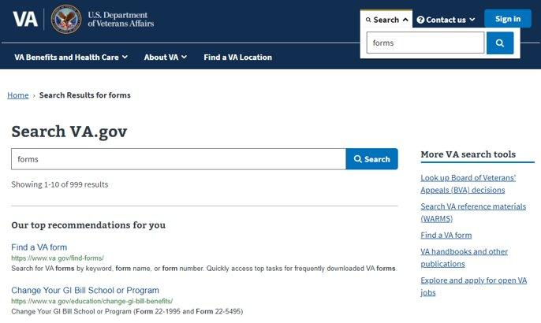

*Fig. 1. Screenshot of how to navigate to Find VA Forms from VA.gov global search results.*

## Search For VA Forms At [VA.gov/find-forms​](http://va.gov/find-forms%E2%80%8B)

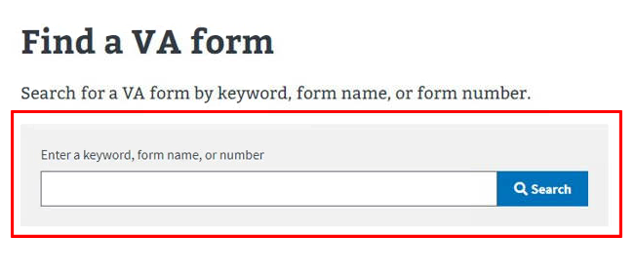  
*Fig. 2. Screenshot of the search field on the main Find a VA Form search screen.*

## Sort Results By default, search results are sorted by closest match to the search term. Other options include using the Sort By drop-down menu to arrange results alphabetically in ascending or descending order or by last updated date.

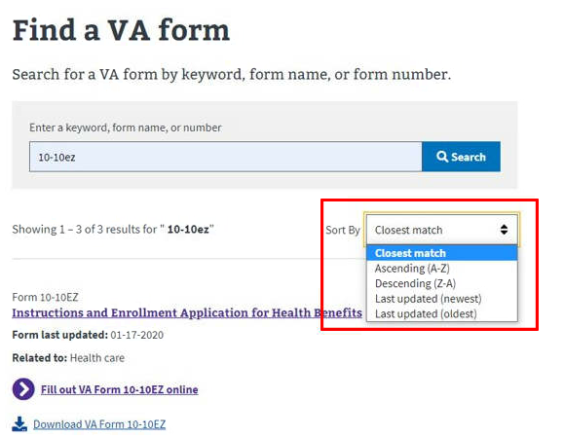

*Fig. 3. Screenshot of the “Sort by” dropdown options on the main Find a VA Form Search screen.*

## 

## Quickly Access Form Details Pages​ By searching for a desired form number, the user will see a link to the corresponding details page (see Fig. 4).

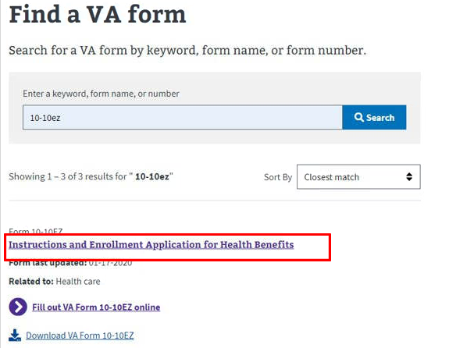

*Fig. 4. Screenshot of a link to a Form Details page in Find a Form search results.*

## Access Online Tools (Where Available) In the following example, a link is available for the user to complete the VA form online (see Fig. 5).

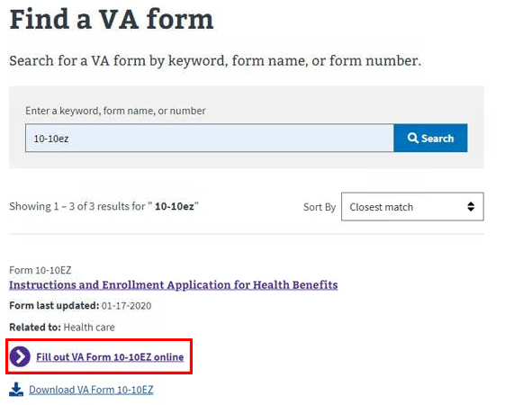

*Fig. 5. Screenshot of Find a VA Form 10-10ez search result.*

## Download VA Form PDFs The option for the user to download the PDF of a VA form is also available (see Fig. 6).

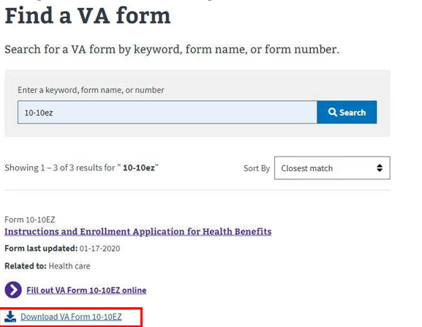

*Fig. 6. Screenshot of the Download VA Form 10-10ez link on the search results page.*

## PDF Information​ Whenever users select a PDF link in search results, they’re advised to download and open forms in Adobe Acrobat Reader. A link to download Acrobat Reader is provided (see Fig. 7). Clicking the “Download” button initiates the PDF download. The user right-clicks on the button to save to their computer. The user must use Acrobat Reader to fill out a PDF form; they cannot currently do so in a browser tab or on a mobile device.

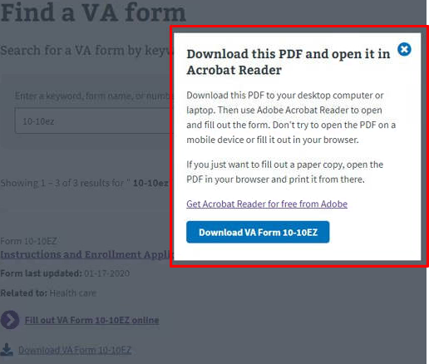

*Fig. 7. Screenshot of the popup prompting users to download the 10-10ez PDF and open it in Acrobat Reader.*

## No Results? Find More in GSA Forms Library​ When no search results are found, the user is prompted to go to the GSA Forms Library to look for non-VA forms (see Fig. 8).

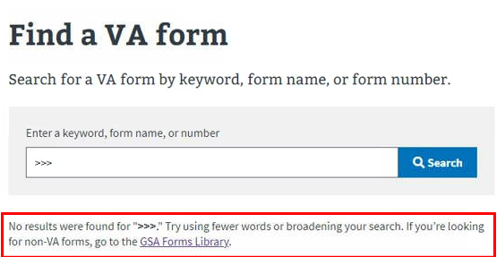

*Fig. 8. Screenshot of the error message when no results were found.*

## Quickly Navigate to Top Tasks​ The Top Tasks section displays frequently downloaded VA forms and links to learn more about them (see Fig. 9).

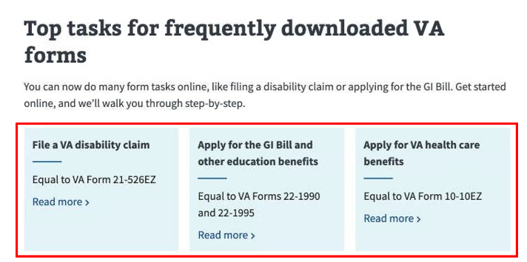

*Fig. 9. Screenshot of the Top Tasks section.*

## Manage Personal Profile Information​ The “Manage Personal Profile Information” section shows various links, such as “Change your direct deposit information,” “Change your address,” “Request your military records, including DD214,” and “Get more records and documents online.” (see Fig. 10).

*Fig. 10. Screenshot of the section on Find a VA Form “Manage Personal Profile Information.”*

## Find Additional Information Outside VA​ In Find VA Forms, users may find information outside of VA, such as SGLI, VGLI, other VA life insurance programs, Department of Defense (DOD) forms, and Contact the VA forms managers (see Fig. 11).

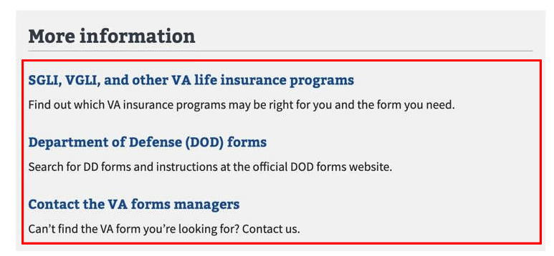

*Fig. 11. Screenshot of the More information section.*

## Find VA Forms—Detail Pages​

## Locating Detail Pages via Search Engine Users can also search for a particular VA form organically on Google, Bing, Edge, Mozilla, etc. The search results will include links to legacy VA Form pages (see Fig. 12).

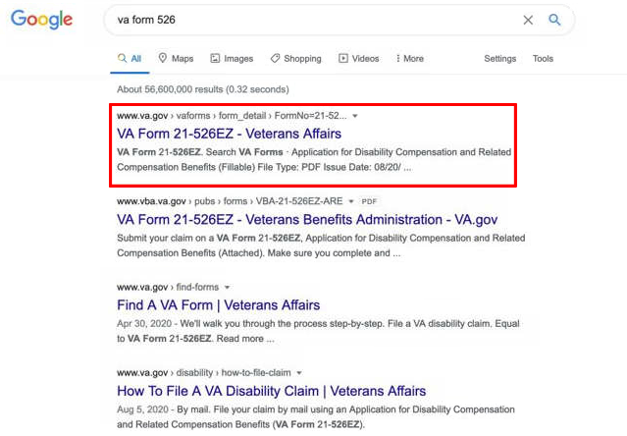

*Fig. 12. Screenshot of how to locate Find VA Form Detail pages via a standard search engine.*

## Locating Detail Pages via Find a VA Form VA Form Detail pages are available via the Find a VA Form Search screen (see Fig. 13).

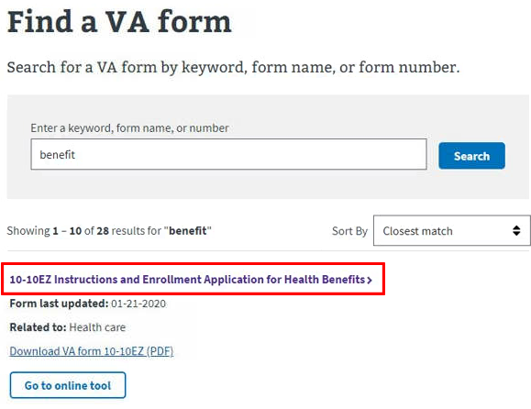

*Fig. 13. Screenshot of finding a VA Form Detail pages from the Find a VA Form Search screen.*

## Sample Form Detail Page​—Maximum Information Form detail pages with the maximum form data provided (see Fig. 14) include:

* Information on when to use the form
* PDF download link
* Online tool link for the form
* Information about related forms
* Links to helpful tools across VA.gov

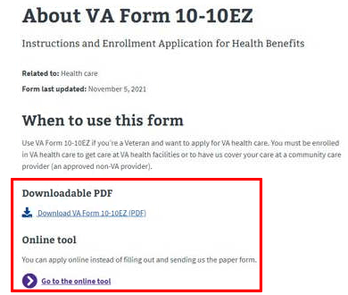

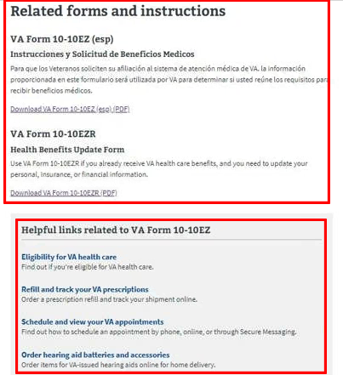

*Fig. 14. Screenshot of the maximum information a user may encounter on a Find a VA Form Detail page.*

## Sample Form Detail Page—Minimum Information VA forms with minimal information provide links for PDF download and helpful tools across VA.gov (see Fig .15).

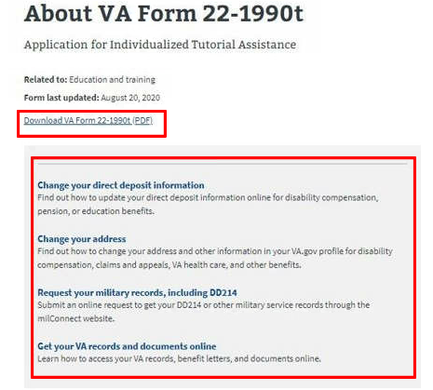

*Fig. 15. Screenshot of a Find a VA Form Detail page with minimal information available.*

## Major Issues and Error Messages

One type of error message occurs when no results are found. The user is advised to use fewer words or broaden their search. If the user is looking for non-VA forms, they’re also given the option to go to the GSA Forms Library via a provided link.

Another error type occurs when a search is initiated with an empty search field (see Fig. 16):  
  
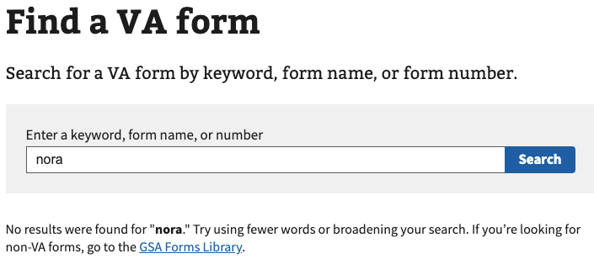

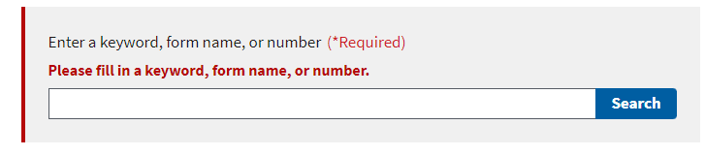

*Fig. 16. Screenshots of error messages.*

**Table of Figures**

Fig. 1. Screenshot of how to navigate to Find VA Forms from VA.gov global search results.

Fig 2. Screenshot of the search field on the main Find a VA Form search screen.

Fig. 3. Screenshot of the “Sort by” dropdown options on the main Find a VA Form Search screen.

Fig. 4. Screenshot of a link to a Form Details page in Find a Form search results.

Fig. 5. Screenshot of Find a VA Form 10-10ez search result.

Fig. 6. Screenshot of the Download VA Form 10-10ez link on the search results page.

Fig. 7. Screenshot of the popup prompting users to download the 10-10ez PDF and open it in Acrobat Reader.

Fig. 8. Screenshot of the error message when no results were found.

Fig. 9. Screenshot of the Top Tasks section.

Fig. 10. Screenshot of the section on Find a VA Form “Manage Personal Profile Information.”

Fig. 11. Screenshot of the More information section.

Fig. 12. Screenshot of how to locate Find VA Form Detail pages via a standard search engine.

Fig. 13. Screenshot of finding a VA Form Detail pages from the Find a VA Form Search screen.

Fig. 14. Screenshot of the maximum information a user may encounter on a Find a VA Form Detail page.

Fig. 15. Screenshot of a Find a VA Form Detail page with minimal information available.

Fig. 16. Screenshots of error messages.