Find a VA form

## Production notes

|  |  |
| --- | --- |
| **IA / Path** | VA.gov > Find VA forms |
| **Desired URL (consult search strategist for URL)** | Current url: <https://www.va.gov/vaforms/>  Recommended? @Mikki |
| **Comments** | * Make recommended URL canonical * Permanently redirect and retire va.gov/vaforms/search_action.asp. * Add event tracking for clicks and downloads. |
| **Source content** | <https://www.va.gov/vaforms/>  <https://www.va.gov/vaforms/search_action.asp>   * Above 2 pages appear to compete for search traffic, but the search_action page does enable users to search. It will omit important new conversion/actionable content that we’re adding to the forms search page. Therefore, recommend retiring the search_action page, permanently redirecting to the main forms search page, and set it as canonical.   <https://www.va.gov/viewer.htm> - Recommend deprecating XTF file format and retiring viewer page. Low traffic.  <https://www.va.gov/vaforms/help.asp> – Very low traffic. Recommend retiring.  <https://www.va.gov/vaforms/contact.asp> - Very low traffic. Recommend retiring. Forms themselves include where to send info. |

## Page properties

|  |  |
| --- | --- |
| **H1 (page title)** | Find VA forms |
| **Browser title (meta title)** | Find VA Forms | Veterans Affairs |
| **Meta description** | Search for VA forms by keyword, form name, or form number. Quickly access top tasks for frequently downloaded VA forms. |
| **SEO terms** | va forms, va gov forms |

## Content

**H1: Find VA forms**

Search for a VA form by keyword, form name, or form number.

|  |  |
| --- | --- |
| Keyword, form name, or number  [ TEXT ENTRY FIELD ] | Search [BUTTON] |

**H2: Top tasks for frequently downloaded VA forms**

Whether you’re looking for a form to file a disability claim or apply for the GI Bill, many top tasks are now also available as secure online applications.

To get started online, go to a top task below. We’ll walk you step-by-step through the process. You can even save your work online and come back to it later.

**File a VA disability claim**   
[LINK <https://www.va.gov/disability/how-to-file-claim/>]

Equal to VA Form 21-526EZ

**Apply for the GI Bill and other education benefits**[LINK <https://www.va.gov/education/how-to-apply/>]

Equal to VA Forms 22-1990 and 22-1995

**Apply for VA health care benefits**   
[LINK <https://www.va.gov/health-care/apply/application/introduction>]

Equal to VA Form 10-10EZ

**H2: Update basic information online**

Need a copy of your medical record or need to update your address for your VA prescriptions? You can now do many form tasks online.

To keep things secure, sign in with your DS Logon, My HealtheVet, or ID.me account. If you don’t have an account, we’ll prompt you to create one.

**Change your direct deposit information**   
[LINK <https://www.va.gov/change-direct-deposit/>]

Equal to VA Form 24-0296

**Change your address**   
[LINK <https://www.va.gov/change-address/> ]

For disability compensation, claims and appeals, VA health care, and more

**Request your medical record**   
[LINK <https://www.va.gov/health-care/get-medical-records/>]

Equal to VA Form 10-5345

**Request your military records, including DD214**[LINK <https://www.va.gov/records/get-military-service-records/>]

Includes DD214, DD215, release papers, orders and endorsements, and more

**RESULTS LIST – TABLE ELEMENTS**

[Q for Ryan: I’m not sure where the results should appear – on the same page but above the **Top tasks** and **Update basic info** sections; or on the same page but after those 2 sections; or as a separate search results page entirely. Would like to discuss.]

CURRENT:

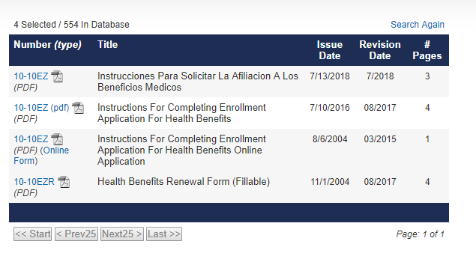

**Columns – for new/proposed:**

|  |  |  |  |
| --- | --- | --- | --- |
| **VA form number** | **Form name** | **Description** | **Available online** |
| 10-10EZ (PDF) | Instructions For Completing Enrollment Application for Health Benefits | Application for VA health benefits | Apply now |
| 29-4364 (PDF) | Application for Service-Disabled Veterans Life Insurance | SDVI application | Apply now |