## Note: Refer to copydeck for final copy. This document is for UI/design reference.

## I. Template form detail landing page

The content fields in a template landing page – if it has everything filled out in the db schema – will be:

1. Form # H1
2. Form name H2
3. Related to: [category, category… one or multi-select]
4. Form download link   
   (NOTE: Download icon is automatically generated for forms that are hosted in Drupal; so currently for MVP, these landing pages will not have the icon.)
5. Button CTA to online exp – omit in FE if N/A
6. Standard helpful links

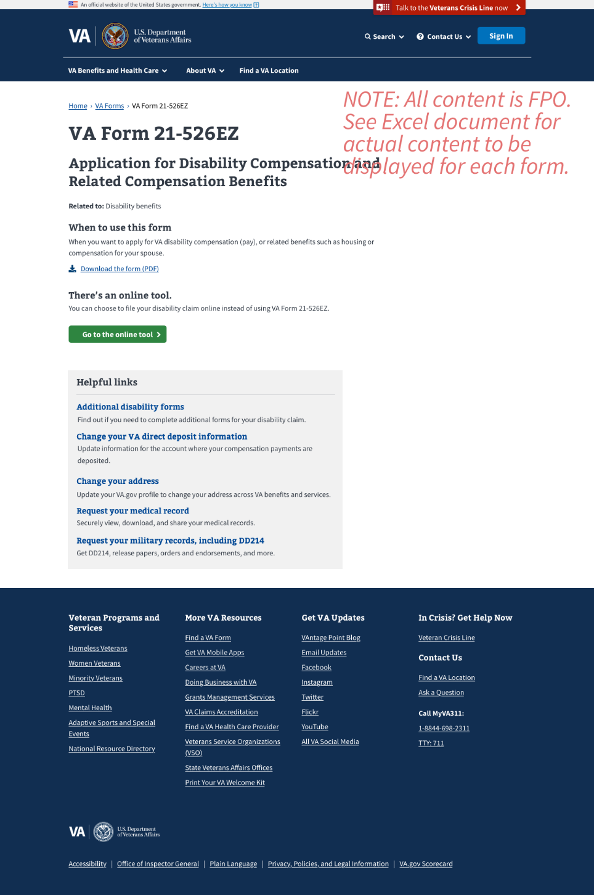

## II. Custom form detail landing page

The content fields in a custom landing page will be:

1. Form # H1
2. Form name H2
3. Related to: [category, category…]
4. When to use this form: [label & custom text TBD Laura]
5. Form download link (NOTE: Download icon is automatically generated for forms that are hosted in Drupal; so currently for MVP, these landing pages will not have the icon.)
6. Button CTA to online exp
7. Related forms and instructions [TBD Laura’s label recommendation & custom text for each of the custom treated forms] – omit section in FE if N/A
8. Custom helpful links

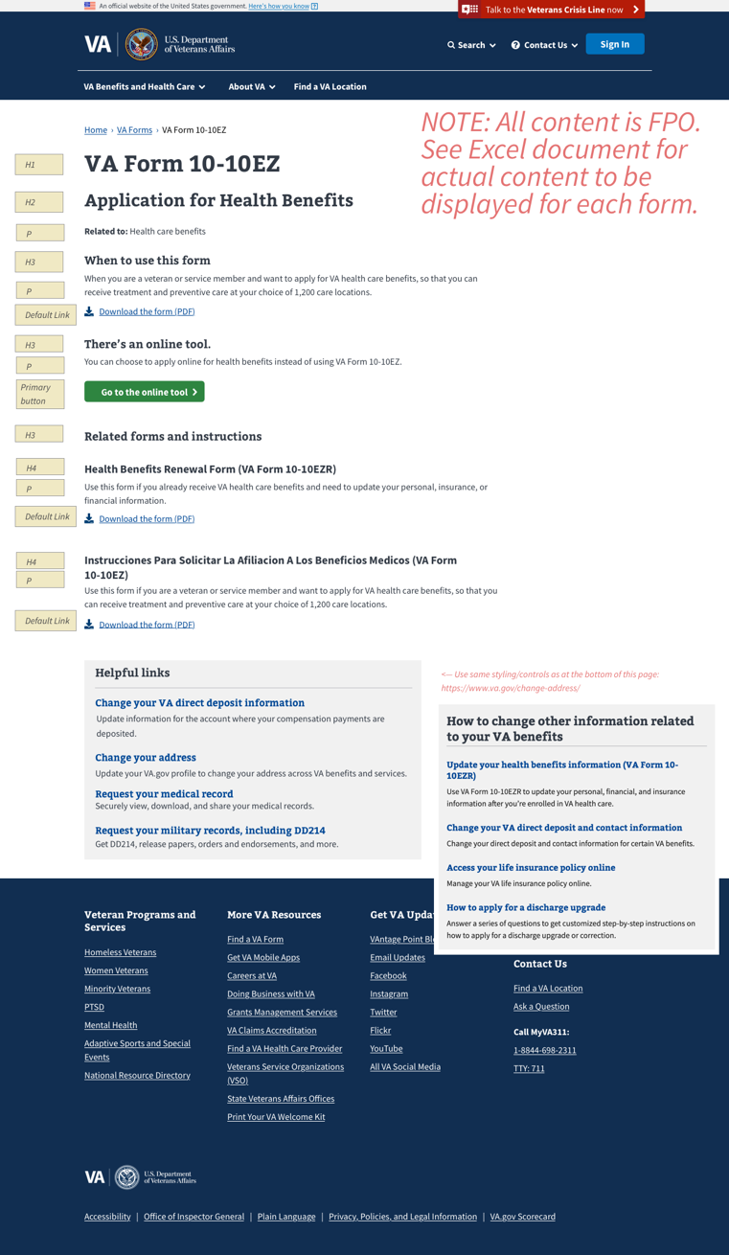

## Generic landing page example (minimal content, no “online tool” button)

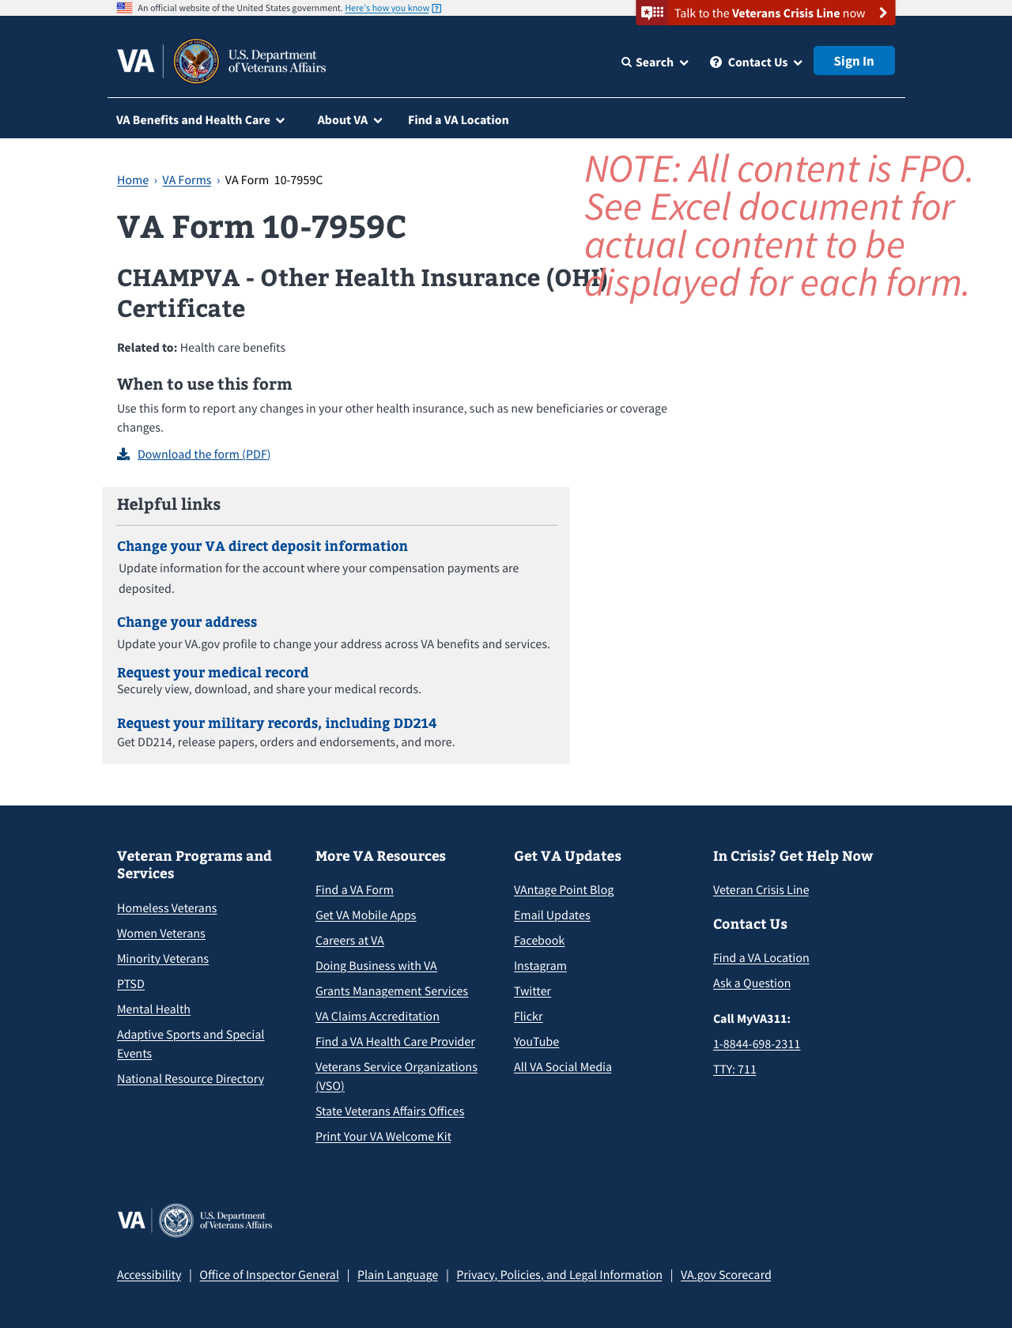

## Single form landing page example/design spec (no online tool button)

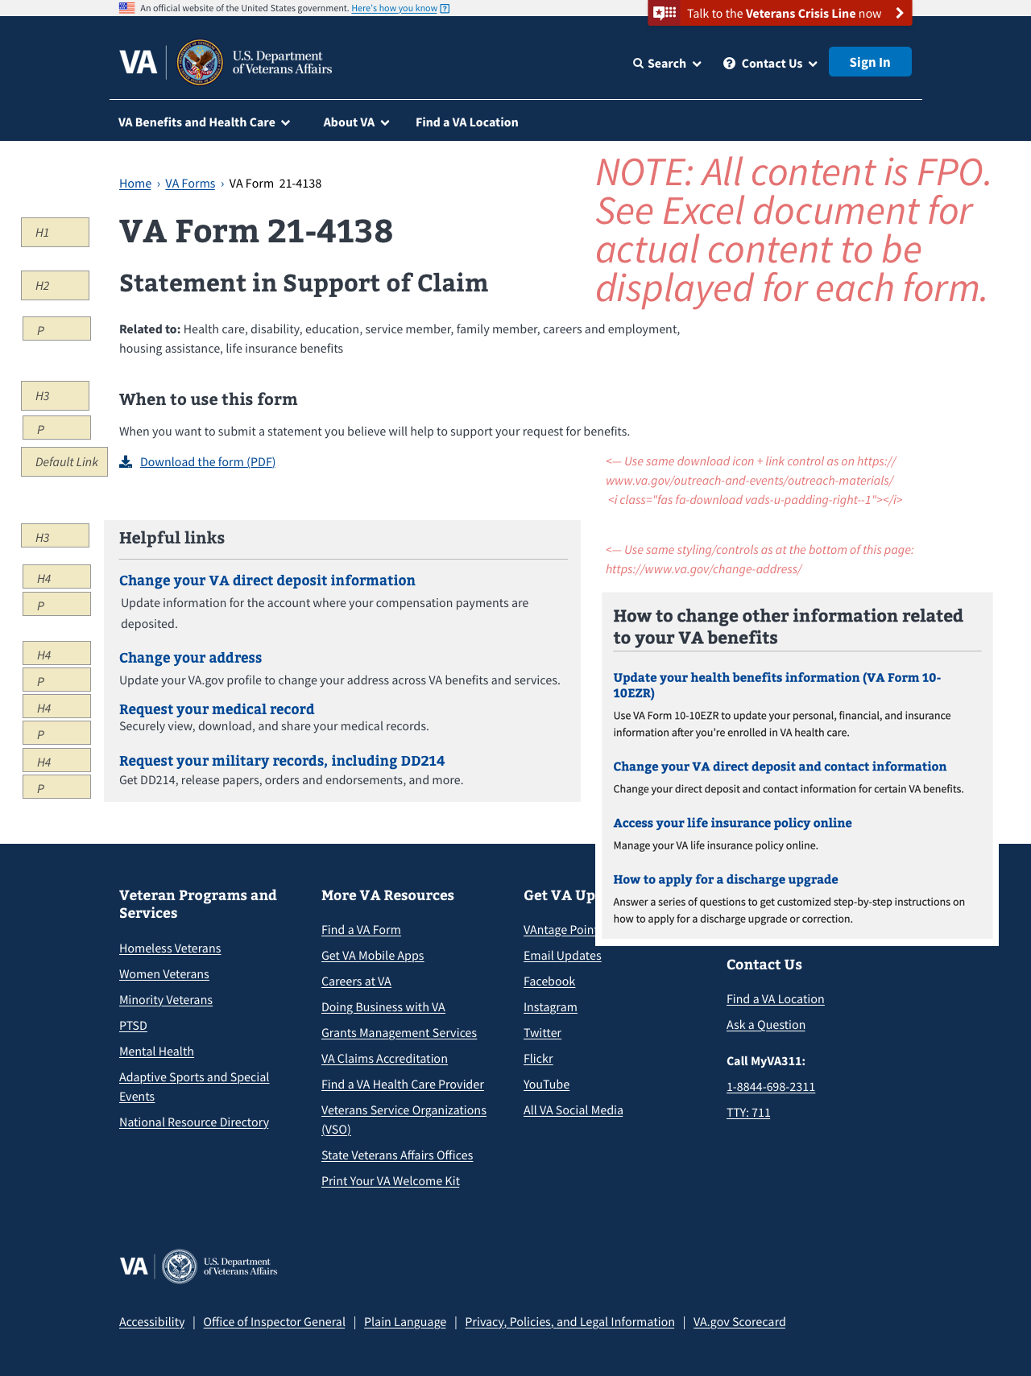

## A11Y programming notes per review by Trevor and Jen

The Helpful links could be wrapped in an unordered list and be labeled by the H3. Markup could look like:

<h3 id="helpful-links-heading">Helpful Links</h3>

<ul aria-labelledby="helpful-links-heading">

<li>

<h4>

<a href="#">Heading</a>

</h4>

<p>Descriptive paragraph</p>

</li>

<li>

<h4>

<a href="#">Heading</a>

</h4>

<p>Descriptive paragraph</p>

</li>

<li>

<h4>

<a href="#">Heading</a>

</h4>

<p>Descriptive paragraph</p>

</li>

</ul>

1. H3 links should be underlined. CSS change requested here: <https://github.com/department-of-veterans-affairs/vets-design-system-documentation/issues/157>
2. Download the PDF link info per <https://github.com/department-of-veterans-affairs/vets-design-system-documentation/issues/152#issuecomment-553127340>

Added aria-hidden="true" to <i> to suppress the injected text content (that renders the icon) from screen readers. To comply with WCAG, we edited link text to be clear about what the link does without the surrounding content. *(2.4.4, 2.4.9 - "****The link text MUST make sense in context, and should make sense when taken out of context****(problematic phrases include: “click here,” “learn more,” “more,” “read more,” etc.).)"*

Download PDF Link Example

<a

href="><https://www.va.gov/playbook/downloads/Voices_Of_Veterans.pdf><"

download="Voices_Of_Veterans.pdf"

title="Download the Voices of Veterans PDF"

type="application/pdf">

<i aria-hidden="true" class="fas fa-download vads-u-padding-right--1"></i>

Download the Voices of Veterans <dfn><abbr title="Portable Document Format">PDF</abbr> (4.9<abbr title="Megabytes">MB</abbr>)</dfn>

</a>