

**10-10EZ Short-Form Health Care Application**Last updated: March 2022

Table of Contents

Filling out the Healthcare Application: Authenticated with Disability Rating 50% or Higher

Veteran Information Page 1: Name/SSN/D.O.B. 3

Veteran Information Page 2: Short-Form Message and Place of Birth 4

Veteran Information Page 3: Mother’s Maiden Name 5

Veteran Information Page 4: Gender Identity 6

Veteran Information Page 5: Race/Ethnicity 7

Veteran Information Page 6: Mailing Address 8

Veteran Information Page 7: Home Address 9

Veteran Information Page 8: Email and Phone Number 10

Veteran Information Page 9: Medicaid 11

Veteran Information Page 10: Other Insurance 12

Veteran Information Page 11: Add Other Insurance Info 13

Veteran Information Page 12: ACA and VA Facility 14

Veteran Information Page 13: Confirmation and Submit 15

Table of Figures 16

**10-10EZ Short-Form for Veterans Authenticated With Disability Ratings of 50% or Higher**

### **Veteran Information Page 1: Name/SSN/DOB Confirmation**

This is the shortened version of the 10-10EZ flow for an authenticated user with a disability rating of 50% or greater. The screen below (Figure 1) is the first screen the user will see after clicking on the button to “Start the health care application.” We will pre-populate the Veteran info and ask them to continue if correct.

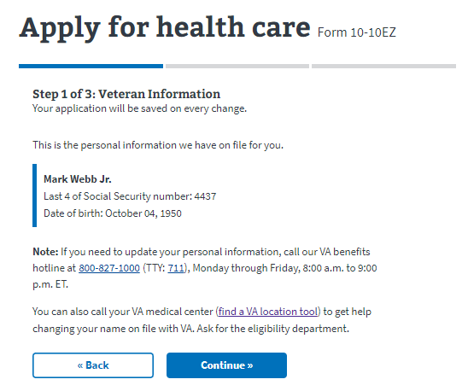

*Figure 1: Veteran name/SSN/DOB.*

### **Veteran Information Page 2: Short-Form Message Display and Place of Birth**

Next, we introduce new messaging to let the Veteran know that they are eligible to apply for health care using a shorter version of the 10-10EZ application (Figure 2). The user will have the opportunity to provide place of birth.

*Figure 2: Short-form message.*

### **Veteran Information Page 3: Mother’s Maiden Name**

Enter or confirm mother’s family name (Figure 3).

*Figure 3: Mother’s family name.*

### **Veteran Information Page 4: Gender Identity**

Select gender (Figure 4) or if pre-filled correctly, click “Continue.”

*Figure 4: Gender identity.*

## Veteran Information Page 5: Race/Ethnicity

*Figure 5: Race/ethnicity.*

## Veteran Information Page 6: Mailing Address

Veteran has the option to select “yes” if mailing and home address are the same. See Figure 6.

Same?

*Figure 6: Mailing address.*

## Veteran Information Page 7: Home Address

* If the Veteran answers “no” to whether their mailing and home address are the same, they will see a screen to enter their home address (Figure 7).

*Figure 7: Home address.*

## Veteran Information Page 8: Email Address and Phone Number

*Figure 8: Email and phone number.*

## Veteran Information Page 9: Medicaid

*Figure 9: Medicaid.*

## Veteran Information Page 10: Other Insurance

*Figure 10: Other insurance.*

## Veteran Information Page 11: Add Other Insurance Info

* If they answer “Yes” to other insurance, this page displays (Figure 11).

*Figure 11: Add other insurance info.*

## Veteran Information Page 12: ACA and VA Facility

*Figure 12: ACA and VA facility.*

## Veteran Information Page 13: Confirmation Page/Submit

*Figure 13: Confirmation page/submit.*

Table of Figures

*Figure 1: Veteran name/SSN/DOB.*

*Figure 2: Short-form message.*

*Figure 3: Mother’s family name**.*

*Figure 4: Gender identity.*

*Figure 5: Race/ethnicity.*

*Figure 6: Mailing address.*

*Figure 7: Home address.*

*Figure 8: Email and phone number.*

*Figure 9: Medicaid.*

*Figure 10: Other insurance.*

*Figure 11: Add other insurance info.*

*Figure 12: ACA and VA facility.*

*Figure 13: Confirmation page/submit.*