

**VA Online Scheduling (VAOS) on VA.gov**

**Table of Contents**

**VA Online Scheduling on VA.gov**

**What is VA Online Scheduling?**

Tool overview

History

**User Access**

Who can use VAOS?

How do Veterans access VAOS?

**View appointments**

Upcoming appointments

Requested appointments

Past appointments

Cancel appointments and requests

**Schedule a new appointment**

Starting the scheduling process

Overview of the scheduling process

Chapter 1: Select type of care and provider details for an appointment

Chapter 2: Appointment details

Chapter 3: Contact information and submit

**Error States**

Global

Appointment list

Cancellation

New Community Care request

New appointment or request flow

**Error Messages Displayed**

Generic error

No registration

No supported facilities

Single system eligibility messages

Podiatry message

Multiple site eligibility messages

Appointment slot error

Appointment submission error

Cancel failed

**Table of Figures**

## What is VA Online Scheduling?

### Tool overview

VA Online Scheduling (VAOS) is a Veteran-facing online application for VA health care appointment scheduling. The legacy VAOS tool with which many Veterans are familiar has been available at [https://Veteran.mobile.va.gov/var/v4/](https://veteran.mobile.va.gov/var/v4/) and through the Appointments dashboard in My HealtheVet for the last several years. This tool has been phased out in favor of VAOS built on top of the VA.gov platform. This guide is only meant to cover the experience of the tool on VA.gov.

### History

Both tools use the same back-end scheduling systems, so there is no difference between them in terms of the data that’s submitted to VA for scheduling or requesting appointments. However, an easy differentiator is the URL of the tool’s website. If the Veteran is on a URL that starts with [VA.gov](http://va.gov), he or she is using the new tool. If the Veteran is on a site with a URL that starts with [Veteran.mobile.va.gov](http://veteran.mobile.va.gov), he or she is using the old tool. The full URLs for the appointment scheduling tools are:

Old VAOS Tool: [https://Veteran.mobile.va.gov/var/v4/](https://veteran.mobile.va.gov/var/v4/)

New VAOS Tool: <https://www.va.gov/health-care/schedule-view-va-appointments/appointments>

The new VAOS tool was released to Veterans in March 2020 through a phased rollout—we gradually released the tool until 100 percent of Veterans were using new VAOS on VA.gov. During the phased rollout, both the legacy and new VAOS tools were available to Veterans, and they could use whichever they preferred.

The new VAOS tool is fully available to all Veterans on VA.gov throughout the VA digital ecosystem. This means that Veterans can be redirected to the new VAOS tool from My HealtheVet, VA Mobile app store, and the native Launchpad app.

## User Access

### Who can use VAOS?

To use VAOS, Veterans must:

* Have an MHV Premium, DS Logon, or ID.me identity-proofed account
* Be enrolled in VA health care
* Be registered in a VA health care system that is still using VistA to   
  manage schedules

If a Veteran does not meet all three of these criteria, he or she should call their local VA health care facility to receive further assistance and schedule an appointment over the phone. VA health care facilities can be found on the VA Facility Locator at [va.gov/find-locations/](https://www.va.gov/find-locations/).

#### Have an MHV Premium, DS Logon, or ID.me verified account

Veterans who do not have any of the above accounts should sign up for a free ID.me account at https://www.id.me/ and go through the process to verify their identity. Learn more about signing into VA apps at [mobile.va.gov/login-information](https://mobile.va.gov/login-information).

#### Be enrolled in VA health care

Only Veterans enrolled in VA health care are eligible to schedule VA health care appointments. Veterans who are not enrolled in VA health care should fill out Form 10-10EZ online following the process at [va.gov/health-care/how-to-apply/](https://www.va.gov/health-care/how-to-apply/).

#### Be registered in a VA health care system that uses VistA

Veterans can only make appointments at facilities within their registered VA health care system or systems. Registration happens automatically when a Veteran has been seen in the past at a VA facility within a given system. Alternatively, Veterans can call or visit their local VA facility to set up their first appointment and register. Veterans who need to register within a system should find and call their preferred local VA facility using the VA Facility Locator at [va.gov/find-locations/](https://www.va.gov/find-locations/). Please note that some systems use proprietary technology to manage appointments (e.g., MyChart). These systems are not supported in VAOS, and Veterans should reach out to their respective local facilities to learn more.

### How do Veterans access VAOS?

Eligible Veterans can access the VAOS tool through several different entry points, detailed below.

#### Direct link

Veterans can navigate to the tool directly by entering the application’s URL into their preferred browser: [va.gov/health-care/schedule-view-va-appointments/appointments](http://va.gov/health-care/schedule-view-va-appointments/appointments). Note that Veterans will be prompted to sign in using one of the three authentication accounts (DS Logon, MHV Premium, or an LOA3 identity proofed ID.me account) to access VAOS directly.

#### VA.gov Schedule and Manage Health Appointments Page

Veterans can navigate to the tool from the VA.gov Schedule and Manage Health Appointments page ([va.gov/health-care/schedule-view-va-appointments/](https://www.va.gov/health-care/schedule-view-va-appointments/)) (Figure 1). If the Veteran is already signed in, they can click the “Go to your VA appointments” button. If the Veteran is signed out, they must first sign in with DS Logon, MHV Premium, or an identity proofed (LOA3) ID.me account by clicking the “Sign in or create an account” button.

*Figure 1. VAOS link from Schedule and Manage Health Appointments page*

#### VA.gov homepage

Veterans can navigate to the Schedule and Manage Health Appointments page from the VA.gov Homepage by clicking the “Schedule and view your appointments” link in the health care card (Figure 2).

*Figure 2. VA.gov homepage health care card*

##### VA Mobile App Store

Veterans will be able to access VAOS on the VA Mobile App store when they search for “VA Online Scheduling.” To launch the new tool, Veterans will not need to download a native app; instead, they will click on the “Launch in Browser” blue button and will be redirected to the VA.gov scheduling page to access VAOS (Figure 3).

*Figure 3. VAOS link from VA Mobile App store*

##### Launchpad App

Veterans can also access VAOS from within the native Launchpad app (available on iOS and Android devices). To do so, Veterans need to search for the VA Online Scheduling section of the app and select the blue “Open Application” button. This will redirect the Veteran to the VA.gov scheduling page to access VAOS (Figure 4).



*Figure 4. VAOS link from VA Launchpad app*

## View appointments

Appointments are grouped into lists by status: upcoming, requested, past, and canceled. The appointment lists display a card for each appointment. The information displayed on each card varies depending on the type of appointment. Additional information about the appointment can be found by selecting the Details link on the card.

### Upcoming appointments

When Veterans navigate to VAOS homepage/upcoming appointments page, they should see a list of various upcoming appointments and a button to start scheduling a new appointment (Figure 5).

The upcoming list shows:

* Future confirmed and cancelled appointments
  + VA and Community Care appointments
  + Only appointments scheduled in the next 396 days

Confirmed appointments (both active and cancelled) are listed in chronological order (soonest appointment at the top, farthest in the future at the bottom).

*Figure 5. VAOS homepage with appointment list and scheduling button*

#### VA appointments

* Date, time, and local facility time zone of appointment
* Name of the VA facility associated to the appointment
* Address of the VA facility
* Link to directions to the facility address
* Name of clinic that the patient has been booked into
* Main phone number of the facility
* Reason for appointment (e.g., follow up, new issue)
* Any content the Veteran entered in the “appointment reason” text field
* Option to download the appointment as an ICS and add it to calendar
* Option to print the appointment information

#### Community Care appointments

* Name of the provider
* Address of the provider
* Link to directions to the provider address
* Any content that the Veteran entered in the “appointment reason” text field
* Option to download the appointment as an ICS and add it to calendar
* Option to print the appointment information

### Requested appointments

A requested appointment is a Veteran-initiated request for an appointment that requires VA staff to complete scheduling. These appointments are considered pending and don’t have a booked date or time yet.

The requested list shows:

* A request that has not been resolved or cancelled
* All future appointment requests with a future preferred date and cancelled status

Requests are listed in the order the request was submitted, with the newest at the top.

##### VA requests

* Name of the VA facility associated to the appointment
* Address of the VA facility
* Link to directions to the facility address
* Preferred type of appointment the Veteran selected
* Preferred dates and times the Veteran selected
* Reason for appointment (e.g., follow up, new issue)
* Any content the Veteran entered in the “appointment reason” text field
* The Veteran’s contact information

##### Community Care requests

* Preferred provider (if provided by the Veteran when submitting the request)
* Preferred dates and times the Veteran selected
* Any content the Veteran entered in the “appointment reason” text field
* The Veteran’s contact information

### Past appointments

The past list shows:

* Appointments scheduled for a date and time before the current day
  + Up to the first day of the prior year

Requests are listed in the order the request was submitted, with the newest at the top.

### Cancel appointments and requests

All appointments and requests in the list on the VAOS homepage have a link that, when clicked, will attempt to cancel the appointment or request. After clicking the link, a Veteran will get a confirmation modal asking them to confirm that they want to cancel (Figure 6). If they affirm their cancellation, the tool will attempt to cancel the appointment or request. If successful, the Veteran will see a confirmation of the cancellation and the appointment list will now show the appointment as cancelled. This does not include appointment requests with past preferred dates, as these will drop off the list.

*Figure 6. Confirm to cancel appointment modal*

#### What can be cancelled?

* All requests (VA and Community Care) can be cancelled at any time
* VA appointments may be cancellable, but the tool won’t know until a cancellation attempt is made
  + The ability to cancel any given appointment is determined by the site’s specific configuration. While some sites allow cancelling online for certain types of care, other sites do not (or may not support cancelling the same types of care).
* VA Video Connect (telehealth) appointments cannot be cancelled online
* Community Care confirmed appointments cannot be cancelled online
* COVID-19 vaccine appointments cannot be cancelled online

#### What happens if a cancellation fails?

Cancellations may fail to go through for a variety of reasons. If the appointment type being cancelled is a confirmed appointment, the most likely reason is that the hosting facility or clinic does not allow online cancellation of appointments for that type of care.

Alternatively, an appointment cancellation may fail for a service-related issue. These typically resolve on their own within a few minutes.

If a cancellation fails, a confirmation screen will indicate that the attempt failed and will give the Veteran phone numbers to call to help resolve the scheduling issue.

## Schedule a new appointment

### Starting the scheduling process

To start the scheduling process, click on the “Schedule an appointment” button at the top of the VAOS homepage (Figure 7).

*Figure 7. Button to start scheduling a new appointment at the top of the VAOS homepage*

### Overview of the scheduling process

The scheduling process is organized into 3 chronological chapters:

1. Selecting a type of care and provider options for an appointment
2. Entering appointment details including the date, time, visit type, etc.
3. Providing contact information and submitting the request

#### Possible scenarios for the Appointment Details chapter

In general, all appointments share similar first and third chapters. However, the second chapter (appointment details) is highly conditional and based on the Veteran’s answers to questions in chapter 1 as well as some questions in the early parts of chapter 2. Depending on the answers, Veterans will see one of:

* VA Appointment Request flow
  + In many cases, Veterans will not be scheduling an appointment but submitting a request to have a scheduling clerk schedule an appointment for them with the given information in the request.
* Community Care Appointment Request flow
  + Some Veterans may have the option of seeing a Community Care provider. Veterans who elect this option are only able to submit a request for an appointment with a Community Care provider. A scheduling clerk will receive this request and take care of scheduling an appointment time.
* VA Direct Scheduling flow
  + Some Veterans may have the option of directly scheduling an appointment. When possible, VAOS will schedule an actual appointment with an actual time slot for Veterans with the entered information.

### Chapter 1: Select type of care and provider details for an appointment

#### Select a type of care

The first screen in the scheduling process is pivotal to the downstream options available to a Veteran. On this page, Veterans pick their type of care (Figure 8). The available options are:

* Amputation care
* Audiology and speech (including hearing aid support)
* COVID-19 vaccine
* Eye care
* Mental health
* MOVE! weight management program
* Nutrition and food
* Pharmacy
* Podiatry
* Primary care
* Sleep medicine
* Social work

*Figure 8. Type of care selection*

##### Audiology and speech

Audiology is a base category that includes both routine hearing exam and hearing aid support subcategories. Veterans who select a VA appointment will not have to pick which of these two subcategories they need, but Veterans who choose Community Care will have to choose one later in the scheduling process.

##### Eye care

Eye care is a base category that includes both optometry and ophthalmology subcategories. Veterans who choose Sleep medicine will need to make a subcategory selection on the next page in the scheduling workflow. Ophthalmology is only available for online scheduling at the VA. Optometry may be available for both VA care and Community Care.

##### Sleep medicine

Sleep medicine is a base category that includes both sleep medicine and home sleep testing as well as Continuous Positive Airway Pressure (CPAP) subcategories. Veterans who choose Sleep medicine will need to make a subcategory selection on the next page in the scheduling workflow (regardless of whether they are making a VA or Community Care appointment).

#### Choose between VA and Community Care providers

After Type of Care is selected, a Veteran may be presented with the choice of scheduling a VA appointment or scheduling a Community Care appointment (Figure 9). Whether or not a Veteran sees this page and must make this choice is determined automatically by the VAOS tool, based on several factors:

* **Type of Care:** Only Audiology, Nutrition and food, Optometry, Podiatry, and Primary Care are eligible for Community Care scheduling online. Likewise, Podiatry is only available online for Veterans wishing to schedule a Community Care appointment.
* **Veteran’s Community Care Eligibility status:** Currently, the service that provides eligibility information to the VAOS tool only checks eligibility based on static codes. However, over the coming weeks, the service will begin factoring in drive time eligibility checks. In the long-term, the service may also check eligibility based on wait times, but this capability does not yet exist. If a Veteran suspects they should be eligible for Community Care but are not, they should call their local VA facility to help them schedule an appointment.
* **Veteran’s VA Healthcare System registration status:** In addition to being eligible for Community Care, a Veteran must be registered in a VA system that currently supports scheduling Community Care appointments online. Not all systems support this capability. Thus, a Veteran who is eligible for Community Care may not get the option to choose Community Care through VAOS because they are not registered at any sites that support Community Care scheduling.

##### Community Care and podiatry

Podiatry is available for online scheduling within the context of Community Care. Thus, if a Veteran selects Podiatry on the Type of Care page and doesn’t meet the above criteria for Community Care scheduling, this Veteran will be told that Podiatry appointments can’t be scheduled for them. Alternatively, if a Veteran does meet Community Care eligibility requirements for Podiatry, that Veteran will be directed to the Community Care scheduling workflow automatically and will bypass the Choose where you want to receive your care page. If they wish to make a Podiatry appointment at a VA facility, they can still do so by calling their local VA facility.

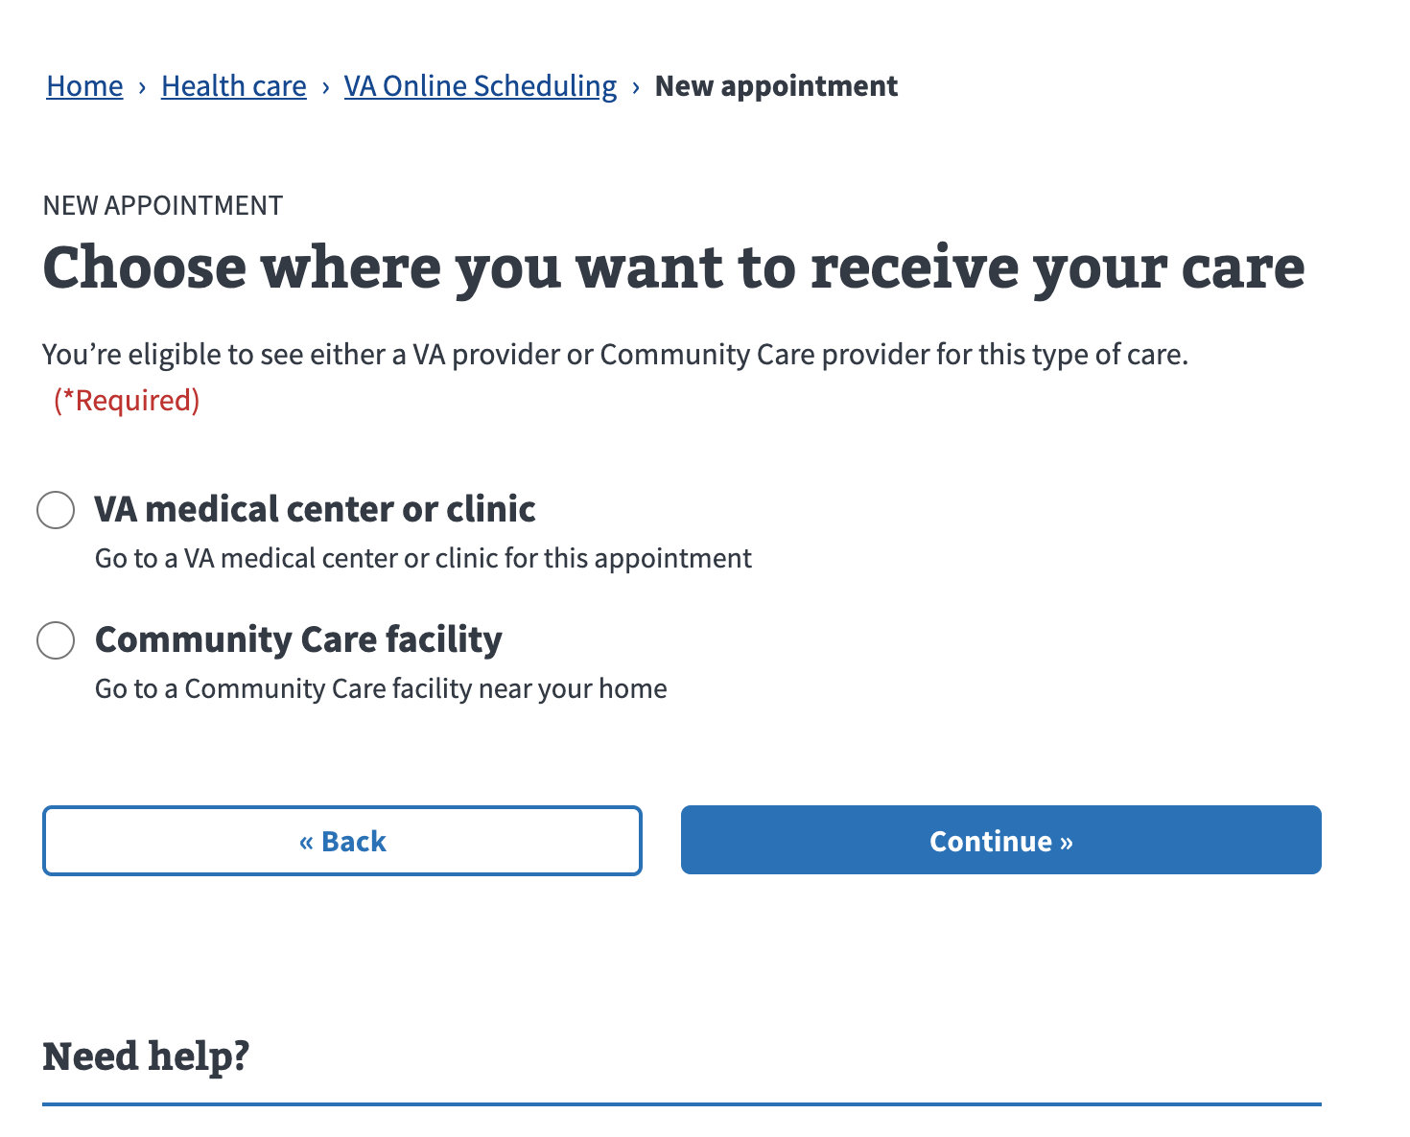

*Figure 9. VA or Community Care choice*

### Chapter 2: Appointment details

#### Scheduling a VA Appointment

If a Veteran either chooses to have their appointment at the VA or doesn’t get the option to choose, they will be put into the VA scheduling flow after selecting a type of care.

##### Choosing a VA health care facility

After selecting a type of care, Veterans will be presented with a list (if registered at more than one) of VA health care facilities (Figure 10). Veterans are required to choose a facility for their appointment.

Once a facility is selected, the VAOS tool performs automated checks to ensure that the Veteran can complete the scheduling process at that facility. These checks include:

* **Type of Care:** Not all facilities support a given type of care. Even when they do, they may not support online scheduling for that type of care. Each facility is configured independently from others.
* **Recency:** Veterans may only be able to use online scheduling if they’ve been seen at the selected facility for that type of care in the past 1 or 2 years. VAOS will automatically check their completed appointment history to make this determination.
* **Request Limits:** Facilities may opt to enforce a limit on the number of outstanding requests that can simultaneously exist for a given type of care. If a Veteran is at or above this number of outstanding requests, they will not be able to complete the scheduling process for that type of care at the facility.
  + Note: Veterans should be able to navigate back to the VAOS homepage and find and cancel the outstanding request from there if desired. That should clear out their active requests and enable them to schedule a new appointment. This may not be prudent as it could adversely reset their wait time for an appointment due to the new request restarting at the bottom of the scheduling queue.

If a Veteran’s scheduling selections fail any of these checks, the Veteran will be prevented from continuing the scheduling process until a different selection is made (either regarding the type of care or the facility for the appointment). An alert message with more details about the failed check will show on the selection page at that time.

*Figure 10. Facility selection*

##### Direct scheduling

Some facility and type of care combinations support direct scheduling (i.e., self-scheduling) an appointment time with a specific clinic. If the VAOS tool determines that a Veteran’s specific combination of answers enables them to directly schedule an appointment time, the tool will put them in the corresponding workflow to finish the direct scheduling process.

###### Selecting a patient clinic

After selecting a VA system and facility, the Veteran may be presented with a screen listing all the clinics at which a Veteran has been seen for that type of care at that VA facility (Figure 11). This screen will only show if the Veteran’s combination of selections makes their appointment eligible for direct scheduling, which is determined automatically by the VAOS tool based on:

* **Direct scheduling is configured for the selected type of care at the selected facility:** Direct scheduling must be configured by the facility for each type of care. Not all types of care at all facilities are configured for direct scheduling.
* **Veteran has been seen for the selected type of care at the given clinic:** In the list of clinics, a Veteran will only see clinics that they’ve been seen at in the past 2 years. Thus, if a Veteran has not been seen at any clinics for this type of care within the past 2 years, they will not have any clinics to select and will not see the direct scheduling page.

If a Veteran does not recognize any of the clinics in their clinics list or does not wish to proceed scheduling into any of them, they can select the “I need a different clinic” option. Clicking this option will send Veterans to the “Request an appointment” flow, which is covered later in this guide.

*Figure 11. Clinic selection*

###### Selecting a date and time for an appointment

Once a clinic has been selected, Veterans will be prompted to select a preferred date for their appointment. This information is used to report on VA wait times and determine which dates are closest to the Veteran’s preferred date, to show the correct dates (Figure 12).

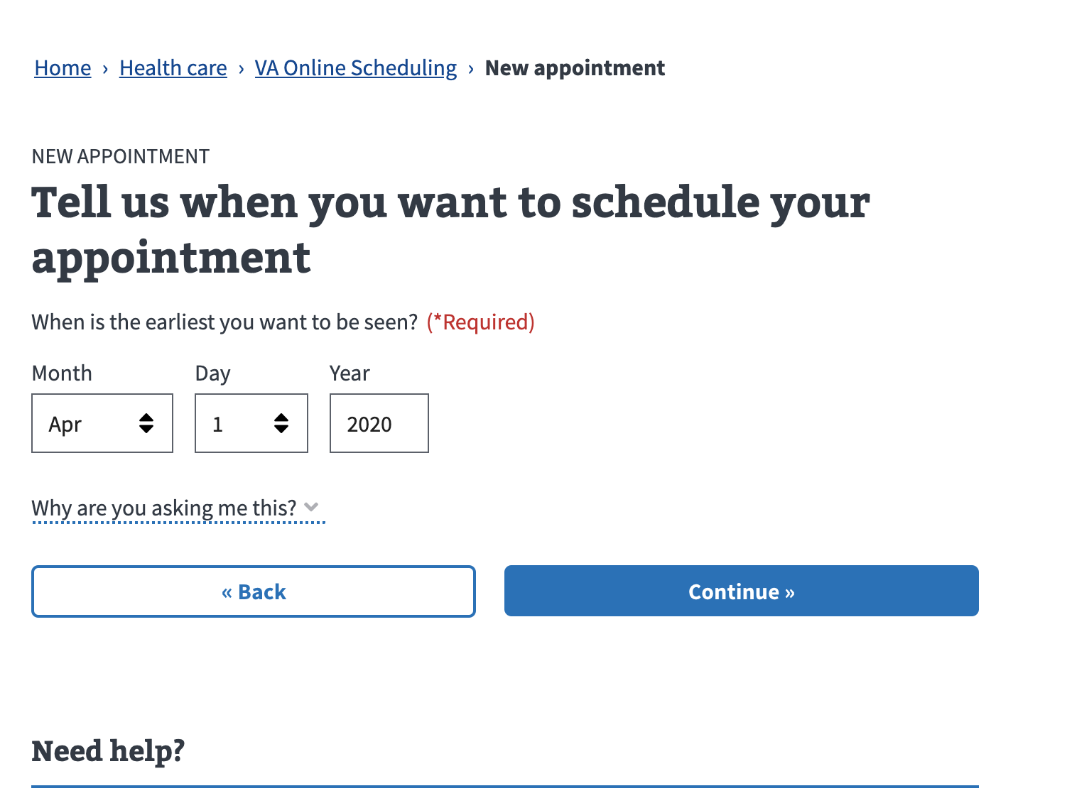

*Figure 12. Preferred appointment date for direct scheduling*

Once a preferred date has been selected, Veterans will see a calendar with available appointment dates (Figure 13). After selecting a date, they’ll be able to choose an open time slot. These available dates and time slots are retrieved from the clinic’s current status, so should accurately reflect the times available for an appointment.

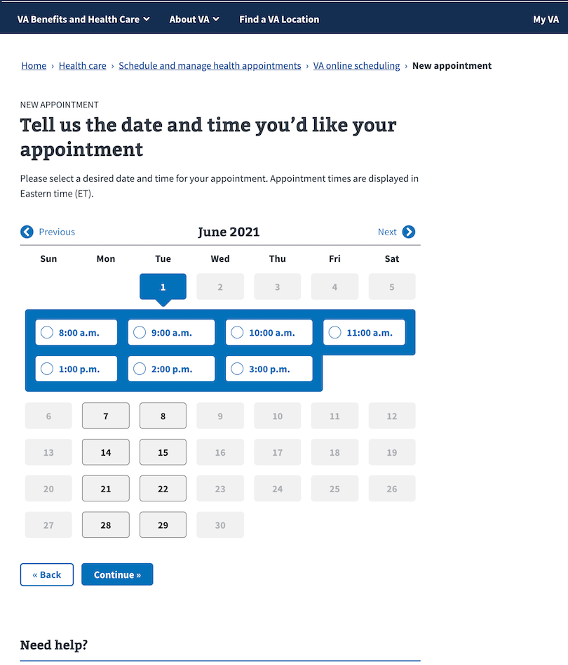

*Figure 13. Select a date and time slot for direct scheduling*

##### Creating an appointment request

Given that not all types of care at all facilities support direct scheduling through VAOS, Veterans may be prompted to create an appointment request instead of directly scheduling an appointment.

###### Select preferred dates

The next page after selecting a VA system and facility will present Veterans with an interactive calendar of dates. Veterans will need to select a date as well as general time of day (a.m. or p.m.) that they would prefer for their appointment. Up to three day/time of day combinations can be selected, but only one is required.

There is no guarantee that the VA will be able to accommodate a Veteran’s date and time preferences, so Veterans are encouraged to use all three possible slots (Figure 14).

*Figure 14. Choose date and time of day preferences for requests*

#### Scheduling a Community Care appointment

If a Veteran meets all the eligibility requirements for scheduling a Community Care appointment (as outlined in the Choose VA or Community Care section earlier) and chooses the Community Care option on the corresponding page, that Veteran will be taken down the Community Care appointment request flow. Note that Community Care appointments cannot be directly scheduled in VAOS—an appointment request must be submitted instead.

##### Select a preferred date

The first page in the Community Care scheduling workflow will present Veterans with an interactive calendar (Figure 14). As with the VA Appointment Request workflow, Veterans will need to make at least one date selection, but can choose up to 3 distinct date and time of day combinations that best fit their schedules.

##### Community Care preferences

After selecting preferred dates, Veterans will be asked for any provider preferences. The experience of the preference selection will depend on whether the Veteran has a residential address filled out in their Vet360 profile.

###### Provider selection

If a Veteran has a residential address in their profile:

* They will be asked for a city/state that is closest to them, if registered at more than one VA healthcare system that supports online scheduling
* [Optional] They may select a preferred provider from a list (Figure 15)
  + The list is based on the approved providers nearest their residential address or current location
  + They may continue without indicating a preference

*Figure 15. Community Care provider preference list*

After indicating location and provider preferences, Veterans will be asked to select the preferred language for the appointment (Figure 16).

*Figure 16. Community Care provider language preference*

#### Select a reason for your appointment

After selecting a date and time (or for VA requests, after selecting a phone, office, or video visit), Veterans may need to select a reason for their appointment (Figure 17) and provide more details about the appointment. For appointment requests, the information written into the text box is sent to scheduling clerks. For directly scheduled appointments, the information goes to the provider who will review it before the appointment.

*Figure 17. Reason for appointment*

#### Select how you’d like to be seen [VA request flow only]

When creating an appointment request, VAOS will ask Veterans to choose between an in-person office visit, a phone call, or a VA Video Connect (telehealth) appointment. This page (Figure 18) appears after the reason for appointment page and does not show for Veterans who are directly scheduling an appointment (only in-person office visits can be directly scheduled online through the VAOS tool).

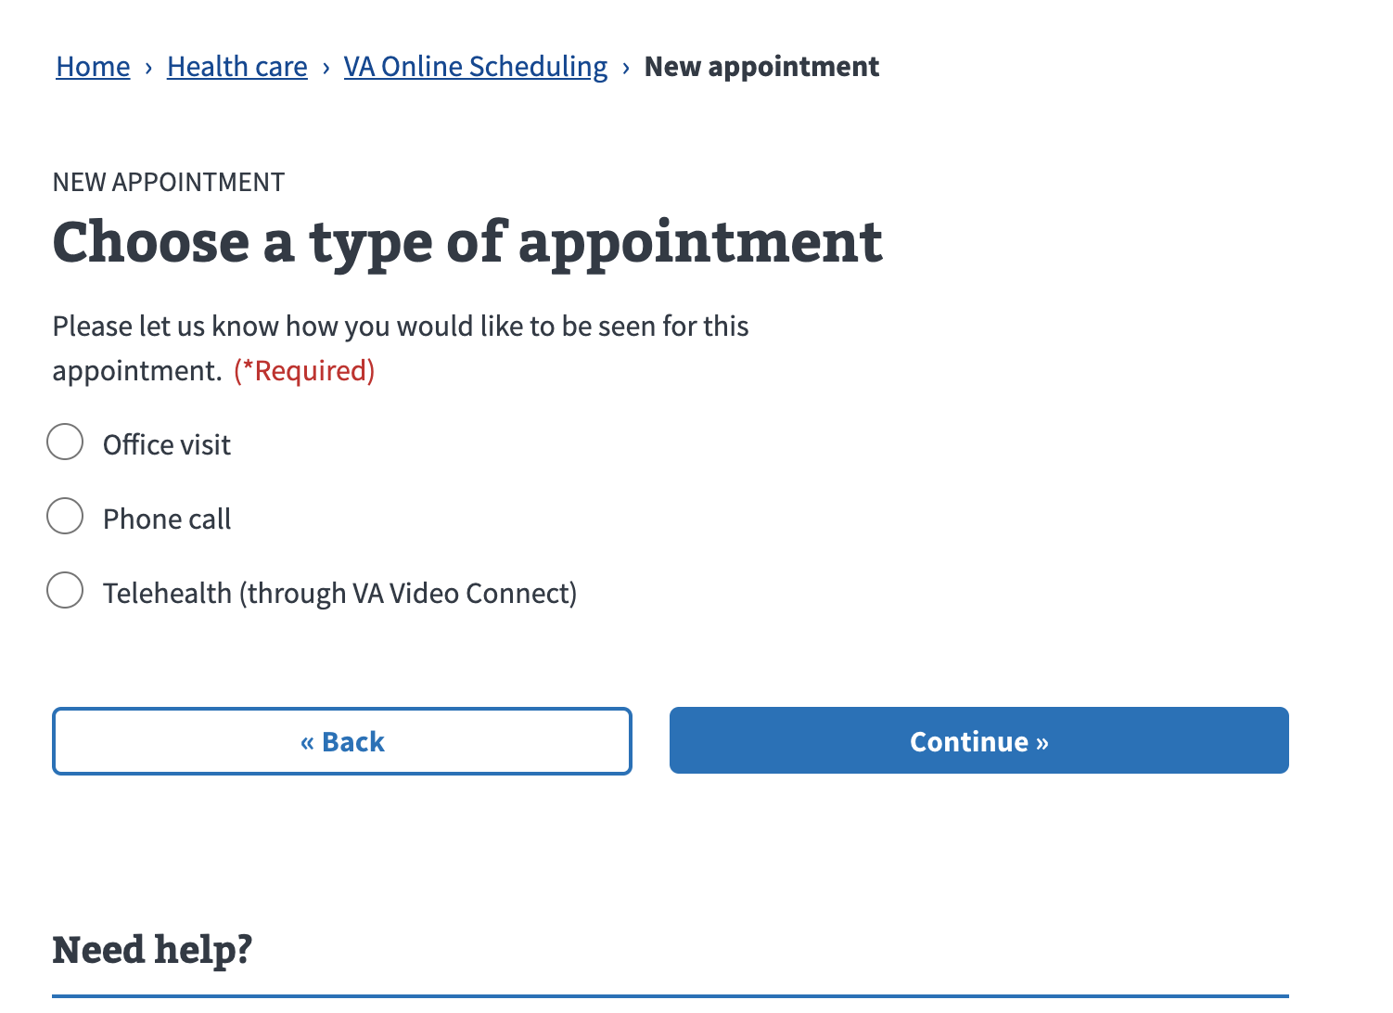

*Figure 18. Choose type of appointment for VA request*

#### Scheduling a COVID-19 vaccine appointment

COVID-19 vaccine scheduling is a separate flow from primary or specialty care scheduling within VAOS. To enter the flow, select “COVID-19 vaccine” from the Type of Care page (Figure 8).

Key information regarding subsequent doses is presented before continuing with scheduling (Figure 19).

*Figure 19. COVID-19 vaccine appointment information for planning ahead*

##### Check if already received vaccine

Veterans are prompted to answer whether they have already received any COVID-19 vaccine dose at a VA health care facility or elsewhere.

* If a Veteran has already received a dose, they are directed to contact the location of their first dose.
* If a Veteran has not yet received any dose, they continue through the online   
  scheduling flow.

##### Selecting a facility

A Veteran may choose to schedule their first dose at any VA health care facility where they are registered if that facility has the COVID-19 vaccine type of care turned on for online scheduling. Veterans are required to choose a facility for their appointment (Figure 10).

##### Selecting a clinic

After selecting a VA facility, the Veteran may be presented with a page listing all the clinics offering COVID-19 vaccine scheduling at the respective facility (Figure 11). Veterans are required to choose a clinic for their appointment. If only one clinic is set up at the respective facility, the Veteran will bypass this page.

##### Selecting a date and time for an appointment

Available dates and time slots are retrieved from the clinic’s status and display in a calendar (Figure 13). Veterans are required to choose a date and time for their appointment.

##### Second dose information

Once a date is selected, an informational page provides guidance on when to expect to return to the selected VA health care facility for a second dose based on the recommendations for each vaccine brand (Figure 20). A Veteran cannot choose which vaccine they receive when scheduling in VAOS.

*Figure 20. COVID-19 vaccine second dose information*

### Chapter 3: Contact information and submit

#### Select preferred contact information

After entering a reason for appointment (or selecting a type of visit in the case of the direct scheduling flow), Veterans are presented with their contact information for purposes of follow-up (Figure 21). The phone and email address that pre-populate are derived from the Veteran Profile database. However, if any Veteran wants to change the contact information for appointments, they can overwrite the populated information on this page.

Additionally, Veterans are required to indicate their preferred time of day for phone calls that may be made by the VA to confirm details about the appointment.

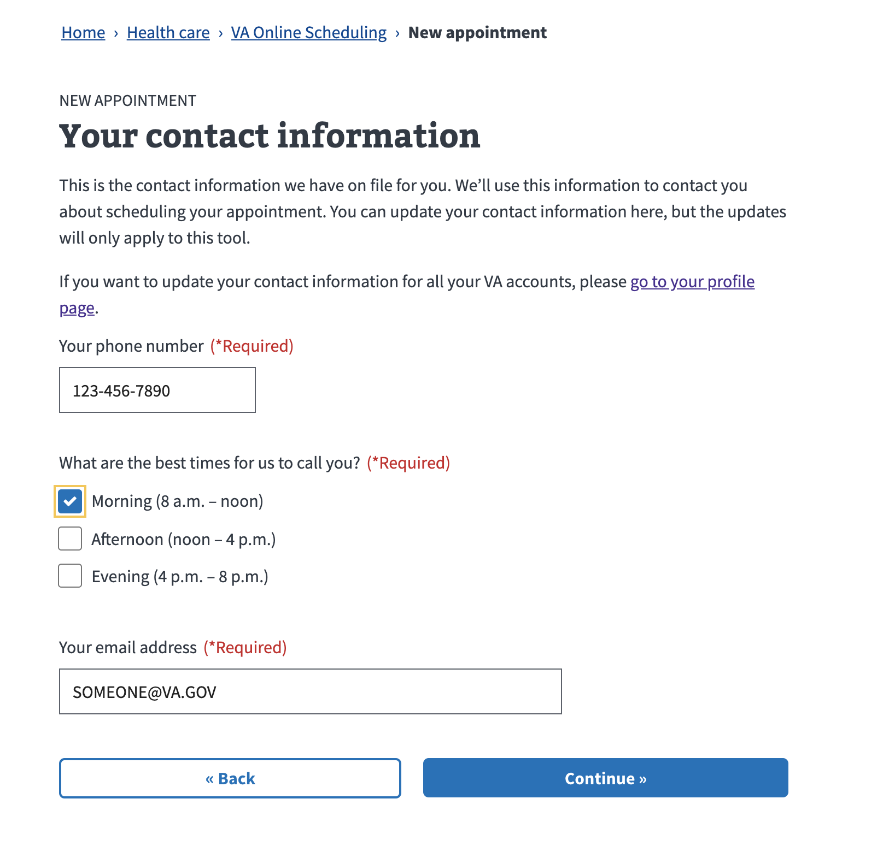

*Figure 21. Contact information for appointment follow-up*

#### Review your appointment and submit

The review page (Figure 22) comes after contact information. On this page, Veterans will get a chance to see the information they’ve provided before submitting the appointment or appointment request. Most review fields include an “edit” button on the right-hand side that, when pressed, will navigate the Veteran to the screen in VAOS that asks for the given information.

Once a Veteran is satisfied that the information on the page is accurate, they can submit by hitting the blue “Submit” button at the bottom of the review screen.

*Figure 22. Review appointment or request details*

#### Confirmation screen

A confirmation screen should show (Figure 23) regardless of whether the submission was successful or failed. In both cases, the confirmation screen will include information about the status of the request as well as the details of the booked appointment or appointment request. From the confirmation screen, Veterans have options to start a new appointment, view their list of appointments and requests, or click a link to add the current appointment to their calendar (in the case of directly scheduled appointments).

*Figure 23. Confirmation screen*

## Error States

The following are examples of the various error states a Veteran may encounter during their scheduling process. Most of these error states are due to configuration settings of the VATS/VistA systems and are considered “acceptable.” Error messages that are due to system-specific errors are logged accordingly.

### Global

* If a user doesn’t have any registered VistA sites, we show a warning modal saying we couldn’t find any health care registrations instead of the application.
* If a user does not have an MVI profile, we show a message saying we were unable to find their veteran records (generic VA.gov message).

### Appointment list

* When one of the 3 appointment/request services fails, we show an error alert instead of any appointment data.
* When either the CDW clinics or facility locator services fail, cards on the appointment list will show links to the facility locator instead of addresses.

### Cancellation

When cancelling fails, we show an error alert with facility contact info in the   
cancel modal.

### New Community Care request

* If a user chooses Podiatry and the eligibility or supported sites calls fail, we show a modal saying Podiatry is not available.
* If a user chooses a Community Care supported type of care but the eligibility or supported sites calls fail, we skip the facility type choice page.

### New appointment or request flow

* If the parent sites or child facilities calls fail, we show an error alert on the facility choice page.
* If a user is registered at one site and none of the child facilities support requests or direct scheduling, we show a warning that this medical center doesn’t allow online scheduling and stop them from continuing.
* If a user is registered at multiple sites and they choose a site where none of the child facilities support requests or direct scheduling, we show a warning that this medical center doesn’t allow online scheduling and stop them from continuing, unless they choose a different site.
* If a user chooses a site and facility where they don’t have a recent enough past visit to make a request, and they’re not eligible for direct scheduling, we show a warning alert and prevent them from continuing with that facility.
* If the past visits or request limits calls fail, and the user is not eligible for direct scheduling, we show a warning alert and prevent them from continuing with   
  that facility.
* If a user chooses a site and facility where more open requests than are allowed, and they’re not eligible for direct scheduling, we show a warning alert and prevent them from continuing with that facility.
* If a user chooses a site and facility where they pass all the request-related checks, but they’re not eligible for direct scheduling, we send them to the calendar page instead of the clinic choice page.
* If a user chooses a site and facility that supports direct scheduling and not requests, but there are no clinics available for that facility and type of care, we show a warning alert and prevent them from continuing with that facility.
* If a user chooses a site and facility that supports direct scheduling and not requests, but they do not have a recent enough visit for that type of care, we show a warning alert and prevent them from continuing with that facility.
* If the call to fetch appointment slots fails, a user is shown an error alert on the calendar page and is presented with a link to go into the request flow instead.
* If the call to fetch appointment slots returns no slots, the user is shown a warning modal and prevented from continuing (we may show a link to the request flow, not sure).
* If the call to submit an appointment or appointment request fails, we show an error alert with facility contact info.

## Error Messages Displayed

### Generic error

We’re sorry. We’ve run into a problem. Something went wrong on our end. Please try again later.

<https://github.com/department-of-veterans-affairs/va.gov-team/blob/master/products/health-care/appointments/va-online-scheduling/design/alerts/generic.png>

### No registration

<https://github.com/department-of-veterans-affairs/va.gov-team/blob/master/products/health-care/appointments/va-online-scheduling/design/alerts/no-registration.png>

### No supported facilities

<https://github.com/department-of-veterans-affairs/va.gov-team/blob/master/products/health-care/appointments/va-online-scheduling/design/alerts/facilities-no-valid-va-facilities.png>

### Single system eligibility messages

Valid:

<https://github.com/department-of-veterans-affairs/va.gov-team/blob/master/products/health-care/appointments/va-online-scheduling/design/alerts/facilities-single-valid.png>

Invalid:

<https://github.com/department-of-veterans-affairs/va.gov-team/blob/master/products/health-care/appointments/va-online-scheduling/design/alerts/facilities-single-invalid.png>

### Podiatry message

<https://github.com/department-of-veterans-affairs/va.gov-team/blob/master/products/health-care/appointments/va-online-scheduling/design/alerts/podiatry-ineligible.png>

### Multiple site eligibility messages

<https://github.com/department-of-veterans-affairs/va.gov-team/blob/master/products/health-care/appointments/va-online-scheduling/design/alerts/multiple-site-eligibility-message-1.png>

<https://github.com/department-of-veterans-affairs/va.gov-team/blob/master/products/health-care/appointments/va-online-scheduling/design/alerts/multiple-site-eligibility-message-2.png>

<https://github.com/department-of-veterans-affairs/va.gov-team/blob/master/products/health-care/appointments/va-online-scheduling/design/alerts/multiple-site-eligibility-message-3.png>

<https://github.com/department-of-veterans-affairs/va.gov-team/blob/master/products/health-care/appointments/va-online-scheduling/design/alerts/multiple-site-eligibility-message-4.png>

### Appointment slot error

<https://github.com/department-of-veterans-affairs/va.gov-team/blob/master/products/health-care/appointments/va-online-scheduling/design/alerts/appointment-slot-error.png>

### Appointment submission error

<https://github.com/department-of-veterans-affairs/va.gov-team/blob/master/products/health-care/appointments/va-online-scheduling/design/alerts/appointment-submission-error.png>

### Cancel failed

<https://github.com/department-of-veterans-affairs/va.gov-team/blob/master/products/health-care/appointments/va-online-scheduling/design/alerts/canceled-failed.png>

**Table of Figures**

Figure 1. VAOS link from Schedule and Manage Health Appointments page

Figure 2. VA.gov homepage health care card

Figure 3. VAOS link from VA Mobile App store

Figure 4. VAOS link from VA Launchpad app

Figure 5. VAOS homepage with appointment list and scheduling button

Figure 6. Confirm to cancel appointment modal

Figure 7. Button to start scheduling a new appointment at the top of the VAOS homepage

Figure 8. Type of care selection

Figure 9. VA or Community Care choice

Figure 10. Facility selection

Figure 11. Clinic selection

Figure 12. Preferred appointment date for direct scheduling

Figure 13. Select a date and time slot for direct scheduling

Figure 14. Choose date and time of day preferences for requests

Figure 15. Community Care provider preference list

Figure 16. Community Care provider language preference

Figure 17. Reason for appointment

Figure 18. Choose type of appointment for VA request

Figure 19. COVID-19 vaccine appointment information for planning ahead

Figure 20. COVID-19 vaccine second dose information

Figure 21. Contact information for appointment follow-up

Figure 22. Review appointment or request details

Figure 23. Confirmation screen