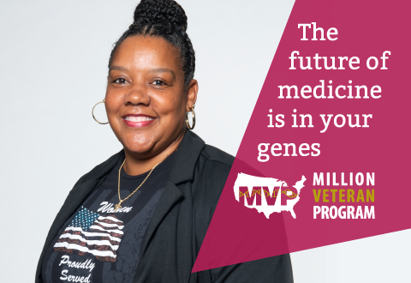

**TITLE: The future of medicine is in your genes. We need your help.**

SUBTITLE (optional): *Fifteen minutes and a blood draw are all it takes to make a lasting difference.*

The INSERT VA HEALTH CARE SYSTEM or VAMC NAME is enrolling Veterans into the Million Veteran Program, a national research program that studies how differences in genes, lifestyle and military experiences affect Veterans' health and illnesses.

The goal is to one day give Veterans specialized care with targeted treatments and preventions based on their genetics and medical history.

Veterans can enroll online at [mvp.va.gov](http://www.mvp.va.gov) or by scheduling an appointment at our facility by calling 866-441-6075. You do not need to receive VA health care to join VA’s Million Veteran Program or schedule an appointment at our facility.

What is the Million Veteran Program (MVP)?

Since launching in 2011, nearly 840,000 Veteran partners have joined MVP, helping researchers better understand the genetics of disease in Veterans.

By collecting DNA from as many Veterans a possible, along with information on their health, lifestyle and military experiences, researchers are beginning to answer important questions like:

* Why does a certain treatment work well for some Veterans but not others?
* Why are some Veterans at greater risk for developing an illness?
* How can we prevent certain illnesses in the first place?

If [more women](https://www.research.va.gov/pubs/docs/va_factsheets/MVP_womens_factsheet.pdf) and diverse populations enroll, MVP researchers can discover new medical breakthroughs that work for all Veterans.

What does it mean to enroll?

To join MVP, you’ll be asked to:

* Complete a consent process online at [mvp.va.gov](http://www.mva.va.gov) or at INSERT VA HEALTH CARE SYSTEM or VAMC NAME by calling 1-866-441-6075 to make an appointment.
* Allow access to your health records.
* Provide a one-time blood sample for genetic analysis.
* Fill out occasional surveys about your health and lifestyle.

Once enrolled, you may be contacted again on a periodic basis if additional information is requested, or if there is a research opportunity you may want to consider. You will also receive newsletters about the program at least once a year with updates on research findings and other topics of interest.

For more questions about MVP, [explore their FAQs](https://www.mvp.va.gov/webapp/mvp-web-participant/#/public/faq) or speak with a staff member at 866-441-6075.