VOA Required Fields – A Visual Guide

**March 10, 2016**

# Contents

Contents i

1. Name and General Information Tab 1

2. VA Information 2

3. Additional Information 3

4. Veterans Address 4

5. Insurance Information 4

6. Medicare/Medicaid 6

7. Service Information 7

8. Financial Disclosure 8

8.1. Children Information: 9

8.2. Annual Income 11

8.3. Deductible Expenses 12

8.4. Spouse Information (Field appears based on Marital Status selection) 13

8.5. Annual Income for Veterans with a Spouse and Child 15

8.6. Deductible Expenses for Veterans with a Spouse and Child 16

9. Review and Print 17

10. Final Information 18

11. Submit Page 19

# Name and General Information Tab

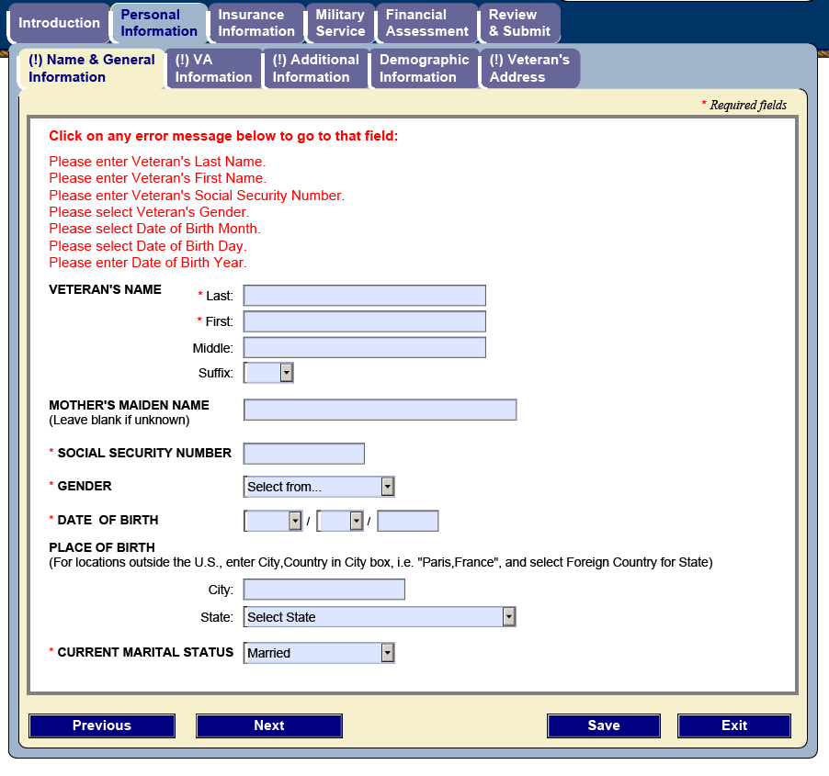

Required Fields:

* Last Name
* First Name
* Social Security Number
* Gender
* Date of Birth (month, day, year)
* Marital Status

# VA Information

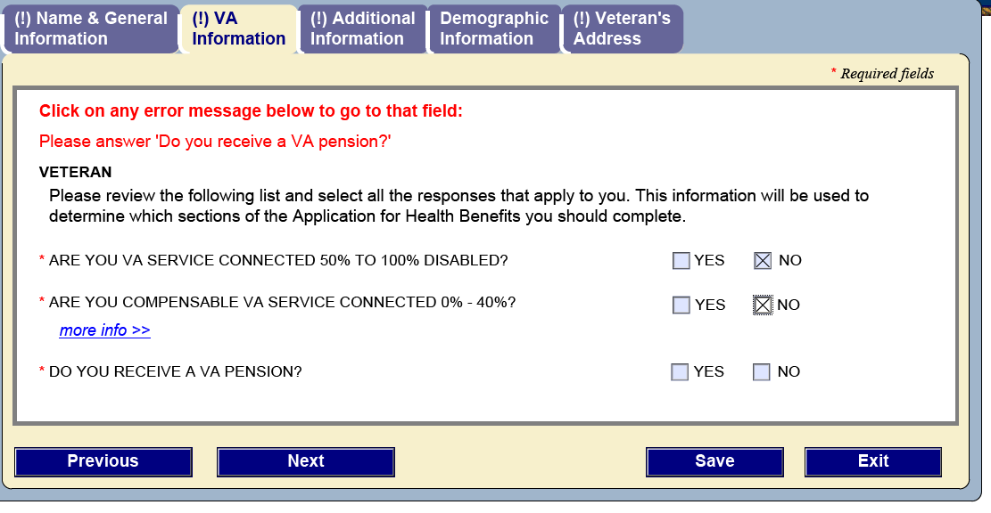

Required Fields:

* Are You VA Service Connected 50% to 100% Disabled?
* Are You Compensable VA Service Connected 0% - 40%?
* Do You Receive a VA Pension?

* If the Veteran selects “Yes” to a question, the other questions will not be displayed.

# Additional Information

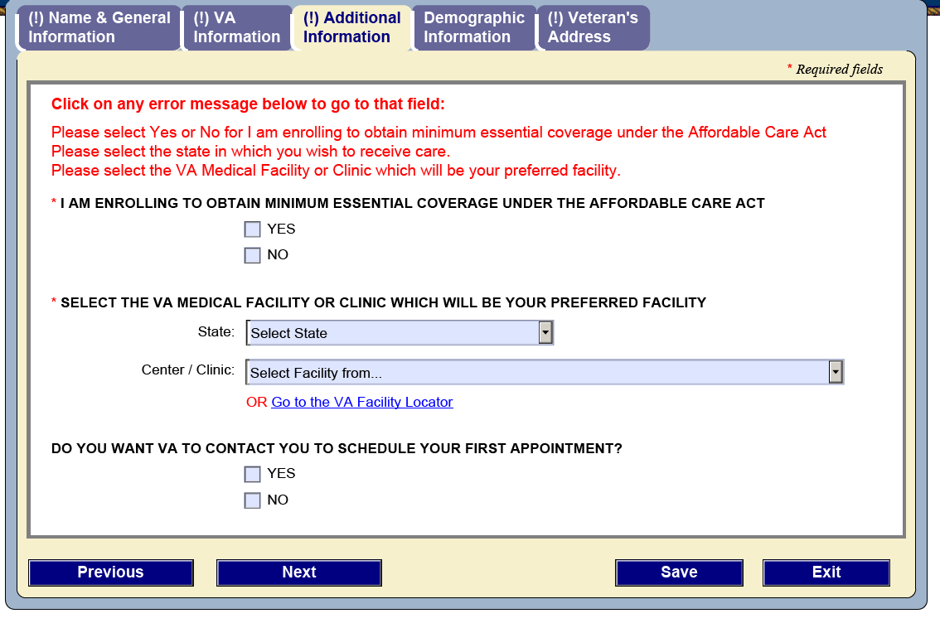

Required Fields:

* I am enrolling to obtain minimum essential coverage under the affordable care act
* Select the VA medical facility or clinic which will be your preferred facility (State. Center or Clinic)

# Veterans Address

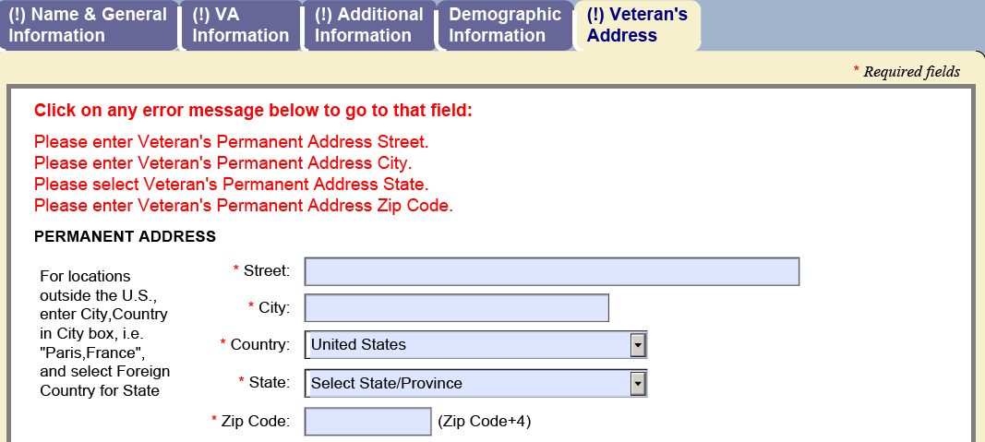

Required Fields:

* Street
* City
* State
* Zip Code (must be valid, does not have to include the +4)

# Insurance Information

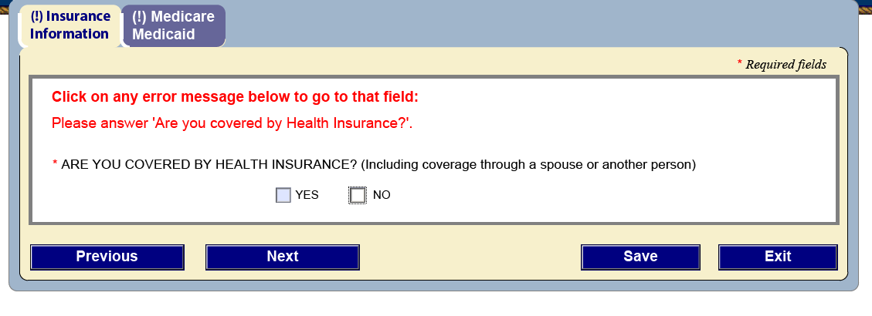

Required Field:

* Are you covered by health insurance? (Yes/No selection)

If yes is checked, the following screen will be displayed.

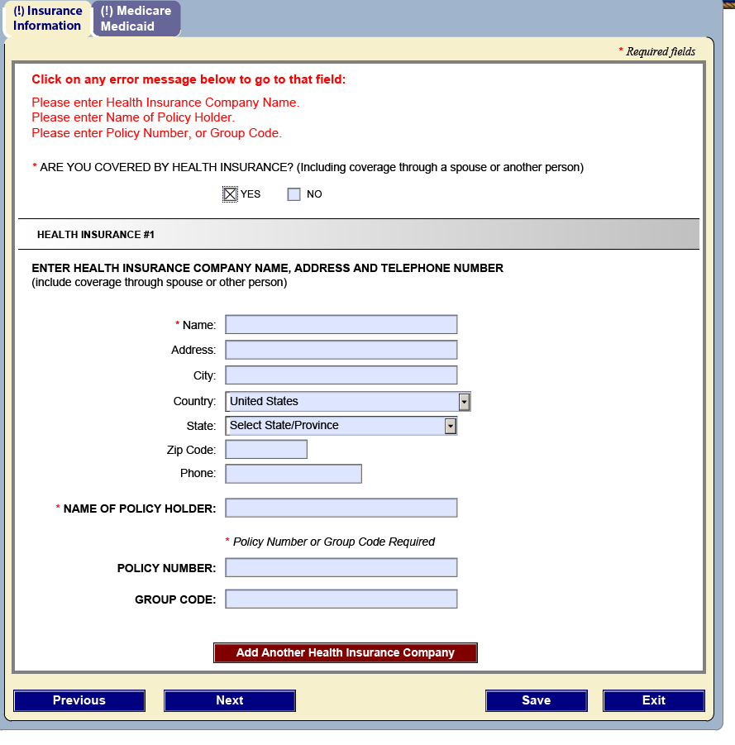

Required Fields:

* Health Insurance Company Name
* Policy Number or Group Number

* The country field is required, but is prepopulated to United States. If for some reason it is blank, it needs to be filled in before the form is submitted.

# Medicare/Medicaid

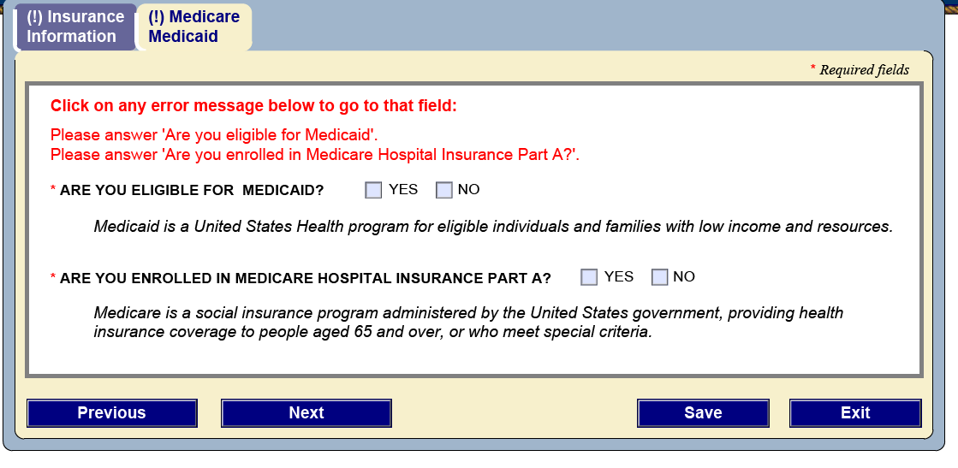

Required Fields:

* Are you eligible for Medicaid (Yes/No)
* Are you enrolled in Medicare Hospital Insurance Part A (Yes/No)

* A “Yes” response to the Medicaid question brings up the following question.

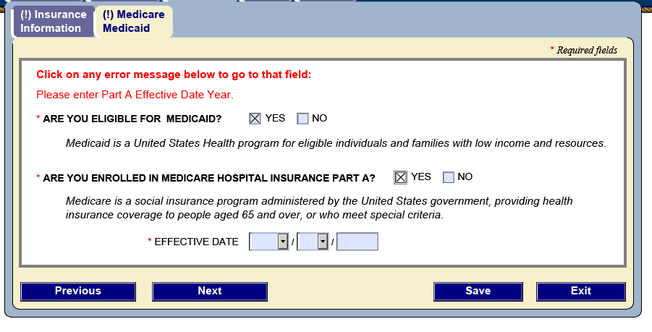

Required Fields:

* Effective date (month, date, year)

# Service Information

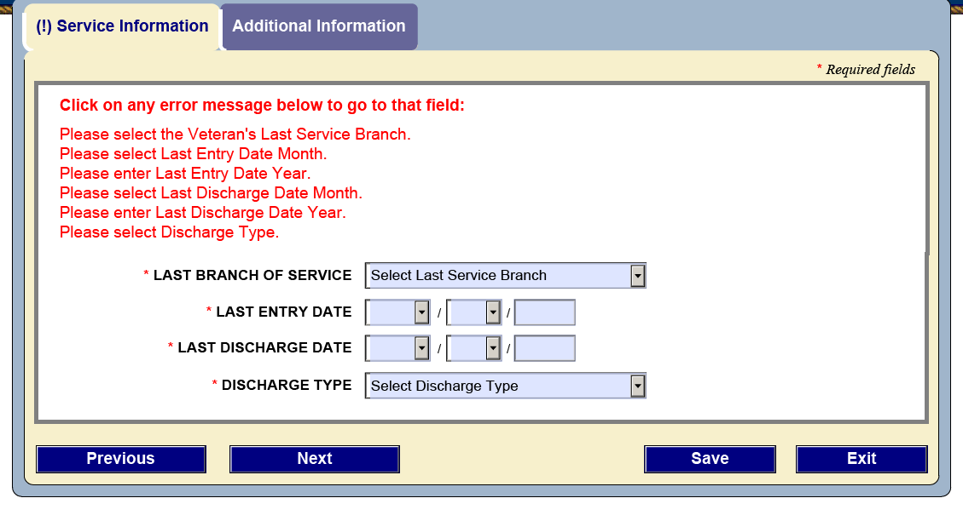

Required Fields:

* Last Branch of Service
* Last Entry Date (month, day, year)
* Last Discharge Date (month, day, year)
* Discharge Type

# Financial Disclosure

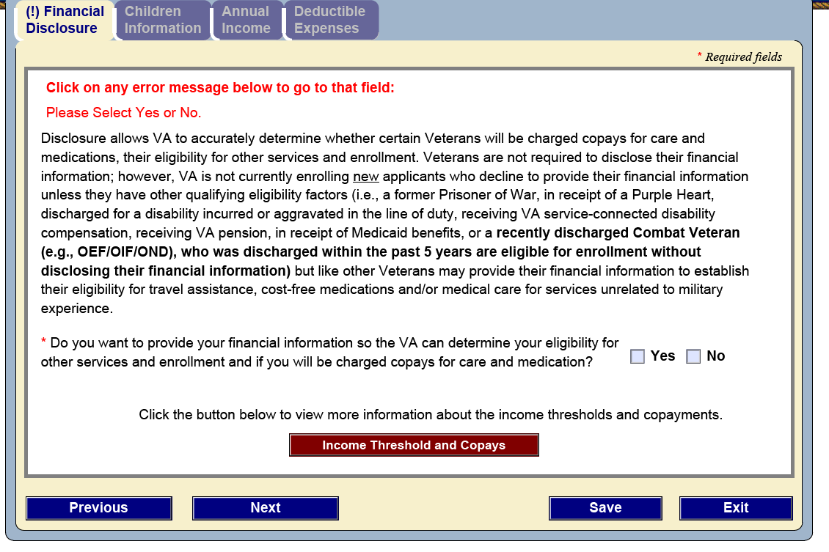

Required Field:

* Do you want to provide your financial information so the VA can determine your eligibility for other services and enrollment and if you will be charged copays for care and medication? (Yes/No)

If the Veteran selects “No” the following question is displayed.

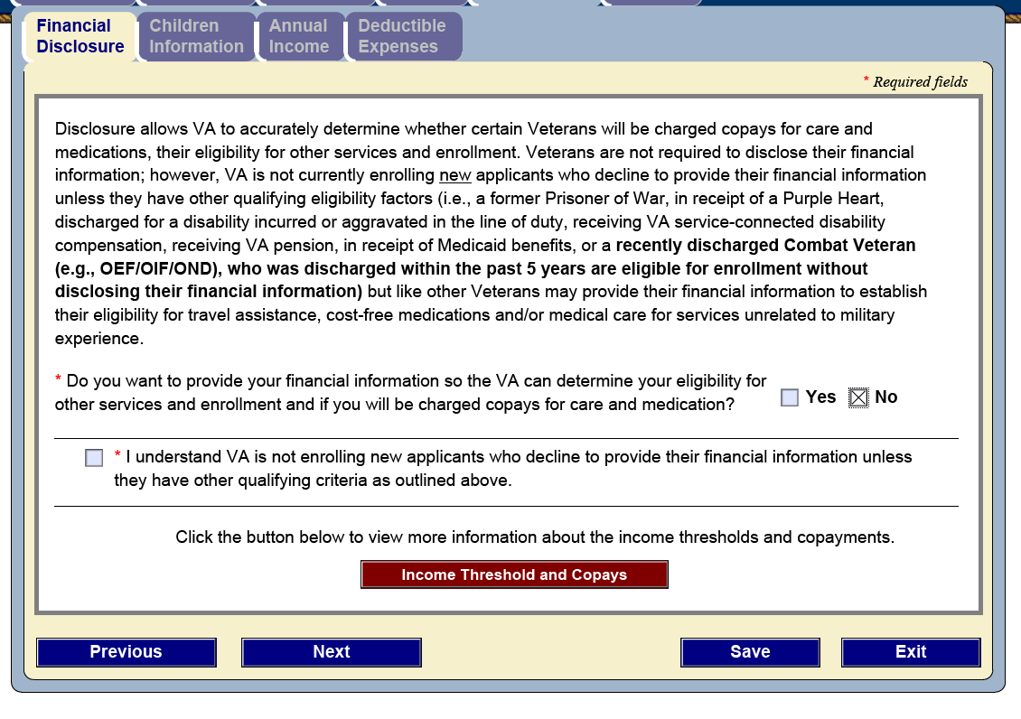

Required Fields:

* I understand that the VA is not enrolling new applicants who decline to provide their financial information unless they have other qualifying criteria as outlined above (Check box)

If the Veteran selects “Yes”, the following panels are displayed.

## Children Information:

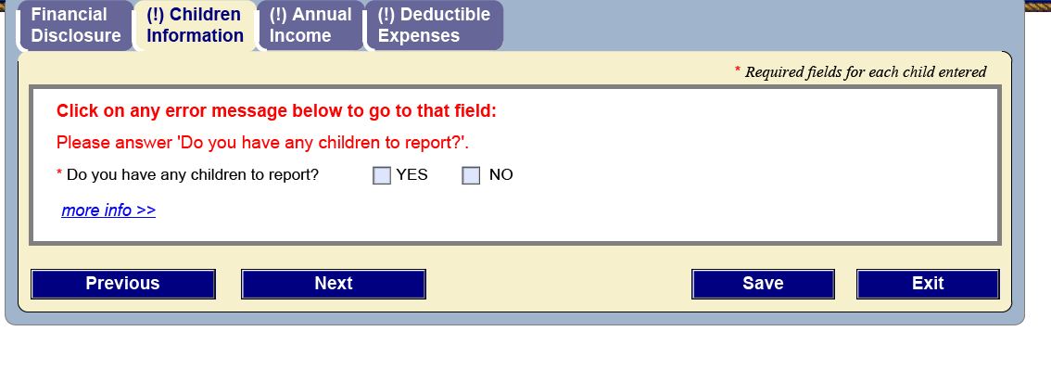

Required Fields:

* Do you have any children to report (Yes/No)

If the Veteran selects “Yes”, the following panel is displayed.

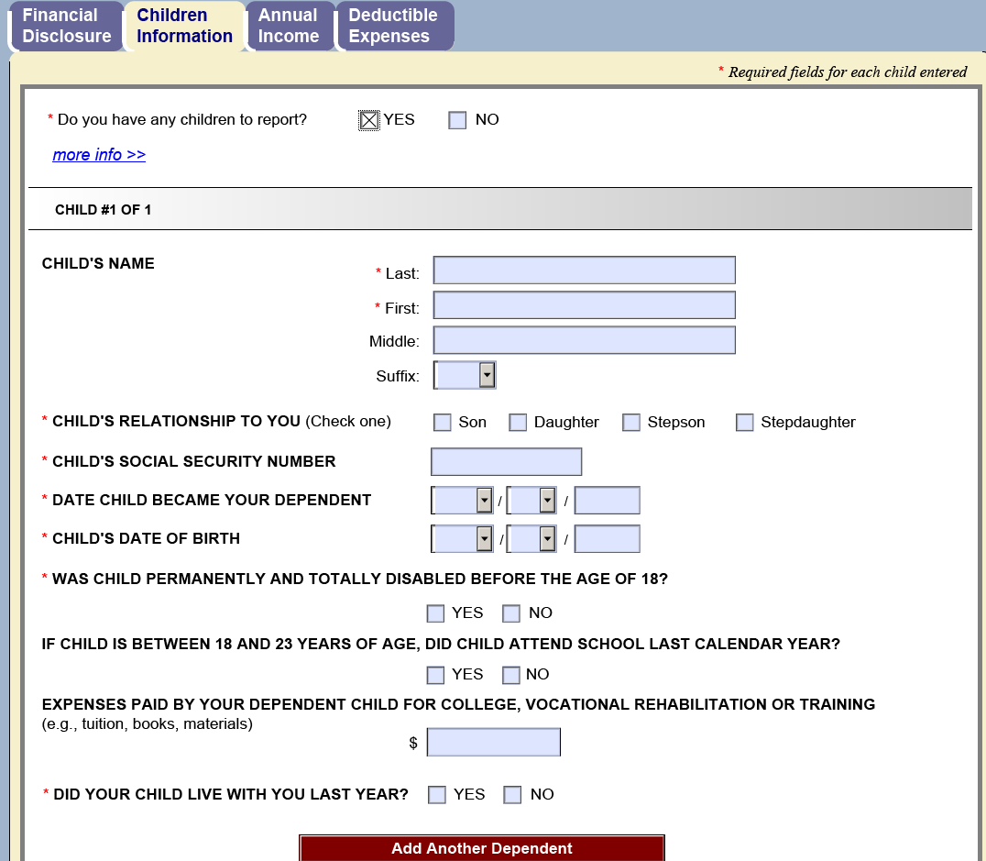

Required Fields:

* Child’s Last Name
* Child’s First Name
* Child’s Relationship to You (check boxes: Son, Daughter, Stepson, Stepdaughter)
* Child’s Social Security Number
* Date Child Became Your Dependent (month, day, year)
* Child’s Date of Birth (month, day, year)
* Was the Child Permanently and totally disabled before the age of 18? (Yes/No)
* Did Your Child Live With You Last Year (Yes/No)

* The Veteran can add an infinite number of dependents.

## Annual Income

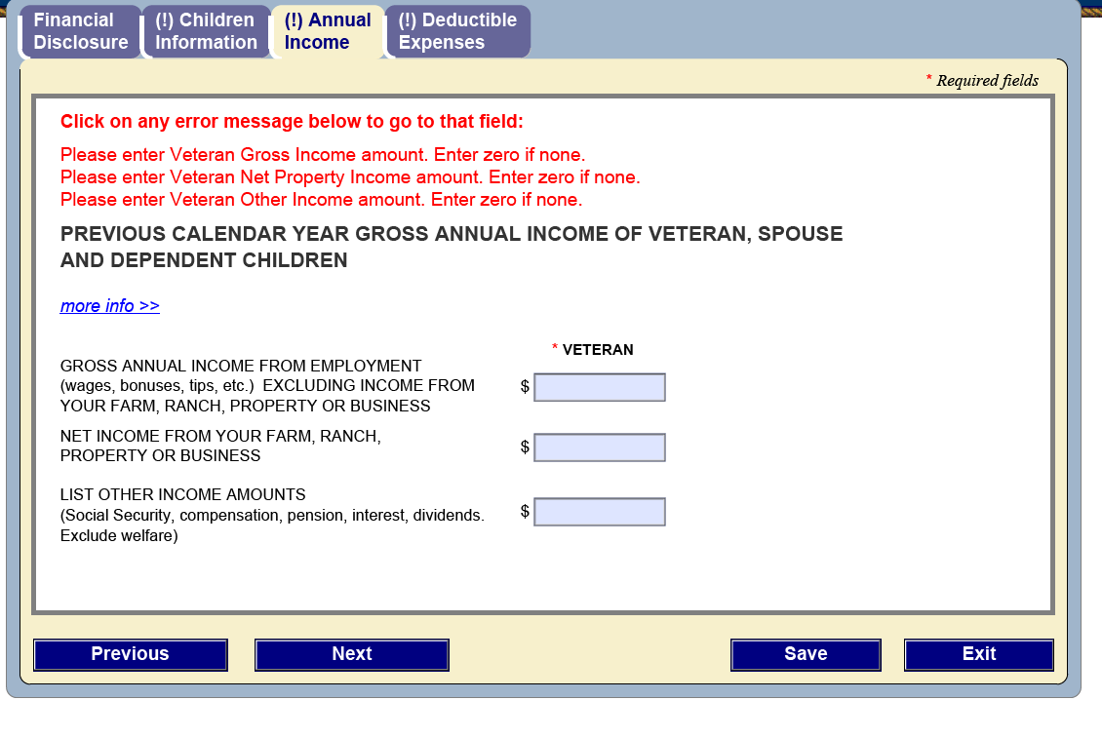

Required Fields:

* Gross Annual Income (numerical value, no commas)
* Net Income (numerical value, no commas)
* List Other Income Amounts (numerical value, no commas)

## Deductible Expenses

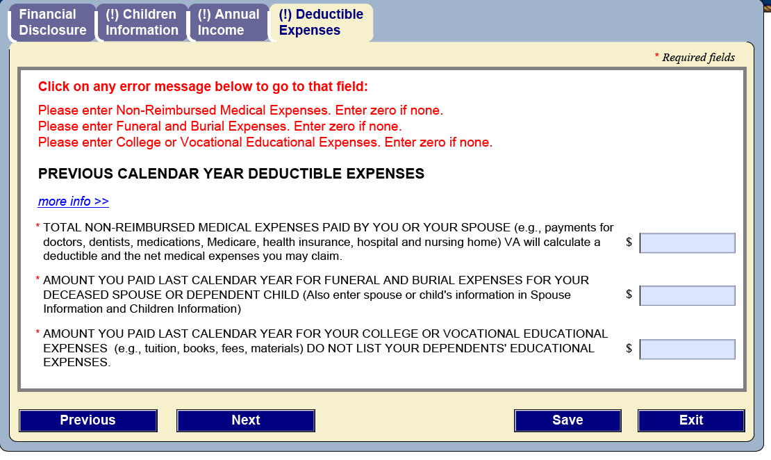

Required Fields:

* Total Non-reimbursed Medical Expenses Paid By You or Your Spouse (numerical value, no commas)
* Amount You Paid Last Calendar Year for Funeral and Burial Expenses For Your Deceased Spouse or Dependent Child (numerical value, no commas)
* Amount You Paid Last Calendar Year for Your College or Vocational Educational Expenses (numerical value, no commas)

## Spouse Information (Field appears based on Marital Status selection)

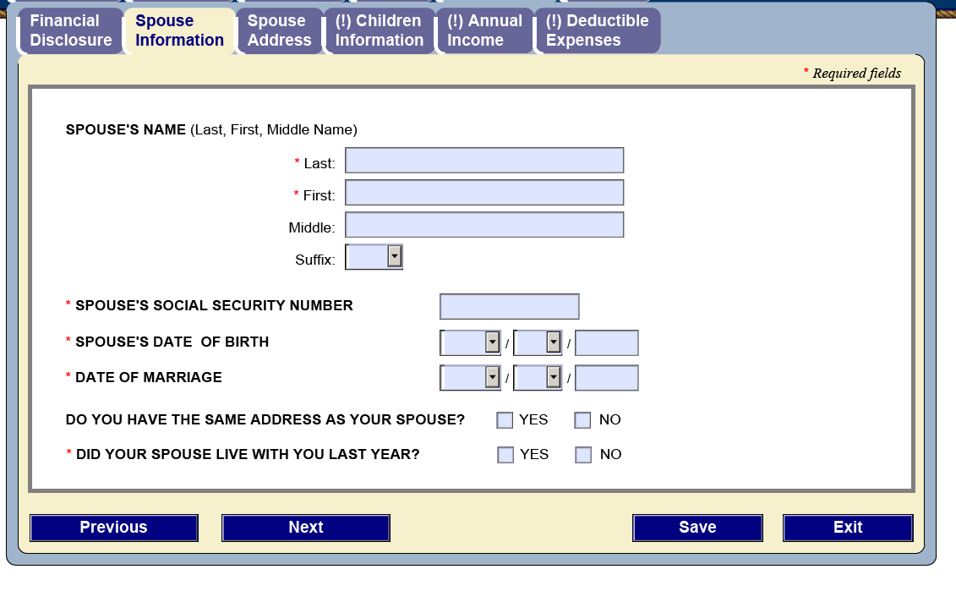

Required Fields:

* Spouse’s Last Name
* Spouse’s First Name
* Spouse’s Social Security Number
* Spouse’s Date of Birth (month, day, year)
* Date of Marriage
* Did Your Spouse Live With You Last Year (Yes/No)

*Selecting “No” for the Do you have the same address as your spouse? question will bring up another panel to collect the spouse’s address; displayed below.

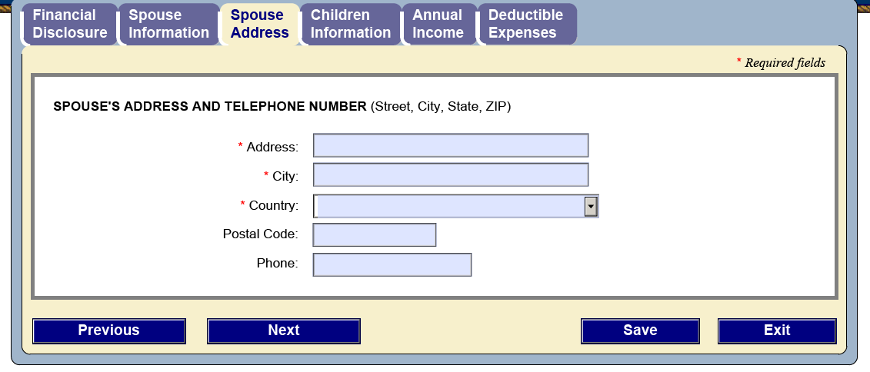

Required Fields:

* Address
* City
* Country

## Annual Income for Veterans with a Spouse and Child

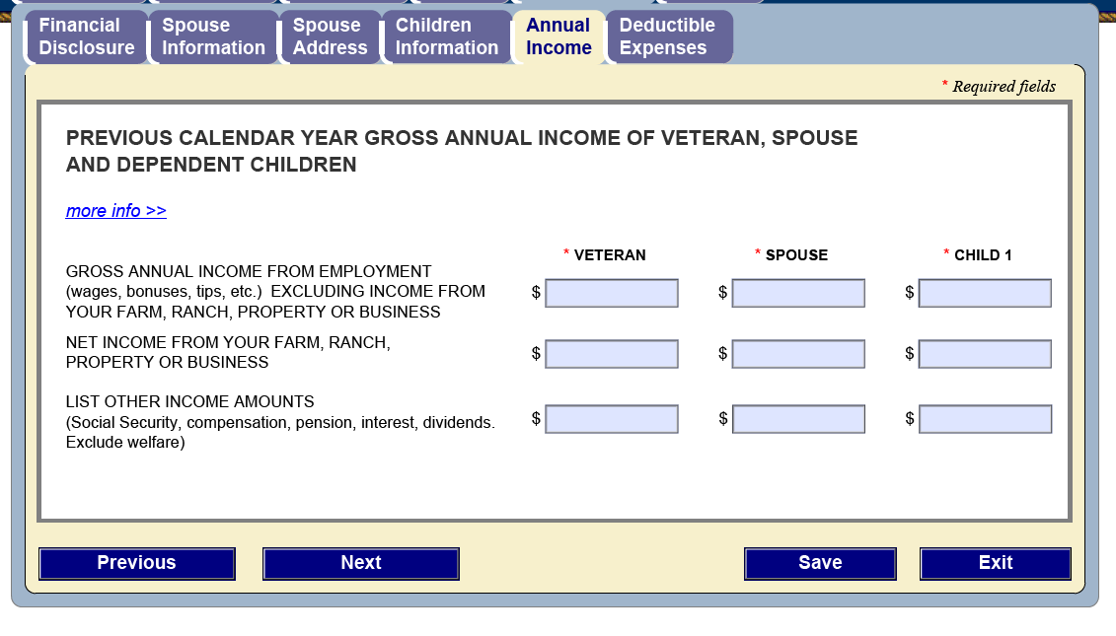

Required Fields:

* Gross Annual Income (numerical value, no commas)
* Net Income (numerical value, no commas)
* List Other Income Amounts (numerical value, no commas)

* The fields for Spouse or Child will only be displayed if the Veteran has previously identified those dependents on the form.

## Deductible Expenses for Veterans with a Spouse and Child

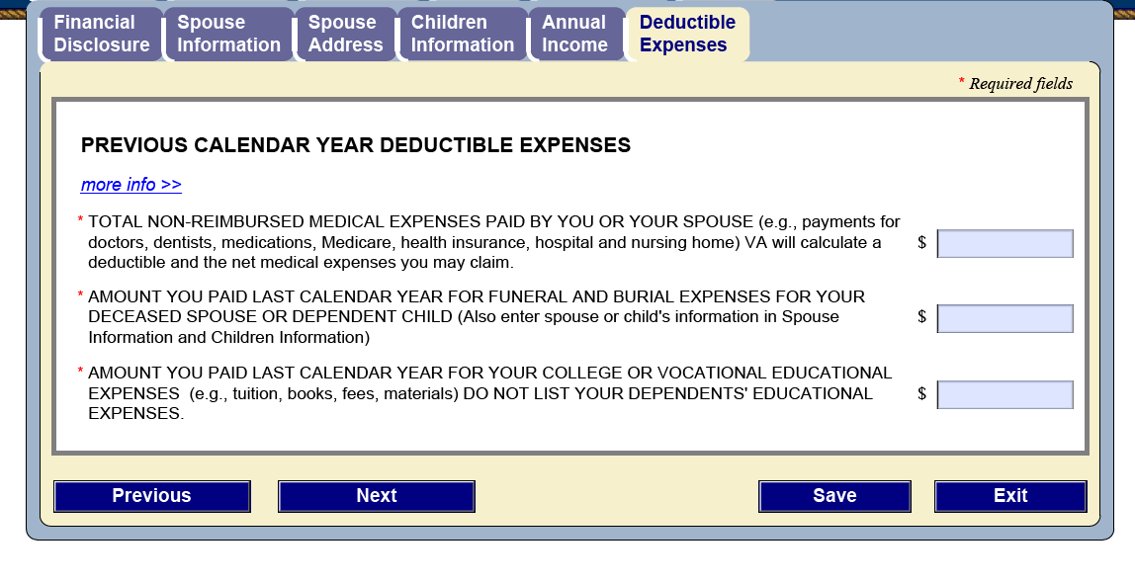

Required Fields:

* Total Non-reimbursed Medical Expenses Paid By You or Your Spouse (numerical value, no commas)
* Amount You Paid Last Calendar Year for Funeral and Burial Expenses For Your Deceased Spouse or Dependent Child (numerical value, no commas)
* Amount You Paid Last Calendar Year for Your College or Vocational Educational Expenses (numerical value, no commas)

# Review and Print

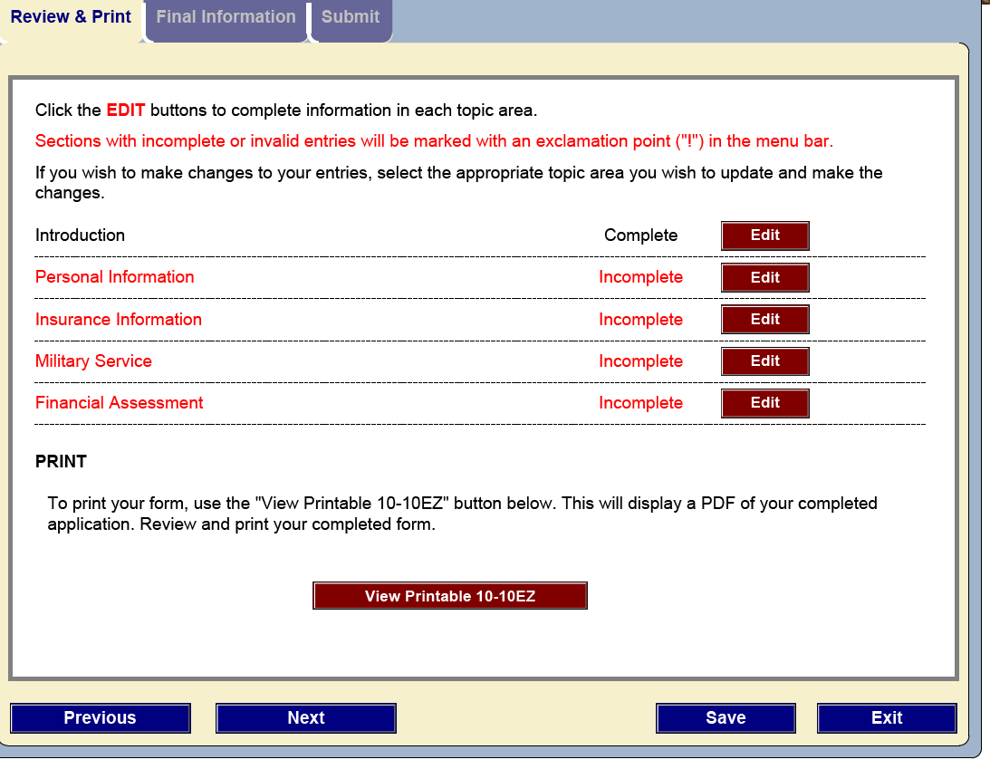

The Review and Print page identifies form areas that have required fields that have not been completed. It will not allow the Veteran to proceed to the Submit page until those required fields have been completed. Clicking on the Edit button will take the Veteran to the page that requires information. The required fields are identified on the top of each of those pages and are linked to the field (see the previous screen shots for examples; pages 1 – 12 specifically).

Once the errors are cleared, the Next button is enabled and the Veteran can proceed to the Submit page.

# Final Information

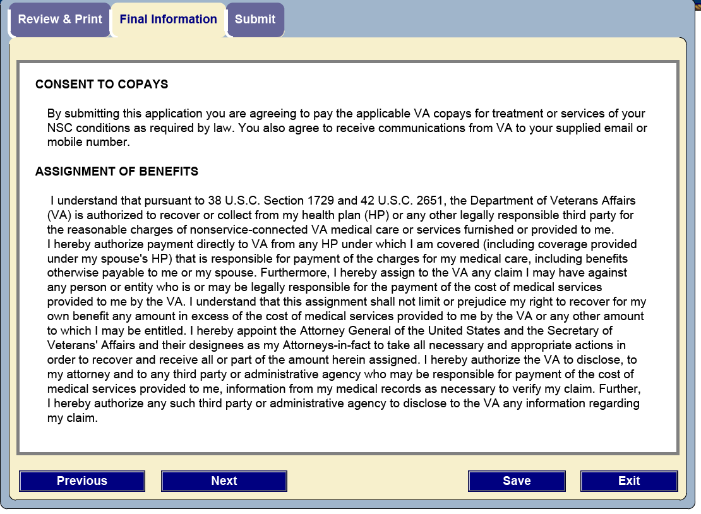

This page presents the Consent to Copays and Assignment of Benefits information to the Veteran.

# Submit Page

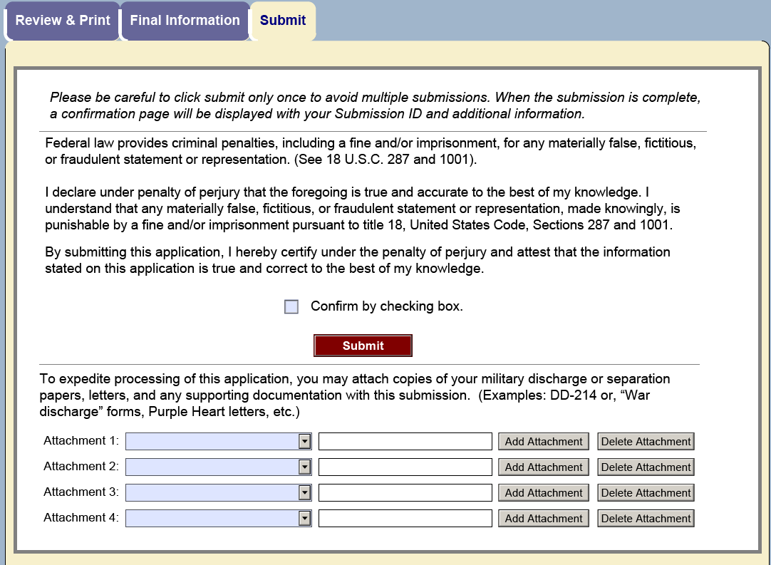

The submit page requires the Veteran to confirm by checking the box provided before the form can be submitted. It also acts as agreement and confirmation of the Consent to Copays and Assignment of Benefits and conforms to the OMB form requirements.

Before submitting, the Veteran has the opportunity to attach any supporting documentation to the application. Each of the Attachment blocks has a pull down list of document types that the Veteran can submit to identify what is being sent. Clicking Add Attachment opens up a dialog that walks the Veteran through the document selection process. Once the document has been added, it will appear in the blank box next to the Add Attachment button. If the Veteran decides not to send the document, clicking the Delete Attachment button will remove the document from the application.