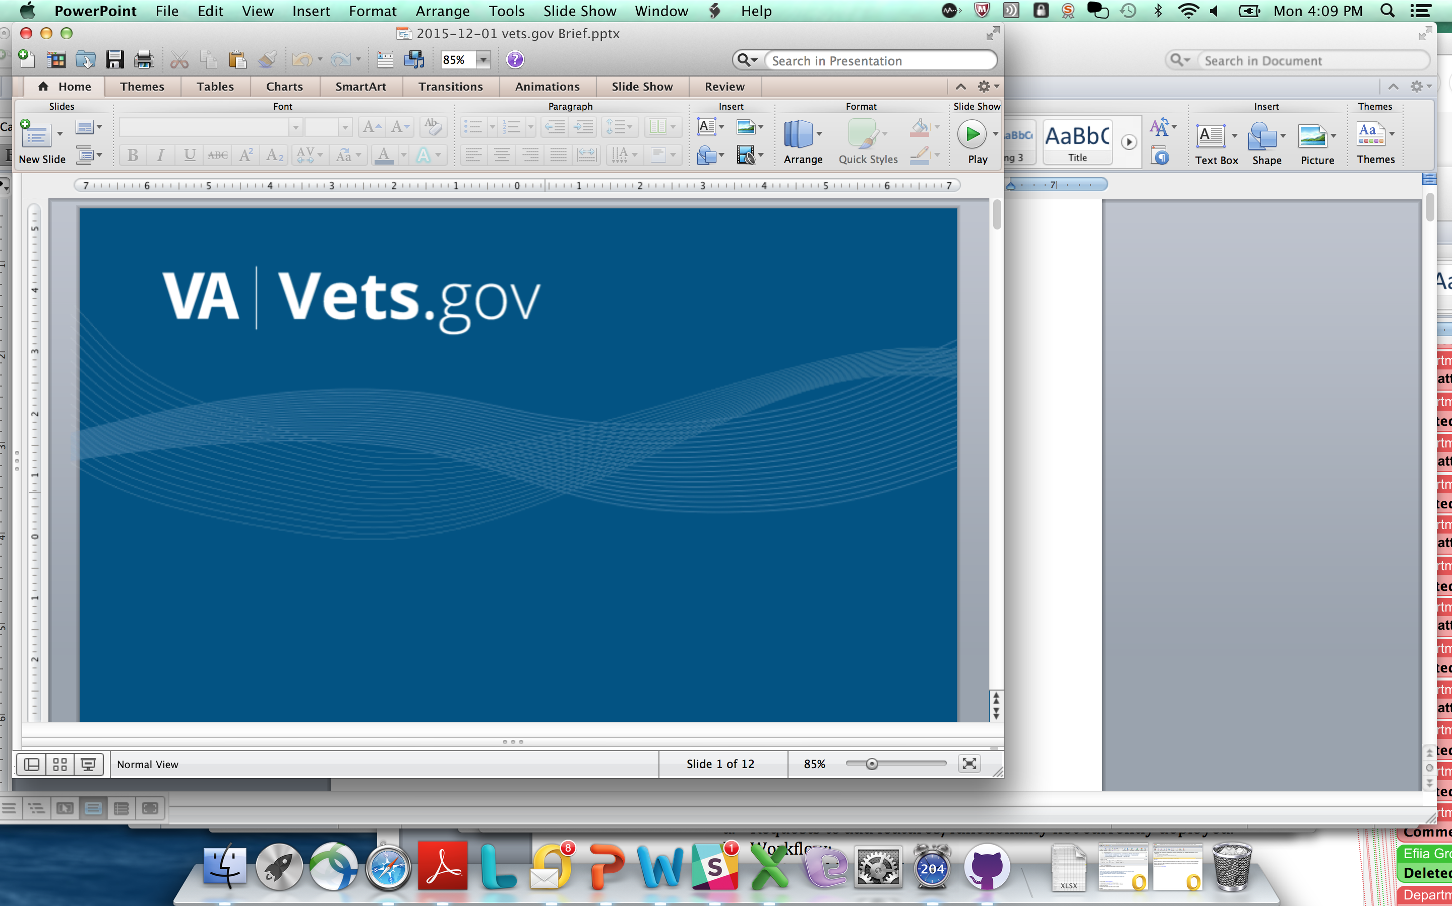

Vets.gov Product Charter

Prescriptions and Secure Messaging

*6/20/2016*

Table of Contents

Authorization 3

1 Document Purpose 4

2 Vision and Approach 4

3 Product Team Roles and Responsibilities 4

4 Minimum Viable Product (MVP) Scope Detail 6

5 Project Milestones & Key Activities 7

6 Ongoing Maintenance 8

7 Assumptions and Constraints 8

8 Vets.gov Product Methodology 8

# Authorization

VA Product Business Owner:

Theresa Hancock, Director of My Health*e*Vet

*Signature Date*

Stacey Langer, vets.gov Product Manager

*Signature Date*

# Document Purpose

This purpose of this document is to define role, scope of work, and milestones for the vets.gov Prescriptions and Secure Messaging Product Team.

The near-term scope of work, includes the following features of the VA’s My Health*e*Vet (MHV) program:

* Prescription history, refills, and tracking
* Secure Messaging (to renew prescriptions)

The period of performance for this work is approximately **May 2016 – September 2016.**

Content updates and future enhancements will continue throughout 2016 and beyond with new charters to define future work.

# Vision and Approach

Vets.gov will enable veterans to discover, apply for, track, and manage the benefits they have earned.

Select features and relevant content (defined above) from the existing MHV website will be migrated to vets.gov using an iterative and Veteran-centered approach defined in our playbook (<https://www.vets.gov/playbook/> ). Features and user interfaces will be redesigned based on Veteran research conducted to date by both the MHV team and the vets.gov team. Content will be rewritten in plain language and adhere to editorial guidelines established with the Office of the Secretary and VA Web Communication leads (<https://www.vets.gov/playbook/editorial/> ).

# Product Team Roles and Responsibilities

| **Role** | **Names** | **Responsibilities** |
| --- | --- | --- |
| Vets.gov Team Members | Mary Ann Brody, User Research Lead & vets.gov Content Lead  Jenny Heiland-Leudtke, VA Health Content Subject Matter Expert (SME)  Gina Kim, Design Lead  Stacey Langer, Product Manager  Kelly O’Connor, Support  Alex Yale-Loehr, Engineering Lead | * Manage product activities and schedule * Design, develop, and deploy product * Manage internal communications in collaboration with VA Business Owner * Write content in plan language; oversee content migration and concurrence * Integrate vets.gov account logon / coordinate with MHV logon * Incorporate MHV team Veteran research and human centered design work completed to date * Work closely with business owner and product team to communicate progress * Support product post launch * Coordinate with VA call centers to update scripts |
| VA Business Owner | Theresa Hancock, Director | * Sign / approve charter * Accept the product * Provide guidance and decision making for the product team * Communicate to VA leadership progress of the product team in collaboration with vets.gov team and web communications leads * Direct OIT and other technical and / or business resources relevant to this work with product team tasks and ensure task completion in timely manger * Serve as escalation point if any issues or delays with team activities * Work closely with vets.gov team to manage VA stakeholder communications and change management; communicate to senior VA leadership messaging that has been coordinated with product team * Work with vets.gov communications leads (Sec. Office, VHA, VBA) to coordinate all external and Veteran communications * Identify VA stakeholders for participation |
| VA Integrated Product Team Members / Subject Matter Experts (SMEs) | John Brekke (VA OIT PM)  Neil Evans (Co-Director Connected Health)  Kathy Frisbee (Co-Director Connected Health)  Ken Graham (API)  Maureen Layden (Physician, Pharmacy SME)  Kim Nazi (Business SME)  Jeff Sartori (Pilot Design; Design Research)  Carnetta Scruggs (Identity and Access Management (IAM) / MHV Logon SME) | * Provide context and subject matter expertise on business, technical, and data requirements collected to date * Work collaboratively with vets.gov team on all discovery and migration activities * Complete tasks in a timely way * Provide technical support for discovery and migration including insight on systems, architecture, APIs, and data * Coordinate all API and / or other backend IT system changes that impact this scope of work with the vets.gov team and VA Business Owner *prior* to making any changes * Provide access to systems, APIs, and code repositories as needed and in a timely way * Support VA Business Owner with delivering approved messaging and stakeholder communications throughout migration * Assist with redirects and other OIT-related activities prior to deployment * Answer questions and respond to data calls in a timely way * Participate in product team working sessions and other product activities as needed * Provide access to VA employees and / or users as needed for discovery activities |
| Content Subject Matter Experts (SMEs) | Richard (Chip) Harmon  Jenny Heiland-Luedtke | * Provide subject matter expertise on prescription and secure messaging content * Provide health content / VHA content expertise * Participate in the vets.gov content concurrent process as required * Work collaboratively with Web Communication Leads on the content concurrence process to provide fact checking and ensure accuracy of content * Adhere to the vets.gov content concurrence policy and process * Update / maintain content on VA.gov until it is migrated to vets.gov * Continue to manage content using existing content processes and tools on VA.gov |
| Call Center Support | Sheila Guitteriez  Ryan Heiman | * Provide vets.gov Call Center (Tier 1) support * Coordinate with vets.gov team on Tiers 2 and 3 support * Participate in pre-launch and launch activities * Coordinate all call center coordination tasks including script updates, call center team training, etc. |
| Web Comms Leads | Jenny Heiland-Luedtke, VHA  Jennifer Rudisill, VBA | * Lead content concurrence for VHA and VBA * Assist with pre-launch activities * Support VA Business Owner with messaging and internal change management * Participate in product team and communications activities * Coordinate communications with Office of the Secretary (M. Taylor) |
| Office of Secretary | Martin Taylor | * Oversee all vets.gov branding * Approve *any and all* external communications / media activities regarding vets.gov including, but not limited to: media, White House, OIG, GAO, Congress, Veteran Service Organizations (VSOs), other government agencies * Coordinates VA-wide messaging and communications with VA senior leadership |

# Minimum Viable Product (MVP) Scope of Work

1. **Integration with vets.gov account (dependency for launch)**
   1. Identify unique MHV requirements for identity integration
   2. Define approach for existing and future state MHV credentials
   3. Determine and build integration between vets.gov account and both the Rx and Secure Messaging APIs
2. **Design and Develop Prescriptions Functionality (MVP)** 
   1. Develop mockups / wireframes
   2. Build out functionality for prescription and secure messaging
      1. Refill* a prescription
      2. Renew* a prescription via secure message with a doctor
      3. View prescription history
      4. Track prescription delivery

*\*Note: A refill means your prescription can be filled again when you have finished the current supply; a renewal is necessary when you have no refills left on a prescription and require a new prescription.*

1. **Content strategy and migration**
   1. Develop vets.gov health content strategy specific to prescriptions
   2. Rewrite content in plain language
   3. Complete content concurrence for accuracy
   4. Deploy content sunsetting strategy as needed prior to / following launch
   5. Develop content update process for ongoing use by a select group of VA content SMEs
2. **Deploy / Change Management and Communications**

MHV and OIT product team members and other internal VA stakeholders will be required to support select change management and communication activities as directed by the VA Business Owner and in collaboration with VHA web communications lead and the Office of the Secretary. Additionally, they will be required to assist with pre-launch activities, including but not limited to, those listed below:

* 1. Support redirects / sunsetting strategy for both content and features
  2. Participate in select testing activities (will be identified by vets.gov team)
  3. Support communications to internal VA stakeholders as directed by the VA Business Owner (in coordination with product team)
  4. Coordinate all external stakeholder communication with the Office of Secretary and the VA Business
  5. Participate in content tool training as directed by the VA Business Owner
     1. Small group of content SMEs (~2-4 users) to be identified by VA Business Owner and validated with vets.gov team
  6. Complete all pre launch checklist items as identified by product team

# Project Milestones & Key Activities

Process and timeline generally reflect the content concurrence process established by the Vets.gov content team, which can and should be referenced in addition to the below for specifics.

|  |  |  |  |  |  |
| --- | --- | --- | --- | --- | --- |
| *Ref* | Tasks | May | June | July | Aug/Sept |
| *A* | Integrating with vets.gov account |  |  |  |  |
| *B* | Design and develop MVP |  |  |  |  |
| *C* | Content strategy and migration |  |  |  |  |
| *D\*\** | Pre-Launch Preparation & Deploy** |  |  |  |  |

***\*\*Deployment date has a hard dependency on vets.gov account deployment dates.***

# Ongoing Maintenance

The vets.gov team will provide ongoing maintenance and support for adding/updating content and providing break/fix for any technical issues on the vets.gov platform.

# Assumptions and Constraints

1. MVP includes select, existing functionality based on Veteran user research; no new functionality is planned at this time.
2. MVP does not include non-prescription (herbals, etc.) or self-entered non-prescription information.
3. Native mobile apps are not in scope of this work; MVP will be mobile responsive.
4. The Rx and Secure Messaging API endpoints and request and response format (including data types and error codes) will not be changed without prior planning with the vets.gov team and approval from the VA Business Owner.
5. Backend VA system changes that impact this scope of work will not be changed without prior planning with the vets.gov team and approval from the VA Business Owner.
6. Content for prescriptions will be aligned with overall vets.gov approach to health content, plain language best practices, and the the vets.gov editorial guidelines.
7. DS Logon will be an accepted vets.gov credential.
8. Refill a prescription feature does not include controlled narcotics / schedule 2 drugs (per existing functionality and VA policies).
9. The vets.gov team will not directly modify any backend VA systems.
10. The vets.gov account product team is a separate team and working in parallel to this work. The vets.gov account is a hard dependency for deployment of the features defined in this charter, and therefore any delays with the launch of the vets.gov account may impact the milestone schedule in this document. The vets.gov team will keep the VA Business Owner informed of the status of the vets.gov account work throughout the project.
11. vets.gov team will identify required changes to existing backend VA systems (e.g., identity integration, addition prescription data fields in API, etc.); VA Business Owner will ensure that VA resources complete required technical and/or business work in a timely way in order to meet milestone schedule.
12. VA Business Owner, in coordination with OIT product team members / SMEs, will ensure that all OIT activities relevant to this work is aligned with product team activities.

# Vets.gov Product Methodology

Please refer to the vets.gov playbook (<https://www.vets.gov/playbook/> ) that defines the product methodology, outputs, and roles in further detail. Relevant content will be reviewed and migrated per the editorial guidelines in the playbook (<https://www.vets.gov/playbook/editorial/> ). All vets.gov products will adhere to the standards and processes defined in the playbook.