Veterans Health Administration  
Informatics and Analytics Office

Connected Health

Veterans/Consumers Health Informatics Office

Requirements Engineering Management

My Health*e*Vet - Remote Identity Proofing  
New Service Request # 20120315

*Business Use Case*



June 2016

Version 3.82

Revision History

| Date | Revision # | Description | Author |
| --- | --- | --- | --- |
| 2/10/14 | 1.0 | Developed 1st Draft | Leon White |
| 2/28/14 | 1.1 | Edits & additions throughout 1st draft | Leon White |
| 3/11/14 | 1.2 | Edit to opening paragraph regarding “L2” | Leon White & Carnetta Scruggs |
| 3/24/14 | 1.3 | Content Manager Messages added | Leon White |
| 3/27/14 | 1.4 | VAAFI Message wording added; figure #s updated | Leon White |
| 3/28/14 | 1.5 | Business Use Case template updated; Account Activity Tracking Log values added per Data Analytics Team | Leon White |
| 5/1/2014 | 1.6 | Removed the technical example “NOT_FOUND” per meeting on May 1st, 2014 between PD and MVI | Leon White |
| 5/7/2014 | 1.7 | Updated Template – No Content Changes | Leon White |
| 5/11/2014 | 1.8 | Updated for formatting | Ro Weaver |
| 6/11/2014 | 1.9 | Alt flow: 4.1 updates for 12.10 ***  Alt flow: 4.2 and 4.6 removal – Password Reset  Basic Flow 3.1: Step .2a New  Step 6 possible removal – re-authentication and the associated alt flow to this step | Carnetta Scruggs, Leon White, Ro Weaver |
| 6/12/2014 | 1.10 | Approved for V/CHIO team review (requires content review) | Carnetta Scruggs |
| 6/12/2014 | 1.11 | Updated Basic & Alternative Flows (requires content) | Carnetta Scruggs, Marcia Berg, Ngozi Abolarin, Ro Weaver |
| 6/18/2014 | 1.12 | Making final edits to prepare for formal approval process | Carnetta Scruggs and Chrysanthe Courniotes |
| 6/20/2014 | 1.13 | Second editorial review | Marcia Berg |
| 7/1/2014 | 1.14 | Updated bookmarks and editorial comments.  BUC still requires hard coded content information. | Ro Weaver |
| 7/1/2014 | 1.15 | Revised Basic Flow and began revising Alternative Flow 4.1. Need to provide requirements that align with updated Instructions page. | C. Scruggs/ C. Courniotes |
| 7/2/2014 | 1.16 | Added AAL Detail_Value Fields in the three AAL tables. | M. Cadwallader, C. Courniotes |
| 7/3/2014 | 1.17 | Added updated instructions page and provided requirements for the instructions page, including highlighting the functionality of the hyperlinks. Added Figures 15-17. | C. Courniotes, C. Scruggs |
| 7/8/2014 | 1.18 | Added appropriate cross-references and deleted MVI figures that did not apply to this Business Use Case. | C. Courniotes |
| 7/10/2014 | 1.19 | Addressed User Story v.0.6 comments and questions and incorporated edits into this Business Use Case. These changes were reviewed and vetted by C. Scruggs. | C. Courniotes |
| 7/16/2014 | 1.20 | Updated text box for Upgrade to Premium Account. | C. Courniotes |
| 7/17/2014 | 1.21 | Highlighted the major changes in Phase II (12.10) in bullet points and incorporated minor changes to the Basic Flow based on the discussion with IAM that took place on 7/16. | C. Scruggs, C. Courniotes |
| 7/23/2014 | 1.22 | Incorporated the updated content provided by N. Abolarin (awaiting M. Berg’s review and approval) and added special requirements from the updated User Story (v.8). Updated Figure 4 to be consistent with the updated language from the User Story. | N. Abolarin, C. Courniotes |
| 9/9/2014 | 1.23 | Validated that all content is up to date by comparing the TUS and also through syst test. | C. Courniotes |
| 9/12/2014 | 1.24 | Updated Figure 16 of the AccessVA screenshot and also provided URL. | C.Courniotes |
| 11/25/14 | 1.25 | Added Note in Red font that changes will be fortcoming in the 12.12 release in support of the Federated Credential enhancements | C. Courniotes |
| 12/8/2014 | 1.26 | Added Alternative Flow 3.2 and incorporated comments from 12/8 WIPT call | C. Courniotes |
| 12/15/2014 | 1.27 | Incorporated comments from 12/10 WIPT call | C. Courniotes |
| 12/19/2014 | 1.28 | Updated 12.12 list of functionality in Description. Updated Basic Flow. Added Alternative Flows 3.6 and 3.7. Updated Figure 3 and Figure 9. | R. Weaver |
| 1/13/15 | 1.29 | Updated based on WIPT discussions | S. Bhamidipaty |
| 1/16/15 | 1.30 | Updated AAL entry for Login and Logout. Added Figures for AAL summary. | R. Weaver |
| 2/2/2015 | 1.31 | Updated Basic Flow based on user flow diagram from IAM | S. Bhamidipaty |
| 2/13/2015 | 1.32 | Feedback from Ken B. incorporated and approved content added | S.Bhamidipaty |
| 2/17/2015 | 1.33 | Content updated and comments from C.Scruggs incorporated. | S. Bhamidipaty |
| 3/12/2015 | 1.34 | Basic flow step 7 updated and new Figure 1 added | S. Bhamidipaty |
| 3/18/2015 | 1.35 | Updated flows based on iRSD | S. Bhamidipaty |
| 3/19/2015 | 1.36 | Updated Connect page content | S. Bhamidipaty |
| 3/20/2015 | 1.37 | Updated based on feedback from C.Scruggs | S. Bhamidipaty |
| 3/30/2015 | 1.38 | Updated based on flow diagram in iRSD | S.Bhamidipaty |
| 4/9/2015 | 1.39 | Updated Figure 7 with approved content and added Figure 23, error message when VAAFI is unavailable. | S. Bhamidipaty |
| 4/14/2015 | 1.40 | Updated screenshots for Figures 12 and 13. | S. Bhamidipaty |
| 4/17/2015 | 1.41 | Figure 7 updated to remove hyperlink from the word Profiles in the error message. | S. Bhamidipaty |
| 06/08/2015 | 1.42 | Added 12.14 requirements | S. Bhamidipaty |
| 06/11/2015 | 1.43 | Updated for 12.14 requirements based on meeting with PD | S. Bhamidipaty |
| 07/20/2015 | 1.44 | Updated for 12.14 based on feedback from PD | S. Bhamidipaty |
| 08/13/2015 | 1.45 | Updated screenshots | S. Bhamidipaty |
| 09/16/2015 | 1.46 | Updated based on feedback received from C.Scruggs’ review  Approved for formal review | S. Bhamidipaty |
| 10/26/15 |  | Third editorial review – spell out acronyms first time used throughout document. Fix bookmarks. Made edits as noted prior to approval by VCHIO Director. | M. Berg |
| 1/29/2016 | 2.0 | Baselined for 16.2 release. Added requirements for 16.2 | S. Bhamidipaty |
| 02/03/2016 | 2.1 | Updated requirements for 16.2 release | S. Bhamidipaty |
| 02/09/2016 | 2.2 | Updated Basic flow step 10 and 11 and Alternative Flow 3.9 based on discussions with PD and Carnetta Scruggs | S. Bhamidipaty |
| 2/11/2016 | 2.3 | Updated wording in Alternative flow 3.9 | S. Bhamidipaty |
| 3/1/2016 | 2.4 | Added a note and highlighted some questions for PD and IAM | S. Bhamidipaty |
| 3/22/2016 | 2.5 | Updated Figure 2 Error Message, IAM Flow, and added SSOe Error Message list in appendix G. | R. Weaver |
| 4/22/2016 | 3.0 | Baselined for 16.2 | S. Bhamidipaty |
| 4/22/2016 | 3.1 | Added requirements for 16.3 | S. Bhamidipaty |
| 4/27/2016 | 3.2 | Added PD Review Comments/Questions | S. Bhan |
| 4/28/2016 | 3.3 | Responded to PD comments/questions and updated section 4 and Basic Flow step 12. | S. Bhamidipaty |
| 5/9/2016 | 3.4 | Added requirement that DS Logon users will go through the Sign-in Partner flow and added requirement to check if a user has selected to limit their login by not allowing Sign-in Partner access. | S. Bhamidipaty |
| 5/24/2016 | 3.5 | Updated step 12 of Basic Flow and updated SSOe error code table and screen mockup of SSOe error message | S. Bhamidipaty |
| 5/31/2016 | 3.6 | Updated steps 2 and 12 of Basic Flow. Reviewed BUC with Carnetta. Updated Appendix G and Figure 2. | S. Bhamidipaty |
| 6/7/2016 | 3.7 | Added new step 9 in the Basic Flow to reference the TLS BUC | S. Bhamidipaty |
| 6/14/2016 | 3.8 | Updated BUC to add placeholder for timeout messaging page, and to split requirements between 16.3 and 16.4 | S. Bhamidipaty |
| 6/21/2016 | 3.81 | Added draft mockup for timeout page and added a post condition for the timeout session | S. Bhamidipaty |
| 7/01/2016 | 3.82 | Changed Delegation requirements from 16.3.1 release to 16.4 release. Changed requirements to Delegation flow based on meeting with Carnetta and PD. | S. Bhamidipaty |
| 7/25/2016 | 3.83 | Added approved content for error message when user has blocked Sign-in Partner access | S. Bhamidipaty |

Table of Contents

1. Remote Identity Proofing 1

1.1. Brief Description 1

1.2. Use Case Actors and Events 4

Preconditions 5

2. Basic Flow of Events 6

2.1. Basic Flow – Full Portal Strategy Traits 6

3. Alternative Flows 9

3.1. Upgrade to Premium Account Button (NOT for 12.12 - Existing Functionality in Production Field Testing) 9

3.2. Standard SSOe Error Message (Existing Functionality) 11

3.3. User Friendly Alert Message AccessVA website is Offline (NOT for 12.12 Existing Functionality) 11

3.4. CSP-Only Traits Received by MHV 11

3.5. Search MHV by User Traits for MHV Record 12

3.6. Search MHV by ICN for MHV Record 13

3.7. Inactive MHV Account Found 15

3.8. EDIPI Not Provided to MHV from CSP Only Traits 15

3.9. Active Delegation Check 16

3.10. Block Sign-in Partner Access 17

4. Post Conditions 18

5. Special Requirements 19

5.1. Special Requirements 19

6. Extension Points 20

Appendix A – Acronyms and Definitions 21

Appendix B – Business Use Case Flow Models 23

Appendix C – Other Models 24

Appendix D – Screen Mockups and Messages 25

Appendix E – Account Activity Tracking 33

Appendix F – Account Activity Mock Up 36

Appendix G – SSOe Error Messages 1

Appendix H – Approval Signatures 1

Table of Figures

Figure 1 – Business Use Case Diagram 4

Figure 2: Standard User-friendly Error Page in a SSOe Session 25

Figure 3: MHV Re-Authentication Page 27

Figure 4: Error Message If The User Enters an Incorrect User ID and Password from Re-Authentication Page 27

Figure 5: Error Message If The User Leaves Either User ID or Password Blank from Re-Authentication Page or Connect Page 27

Figure 6: Error Message If User ID and Password Cannot Be Found from Connect Page 28

Figure 7: Error Message If User ID and Password Does Not Match User’s Identity from Connect Page and Re-authentication Page 28

Figure 8: Error Message If the User Account is Deactivated and the User Enters User ID and Password on Connect Page 28

Figure 9: Start Upgrade Page 29

Figure 10: Current MHV Login Box (10/26/15) 29

Figure 11: Proposed Member Login Box Upgrade Account Button 30

Figure 12: Instructions Page to Upgrade Account to Premium 30

Figure 13: Technical Help File – Upgrade to Premium Account 31

Figure 14: AccessVA Website - MHV Page 31

Figure 15: Error Message AccessVA Website is Offline 32

Figure 16: Connect Page 32

Figure 17: Account Tracking Entries for the Login (12.9) 33

Figure 18: Account Tracking Entries for the Login 33

Figure 19: Account Tracking Entries for Account Connected 34

Figure 20: Account Activity Entries for Account Upgrade Requested 34

Figure 21: Account Activity Entry to Continue to AccessVA to Upgrade to Premium 35

Figure 22: User-Friendly Error Message if Login through Sign-in Partner is Blocked 35

Figure 23: Account Activity History Mockup 36

Figure 24: Error Message When VAAFI is Unavailable 37

Figure 25: MHV Session Timeout Page With Active SSOe Session 38

# Remote Identity Proofing

## Brief Description

This Use Case describes the Veterans/Consumers Health Informatics Office (V/CHIO) My Health**e**Vet (MHV) actions taken by a person wanting to access a MHV account using a third party credential. The Identity Access Management (IAM) website, AccessVA (https://www.access.va.gov/accessva/), provides a list of Level of Assurance (LOA) Two or higher credentials. AccessVA will expose credentials for new and existing MHV users of all user types to login or visit MHV. This process is referred to as Single Sign On external (SSOe) and utilizes IAM Enterprise Services such as the IAM Portal Strategy and the VA Authentication Federation Infrastructure (VAAFI).

MHV will accept any LOA 2 credential hosted by the AccessVA Enterprise login widget and/or eBenefits websites for users to SSOe to MHV. New MHV users will use one of these credentials to register for a MHV account that will promoted to the Advanced status. MHV VA Patient/Veteran users with an Advanced account can leverage any Level Two or higher credential to log into their MHV account and satisfy the identity proofing requirement to upgrade their account to Premium.

**Please Note**: This Use Case is to be delivered in multiple phases. As functionality and phases are added, they will be included as summaries below:

**12.9 Release June of 2014 functionality**:

* Account Activity Log-In entry identifies the credential the user is logged in with
* MHV VAAFI "Not Found" header ID errors displays a user-friendly error message
* When multiple accounts are returned from MVI, MHV displays a user friendly error message
* Allow user to access MHV through a SSOe with any credential supported by AccessVA
* Changed the read of the VAAFI header field name from va_eauth_id to va_eauth_pnid
* Allowed gender to be null when calling MVI with user traits to find their MHV account

**12.10 Release September 2014 functionality**:

* Accept Internal Contron Number (ICN) (if it exists) in VAAFI header and send to MVI
* Require users to re-authenticate with their MHV credential
* Match / correlate MHV record to MVI, if not already completed
* Add Upgrade to Premium Account button for Advanced users
* Create Account Activity log entry for Account Upgrade requested
* Create Account Activity log entry for Continue to AccessVA to Upgrade to Premium

**12.13 Release June 2015 functionality**:

* Checking Traits as listed in Appendix E.
* Added a Connect Page for Sign-in Partners
* New Fields to set in MHV and Account Activity Log
* MHV stops storing the hash value
* Preparing for pilot release of sign-in partners

**12.14 Release September 2015 functionality:**

Account Information section will be added back to the pre-populated registration page.

* The AccessVA logo has been removed from the Connect page
* The Forgot User ID/Forgot Password links have been moved to the new secondary login page.

**16.2 Release May 2016 functionality:**

* Updating flows to include calls made to IAM for Delegation

**16.3 (July 30th, 2016) Release functionality:**

* No requirements for this release

**16.3.1 (August 27th, 2016) Release NEW:**

* Added requirements for timeout messaging from SSOe session
* Alternative flow added to block a user from signing in with a Sign-in Partner if the ‘Block Sign-in Partner Access’ is selected.
* Added reference to the TLS BUC (for checking user’s browser)
* Updated SSOe error message to include error code, date/time and other information
  + Table added to include the error code that goes with each error message.

**16.4 (September 2016) Release**

* Updates made to Delegation call made in the flow

**Increasing Veteran Access to Their MHV Personal Health Record**

As part of the continuing access enhancements to MHV, MHV will partner with AccessVA (partnered with Department of Veterans Affairs) and Connect.gov (partnered with Federal Government) to provide users a way to login with a third party Credential Service Provider. These Credential Service Providers will be offered to My Health***e***Vet users through an AccessVA login page. Users can use the same credential to log in to multiple websites.

Eligible applications associated to AccessVA Credential Service Providers:

| **Credential Service Providers (CSPs)** | **Eligible Applications** |
| --- | --- |
| **AccessVA – partnered with Department of Veterans Affairs** |  |
| **DS Logon** | ROES My Health***e***Vet |
| **DOD CAC** | ROES  My Health***e***Vet |
| **PIV Card** | My Health***e***Vet |
| **Norton Symantec** | SEP  My Health***e***Vet |
| **Connect.gov – partnered with Federal Government** |  |
| **Verizon** | My Health***e***Vet |
| **ID.me** | My Health***e***Vet |

## Use Case Actors and Events

|  |  |  |
| --- | --- | --- |
| **Event** | **Event Description** | **Actor** |
| 1 | System | My Health***e***Vet System |
| 2 | User leverages their third party credential to login to their MHV account | All MHV users |
| 3 | User logs into their MHV account through AccessVA | All MHV users |

Actor: MHV User with a third party credential

MHV

**Business Use Case Diagram**

Figure – Business Use Case Diagram

# Preconditions

1. The AccessVA website is available.
2. The MHV system is available.
3. VAAFI/IAM services are available.
4. The MVI system is available.
5. The User is successfully signed in to a third party Credential Service Provider and wants to go to MHV.

# Basic Flow of Events

## Basic Flow – Full Portal Strategy Traits

The Basic Flow will be represented in the process diagram in Appendix B – Business Use Case Flow Models.

**Note: Changes for 12.14 to the MHV Homepage will be displayed to Pilot users only.**

**Step 1:** The VAAFI System sends the user session with information to MHV System.

* If the VAAFI System is unavailable, a user-friendly error message will be displayed. (Figure 23)
  + The user will be redirected from the MHV System to the IAM System and the error message will be displayed in the eauth.va.gov URL.
  + The error message is displayed by the IAM System.
  + There will be information in the error message as to who the user can contact for help.

**Step 2:** The MHV System checks the Pilot configuration setting. For 16.3.1, the setting will be changed so that all credentials (including DS Logon Premium) will go through the flow below.

Note: When the pilot configuration setting is set, DS Logon Premium credential users will bypass some of the steps below.

**Step 3:** The MHV System validates the header information received from VAAFI in accordance to VAAFI application guidelines to ensure that all required VAAFI header is received in the proper format.

* If the hash value is blank, refer to Alternative Flow 3.2.
* If the LOA is less than level 2, refer to Alternative Flow 3.2.
* If CSID is blank, refer to Alternative Flow 3.2.
* If CSID = ORC, refer to Alternative Flow 3.2.

**~~Step 4:~~** ~~The MHV System checks whether a DS Logon/CAC credential is being used.~~

* ~~If the credential is a DS Logon/CAC, the 12.11 user flow will be followed~~.

**Step 4:** The MHV System will check if full Portal Strategy traits are received. Refer to the VAAFi guideline document for the section on traits.

* If CSP only traits are received refer to Alternative Flow 3.4.

**Step 5:** The MHV System checks to see if the user’s MHV Internal Entry Number (IEN) is sent from IAM.

* If no MHV IEN was received from IAM, proceed to Alternative Flow 3.5.

**Step 6:** The MHV System then performs a check if multiple MHV IEN(s) exist for the user account.

* + - If multiple MHV IEN(s) exist, the System will display a user-friendly error message (See Figure 2).
      * The error detail will show the error message that the user has more than one My Health***e***Vet account, and that the Help Desk should be contacted. Selecting the Close button will take the user to the MHV home page, not logged in.
        + Error detail is Multiple account error

**Step 7:** The MHV System checks if the MHV IEN sent from VAAFI is for an account not marked as an inactive MHV account.

* + - If the MHV account is inactive, proceed to Alternative flow 3.7.

**Step 8:**  The MHV System checks if the flag is set in the user account to block Sign-in Partner Access. (New for release 16.3.1)

* If the flag is set, proceed to Alternative flow 3.10.

**Step 9:** The MHV System checks if the Actor’s browser is compliant with the current required TLS version.

* If the browser is compliant with current required TLS version, refer to Alternative Flow 4.4 in the TLS BUC.
* If the browser is not compliant with current required TLS version, refer to Alternative Flow 4.1 in the TLS BUC.

**Step 10:** The MHV System checks if the MHV account’s treatment facilities were updated within the calendar day only if the user is a VA Patient or Veteran.

* + - If the treatment facility list needs to be updated in MHV, it will be updated using existing functionality.
      * If there is an error in updating the treatment facility list, the error message will be logged. Proceed to Step 11.
      * If a record is not found in MVI, proceed to Alternative Flow 3.2.
      * If MVI System is unavailable, the error message will be logged in the MHV log file. Proceed to Step 11.
    - If VA Patient is not selected for the user, the System will select VA Patient if treatment facility contains a VAMC station number.
    - The ICN will be updated in MHV if needed.

**Step 11:** The MHV System will display an option for the User to upgrade the account.

•         If the User is a correlated user, and logged in via DS Logon, then the System will display the upgrade page with all three bullet selections. (Figure 8). This flow is captured in the Account Upgrade Using the Electronic Right of Access Request (eRAR) Form BUC.  When the user requests to upgrade their account, an AAL entry will be created to record the account upgrade was requested.

•        If the User is a correlated, and logged in with any credential, then the System will display the upgrade page with the last two bullet selections.

* + - * For all other users, continue to step 12.

**Step 12:** The MHV System will check to see if the user’s account is in the Premium account status. Note: This check is for Delegation pilot only. **New for 16.2**

* If the user’s account is a Premium account, proceed to Alternative Flow 3.9.
* If the user’s account is not a Premium account, proceed to Step 32.

**Step 13:** The MHV System takes the user to the MHV homepage, logged in to their account. MHV System will record this login as the last time the user logged in to their MHV account using the member login box in the AAL. (Existing functionality)

* Five minutes prior to the MHV session time out, if there is no user activity (including keyboard keys and mouse movement), a warning message will be displayed on the screen with an Extend button. See Timeout Messaging BUC for requirements on the banner to extend the session.
* If the Extend button is not selected, and the MHV user session has timed out but the SSOe session is still active, a new timeout page (pop-up) will be displayed that will include a button to open a new MHV session without logging in again. (See Figure 25)
* If button is selected, but the SSOe session gets timed out, the user will be taken to the MHV log in page (not logged in)
* If button is selected, and the SSOe session is active, the user will be taken to the MHV homepage page, logged in.
* If the SSOe session has timed out because there is no user activity in any open SSOe session, user has to sign in again (MHV session ends and the user is taken to the MHV home page, not logged in).

**Step 14:** The MHV System will capture Reporting Metrics in the current eAuth log tables.

**Step 15:** The MHV System will record the Login with the Federated Credential (CSP ID) used on the Account Activity Log. See Appendix F.

* Activity Field Changes (For all Logins for MHV main portal and SSOe portal)
  + - * + Stop using Login/logout
        + Start using Login and Logout as two separate activities.
* Action Field Changes
  + - * + Stop using Login
        + Start using: Login with [Fed Credential used or My Health***e***Vet]
      * Activity Field Change (Deep Linking from eBenefits AAL)
        + Stop using DS Logon
        + Start using Login
      * Action Field Change (Deep Linking from eBenefits AAL)
        + Stop using Login
        + Start using: Login with DS Logon

**Step 16:** The Use Case ends.

# Alternative Flows

## Upgrade to Premium Account Button (NOT for 12.12 - Existing Functionality in Production Field Testing)

This Alternative Flow has a dependency on AccessVA and VAPii modifying the online process to sign form 10-5345a-MHV. **This functionality should only be visible to users who are participating in a production field test. This functionality should be turned on nationally for all users by running a script.**

**Step 1:** The user logs in to their MHV account through the MHV Member Login Box on the MHV Home page with their MHV User ID and Password. (See Figure 14: MHV pre-select AccessVA Credential Page (12.10 – Current MHV Login Box).

**Step 2**: The system verifies the user’s account is in the Advanced account status (new). Logic for checking Advanced status: check matched date is populated and correlation status is correlated and authentication status is unauthenticated or pending authentication or in-process or data mismatch (show Upgrade button).

**Note:** This process below is very similar to what was developed for the eRAR Upgrade BUC. Please refer to the eRAR Upgrade BUC.

* 1. System checks the “Date/Time Start Upgrade Online” field to see if user started to sign the form online. The system should also check to see if the “Signed 10-5345a-MHV form online” field is blank. Note: This is the way these fields display in the MHV Admin Portal.
  2. System makes a call to VAPii to see if 10-5345a-MHV form was signed and stored in VAPii.
  3. If the MHV user has a signed form; set the “Signed 10-5345a-MHV form online” field to the Date and Time the MHV user signed the form. Upgrade the account to Premium, following existing functionality.

**Step 3:** System displays button if account is in the Advanced status. Example:Upgrade to Premium Account (See Figure 11) **Note:** Once the account is upgraded to the Premium account status the Upgrade to Premium Account button no longer displays. The button should appear even if the Advanced account status is in a pending or in-process Authentication state.

The button should go in the Member logout box above the LOGOUT button. **Note:** The new button should appear on all the pages that the Member logout box appears.

**Step 4:** The User selects the Upgrade to Premium Account button.

**Step 5: The system displays an Instructions page** (See Figure 13)**.** This new page provides with 1, 2, 3 steps on how to upgrade the user’s account through a 3rd Party credential. (e.g. Norton Symantec, DS Logon etc.)

Future enhancement will include a hyperlink to the instructions page which will open in a new tab while they continue reviewing the actual instructions page.

**New Instructions page requirements**:

1. Figure 13 contains the approved content for the Instructions page.
2. The hyperlinks within the Instructions page will bring the user to a new window when those links are selected.
3. The Help [View Help File](https://www.myhealth.va.gov/mhv-portal-web/resources/jsp/help.jsp?helpDirectRequest=blended_medication_summary_general.html)and Printer Friendly [View Printer Friendly Version](https://www.myhealth.va.gov/mhv-portal-web/mhv.portal?_nfpb=true&_windowLabel=vaMedicationsView&vaMedicationsView_actionOverride=/gov/va/med/mhv/pharmacy/portlet/vaview/viewPrinterFriendlyList&_pageLabel=vaMedicationsList) links will be located at the top right of the Instructions page and will contain the appropriate icons.
   * 1. When the user selects the Help link, the technical file for this Instructions page will display.
     2. When the user selects the Printer Friendly link, the system will print this Instructions page.
        + 1. When the user selects the Printer Friendly link, the Print View screen displays with Print and Done tabs at the top right.
          2. When the user selects Print, the available printers’ box appears and the user selects the appropriate printer and the Instructions page is printed.
4. The user should be taken to the existing page located within the [My Health***e***Vet Account Types](https://www.myhealth.va.gov/mhv-portal-web/anonymous.portal?_nfpb=true&_nfto=false&_pageLabel=spotlightArchive&contentPage=ipa/mhv_account_status-definitions.html) hyperlink.
5. The user should be taken to the existing pages located within the [Advanced](https://www.myhealth.va.gov/mhv-portal-web/anonymous.portal?_nfpb=true&_nfto=false&_pageLabel=spotlightArchive&contentPage=ipa/mhv_account_status-definitions.html#advanced) Account and [Premium](https://www.myhealth.va.gov/mhv-portal-web/anonymous.portal?_nfpb=true&_nfto=false&_pageLabel=spotlightArchive&contentPage=ipa/mhv_account_status-definitions.html#premium) Account hyperlinks.
6. [Frequently Asked Questions](https://www.myhealth.va.gov/mhv-portal-web/anonymous.portal?_nfpb=true&_nfto=false&_pageLabel=faqsHome) hyperlink has questions and answers that may help the user understand more about upgrading their account to Premium.
7. There are two radio buttons on this Instructions page, the first radio button “Yes, I would like to Upgrade my Account to Premium” and the second radio button, “Not Interested at this Time”. There is a Continue button located below the two radio buttons.
8. The first radio button “Yes, I would like to Upgrade my Account to Premium”is the default selection and should be preselected. If the user selects the “Not Interested at this Time” radio button, then the first radio button, “Yes, I would like to Upgrade my Account to Premium” is deselected.
   * + 1. The user must select one of the radio buttons before he/she selects Continue**.**
9. When the user selects “Yes, I would like to Upgrade my Account to Premium” and selects to Continue, the system takes the user to AccessVA website on the MHV preselect page. This will not open up a separate tab.
10. When the user selects “Not Interested at this Time” and selects to Continue, the system returns user to login box on previous page and account remains in the Advanced status.

**Step 6:** The user selects the Continuebuttonand the system accepts “Yes, I would like to Upgrade my Account to Premium” as the default.

* + - 1. When the user selects the Continue button an Account Activity tracking entry or reporting metric must be created (See Figure 21). AAL details are provided in Figure 21.

**Step 7:** The system takes the user to the MHV pre-select AccessVA Credential Page with URL (<https://www.access.va.gov/accessva/?appId=mhv>) (See Figure 14). Please refer to Alternative Flow 3.3 when Access VA is offline. **Note:** The graphic is from the lower development environment which includes FCCX; FCCX is currently in development.

**Step 8:** User lands in their MHV account still logged-in and in the Advanced status or if timed out, lands on the MHV Home page not logged in.

**Step 9:** Use Case ends.

## Standard SSOe Error Message (Existing Functionality)

**Step 1:** MHV displays user-friendly error message (See Figure 2: Standard User-friendly Error Message). Please note: the page displaying this error message should have a button labeled “CLOSE” added so that the user may close the message screen. Note: the error message has been updated for 16.3.1 release.

See Appendix G for a list of the different error message details and the corresponding error code.

The ‘Close’ button will be moved to the top of the error message and the error details will be displayed below the error message.

**Step 2:** The Actor selects the *new* Close button.

**Step 3:** The MHV System closes the error message screen and places the user on the page: http://www.myhealth.va.gov.

**Step 4:** This Alternative Flow ends.

## User Friendly Alert Message AccessVA website is Offline (NOT for 12.12 Existing Functionality)

**Step 1:** MHV displays user-friendly alert message when AccessVA website is offline (See Figure 15) **Please note:** the page displaying this error message should have a button labeled “CLOSE” added so that the user may close the message screen.

**Step 2:** When the message screen closes the User should be placed on the MHV home page not logged in to MHV.

**Step 3:** Use Case ends.

## CSP-Only Traits Received by MHV

*These are traits that are not from the IAM Provisioning database.*

**Step 1:**  The MHV System receives CSP only traits from MVI for the user account.

**Step 2:**  The MHV System does a check to see if an EDIPI is provided.

* If the EDIPI is not provided, proceed to Alternative Flow 3.8.

**Step 3:**  The MHV System checks the EDIPI.

* + If the EDIPI is not valid, the MHV System will display the Connect page (Figure 16).
  + If there are multiple EDIPI’s, proceed to Alternative Flow 3.2.

**Step 4:** The MHV System will make a call to MVI to initiate a MVI Retrieve Person request by EDIPI.

**Step 5:** The MVI System returns the results of the Retrieve request to the MHV System.

**Step 6:** The MHV System reads the results of the search sent by MVI.

* If a record is not found in MVI, proceed to Alternative Flow 3.2.
* If MVI System is unavailable, proceed to Alternative Flow 3.2.
* If an error is received from MVI, proceed to Alternative Flow 3.2.

**Step 7:** Proceed to Step 6 of the Basic Flow.

## Search MHV by User Traits for MHV Record

**Step 1:** The MHV System does a check to see if the header was previously validated if the MVI System does not send a MHV record number (IEN).

* If the header has ‘Not_Found’, proceed to Alternative Flow 3.2.
* If there is not a valid SSN, proceed to Alternative Flow 3.2.
* If there is not a valid DOB, proceed to Alternative Flow 3.2.

**Step 2:** The MHV System will check for a MHV user account with the exact user traits: First Name, Last Name, Date of Birth (DOB), Gender and SSN.

* If the user traits do not match, proceed to Alternative Flow 3.6.
* If the user traits match to a deactivated MHV account, proceed to Alternative flow 3.7.

**Step 3:** The MHV System will display the MHV Re-Authentication/Confirm page (Figure 3) if a user account has been found using the trait or ICN search.

**Step 4:** The Actor enters their MHV User ID and Password and selects Continue.

* If the user selects Continue without entering a User ID and/or Password, an existing user-friendly error message will be displayed at the top of the page. (Figure 5)
* If the user enters a User ID and Password that is not exactly the same as the information in the Federated Credential that was used, a *new* user-friendly error message will be displayed at the top of the page. (Figure 4).
* If the user enters an incorrect MHV User ID and/or Password, the System will display a user-friendly error message at the top of the page. (See Figure 6).
* If the MHV account was found using the ICN search, and there are 4 or more user traits different in the MHV user account (than the traits used in the single sign on, an error message will be displayed to the user in a yellow box (Figure 7) on top of the page in Figure 2.
  + If the user selects Close, the user will be taken to the MHV home page, not logged in. The SSOe session will be disconnected.
* If the user selects the Forgot User ID link or Forgot Password link, refer to New User Registration BUC for updated flow. Updated for 12.14.
* If the user selects the Cancel button, the MHV System takes the user to the MHV Pilot home page, not logged in. The SSOe session is disconnected.

**Step 5:** The MHV System will correlate the account if it is not already correlated.

**Step 6:** The MHV System will create an AAL entry to record that the account was connected. (See Figure 19).

* An entry will be made in the eAuth audit log file.

**Step 7:** Return to Step 9 of the Basic Flow.

## Search MHV by ICN for MHV Record

**Step 1:** The MHV System does not find an existing user account with the same user traits (First Name, Last Name, DOB and SSN).

**Step 2:** The MHV System will check the ICN.

* If the ICN is not valid, proceed to Alternative Flow 3.2.

**Step 3:** The MHV System will check if a MHV account exists with the ICN.

* If a MHV account does not exist with the ICN, proceed to Step 7.

**Step 4:** The MHV System does a check if the SSN matches with the SSN sent from IAM.

* If the SSN matches, proceed to Step 3 in Alternative Flow 3.5.
* If the SSN does not match, proceed to Alternative Flow 3.2.

**Step 5:** The MHV System initiates a MVI GetCorrespondingID call using the ICN received from IAM User session.

* MHV will use this call to determine if there are hospital correlations existing for the User.

**Step 6:** The MHV System reads the results of the CorrespondingID call.

* If a record is not found, proceed to Alternative Flow 3.2.
* If an error is found, proceed to Alternative Flow 3.2.
* If MVI is unavailable, proceed to Alternative Flow 3.2.

**Step 7:** The System will display the Connect page. The page gives the user the option to Register for MHV or to log in to their existing MHV account (See Figure 16). Content approved on March 20, 2015.

* The AccessVA logo and the MHV Logo will be displayed on top of the page.
* The banner will read Welcome to My Health***e***Vet
* The page will be divided into three sections.
  + Not a My Health***e***vet member?

Select the Register button below to create a My Health***e***Vet account.

* + - A Register button will be below the text. This button will take the user to the pre-populated registration page.
* Already a My Health***e***Vet member?
* The user has the option to enter their MHV User ID and Password and select the Login button or select the Forgot User ID link or Forgot Password link. The Forgot User ID? link will be below the ‘Enter your My Health***e***Vet ID’ field. The Forgot Password? link will be below the ‘Enter your My Health***e***Vet Password’ field. The Login button will be below the Forgot Password? link and will take the user to their MHV account.
* Not interested in registering or logging in at this time?
  + There will be a Cancel button that takes the user to the My Health***e***Vet home page, not logged in. The SSO session will be disconnected.

**Step 7:** The Actor enters their MHV User ID and Password and selects Login.

* If the user selects Login button without entering a User ID and/or Password, an existing user-friendly error message will be displayed at the top of the page. (Figure 5)
* If the user enters an incorrect MHV User ID and/or Password, the System will display a user-friendly error message at the top of the page. (See Figure 6).
* If the user enters a User ID and Password for a deactivated MHV account, a new user-friendly error message will be displayed at the top of the page. (Figure 8).
* If there are 4 or more user traits different in the MHV user account than the traits used in the single sign on, an error message will be displayed to the user in a yellow box (Figure 7) on top of the page in Figure 2.
  + If the user selects Close, the user will be taken to the MHV home page, not logged in. The SSOe session will be disconnected.
* If the user selects the Forgot User ID link or Forgot Password link, refer to New User Registration BUC for updated flow. (updated for 12.14, content will be updated).
* If the user selects the Cancel button, the MHV System takes the user to the MHV Splash page, not logged in.
  + The SSOe session will be disconnected.
* If the User selects to register, the MHV System will display the pre-populated registration page (Step 7 of Basic Flow in New User Login and Registration BUC). Updated for 12.14.
  + The account information section wll be added back in the pre-populated registration page.
  + There will not be a System-generated User ID.

**Step 8:** The MHV System will update the user-selected MHV user account’s traits (Name, SSN, DOB, Gender) and ICN (if it needs updating) based on user traits received from VAAFI.

* The System will set the Match Date.

**Step 7:** The MHV System will correlate the user account with MVI.

* The MHV System will send a correlation request to MVI.
* The MHV System will set appropriate fields for correlation.

**Step 8:** The MVI System sends an acknowledgment to the MHV System that the user account was successfully correlated in MVI.

* If the MVI System is unavailable, the MHV System will submit the record for a correlation attempt at a later time. Continue to Step 9.
* If there is an error, the System will log an error message. Continue to Step 9.

**Step 9:**  The MHV System will create an AAL entry to record that the account was connected. (See Figure 19).

* An entry will be made in the eAuth audit log file.

**Step 10:** Return to Step 9 of the Basic Flow.

## Inactive MHV Account Found

**Step 1:** The MHV System will initiate removal of correlation from MVI for the inactive MHV account.

**Step 2:** The IAM System will process the removal of correlation request and return the results of the removal.

**Step 3:** The MHV System will read the results returned by the IAM System.

* If remove correlation fails, the correlation status will be set to Pending Uncorrleation. (existing functionality) Continue to Step 4.

**Step 4:** The MHV System will display the Connect page (Figure 16).

**Step 5:** Return to Step 7 of Alternative Flow 3.6.

## EDIPI Not Provided to MHV from CSP Only Traits

**Step 1:** The MHV System does a check that EDIPI is not provided.

**Step 2:** The MHV System will validate the header information.

* If the header has ‘Not_Found’, proceed to Alternative Flow 3.2.
* If there is not a valid Social Security Number (SSN), proceed to Alternative Flow 3.2.
* If there is not a valid Date of Birth (DOB), proceed to Alternative Flow 3.2.

**Step 3:** The System will then make a call to MVI to initiate a MVI Search Person request by user traits.

**Step 4:** The MHV System reads the results of the search sent by MVI.

* If a record is not found in MVI, proceed to Alternative Flow 3.2.
* If MVI System is unavailable, proceed to Alternative Flow 3.2.
* If an error is received from MVI, proceed to Alternative Flow 3.2.

**Step 5:** Proceed to Step 6 of the Basic Flow.

## Active Delegation Check

This flow continues from Step 12 of the Basic Flow. **Updated for 16.4 release**

**Step 1:** The MHV System will check the VAAFI header to check if the delegation field is true.

If the delegation field is false or null, return to Step 12 of the Basic Flow.

**Step 2:** The MHV System will check to see if the IAM session contains the Delegator(s) ICN. Phase I will have only one delegator.

**Step 3:** The MHV System will make a 1305 - Retrieve call with the expectation that delegation information is being returned from the ICN that was sent.

Note: this needs to be verified by PD

The IAM System will return the following fields for each delegator (could be multiple delegators):

* + - Status (Active/Pending/Inactive/Revoked)

Note: for Phase I, IAM will only send ‘Active’

* + - Full Name (Note: future phase, IAM will send more identifiers)
    - Identifier [ICN or SecID])
    - Authorization Type (VAHP, Personal Representative)

Note: for Phase I, it should be VA Healthcare Proxy with full access

* + - Authorization Permission (ReadWrite/Send, View/Print/Download)

Note: for Phase I, it will be assumed that the permission is ReadWrite/Send

* + - Authorization Effective Dates

Note: for Phase I, there will not be any effective dates

If IAM is unavailable, return to Step 13 of the Basic Flow.

**Step 3:** The MHV System will validate the data returned from IAM System. If the data fields do not exist, return to Step 13 of the Basic Flow.

(Note: need to verify with IAM if the user is not a delegate, will all fields be null? As of 5/27/16, IAM does not have the ICD, therefore this cannot be coded.

Question to IAM: if there is a deceased Veteran, will the deceased flag be sent to MHV?

Refer to the IAM Integration Control Document for specific syntax.

* Effective date should be in the future
* ICN and/or SecID will be a numeric field
* Delegation Type should be one of two values (Note: Check with IAM)
* Specific Rights (Note: need to check with IAM for the exact wording of the rights)

**Step 4:** The MHV System will check if active delegations are received from IAM.

Note: For Phase 1 of Delegation Integration, other filters may be included (both the delagatee and delegator must have a Premium MHV account and they must have read/write download rights). See Special Requirements 11.

* If active delegations are received, go to the Delegations Integration BUC Alternative Flow 4.2
* If no active delegations are received, retun to Step 12 of the Basic Flow.

This Alternative Flow ends.

## Block Sign-in Partner Access

*This flow continues from Step 8 of the Basic Flow.*

New for 16.3.1 release

**Step 1:** The MHV System checks that the flag is set to on to block Sign-in Partner access.

**Step 2:** The MHV System stops the log in process and displays a *new* user-friendly message on the screen. See Figure 22.

* The message informs the user that login has been unsuccessful with a link to contact the Help Desk for further information.
* The error message will be displayed as a pop up window, with the MHV home page shaded gray in the background.
* There will be an ‘X’ at the top right corner of the pop up window to close the window.

**Step 3:** The Actor selects the ‘X’ on the pop up window.

**Step 4:** The MHV System will display the MHV home page, not logged in.

**Step 5:** This Alternative flow ends.

# Post Conditions

1. The User is able to go to the AccessVA website, login with their selected credential, and access their MHV account.
2. The MHV System will log the appropriate Account Activity entries.
3. The MHV System is able to identify active Delegates.
4. The User is able to successfully go through the SSOe process, login with a Sign-in Partner and log in to MHV.
5. The SSOe error message displays an error code along with the error detail.
6. The MHV System will stop a user from signing in through a Sign-in Partner if the flag is set.
7. A new timeout page will be displayed if the user’s SSOe session is active but MHV session gets timed out.
8. Once the User has upgraded their account to Premium status, the new upgrade to Premium button will no longer appear on the MHV screen.

# Special Requirements

## Special Requirements

1. Advanced/Premium users can also use their DOD CAC card to access My Health***e***Vet through AccessVA.
2. Premium Users can also use their Norton Symantec credential to access My Health***e***Vet through AccessVA.
3. All users entering this single sign-on flow with an Advanced account status will be prompted to start the upgrade process to Premium account status (as DS Logon users are currently prompted).
4. Existing users whose MHV account had been previously mapped to a DS Logon credential will not have to enter their MHV User ID and Password in this initial process.
5. All the data fields sent from VAAFI should be validated by MHV to conform to the VAAFI specification.
6. When user is presented with the authentication page for the first time, it is required that they enter values in both fields: MHV User ID and Password. If they fail to enter their correct MHV User ID and Password the error message will change to Figure 4 and the functionality will mimic the MHV login page.
7. IAM will not allow MHV accounts to be accessed if their records indicate the person is deceased.
8. IAM will set a flag if HC IDM knows that the user's identity or account was stolen. This flag will be set by HC IDM.
9. When VAAFI is down, no one can log into MHV using a Federated Credential.
10. After the session logout or timeout, the user will be taken to the <http://www.myhealth.va.gov>
11. Only users with full Portal Strategy traits can act as a Delegate.

# Extension Points

Not applicable for this work effort.

Appendix A – Acronyms and Definitions

| **Acronym** | **Definition** |
| --- | --- |
| AAL | Activity Account Log |
| BUC | Business Use Case |
| CAC | Common Access Card |
| CSP | Credential Service Providers |
| DOB | Date of Birth |
| DOD | Department of Defense |
| DS Logon | Department of Defense (DoD) Self Service Logon |
| eRAR | Electronic Right of Access Request |
| FCCX | Federal Cloud Credential Exchange |
| GUI | Graphical User Interface |
| IAM | Identity Access Management |
| LOA | Level of Assurance |
| MHV | My Health***e***Vet |
| MVI | Master Veteran Index |
| OIA | Office of Informatics and Analytics |
| PD | Product Development |
| PIV | Personal Identity Verification |
| ROES | Remote Order Entry System |
| SSN | Social Security Number |
| SSO | Single Sign On |
| SSOe | Single Sign On external |
| URL | Uniform Resource Locator |
| User ID | Account identifier for a specific individual’s logon |
| V/CHIO | Veterans and Consumers Health Informatics Office |
| VA | Department of Veterans Affairs |
| VAAFI | VA Authentication Federation Infrastructure |
| VAMC | Veterans Affairs Medical Center |
| VHA | Veterans Health Administration |
| WIPT | Workplace Integrated Project Team |

| Term | Definition |
| --- | --- |
| Actor | A role played by a user when using the System.  An Actor may be a person or another System.  An Actor may input information or receive information. |
| Alternative Flow | Secondary paths which are variations of the Basic Flow of Events. |
| Basic Flow | The normal or usual course of events within a Business Use Case. |
| Business Use Case | A sequence of transactions performed by a user to produce a measurable result of value; a dialog between an Actor and the System; a specific way of interacting with the System to accomplish a business-related goal. |
| Business Use Case Diagram | Depicts the relationship between an Actor and the Business Use Case. |
| Interface | A point of communication between two Systems or between an Actor and a System (often a GUI today.) |
| Post Condition | The state of an event that has been fulfilled once the Basic Flow of Events has ended. |
| Pre-condition | An event which must logically occur before the Basic Flow of Events begins. |
| Primary Actor | A role one carries out when using the System in order to implement a defined business process. |
| Referenced Business Use Case | A separate Business Use Case that is “used by” the Business Use Case being described. |
| Scenario | A single path through a Business Use Case.  May be a Basic scenario or an Extension scenario. |
| Secondary Actor | A role one carries out when using the System in order to make a Primary Actor complete. |

Appendix B – Business Use Case Flow Models



Approval Status: Draft as of 2/9/16

# Appendix C – Other Models

N/A

# Appendix D – Screen Mockups and Messages

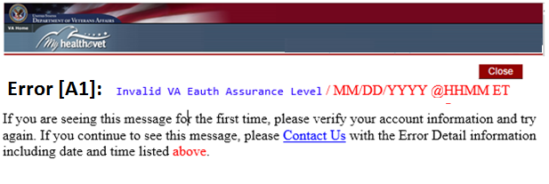

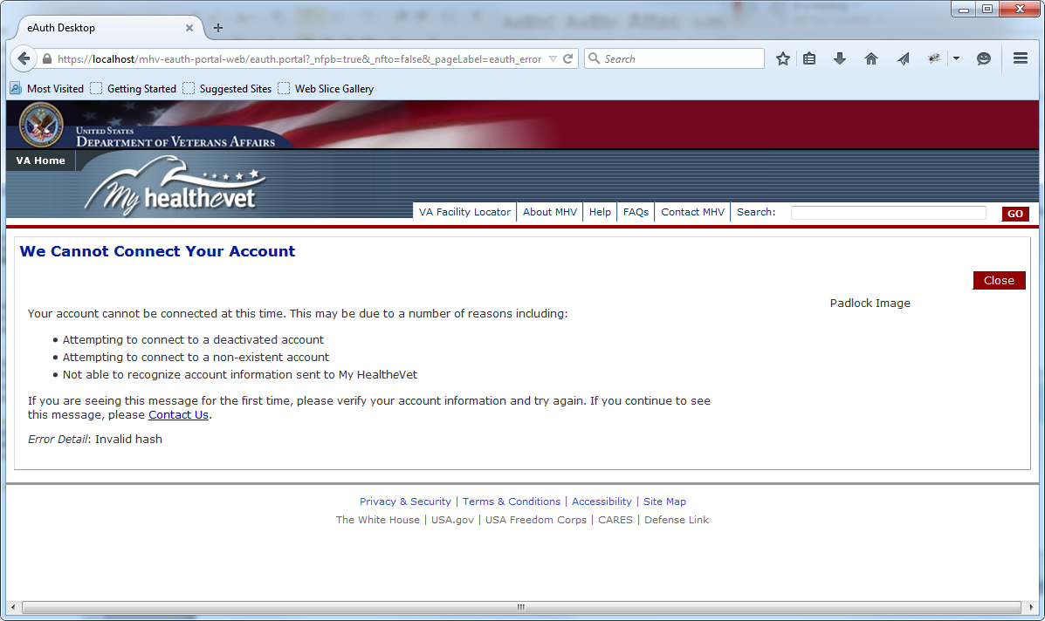

Figure : Standard User-friendly Error Page in a SSOe Session

Content Status: Need approved content

Refer to Appendix G for error codes and error messages

Error message updated for release 16.3.1

Needs approval

Note to PD: remove links from skin and make the text ‘Error [A1]’ font size bigger.

Question to Ngozi: is this the proper skin to user for error messages?

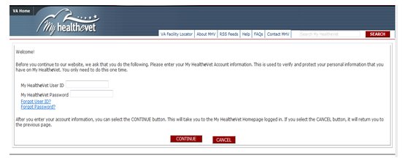

Figure : MHV Re-Authentication Page

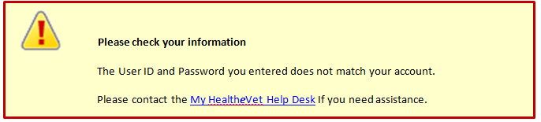

Figure : Error Message If The User Enters an Incorrect User ID and Password from Re-Authentication Page

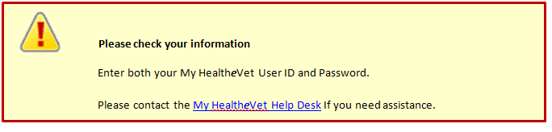

Figure : Error Message If The User Leaves Either User ID or Password Blank from Re-Authentication Page or Connect Page

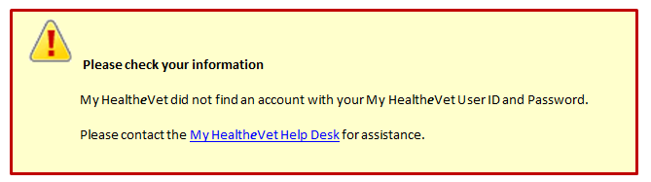

Figure 6: Error Message If User ID and Password Cannot Be Found from Connect Page

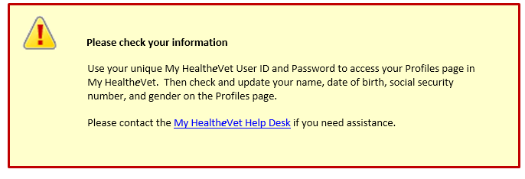

Figure : Error Message If User ID and Password Does Not Match User’s Identity from Connect Page and Re-authentication Page

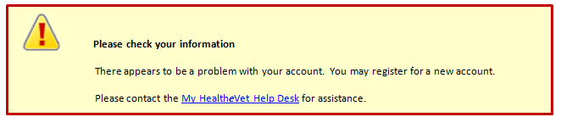

Figure : Error Message If the User Account is Deactivated and the User Enters User ID and Password on Connect Page

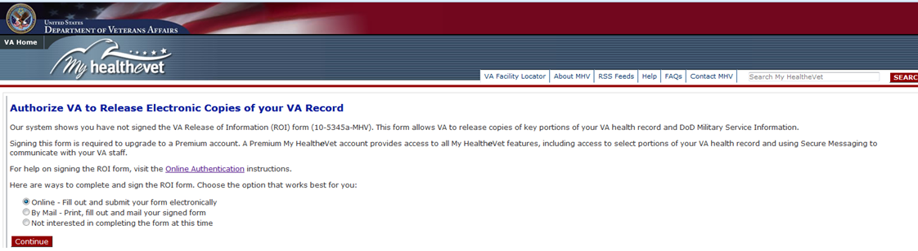

Figure : Start Upgrade Page

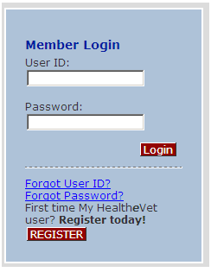

Figure : Current MHV Login Box (10/26/15)

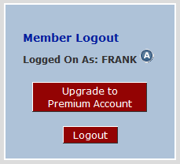

Figure : Proposed Member Login Box Upgrade Account Button

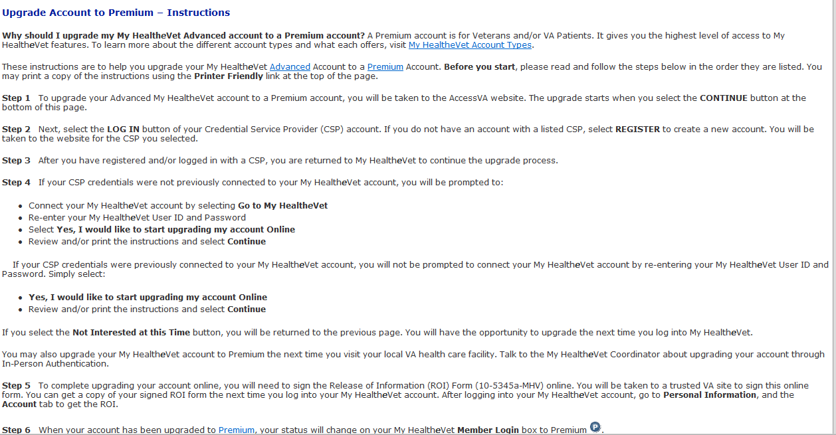

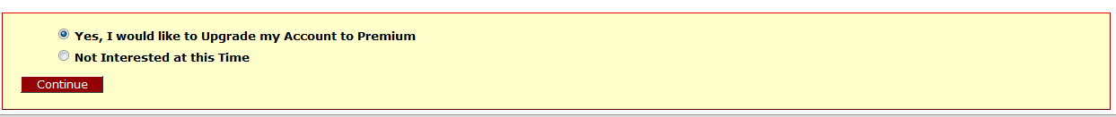

Figure : Instructions Page to Upgrade Account to Premium

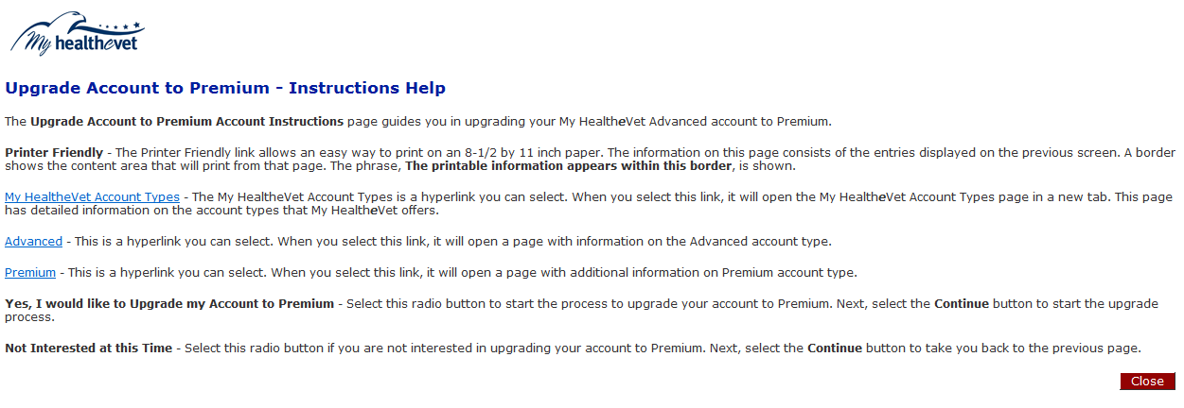

Figure : Technical Help File – Upgrade to Premium Account

URL: <https://www.access.va.gov/accessva/?appId=mhv>

f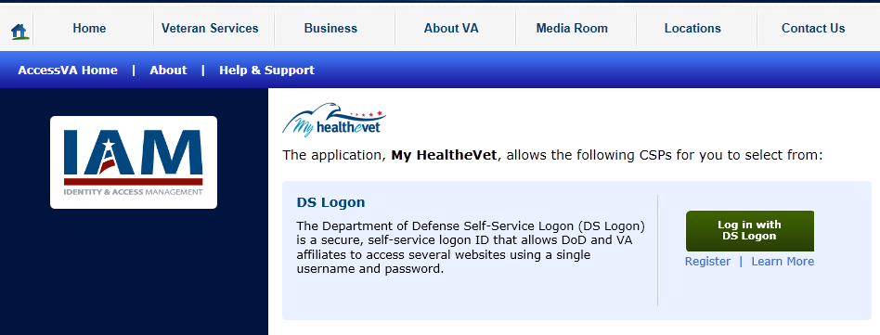

Figure : AccessVA Website - MHV Page

<https://www.access.va.gov/accessva/signinpartners>

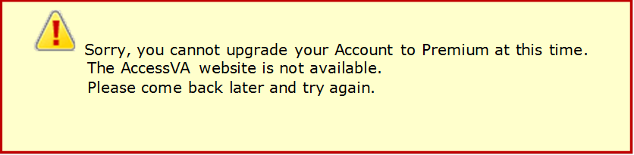

Figure : Error Message AccessVA Website is Offline

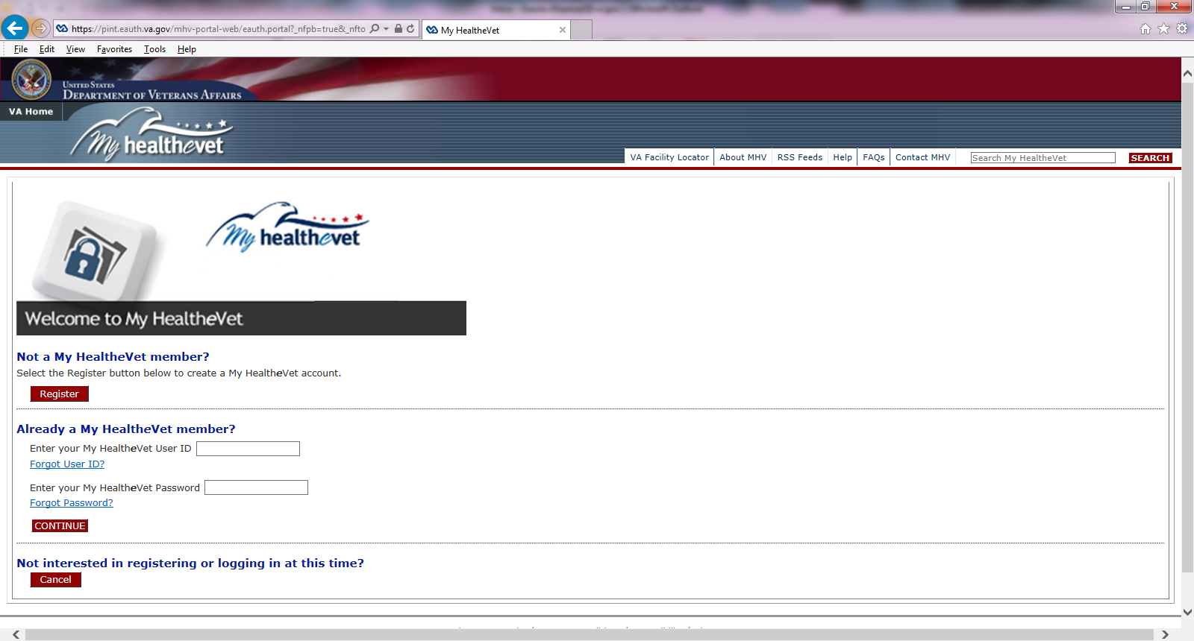

Figure : Connect Page

# Appendix E – Account Activity Tracking

1. **Account Activity Tracking Entries**

|  |  |
| --- | --- |
| Activity_Id | as defined in Activity Table Schema |
| User_Profile_Id | as defined in Activity Table Schema |
| Action | Login |
| Status | Successful or Unsuccessful |
| Performer_Type | Self |
| Detail_Value | [existing functionality - include if deep linking from eBenefits] |
| Activity | Login with [Name of Credential Used] i.e. “DS Logon, Norton Symantec, CAC” |
| Completion_Time | as defined in Activity Table Schema |

Figure : Account Tracking Entries for the Login (12.9)

|  |  |
| --- | --- |
| Activity_Id | as defined in Activity Table Schema |
| User_Profile_Id | as defined in Activity Table Schema |
| Action | Logout |
| Status | Successful or Unsuccessful |
| Performer_Type | Self |
| Detail_Value |  |
| Activity | Logout |
| Completion_Time | as defined in Activity Table Schema |

Figure : Account Tracking Entries for the Login

|  |  |
| --- | --- |
| Activity_Id | as defined in Activity Table Schema |
| User_Profile_Id | as defined in Activity Table Schema |
| Action | Account Connected |
| Status | Successful or Unsuccessful |
| Performer_Type | Self |
| Detail_Value |  |
| Activity_Type | [Name of Credential Used] i.e. “DS Logon, Norton Symantec, FCCX” |
| Completion_Time | as defined in Activity Table Schema |

Figure : Account Tracking Entries for Account Connected

|  |  |
| --- | --- |
| Activity_Id | as defined in Activity Table Schema |
| User_Profile_Id | as defined in Activity Table Schema |
| Action | Account Upgrade Requested |
| Status | Successful or Unsuccessful |
| Performer_Type | Self |
| Detail_Value |  |
| Activity_Type | [Name of Credential Used] i.e. “DS Logon, Norton Symantec, FCCX” |
| Completion_Time | as defined in Activity Table Schema |

Figure : Account Activity Entries for Account Upgrade Requested

|  |  |
| --- | --- |
| **Date/Time:** | Sysdate |
| **Performed By:** | Self |
| **Activity:** | Account Upgrade |
| **Activity Details:** |  |
| **Action:** | Continue to AccessVA to Upgrade to Premium |
| **Result:** | Successful or Unsuccessful |

Figure : Account Activity Entry to Continue to AccessVA to Upgrade to Premium

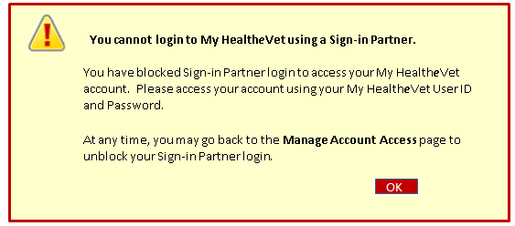

New for 16.3.1 release

Approved on 7/22/16

Figure : User-Friendly Error Message if Login through Sign-in Partner is Blocked

# Appendix F – Account Activity Mock Up

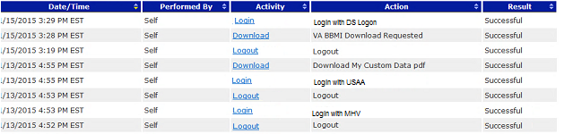

Typical Login AAH Summary:

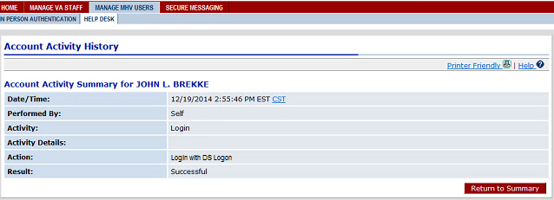

Only populate activity details for Deep Linkings from eBenefits:

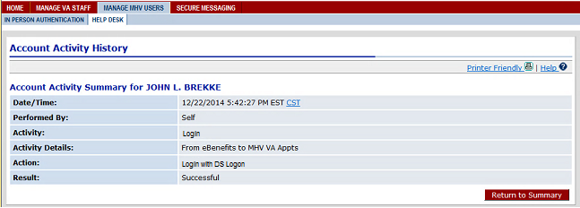

Figure : Account Activity History Mockup

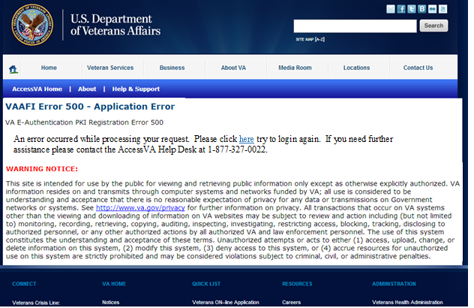

Figure : Error Message When VAAFI is Unavailable

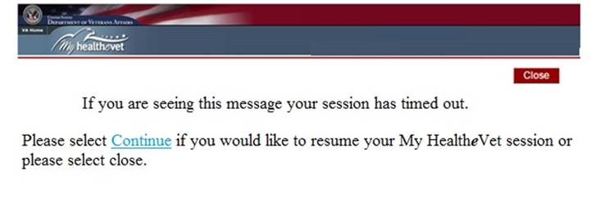

Figure : MHV Session Timeout Page With Active SSOe Session

New for 16.3.1

Status: Draft

# Appendix G – SSOe Error Messages

New for 16.3.1 release

**Legend**

|  |  |
| --- | --- |
| **Symbol** | **Name** |
| F | Full Trait Flow |
| C | CSP only Flow |
| A | For All Flows |
| O | Original Flow for DS Logon |

**New Error Code Table**

|  |  |  |  |
| --- | --- | --- | --- |
| **Symbol** | **Error Code** | **Error Message** | **Flow Check in MHV code** |
| A | 1 | Invalid VA Eauth Assurance Level | If the LOA is less than level 2 |
| A | 2 | CSID is empty | If CSID is blank |
| A | 3 | ORC Logon is not allowed | If CSID = ORC |
| C/F/O | 4 | NOT_FOUND on first name, last name birth date or ssn | If the header has ‘Not_Found’ |
| C/F/O | 5 | Invalid SSN | If there is not a valid SSN |
| C/F/O | 6 | Invalid Birth Date | If there is not a valid DOB |
| C/F/O | 7 | Invalid ICN | If the ICN is not valid |
| C/F | 8 | Your account cannot be connected at this time as the system cannot process your request | If MVI is unavailable |
| C/F/O | 9 | Error message from MVI:<Actual Error message from MVI> | Error Messages from MVI |
| C/F/O | 10 | multiple IDs Error | If there are multiple EDIPI’s, |
| C/F/O | 11 | SSN Mismatch | If the SSN does not match |
| C | 12 | Multiple EDIPIs | If the EDIPI is not valid |
| C | 13 | Invalid EDIPI: If EDIPI is provided but invalid: NOT_FOUND ; length is more than 10 digits; non-digits | If the EDIPI is not valid |
| F | 14 | Multiple Account Error | If multiple MHV IEN(s) exist |
| C/F | 15 | Unrecoverable Error | On the Upgrade page, when the user selects the “Cancel” button and MHV system cannot process this request |
| F | 16 | Multiple Account Error | If multiple MHV IEN(s) exist |
| O | 17 | Deactivated Account | Check for Deactivated Account Status |
| A | 18 | Invalid Hash | Validate VAAFI Header. If Hash is not valid |
| O | 19 | Pending Uncorrelation or Failed Correlation Status | Failure during Correlation with MVI |
| A | 20 | Four or More Traits update | When MHV finds that the 4 or more user traits from VAAFI are different than the traits in MHV record. |
| A | 21 | Patient Record cannot be created | When some unknown issues the MHV record cannot be created. |

Appendix H – Approval Signatures

The requirements defined in this document are the high level business requirements necessary to meet the strategic goals and operational plans of the Veterans/Consumers Health Informatics Office.

**My Health*e*Vet Program Management Office**

Signifies that the customer approves the documented requirements, that they adequately represent the customers desired needs, and that the customer agrees with the defined scope for the Business Use Case.

Signed: Date:

Theresa Hancock, Director, Veterans/Consumers Health Informatics Office