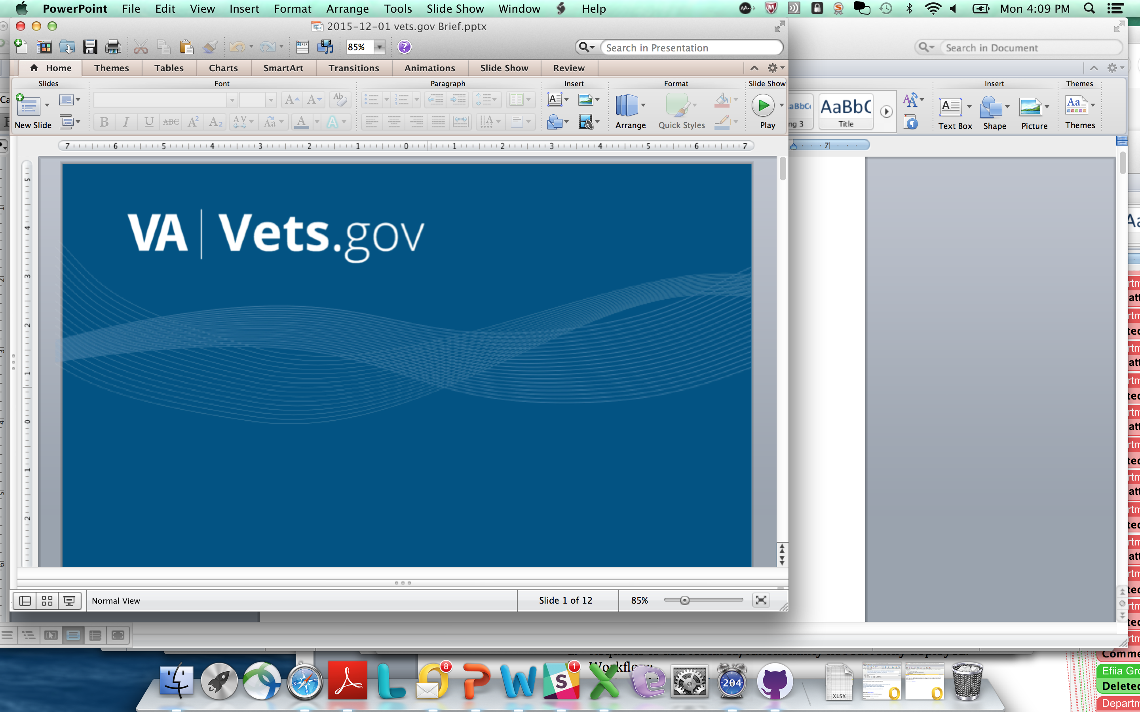

Vets.gov Product Charter

My Health*e*Vet (MHV) Prescriptions and Secure Messaging

DRAFT v.2

*6/13/2016*

Table of Contents

Authorization 3

1 Document Purpose 4

2 Vision and Goals 4

3 Product Team Roles and Responsibilities 4

4 Content and Information Architecture (IA) Error! Bookmark not defined.

5 Features & Functionality Enhancements 6

6 Project Milestones & Key Activities 7

7 Ongoing Maintenance 7

8 Assumptions and Constraints 7

9 Vets.gov Product Methodology 8

# Authorization

VA Product Business Owner:

Theresa Hancock, Director of My Health*e*Vet

*Signature Date*

Stacey Langer, vets.gov Product Manager

*Signature Date*

# Document Purpose

This purpose of this document is to define the near-term scope of work, team roles, and milestones for one major feature of the current My Health*e*Vet (MHV) program: Prescriptions.

The scope of work defined in this document includes both content and features / functionality for:

* MHV Prescription Refills
* MHV Secure Messaging

The period of performance for this work is approximately **May 2016 – August 2016.**

Content updates and feature enhancements will continue throughout 2016 and beyond with new charters to define future work.

# Vision and Goals

Vets.gov will enables veterans to discover, apply for, track, and manage the benefits they have earned.

Features and content from the existing MHV website will be migrated to vets.gov using an iterative and Veteran-centered approach, starting with prescription refill and secure messaging.

# Product Team Roles and Responsibilities

| **Role** | **Names** | **Responsibilities** |
| --- | --- | --- |
| Vets.gov Team Members | Jenny Heiland-Leudtke (Content)  Gina Kim (Design)  Stacey Langer, Product Manager  Kelly O’Connor, Product Support  Alex Yale Loehr, Engineering | * Manage product activities and schedule * Design and develop products * Write content in plan language * Oversee content migration and concurrence * Design and develop vets.gov account logon / coordinate with MHV logon * Incorporate MHV Veteran research and human centered design work completed to date * Work closely with business owner and product team to communicate progress |
| VA MHV Business Owner | Theresa Hancock, Director | * Make decisions and accept product * Work closely with vets.gov team to manage VA stakeholder communications and change management * Work with vets.gov communications leads (Sec. Office, VHA, VBA) to coordinate communications * Provide guidance to the team * Identify VA stakeholders for participation * Sign / approve charter |
| VA Integrated Product Team Members / Subject Matter Experts (SMEs) | John Brekke (VA OIT PM)  Neil Evans (Co-Director Connected Health)  Kathy Frisbee (Co-Director Connected Health)  Kim Nazi (Business SME)  Maureen Layden (Physician, Pharmacy SME)  Jeff Sartori (Pilot Design; Design Research)  Carnetta Scruggs (Business SME)  Ken Graham (API) | * Provide context and subject matter expertise on business, technical, and data requirements collected to date * Work collaboratively with vets.gov team on all discovery and migration activities * Provide technical support for discovery and migration including insight on systems, architecture, APIs, and data. * Provide access to systems, APIs, and code repositories as needed and in a timely way * Support business owner with (approved) messaging and stakeholder communications and change management throughout migration * Assist with redirects and other OIT-related activities prior to deployment * Coordinate with VA call centers to update scripts as needed * Answer questions and respond to data calls in a timely way * Participate in product team working sessions * Provide access to VA employees and / or users as needed for discovery activities |
| VA Content Subject Matter Experts (SMEs) | Richard (Chip) Harmon | * Provide subject matter expertise on prescription and secure messaging content * Participate in the vets.gov content concurrent process as required * Work collaboratively with VBA and VHA Web Communication Leads on the content concurrence process to provide fact checking and ensure accuracy of content * Adhere to the vets.gov content concurrence policy and process * Update / maintain content on VA.gov until it is migrated to vets.gov * Continue to manage content using existing content processes and tools on VA.gov |
| Call Center Support | Sheila Guitteriez  Ryan Heiman | * MHV Call Center support * Coordinate all call center coordination including script updates, training,etc. |
| Web Comms Office Leads / Content Concurrence Leads | Jenny Heiland-Luedke, VHA  Jennifer Rudisill, VBA | * Lead content concurrence for VHA and VBA * Assist with pre-launch activities * Participate in product team and communications activities * Coordinate communications with Office of the Secretary (M. Taylor) |
| Office of Secretary | Martin Taylor | * Oversee all vets.gov branding * Approve ANY and ALL external communications / media activities regarding vets.gov including, but not limited to: media, OIG, GAO, Congress, and Veteran Service Organizations (VSOs), other government agencies |

# 

# Minimum Viable Product (MVP) Scope Detail

High-level scope is defined below:

1. **Stand-up Vets.gov account / MHV Logon** 
   1. Vets.team to develop our point of view (POV) paper and high-level CONOPS for identity and the vest.gov account
   2. Design and build a prototype for vets.gov account
   3. Coordinate work with VA OIT on required dependencies (based on the POV) such as the VA Master Veteran Index (MVI); examples:
      * VA OIT team to accept Vets.gov account rather than (or in addition to) MHV
      * Discovery sessions with VA IAM / VA OIT
2. **Design and Develop Prescriptions Functionality (MVP)** 
   1. Develop mockups / wireframes
   2. Build out functionality for prescription and secure messaging
      1. Refill a prescription
      2. View prescription history
      3. Track prescription delivery
      4. Secure message with a doctors’ office for a prescription renewal
3. **Content strategy and migration**
   1. Develop vets.gov health content strategy specific to prescriptions
   2. Rewrite content in plain language
   3. Complete content concurrence for accuracy
   4. Deploy content sunsetting strategy as needed prior to / following launch
   5. Develop MHV content update process for ongoing use by a select group of VA content SMEs
4. **Deploy / Change Management and Communications**
   1. Coordinate pre launch activities
      1. Redirects / sunsetting strategy for both content and features
      2. Testing
      3. Communications
         * Internal VA stakeholders – MHV team*
         * External stakeholders – Office of Secretary
      4. Complete all pre launch checklist items
   2. Launch

*Internal VA stakeholder change management activities are led by the MHV business owner and MHV team in collaboration with VHA web communications lead; vets.gov team will provide support with messaging as needed.

# Project Milestones & Key Activities

Process and timeline generally reflect the content concurrence process established by the Vets.gov content team, which can and should be referenced in addition to the below for specifics.

|  |  |  |  |  |  |
| --- | --- | --- | --- | --- | --- |
| *Ref* | Tasks | May | June | July | August |
| *A* | Stand up vets.gov account / MHV logon |  |  |  |  |
| *B* | Design and develop MVP |  |  |  |  |
| *C* | Content strategy and migration |  |  |  |  |
| *D* | Deploy |  |  |  |  |

# Ongoing Maintenance

The vets.gov team will provide ongoing maintenance and support for adding/ updating content and providing break/fix for any technical issues on the vets.gov platform. The product owner (or designee) will email [vavetsgov-team@va.gov](mailto:vavetsgov-team@va.gov) to report technical issues.

The vets.gov team will be implementing a robust maintenance and support help desk in 2016, and will provide updated service level information and processes at that time.

# Assumptions and Constraints

* MVP includes existing functionality; no new functionality
* MVP does not include view only non-prescription (herbals, etc.) or self-entered non-prescription information
* Native mobile apps are not in scope of this work; MVP will be mobile responsive
* Content for prescriptions will be aligned with overall vets.gov approach to health content; we anticipate this will be a significant area for change management
* MHV logon will be an accepted vets.gov credential.
* DS Logon will be an accepted vets.gov credential.
* Refill a prescription feature does not include controlled narcotics / schedule 2 drugs (per current functionality and policies)

1. Others TBD

# Vets.gov Product Methodology

Please refer to the vets.gov playbook (*https://www.vets.gov/playbook/)* that defines the product methodology, outputs, and roles in further detail. All vets.gov products will adhere to the standards and processes defined in the playbook.