**Veterans Health Administration  
Office of Informatics and Analytics**

**Connected Health**

**Veterans/Consumers Health Informatics Office**

**Requirements Engineering Management**

My Health*e*Vet (MHV) Notification of Prescriptions Filled by Consolidated Mail Outpatient Pharmacies (CMOP)

New Service Request #20120315

BUC #

*Business Use Case*



March 2014

Revision History

|  |  |  |  |
| --- | --- | --- | --- |
| **Date** | **Revision #** | **Description** | **Author** |
| 4/30/2014 | 0.01 | Initial entries | Tedrick Vernon |
| 5/24/2014 | 0.02 | Draft #1 made changes to basic flow and alternate flows based on meeting with Carnetta Scruggs on 5/23/2014 | Tedrick Vernon |
| 11/24/2014 | 0.03 | Updated to reflect subscribe/unsubscribe to notifications on MHV User Profile page. Added requirements for Background Job to trigger the events. Added requirements for AAL and email address formatting. | Ro Weaver |
| 1/06/2015 | 0.04 | Updated based on PD comments and feedback | Ro Weaver |
| 1/7/1015 | 0.05 | Updated based on V/CHIO team review  Added email and SM notification examples | Ro Weaver |
| 1/9/2015 | 0.06 | Updated based on PD review with Dr. Douglas and Lisa. Updated Alternative Flow 4.6 | Ro Weaver |
| 1/14/2015 | 0.07 | Updated User Profile page based on approved content dated 1/6/15 | Ro Weaver |
| 1/21/2015 | 0.08 | Updated email content based on email from K. Seihr and C. Scruggs | Ro Weaver |
| 1/26/2015 | .09 | Added additional steps to illustrate user flow for selecting the hyperlinked tracking number | Ro Weaver |
| 1/30/2015 | .10 | Incorporated comments from review with PD on 1/27. Added flow for user registration and mock up. | Ro Weaver |
| 2/9/2015 | .11 | Incorporated approved content. Added precondition #3 from PD, updated formatting, spell check, and bookmarks/cross references | Ro Weaver |
| 2/23/2015 | .12 | Updated email content to show sending email from: [No\_Reply\_Allowed@va.gov](mailto:No_Reply_Allowed@va.gov) [<mailto:No_Reply_Allowed@va.gov>] and adding sorting requirements for multiple RX shipped in one day. | Ro Weaver |
| 3/4/2015 | .13 | Updated email content to remove table indicating who patients should contact and replaced with just text. Updated approved content from 2/24 for Pharmacy pages. | Ro Weaver |
| 3/4/2015 | 1.0 | Baselined for 12.12 | Ro Weaver |
| 3/25/2015 | 1.1 | Updated Basic Flow to include refresh for Treatment Facility. Added Treatment Facility to the Special Requirements. | J. Phiffer |
| 8/17/2015 | 1.2 | Removed the profile update from 6.1.2 as per C. Scruggs; updated refresh to one calendar day in 3.2; approved for submittal by C. Scruggs | J. Phiffer |
| 8/25/15 | 1.3 | Editorial Review | M. Berg |
| 8/26/15 | 1.4 | Made final editorial changes stipulated by M. Berg | J. Phiffer |
| 8/26/2015 | 2.0 | Baseline for 12.14 | J. Phiffer |
| 10/16/2015 | 2.1 | Updated to remove email validation check | R. Weaver |
| 10/23/2015 | 2.2 | Added email validation check back into Basic Flow 3.1. Added validation check information into brief description section. | R. Weaver |
| 1/25/2016 | 2.3 | Updated for 16.1 Release: nightly jobs to initiate a MVI facility update if the last facility update was greater than or equal to 48 hours from present. | R. Weaver |

Table of Contents

[1. Notification of Prescriptions Filled by CMOP 5](#_Toc428355102)

[1.1. Brief Description 5](#_Toc428355103)

[1.2. Actors 5](#_Toc428355104)

[2. Preconditions 6](#_Toc428355105)

[3. Basic Flow of Events 7](#_Toc428355106)

[3.1. Setting the Email Preference 7](#_Toc428355107)

[3.2. Prescription Notification Background Job 8](#_Toc428355108)

[4. Alternative Flows 10](#_Toc428355109)

[4.1. Alternative Methods for Setting Email Preference 10](#_Toc428355110)

[4.1.1. User Profile from Rx Refill History Page 10](#_Toc428355111)

[4.1.2. User Profile Rx Tracking Summary Page 10](#_Toc428355112)

[4.1.3. User Profile from Refill My Prescription Page 10](#_Toc428355113)

[4.2. Background Jobs that are Unable to Run/Process 11](#_Toc428355114)

[4.2.1. MHV System Down 11](#_Toc428355115)

[4.2.2. Prescription Refresh did not Occur 11](#_Toc428355116)

[4.2.3. CDW Down 11](#_Toc428355117)

[4.2.4. Background Job Fails 11](#_Toc428355118)

[4.3. MHV User Profile Does Not Have Valid Email 12](#_Toc428355119)

[4.4. Multiple Prescriptions Shipped on One Day 12](#_Toc428355120)

[4.5. New MHV Registrants 12](#_Toc428355121)

[4.5.1. From MHV Splash Page 12](#_Toc428355122)

[4.5.2. From MHV Home Page 13](#_Toc428355123)

[5. Post Conditions 13](#_Toc428355124)

[6. Special Requirements 13](#_Toc428355125)

[6.1. Business Rules 13](#_Toc428355126)

[6.1.1. Verification for Email and Email Confirmation 13](#_Toc428355127)

[6.1.2. Request for Updated Treatment Facility List 13](#_Toc428355128)

[7. Extension Points 15](#_Toc428355129)

[Appendix A Acronyms and Definitions 16](#_Toc428355130)

[Appendix B Business Use Case Flow Models 18](#_Toc428355131)

[Appendix C Pharmacy Landing Page 19](#_Toc428355132)

[Appendix E MHV User Profile Preferences 21](#_Toc428355133)

[Appendix F View Prescription History Information Page 22](#_Toc428355134)

[Appendix G Email Notification Message 23](#_Toc428355135)

[Appendix H Carrier Tracking Window 24](#_Toc428355136)

[Appendix I Email Information Successfully Saved 25](#_Toc428355137)

[Appendix J Job Failed Distribution Group Message 26](#_Toc428355138)

[Appendix K Refill Prescription Information Page 27](#_Toc428355139)

[Appendix L Account Activity Log 28](#_Toc428355140)

[Appendix M Registration Page 29](#_Toc428355141)

[Appendix N Error Message – Email Address Required 31](#_Toc428355142)

[Appendix O Approval Signatures 32](#_Toc428355143)

# Notification of Prescriptions Filled by CMOP

This is the Business Use Case (BUC) for My Health***e***Vet Notification of Prescriptions Filled by CMOP. This BUC defines the business level response of the system to a sequence of actions performed by any of the Actors listed below to log onto MHV, and receive notification of their prescriptions filled by a VA Consolidated Mail Outpatient Pharmacies (CMOP) described in this document as a VA Mail Order Pharmacy.

## Brief Description

The Department of Veterans Affairs (VA) sends the majority of outpatient prescriptions to patients via the United States Postal Service (USPS) and United Parcel Service (UPS), the current VA contracted delivery services for prescriptions mailed from both local VA facilities and the VA CMOP. The majority of these prescriptions are filled at seven large CMOPs which are located across the United States.  Over 115 million prescriptions or 80% of all Veterans Health Administration’s (VHA) outpatient prescriptions are sent to Veterans annually via the CMOP.  The CMOP is also referred to as the VA Mail Order Pharmacy in this BUC.

Veterans can track the delivery of their mail-out prescription medications by using the Online Prescription Tracking form the Pharmacy menu located on MHV. Online Prescription Tracking displays a link within MHV for Veterans to use so they can access USPS and UPS package tracking information that is already available from the Veterans Administration CMOP. This Business Use Case details the functionality requested for Veterans to have the option of receiving an email notification when a prescription has been filled by CMOP.

Email validation check in Flow 3.2 was removed in previous versions of these requiremetns since the email validation occurs in the Basic Flow 3.1 as existing functionality.

## Actors

Actors have three access levels.

|  |  |
| --- | --- |
| **Event** | **Actors** |
| Receive Email Alert Notification | VA Patient |
| System Events | My Health***e***Vet National Portal |

Actor

Rx Tracker

Notification

**Business Use Case Diagram**

# Preconditions

1. The Actor must be a VA Patient registered with an Active MHV Advanced or Premium account.
2. The Actor must have a VA prescription filled by Consolidated Mail Outpatient Pharmacy (CMOP).
3. The Actor has accepted the Rx Terms and Conditions

# Basic Flow of Events

This Business Use Case describes the basic business requirements for MHV Notification of Prescriptions Filled by CMOP functionality in MHV. This functionality allows Veterans with an Advanced or Premium MHV account to receive a notification message when VA prescriptions are shipped from any of the seven CMOP locations in the USA.

## Setting the Email Preference

oOn the Prescription Tracking Summary page Advanced and Premium MHV account users can setup their email preference to receive email notification for prescriptions filled by CMOP.

**Step 1:** The Actor logs into My Health***e***Vet Portal. (See Alternative Flow 4.6 for users who register for a MHV account)

**Step 2:** The System shall display the MHV home page.

**Step 3:** The Actor selects the Pharmacy tab.

**Step 4:** The System shall display the Pharmacy landing page. (See **Appendix C**)

**Step 5**: The Actor selects the Prescription Track Delivery image/icon from thePharmacy landing page**.** (See[Alternate Flow 4.1](#Altflow_4_1))

**Step 6**: The System displays the Prescription Tracking Summary page. (See [**Appendix D**](#Appendix_D))

**Step 7:** The system displays the following content under the introduction text: “Subscribe to VA Rx shipment notifications on your [Profiles](https://www.myhealth.va.gov/mhv-portal-web/anonymous.portal?_nfpb=true&_pageLabel=profiles&_nfls=false) page.” (See [**Appendix D**](#Appendix_D))

**Step 8:** The Actor selects the “Profiles” hyperlink.

**Step 9:** The System navigates the user to the MHV User Profile Page. (See [**Appendix E**](#Appendix_E)) The section for “Subscribe to Email Notifications and Reminders” is listed after the Contact Information Section. There is an available option for “Rx Refill Shipment Notifications” with radio buttons to “Turn On” and “Turn Off” with the default selected as “Turn off”. (Note to developer: The greyed out sections listed in the mock up will not be coded and are only for reference of future functionality desired)

**Step 10:** The Actor enters an email address in the Email text box and re-enters the email address in the “Confirm Email” text box. ([See Special Requirements in Section **6** and **6.1.1** Verification for Email and Email Confirmation)](#Verify_email_6_1_1).

**Step 11:** The Actor selects the “Turn On” radio button for Rx Tracker Notifications.

* Default will be ”Turn Off”

**Step 12:** The Actor selects Save.

**Step 13:** The System will verify that a properly formatted email address is listed in the Contact Information section of the MHV User Profile any time a subscription to an email reminder is selected. (Existing Functionality)

**Step 14:** The System will verify that the address in the Email box and Confirmation email box match. ([See Special Requirements in Section **6** and **6.1.1** Verification for Email and Email Confirmation)](#Verify_email_6_1_1). (See Alternative Flow [**4.3**](#Altflow_4_2) if the email address is missing).

**Step 15:** The System displays the message “Your information has been successfully saved.” (Existing Functionality) (See **Appendix I**)

**Step 16:** The System captures an Account Activity Log (AAL) **Step 1:** The Actor logs into My Health***e***Vet Portal. (See Alternative Flow 4.6 for users who register for a MHV account)

**Step 2:** The System shall display the MHV home page.

**Step 3:** The Actor selects the Pharmacy tab.

**Step 4:** The System shall display the Pharmacy landing page. (See **Appendix C**)

entry for the User Profile Updates as shown in Row **1** of the AAL table in **Appendix M**. The System captures the Rx notification status as Turned On as shown in Row **4** of the AAL Table in **Appendix M**.

The Use Case ends.

## Prescription Notification Background Job

**Step 1:** The system shall run a daily automated background job every day after 3:00 AM Eastern Time (ET). The system job shall be part of the startup protocol. Refer to Alternative Flow **4.2.1** if MHV is down. Refer to Alternative Flow **4.2.3** if the Corporate Data Warehouse (CDW) is down. Refer to Alternative Flow **4.2.4** if for Background Jobs that are Unable to Run or Process.

**Step 2:** The system job will loop through all users who have turned on Prescription Tracking email notifications. (See Basic Flow **3.1**).

**Step 3:** The system will call Master Veteran Index (MVI) to get a list of treatment facilities for this user if not already done for this user within the past 48 hours. (New for 16.1)

* If MVI is not available, skip this step.
* If no Treatment Facility is returned, skip this step.

**Step 4:** The system shall perform a data refresh of VA prescription data for that user. (See Alternative **4.2.2** if the refresh did not occur)

**Step 5:** The system shall identify prescription tracking information received from the CDW since the last successful Prescription Notification Background Job completed. Note: The first time this job runs after implementation, the CDW will pull on the same calendar day.

**Step 6**: The system will send the email notification to the email address on file in the MHV user profile for that user. (See [**Appendix G**](#Appendix_G) for email example)

**Step 7**: The system shall create an AAL entry for the user when the email notification is sent. (See Row **5** and Row **6** of the AAL Table in **Appendix M**)

**Step 8:** The Actor receives a notification email to the address listed on the MHV User Profile page one time when a prescription is shipped. (See [**Appendix G**](#Appendix_G))

**Step 9:** The Actor opens the email notification for VA Prescription Shipment Notification.

**Step 10:** They email notification message displays with the following data elements:

* Message header:
  + To: [Veteran@email.com](mailto:Veteran@email.com)
  + From: Department of Veterans Affairs: My Health*e*Vet [<mailto:No_Reply_Allowed@va.gov>]
  + Subject: VA Prescription Shipment Notification
* Message body:
  + Dear [Veteran First Name],

This is a notification of prescription package(s) shipped from the VA Mail Order Pharmacy.

Additional information can be found by logging into your My Health***e***Vet account and going to the Pharmacy menu.

* Shipping information section:
  + **Package(s) Shipped from VA Mail Order Pharmacy:**
  + -------------------------------------------------------------------------------------------
  + Ship Date: [Developer: list date the package was shipped]
  + Carrier: [Developer: list which carrier shipped the package]
  + Tracking: [Developer: list hyperlinked carrier tracking number]
  + -------------------------------------------------------------------------------------------
* Miscellaneous Content:
  + In the salutation, the message will be addressed to the Veteran using the Veteran’s first name.
  + Include date and time information was last updated on MHV. This date and time will be equal to the date and time the tracking information came from the CDW. Content: \*Tracking Information last updated in My Health***e***Vet on DDMMMYYYY @ XX:XX ET
  + Include a message stating “\*\* If you have already received your package, please disregard this message.”
  + If multiple packages are listed in one email, the system shall use the following sort order: Primary sort by Shipping date and secondary sort by Tracking number.
  + Include a the following statement below the tracking information: If you have questions about your prescription(s), please contact your local VA Pharmacy.

If you received this message in error or need technical assistance, please contact the My Health***e***Vet Help Desk [online](https://www.myhealth.va.gov/mhv-portal-web/anonymous.portal?_nfpb=true&_nfto=false&_pageLabel=contactMHVHome" \t "_blank) or by phone at 1-877-327-0022 Monday - Friday, 7:00 a.m. - 7:00 p.m. CT or 1-800-877-8339 (TTY). [online should be hyperlinked to the MHV Contact Us page.]

* + At the bottom of the message, include the following statement in bold font: **Please do not reply directly to this email as it is an automated message from the My Health*e*Vet System**

**Step 11:** The Actor selects the Tracking Number hyperlink.

**Step 12:** The system opens a new window/tab to the carrier’s tracking webpage. (See [**Appendix H**](#Appendix_H))

This Use Case ends.

# Alternative Flows

## Alternative Methods for Setting Email Preference

### User Profile from Rx Refill History Page

Advanced and Premium MHV account users on the View Prescription History Information page can setup their email preference to receive email notification for prescriptions filled by CMOP

**Step 1**: The Actor selects the Prescription Refill Historyimage/icon from thePharmacy landing page**. (**See [**Appendix C**](#Appendix_C)**)**

**Step 2**: The System displays the View Prescription History Information page with the following content under the introduction text: “Subscribe to VA Rx shipment notifications on your [Profiles](https://www.myhealth.va.gov/mhv-portal-web/anonymous.portal?_nfpb=true&_pageLabel=profiles&_nfls=false) page.” (See [**Appendix F**](#Appendix_F)).

**Step 3:** The Actor selects the link “Profiles” from the View Prescription History Information page.

**Step 4:** Return to Basic Flow **3.1, Step 9.**

### User Profile Rx Tracking Summary Page

Advanced and Premium MHV account users on the MHV Homepage can setup their email preference to receive email notification for prescriptions filled by CMOP

**Step 1:** The Actor logs into My Health***e***Vet Portal. (See Alternative Flow 4.6 for users who register for a MHV account)

**Step 2:** The System shall display the MHV home page.

**Step 3:** The Actor selects the Pharmacy tab.

**Step 4:** The System shall display the Pharmacy landing page. (See **Appendix C**)

**Step 5**: The Actor selects the Prescription Tracking Summaryimage/icon from thePharmacy landing page**. (**See [**Appendix C**](#Appendix_C)**)**

**Step 6**: The System displays the Rx Tracking Summary page with the following content under the introduction text: “Subscribe to VA Rx shipment notifications on your [Profiles](https://www.myhealth.va.gov/mhv-portal-web/anonymous.portal?_nfpb=true&_pageLabel=profiles&_nfls=false) page.” (See [**Appendix D**](#Appendix_F)).

**Step 7:** The Actor selects the link “Profiles” from the Rx Tracking Summary page.

**Step 8:** Return to Basic Flow **3.1, Step 9**.

### User Profile from Refill My Prescription Page

Advanced and Premium MHV account users on the MHV Homepage can setup their email preference to receive email notification for prescriptions filled by CMOP

**Step 1:** The Actor logs into My Health***e***Vet Portal. (See Alternative Flow 4.6 for users who register for a MHV account)

**Step 2:** The System shall display the MHV home page.

**Step 3:** The Actor selects the Pharmacy tab.

**Step 4:** The System shall display the Pharmacy landing page. (See **Appendix C**)

**Step 5**: The Actor selects the Refill My Prescriptionimage/icon from thePharmacy landing page**. (**See [**Appendix C**](#Appendix_C)**)**

**Step 6**: The System displays the Refill My Prescription page with the following content under the introduction text: “Subscribe to VA Rx shipment notifications on your [Profiles](https://www.myhealth.va.gov/mhv-portal-web/anonymous.portal?_nfpb=true&_pageLabel=profiles&_nfls=false) page.” (See

**Step 7:** The Actor selects the link “Profiles” from the Refill My Prescription page.

**Step 8:** Return to Basic Flow **3.1, Step 9**.

## Background Jobs that are Unable to Run/Process

### MHV System Down

**Step 1**: When the regular scheduled background job did not start at the appropriate date/time, the background job should run at the next scheduled time to include the time period of when the MHV System was down.

**Step 2:** This Alternative Flow ends**.**

### Prescription Refresh did not Occur

**Step 1**: If the prescription data was not refreshed for this user**:**

* + 1. If MHV has new shipment data, and Rx is not known by MHV, this Rx **CANNOT** be included in the email message.
    2. If MHV has new shipment data, and Rx is known to MHV, this Rx **CAN** be included in the email message.
    3. If MHV has new shipment data, and Rx refill data is not known to MHV, this Rx refill CAN be included in the email message.

**Step 2:** This Alternative Flow ends.

### CDW Down

**Step 1**: If MHV did not receive data from CDW, the background job for sending out the VA RX Shipment Notification shall not run.

**Step 2:** This Alternative Flow ends.

### Background Job Fails

**Step 1:** A System notification message will be sent to the Distribution Group in Outlook informing the group that the job failed. See **Appendix J**.

**Step 2:** The job needs to be rescheduled right away for the scheduled day that was missed.

**Step 3:** This Alternative Flow ends.

## MHV User Profile Does Not Have Valid Email

**Step 1**: If the Actor selected to receive email notifications, the system shall validate that a properly formatted email address is populated in the email address field of the MHV User Profile.

**Step 2:** If an email address is not listed, the System shall display an error message. (See **Appendix N**)

**Step 3:** Actor must enter a valid email address in order to receive email reminder notifications. If the Actor tries to turn on email reminders and does not have an email address on the MHV User Profile, an error message stating “An email address must be provided to Subscribe to Email Reminders.” ([See Special Requirements in Section **6** and **6.1.1**Verification for Email and Email Confirmation)](#Verify_email_6_1_1) (See **Appendix N**)

**Step 4:** This Alternative Flow ends.

## Multiple Prescriptions Shipped on One Day

**Step 1:** They MHV system shall generate automatic notifications based on the Tracking number established for a prescription package delivery. If multiple prescription packages are shipped from the same facility or from multiple facilities on the same day, the MHV System shall send the Actor one notification email to the address listed on the MHV User Profile page, listing the tracking information for each shipment. The primary sort of the packages listed in the email will be by Shipping date and secondary sort will be by Tracking number. Refer to **Appendix G** for the email example.

**Step 2:** This Alternative Flow ends.

## New MHV Registrants

Note: Parallel effort for the implementation of Federated Credentials will impact how a user registers for a MHV account. Note that the inclusion of the “Subscribe to Email Notifications and Reminders” section as documented in this BUC will be true for Federated Credentials as well.

### From MHV Splash Page

**Step 1:** The Actor navigates to the MHV Splash Page and selects “Register Today” icon. (See Alt Flow **4.5.2** for Actors registering from the MHV Home page)

**Step 2:** The system displays the My Health*e*Vet Registration page. The section for “Subscribe to Email Notifications and Reminders” is listed after the Contact Information Section. There is an available option for “Rx Refill Shipment Notifications” with radio buttons to “Turn On” and “Turn Off” with the default selected as “Turn off”. (See **Appendix M**)

**Step 3:** The Actor completes the required fields on the registration page.

**Step 4:** Return to Basic Flow **3.1, Step 9**.

### From MHV Home Page

**Step 1:** The Actor navigates to the MHV Splash Page and selects “Go to My Health***e***Vet Enter Here” icon.

**Step 2:** The system navigates the Actor to the My Health*e*Vet home page.

**Step 3:** The Actor selects the “Register” icon.

**Step 4:** Return to Step 2 of Alternative Flow **4.5.1**.

# Post Conditions

1. VA Patients who turn on Prescription delivery notifications and meet conditions set forth in this BUC will receive email generated notifications.
2. VA Patients are able to access the MHV User Profile from the Prescription Tracking Summary page, the Prescription Refill History page, and the Refill My Prescription page in order to turn on and off email notifications.
3. VA Patients are able to turn off and off email notifications from the MHV User Profile page and upon MHV account registration.
4. Account Activity Log will track successful and unsuccessful email delivery attempts.
5. Account Activity Log will track updates to email subscription preferences (Turn On/Turn Off)
6. Account Activity Log will track changes to MHV user email address listed in MHV User Profile.

# Special Requirements

## Business Rules

### Verification for Email and Email Confirmation

1. When a user is prompted to enter an email address, the system shall include a confirmation email data field for the user to re-enter the email address. The System must verify that both emails match.
2. If the email addresses match, a confirmation message will be displayed stating “Your information has been successfully saved.” (Existing Functionality) (See [**Appendix I**](#Appendix_J))
3. If the email address and confirmation email listed in the “Confirm Email” field do not match each other, the System will display an error message under the confirmation email text box as follows:
4. “We are unable to process your request. The email addresses you entered do not match. Please make any necessary corrections and try again.” (Content approved 2/3/15)
5. The System will not save the email address unless it matches the confirmation email address listed in the “Confirm Email” field.

### Request for Updated Treatment Facility List

1. If MVI is no longer sending Treatment Facility Updates, the system then send an update request to MVI to get the user’s most recent Treatment Facility Lists information.

**Note:** This requirement has a dependency on the Treatment Facility BUC.

# Extension Points

Not applicable for this work effort.

Appendix A Acronyms and Definitions

Table : Acronyms

| **Term** | **Description** |
| --- | --- |
| AAL | Account Activity Log |
| BUC | Business Use Case |
| CDW | Corporate Data Warehouse |
| CMOP | Consolidated Mail Outpatient Pharmacies (for MHV users CMOP is being referred to as VA Mail Order Pharmacy) |
| MHV | My Health***e***Vet |
| MVI | Master Veteran Index |
| Rx | Prescription |
| UPS | United Parcel Service |
| USPS | United States Postal Service |
| VA | Department of Veterans Affairs |
| VHA | Veterans Health Administration |
|  |  |

Table : Definitions

| Term | Definition |
| --- | --- |
| Actor | A role played by a user when using the System.  An Actor may be a person or another System.  An Actor may input information or receive information. |
| Alternative Flow | Secondary paths which are variations of the Basic Flow of Events. |
| Basic Flow | The normal or usual course of events within a Business Use Case. |
| Business Use Case | A sequence of transactions performed by a user to produce a measurable result of value; a dialog between an Actor and the System; a specific way of interacting with the System to accomplish a business-related goal. |
| Business Use Case Diagram | Depicts the relationship between an Actor and the Business Use Case. |
| Interface | A point of communication between two Systems or between an Actor and a System (often a GUI today.) |
| Post Condition | The state of an event that has been fulfilled once the Basic Flow of Events has ended. |
| Pre-condition | An event which must logically occur before the Basic Flow of Events begins. |
| Primary Actor | A role one carries out when using the System in order to implement a defined business process. |
| Referenced Business Use Case | A separate Business Use Case that is “used by” the Business Use Case being described. |
| Scenario | A single path through a Business Use Case.  May be a Basic scenario or an Extension scenario. |
| Secondary Actor | A role one carries out when using the System in order to make a Primary Actor complete. |

Appendix B Business Use Case Flow Models

Not applicable for this work effort.

Appendix C Pharmacy Landing Page

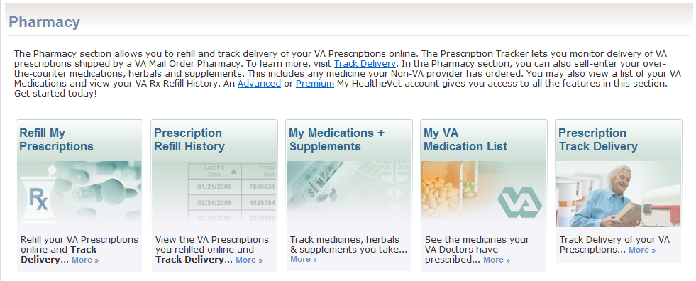

Approval Status: Existing ContentAppendix D Prescription Tracking Summary Page

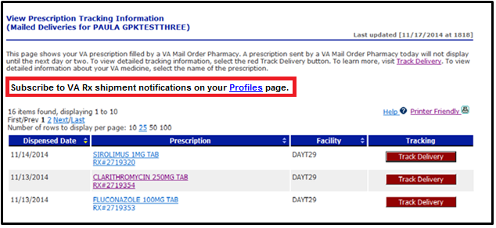

Approval Status: Approved 2/24/15.

Appendix E MHV User Profile Preferences

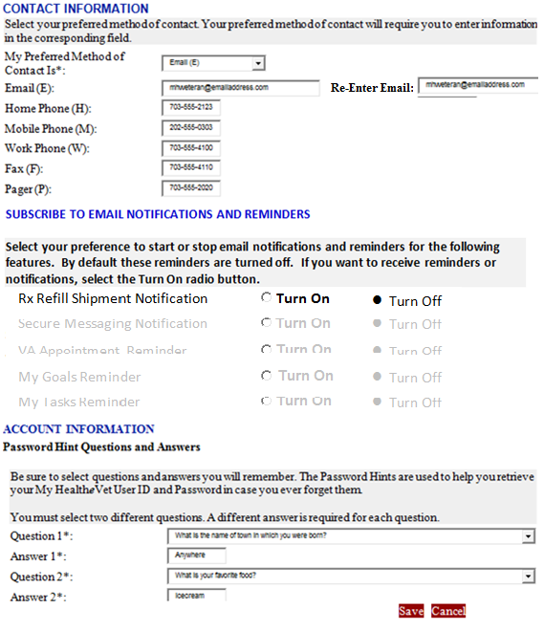

Approval Status: Approved 1/14/15

Appendix F View Prescription History Information Page

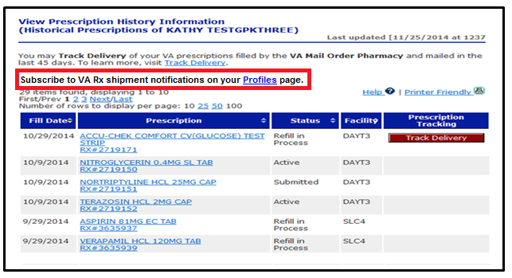

Approval Status: Approved 2/24/15.

Appendix G Email Notification Message

|  |
| --- |
| **\_\_\_\_\_\_\_\_\_\_\_\_\_\_\_\_\_\_\_\_\_\_\_\_\_\_\_\_\_\_\_\_\_\_\_\_\_\_\_\_\_\_\_\_\_\_\_\_\_\_\_\_\_\_\_\_\_\_\_\_\_\_\_\_\_\_\_\_\_\_\_\_\_\_**  **To**: [Veteran@email.com](mailto:Veteran@email.com)  **From:** Department of Veterans Affairs: My Health***e***Vet [<mailto:No_Reply_Allowed@va.gov>]  **Subject**: VA Prescription Shipment Notification  **\_\_\_\_\_\_\_\_\_\_\_\_\_\_\_\_\_\_\_\_\_\_\_\_\_\_\_\_\_\_\_\_\_\_\_\_\_\_\_\_\_\_\_\_\_\_\_\_\_\_\_\_\_\_\_\_\_\_\_\_\_\_\_\_\_\_\_\_\_\_\_\_\_\_**  Dear [Veteran’s First Name],  This is a notification of prescription package(s) shipped from the VA Mail Order Pharmacy.  Additional information can be found by logging into your My Health***e***Vet account and going to the Pharmacy menu.  **Package(s) Shipped from VA Mail Order Pharmacy:**  -------------------------------------------------------------------------------------------  Ship Date:     12 Dec 2014  Carrier:         USPS  Tracking:       0987654321  -------------------------------------------------------------------------------------------  Ship Date:     12 Dec 2014  Carrier:         UPS  Tracking:       1234567890  -------------------------------------------------------------------------------------------  Ship Date:     12 Dec 2014  Carrier:         UPS  Tracking:       1357924680  -------------------------------------------------------------------------------------------  \*Tracking Information last updated in My Health***e***Vet on 12 Sep 2014 @ 1800 ET.  \*\* If you have already received your package, please disregard this message.  If you have questions about your prescription(s), please contact your local VA Pharmacy.  If you received this message in error or need technical assistance, please contact the My Health***e***Vet Help Desk [online](https://www.myhealth.va.gov/mhv-portal-web/anonymous.portal?_nfpb=true&_nfto=false&_pageLabel=contactMHVHome" \t "_blank) or by phone at 1-877-327-0022 Monday - Friday, 7:00 a.m. - 7:00 p.m. CT or 1-800-877-8339 (TTY).  **Please do not reply directly to this email**  **as it is an automated message from the My Health*e*Vet System** |

Approval Status: Approved 3/3/15.

Appendix H Carrier Tracking Window

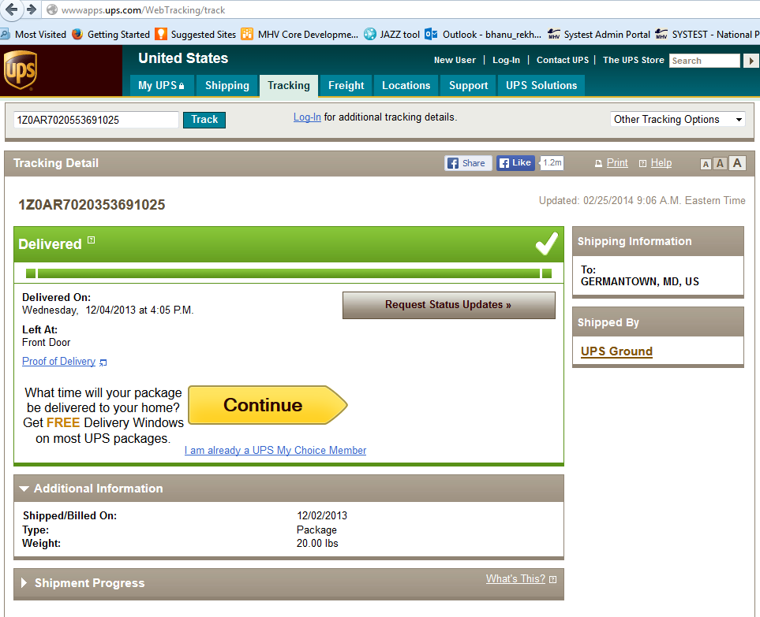Approval Status: Existing Content

Appendix I Email Information Successfully Saved

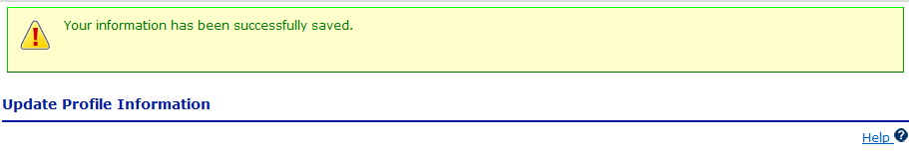

Approval Status: Existing Content

Appendix J Job Failed Distribution Group Message

|  |
| --- |
| **\_\_\_\_\_\_\_\_\_\_\_\_\_\_\_\_\_\_\_\_\_\_\_\_\_\_\_\_\_\_\_\_\_\_\_\_\_\_\_\_\_\_\_\_\_\_\_\_\_\_\_\_\_\_\_\_\_\_\_\_\_\_\_\_\_\_\_\_\_\_\_\_\_\_**  **To**: [VHA10P2AMHVDataAnalyticsTeam@va.gov](mailto:VHA10P2AMHVDataAnalyticsTeam@va.gov)  **From:** Department of Veterans Affairs: My Health***e***Vet [<mailto:No_Reply_Allowed@va.gov>]  **Subject**: VA RX Shipment Notification Nightly Background Job  **\_\_\_\_\_\_\_\_\_\_\_\_\_\_\_\_\_\_\_\_\_\_\_\_\_\_\_\_\_\_\_\_\_\_\_\_\_\_\_\_\_\_\_\_\_\_\_\_\_\_\_\_\_\_\_\_\_\_\_\_\_\_\_\_\_\_\_\_\_\_\_\_\_\_**  The nightly background job did not run as scheduled on MM/DD/YYYY.  **Please do not reply directly to this email**  **as it is an automated message from the My Health*e*Vet System** |

Approval Status: Approved 2/24/15.

Appendix K Refill Prescription Information Page

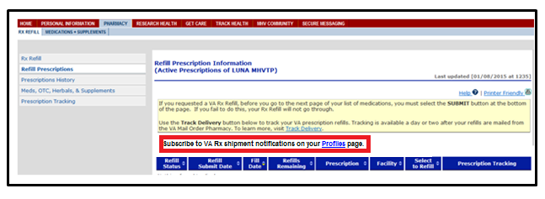Approval Status: Approved 2/24/15

Appendix L Account Activity Log

|  |  |  |  |  |  |  |  |  |
| --- | --- | --- | --- | --- | --- | --- | --- | --- |
| Row | Activity\_Id | User\_Profile\_Id | Action | Status | Performer\_Type | Detail\_Value | Activity\_Type | Completion\_Time |
| 1 | as defined in Activity Table Schema | as defined in Activity Table Schema | Update | successful | self |  | Profiles | as defined in Activity Table Schema |
| 2 | as defined in Activity Table Schema | as defined in Activity Table Schema | Updated email address | successful | self |  | Profiles | as defined in Activity Table Schema |
| 3 | as defined in Activity Table Schema | as defined in Activity Table Schema | Turn On Rx Notifications | successful | self |  | Profiles | as defined in Activity Table Schema |
| 4 | as defined in Activity Table Schema | as defined in Activity Table Schema | Turn Off Rx Notifications | successful | self |  | Profiles | as defined in Activity Table Schema |
| 5 | As defined in activity table schema | as defined in Activity Table Schema | Sent Rx Tracking Email | Successful | System | Reminder sent to email address: veteran@email.com | Notifications | System Date/Time |
| 6 | As defined in activity table schema | as defined in Activity Table Schema | Sent Rx Tracking Email | Unsuccessful | System | Reminder could not be sent to email address listed in MHV user profile: veteran.email.com | Notifications | System Date/Time |

Approval Status: Approved 1/30/15

Appendix M Registration Page

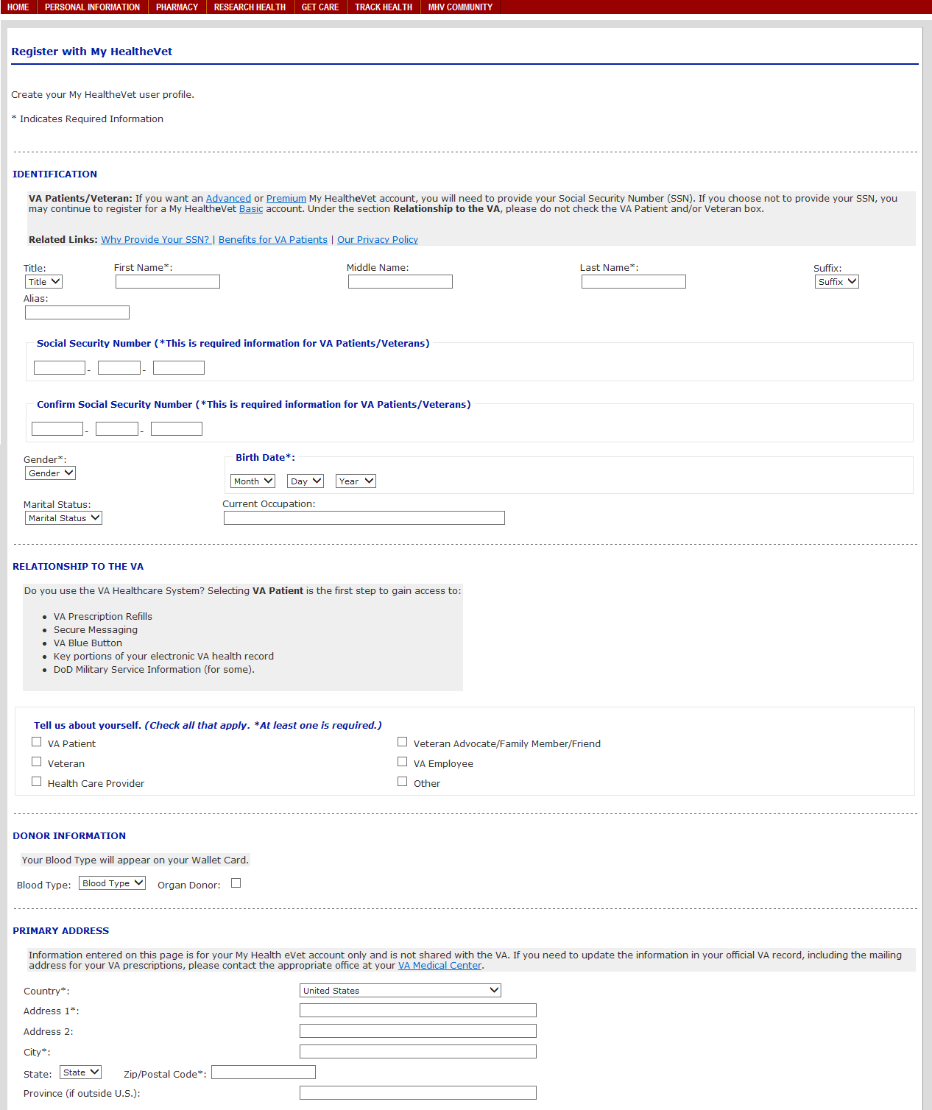

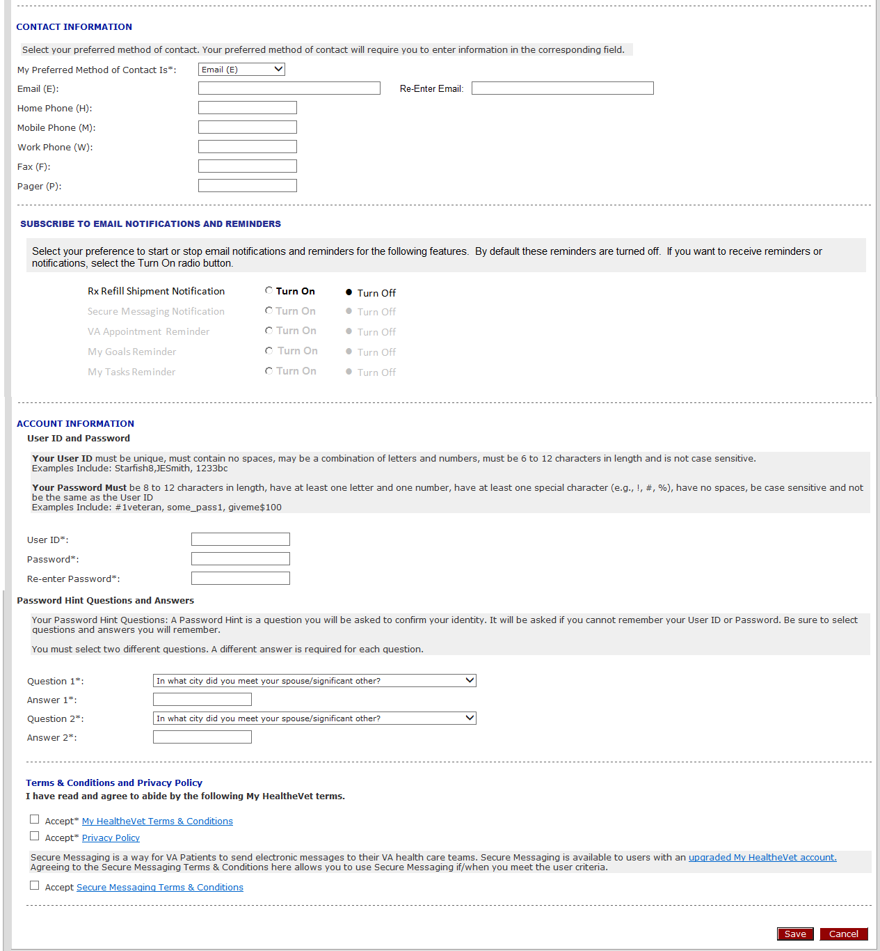

Approval Status: Approved 1/14/15

Appendix N Error Message – Email Address Required

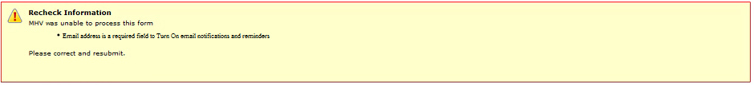

Approval Status: Approved 2/9/15

Appendix O Approval Signatures

The requirements defined in this document are the high level business requirements necessary to meet the strategic goals and operational plans of the Veterans/Consumers Health Informatics Office.

**My Health*e*Vet Program Management Office**

Signifies that the customer approves the documented requirements, that they adequately represent the customers desired needs, and that the customer agrees with the defined scope for the Business Use Case.

Signed: Date:

Theresa Hancock, Director, Veterans/Consumers Health Informatics Office