Veterans Health Administration  
Connected Health

Informatics and Analytics Office

Requirements Engineering Management  
My Health*e*Vet (MHV) End User Functionality

MHV Online Prescription Delivery Tracking

NSR #20120315

BUC #206

*Business Use Case*



May 2014

Revision History

**Note**: The revision history cycle begins once changes or enhancements are requested after the Business Use Case Document has been baselined.

| Date |  | Description | Author |
| --- | --- | --- | --- |
| 12/10/2013 | 0.1 | Initial entries | Rick Maxson |
| 1/21/2014 | 0.2 | Scope reduced for a March 2014 release   * Modify 2 existing Rxpages * Modify new Tracking detail page * Relaxed image requirement | Carnetta Scruggs and team  (Updates in Word doc only) |
| 1/30/2014 | 0.3 | Phase I revision to remove Tracking Prescription from based on 1/17/2014 call with Tedrick Vernon | Carnetta Scruggs and team  Tedrick Vernon  Rick Maxson |
| 2/19/2014 | 0.4 | Phase I revision based on comments from team and content updates from Kathleen Painter | Tedrick Vernon |
| 2/24/2014 | 0.5 | Draft #6 - Removed Phase 1 references and made changes based on calls and emails with Carnetta Scruggs and Rick Maxson. The changes reflect all of the requirements independent of phases | Tedrick Vernon |
| 3/3/2014 | 0.6 | Draft #7 – Made changes based on call with Carnetta Scruggs and feedback from Kathleen Painter and development team. | Tedrick Vernon |
| 3/13/2014 | 0.7 | Draft #8 – Applied new template, changed format of appendices, added/updated content including new screenshots, updated requirements, modified gaps in flow based on conversations with Carnetta Scruggs and Kathleen Painter | Tedrick Vernon |
| 3/14/2014 | 0.7 | Draft #9 – Made updates and changes to screens, screen specifications and requirements based on conversations with Carnetta Scruggs, Kathleen Painter, and Bhanu Goparaju | Tedrick Vernon and Carnetta Scruggs |
| 3/17/2014 | 0.8 | Draft #10 – Made minor edits submitted by Kathleen Painter | Tedrick Vernon |
| 3/19/2014 | 0.9 | Made minor edits based on feedback from Carnetta Scruggs, Ken Siehr, and Eric Spahn | Tedrick Vernon |
| 3/19/2014 | 0.10 | Submitted to Patricia Wigfield VCHIO for approval | Tedrick Vernon |
| 4/1/2014 | 0.11 | Made minor edits based on feedback from PD and Carnetta Scruggs | Tedrick Vernon |
| 4/1/2014 | 0.12 | Resubmitted to Patrica Wigfield VCHIO for approval | Tedrick Vernon |
| 5/13/2014 | 0.13 | Final review and edits | Marcia Berg |
| 5/13/2014 | 0.14 | Made minor edits and resubmitted to Terry Cooper for signatures | Tedrick Vernon |
| 5/15/2014 | 0.15 | Combined latest updates with signature page | Terry Cooper |
| 5/15/2014 | 0.16 | Additional edits/corrections/adjustments to combined document | Marcia Berg |
| 6/19/2014 | 0.17 | Made final edits based feedback from Marcia | Tedrick Vernon |
| 08/6/2014 | 0.18 | Replaced screenshot in Appendix H and changed screen specification information and changed AAL Entry | Tedrick Vernon |
| 8/12/2014 | 0.19 | Replaced screenshots in Appendix G and J with new screenshots received from Bhanu Goparaju and Ngozi Abolarin. Also modified screen spec information per new screens. | Tedrick Vernon |
| 10/09/2014 | 0.20 | Add Prescription Tracking column to table in Appendix F.  Add Business Rules for:   * Data refresh * Approved status of medical images * Adding medical image version # or date to MIL image displayed * Removing “View Image” hyperlink if there is no image available from MIL   Add note that icon image for Pharmacy Landing page may change  Modify BR for Track Delivery from 50 to 45 days. | Carnetta Scruggs  Rick Maxson |
| 10/31/2014 | 0.21 | RX Refill pages were updated in the 12.10.1 release last weekend, so BUC updated with this version number where 12.10.x was noted, | Tedrick Vernon |
| 10/31/2014 | 0.22 | Made a note in the BUC there are 2 Pharmacy landing pages that were updated with the new icon (image). | Tedrick Vernon |
| 11/3/2014 | 0.23 | Replaced screenshots in Appendix D provided by Ngozi Abolarin and updated approved overview content. Replaced screen shot in Appendix E and added new Overview content provided by Ngozi Abolarin. Replaced screen shot in Appendix I with updated screen shot and removed business rule 6.1.11, which was no longer applicable. | Tedrick Vernon |
| 11/3/2014 | 1.0 | Baseline |  |
| 3/27/2015 | 1.1 | Updated to include Web Trends tracking for 12.13 | Janice Phiffer |
| 8/14/2015 | 1.2 | Submitted and reviewed with C. Harman; approved for final approval | Janice Phiffer |
| 8/25/2015 | 1.3 | Editorial review #3 | M. Berg |
| 8/26/2015 | 1.4 | Made final formatting edits as per M.Berg’s comments | J. Phiffer |
| 8/26/2015 | 2.0 | Baseline for 12.13 | J. Phiffer |
| 10/16/2015 | 2.1 | Updated Business Rule for Track Delivery from 45 to 30 days | R. Weaver |
| 01/07/2016 | 2.2 | Updated Business Rule #2, Appendix G and F | Soujanya Bhamidipaty |
| 01/08/2016 | 2.3 | Updates screenshots in Appendix H and N. | Soujanya Bhamidipaty |

Table of Contents

[1. Online Prescription Delivery Tracking 1](#_Toc428441370)

[1.1. Brief Description 1](#_Toc428441371)

[1.2. Actors 2](#_Toc428441372)

[2. Preconditions 3](#_Toc428441373)

[3. Basic Flow of Events 3](#_Toc428441374)

[3.1. Track from Prescription Tracking 3](#_Toc428441375)

[4. Alternative Flows 4](#_Toc428441376)

[4.1. Track from Refill My Prescription 4](#_Toc428441377)

[4.2. Track from Prescription History Refill 4](#_Toc428441378)

[4.3. Prescription Name Link Selected on the Prescription Tracking Summary Page 5](#_Toc428441379)

[4.4. View Image Link Selected on the Prescription Tracking Information Details Page 5](#_Toc428441380)

[4.5. Return to List Button Selected on the Prescription Tracking Information Detail Page 5](#_Toc428441381)

[4.6. Cancel Button Selected on the MHV Warning Page 5](#_Toc428441382)

[5. Post Conditions 6](#_Toc428441383)

[6. Special Requirements 6](#_Toc428441384)

[6.1. Business Rules 6](#_Toc428441385)

[7. Extension Points 7](#_Toc428441386)

[Appendix A Acronyms and Definitions 8](#_Toc428441387)

[Appendix B Business Use Case Flow Models 10](#_Toc428441388)

[Appendix C Account Activity History Entry 11](#_Toc428441389)

[Appendix D Pharmacy Landing Page 12](#_Toc428441390)

[Appendix E View Prescription Tracking Information Page 14](#_Toc428441391)

[Appendix F Refill Prescription Information Summary Page 16](#_Toc428441392)

[Appendix G View Prescription History Information Summary Page 18](#_Toc428441393)

[Appendix H View Prescription Tracking Information Page 19](#_Toc428441394)

[Appendix I VA Prescription Medication Image Page 21](#_Toc428441395)

[Appendix J Leaving MHV Warning Page 23](#_Toc428441396)

[Appendix K Example of UPS and USPS Tracking Information Page 24](#_Toc428441397)

[Appendix L View Prescription Information page 26](#_Toc428441398)

[Appendix M Web Trends Tracking - Track Delivery Button 27](#_Toc428441399)

[Appendix N Web Trends Tracking – Select Carrier Hyperlink 28](#_Toc428441400)

[Appendix O Approval Signatures 29](#_Toc428441401)

# Online Prescription Delivery Tracking

This is the [Business Use Case](#bususecase) ([BUC](#buc)) for My Health***e***Vet Online Prescription Tracking. This BUC defines the business level response of the System to a sequence of actions performed by any of the Actors listed below to log onto [MHV](#mhv), view and track their prescriptions by a VA [Consolidated Mail Outpatient Pharmacies](http://en.wikipedia.org/wiki/Consolidated_Mail_Outpatient_Pharmacy) ([CMOP](#cmop)), described in this document as a VA Mail Order Pharmacy. A single [Business Use Case Model](#bususecasediagram) may have many (System) Use Case Models associated with it, where each Business Use Case Model represents a single application.

**Note:** This document uses hyperlinks to display wireframes of the new webpages to be designed. For ease of browsing, you may install a hyperlink back button with these simple steps:

1. Click **File/Options/Quick Access Toolbar**
2. Select **All Commands** from the drop-down list over the left command column.
3. Find the green arrow **Back** button in the left command column.
4. Highlight the **Back** button and **Add** it to the right command column.
5. Use the **Up/Down Arrows** to move the **Back** button to the top of the right command column.
6. You can now view pages or sections, within any Word document, from the Table of Contents, and view appendices with wireframes and/or other document references and return to where you were using the hyperlink **Back** button.

## Brief Description

The Department of Veterans Affairs ([VA](#va)) sends the majority of outpatient prescriptions to patients via the United States Postal Service ([USPS](#usps)) and United Parcel Service ([UPS](#ups)), the current VA contracted delivery services for prescriptions mailed from both local VA facilities and the VA [CMOP](#cmop). The majority of these prescriptions are filled at seven large [CMOP](#cmop)s which are located across the United States.  Over 115 million prescriptions, or 80%, of all Veterans Health Administration’s (VHA) outpatient prescriptions are sent to Veterans annually via the CMOP.  The CMOP is also referred to as the VA Mail Order Pharmacy in this BUC.

Currently, in order for Veterans to track the delivery of their mail-out prescription medications they must telephone their local VA Medical Center or request tracking information via the VHA’s web based portal, My Health***e***Vet, using Secure Messaging, an on-line communication system utilized by VA patients and staff.  This results in an increased number of telephone calls and messages to pharmacy staff at medical centers and decreased Veteran satisfaction.

My Health***e***Vet ([MHV](#mhv)) is VHA’s web based portal for Veterans to use when accessing their personal health information and communicating with the VHA health care system.  Veterans can currently order VA medication using the portal.  The vast majority of on line retailers and private sector prescription mail pharmacies provide a functionality that allows the purchaser/patient to track the delivery of their parcel via the internet.

Veterans and consumers expect to have this functionality available and are familiar with the concept and use.  Online Prescription Tracking displays a link within MHV for Veterans to use so they can access USPS and UPS package tracking information that is already available from the Veterans Administration CMOP.  It is estimated that 460,000 phone calls from Veterans could be eliminated quarterly by providing this service. It should noted that the ability to track prescription delivery on line, thereby reducing personnel costs incurred by calling the pharmacy staff, was a winner of the Presidential SAVE Award.

This prescription tracker will be released in multiple phases;

Phase 1 (MHV Release 12.10 September 2014)

* Add prescription tracker to existing Prescription Refill page
* Add the Prescription Tracker Detail page
* Allow user to accept the tracker number and go to delivery service website

Phase 1B (MHV Release 12.10.x October 2014)

* Add prescription tracker to existing Prescription History Refill page

Phase 2 (MHV Release 12.11 December 2014)

* Add new Presciption Tracker Summary page
* Add view image functionality

MHV Release 12.14.3 December 2015

* Updated Business Rule for Track Delivery from 45 to 30 days

MHV Release 16.1 February 2016

* Added W to the Routing field

## Actors

Actors have three access levels.

|  |  |
| --- | --- |
| **Event** | **Actors** |
| Track Package | VA Patient |
| System Events | My Health***e***Vet National Portal |



# Preconditions

1. The Actor must be a VA Patient.
2. The Actor must have a VA prescription filled by Consolidated Mail Outpatient Pharmacy (CMOP).
3. The Actor must be logged into MHV with an Advanced or Premium account.

# Basic Flow of Events

This Business Use Case describes the basic business requirements for MHV Online Prescription Tracking functionality in MHV. This functionality allows Veterans with an Advanced or Premium account in My Health***e***Vet to track VA prescriptions filled and mailed from any of the seven CMOP locations in the USA, much the same as packages are currently tracked using delivery services such as USPS or UPS.

## Track from Prescription Tracking

Advanced/Premium MHV users on the Prescription Tracking Summary page can select a button to take them to the **View** **Prescription Tracking Information Details** page.

**Step 1:** The Actor enters the User ID and Password for an MHV Advanced or Premium account. ([Business Rule 6.1.1](#onlypremiumaccountBR))

**Step 2:** The System shall authenticate the Actor.

**Step 3:** The System shall display the MHV home page.

**Step 4:** The Actor selects the Pharmacy tab from the MHV homepage menu.

**Step 5**: The System shall display the **Pharmacy landing page**. (See [Appendix D](#Appendix_D))

**Step6:** The Actor selects the **Track Prescriptions** icon/image from the Pharmacy landing page. (See [Alternative Flow 4.1](#Altflow_4_1) and [Alternative Flow 4.2](#Altflow_4_2)) ([Business Rule 6.1.9](#datarefreshBR))

**Step 7:** The System shall display the **Prescription Tracking Summary page** (See [Appendix E](#Appendix_E)) and the table displays on that page.

**Step 8:** The Actor selects a prescription record to track from the table on the **Prescription Tracking Summary page** by clicking the **Track Delivery** button in the Tracking column. (See [Alternative Flow 4.3](#Altflow_4_3)) ([Business Rule 6.1.2](#trackdeliveryfrequencyBR))(See [Appendix F](#Appendix_F))

**Step 9:** The System applies Web Trend tracking once the user selects the **Track Delivery** button. ([Business Rule 6.1.12](#br12)) (See [Appendix M](#Appendix_M))

**Step 10:** The System displays the **View** **Prescription Tracking Information Details page (**See [Appendix H](#Appendix_H)) for the selected prescription.

**Step 11:** The Actor selects the **Carrier Tracking Number** hyperlink. (See [Alternative](#Altflow_4_4) [Flow 4.4](#Altflow_4_4) and [Alternative Flow 4.5](#Altflow_4_5))

**Step 12:** The System applies Google Analytics event tracking once the user selects the **Carrier Tracking Number** hyperlink. ([Business Rule 6.1.13](#br13)) (See [Appendix N](#Appendix_N))

**Step 13:** The System displays a **MHV warning page** (See [Appendix J](#Appendix_J)) to inform the Actor that he/she will be transferred to a non-VA website USPS or UPS to track their Rx delivery.

**Step 14:** The Actor selects the **Continue** button from the MHV warning page. (See [Alternative Flow 4.6](#Altflow_4_6))

**Step 15:** The System creates an **Account Activity History** entry (See [Appendix C](#Appendix_C)) to record the activity as tracking a mailed prescription.

**Step 16:** The System logs an entry in a table for reporting metric by the VAMC Rx is filled for. Record User Profile ID, Rx#, Rx Station#, date/time. This may be logged multiple times a day for the same Rx.

**Step 17:** The System opens a new window session at the UPS or USPS page that has the selected Rx tracking information.

**Step 18:** The Actor leaves MHV and lands on the UPS or USPS page with the **Delivery Tracking Detail**. (See [Appendix K](#Appendix_K))

**Step 19:** The Basic Use Case flow ends.

# Alternative Flows

## Track from Refill My Prescription

Advanced/Premium MHV users on the **Refill Prescription History Information Summary** page can select a button to take them to the **View** **Prescription Tracking Information Details** page. (See [Appendix F](#Appendix_F))

**Step 1:** On the Pharmacy Landing page, the Actor selects **Refill My Prescriptions**. (See [Appendix D](#Appendix_D))

**Step 2:** The System displays the **Refill Prescription History Information Summary page**. (See [Appendix F](#Appendix_F))

**Step 3:** The Actor selects the **Track Delivery** button. (See [Appendix M](#Appendix_M))

**Step 4:** Alternate Flow 4.1 continues with the [**Basic Flow**](#_Track_from_Prescription) Steps 9 through 17.

## Track from Prescription History Refill

Advanced/Premium MHV users on the **View Prescription History Information Summary** (See [Appendix G](#Appendix_G)) page can select a button to take them to the **View** **Prescription Tracking Information Details** page. **(**See [Appendix H](#Appendix_H))

**Step 1:** On the Pharmacy Landing page, the Actor selects **Prescription** **Refill Prescriptions**. (See [Appendix D](#Appendix_D))

**Step 2:** The System displays the **View Prescription History Information Summary page**. (See [Appendix G](#Appendix_G))

**Step 3:** The Actor selects the **Track Delivery** button. (See [Appendix M](#Appendix_M))

**Step 4:** Alternate Flow 4.2 continues with the [**Basic Flow**](#_Track_from_Prescription) Steps 9 through 17

## Prescription Name Link Selected on the Prescription Tracking Summary Page

**Step 1:** On the **Prescription Tracking Summary page**, the Actor selects the **Prescription Name link**. (See [Appendix E](#Appendix_E))

**Step 2:** The System displays the **View Prescription Information page**. (See [Appendix L](#Appendix_L))

**Step 3:** The Actor clicks the  **Return to List button**.

**Step 4:** The System displays the **Prescription Tracking Summary page**. (See [Appendix E](#Appendix_E))

**Step 4:** The Alternative Flow ends.

## View Image Link Selected on the Prescription Tracking Information Details Page

**Step 1:** On the **View** **Prescription Tracking Information Details page**, the Actor selects the **View Image** link**.**

**Step 2:** In a second window, the System displays the VA Prescription Medication Image page. (See [Appendix I](#Appendix_I))

**Step 3:** The Actor clicks the **Return to List** button..

**Step 4:** The System displays the **View** **Prescription Tracking Information Details page.** (Business Rules 6.1.10, 6.1.11 and 6.1.12) **(**See [Appendix H](#Appendix_H))

**Step 5:** The Alternative Flow ends.

## Return to List Button Selected on the Prescription Tracking Information Detail Page

**Step 1:** On the **View Prepscription Tracking Information Details page**, the Actor selects the **Return to List** button. **(**See [Appendix H](#Appendix_H))

**Step 2:** The System displays the previous page.

**Note**: The previous page displayed is determined by the Summary page selected by the Actor during the flow. It will be one of the following:

* Prescription Tracking Summary page (See [Appendix E](#Appendix_E))
* Refill Prescription Information Summary page (See [Appendix F](#Appendix_F))
* View Prescription History Information Summary page (See [Appendix G](#Appendix_G))

**Step 3:** The Alternative Flow ends.

## Cancel Button Selected on the MHV Warning Page

**Step 1:** On the **MHV Warning page**(See [Appendix J](#Appendix_J)), the Actor clicks the **Cancel** button.

**Step 2:** The System takes the Actor back to the previous page (the **View** **Prescription Tracking Information Details page**). **(**See [Appendix H](#Appendix_H))

**Step 3:** The Alternative Flow ends.

# Post Conditions

1. Actor’s mailed prescription tracking information is displayed.

# Special Requirements

## Business Rules

**Note**: This Use Case will not address any changes being made to the other icons on the Pharmacy Landing page, for example My Medications and My VA Medication List.

1. Only MHV accounts with an Advanced or Premium status can track VA medications sent by the CMOP.
2. Display **Track Delivery** button that takes user to window session w/UPS or USPS.

* ***If Dispensed On Date*** *> or = T – 31 days ( T = Sysdate)*

***and*** *Routing (M/W) field =* ***M or W*** *( MHV pulls this in IA# 4687 – this field is not displayed in the MHV GUI pharmacy pages) Updated. Targeted for 16.1 release*

1. Prescription data is pulled from CDW/VistA once per calendar day.
2. Prescriptions can have multiple dispense dates within a 30 calendar day timeframe.
3. A page will display to the user when they select the carrier tracking number link which informs users they are opening a window session to a trusted commercial site and their MHV session will still be active.
4. All the Account Activity tracking entries will be Successful.
5. Specific Rx tracking information can be purged after 46 calendar days.
6. UPS currently has a contract with the VA; this is subject to change.
7. When a user lands on the Prescription Tracking Summary page (See [Appendix E](#Appendix_E)), the System shall initiate a prescription data refresh.
8. The System shall display only images of what? in an approved status in the Medical Image Library (MIL).
9. If there is no approved image of a medication in the MIL, do not display the “View Image” hyperlink on the View Prescription Tracking Information page. **(**See [Appendix H](#Appendix_H))
10. The System applies “WT.ac” tracking code with unique tags for each “Track Delivery” hyperlinked button.  (“Track-1, Track-2, etc.”)
11. The System applies “WT.ac“ tracking code with unique tags for each “Select Tracking Number” hyperlink.  (“Selecttrack-1, Selecttrack-2, etc.”)

# Extension Points

Not applicable for this work effort.

Appendix A Acronyms and Definitions

Table : Acronyms Missing acronyms

| **Term** | **Description** |
| --- | --- |
| BUC | Business Use Case |
| CDW | Corporate Data Warehousw |
| CMOP | Consolidated Mail Outpatient Pharmacies (for MHV users CMOP is being referred to as VA Mail Order Pharmacy) |
| MHV | My Health***e***Vet |
| MIL | Medical Information Library |
| NSR | National Service Request |
| Rx | Prescription |
| UPS | United Parcel Service |
| USA | United States of America |
| USPS | United States Postal Service |
| VA | Department of Veterans Affairs |
| VHA | Veterans Health Administration |
| VistA | Veterans Health Information Systems and Technology Architecture |

Table : Definitions

| Term | Definition |
| --- | --- |
|  |  |
| Actor | A role played by a user when using the System.  An Actor may be a person or another System.  An Actor may input information or receive information. |
| Alternative Flow | Secondary paths which are variations of the Basic Flow of Events. |
| Basic Flow | The normal or usual course of events within a Business Use Case. |
| Business Process Model | A business process model is a representation of activities or tasks that produce a specific service or product for a customer or customers. |
| Business Use Case | A sequence of transactions performed by a user to produce a measurable result of value; a dialog between an Actor and the System; a specific way of interacting with the System to accomplish a business-related goal. |
| Business Use Case Diagram | Depicts the relationship between an Actor and the Business Use Case. |
| Consolidated Mail Outpatient Pharmacies  VA Mail Order Pharmacy | [CMOP](#cmop) provides mail order prescriptions to veterans using facilities with highly automated distribution systems at strategic locations throughout the country.  In place of CMOP, MHV uses the term VA Mail Order Pharmacy , which is user friendly and more easily understood by patients. |
| Interface | A point of communication between two Systems or between an Actor and a System (often a GUI today.) |
| MHV Advanced Account | This account is only for Veterans and/or VA Patients whose MHV account is matched to their VA/DOD record and who have not completed the Authentication process. |
| MHV Premium Account | This account is only for Veterans and/or VA Patients. It gives users the highest level of access to My Health***e***Vet features. To get this type of account users must complete an [Authentication\*](https://www.myhealth.va.gov/mhv-portal-web/anonymous.portal?_nfpb=true&_nfto=false&_pageLabel=spotlightArchive&contentPage=ipa/ipa_instructions-anonymous.html) process which includes linking their My Health***e***Vet profile information (full name, Social Security Number (SSN), date of birth (DOB) and gender) to VA/DoD records. |
| Post Condition | The state of an event that has been fulfilled once the Basic Flow of Events has ended. |
| Pre-condition | An event which must logically occur before the Basic Flow of Events begins. |
| Primary Actor | A role one carries out when using the System in order to implement a defined business process. |
| Referenced Business Use Case | A separate Business Use Case that is “used by” the Business Use Case being described. |
| Scenario | A single path through a Business Use Case.  May be a Basic scenario or an Extension scenario. |
| Screen Specifications | Elements that make up the look and feel of screens, hard coded instructional text, and left and right sidebar navigation. |
| Secondary Actor | A role one carries out when using the System in order to make a Primary Actor complete. |
| Wireframes | A wireframe for a website is a visual representation of how the website will look textually and graphically. |

Appendix B Business Use Case Flow Models

Not applicable for this work effort.

Appendix C Account Activity History Entry

AAL tracking table entry

|  |  |
| --- | --- |
| **Date/Time:** | Sysdate |
| **Performed By:** | Self |
| **Activity:** | Track |
| **Activity Details:** | [“RX #: ” RX Number]  [“RX Name: ” RX Name] |
| Action: | Prescription |
| Result: | Successful |

Appendix D Pharmacy Landing Page

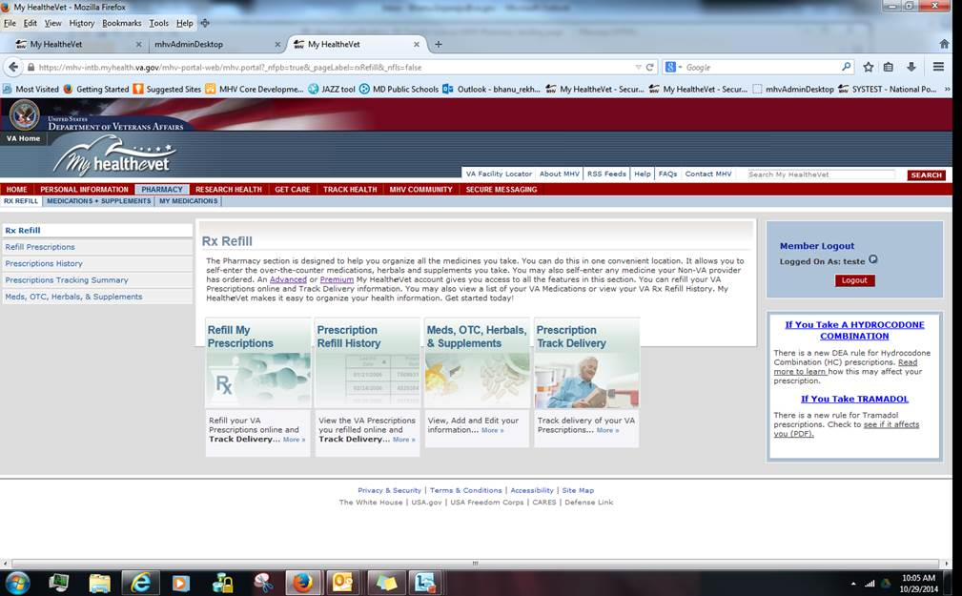

**Note:** The Pharmacy Landing page and the Rx Refill include the the Prescription Track Delivery icon.

**Screen Specifications**

1. **Updated (Overview statement on Pharmacy Landing Page) - (reading level 8.2) APPROVED CONTENT**

The Pharmacy section allows you to refill and track delivery of your VA Prescriptions online. The Prescription Trackerlets you monitor delivery of VA prescriptions shipped by a VA Mail Order Pharmacy. To learn more, visit [Track Delivery](https://mhv-syst.myhealth.va.gov/mhv-portal-web/ShowBinary/BEA%20Repository/pharmacy/trackDelivery.html" \t "_blank). In the Pharmacy section, you can also self-enter your over-the-counter medications, herbals and supplements. This includes any medicine your Non-VA provider has ordered. You may also view a list of your VA Medications and view your VA Rx Refill History. An [Advanced](https://www.myhealth.va.gov/mhv-portal-web/ShowBinary/BEA%20Repository/Registration/mhv_account_status.html" \l "advancedaccount" \t "_blank) or [Premium](https://www.myhealth.va.gov/mhv-portal-web/ShowBinary/BEA%20Repository/Registration/mhv_account_status.html" \l "premiumaccount" \t "_blank) My Health***e***Vet account gives you access to all the features in this section. Get started today

1. **Modify wording in the two images for Refill My Prescriptions – Prescription Refill History** 
   * **Refill My Prescriptions**

Refill your VA Prescriptions

online and Track Delivery…

**More>>**

* + **Prescription Refill History**

View the VA Prescriptions

you refilled online and

Track Delivery…

**More>>**

1. **Create new image w/text** 
   * **Prescription Track Delivery**

Track Delivery of your

VA Prescriptions…

**More>>**

Appendix E View Prescription Tracking Information Page

**Note:** Users land here when Prescription Tracking image is selected from the Pharmacy Landing page ( See [Appendix D](#Appendix_D))

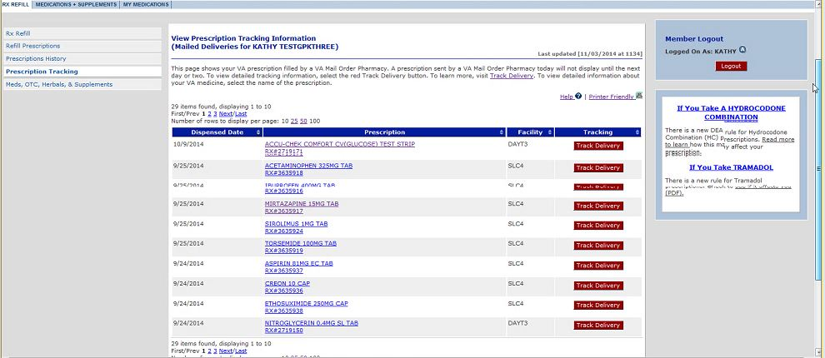

**Screen Specifications**

The System shall display the following components of the Prescription Tracking Summary page:

1. Follow standard MHV page guidelines for Prescription Tracking Summary page.
2. In left navigation column add a hyperlink to the Prescription Tracking Summary page.
3. No new tab on the blue bar at the top of the page
4. Right most column will have Member Logout box on the top and Are You at Risk box underneath
5. Standard footer
6. Last Date/Time updated as displayed on other pages above the page (blue) separation line (when data was refreshed from VistA and uploaded to My Health***e***Vet) – Display date updated as mm/dd/yyyy at military time.
7. Blue separation line
8. Printer Friendly image to print what is on the page.
9. Technical Help link to top right corner of page. Takes user to the Help file page.
10. Page heading – **View** **Prescription Tracking Information**
11. Name user – “(Mailed Deliveries for “\_Firstname Middle and Lastname\_”)”
12. Overview text describes the Prescription Tracking Summary feature as follows:

This page shows your VA prescription filled by a VA Mail Order Pharmacy. A prescription sent by a VA Mail Order Pharmacy today may not display until the next day or two. To learn more, visit [Track Delivery](https://mhv-syst.myhealth.va.gov/mhv-portal-web/ShowBinary/BEA%20Repository/pharmacy/trackDelivery.html" \t "_blank). To view detailed tracking information, select the red Track Delivery button.

1. Insert standard pagination (above and below table) – with default of 10 items to a page as presented on other MHV pages. If there are 10 or less items, it will display the number of items found and notify the user that all items are displayed. (e.g *5 items found, displaying all items*)
2. New table – Displays blue navigation bar with 4 columns. Each column has up/down arrows for ascending/descending sorting.
   1. Left navigation column titled: **Dispensed On -**  will show the date the prescription was dispensed from a VA Mail Order Pharmacy. The default sort order will be by Dispensed On date in descending order then by Rx name.
   2. 2nd navigation column titled **Prescription** - will display the name and number of the prescription dispensed from a VA Mail Order Pharmacy. This is the second sort order and sorts alphabetically.

Prescription Name and Number: will display with a hyperlink that will take them to the View Prescription Information page. ([Appendix L](#Appendix_L))

* 1. 3rd Navigation column titled **Facility** – displays the name of the VA Facility where the VA prescription was ordered. Facility sorts alphabetically.
  2. 4th navigation column titled **Tracking** – displays red **Track Delivery** button(s) that takes the user to detailed tracking/delivery information about the prescription ([Appendix H](#Appendix_H))

1. If there are no Rxs found that meet that criteria, display the words “Nothing found to display.” under the blue bar similar to other Rx pages.
2. Tracking button: View Prescription Tracking Information Detail – Heading on that page

Appendix F Refill Prescription Information Summary Page

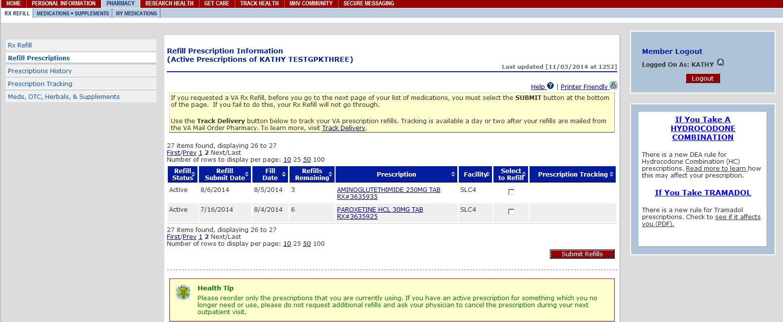

**Screen Specifications**

The System shall display the Refill Prescription Information Summary page with following components:

1. Overview text in the yellow alert box that describes the Track Delivery feature as follows:
2. If you requested a VA Rx Refill, before you go to the next page of your list of medications, you must select the **SUBMIT** button at the bottom of the page. If you fail to do this your, Rx Refill will not go through.
3. Use the Track Delivery button below to track your VA prescription refills. Tracking is available a day or two after your refills are mailed from the VA Mail Order Pharmacy. To learn more, visit [Track Delivery](https://mhv-syst.myhealth.va.gov/mhv-portal-web/ShowBinary/BEA%20Repository/pharmacy/trackDelivery.html" \t "_blank) **Note for PD**: This should display in the same yellow box as the text above with a blank line separator. This hyperlink will take the user to a 2nd window with overview information about the Tracking feature. This wording is outlined in item b) below.
4. Track Delivery hyperlink in the yellow alert box. This hyperlink will take the user to a window with overview information about the Tracking feature. The following is the overview text that describes what the Track Delivery feature is when a user clicks the Track Delivery link:
5. The **Track Delivery** feature is designed to help you track the delivery of your VA prescription via My Health***e***Vet. It lets you view when your prescription was shipped by a VA Mail Order Pharmacy. **Track Deliver**y also shows Delivery Service used (like the U.S.Post Office or UPS). When using **Track Delivery**, you do not have to remember or write down tracking numbers. When you want to find out where your mailed VA prescription is, you may go straight to **Track Delivery** to find the location of your package.

**Please Note**: The **Track Delivery** feature is available a day or two after your prescriptions are actually mailed from the VA Mail Order Pharmacy.

**Track Delivery** does not track VA prescriptions mailed from your local VA facility.  There are some special prescriptions that cannot be tracked using this feature, such as controlled substances (also called Schedule II medications).  These, and other medications or supplies, may be mailed directly from your local VA facility.

If you have any questions about your prescription, please contact your VA Pharmacy.  The name of your VA Pharmacy is on your prescription label. You may also use the [VA Facility Locator](http://www2.va.gov/directory/guide/home.asp?isFlash=1) to find the phone number of your local VA facility to request assistance.

**Note to PD coders**: The Facility Locator link is the same URL as the white tab on top of the MHV home page. Please open in a new window tab. The link goes to the VA Facility Locator, which is the same as on the MHV homepage: <http://www1.va.gov/directory/guide/home.asp?isflash=1>

1. New column to the far right named **Prescription Tracking**.
2. Track Delivery button that takes user to a window session w/UPS or USPS. Updated. Targeted for 16. 1 release.
3. **If Dispensed On Date** = Yesterday – 30 days in the past

**and** Routing (M/W) field = **M or W** ( MHV pulls this in IA# 4687)

**M=Mailed**

**W=Window Pick-up by Veteran**

**Note** **to** **PD coders:** If the user has a prescription that meets the tracking criteria, the row with the prescription information will display the button **Track Delivery** at the end of the row and under the **Prescription Tracking** column. If they do not meet the criteria, this cell will be empty.

Appendix G View Prescription History Information Summary Page

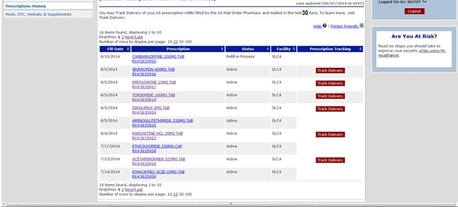

**Screen Specifications**

The System shall display the Prescription History Information page with following components:

1. Information box at the top of the page with the following content:
2. Text: You may **Track Delivery** of your VA prescription(s) filled by the VA Mail Order Pharmacy and mailed in the last 30 days. To learn more, visit Track Delivery.

NOTE to PD Coders: The Track Delivery hyperlink takes the user to the same overview statement in [Appendix F (b.(i.)](#Appendix_F_i)

1. Add new column to the far right of the table on the blue bar with header named **Prescription Tracking**.
2. Display **Track Delivery** - the **Track Delivery** button will display in the column:
3. **If Dispensed On Date** = Yesterday – 30 days in the past **and** Routing (M/W) field = **M** **or W** (MHV pulls this in IA# 4687). Updated. Targeted for 16. 1 release.
4. UPS/USPS is unavailable – They will have their own message. User still lands on that URL.
5. Technical Help Files
6. Explain in Technical HELP criteria for Rxs that are trackable in new column. Developer will update the technical help file on this page.

Appendix H View Prescription Tracking Information Page

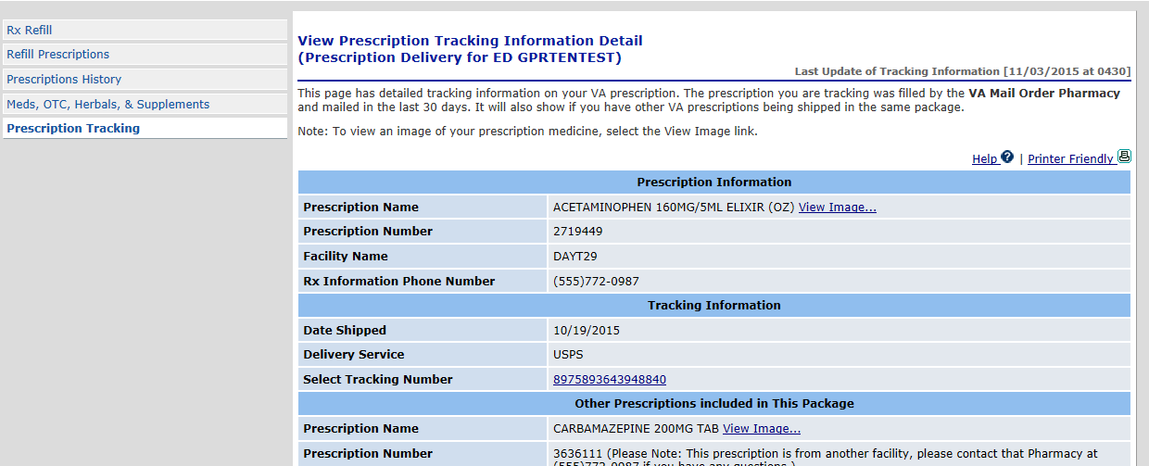

**Screen Specifications**

**Note**: Users land here when **Track Delivery** button is selected from summary pages; **Refill My Prescriptions, Prescription Refill History, and the new Prescription Tracking Summary page**

The System shall display the following components on the **View Prescription Tracking Information** page:

1. Heading: **Prescription Information**
2. **Prescription Name**: Name of Rx
3. **Prescription Number:** Rx#
4. **Facility Name:** Facility Name
5. **Rx Information Phone Number:** Phone number retrieved from CDW (where they can call for assistance, not to our Help Desk…but to a VAMC or other number)
6. The “View Image” hyperlink will display only if there is an approved image available. ([Business Rule 6.1.10](#onlyapprovedMILimagesBR))
7. Heading: **Tracking Information** (**Note**: Can have multiple Tracking information for the same Rx. Repeat grouping by Date Shipped)
8. **Date Shipped:** Date format MM/DD/YYYY
9. **Delivery Service:** UPSP or UPS
10. **Select Tracking Number**: carrier tracking number
    1. **There could be more than one Tracking number for the same Rx Shipped on the same day.** When this occurs, separate the carrier Tracking number with a comma and a space (i.e. 1234567891A, 1234566746B)

**Note**: The Delivery Service Tracking number will have a hyperlink to the Leaving MHV Warning page. (See [Appendix J](#Appendix_J) )

1. Heading: **Other Prescriptions included in This Package**

A package could include more than one Rx in a package. If there is one Rx in a box it may not have anything listed here because that one Rx (info) is listed above. **Note:** Do not display this subsection (blue bar included) if only one prescription is in a package*.*

1. (1) **Prescription Name**: Prescription Name
2. (1) **Prescription Number**: Prescription Number
3. Heading: **In the last 30 days (Rx name) was also mailed on the following dates**:
4. Heading: **Tracking Information** (**Note**: Can have multiple Tracking information for the same Rx. Repeat grouping by Date Shipped)
5. Heading: **Tracking Information** (**Note**: Can have multiple Tracking information for the same Rx. Repeat grouping by Date Shipped)
6. **Date Shipped:** Date format MM/DD
7. **Delivery Service:** USPS or UPS
8. **Select Tracking Number:** carrier tracking number
9. **There could be more than one Tracking number for the same Rx shipped on the same day.** When this occurs, separate the carrier Tracking number with a comma and a space (i.e. 1234567891A, 1234566746B)

Appendix I VA Prescription Medication Image Page

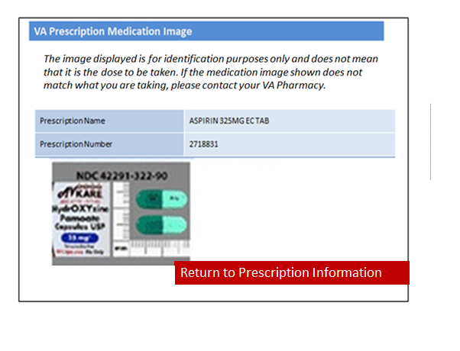**Screen Specifications**

Note: Users lands here when they are on the [View Prescription Tracking Information Detail page](#Appendix_H) and select View Image.

The System shall display the following components on the VA Prescription Medication Image page:

1. Follow standard of a new MHV page guidelines for a new window.
2. Heading in a blue bar at the top of the window, “VA Prescription Medication Image”
3. **Note**: If there is no medication image to display **and** the “View Image” hyperlink is there, when the **VA Prescription Medication** page displays the area where the medication image typically displays should say “**No Image Available.**” (see example below)

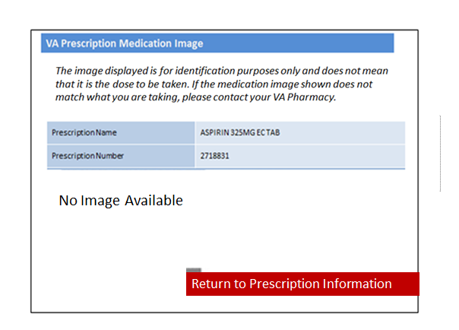

1. Add disclaimer text under heading (italicized below); **Note to developer**: This wording is according to the PBM Chief Consultant Memo dated April 23, 2014.
2. “*The image displayed is for identification purposes only and does not mean that it is the dose to be taken. If the medication image shown does not match what you are taking, please contact your VA Pharmacy.”*
3. Display Prescription Name: prescription name in blue colored row
4. Display Prescription Number: prescription number in blue colored row
5. MHV will always display the combination image from the MIL.
6. Display **Return to Prescription Information** button in red box with white letters. If user selects the **Return to Prescription Information** button the System closes the window returning them to the View Prescription Tracking Information Details page.

Appendix J Leaving MHV Warning Page



**Screen Specifications**

The System shall display the following components on the Leaving MHV Warning page:

1. MHV Logo at the top of the page
2. Add heading: “Continue to Delivery Service Website”
3. Text on the page as follows:
4. If you select **Continue**, the Delivery Service website will open in a new window or tab. Tracking information for the prescription you just selected is available on that website. If you select **Cancel** you will be returned to the previous page.
5. Continue button (**NOTE**: PD - If the user selects Continue they should land on the carrier’s page that has that Rxs tracking information.)
6. Cancel button (**NOTE**: PD - If the user selects Cancel they return to the prevous page.)
7. If UPS/USPS is unavailable – They will have their own message. User still lands on that URL.

Appendix K Example of UPS and USPS Tracking Information Page

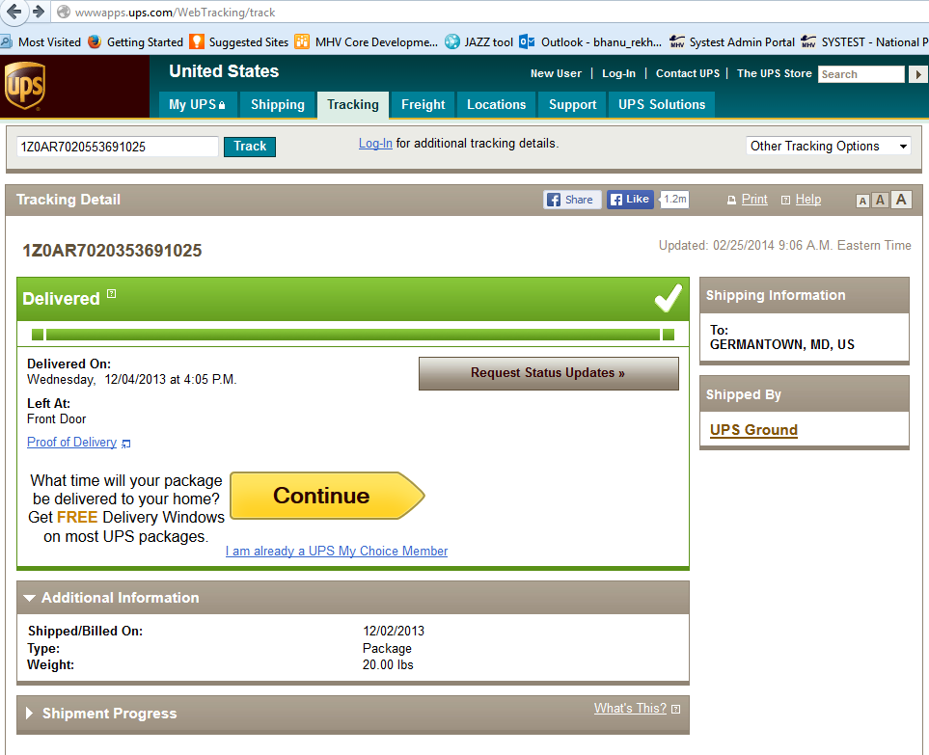

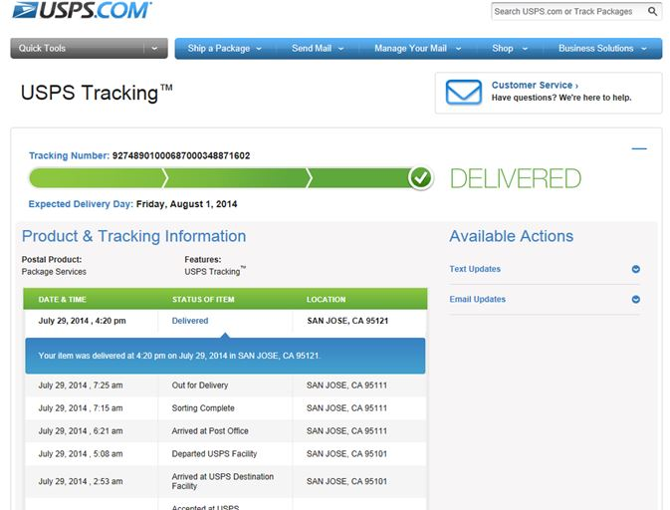

Appendix L View Prescription Information page

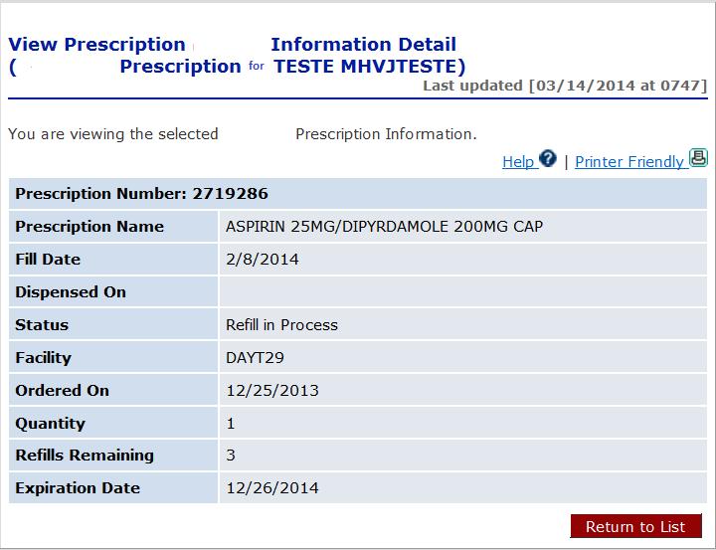

**Screen Specifications**

Users come to this page from selecting the Rx Name and Number hyperlink from the **Prescription Tracking Summary** page.

The System shall display the standard components from the **Prescription History Information Details** page.

1. The heading: **View Prescription Information Details** page
2. Sub-user name line: “(Prescription for” \_firstname middlename lastname\_”)”
3. Sub line text: “You are viewing the selected Prescription Information.”
4. Help and Printer friendly button should display as common MHV guidelines
5. Details table will be the same as displayed on Rx History information table.
6. Return to List will take user back to the previous page

Appendix M Web Trends Tracking - Track Delivery Button

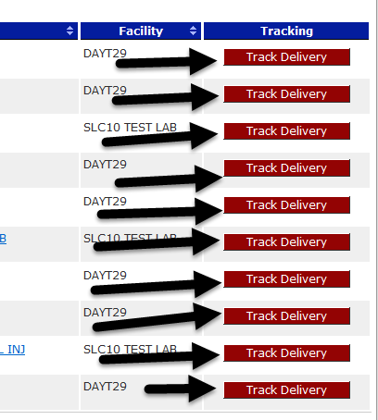

Appendix N Web Trends Tracking – Select Carrier Hyperlink

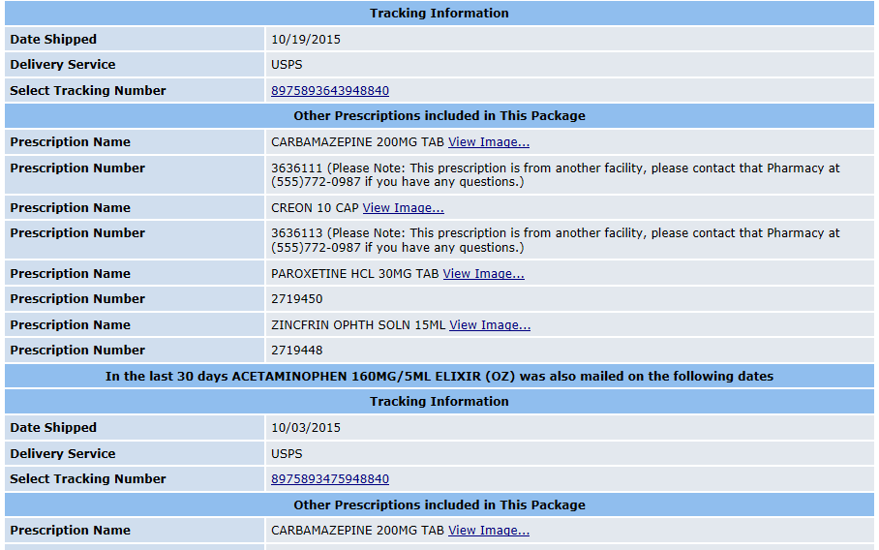

Appendix O Approval Signatures

The requirements defined in this document are the high level business requirements necessary to meet the strategic goals and operational plans of the Veterans/Consumers Health Informatics Office.

**My Health*e*Vet Program Management Office**

Signifies that the customer approves the documented requirements, that they adequately represent the customers desired needs, and that the customer agrees with the defined scope for the Business Use Case.

Signed: Date:

Theresa Hancock, Director, Veterans/Consumers Health Informatics Office