[**My Profile**](https://mhv-syst.myhealth.va.gov/mhv-portal-web/profiles)

**Identification**

1. How does MHV use the following information:
   1. **Title?**
      1. MHV stores but no longer displays this optional data field.
      2. The field display in Blue Button as Self Entered Demographic Info
      3. Always editable
   2. **First Name?**
      1. MHV uses this to match the identity to MVI
      2. Once identity is match to MVI it is un-editable by user
      3. MHV Basic account users only can edit this information
      4. MHV displays first name on most UI pages and SM
      5. Field is updated when Advanced/Premium account user goes to VA and makes a change
      6. Displays to MHV Administrators
   3. **Middle Name?**
      1. MHV uses this to match the identity to MVI
      2. Once identity is match to MVI it is un-editable by user
      3. MHV Basic account users only can edit this information
      4. Field is updated when Advanced/Premium account user goes to VA and makes a change
      5. Displays to MHV Administrators
   4. **Last Name?**
      1. MHV uses this to match the identity to MVI
      2. Once identity is match to MVI it is un-editable by user
      3. MHV Basic account users only can edit this information
      4. MHV displays last name on some UI pages and SM
      5. Field is updated when Advanced/Premium account user goes to VA and makes a change
      6. Displays to MHV Administrators
   5. **Suffix?**
      1. MHV stores but no longer displays this optional data field.
      2. The field display in Blue Button as Self Entered Demographic Info
      3. Always editable
   6. **Alias?** 
      1. MHV stores but no longer displays this optional data field.
      2. The field display in Blue Button as Self Entered Demographic Info
      3. Always editable
   7. **SSN?**
      1. MHV uses this to match the identity to MVI
      2. Once identity is match to MVI it is un-editable by user
      3. MHV Basic account users only can edit this information
      4. SSN does not display to users in MHV
      5. Field is updated when Advanced/Premium account user goes to VA and makes a change
      6. Displays to MHV Administrators
   8. **Confirm SSN?**
      1. Must match the SSN field (input validation)
      2. Once identity is match to MVI it is un-editable by user
      3. MHV Basic account users only can edit this information
      4. Confirm SSN does not display to users in MHV or MHV Administrators
   9. **Gender?**
      1. MHV uses this to match the identity to MVI
      2. Can only be Male or Female as in their VA health Record
      3. Once identity is match to MVI it is un-editable by user
      4. MHV Basic account users only can edit this information
      5. Field is updated when Advanced/Premium account user goes to VA and makes a change
      6. Displays to MHV Administrators
   10. **Birth Date?**
       1. MHV uses this to match the identity to MVI
       2. Can only be imprecise (month and year only)
       3. Once identity is match to MVI it is un-editable by user
       4. MHV Basic account users only can edit this information
       5. Field is updated when Advanced/Premium account user goes to VA and makes a change
       6. Displays to MHV Administrators
   11. **Marital Status?**
       1. MHV stores but no longer displays this optional data field.
       2. The field display in Blue Button as Self Entered Demographic Info
       3. Always editable
   12. **Current Occupation?**
       1. MHV stores but no longer displays this optional data field.
       2. The field display in Blue Button as Self Entered Demographic Info
       3. Always editable
   13. **Relationship to the VA?**
       1. MHV uses this to determine the relationship to the VA
          1. If Veteran or VA Patient the account is match to MVI
          2. Soon if Service Member, Champ VA or other the account is match to MVI
       2. User can select more than one
       3. Always editable
       4. Displays to MHV Administrators
2. **What is the goal of having the SSN field in the profile since it appears as non-editable and the numbers are hidden (at least, this is how it appears in the test account our team has access to)?** The field is not un-editable when/if the MHV account is in the Basic status. Also used to not be a required field.

**My HealtheVet Welcome Bar Personalization**

1. How does MHV use the following information:
   1. **How Would You Like to be Addressed?**
      1. As a personal salutation in the Welcome Bar at the top of the page
      2. See Figure 2
   2. **Which Military Branches Have You Served?**
      1. Display in the Welcome Bar at the top of the page for account Personalization
      2. See Figure 2

**Donor Information**

1. How does MHV use the following information:
   1. **Blood Type?**
      1. Self-entered health information used to display on the Health Wallet Card but will soon be removed
      2. See Figure 1 below
   2. **Organ Donor?**
      1. Self-entered health information

**Contact Information**

1. How does MHV use the following information:
   1. **My Preferred Method of Contact?**
      1. Displays to MHV Help Desk so they can contact users about their MHV account if needed
   2. **Email?**
   3. **Home Phone?**
   4. **Mobile Phone?**
   5. **Work Phone?**
   6. **Fax?**
   7. **Pager?**
2. **Is this information already syncing with Vet360?**
   1. No interface to Vets360 yet. However, we are on their list to integrate with.

**My VA Treating Facilities**

1. **How does MHV use the following information:**
   1. Currently, just displays to the MHV Administrators
   2. Future use is to connect them with their VA they use today for driving directions and the local VA Web site
2. **Do people ever have more than one facility in this list**?
   1. No studies done yet.

[**In Case of Emergency**](https://mhv-syst.myhealth.va.gov/mhv-portal-web/in-case-of-emergency)

**Identification**

1. **How does MHV use the following information**: Displays on MHV Health Information card as Emergency Contact See Figure 1
   1. **Title?**
   2. **First Name?**
   3. **Middle Name?**
   4. **Last Name?**
   5. **Suffix?**

**Primary Contact**

1. **How does MHV use the following information:** Primary Contact Displays on MHV Health Information Card See Figure 1
   1. **"This is my primary contact" checkbox?**

**Primary Address**

1. **How does MHV use the following information:**
   1. Displays on MHV Health Information Card See Figure 1
   2. Will be moved from Profile page soon
   3. **Country?**
   4. **Address 1?**
   5. **Address 2?**
   6. **City?**
   7. **State?**
   8. **Zip/Postal Code?**
   9. **Province?**

**Contact Information**

1. Displays on MHV Health Information Card See Figure 1
2. How does MHV use the following information:
   1. My Preferred Method of Contact?
   2. Email?
   3. Home?
   4. Mobile?
   5. Work?
   6. Fax?
   7. Pager?

**Figure 1. Example of MHV current Health Information card and future one.**

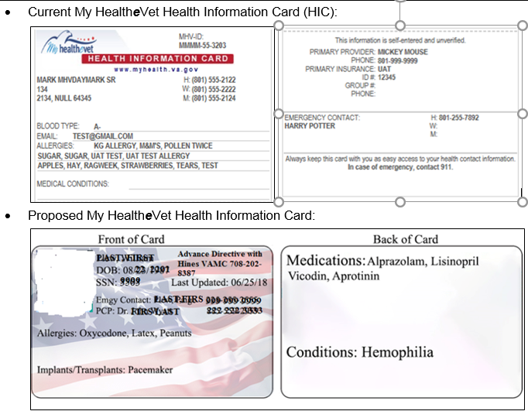

**Figure 2. Personalizing User Experience**

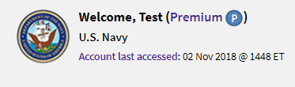

Other notes from Carnetta:

1. Preferred facility — if you have that in [VA.gov](http://VA.gov), we could present info about local VA when they log in and give driving direction.

2. They have request to pull over photo that's on their VHIC. We can use that if MHV has access to it. After March, this will be possible because November contract is ending and new contract doesn't start until March.

3. MHV clinical reminders are disabled but this might be something Cerner can implement.