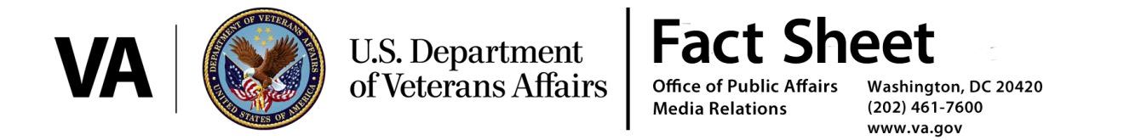

**ID.me and Secure Authentication**

Jan. 2017

**Overview of ID.me:**

ID.me is a Veteran founded company headquartered in McLean, Virginia. USAA is the company’s lead institutional investor. In 2013, the [United States Department of Commerce selected ID.me](mailto:http://www.secureidnews.com/news-item/nstic-winner-troop-id/) to provide a secure and privacy-enhancing credential to members of Military and Veteran families so they could more easily authenticate their identities online. In 2016, the Department of Veterans Affairs selected ID.me to power the identity component of Vets.gov.

**ID.me Support of Vets.gov**

VA is leveraging ID.me’s Identity Gateway to materially improve security and access to VA benefits and services online. ID.me’s Identity Gateway enables the Vets.gov approach in the following ways:

* **Secure:** The ID.me solution meets the most rigorous standards outlined by NIST and is one of only four federally certified solutions in America.
* **Flexible:** Veterans will be able to verify their identity in the following ways:
  + Combination of a physical ID document and a mobile phone.
  + Combination of answering questions and a mobile phone.
  + Alternatively, the Veteran will be able to verify their identity in person through available VA facilities.
* **Proportional:** Identity verification is not required until the Veteran attempts to access an application that includes sensitive personal information or applies for benefits.
* **Scalable:** The ID.me solution empowers VA to easily consume trusted logins from external organizations that excel at secure authentication e.g. USAA, Verizon, etc.
* **Unified:** The ID.me solution will enable VA to unify systems across the Department via a Veteran-centric design.

**ID.me Accreditations and Security Infrastructure**

The Federal Government and financial institutions have certified ID.me information security infrastructure. These include, but are not limited to the following:

* Certified by GSA FICAM at NIST Levels of Assurance (LOA) 1,2 & 3 (non-PKI)
* One of only four companies certified up to FICAM LOA 3
* Kantara Trust Framework Approved
* Utilizes NIST Risk Management Framework to include NIST 800-53 control framework
* Multi-factor authentication with FIPS 140-2 compliant encryption
* Passed multiple security audits administered by a Fortune 100 Financial Institution