# ZenHub FAQ

# How we use ZenHub

Zenhub is a project management tool integrated into GitHub that helps us visualize and track issues in our many GitHub repositories. In ZenHub, we collaborate as a team to group issues together for sprint and epics planning, refine our product backlog and track our progress.

You can access an issue through GitHub.com or ZenHub.com. No separate login is needed.

# ZenHub Permissions

You’ll need *write* access to create or make changes to an issue in a ZenHub board. if you have *read-only* access to the ZenHub board and are using a Chrome or Firefox web browser, try installing this ZenHub browser [extension](https://www.zenhub.com/extension) to solve the issue. It will add the ZenHub-only features to the [GitHub.com](https://slack-redir.net/link?url=http%3A%2F%2FGitHub.com&v=3) interface so that you can still see things like Pipeline, Epics, etc.

Reach out to Nick Sullivan if the problem persists.

# ZenHub Board(s) and finding an issue in ZenHub

If you’re having trouble finding a ZenHub issue in the [department-of-veterans-affairs](https://github.com/department-of-veterans-affairs)/[va.gov-team](https://github.com/department-of-veterans-affairs/va.gov-team) **repository and ZenHub board, the board our team commonly uses, it is likely that the issue is being tracked in another repository/board. To view all repositories and boards:**

1. Click on the **Repos** dropdown.

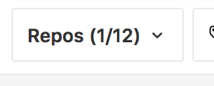

Figure : Repos Dropdown on ZenHub Board

1. Click **Show all**.

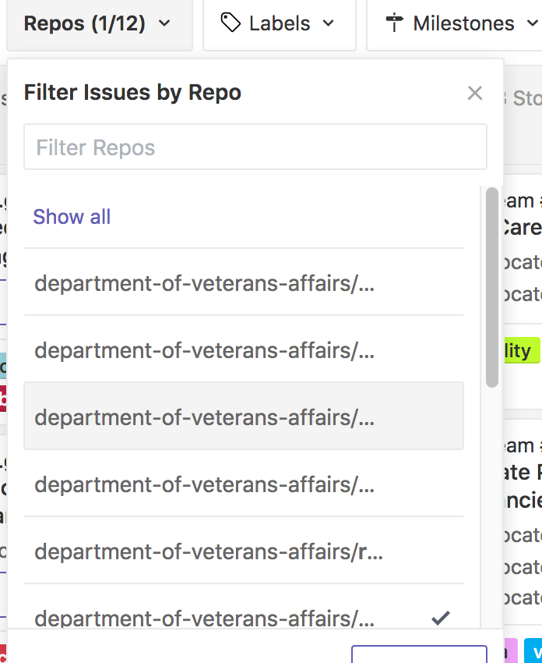

Figure : Show All

1. In the **Search** field, enter *VSA-Public-Websites* to filter the ZenHub board to only show issues with our team label.

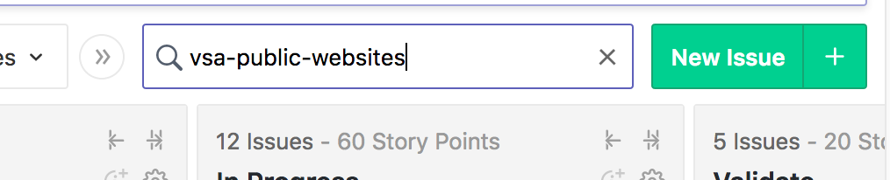

Figure : Filtering ZenHub Board with Team Label

**\*\*Note**: You can also use the Search field to view issues assigned to you, another person, according to keyword or tag, and by issue number.

Reach out to our Product Manager, Kara Kamahli, if you’re still having trouble finding an issue.

# ZenHub Pipelines

Here’s a basic description of each pipeline in our ZenHub board.

* **Icebox:** Issues that are low priority in backlog
* **Backlog:** Prioritized backlog issues ready for development
* **Epics:** Group of issues related to specific subject or development objective
* **Ready:** Issues ready to be worked on for upcoming sprint
* **Current Sprint:** Issues that will be worked on during current sprint
* **In Progress:** Issues currently being worked on during sprint
* **Validate:** Issues that need to be reviewed to confirm completion of objectives prior to closing issue.
* **Closed:** Issues that are confirmed as completed according to specified objectives

Reach out to our Product Manager, Kara Kamahli, if you’re unsure which pipeline an issue should be listed.

# Things to include when creating or updating issue (i.e., ticket)

* Clear and detailed description of objective or issue, and relevant information (e.g., urls, POCs, checklists, document links, etc.). You have the option to create a new issue using an existing template.
* Assign relevant team members that need to be kept in the loop to assist in completing the issue or for status reporting.
* On the right side of the page, designate:
  + VFT Pipeline: see ***ZenHub Pipelines*** for more information
  + Assignees: see above bulleted point
  + Labels: Be sure to include our team label (vsa-public-websites), other team labels (if this is a cross-functional collaborative effort) and additional relevant labels such as “content” or “508/accessibility” to help with filtering on the ZenHub board
  + Milestone: Specify the sprint this issue will be completed
  + Estimate: Specify the issue complexity in a numerical value
  + Epics: Link this issue to an epic if necessary
* Issue blockers or blocking other issues: List any dependencies/issues that may prevent you from completing the issue at hand or may prevent other issues from being completed. To mark an issue as blocked:

1. Open the issue and click **Add dependency**.

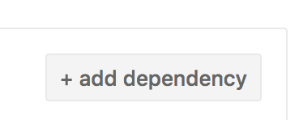

Figure : Add Dependency to Issue

1. Select **Blocked by** or **Blocking** from the dropdown and list any dependencies in the **Search** field.

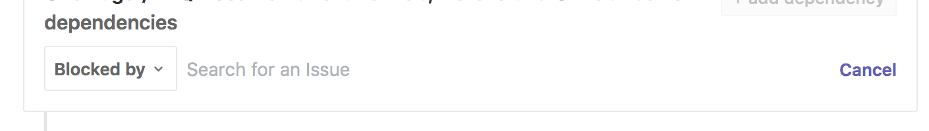

Figure : Listing Blockers or Blocking Issues